A Few Terms
These words are used often in Access so you will want to become familiar with them before using the program and this tutorial.
- A database is a collection of related information.
- An object is a competition in the database such as a table, query, form, or macro.
- A table is a grouping of related data organized in fields (columns) and records (rows) on a datasheet. By using a common field in two tables, the data can be combined. Many tables can be stored in a single database.
- A field is a column on a datasheet and defines a data type for a set of values in a table. For a mailing list table might include fields for first name, last name, address, city, state, zip code, and telephone number.
- A record in a row on a datasheet and is a set of values defined by fields. In a mailing list table, each record would contain the data for one person as specified by the intersecting fields.
- Design View provides the tools for creating fields in a table.
- Datasheet View allows you to update, edit, and delete in formation from a table.

Getting Started
After opening Access, you will be presented with the window shown below. Select one of the first two options if you are creating a new database, or the third if you want to edit an existing database. All three choices are explained in detail below.
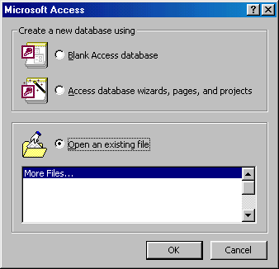

Blank Access database
- Unlike Word documents, Excel worksheets, and Power Point presentations, you must save an Access database before you start working on it. After selecting "Blank Access database", you will first be prompted to specify a location and name for the database.
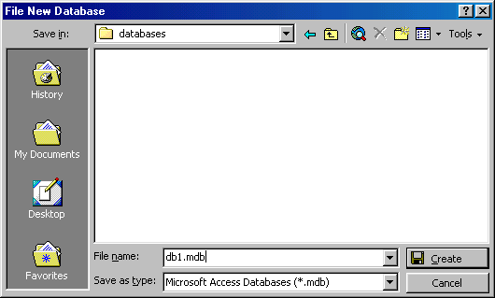
- Find the folder where the database should reside in the Save in drop-down menu.
- Type the name of the database in the File name line and click the Create button.

Access database wizards, pages, and projects
Access' wizards and layout are existing database structures that only need data input. Select a database type and click OK. Name the database on the next screen.
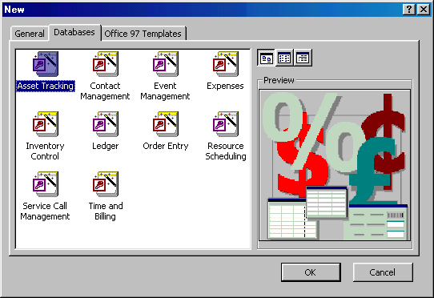

Open an existing database
If the database was opened recently on the computer, it will be listed on the main window. Highlight the database name and click OK. Otherwise, highlight "More Files..." in the list and click OK. From the subsequent window, click the "Look In:" drop-down menu to find the folder where the database is located, highlight the database name in the listing and click OK.

Converting to Access 2000
Before opening an existing file that was created in a previous version of Access, it must first be converted to Access 2000 format. Convert a database by following these steps:
- Open Access and select Tools|Database Utilities|Convert Database|To Current Access Database Version from the menu bar.
- Select the database that should be converted and click the Convert button.
- The new version will be a completely separate database and the old one will remain intact so you must then name the new version of the database.

Database Window
The Database Window organizes all of the objects in the database. The default tables listing provides links for creating tables and will list all of the tables in the database when they have been added.
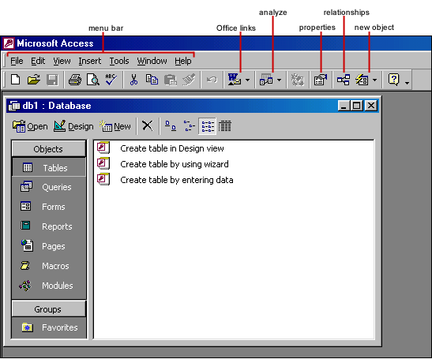

Design View
Design View customizes the fields in the database so that data can be entered.
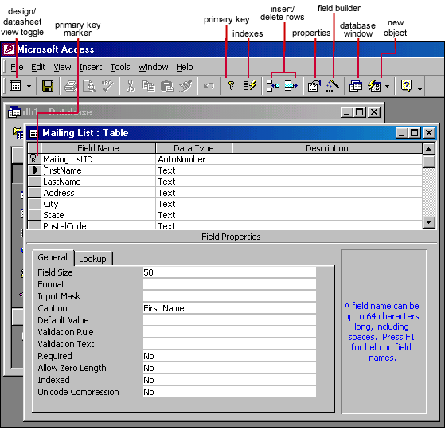

Datasheet View
The datasheet allows you to enter data into the database
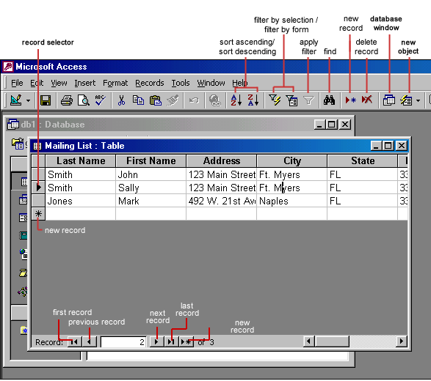

Introduction to Tables
Tables are grids that store information in a database similar to the way an Excel worksheet stores information in a workbook. Access provides three ways to create a table for which there are icons in the Database Window. Double-click on the icons to create a table.
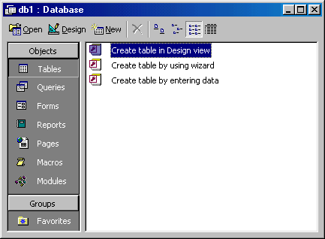
the Database Window
- Create table in Design view will allow you to create the fields of the table. This is the most common way of creating a table and is explained in detail below.
- Create table using wizard will step you through the creation of a table.
- Create table by entering data will give you a blank datasheet with unlabelled columns that looks much like an Excel worksheet. Enter data into the cells and click the Save button. You will be prompted to add a primary key field. After the table is saved, the empty cells of the datasheet are trimmed. The fields are given generic names such as "Field1", "Field2", etc. To rename them with more descriptive titles that reflect the content of the fields, select Format|Rename Column from the menu bar or highlight the column, right-click on it with the mouse, and select Rename Column from the shortcut menu.

Create a Table in Design View
Design View will allow you to define the fields in the table before adding any data to the datasheet. The window is divided into two parts: a top pane for entering the field name, data type, and an option description of the field, and a bottom pane for specifying field properties.
- Field Name - This is the name of the field and should represent the contents of the field such as "Name", "Address", "Final Grade", etc. The name can not exceed 64 characters in length and may include spaces.
- Data Type is the type of value that will be entered into the fields.
  - Text - The default type, text type allows any combination of letters and numbers up to a maximum of 255 characters per field record.
  - Memo - A text type that stores up to 64,000 characters.
  - Number - Any number can be stored.
  - Date/Time - A date, time, or combination of both.
  - Currency - Monetary values that can be set up to automatically include a dollar sign ($) and correct decimal and comma positions.
  - AutoNumber - When a new record is created, Access will automatically assign a unique integer to the record in this field. From the General options, select Increment if the numbers should be assigned in order or random if any random number should be chosen. Since every record in a datasheet must include at least one field that distinguishes it from all others, this is a useful data type to use if the existing data will not produce such values.
  - Yes/No - Use this option for True/False, Yes/No, On/Off, or other values that must be only one of two.
  - OLE Object - An OLE (Object Linking and Embedding) object is a sound, picture, or other object such as a Word document or Excel spreadsheet that is created in another program. Use this data type to embed an OLE object or link to the object in the database.
  - Hyperlink - A hyperlink will link to an Internet or Intranet site, or another location in the database. The data consists of up to four parts each separated by the pound sign (#): DisplayText#Address#SubAddress#ScreenTip. The Address is the only required part of the string. Examples:
Internet hyperlink example: | FGCU Home Page#http://www.fgcu.edu#
Database link example: | #c:\My Documents\database.mdb#MyTable
- Description (optional) - Enter a brief description of what the contents of the field are.
- Field Properties - Select any pertinent properties for the field from the bottom pane.

Field Properties
Properties for each field are set from the bottom pane of the Design View window.
- Field Size is used to set the number of characters needed in a text or number field. The default field size for the text type is 50 characters. If the records in the field will only have two or three characters, you can change the size of the field to save disk space or prevent entry errors by limiting the number of characters allowed. Likewise, if the field will require more than 50 characters, enter a number up to 255. The field size is set in exact characters for Text type, but options are give for numbers:
  - Byte - Positive integers between 1 and 255
  - Integer - Positive and negative integers between -32,768 and 32,768
  - Long Integer (default) - Larger positive and negative integers between -2 billion and 2 billion.
  - Single - Single-precision floating-point number
  - Double - Double-precision floating-point number
  - Decimal - Allows for Precision and Scale property control
- Format conforms the data in the field to the same format when it is entered into the datasheet. For text and memo fields, this property has two parts that are separated by a semicolon. The first part of the property is used to apply to the field and the second applies to empty fields.
Text and memo format.
Text Format
Format | Datasheet Entry | Display | Explanation
@@@-@@@@ | 1234567 | 123-4567 | @ indicates a required  character or space
@@@-@@@& | 123456 | 123-456 | & indicates an optional  character or space
< | HELLO | hello | < converts characters to lowercase
> | hello | HELLO | > converts characters to uppercase
@\! | Hello | Hello! | \ adds characters to the end
@;"No Data Entered" | Hello | Hello
@;"No Data Entered" | (blank) | No Data Entered
- Number format. Select one of the preset options from the drop down menu or construct a custom format using symbols explained below:
Number Format
Format | Datasheet Entry | Display | Explanation
###,##0.00 | 123456.78 | 123,456.78 | 0 is a placeholder that displays a digit or 0 if there is none.  # is a placeholder that displays a digit or nothing if there is none.
$###,##0.00 | 0 | $0.00
###.00% | .123 | 12.3% | % multiplies the number by 100 and added a percent sign
- Currency format. This formatting consists of four parts separated by semicolons:
format for positive numbers; format for negative numbers; format for zero values; format for Null values.
Currency Format
Format | Explanation
$##0.00;($##0.00)[Red];$0.00;"none" | Positive values will be normal currency format, negative numbers will be red in parentheses, zero is entered for zero values, and "none" will be written for Null values.
- Date format. In the table below, the value "1/1/01" is entered into the datasheet, and the following values are displayed as a result of the different assigned formats.
Date Format
Format | Display | Explanation
dddd","mmmm d","yyyy | Monday, January 1, 2001 | dddd, mmmm, and yyyy print the full day name, month name, and year
ddd","mmm ". " d", '"yy | Mon, Jan. 1, '01 | ddd, mmm, and yy print the first three day letters, first three month letters, and last two year digits
"Today is " dddd | Today is Monday
h:n:s: AM/PM | 12:00:00 AM | "n" is used for minutes to  avoid confusion with months
- Yes/No fields are displayed as check boxes by default on the datasheet. To change the formatting of these fields, first click the Lookup tab and change the Display Control to a text box. Go back to the General tab choices to make formatting changes. The formatting is designated in three sections separated by semicolons. The first section does not contain anything but the semicolon must be included. The second section specifies formatting for Yes values and the third for No values.
Yes/No Format
Format | Explanation
;"Yes"[green];"No"[red] | Prints "Yes" in green or "No" in red

- Default Value - There may be cases where the value of a field will usually be the same for all records. In this case, a changeable default value can be set to prevent typing the same thing numerous times. Set the Default Value property.

Primary Key
Every record in a table must have a primary key that differentiates it from every other record in the table. In some cases, it is only necessary to designate an existing field as the primary key if you are certain that every record in the table will have a different value for that particular field. A social security number is an example of a record whose values will only appear once in a database table.
Designate the primary key field by right-clicking on the record and selection Primary Key from the shortcut menu or select Edit|Primary Key from the menu bar. The primary key field will be noted with a key image to the left. To remove a primary key, repeat one of these steps.
If none of the existing fields in the table will produce unique values for every record, a separate field must be added. Access will prompt you to create this type of field at the beginning of the table the first time you save the table and a primary key field has not been assigned. The field is named "ID" and the data type is "autonumber". Since this extra field serves no purpose to you as the user, the autonumber type automatically updates whenever a record is added so there is no extra work on your part. You may also choose to hide this column in the datasheet as explained on a later page in this tutorial.

Indexes
Creating indexes allows Access to query and sort records faster. To set an indexed field, select a field that is commonly searched and change the Indexed property to Yes (Duplicates OK) if multiple entries of the same data value are allowed or Yes (No Duplicates) to prevent duplicates.

Field Validation Rules
Validation Rules specify requirements (change word) for the data entered in the worksheet. A customized message can be displayed to the user when data that violates the rule setting is entered. Click the expression builder ("...") button at the end of the Validation Rule box to write the validation rule. Examples of field validation rules include <> 0 to not allow zero values in the record, and ??? to only all data strings three characters in length.

Input Masks
An input mask controls the value of a record and sets it in a specific format. They are similar to the Format property, but instead display the format on the datasheet before the data is entered. For example, a telephone number field can formatted with an input mask to accept ten digits that are automatically formatted as "(555) 123-4567". The blank field would look like (___) ___-____. An an input mask to a field by following these steps:
- In design view, place the cursor in the field that the input mask will be applied to.
- Click in the white space following Input Mask under the General tab.
- Click the "..." button to use the wizard or enter the mask, (@@@) @@@-@@@@, into the field provided. The following symbols can be used to create an input mask from scratch:
Input Mask Symbols
Symbol | Explanation
A | Letter or digit
0 | A digit 0 through 9 without a + or - sign and with blanks displayed as zeros
9 | Same as 0 with blanks displayed as spaces
# | Same as 9 with +/- signs
? | Letter
L | Letter A through Z
C or & | Character or space
< | Convert letters to lower case
> | Convert letters to upper case

Adding Records
Add new records to the table in datasheet view by typing in the record beside the asterisk (*) that marks the new record. You can also click the new record button at the bottom of the datasheet to skip to the last empty record.

Editing Records
To edit records, simply place the cursor in the record that is to be edited and make the necessary changes. Use the arrow keys to move through the record grid. The previous, next, first, and last record buttons at the bottom of the datasheet are helpful in maneuvering through the datasheet.

Deleting Records
Delete a record on a datasheet by placing the cursor in any field of the record row and select Edit|Delete Record from the menu bar or click the Delete Record button on the datasheet toolbar.

Adding and Deleting Columns
Although it is best to add new fields (displayed as columns in the datasheet) in design view because more options are available, they can also be quickly added in datasheet view. Highlight the column that the new column should appear to the left of by clicking its label at the top of the datasheet and select Insert|Column from the menu bar.
Entire columns can be deleted by placing the cursor in the column and selecting Edit|Delete Column from the menu bar.

Resizing Rows and Columns
The height of rows on a datasheet can be changed by dragging the gray sizing line between row labels up and down with the mouse. By changing the height on one row, the height of all rows in the datasheet will be changed to the new value.
Column width can be changed in a similar way by dragging the sizing line between columns. Double click on the line to have the column automatically fit to the longest value of the column. Unlike rows, columns on a datasheet can be different widths. More exact values can be assigned by selecting Format|Row Height or Format|Column Width from the menu bar.

Freezing Columns
Similar to freezing panes in Excel, columns on an Access table can be frozen. This is helpful if the datasheet has many columns and relevant data would otherwise not appear on the screen at the same time. Freeze a column by placing the cursor in any record in the column and select Format|Freeze Columns from the menu bar. Select the same option to unfreeze a single column or select Format|Unfreeze All Columns.
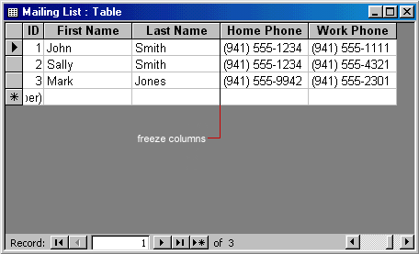

Hiding Columns
Columns can also be hidden from view on the datasheet although they will not be deleted from the database. To hide a column, place the cursor in any record in the column or highlight multiple adjacent columns by clicking and dragging the mouse along the column headers, and select Format|Hide Columns from the menu bar.
To show columns that have been hidden, select Format|Unhide Columns from the menu bar. A window displaying all of the fields in the table will be listed with check boxes beside each field name. Check the boxes beside all fields that should be visible on the data table and click the Close button.
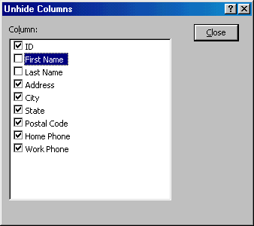

Finding Data in a Table
Data in a datasheet can be quickly located by using the Find command.
- Open the table in datasheet view.
- Place the cursor in any record in the field that you want to search and select Edit|Find... from the menu bar.
- Enter the value criteria in the Find What: box.
- From the Look In: drop-down menu, define the area of the search by selecting the entire table or just the field in the table you placed your cursor in during step 2.
- Select the matching criteria from Match: to and click the More >> button for additional search parameters.
- When all of the search criteria is set, click the Find Next button. If more than one record meets the criteria, keep clicking Find Next until you reach the correct record.
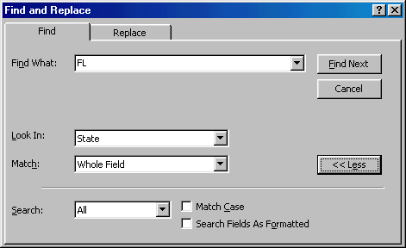

Replace
The replace function allows you to quickly replace a single occurrence of data with a new value or to replace all occurrences in the entire table.
- Select Edit|Replace... from the menu bar (or click the Replace tab if the Find window is already open).
- Follow the steps described in the Find procedure for searching for the data that should be replaced and type the new value of the data in the Replace With: box.
- Click the Find Next button to step through occurrences of the data in the table and click the Replace button to make single replacements. Click Replace All to change all occurrences of the data in one step.
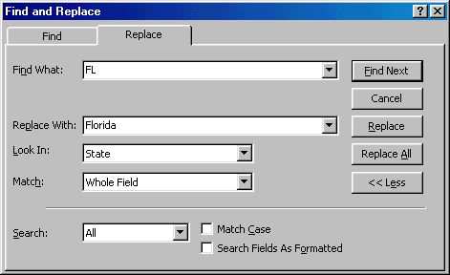

Check Spelling and AutoCorrect
The spell checker can be used to flag spelling errors in text and menu fields in a datasheet. Select Tools|Spelling from the menu bar to activate the spell checker and make corrections just as you would using Word or Excel. The AutoCorrect feature can automatically correct common spelling errors such as two INitial CApitals, capitalizing the first letter of the first word of a sentence, and anything you define. Select Tools|AutoCorrect to set these features.

Print a Datasheet
Datasheets can be printed by clicking the Print button on the toolbar or select File|Print to set more printing options.

Table Relationships
To prevent the duplication of information in a database by repeating fields in more than one table, table relationships can be established to link fields of tables together. Follow the steps below to set up a relational database:
- Click the Relationships button on the toolbar.
- From the Show Table window (click the Show Table button on the toolbar to make it appear), double click on the names of the tables you would like to include in the relationships. When you have finished adding tables, click Close.
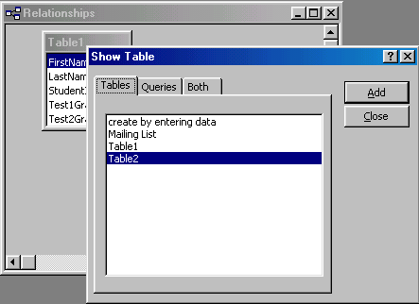
- To link fields in two different tables, click and drag a field from one table to the corresponding field on the other table and release the mouse button. The Edit Relationships window will appear. From this window, select different fields if necessary and select an option from Enforce Referential Integrity if necessary. These options give Access permission to automatically make changes to referential tables if key records in one of the tales is deleted. Check the Enforce Referential Integrity box to ensure that the relationships are valid and that the data is not accidentally deleted when data is added, edited, or deleted. Click Create to create the link.
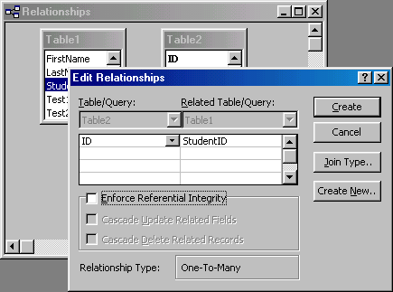
- A line now connects the two fields in the Relationships window.
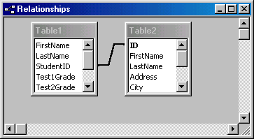
- The datasheet of a relational table will provide expand and collapse indicators to view subdatasheets containing matching information from the other table. In the example below, the student address database and student grade database were related and the two can be shown simultaneously using the expand feature. To expand or collapse all subdatasheets at once, select Format|Subdatasheet|Expand All or Collapse All from the toolbar.
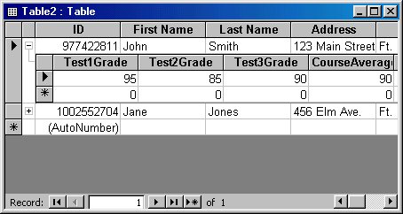

Sorting and filtering allow you to view records in a table in a different way either by reordering all of the records in the table or view only those records in a table that meet certain criteria that you specify.

Sorting
You may want to view the records in a table in a different order than they appear such as sorting by a date or in alphabetical order, for example. Follow these steps to execute a simple sort of records in a table based on the values of one field:
- In table view, place the cursor in the column that you want to sort by.
- Select Records|Sort|Sort Ascending or Records|Sort|Sort Descending from the menu bar or click the Sort Ascending or Sort Descending buttons on the toolbar.
To sort by more than one column (such as sorting by date and then sorting records with the same date alphabetically), highlight the columns by clicking and dragging the mouse over the field labels and select one of the sort methods stated above.

Filter by Selection
This feature will filter records that contain identical data values in a given field such as filtering out all of the records that have the value "Smith" in a name field. To Filter by Selection, place the cursor in the field that you want to filter the other records by and click the Filter by Selection button on the toolbar or select Records|Filter|Filter By Selection from the menu bar. In the example below, the cursor is placed in the City field of the second record that displays the value "Ft. Myers" so the filtered table will show only the records where the city is Ft. Myers.
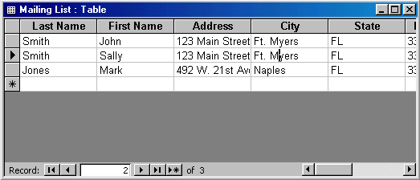

Filter by Form
If the table is large, it may be difficult to find the record that contains the value you would like to filter by so using Filter by Form may be advantageous instead. This method creates a blank version of the table with drop-down menus for each field that each contain the values found in the records of that field. Under the default Look for tab of the Filter by Form window, click in the field to enter the filter criteria. To specify an alternate criteria if records may contain one of two specified values, click the Or tab at the bottom of the window and select another criteria from the drop-down menu. More Or tabs will appear after one criteria is set to allow you to add more alternate criteria for the filter. After you have selected all of the criteria you want to filter, click the Apply Filter button on the toolbar.
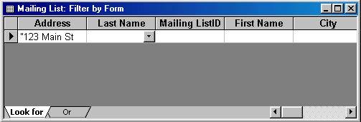
The following methods can be used to select records based on the record selected by that do not have exactly the same value. Type these formats into the field where the drop-down menu appears instead of selecting an absolute value.
Filter by Form
Format | Explanation
Like "*Street" | Selects all records that end with "Street"
<="G" | Selects all records that begin with the letters A through G
>1/1/00 | Selects all dates since 1/1/00
<> 0 | Selects all records not equal to zero
Saving A Filter
The filtered contents of a table can be saved as a query by selecting File|Save As Query from the menu bar. Enter a name for the query and click OK. The query is now saved within the database.
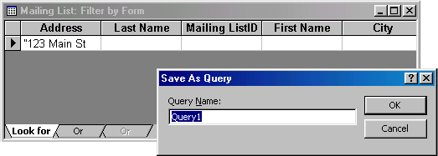

Remove a Filter
To view all records in a table again, click the depressed Apply Filter toggle button on the toolbar.
Introduction to Queries
Queries select records from one or more tables in a database so they can be viewed, analyzed, and sorted on a common datasheet. The resulting collection of records, called a dynaset (short for dynamic subset), is saved as a database object and can therefore be easily used in the future. The query will be updated whenever the original tables are updated. Types of queries are select queries that extract data from tables based on specified values, find duplicate queries that display records with duplicate values for one or more of the specified fields, and find unmatched queries display records from one table that do not have corresponding values in a second table.

Create a Query in Design View
Follow these steps to create a new query in Design View:
- From the Queries page on the Database Window, click the New button.
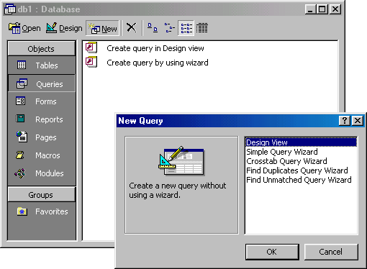
- Select Design View and click OK.
- Select tables and existing queries from the Tables and Queries tabs and click the Add button to add each one to the new query.
- Click Close when all of the tables and queries have been selected.
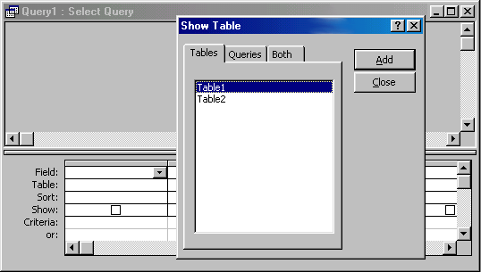
- Add fields from the tables to the new query by double-clicking the field name in the table boxes or selecting the field from the Field: and Table: drop-down menus on the query form. Specify sort orders if necessary.
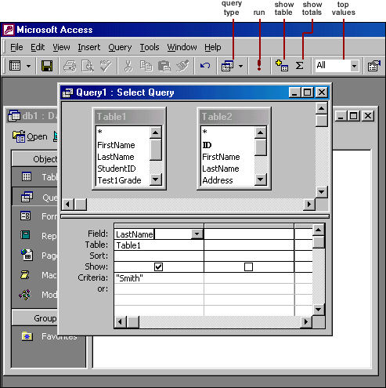

- Enter the criteria for the query in the Criteria: field. The following table provides examples for some of the wildcard symbols and arithmetic operators that may be used. The Expression Builder can also be used to assist in writing the expressions.
Query Wildcards and Expression Operators
Wildcard / Operator | Explanation
? Street | The question mark is a wildcard that takes the place of a single letter.
43th * | The asterisk is the wildcard that represents a number of characters.
<100 | Value less than 100
>=1 | Value greater than or equal to 1
<>"FL" | Not equal to (all states besides Florida)
Between 1 and 10 | Numbers between 1 and 10
Is Null  Is Not Null | Finds records with no value  or all records that have a value
Like "a*" | All words beginning with "a"
>0 And <=10 | All numbers greater than 0 and less than 10
"Bob" Or "Jane" | Values are Bob or Jane

- After you have selected all of the fields and tables, click the Run button on the toolbar.
- Save the query by clicking the Save button.

Query Wizard
Access' Query Wizard will easily assist you to begin creating a select query.
- Click the Create query by using wizard icon in the database window to have Access step you through the process of creating a query.
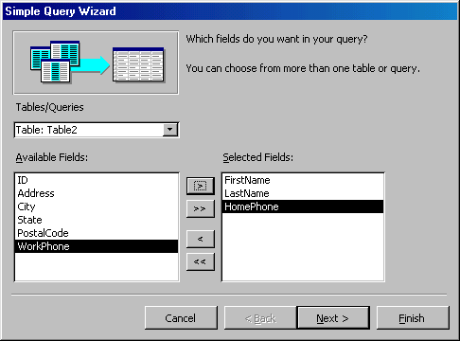
- From the first window, select fields that will be included in the query by first selecting the table from the drop-down Tables/Queries menu. Select the fields by clicking the > button to move the field from the Available Fields list to Selected Fields. Click the double arrow button >> to move all of the fields to Selected Fields. Select another table or query to choose from more fields and repeat the process of moving them to the Selected Fields box. Click Next > when all of the fields have been selected.
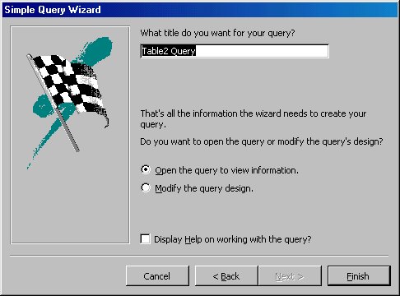
- On the next window, enter the name for the query and click Finish.
- Refer to steps 5-8 of the previous tutorial to add more parameters to the query.

Find Duplicates Query
This query will filter out records in a single table that contain duplicate values in a field.
- Click the New button on the Queries database window, select Find Duplicates Query Wizard from the New Query window and click OK.
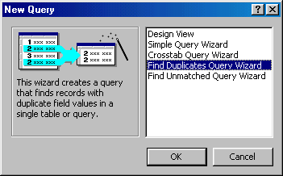
- Select the table or query that the find duplicates query will be applied to from the list provided and click Next >.
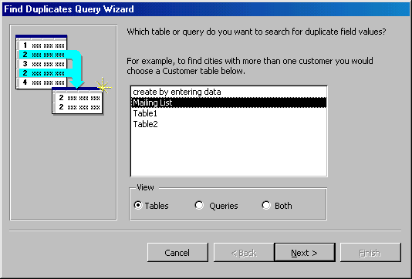
- Select the fields that may contain duplicate values by highlighting the names in the Available fields list and clicking the > button to individually move the fields to the Duplicate-value fields list or >> to move all of the fields. Click Next > when all fields have been selected.
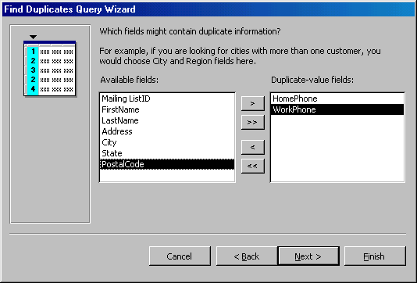
- Select the fields that should appear in the new query along with the fields selected on the previous screen and click Next >.
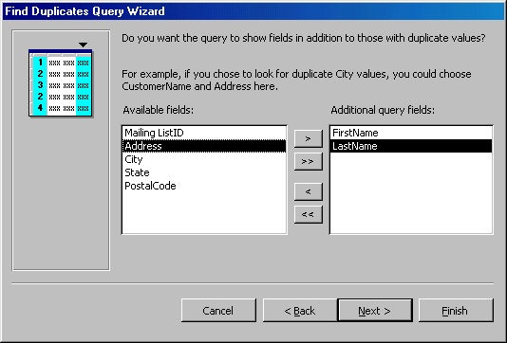
- Name the new query and click Finish.
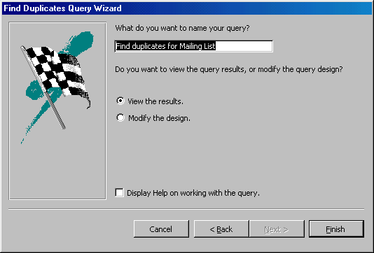

Delete a Query
To delete a table from the query, click the table's title bar and press the Delete key on the keyboard.
Forms are used as an alternative way to enter data into a database table.

Create Form by Using Wizard
To create a form using the assistance of the wizard, follow these steps:
- Click the Create form by using wizard option on the database window.
- From the Tables/Queries drop-down menu, select the table or query whose datasheet the form will modify. Then, select the fields that will be included on the form by highlighting each one the Available Fields window and clicking the single right arrow button > to move the field to the Selected Fields window. To move all of the fields to Select Fields, click the double right arrow button >>. If you make a mistake and would like to remove a field or all of the fields from the Selected Fields window, click the left arrow < or left double arrow << buttons. After the proper fields have been selected, click the Next > button to move on to the next screen.
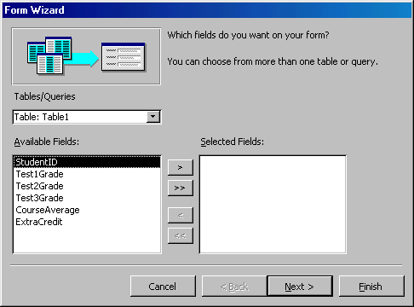
- On the second screen, select the layout of the form.
  - Columnar - A single record is displayed at one time with labels and form fields listed side-by-side in columns
  - Justified - A single record is displayed with labels and form fields are listed across the screen
  - Tabular - Multiple records are listed on the page at a time with fields in columns and records in rows
  - Datasheet - Multiple records are displayed in Datasheet View
Click the Next > button to move on to the next screen.
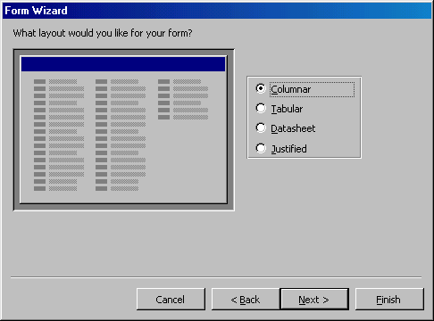
- Select a visual style for the form from the next set of options and click Next >.
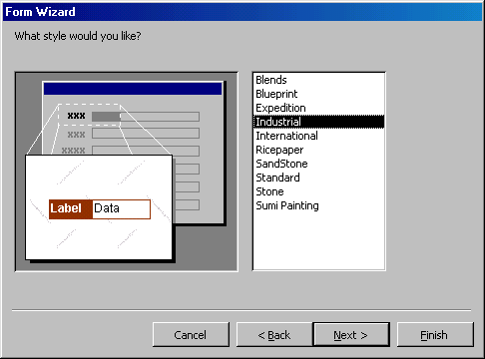
- On the final screen, name the form in the space provided. Select "Open the form to view or enter information" to open the form in Form View or "Modify the form's design" to open it in Design View. Click Finish to create the form.
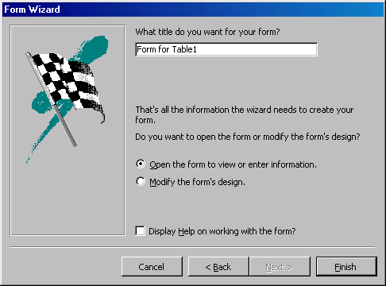

Create Form in Design View
To create a form from scratch without the wizard, follow these steps:
- Click the New button on the form database window.
- Select "Design View" and choose the table or query the form will be associated with the form from the drop-down menu.
- Select View|Toolbox from the menu bar to view the floating toolbar with additional options.
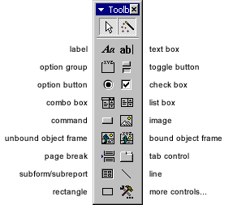
- Add controls to the form by clicking and dragging the field names from the Field List floating window. Access creates a text box for the value and label for the field name when this action is accomplished. To add controls for all of the fields in the Field List, double-click the Field List window's title bar and drag all of the highlighted fields to the form.
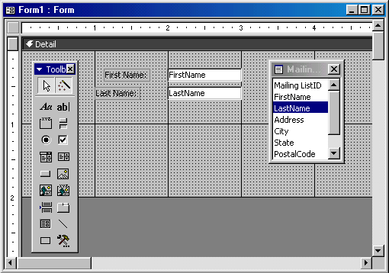

Adding Records Using A Form
Input data into the table by filling out the fields of the form. Press the Tab key to move from field to field and create a new record by clicking Tab after the last field of the last record. A new record can also be created at any time by clicking the New Record button at the bottom of the form window. Records are automatically saved as they are entered so no additional manual saving needs to be executed.
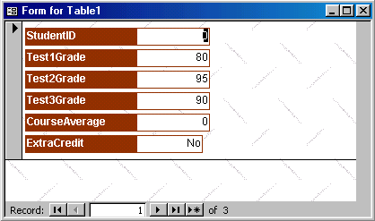

Editing Forms
The follow points may be helpful when modifying forms in Design View.
- Grid lines - By default, a series of lines and dots underlay the form in Design View so form elements can be easily aligned. To toggle this feature on and off select View|Grid from the menu bar.
- Snap to Grid - Select Format|Snap to Grid to align form objects with the grid to allow easy alignment of form objects or uncheck this feature to allow objects to float freely between the grid lines and dots.
- Resizing Objects - Form objects can be resized by clicking and dragging the handles on the edges and corners of the element with the mouse.
- Change form object type - To easily change the type of form object without having to create a new one, right click on the object with the mouse and select Change To and select an available object type from the list.
- Label/object alignment - Each form object and its corresponding label are bounded and will move together when either one is moved with the mouse. However, to change the position of the object and label in relation to each other (to move the label closer to a text box, for example), click and drag the large handle at the top, left corner of the object or label.
- Tab order - Alter the tab order of the objects on the form by selecting View|Tab Order... from the menu bar. Click the gray box before the row you would like to change in the tab order, drag it to a new location, and release the mouse button.
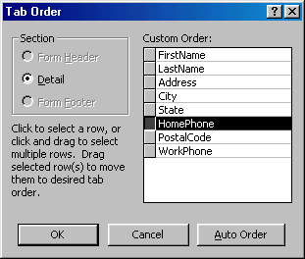
- Form Appearance - Change the background color of the form by clicking the Fill/Back Color button on the formatting toolbar and click one of the color swatches on the palette. Change the color of individual form objects by highlighting one and selecting a color from the Font/Fore Color palette on the formatting toolbar. The font and size, font effect, font alignment, border around each object, the border width, and a special effect can also be modified using the formatting toolbar:
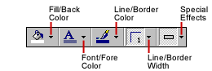
- Page Header and Footer - Headers and footers added to a form will only appear when it is printed. Access these sections by selecting View|Page Header/Footer on the menu bar. Page numbers can also be added to these sections by selecting Insert|Page Numbers. A date and time can be added from Insert|Date and Time.... Select View|Page Header/Footer again to hide these sections from view in Design View.
This page explains the uses for other types of form controls including lists, combo boxes, checkboxes, option groups, and command buttons.

List and Combo Boxes
If there are small, finite number of values for a certain field on a form, using combo or list boxes may be a quicker and easier way of entering data. These two control types differ in the number of values they display. List values are all displayed while the combo box values are not displayed until the arrow button is clicked to open it as shown in these examples:
Combo Box | List Box
By using a combo or list box, the name of the academic building does not need to be typed for every record. Instead, it simply needs to be selected from the list. Follow these steps to add a list or combo box to a form:
- Open the form in Design View.
- Select View|Toolbox to view the toolbox and make sure the "Control Wizards" button is pressed in.
- Click the list or combo box tool button and draw the outline on the form. The combo box wizard dialog box will appear.
- Select the source type for the list or combo box values and click Next >.
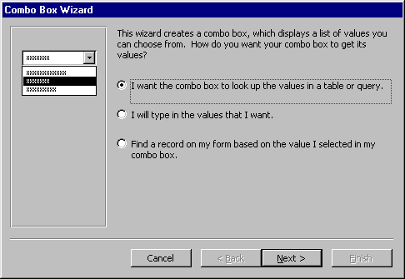
- Depending on your choice in the first dialog box, the next options will vary. If you chose to look up values from a table or query, the following box will be displayed. Select the table or query from which the values of the combo box will come from. Click Next > and choose fields from the table or query that was selected. Click Next > to proceed.
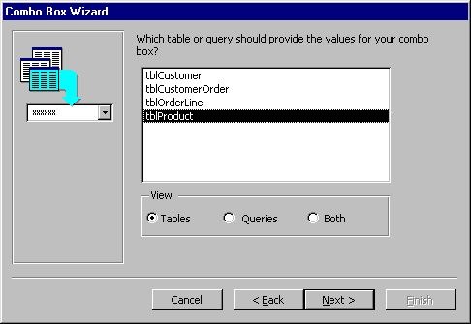
- On the next dialog box, set the width of the combo box by clicking and dragging the right edge of the column. Click Next >.
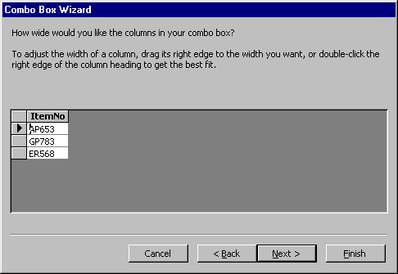
- The next dialog box allows tells Access what to do with the value that is selected. Choose "Remember the value for later use" to use the value in a macro or procedure (the value is discarded when the form is closed), or select the field that the value should be stored in. Click Next > to proceed to the final screen.
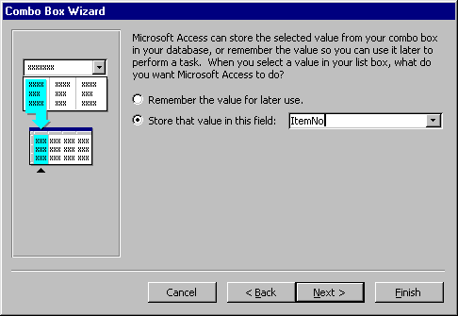
- Type the name that will appear on the box's label and click Finish.

Check Boxes and Option Buttons
Use check boxes and option buttons to display yes/no, true/false, or on/off values. Only one value from a group of option buttons can be selected while any or all values from a check box group can be chosen. Typically, these controls should be used when five or less options are available. Combo boxes or lists should be used for long lists of options. To add a checkbox or option group:
- Click the Option Group tool on the toolbox and draw the area where the group will be placed on the form with the mouse. The option group wizard dialog box will appear.
- On the first window, enter labels for the options and click the tab key to enter additional labels. Click Next > when finished typing labels.
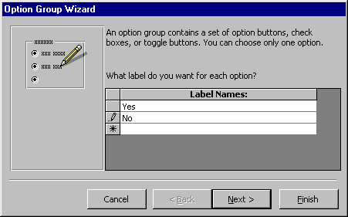
- On the next window, select a default value if there is any and click Next >.
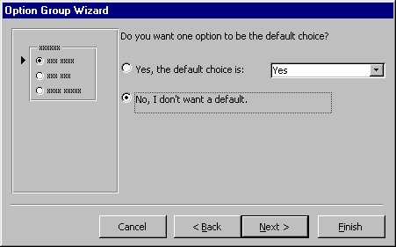
- Select values for the options and click Next >.
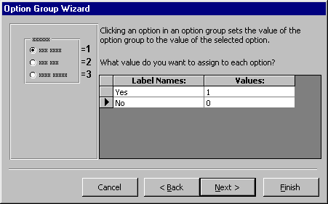
- Choose what should be done with the value and click Next >.
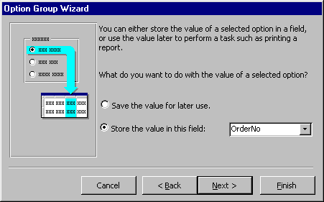
- Choose the type and style of the option group and click Next >.
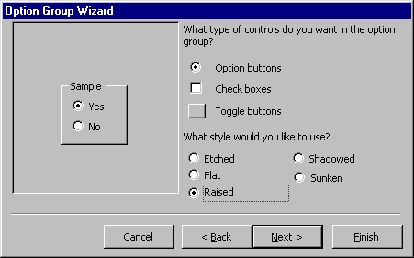
- Type the caption for the option group and click Finish.

Command Buttons
In this example, a command button beside each record is used to open another form.
- Open the form in Design View and ensure that the Control Wizard button on the toolbox is pressed in.
- Click the command button icon on the toolbox and draw the button on the form. The Command Button Wizard will then appear.
- On the first dialog window, action categories are displayed in the left list while the right list displays the actions in each category. Select an action for the command button and click Next >.
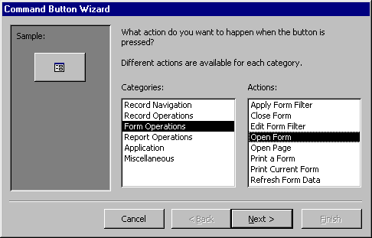
- The next few pages of options will vary based on the action you selected. Continue selecting options for the command button.
- Choose the appearance of the button by entering caption text or selecting a picture. Check the Show All Pictures box to view the full list of available images. Click Next >.
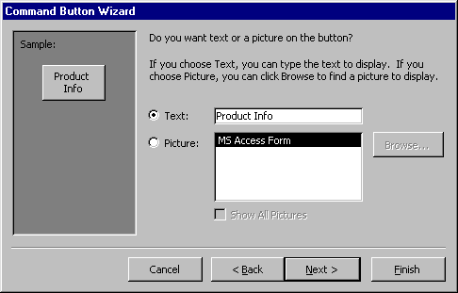
- Enter a name for the command button and click Finish to create the button.

What Is A Subform?
A subform is a form that is placed in a parent form, called the main form. Subforms are particularly useful to display data from tables and queries that have one-to-many relationships. For example, in the sample below, data on the main form is drawn from an item information table while the subform contains all of the orders for that item. The item record is the "one" part of this one-to-many relationship while the orders are the "many" side of the relationship since many orders can be placed for the one item.
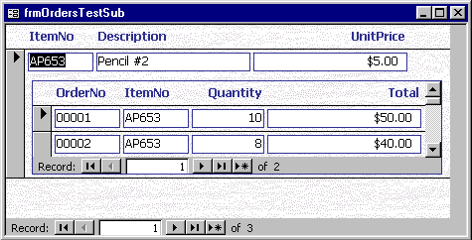
The remainder of this page explains three methods for creating subforms and they assume that the data tables and/or queries have already been created.

Create a Form and Subform at Once
Use this method if neither form has already been created. A main form and subform can be created automatically using the form wizard if table relationships are set properly or if a query involving multiple tables is selected. For example, a relationship can be set between a table containing customer information and one listing customer orders so the orders for each customer are displayed together using a main form and subform. Follow these steps to create a subform within a form:
- Double-click Create form by using wizard on the database window.
- From the Tables/Queries drop-down menu, select the first table or query from which the main form will display its data. Select the fields that should appear on the form by highlighting the field names in the Available Fields list on the left and clicking the single arrow > button or click the double arrows >> to choose all of the fields.
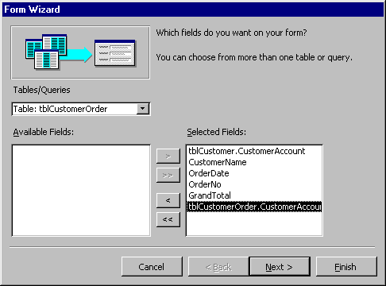
- From the same window, select another table or query from the Tables/Queries drop-down menu and choose the fields that should appear on the form. Click Next to continue after all fields have been selected.
- Choose an arrangement for the forms by selecting form with subform(s) if the forms should appear on the same page or Linked forms if there are many controls on the main form and a subform will not fit. Click Next to proceed to the next page of options.
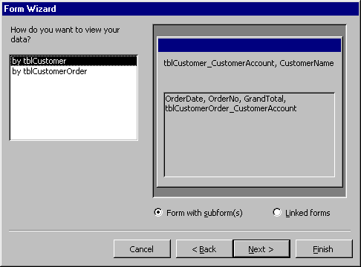
- Select a tabular or datasheet layout for the form and click Next.
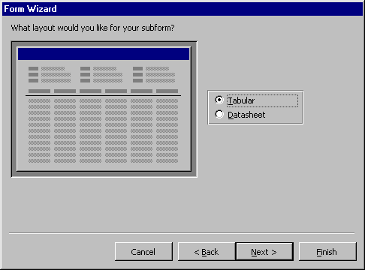
- Select a style for the form and click Next.
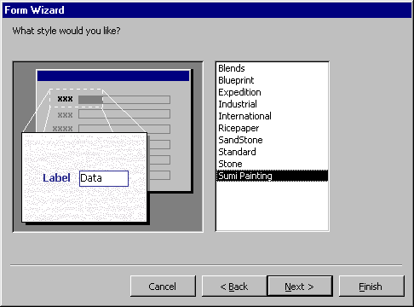
- Enter the names for the main form and subform. Click Finish to create the forms.
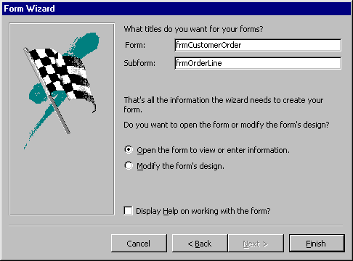
- New records can be added to both tables or queries at once by using the new combination form.

Subform Wizard
If the main form or both forms already exist, the Subform Wizard can be used to combine the forms. Follow these steps to use the Subform Wizard:
- Open the main form in Design View and make sure the Control Wizard button on the toolbox is pressed in.
- Click the Subform/Subreport icon on the toolbox and draw the outline of the subform on the main form. The Subform Wizard dialog box will appear when the mouse button is released.
- If the subform has not been created yet, select "Use existing Tables and Queries". Otherwise, select the existing form that will become the subform. Click Next to continue.
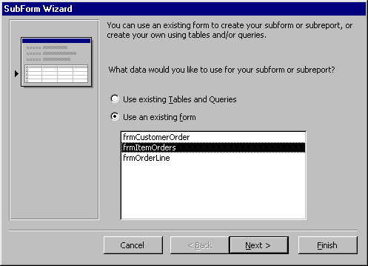
- The next dialog window will display table relationships assumed by Access. Select one of these relationships or define your own and click Next.
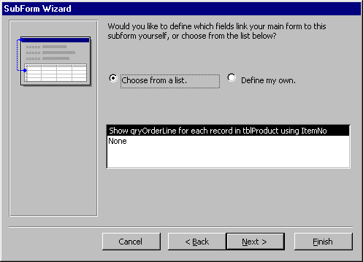
- On the final dialog box, enter the name of the subform and click Finish.

Drag-and-Drop Method
Use this method to create subforms from two forms that already exist. Make sure that the table relationships have already been set before proceeding with these steps.
- Open the main form in Design View and select Window|Tile Vertically to display both the database window and the form side-by-side.
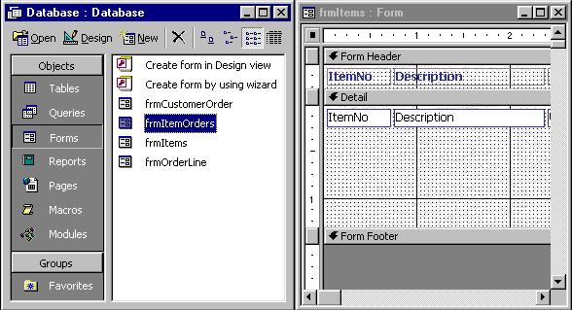
- Drag the form icon beside the name of the subform onto the detail section of the main form design.
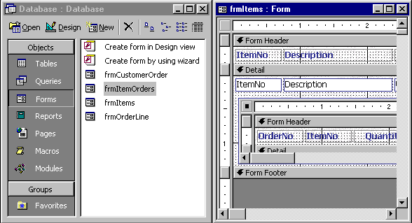

Multiple-Page Forms Using Tabs
Tab controls allow you to easily create multi-page forms. Create a tab control by following these steps:
- Click the Tab Control icon on the toolbox and draw the control on the form.
- Add new controls to each tab page the same way that controls are added to regular form pages and click the tabs to change pages. Existing form controls cannot be added to the tab page by dragging and dropping. Instead, right-click on the control and select Cut from the shortcut menu. Then right-click on the tab control and select Paste. The controls can then be repositioned on the tab control.
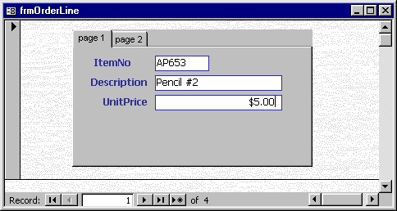
  - Add new tabs or delete tabs by right-clicking in the tab area and choosing Insert Page or Delete Page from the shortcut menu.
  - Reorder the tabs by right-clicking on the tab control and selecting Page Order.
  - Rename tabs by double-clicking on a tab and changing the Name property under the Other tab.

Conditional Formatting
Special formatting that depends on the control's value can be added to text boxes, lists, and combo boxes. A default value can set along with up to three conditional formats. To add conditional formatting to a control element, follow these steps:
- Select the control that the formatting should be applied to and select Format|Conditional Formatting from the menu bar.
- Under Condition 1, select one of the following condition types:
  - Field Value Is applies formatting based upon the value of the control. Select a comparison type from the second drop-down menu and enter a value in the final text box.
  - Expression Is applies formatting if the expression is true. Enter a value in the text box and the formatting will be added if the value matches the expression.
  - Field Has Focus will apply the formatting as soon as the field has focus.
- Add additional conditions by clicking the Add >> button and delete conditions by clicking Delete... and checking the conditions to erase.
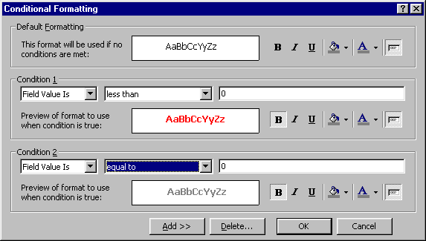

Password Text Fields
To modify a text box so each character appears as an asterisk as the user types in the information, select the text field in Design View and click Properties. Under the Data tab, click in the Input Mask field and then click the button [...] that appears. Choose "Password" from the list of input masks and click Finish. Although the user will only see asterisks for each character that is typed, the actual characters will be saved in the database.

Change Control Type
If you decide the type of a control needs to be changed, this can be done without deleting the existing control and creating a new one although not every control type can be converted and those that can have a limited number of types they can be converted to. To change the control type, select the control on the form in Design View and choose Format|Change To from the menu bar. Select one of the control types that is not grayed out.

Multiple Primary Keys
To select two fields for the composite primary key, move the mouse over the gray column next to the field names and note that it becomes an arrow. Click the mouse, hold it down, and drag it over all fields that should be primary keys and release the button. With the multiple fields highlighted, click the primary key button.
Reports will organize and group the information in a table or query and provide a way to print the data in a database.

Using the Wizard
Create a report using Access' wizard by following these steps:
- Double-click the "Create report by using wizard" option on the Reports Database Window.
- Select the information source for the report by selecting a table or query from the Tables/Queries drop-down menu. Then, select the fields that should be displayed in the report by transferring them from the Available Fields menu to the Selected Fields window using the single right arrow button > to move fields one at a time or the double arrow button >> to move all of the fields at once. Click the Next > button to move to the next screen.
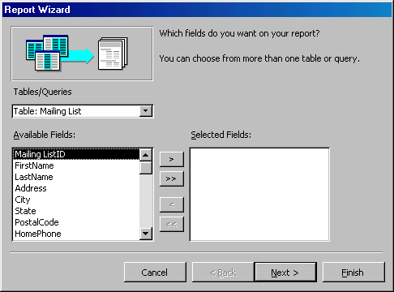
- Select fields from the list that the records should be grouped by and click the right arrow button > to add those fields to the diagram. Use the Priority buttons to change the order of the grouped fields if more than one field is selected. Click Next > to continue.
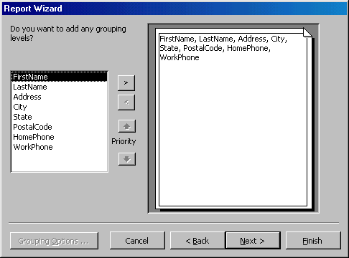
- If the records should be sorted, identify a sort order here. Select the first field that records should be sorted by and click the A-Z sort button to choose from ascending or descending order. Click Next > to continue.
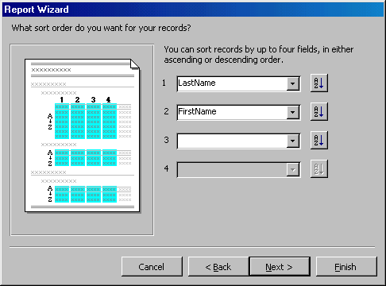
- Select a layout and page orientation for the report and click Next >.
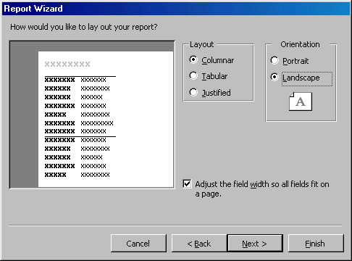
- Select a color and graphics style for the report and click Next >.
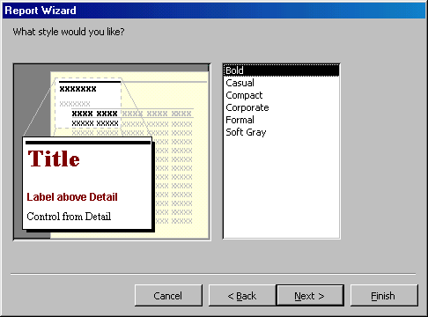
- On the final screen, name the report and select to open it in either Print Preview or Design View mode. Click the Finish button to create the report.
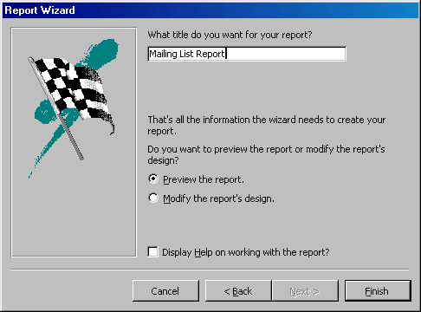

Create in Design View
To create a report from scratch, select Design View from the Reports Database Window.
- Click the New button on the Reports Database Window. Highlight "Design View" and choose the data source of the report from the drop-down menu and click OK.
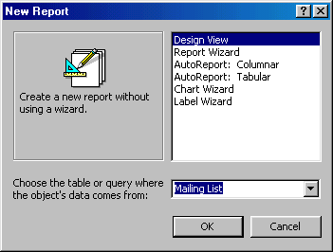
- You will be presented with a blank grid with a Field Box and form element toolbar that looks similar to the Design View for forms. Design the report in much the same way you would create a form. For example, double-click the title bar of the Field Box to add all of the fields to the report at once. Then, use the handles on the elements to resize them, move them to different locations, and modify the look of the report by using options on the formatting toolbar. Click the Print View button at the top, left corner of the screen to preview the report.
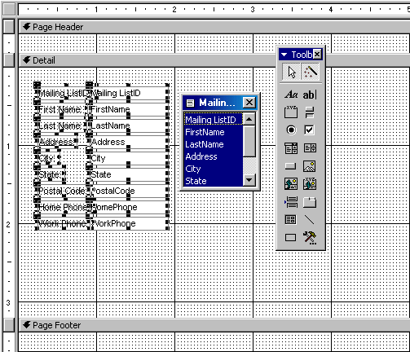

Printing Reports
Select File|Page Setup to modify the page margins, size, orientation, and column setup. After all changes have been made, print the report by selecting File|Print from the menu bar or click the Print button on the toolbar.

Importing
Importing objects from another database will create a complete copy of a table, query, or any other database object that you select. Import a database object by following these steps:
- Open the destination database.
- Select File|Get External|Import from the menu bar.
- Choose the database the object is located in a click the Import button.
- From the Import Objects window, click on the object tabs to find the object you want to import into the database. Click the Options >> button to view more options. Under Import Tables, select "Definition and Data" if the entire table should be copied or "Definition Only" if the table structure should be copied but not the data. Under Import Queries, select "As Tables" if the queries should appear as regular tables in the destination database. Highlight the object name, and click OK.
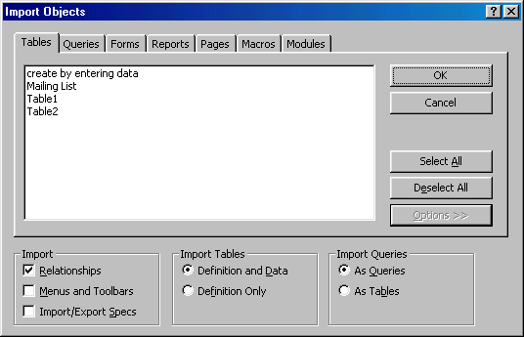
- The new object will now appear with the existing objects in the database.

Exporting
The effect of importing can also be achieved using the opposite method of exporting.
- Open the database containing an object that will be copied (exported) to another database.
- Find the object in the Database Window and highlight it. Then, select File|Export... from the menu bar.
- Select the destination database from the window and click Save.
- You will be prompted to name the new object and may also be given other options, such as whether to copy the structure or data and structure of a table. Click OK to complete the export procedure.

Linking
Unlike importing, linking objects from another database will create a link to an object in another database while not copying the table to the current database. Create a link by following these steps:
- Open the destination database.
- Select File|Get External|Link Tables... from the menu bar.
- Choose the database that the table is located in and click the Link button.
- A window listing the tables in the database will then appear. Highlight the table or tables that should be linked and click OK. A link to the table will appear in the Database Window as a small table icon preceded by a small right arrow.
Keyboard shortcuts can save time and the effort of constantly switching from the keyboard to the mouse to execute simple commands. Print this list of Access keyboard shortcuts and keep it by your computer for a quick reference.
Note: A plus sign indicates that the keys need to be pressed at the same time.
  Action | Keystroke
  Database actions
  Open existing database | CTRL+O
  Open a new database | CTRL+N
  Save | CTRL+S
  Save record | SHIFT+ENTER
  Print | CTRL+P
  Display database window | F11
  Find and Replace | CTRL+F
  Copy | CTRL+C
  Cut | CTRL+X
  Paste | CTRL+V
  Undo | CTRL+Z
  Help | F1
  Toggle between Form and Design view | F5
  Other
  Insert line break in a memo field | CTRL+ENTER
  Insert current date | CTRL+;
  Insert current time | CTRL+:
  Copy data from previous record | CTRL+'
  Add a record | CTRL++
  Delete a record | CTRL+-
  Action | Keystroke
  Editing
  Select all | CTRL+A
  Copy | CTRL+C
  Cut | CTRL+X
  Paste | CTRL+V
  Undo | CTRL+Z
  Redo | CTRL+Y
  Find | CTRL+F
  Replace | CTRL+H
  Spell checker | F7
  Toggle between Edit mode and Navigation mode | F2
  Open window for editing large content fields | SHIFT+F2
  Switch from current field to current record | ESC
  Navigating Through a datasheet
  Next field | TAB
  Previous field | SHIFT+TAB
  First field of record | HOME
  Last field of record | END
  Next record | DOWN ARROW
  Previous record | UP ARROW
  First field of first record | CTRL+HOME
  Last field of last record | CTRL+END

