Screen Layout
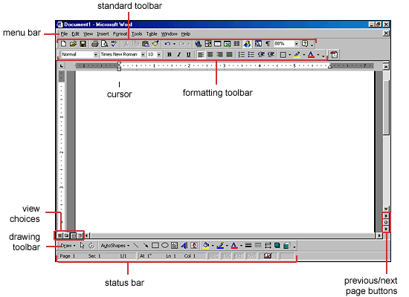
Menus
When you begin to explore Word 2000, you will notice a significant change in the menu structure if you are familiar with previous versions of Word. The menus in Word 2000 display only the commands you have recently used. To view all options in each menu, you must click the double arrows at the bottom of the menu. The images below show the Format menu collapsed (left) and expanded (right) after the double arrows at the bottom of the menu were clicked:
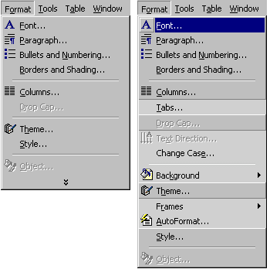
Follow the steps below to display menus similar to previous versions of Word with all the choices listed initially:
- Select View|Toolbars|Customize from the menu bar.
- Click on the Options tab.
- Uncheck the Menus show recently used commands first check box.
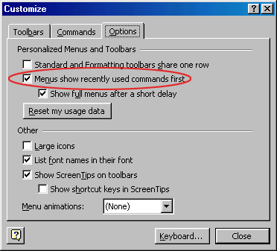

Shortcut Menus
These features allow you to access various Word commands faster than using the options on the menu bar. View shortcut menus by right-clicking with the mouse. The options on this menu will vary depending on the element that was right-clicked. For example, the shortcut menu below is produced by right-clicking on a bulleted list.
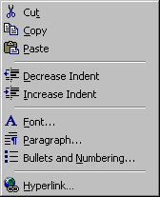
Actions such as "Decrease Indent" and "Increase Indent" are only applicable to lists and therefore only appear on the list shortcut menu. The shortcut menus are helpful because they only display the options that can be applied to the item that was right-clicked and, therefore, prevent searching through the many menu options.
Toolbars
Many toolbars displaying shortcut buttons are also available to make editing and formatting quicker and easier. Select View|Toolbars from the menu bar to select the toolbars. The toolbars that are already displayed on the screen are checked. Add a toolbar simply by clicking on the name.
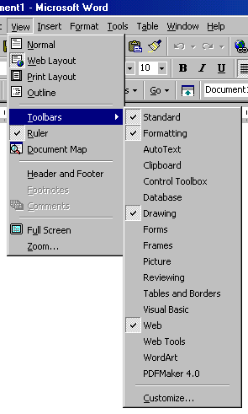
Customizing Toolbars
There may be certain actions on a toolbar that you do not use and there may also be commands that you execute often but that are not located on any toolbar. Word toolbars can be customized so these commands can be added and deleted.
- Select View|Toolbars|Customize and click the Commands tab.
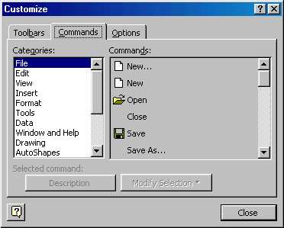
- By highlighting the command categories in the Categories box, the choices will change in the Commands box to the right.
- Select the command you would like to add to the toolbar by selecting it in the Commands box.
- Drag the command with the mouse to the desired location on the toolbar and release the mouse button.
- Remove a button from the toolbar by clicking and dragging the button off the toolbar.

Creating and Opening Documents
There are several ways to create new documents, open existing documents, and save documents in Word:
Create a New Document
- Click the New Document button on the menu bar.
- Choose File|New from the menu bar.
- Press CTRL+N (depress the CTRL key while pressing "N") on the keyboard.
Open an Existing Document
- Click the Open File button on the menu bar.
- Choose File|Open from the menu bar.
- Press CTRL+O on the keyboard.
Each method will show the Open dialog box. Choose the file and click the Open button.
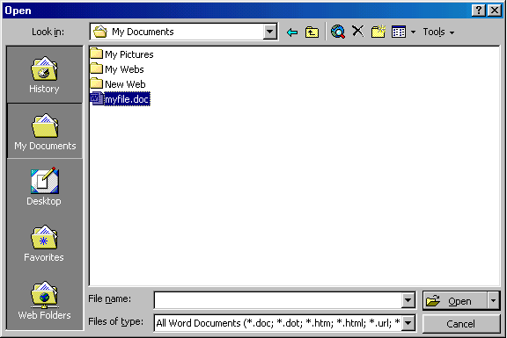
Save a Document
- Click the Save button on the menu bar.
- Select File|Save from the menu bar.
- Press CTRL+S on the keyboard.
Renaming Documents
To rename a Word document while using the program, select File|Open and find the file you want to rename. Right-click on the document name with the mouse and select Rename from the shortcut menu. Type the new name for the file and press the ENTER key.
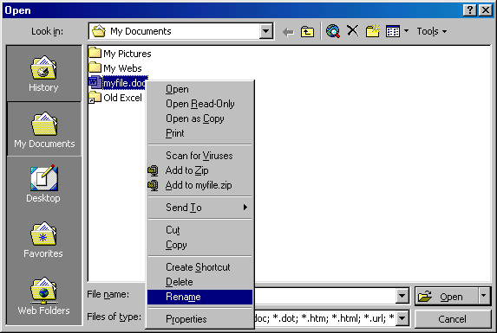
Working on Multiple Documents
Several documents can be opened simultaneously if you are typing or editing multiple documents at once. All open documents are listed under the Window menu as shown below. The current document has a checkmark beside the file name. Select another name to view another open document or click the button on the Windows taskbar at the bottom of the screen.
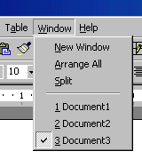
Close a Document
Close the current document by selecting File|Close or click the Close icon if it's visible on the Standard Toolbar.

Typing and Inserting Text
To enter text, just start typing! The text will appear where the blinking cursor is located. Move the cursor by using the arrow buttons on the keyboard or positioning the mouse and clicking the left button. The keyboard shortcuts listed below are also helpful when moving through the text of a document:
Move Action | Keystroke
Beginning of the line | HOME
End of the line | END
Top of the document | CTRL+HOME
End of the document | CTRL+END
Selecting Text
To change any attributes of text it must be highlighted first. Select the text by dragging the mouse over the desired text while keeping the left mouse button depressed, or hold down the SHIFT key on the keyboard while using the arrow buttons to highlight the text. The following table contains shortcuts for selecting a portion of the text:
Selection | Technique
Whole word | double-click within the word
Whole paragraph | triple-click within the paragraph
Several words or lines | drag the mouse over the words, or hold down SHIFT while using the arrow keys
Entire document | choose Edit|Select All from the menu bar, or press CTRL+A
Deselect the text by clicking anywhere outside of the selection on the page or press an arrow key on the keyboard.
Deleting Text
Use the BACKSPACE and DELETE keys on the keyboard to delete text. Backspace will delete text to the left of the cursor and Delete will erase text to the right. To delete a large selection of text, highlight it using any of the methods outlined above and press the DELETE key.
Formatting Text
The formatting toolbar is the easiest way to change many attributes of text. If the toolbar as shown below isn't displayed on the screen, select View|Toolbars and choose Formatting.
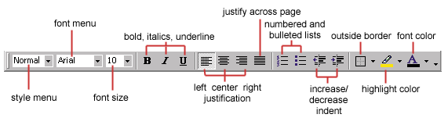
- Style Menu - Styles are explained in detail later in this tutorial.
- Font Face - Click the arrowhead to the right of the font name box to view the list of fonts available. Scroll down to the font you want and select it by clicking on the name once with the mouse. A serif font (one with "feet" circled in the illustration below) is recommended for paragraphs of text that will be printed on paper as they are most readable. The following graphic demonstrates the difference between serif (Times New Roman on the left) and sans-serif ("no feet", Arial on the right) fonts.

- Font Size - Click on the white part of the font size box to enter a value for the font size or click the arrowhead to the right of the box to view a list of font sizes available. Select a size by clicking on it once. A font size of 10 or 12 is best for paragraphs of text.
- Font Style - Use these buttons to bold, italicize, and underline text.
- Alignment - Text can be aligned to the left, center, or right side of the page or it can be justified across the page.
- Numbered and Bulleted Lists - Lists are explained in detail later in this tutorial.
- Increase/Decrease Indent - Change the indentation of a paragraph in relation to the side of the page.
- Outside Border - Add a border around a text selection.
- Highlight Color - Use this option to change the color behind a text selection. The color shown on the button is the last color used. To select a different color, click the arrowhead next to the image on the button.
- Text Color - This option changes the color of the text. The color shown on the button is the last color chosen. Click the arrowhead next to the button image to select another color.
The Font dialog box allows you to choose from a larger selection of formatting options. Select Format|Font from the menu bar to access the box.
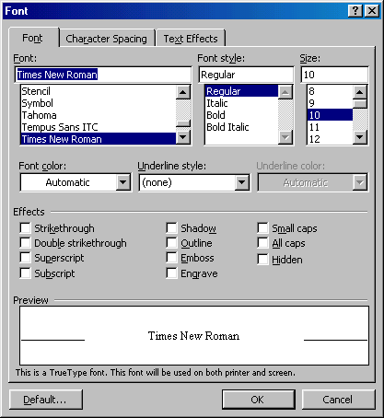
Format Painter
A handy feature for formatting text is the Format Painter located on the standard toolbar. For example, if you have formatting a paragraph heading with a certain font face, size, and style and you want to format another heading the same way, you do not need to manually add each attribute to the new headline. Instead, use the Format Painter by following these steps:
- Place the cursor within the text that contains the formatting you want to copy.
- Click the Format Painter button in the standard toolbar. Notice that your pointer now has a paintbrush beside it.
- Highlight the text you want to add the same format to with the mouse and release the mouse button.
To add the formatting to multiple selections of text, double-click the Format Painter button instead of clicking once. The format painter then stays active until you press the ESC key to turn it off.
Undo
Feel free to experiment with various text styles. You can always undo your last action by clicking the Undo button on the standard toolbar or selecting Edit|Undo... from the menu bar. Click the Redo button on the standard toolbar or select Edit|Redo... to erase the undo action.

Paragraph Attributes
Format a paragraph by placing the cursor within the paragraph and selecting Format|Paragraph from the menu bar.
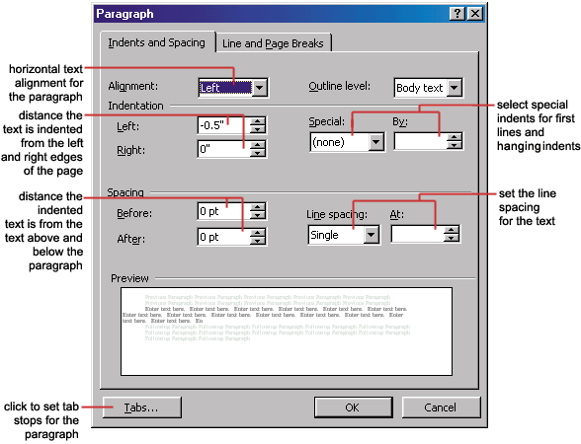
Moving (Cutting) Text
Highlight the text that will be moved and select Edit|Cut from the menu bar, click the Cut button on the standard tool bar, or press CTRL+X at once. This will move the text to a clipboard.
To move a small amount of text a short distance, the drag-and-drop method may be quicker. Highlight the text you want to move, click the selection with the mouse, drag the selection to the new location, and release the mouse button.
Copying Text
To copy text, choose Edit|Copy, click the Copy button on the standard toolbar, or press CTRL+C to copy the text to the clipboard.
Paste Text
To paste cut or copied text, move the cursor to the location you want to move the text to and select Edit|Paste from the menu bar, click the Paste button on the standard toolbar, or press CTRL+V.
The Clipboard
The last 12 elements that were cut or copied are placed onto Word's clipboard. You can view the elements on the clipboard by selecting View|Toolbars|Clipboard from the menu bar.
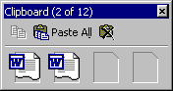
Place the mouse arrow over each element in the clipboard to view the contents of each item and click on an element to add its contents to the document. Click Paste All to add all of the items to the document at once. Click the Clear Clipboard button (the icon with an "X" over the clipboard image) to clear the contents of the clipboard.
Columns
To quickly place text in a column format, click the Columns button on the standard toolbar and select the number of columns by dragging the mouse over the diagram.
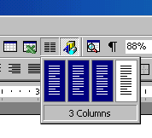
For more column options, select Format|Columns from the menu bar. The Columns dialog box allows you to choose the properties of the columns. Select the number and width of the columns from the dialog box.
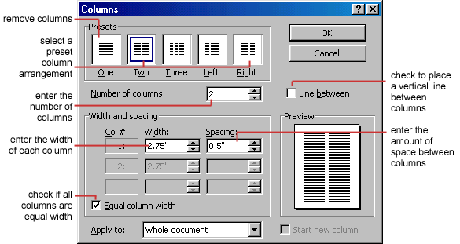
Drop Caps
A drop cap is a large letter that begins a paragraph and drops through several lines of text as shown below.
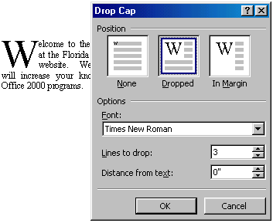
Add a drop cap to a paragraph by following these steps:
- Place the cursor within the paragraph whose first letter will be dropped.
- Select Format|Drop Cap from the menu bar.
- The Drop Cap dialog box allows you to select the position of the drop cap, the font, the number of lines to drop, and the distance from the body text.
- Click OK when all selections have been made.
- To modify a drop cap, select Format|Drop Cap again to change the attributes, or click on the letter and use the handles to move and resize the letter.
The use of styles in Word will allow you to quickly format a document with a consistent and professional look. Paragraph and character styles can be saved for use in many documents.
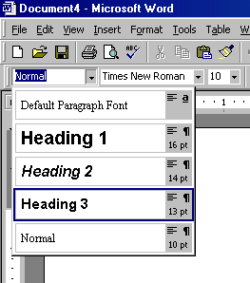
Applying a Style
- Place the cursor in the paragraph where the style will be applied.
- Click the Style drop-down menu on the Formatting toolbar and select a style by clicking on it.
- To apply the same style to multiple paragraphs, double click the Format Painter button on the standard toolbar and click in all the paragraphs that the style should be applied to. Press the ESC key to disable the Format Painter.
Apply a Style from the Style Dialog Box
Choose from a larger selection of styles from the Style dialog box.
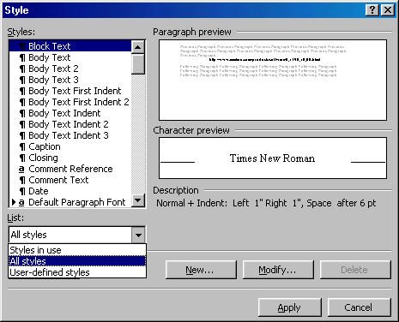
- Click in the paragraph you want to add a style to.
- Select Format|Style... from the menu bar.
- From the List drop-down menu, choose All styles to view all the styles available.
- The styles are displayed in the Styles list. Preview each style by clicking once on the name. Paragraph styles are preceded by the paragraph symbol () and character styles are preceded by an "a" icon (). A pointer arrow is located next to the current style. Highlight the style you want to apply to the paragraph and click Apply.
Create a New Style from a Model
To create a style from text that is already formatted in a document, follow these steps:
- Place the cursor in the paragraph you would like to set as a new style.
- Click the Style box on the formatting toolbar so the style name is highlighted.
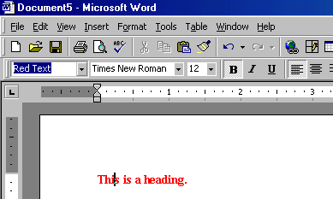
- Delete the text in the field and type the name of the new style.
- Press the ENTER key to save the new style.
Create a Simple Style from the Style Dialog Box
- Select Format|Style... from the menu bar and click the New button on the Style dialog box to access the New Style dialog box.
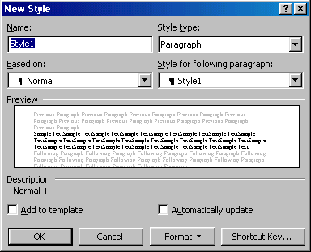
- Type the name for the new style in the Name field.
- Select "Paragraph" or "Character" from the Style type drop-down menu.
- Click the Format button at the bottom of the window and choose the paragraph element that will be formatted for the style. Continue to make changes from the options from the Format button menu, making changes to the dialog boxes for each element you choose.
- Click OK to set the style and close the New Style dialog box.
- Click Apply on the Style dialog box to apply the new style to the current paragraph.
Modify or Rename a Style
An existing style can be changed from the Style dialog box.
- Select Format|Style... from the menu bar.
- Highlight the style from the Styles list that you want to modify and click the Modify button.
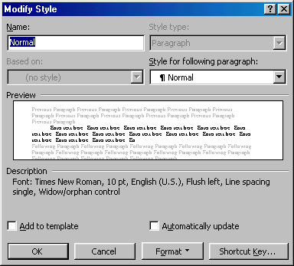
- Use the same methods to modify the style from the Modify Style dialog box that were used for the New Style box.
- To only rename the style, type a new name in the Name field.
- Click OK when you are finished making modifications.
- Click Apply to update the style in the document.
Delete a Style
Preset styles created by Word cannot be deleted, but to delete a style you have made, follow these steps:
- Select Format|Style... from the menu bar
- Highlight the style from the Styles list that you want to delete.
- Click the Delete button.
- You will be asked if you really want to delete the style. Click Yes.
- Click Close on the dialog box.
To create a bulleted or numbered list, use the list features provided by Word.
Bulleted and Numbered Lists
- Click the Bulleted List button or Numbered List button on the formatting toolbar.
- Type the first entry and press ENTER. This will create a new bullet or number on the next line. If you want to start a new line without adding another bullet or number, hold down the SHIFT key while pressing ENTER.
- Continue to typing entries and press ENTER twice when you are finished typing to end the list.
Use the Increase Indent and Decrease Indent buttons on the formatting toolbar to create lists of multiple levels.
NOTE: You can also type the text first, highlight the section, and press the Bulleted List or Numbered List buttons to add the bullets or numbers.
Nested Lists
To create a nested list, such as a numbered list inside of a bulleted list, follow these steps:
- Type the list and increase the indentation of the items that will make up the nested list by clicking the Increase Indent button for each item.
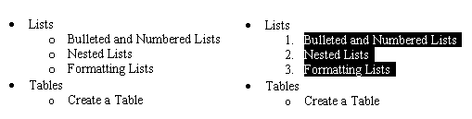
- Highlight the items and click the Numbered List button on the formatting toolbar.
Formatting Lists
The bullet image and numbering format can be changed by using the Bullets and Numbering dialog box.
- Highlight the entire list to change all the bullets or numbers, or
Place the cursor on one line within the list to change a single bullet.
- Access the dialog box by selecting Format|Bullets and Numbering from the menu bar or by right-clicking within the list and selecting Bullets and Numbering from the shortcut menu.
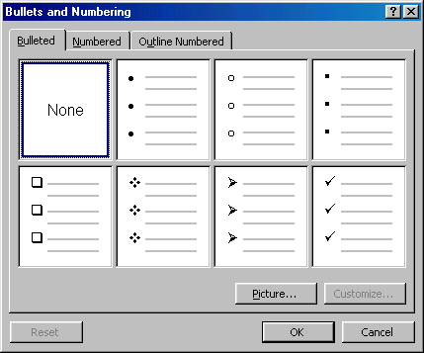
- Select the list style from one of the seven choices given, or click the Picture... button to choose a different icon. Click the Numbered tab to choose a numbered list style.
- Click OK when finished.
Adding Clip Art
To add a clip art image from the Microsoft library to a document, follow these steps:
- Select Insert|Picture|Clip Art from the menu bar.
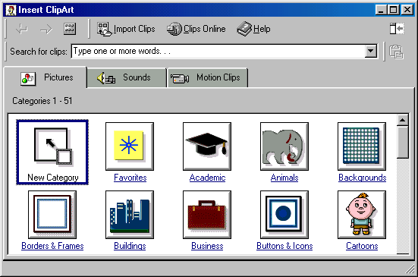
- To find an image, click in the white box following Search for clips. Delete the words "Type one or more words. . ." and enter keywords describing the image you want to use.
- OR -
Click one of the category icons.
- Click once on the image you want to add to the document and the following popup menu will appear:
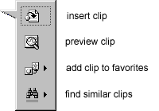
  - Insert Clip to add the image to the document.
  - Preview Clip to view the image full-size before adding it to the document. Drag the bottom, right corner of the preview window to resize the image and click the "x" close button to end the preview.
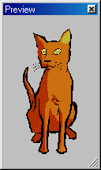
  - Add Clip to Favorites will add the selected image to your favorites directory that can be chosen from the Insert ClipArt dialog box.
  - Find Similar Clips will retrieve images similar to the one you have chosen.
- Continue selecting images to add to the document and click the Close button in the top, right corner of the Insert ClipArt window to stop adding clip art to the document.
Add An Image from a File
Follow these steps to add a photo or graphic from an existing file:
- Select Insert|Picture|From File on the menu bar.
- Click the down arrow button on the right of the Look in: window to find the image on your computer.
- Highlight the file name from the list and click the Insert button.
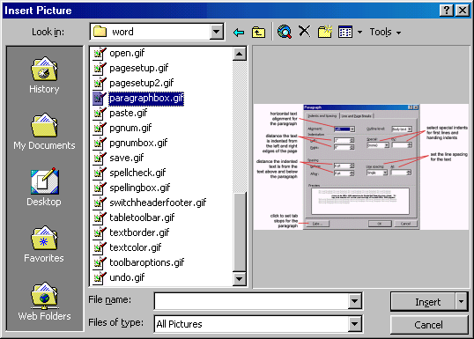
Editing A Graphic
Activate the image you wish to edit by clicking on it once with the mouse. Nine handles will appear around the graphic. Click and drag these handles to resize the image. The handles on the corners will resize proportionally while the handles on the straight lines will stretch the image. More picture effects can be changed using the Picture toolbar. The Picture toolbar should appear when you click on the image. Otherwise, select View|Toolbars|Picture from the menu bar to activate it.
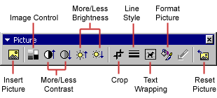
- Insert Picture will display the image selection window and allows you to change the image.
- Image Control allows to to make the image grayscale, black and white, or a watermark.
- More/Less Contrast modifies the contrast between the colors of the image.
- More/Less Brightness will darken or brighten the image.
- Click Crop and drag the handles on the activated image to delete outer portions of the image.
- Line Style will add a variety of borders to the graphic.
- Text Wrapping will modify the way the document text wraps around the graphic.
- Format Picture displays all the image properties in a separate window.
- Reset Picture will delete all the modifications made to the image.
Auto Shapes
The AutoShapes toolbar will allow you to draw many different geometrical shapes, arrows, flow chart symbols, stars, and banners on the document. Activate the AutoShapes toolbar by selecting Insert|Picture|AutoShapes or View|Toolbars|AutoShapes from the menu bar, or clicking the AutoShapes button on the Drawing toolbar. Click each button on the toolbar to view the options for drawing the shape.
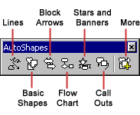
- Lines - After clicking the Lines button on the AutoShapes toolbar, draw a straight line, arrow, or double-ended arrow from the first row of options by clicking the respective button. Click in the document where you would like the line to begin and click again where it should end. To draw a curved line or freeform shape, select curved lines from the menu (first and second buttons of second row), click in the document where the line should appear, and click the mouse every time a curve should begin. End creating the graphic by clicking on the starting end or pressing the ESC key. To scribble, click the last button in the second row, click the mouse in the document and hold down the left button while you draw the design. Let go of the mouse button to stop drawing.
- Basic Shapes - Click the Basic Shapes button on the AutoShapes toolbar to select from many two- and three-dimensional shapes, icons, braces, and brackets. Use the drag-and-drop method to draw the shape in the document. When the shape has been made, it can be resized using the open box handles and other adjustments specific to each shape can be modified using the yellow diamond handles.
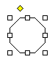
- Block Arrows - Select Block Arrows to choose from many types of two- and three-dimensional arrows. Drag-and-drop the arrow in the document and use the open box and yellow diamond handles to adjust the arrowheads. Each AutoShape can also be rotated by first clicking the Free Rotate button on the drawing toolbar . Click and drag the green handles around the image to rotate it. The tree image below was created from an arrow rotated 90 degrees.

- Flow Chart - Choose from the flow chart menu to add flow chart elements to the document and use the line menu to draw connections between the elements.
- Stars and Banners - Click the button to select stars, bursts, banners, and scrolls.
- Call Outs - Select from the speech and thought bubbles, and line call outs. Enter the call out text in the text box that is made.
- More AutoShapes - Click this button to choose from a list of clip art categories.
Each of the submenus on the AutoShapes toolbar can become a separate toolbar. Just click and drag the gray bar across the top of the submenus off of the toolbar and it will become a separate floating toolbar.
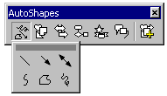 | 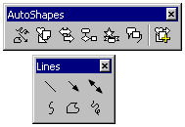

Tables are used to display data and there are several ways to build them in Word. Begin by placing the cursor where you want the table to appear in the document and choose one of the following methods.
Insert a Table
There are two ways to add a table to the document using the Insert feature:
- Click the Insert Table button on the standard toolbar. Drag the mouse along the grid, highlighting the number of rows and columns for the table.
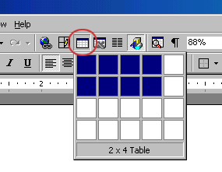
- Or, select Table|Insert|Table from the menu bar. Select the number of rows and columns for the table and click OK.
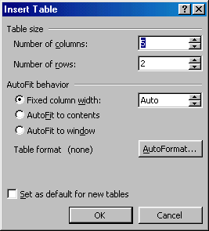
Draw the Table
A table can also be drawn onto the document:
- Draw the table by selecting Table|Draw Table from the menu bar. The cursor is now the image of a pencil and the Tables and Borders toolbar has appeared.
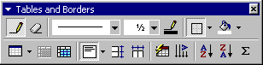
- Draw the cells of the table with the mouse. If you make a mistake, click the Eraser button and drag the mouse over the area to be deleted.
- To draw more cells, click on the Draw Table button .
Inserting Rows and Columns
Once the table is drawn, insert additional rows by placing the cursor in the row you want to be adjacent to. Select Table|Insert|Rows Above or Rows Below. Or, select an entire row and right-click with the mouse. Choose Insert Rows from the shortcut menu.
Much like inserting a row, add a new column by placing the cursor in a cell adjacent to where the new column will be added. Select Table|Insert|Columns to the Left or Columns to the Right. Or, select the column, right-click with the mouse, and select Insert Columns.
Moving and Resizing a Table
A four-sided moving arrow and open box resizing handle will appear on the corners of the table if the mouse is placed over the table. Click and drag the four-ended arrow to move the table and release the mouse button when the table is positioned where you want it. Click and drag the open box handle to resize the table. Change the column widths and row heights by clicking the cell dividers and dragging them with the mouse.
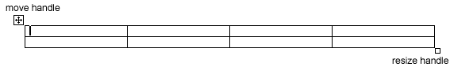
Tables and Borders Toolbar
The Tables and Borders toolbar allows you to add border styles, shading, text effects, alignment, and more options to your table. Access the toolbar by clicking Table|Draw Table or View|Toolbars|Tables and Borders.
You will need to highlight the cells of the table you want to format. Click and drag the mouse over the cells, or use the following shortcuts:
Selection | Menu Method | Mouse Method
One cell | Table|Select|Cell | Click the bottom, left corner of the cell when a black arrow appears
One row | Table|Select|Row | Click outside the table to the left of the row
One column | Table|Select|Column | Click outside the table above the column when a black arrow appears
Several rows | (none) | Click outside the table to the left of the row and drag the mouse down
Several columns | (none) | Click outside the table above the column
Entire table | Table|Select|Table | Triple-click to the left of the table
Table Properties
Use the Table Properties dialog box to modify the alignment of the table with the body text and the text within the table. Access the box by selecting Tables|Table Properties.
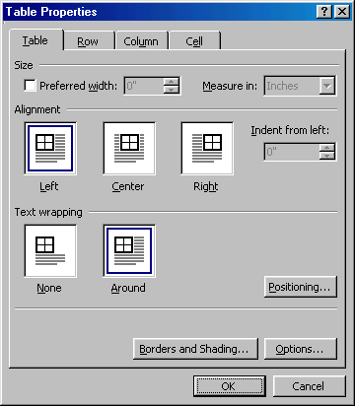
- Size - Check the Preferred width box and enter a value if the table should be an exact width.
- Alignment - Highlight the illustration that represents the alignment of the table in relation to the text of the document.
- Text wrapping - Highlight "None" if the table should appear on a separate line from the text or choose "Around" if the text should wrap around the table.
- Borders and Shading - Select from a number of border styles, colors, and widths. Click the Shading tab to change the background color and pattern.
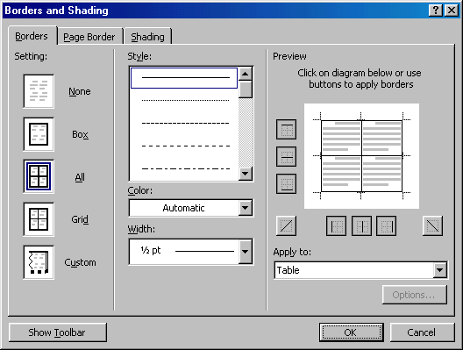
- Options - Click the Options button on the Table Properties window. To change the spacing between the document text and the table borders under Default cell margins. Check the Allow spacing between cells box and enter a value to add space between the table cells.
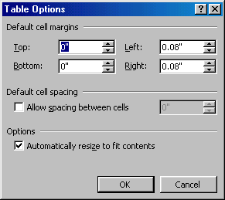
AutoCorrect
Word automatically corrects many commonly misspelled words and punctuation marks with the AutoCorrect feature. To view the list of words that are automatically corrected, select Tools|AutoCorrect. This may be a hidden feature so click the double arrows at the bottom of the Tools menu listing if the AutoCorrect choice is not listed.
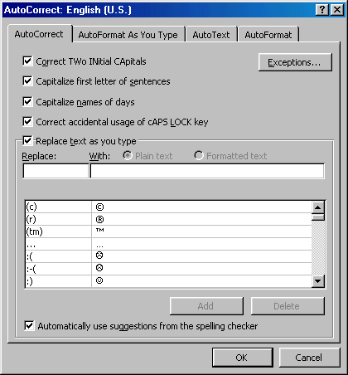
Many options including the accidental capitalization of the first two letters of a word and capitalization of the first word of the sentence can be automatically corrected from this page. If there are words you often misspell, enter the wrong and correct spellings in the Replace and With fields.
Spelling and Grammar Check
Word will automatically check for spelling and grammar errors as you type unless you turn this feature off. Spelling errors are noted in the document with a red underline. Grammar errors are indicated by a green underline. To disable this feature, select Tools|Options from the menu bar and click the Spelling and Grammar tab on the dialog box. Uncheck "Check spelling as you type" and "Check grammar as you type", and click OK.
To use the spelling and grammar checker, follow these steps:
- Select Tools|Spelling and Grammar from the menu bar.
- The Spelling and Grammar dialog box will notify you of the first mistake in the document and misspelled words will be highlighted in red.
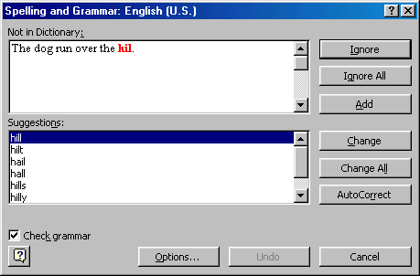
- If the word is spelled correctly, click the Ignore button or click the Ignore All button if the word appears more than once in the document.
- If the word is spelled incorrectly, choose one of the suggested spellings in the Suggestions box and click the Change button or Change All button to correct all occurrences of the word in the document. If the correct spelling is not suggested, enter the correct spelling in the Not In Dictionary box and click the Change button.
- If the word is spelled correctly and will appear in many documents you type (such as your name), click the Add button to add the word to the dictionary so it will no longer appear as a misspelled word.
As long as the Check Grammar box is checked in the Spelling and Grammar dialog box, Word will check the grammar of the document in addition to the spelling. If you do not want the grammar checked, remove the checkmark from this box. Otherwise, follow these steps for correcting grammar:
- If Word finds a grammar mistake, it will be shown in the box as the spelling errors. The mistake is highlighted in green text.
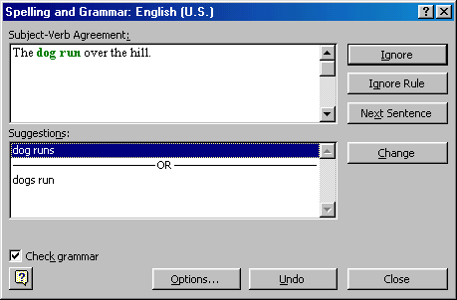
- Several suggestions may be given in the Suggestions box. Select the correction that best applies and click Change.
- If no correction is needed (Word is often wrong more than it is right), click the Ignore button.
Synonyms
Word 2000 has a new feature for finding synonyms. Simply right-click on the word and select Synonyms from the shortcut menu. From the list of suggested words, highlight the word you would like to use or click Thesaurus... for more options.
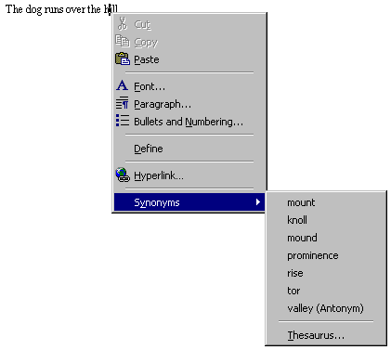
Thesaurus
To use the thesaurus, select Tools|Language|Thesaurus from the menu bar or select it from the Synonyms shortcut menu as detailed above.
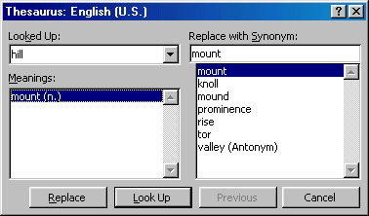
A list of meanings and synonyms are given on the windows. Double-click on the words in the Meanings box or click the Look Up button to view similar words. Double-click words in the Replace with Synonym box to view synonyms of those words. Highlight the word you would like to add and click the Replace button.
Page Margins
The page margins of the document can be changed using the rulers on the page and the Page Setup window. The ruler method is discussed first:
- Move the mouse over the area where the white ruler changes to gray.
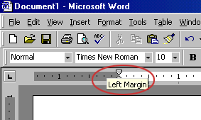
- When the cursor becomes a double-ended arrow, click with the mouse and drag the margin indicator to the desired location.
- Release the mouse when the margin is set.
The margins can also be changed using the Page Setup dialog box:
- Select File|Page Setup and choose the Margins tab in the dialog box.
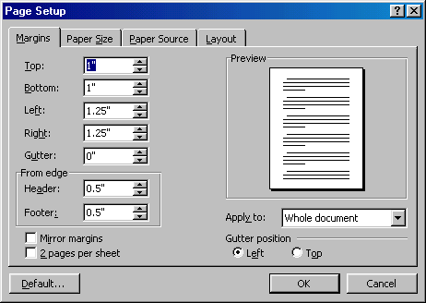
- Enter margin values in the Top, Bottom, Left, and Right boxes. The Preview window will reflect the changes.
- If the document has Headers and/or Footers, the distance this text appears from the edge of the page can be changed.
- Click OK when finished.
Page Size and Orientation
Change the orientation page within the Page Setup dialog box.
- Select File|Page Setup and choose the Paper Size tab.
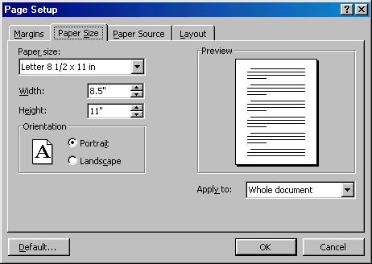
- Select the proper paper size from the drop-down menu.
- Change the orientation from Portrait or Landscape by checking the corresponding radio button.
Headers and Footers
A header is text that is added to the top margin of every page such as a document title or page number and a footer is text added to the bottom margin. Follow these steps to add or edit headers and footers in the document:
- Select View|Header and Footer from the menu bar. The Header and Footer toolbar will appear and the top of the page will be highlighted as shown below.
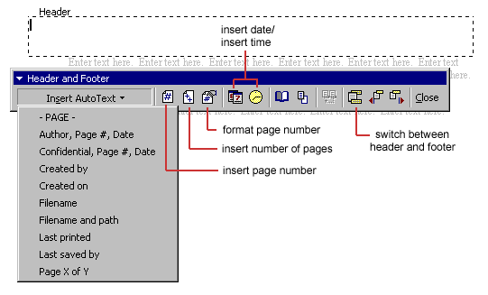
- Type the heading in the Header box. You may use many of the standard text formatting options such as font face, size, bold, italics, etc.
- Click the Insert AutoText button to view a list of quick options available.
- Use the other options on the toolbar to add page numbers, the current date and time.
- To edit the footer, click the Switch Between Header and Footer button on the toolbar.
- When you are finished adding headers and footers, click the Close button on the toolbar.
Page Numbers
Follow these instructions for another way to add page numbers to a document.
- Select Insert|Page Numbers from the menu bar and the following dialog box will appear.
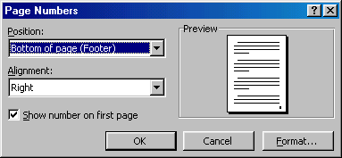
- Select the position of the page numbers by choosing "Top of page" or "Bottom of page" from the Position drop-down menu.
- Select the alignment of the page numbers in the Alignment drop-down menu.
- If you do not want the page number to show on the first page (if it is a title page, for example), uncheck the Show number of first page box.
- Click OK when finished.
Print Preview and Printing
Preview your document by clicking the Print Preview button on the standard toolbar or by selecting File|Print Preview. When the document is ready to print, click the Print button from the Print Preview screen or select File|Print.
Macros are advanced features that can speed up editing or formatting you may perform often in a Word document. They record sequences of menu selections that you choose so that a series of actions can be completed in one step.
Recording A Macro
To record a macro, follow these steps:
- Click Tools|Macro|Record New Macro on the menu bar.
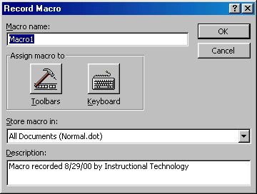
- Name the macro in the Macro name field. This name cannot contain spaces and or begin with a number.
- From the Store macro in drop-down box, select the document you would like the macro to be associated with or choose "All Documents" be able to use the macro in any document.
- Enter a description of the macro in the Description field. This is for your reference only so you remember what the macro does.
- Click OK to begin recording.
- Select options from the drop-down menus and Word will record the options you choose from the dialog boxes, such as changing the margins on the Page Setup window. Select only options that modify the document. Word will not record toggle actions such as View|Toolbars that have no effect on the document itself.
- The recording toolbar will allow you to stop, pause, and resume recording.
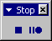
- Click the Stop button the recording toolbar. The macro is now saved.
Running A Macro
To run an existing macro, follow these steps.
- Select Tools|Macro|Macros from the menu bar.
- From the Macros window, highlight the Macro name in the list and click Run.
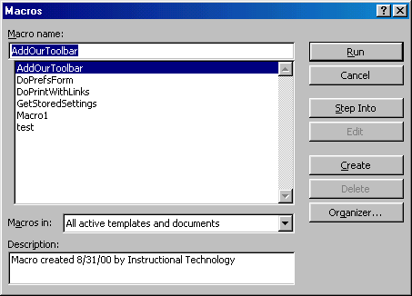
- If the macro is long and you want to stop it while it is running, press BREAK (hold CTRL and press PAUSE).
Word will automatically create a Table of Contents page if a document is designed using Heading and Paragraph styles (see the Styles section). Follow the steps on this page to create a Table of Contents.
Mark Table of Contents Entries
- Highlight a heading that you would like to appear in the Table of Contents (TOC).
- Press ALT+SHIFT+O and the Mark Table of Contents Entry box will appear.
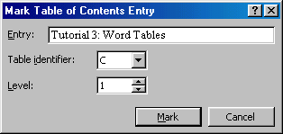
- Entry - Rename the entry if you would like a different heading to appear in the TOC.
- Table identifier - Select "C".
- Level - Choose "1" for first-level heading, "2" for second-level heading, etc.
- Click the Mark button.
- The document will be toggled to "reveal codes" view and notice the TOC field code. To hide all codes click the Show/Hide codes button on the standard toolbar.
- Select another heading to add to the TOC, or click the Close button on the Mark Table of Contents Entry dialog box.
Generate a Table of Contents
After you have marked all the headings for your TOC, follow these steps to generate the Table of Contents.
- Place the cursor where you would like the TOC to appear in the document.
- Select Insert|Index and Tables from the menu bar.
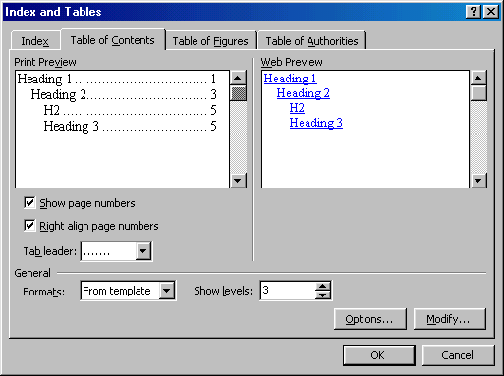
- Customize the appearance of the TOC from the Table of Contents tab. You may choose a preset design from the Formats drop-down menu. A preview of each design will be shown in the Print Preview window.
- Check the Show page numbers box if you would like page numbers to show on the TOC. Check the Right align page numbers box if the page numbers should appear on the right side, then select the Tab leader between the heading and the page number. Uncheck the box if the page numbers should appear right next to the heading.
- Click OK.
Word's Web Page Wizard will help you quickly create web pages for the Internet with preset layouts and graphics. Follow these steps to create a web page using the wizard.
- Select File|New... from the menu bar.
- Click the Web Pages tab on the New dialog box.
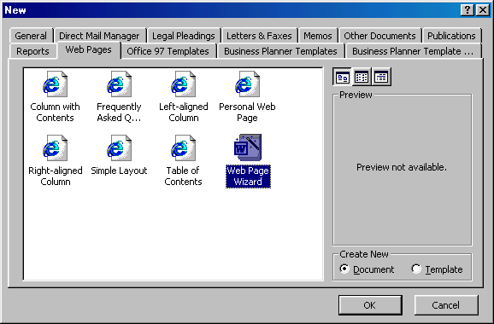
- Highlight the Web Page Wizard icon and click OK.
- Click the Next button on the first Web Page Wizard box.
- Title and Location - Enter a title for your web site and select the location on your computer where the files will be saved. Click Next when finished.
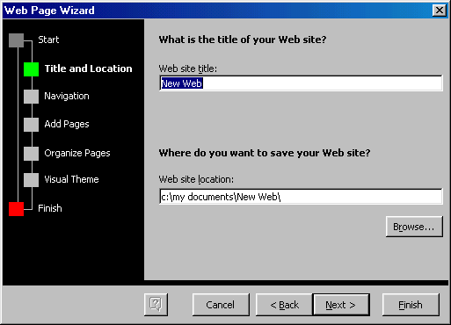
- Navigation - Select a navigation type for the web page. Separate page is usually the best choice as it is the easiest to use.
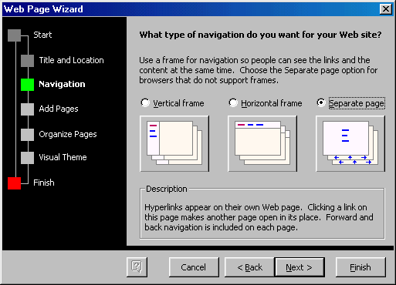
- Add Pages - The next screen will list the pages currently in the web site. Click the Add New Blank Page button to add a new page, and highlight a page in the list and click Remove Page to delete pages from the web site. To add a page that you have already created to the site, click the Add Existing File... button and select the page you want to add.
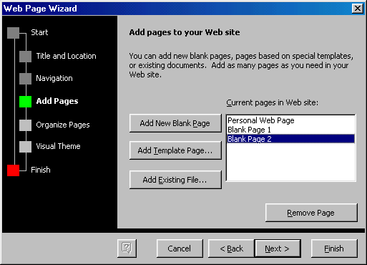
Click the Add Template Page... to insert a page with a layout. Highlight the choices in the Web Page Templates window to preview the template in the main window. Click OK to select a template.
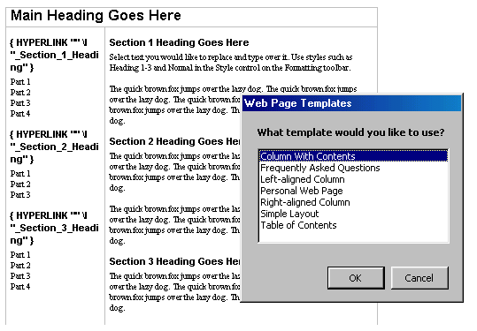
- Organize Pages - Reorder the pages of the web site. Highlight the name of the page that will be moved and click the Move Up and Move Down buttons. Click Rename to rename a page.
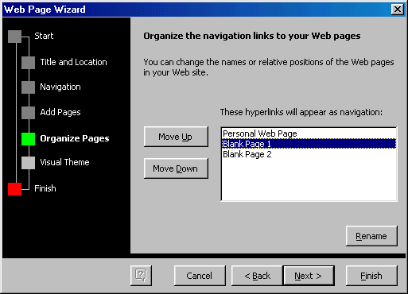
- Visual Theme - Select No visual theme for a blank page or select check Add a visual theme and click Browse Themes... to select a graphical theme.
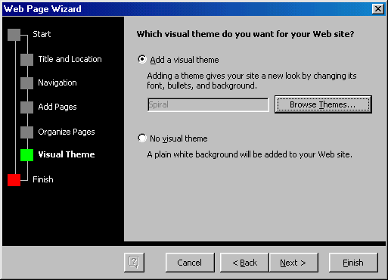
From the Themes window, highlight the themes in the list to preview them. Check the Vivid Colors and Active Graphics boxes to apply those options. Uncheck the Background Image box to remove the graphic from the background of the page. Click OK when finished.
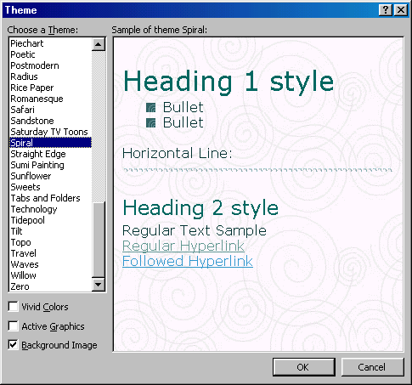
- Click Finish to create the web site.
The previous page explained how to create a web page using the Web Page Wizard. This page describes creating a web page from scratch and adding elements to a page from the wizard. When working on a web format document, view the page in web layout by selecting View|Web Layout from the menu bar. Enter text and insert graphics just as you would in a normal Word document.
Hyperlinks
A hyperlink is a connection between two web pages on the Internet. Hyperlinks can be produced from text or graphics and both methods will be discussed here. Follow these steps to create links to other web sites and pages within your site:
- Type the text you want to appear on the page as a link or add the graphic that will be a link.
- Highlight the text or graphic and click the Insert Hyperlink button on the standard toolbar or press CTRL+K.
- From the Insert Hyperlink dialog box, change the Text to display if necessary.
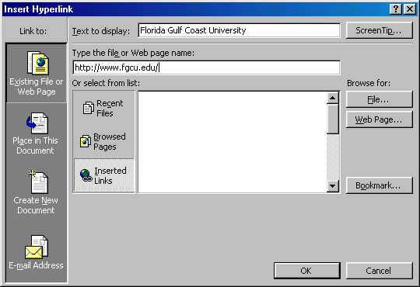
- Type the file or Web page name in the appropriate box or select from list.
- Click OK to create the link.
Saving Web Pages
Pages on the web must be saved in a format called HTML (Hypertext Markup Language) that is readable by web browsers. Word will convert your document to HTML using the Save as Web Page feature.
- Select File|Save as Web Page from the menu bar.
- Click the Change Title button to add a title to the web page.
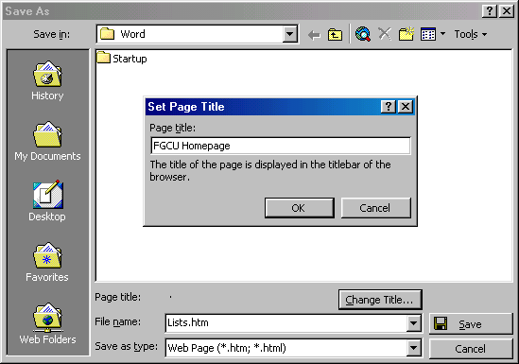
- Type the File name in the box provided.
- Be sure the Save as type is set to Web Page.
- Click Save.
Creating a Web Page from a Template
Word features several layout templates that you can add your own content to. Create a web page from a template by following these steps:
- Select File|New... from the menu bar.
- Click the Web Pages tab on the New dialog box.
- Highlight one of the templates listed and click OK.
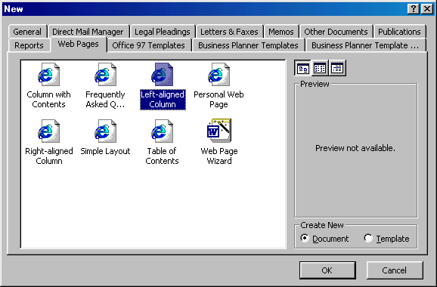
- The template will now appear in the main window. Replace the placeholding text with your own text by highlighting it and typing. Replace photos and images by deleting them and adding new images.
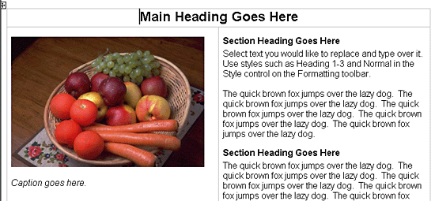
- Save the page by selecting File|Save as Web Page from the menu bar.
Web Page Themes
The Visual Theme feature from the Web Page Wizard can be accessed for any web page. To add a theme to a blank page or existing page, select Format|Theme... from the menu bar. Choose a theme from the list and click OK. The page content will remain blank unless a background image is part of the theme that was selected. The style listings, default font, and bullet images have been changed to reflect the new theme. To change the theme of the page, simply select Format|Theme... from the menu bar again and choose a different theme.
Preview the Web Page
The page may look slightly different when converted to HTML and viewed on the web. Before publishing your web page, be sure to use Word's web preview feature. Select File|Web Page Preview to open the page in a web browser.
Keyboard shortcuts can save time and the effort of switching from the keyboard to the mouse to execute simple commands. Print this list of Word keyboard shortcuts and keep it by your computer for a quick reference.

Mail Merge using Word 2000
DESCRIPTION: Mail Merge using Word 2000 is intended to provide detailed instructions on how to use
the Mail Merge feature in Word 2000 to create form letters, mailing labels, and data
files, and how to merge with external data sources such as an Access table and Excel
spreadsheet.

CLASS

OBJECTIVES:
• Create a form letter from scratch
• Create a data file
• Merge a form letter and data file
• Create a form letter from an existing word document
• Merge a form letter with an excel spread sheet
• Merge a form letter with an access table
• Set sorting options before merging
• Set querying options before merging

WHAT IS

MAIL

MERGE?
“Mail merge” is a misleading term. Although it is probably most commonly used to create
individualized form letters, address labels, and the like, it can in fact be used to merge any
kind of data with any kind of document to create a single Word file containing a whole series of
individualized documents.

Basic Merge

Steps

1. Create the main document.
letter, envelope, mailing labels

2. Create or attach the data that will be merged with the document.
Word table, Excel spreadsheet, Access query or table

3. Insert the merge fields in the main document.
these fields tell Word where to put the data from the data source

4. Merge the data and the main document
a new document will appear with individualize documents based on the main document,
each one containing one set of data from the data source

5. Print
print all the document or a range

Using the

Mail Merge

Helper
Within Word, choose Tools, Mail Merge to begin the mail merge process. There are three
broad steps to merging and the Mail Merge helper will only allow you to advance to the next
step once the previous step is complete.
Create letters, mailing labels,
envelopes or a catalog using
an existing or blank document.
Attach a data source (Word
table, Access query or table, or
an Excel spreadsheet) or
create a data source.
Insert merge fields
(placeholders for each record
of the data source)
Set query options. Merge the
letter and data source to a new
document or to the printer.

CREATE A

FORM

LETTER
1. Within Word do one of the following:
a) Open an existing Word document
b) Click the new button to start a blank Word document
2. Click Tools, Mail Merge.
3. Click the Create button, Form Letters
4. Select Active Window

ATTACH A

DATA

SOURCE
Once the current document has been specified as the form letter, specify the data that will be
inserted into the letter. To do this, a data source must now be attached to the Word file. The
data source can be an Excel worksheet, Access table or query, Word table or several other
formats.
For every row in a data file, a new letter will be created. Each letter will contain a rows’
variable information. Data files, or lists of information, are organized into rows and columns.
The top row is the header row. These headers contain the field names for the data that is
entered below.

Attaching an

Existing

Data Source
If your data file has already been created:
1. Click Tools, Mail Merge (if the Mail Merge Helper box isn’t currently open)
2. Click the Get Data button, then select Open Data Source
3. Use the Look-In drop down list box to navigate to where the data source is saved.
If opening a data source that is not a Word file, click the down arrow to the right of Files
of Type and select the data file type (i.e. Excel spreadsheet or Access database).
4. Click on the data source, then OK.
• For Excel sources select the spreadsheet that contains the data
• For Access sources select the table or query that contains the data
5. After clicking OK to indicate the exact data, click the Edit Main Document button that will
appear in the middle of the screen.
This dialog box indicates that the data
source is attached but there are no
placeholders (merge fields) within the
Word letter.
6. Move on to the section entitled Inserting Merge Fields

Header Row

These field names will
become the merge fields
in the Word document
New field name to be
added to the header row
Field names that will
make up the data
source’s header row

Creating a

New Data

Source
If the data source does not exist use the Create Data Source option to create a new data list
that will be entered directly into a Word table.
1. Click Tools, Mail Merge (if the Mail Merge Helper box isn’t currently open)
2. Click the Get Data button, then select Create Data Source
3. Select field names from the box on
the left to delete, move or rename.
Click in the Field name box to type a
new fieldname and then click the Add
Field Name button to move it to the
listing of field names that will make up
the header row.
4. Field names cannot contain spaces. If
you are creating a two-word field
name use an upper and lower case
naming convention (i.e.
CampusPhone).
5. Click OK
6. Save the data source.
7. A dialog box appears asking if you want to
edit the Word document (insert merge fields) or populate the data source with
information. Choose Edit the Data Source.
8. A data form appears. Use this to enter information into the data source. Use the TAB
key to move from field to field.
• Click the View Source button to display the data in a table.
• Click the Data Form button to bring the form back onto the screen
Once the data is
entered into the
table.
9. Once all the data is entered close the data form and save the file.
10. Click the Mail Merge Main Document button
11. Move on to the section entitled Inserting Merge Fields

Data entry form.

The View Source button will
display the data in a table.
The data source
displayed in a table
format. To use the
data form to enter
information, click on
the Data Form button. Data Form button

INSERT

FIELDS
Merge fields are field names taken from the header row in the attached data file. Place merge
fields in the Form Letter to indicate where the information from the data source should go.
From within the Form Letter:
1. Move the cursor where you want the first merge field.
2. Click the Insert Merge Field button .
3. Select a field.
4. Move the cursor where you want the next merge field and repeat steps 3 & 4.
• If you have two merge fields inserted next to each other, make sure to strike the space
bar for proper spacing.

MERGE Before merging preview how the data will look when it is merged to the form letter. To
preview, click the View Merge data button . The first records’ data will display in the letter.
Look for any spacing or placement errors. Click the View Merged Data button again to turn off
this view.
To merge to a new document click the Merge to New Document button .
To merge directly to the printer, click the Merge to Printer button .
Merge fields placed in the form
letter. Proper spacing and
punctuation between fields.

Sort and

Query

Options

Query Options appear in the Mail Merge Helper
and will open a dialog box with two tabs, Filter
Records and Sort Records. Click Tools, Mail
Merge, and then the Query Options button before
merging to apply one or both of these options.

Filer Records Before merging, use Filter Records to control which records (that meet a criteria) are used in
the mail merge.
Choose the field you want to filter in the first column, and then choose the type of comparison
you want to make (equal, not equal, greater than, less than, greater than or equal, less than or
equal, blank or not blank), and finally enter what you want to compare the field to. Click OK to
set the query rule, and then merge.

Sort Records Before merging, use Sort Records to sort records by up to three fields.
Enter the first field you want to sort the records by in the first blank, and whether you want to
sort in ascending or descending order; then, in the remaining blanks, enter the fields you’d like
to use to settle any ties among records sorted by the first field. Click Ok to the set the sort,
and then merge.
Once you choose to
merge, only those
records that have Media
Relations in the
Department field will be
merged.
Once you choose to
merge, records will be
sorted by last name in
ascending order and
then by first name in
ascending order. For
example, Mary Smith
will come before Mike
Smith.
Query Options button will
provide options for filtering
and sorting before merging.

CREATING

LABELS
1. Begin a new document in Word.
2. Click Tools, Mail Merge, Create, Mailing Labels, In the Active Window
3. Click Get Data, Open Data Source (see attaching a Data Source on page 3)
4. Click Setup Main Document (the label)
5. Select the Label number then click OK
6. Insert fields on to the sample label
(see example at right)
• Click Insert Postal Bar Code,
select the field that contains the
zip code, then click OK to insert
the delivery bar code used by post
office scanning devices.
• Type text (if any) that should
appear on every label
7. Click OK.
8. Click the Merge button, and then merge
to a new document.

CREATING

ENVELOPES
Creating envelopes is very similar to creating mailing labels, except you specify the type of
envelope to use instead of the type of label.
1. Begin a new document in Word.
2. Click Tools, Mail Merge, Create, Envelopes, then click the Active Window button
3. Click Get Data, Open Data Source (see attaching a Data Source on page 3)
4. Click Setup Main Document (the envelope)
5. Select the Envelope Size, and then click OK
6. Insert fields on to the sample envelope, then click OK.
7. Click the Merge button, and
then merge to a new
document.
8. Insert blank envelopes into
the sheet feeder, then print
Label layout includes merge fields, postal bar code, and text
that will appear on every label.
After completing Step 8,
the merged data appears
in label format.
Note the Attn: text at the
bottom of every label and
the postal bar code at the
top of each label.
After completing Step 7, the merged data
appears in envelope format. Note the
postal bar code above the name and the
Attn: text that appears on every envelope.

