Menus
Unlike previous versions of Excel, the menus in Excel 2000 initially list only the commands you have recently used. To view all options in each menu, click the double arrows at the bottom of the menu. If you would like to revert to the way older versions of Excel displayed menu options, follow these steps:
- Select View|Toolbars|Customize from the menu bar.
- Click on the Options tab.
- Uncheck the Menus show recently used commands first check box.
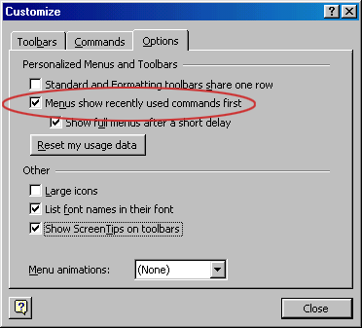
Toolbars
Many toolbars displaying shortcut buttons are available. Select View|Toolbars from the menu bar to select more toolbars.
Customize Toolbars
Customizing toolbars allows you to delete certain shortcut buttons from a toolbar if you do not use them and add the shortcut buttons for commands you use often.
- Select View|Toolbars|Customize and select the Commands tab.
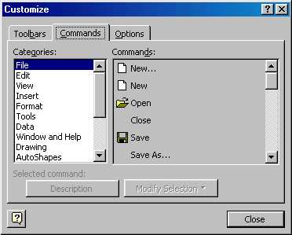
- By clicking on the command categories in the Categories box, the commands will change in the Commands box to the right.
- Select the command you would like to add to the toolbar by selecting it from the Commands box.
- Drag the command with the mouse to the desired location on the toolbar and release the mouse button. The shortcut button should now appear on the toolbar.
- Remove buttons from the toolbars by reversing these steps. Highlight the button on the toolbar, drag it off the toolbar with the mouse, and release the mouse button.
Recording A Macro
Macros can speed up any common editing sequence you may execute in an Excel spreadsheet. In this example we will make a simple macro that will set all the margins on the page to one inch.
- Click Tools|Macro|Record New Macro from the menu bar.
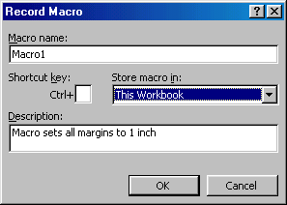
- Name the macro in the Macro name field. The name cannot contain spaces and must not begin with a number.
- If you would like to assign a shortcut key to the macro for easy use, enter the letter under Shortcut key. Enter a lower case letter to make a CTRL+number shortcut and enter an upper case letter to assign a CTRL+SHIFT+number shortcut key. If you select a shortcut key that Excel already uses, your macro will overwrite that function.
- Select an option from the Store macro in drop-down menu.
- Enter a description of the macro in the Description field. This is for your reference only so you remember what the macro does.
- Click OK when you are ready to start recording.
- Select options from the drop down menus and Excel will record the options you choose from the dialog boxes, such as changing the margins on the Page Setup window. Select File|Page Setup and change all the margins to 1". Press OK. Replace this step with whatever commands you want your macro to execute. Select only options that modify the worksheet. Toggle actions such as View|Toolbars that have no effect on the worksheet will not be recorded.
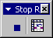
- Click the Stop button the recording toolbar. The macro is now saved.
Running A Macro
- To run a macro you have created, select Tools|Macro|Macros from the menu bar.
- From the Macros window, highlight the Macro name in the list and click Run.
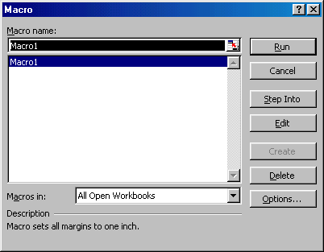
- If the macro is long and you want to stop it while it is running, press BREAK (hold CTRL and press PAUSE).
Moving Through Cells
Use the mouse to select a cell you want to begin adding data to and use the keyboard strokes listed in the table below to move through the cells of a worksheet.
Movement | Key stroke
One cell up | up arrow key
One cell down | down arrow key or ENTER
One cell left | left arrow key
One cell right | right arrow key or TAB
Top of the worksheet (cell A1) | CTRL+HOME
End of the worksheet (last cell containing data) | CTRL+END
End of the row | CTRL+right arrow key
End of the column | CTRL+down arrow key
Any cell | File|Go To menu bar command
Adding Worksheets, Rows, and Columns
- Worksheets - Add a worksheet to a workbook by selecting Insert|Worksheet from the menu bar.
- Row - To add a row to a worksheet, select Insert|Rows from the menu bar, or highlight the row by clicking on the row label, right-click with the mouse, and choose Insert.
- Column - Add a column by selecting Insert|Columns from the menu bar, or highlight the column by click on the column label, right-click with the mouse, and choose Insert.
Resizing Rows and Columns
There are two ways to resize rows and columns.
- Resize a row by dragging the line below the label of the row you would like to resize. Resize a column in a similar manner by dragging the line to the right of the label corresponding to the column you want to resize.
- OR -
- Click the row or column label and select Format|Row|Height or Format|Column|Width from the menu bar to enter a numerical value for the height of the row or width of the column.
Selecting Cells
Before a cell can be modified or formatted, it must first be selected (highlighted). Refer to the table below for selecting groups of cells.
Cells to select | Mouse action
One cell | click once in the cell
Entire row | click the row label
Entire column | click the column label
Entire worksheet | click the whole sheet button
Cluster of cells | drag mouse over the cells or hold down the SHIFT key while using the arrow keys
To activate the contents of a cell, double-click on the cell or click once and press F2.
Moving and Copying Cells
Moving Cells
To cut cell contents that will be moved to another cell select Edit|Cut from the menu bar or click the Cut button on the standard toolbar.
Copying Cells
To copy the cell contents, select Edit|Copy from the menu bar or click the Copy button on the standard toolbar.
Pasting Cut and Copied Cells
Highlight the cell you want to paste the cut or copied content into and select Edit|Paste from the menu bar or click the Paste button on the standard toolbar.
Drag and Drop
If you are moving the cell contents only a short distance, the drag-and-drop method may be easier. Simply drag the highlighted border of the selected cell to the destination cell with the mouse.
Freeze Panes
If you have a large worksheet with column and row headings, those headings will disappear as the worksheet is scrolled. By using the Freeze Panes feature, the headings can be visible at all times.
- Click the label of the row below the row that should remain frozen at the top of the worksheet.
- Select Window|Freeze Panes from the menu bar.
- To remove the frozen panes, select Window|Unfreeze Panes.
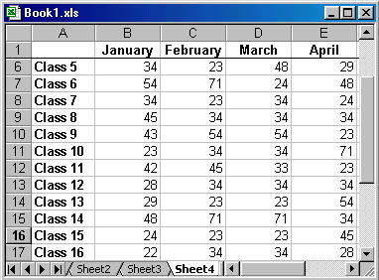
Freeze panes has been added to row 1 in the image above. Notice that the row numbers skip from 1 to 6. As the worksheet is scrolled, row 1 will remain stationary while the remaining rows will move.

Formatting Toolbar
The contents of a highlighted cell can be formatted in many ways. Font and cell attributes can be added from shortcut buttons on the formatting bar. If this toolbar is not already visible on the screen, select View|Toolbars|Formatting from the menu bar.
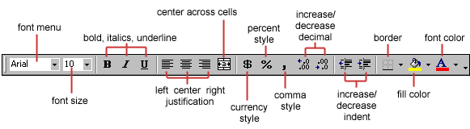
Format Cells Dialog Box
For a complete list of formatting options, right-click on the highlighted cells and choose Format Cells from the shortcut menu or select Format|Cells from the menu bar.
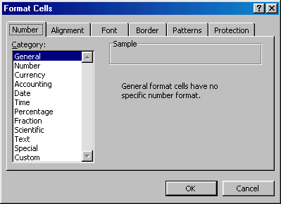
- Number tab - The data type can be selected from the options on this tab. Select General if the cell contains text and number, or another numerical category if the cell is a number that will be included in functions or formulas.
- Alignment tab - These options allow you to change the position and alignment of the data with the cell.
- Font tab - All of the font attributes are displayed in this tab including font face, size, style, and effects.
- Border and Pattern tabs - These tabs allow you to add borders, shading, and background colors to a cell.
Dates and Times
If you enter the date "January 1, 2001" into a cell on the worksheet, Excel will automatically recognize the text as a date and change the format to "1-Jan-01". To change the date format, select the Number tab from the Format Cells window. Select "Date" from the Category box and choose the format for the date from the Type box. If the field is a time, select "Time" from the Category box and select the type in the right box. Date and time combinations are also listed. Press OK when finished.
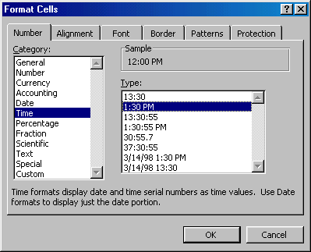
Styles
The use of styles in Excel allow you to quickly format your worksheet, provide consistency, and create a professional look. Select the Styles drop-down box from the formatting toolbar (it can be added by customizing the toolbar). Excel provides several preset styles:
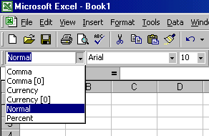
- Comma - Adds commas to the number and two digits beyond a decimal point.
- Comma [0] - Comma style that rounds to a whole number.
- Currency - Formats the number as currency with a dollar sign, commas, and two digits beyond the decimal point.
- Currency [0] - Currency style that rounds to a whole number.
- Normal - Reverts any changes to general number format.
- Percent - Changes the number to a percent and adds a percent sign.
Style Dialog Box
Create your own styles from the Style Dialog Box.
- Highlight the cell(s) you want to add a style to.
- Select Format|Style... from the menu bar.
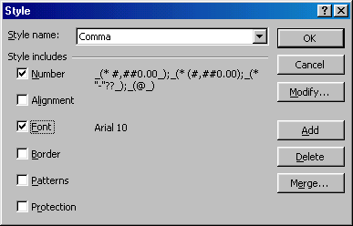
- Modify the attributes by clicking the Modify button.
- Check all the items under Style includes that the style should format.
- Click Add to preview the formatting changes on the worksheet.
- Highlight the style you want to apply to the paragraph and click Apply.
Create a New Style
- Select the cell on the worksheet containing the formatting you would like to set as a new style.
- Click the Style box on the Formatting toolbar so the style name is highlighted.
- Delete the text in the Style box and type the name of the new style.
- Press ENTER when finished.
Format Painter
A handy feature on the standard toolbar for formatting text is the Format Painter. If you have formatted a cell with a certain font style, date format, border, and other formatting options, and you want to format another cell or group of cells the same way, place the cursor within the cell containing the formatting you want to copy. Click the Format Painter button in the standard toolbar (notice that your pointer now has a paintbrush beside it). Highlight the cells you want to add the same formatting to.
To copy the formatting to many groups of cells, double-click the Format Painter button. The format painter remains active until you press the ESC key to turn it off.
AutoFormat
Excel has many preset table formatting options. Add these styles by following these steps:
- Highlight the cells that will be formatted.
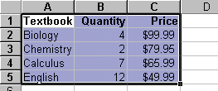
- Select Format|AutoFormat from the menu bar.
- On the AutoFormat dialog box, select the format you want to apply to the table by clicking on it with the mouse. Use the scroll bar to view all of the formats available.
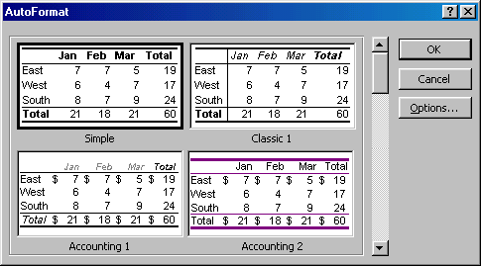
- Click the Options... button to select the elements that the formatting will apply to.
- Click OK when finished.
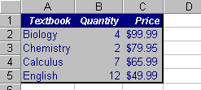
« Formatting Cells | Formulas and Functions | Sorting and Filling »
The distinguishing feature of a spreadsheet program such as Excel is that it allows you to create mathematical formulas and execute functions. Otherwise, it is not much more than a large table for displaying text. This page will show you how to create these calculations.
Formulas
Formulas are entered in the worksheet cell and must begin with an equal sign "=". The formula then includes the addresses of the cells whose values will be manipulated with appropriate operands placed in between. After the formula is typed into the cell, the calculation executes immediately and the formula itself is visible in the formula bar. See the example below to view the formula for calculating the sub total for a number of textbooks. The formula multiplies the quantity and price of each textbook and adds the subtotal for each book.
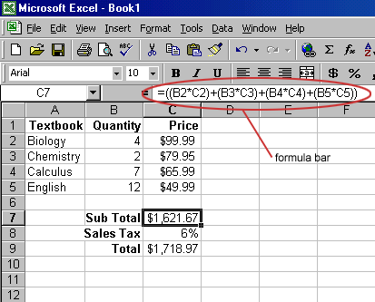
Linking Worksheets
You may want to use the value from a cell in another worksheet within the same workbook in a formula. For example, the value of cell A1 in the current worksheet and cell A2 in the second worksheet can be added using the format "sheetname!celladdress". The formula for this example would be "=A1+Sheet2!A2" where the value of cell A1 in the current worksheet is added to the value of cell A2 in the worksheet named "Sheet2".
Relative, Absolute, and Mixed Referencing
Calling cells by just their column and row labels (such as "A1") is called relative referencing. When a formula contains relative referencing and it is copied from one cell to another, Excel does not create an exact copy of the formula. It will change cell addresses relative to the row and column they are moved to. For example, if a simple addition formula in cell C1 "=(A1+B1)" is copied to cell C2, the formula would change to "=(A2+B2)" to reflect the new row. To prevent this change, cells must be called by absolute referencing and this is accomplished by placing dollar signs "$" within the cell addresses in the formula. Continuing the previous example, the formula in cell C1 would read "=($A$1+$B$1)" if the value of cell C2 should be the sum of cells A1 and B1. Both the column and row of both cells are absolute and will not change when copied. Mixed referencing can also be used where only the row OR column fixed. For example, in the formula "=(A$1+$B2)", the row of cell A1 is fixed and the column of cell B2 is fixed.
Basic Functions
Functions can be a more efficient way of performing mathematical operations than formulas. For example, if you wanted to add the values of cells D1 through D10, you would type the formula "=D1+D2+D3+D4+D5+D6+D7+D8+D9+D10". A shorter way would be to use the SUM function and simply type "=SUM(D1:D10)". Several other functions and examples are given in the table below:
Function | Example | Description
SUM | =SUM(A1:100) | finds the sum of cells A1 through A100
AVERAGE | =AVERAGE(B1:B10) | finds the average of cells B1 through B10
MAX | =MAX(C1:C100) | returns the highest number from cells C1 through C100
MIN | =MIN(D1:D100) | returns the lowest number from cells D1 through D100
SQRT | =SQRT(D10) | finds the square root of the value in cell D10
TODAY | =TODAY() | returns the current date (leave the parentheses empty)
Function Wizard
View all functions available in Excel by using the Function Wizard.
- Activate the cell where the function will be placed and click the Function Wizard button on the standard toolbar.
- From the Paste Function dialog box, browse through the functions by clicking in the Function category menu on the left and select the function from the Function name choices on the right. As each function name is highlighted a description and example of use is provided below the two boxes.
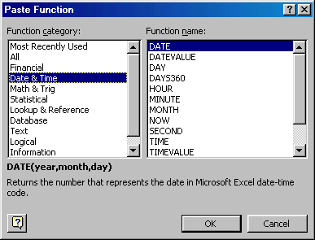
- Click OK to select a function.
- The next window allows you to choose the cells that will be included in the function. In the example below, cells B4 and C4 were automatically selected for the sum function by Excel. The cell values {2, 3} are located to the right of the Number 1 field where the cell addresses are listed. If another set of cells, such as B5 and C5, needed to be added to the function, those cells would be added in the format "B5:C5" to the Number 2 field.
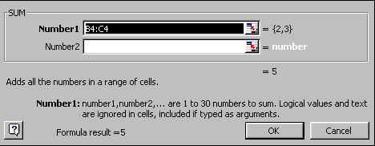
- Click OK when all the cells for the function have been selected.
Autosum
Use the Autosum function to add the contents of a cluster of adjacent cells.
- Select the cell that the sum will appear in that is outside the cluster of cells whose values will be added. Cell C2 was used in this example.
- Click the Autosum button (Greek letter sigma) on the standard toolbar.
- Highlight the group of cells that will be summed (cells A2 through B2 in this example).
- Press the ENTER key on the keyboard or click the green check mark button on the formula bar .
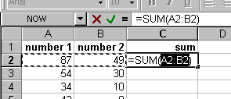

Basic Sorts
To execute a basic descending or ascending sort based on one column, highlight the cells that will be sorted and click the Sort Ascending (A-Z) button or Sort Descending (Z-A) button on the standard toolbar.
Complex Sorts
To sort by multiple columns, follow these steps:
- Highlight the cells, rows, or columns that will be sorted.
- Select Data|Sort from the menu bar.
- From the Sort dialog box, select the first column for sorting from the Sort By drop-down menu and choose either ascending or descending.
- Select the second column and, if necessary, the third sort column from the Then By drop-down menus.
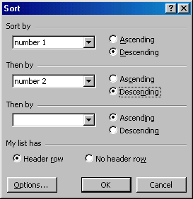
- If the cells you highlighted included the text headings in the first row, mark My list has...Header row and the first row will remain at the top of the worksheet.
- Click the Options button for special non-alphabetic or numeric sorts such as months of the year and days of the week.
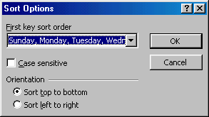
- Click OK to execute the sort.
Autofill
The Autofill feature allows you to quickly fill cells with repetitive or sequential data such as chronological dates or numbers, and repeated text.
- Type the beginning number or date of an incrementing series or the text that will be repeated into a cell.
- Select the handle at the bottom, right corner of the cell with the left mouse button and drag it down as many cells as you want to fill.
- Release the mouse button.
If you want to autofill a column with cells displaying the same number or date you must enter identical data to two adjacent cells in a column. Highlight the two cells and drag the handle of the selection with the mouse.
Alternating Text and Numbers with Autofill
The Autofill feature can also be used for alternating text or numbers. For example, to make a repeating list of the days of the week, type the seven days into seven adjacent cells in a column. Highlight the seven cells and drag down with the mouse.
Autofilling Functions
Autofill can also be used to copy functions. In the example below, column A and column B each contain lists of numbers and column C contains the sums of columns A and B for each row. The function in cell C2 would be "=SUM(A2:B2)". This function can then be copied to the remaining cells of column C by activating cell C2 and dragging the handle down to fill in the remaining cells. The autofill feature will automatically update the row numbers as shown below if the cells are reference relatively.
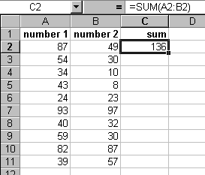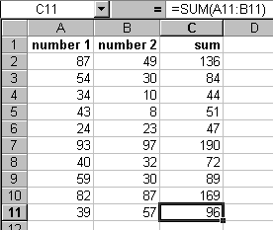
Adding Clip Art
To add a clip art image to the worksheet, follow these steps:
- Select Insert|Picture|Clip Art from the menu bar.
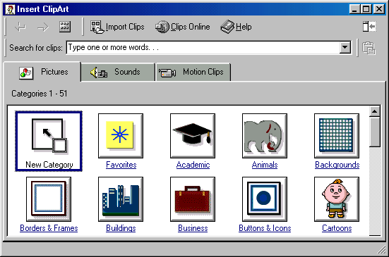
- To find an image, click in the white box following Search for clips. Delete the words "Type one or more words. . ." and enter keywords describing the image you want to use.
- OR -
Click one of the category icons.
- Click once on the image you want to add to the worksheet and the following popup menu will appear:
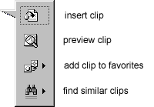
  - Insert Clip to add the image to the worksheet.
  - Preview Clip to view the image full-size before adding it to the worksheet. Drag the bottom, right corner of the preview window to resize the image and click the "x" close button to end the preview.
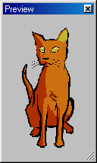
  - Add Clip to Favorites will add the selected image to your favorites directory that can be chosen from the Insert ClipArt dialog box.
  - Find Similar Clips will retrieve images similar to the one you have chosen.
- Continue selecting images to add to the worksheet and click the Close button in the top, right corner of the Insert ClipArt window to stop adding clip art to the worksheet.
Add An Image from a File
Follow these steps to add a photo or graphic from an existing file:
- Select Insert|Picture|From File on the menu bar.
- Click the down arrow button on the right of the Look in: window to find the image on your computer.
- Highlight the file name from the list and click the Insert button.
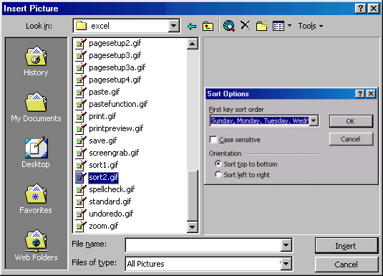
Editing A Graphic
Activate the image you wish to edit by clicking on it once with the mouse. Nine handles will appear around the graphic. Click and drag these handles to resize the image. The handles on the corners will resize proportionally while the handles on the straight lines will stretch the image. More picture effects can be changed using the Picture toolbar. The Picture toolbar should appear when you click on the image. Otherwise, select View|Toolbars|Picture from the menu bar to activate it.
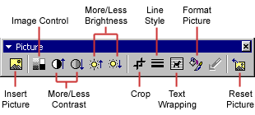
- Insert Picture will display the image selection window and allows you to change the image.
- Image Control allows to to make the image gray scale, black and white, or a watermark.
- More/Less Contrast modifies the contrast between the colors of the image.
- More/Less Brightness will darken or brighten the image.
- Click Crop and drag the handles on the activated image to delete outer portions of the image.
- Line Style will add a variety of borders to the graphic.
- Text Wrapping will modify the way the worksheet text wraps around the graphic.
- Format Picture displays all the image properties in a separate window.
- Reset Picture will delete all the modifications made to the image.
AutoShapes
The AutoShapes toolbar will allow you to draw a number of geometrical shapes, arrows, flow chart elements, stars, and more on the worksheet. Activate the AutoShapes toolbar by selecting Insert|Picture|AutoShapes or View|Toolbars|AutoShapes from the menu bar. Click the button on the toolbar to view the options for drawing the shape.
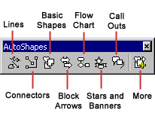
- Lines - After clicking the Lines button on the AutoShapes toolbar, draw a straight line, arrow, or double-ended arrow from the first row of options by clicking the respective button. Click in the worksheet where you would like the line to begin and click again where it should end. To draw a curved line or freeform shape, select curved lines from the menu (first and second buttons of second row), click in the worksheet where the line should appear, and click the mouse every time a curve should begin. End creating the graphic by clicking on the starting end or pressing the ESC key. To scribble, click the last button in the second row, click the mouse in the worksheet and hold down the left button while you draw the design. Let go of the mouse button to stop drawing.
- Connectors - Draw these lines to connect flow chart elements.
- Basic Shapes - Click the Basic Shapes button on the AutoShapes toolbar to select from many two- and three-dimensional shapes, icons, braces, and brackets. Use the drag-and-drop method to draw the shape in the worksheet. When the shape has been made, it can be resized using the open box handles and other adjustments specific to each shape can be modified using the yellow diamond handles.

- Block Arrows - Select Block Arrows to choose from many types of two- and three-dimensional arrows. Drag-and-drop the arrow in the worksheet and use the open box and yellow diamond handles to adjust the arrowheads. Each AutoShape can also be rotated by first clicking the Free Rotate button on the drawing toolbar . Click and drag the green handles around the image to rotate it. The tree image below was created from an arrow rotated 90 degrees.

- Flow Chart - Choose from the flow chart menu to add flow chart elements to the worksheet and use the line menu to draw connections between the elements.
- Stars and Banners - Click the button to select stars, bursts, banners, and scrolls.
- Call Outs - Select from the speech and thought bubbles, and line call outs. Enter the call out text in the text box that is made.
- More AutoShapes - Click this button to choose from a list of clip art categories.
Each of the submenus on the AutoShapes toolbar can become a separate toolbar. Just click and drag the gray bar across the top of the submenus off of the toolbar and it will become a separate floating toolbar.
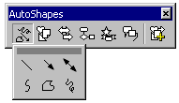 | 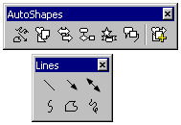

Charts allow you to present data entered into the worksheet in a visual format using a variety of graph types. Before you can make a chart you must first enter data into a worksheet. This page explains how you can create simple charts from the data.
Chart Wizard
The Chart Wizard brings you through the process of creating a chart by displaying a series of dialog boxes.
- Enter the data into the worksheet and highlight all the cells that will be included in the chart including headers.
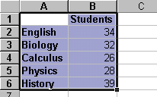
- Click the Chart Wizard button on the standard toolbar to view the first Chart Wizard dialog box.
- Chart Type - Choose the Chart type and the Chart subtype if necessary. Click Next.
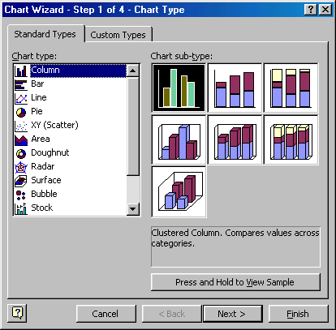
- Chart Source Data - Select the data range (if different from the area highlighted in step 1) and click Next.
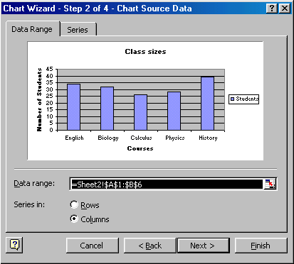
- Chart Options - Enter the name of the chart and titles for the X- and Y-axes. Other options for the axes, grid lines, legend, data labels, and data table can be changed by clicking on the tabs. Press Next to move to the next set of options.
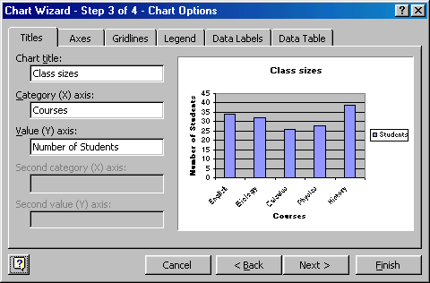
- Chart Location - Click As new sheet if the chart should be placed on a new, blank worksheet or select As object in if the chart should be embedded in an existing sheet and select the worksheet from the drop-down menu.
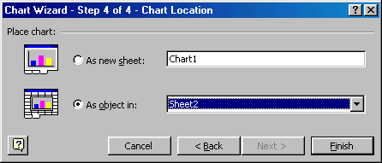
- Click Finish to create the chart.
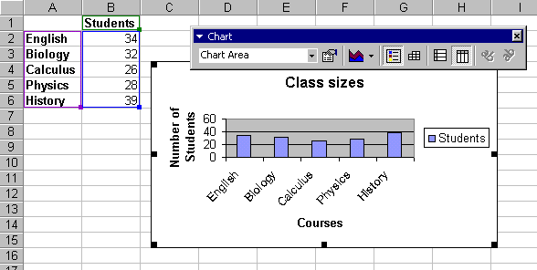
Resizing the Chart
To resize the chart, click on its border and drag any of the nine black handles to change the size. Handles on the corners will resize the chart proportionally while handles along the lines will stretch the chart.
Moving the Chart
Select the border of the chart, hold down the left mouse button, and drag the chart to a new location. Elements within the chart such as the title and labels may also be moved within the chart. Click on the element to activate it, and use the mouse to drag the element to move it.

Chart Formatting Toolbar
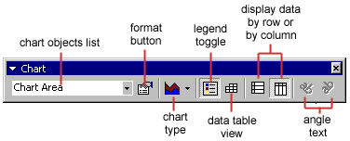
Chart Objects List - To select an object on the chart to format, click the object on the chart or select the object from the Chart Objects List and click the Format button. A window containing the properties of that object will then appear to make formatting changes.
Chart Type - Click the arrowhead on the chart type button to select a different type of chart.
Legend Toggle - Show or hide the chart legend by clicking this toggle button.
Data Table view - Display the data table instead of the chart by clicking the Data Table toggle button.
Display Data by Column or Row - Charts the data by columns or rows according to the data sheet.
Angle Text - Select the category or value axis and click the Angle Downward or Angle Upward button to angle the the selected by +/- 45 degrees.
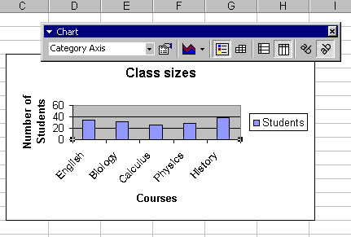

Copying the Chart to Microsoft Word
A finished chart can be copied into a Microsoft Word document. Select the chart and click Copy. Open the destination document in Word and click Paste.
Page Breaks
To set page breaks within the worksheet, select the row you want to appear just below the page break by clicking the row's label. Then choose Insert|Page Break from the menu bar. You may need to click the double down arrow at the bottom of the menu list to view this option.

Page Setup
Select File|Page Setup from the menu bar to format the page, set margins, and add headers and footers.
- Page
Select the Orientation under the Page tab in the Page Setup window to make the page Landscape or Portrait. The size of the worksheet on the page can also be formatting under Scaling. To force a worksheet to print only one page wide so all the columns appear on the same page, select Fit to 1 page(s) wide.
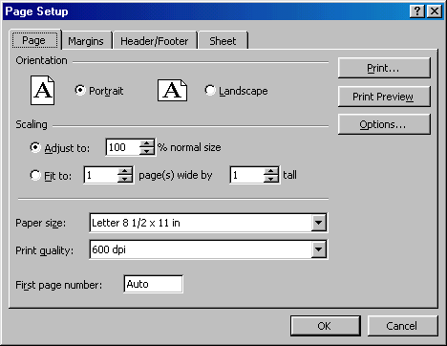
- Margins
Change the top, bottom, left, and right margins under the Margins tab. Enter values in the header and footer fields to indicate how far from the edge of the page this text should appear. Check the boxes for centering horizontally or vertically on the page.
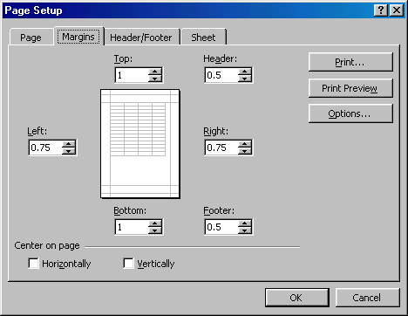
- Header/Footer
Add preset headers and footers to the page by clicking the drop-down menus under the Header/Footer tab.
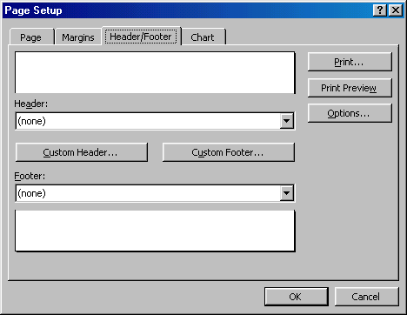
To modify a preset header or footer, or to make your own, click the Custom Header and Custom Footer buttons. A new window will open allowing you to enter text in the left, center, or right on the page.
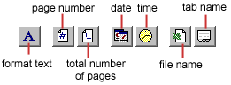
Format Text - Click this button after highlighting the text to change the font, size, and style.
Page Number - Insert the page number of each page.
Total Number of Pages - Use this feature along with the page number to create strings such as "page 1 of 15".
Date - Add the current date.
Time - Add the current time.
File Name - Add the name of the workbook file.
Tab Name - Add the name of the worksheet's tab.
- Sheet
Check Gridlines if you want the gridlines dividing the cells to be printed on the page. If the worksheet is several pages long and only the first page includes titles for the columns, select Rows to repeat at top to choose a title row that will be printed at the top of each page.
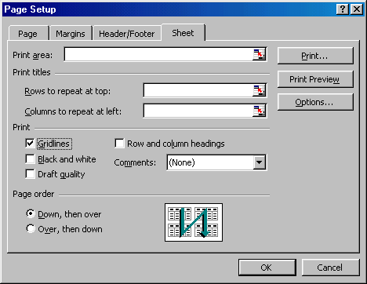
Print Preview
Select File|Print Preview from the menu bar to view how the worksheet will print. Click the Next and Previous buttons at the top of the window to display the pages and click the Zoom button to view the pages closer. Make page layout modifications needed by clicking the Page Setup button. Click Close to return to the worksheet or Print to continue printing.

Print
To print the worksheet, select File|Print from the menu bar.
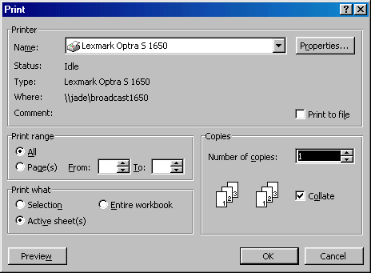
- Print Range - Select either all pages or a range of pages to print.
- Print What - Select selection of cells highlighted on the worksheet, the active worksheet, or all the worksheets in the entire workbook.
- Copies - Choose the number of copies that should be printed. Check the Collate box if the pages should remain in order.
Click OK to print.
Keyboard shortcuts can save time and the effort of switching from the keyboard to the mouse to execute simple commands. Print this list of Excel keyboard shortcuts and keep it by your computer for a quick reference.
Note: A plus sign indicates that the keys need to be pressed at the same time.
  Action | Keystroke
  Document actions
  Open a file | CTRL+O
  New file | CTRL+N
  Save As | F12
  Save | CTRL+S
  Print | CTRL+P
  Find | CTRL+F
  Replace | CTRL+H
  Go to | F5
  Cursor Movement
  One cell up | up arrow
  One cell down | down arrow
  One cell right | Tab
  One cell left | SHIFT+Tab
  Top of worksheet (cell A1) | CTRL+Home
  End of worksheet  (last cell with data) | CTRL+End
  End of row | Home
  End of column | CTRL+left arrow
  Move to next worksheet | CTRL+PageDown
  Formulas
  Apply AutoSum | ALT+=
  Current date | CTRL+;
  Current time | CTRL+:
  Spelling | F7
  Help | F1
  Macros | ALT+F8
  Action | Keystroke
  Selecting Cells
  All cells left of current cell | SHIFT+left arrow
  All cells right of current cell | SHIFT+right arrow
  Entire column | CTRL+Spacebar
  Entire row | SHIFT+Spacebar
  Entire worksheet | CTRL+A
  Text Style
  Bold | CTRL+B
  Italics | CTRL+I
  Underline | CTRL+U
  Strikethrough | CTRL+5
  Formatting
  Edit active cell | F2
  Format as currency with 2 decimal places | SHIFT+CTRL+$
  Format as percent with no decimal places | SHIFT+CTRL+%
  Cut | CTRL+X
  Copy | CTRL+C
  Paste | CTRL+V
  Undo | CTRL+Z
  Redo | CTRL+Y
  Format cells dialog box | CTRL+1

