<

ClockGen

User's manual

Presentation of the board 2
Board specifications 3
Using the interface 4
Main screen 5
Clock parameters screen 5
Option screen 6
Store screen 6
Sweep screen 6
Sweep Cx screen 6
Setting-up a phase shift (opposition, quadrature etc) 8
Setting-up frequency sweeping 9
Arduino IDE installation 10
Arduino Core STM32 10
Arduino IDE Setup 10
Programming 12
SWD programming using an STLINK probe 12
USB/DFU programming 13
Exposed functions 14
Loading the minimum program 15
Programming examples 15
Schematics 16
Troubleshooting 17

Presentation of the board

The Clock generator is a complete module based on Si5351 Clock chip, STM32F103CB and an interface made of a TFT display a selector and a button to offer a ready to use, but also versatile 3 channels clock solution.

Clocks are everywhere in modern microelectronics, but you might not find anywhere the clock you need when you need it.

With clockGen you can generate 3 different clocks at frequency from 2.5 KHz to 225 MHz.

You have some control over each clock power (drive). They are designed to drive a 50 Ohm or more load. In the MHZ range you can also set a phase shift between two or three clocks.

There is also a pre-programmed sweep function.

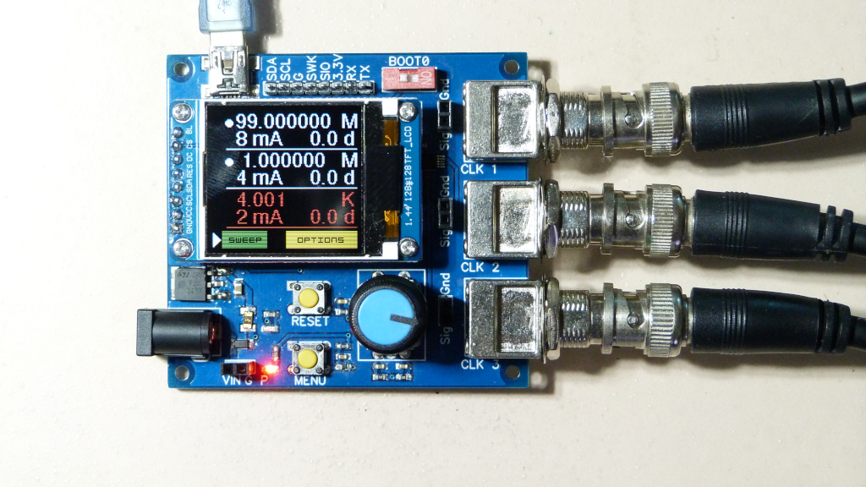

There are a couple of Si5351 modules available on the market but rare totally integrated modules and the programming is time consuming and possibly not this easy. The ClockGen program has more than 2500 lines of code + the etherkit Si5351 library... And you probably don’t like to have a couple of modules connected by cables that are not secure and will be sensitive to EMIs.

The board can be very easily programmed. For example you might want to set the clock parameters through the Serial, I2C or SPI buses and integrate it into a toolchain…

This is why you will certainly find ClockGen handy, either used as a VCO or for any other application.

Note that this is not a function generator. It will provide very high speed clocks, but not very clean signals with a defined shape. The shape is square in low frequencies and resembling a sine in the VHF range. If the clock is too noisy, check the troubleshoot section.

Board specifications
 | ClockGen
Clock chip | Si5351A, 3 channels click IC
MCU | STM32F103CBT6
Operating voltage | - Vin: 4.5 to 15 volts  - USB 5V  - or direct 3.3V
Max current
Remaining Flash
Remaining RAM
I/Os | Serial (port …)  SPI  I2C (port..)
Size
Weight

Using the interface

ClockGen has an interface to set clock parameters, store data and set sweep parameters. It can also be programmed in the Arduino IDE (LIEN VERS PROGRAMMATION).

The interface is made of

- The 1.44” TFT 128x128 pixels screen. it displays
  - Info and parameters
  - A triangle shaped cursor to know what it the actual selected parameter. It flashes when editing a parameter
  - A "button” area at the bottom to access another screen or navigate back

- The rotating selector. It uses two speeds to display numbers. When turned slowly the number changes by one unit. When turned fast it changes by ten units.

- The “Menu" button is used either to make
  - single clicks for most of the interaction. Fast single press once to navigate, select, deselect
  - (long) press to display each clock parameters when you are displaying the main screen with the cursor in front of a clock data.

- The “RESET" button to reset the microcontroller

It also features a number of communication/programming ports, power connectors and output connectors.

Image 3D commentée

Main screen
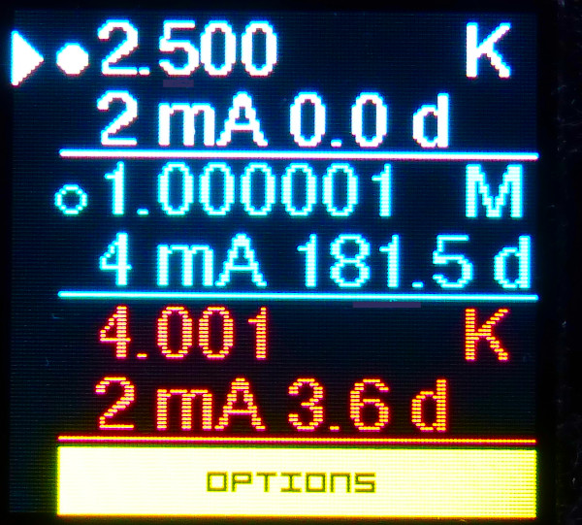
The main screen shows :

- For each clock
  - Frequency
  - Frequency range (K(Hz) or M(Hz)
  - Drive: 2, 4, 6 or 8 mA
  - The phase shift. Only when applicable

When the selector is in front of a clock you can
* Single click to change the output state to
  - Normal output
  - Inversed phase
  - Output deactivated
* Button press to access the clock parameters screen

- A sweep button. That is colored in
  - dark grey when sweep is not activated
  - green when ready and HOLD
  - red when RUNNING

- A button to navigate to the Options screen by single clicking it

Clock parameters screen

All parameters are set after clicking (the selector flashes) and you leave the select mode by single clicking again.

When accessing the clock parameters you will see

- Range. Select "KHz” or "MHz"
- S: frequency step selection. You can choose how the selector will modify the frequency. All settings have double values depending on the speed at wich you turn the selector. For example choosing 1/10 MHz means that the selector will modify the frequency by 1 MHz at low speed and 10 MHz when turned faster. Only one clock can be set above 100 MHz. It is better to use “Clock 1” (program id=0) for the highest frequency since the trace is shorter.
- F: modify the clock frequency by rotating the selector
- D: choose the clock output drive: 2, 4, 6, 8 mA to adapt to the load
- P: phase setting. Applies only when the clock is “phase tied” (see the options screen explanation) and the frequency is high enough. If not phase tied, prints “IND”, if the frequency is too low prints “F too low”.

You will be able to select a phase shift in degrees, to set the clock in quadrature or another phase angle. The phase step varies with the clock frequency but should always allow phase quadrature and is limited to 360°. See the setting a phase shift section for precise explanation

Option screen

The option screen shows

- Sub menu “Store”
- Sub menu “Sweep"
- Calibration: you can change the frequency by +/- 9.9 ppm to compensate the frequency error.
- Ph tied: select if clocks 1, 2 and 3 are phase related or not.
  - Phase related clocks are attached to the Si5351A PLLA vco
  - while the other clocks are attached to PLLB and can’t have a phase value selected

Store screen

The store screen shows

- STORE A: store all the clocks settings in a storage A emulated EEPROM space
- STORE B: same, in storage B
- RETRIEVE A: retrieves clocks settings from storage A
- RETRIEVE A: same, from storage B

So you can store two sets of clocks settings at any time.

Plus all your current settings are kept in memory and initialised when starting the device.

Sweep screen

The sweep screen shows

- Steps: number of sweep steps from 1 to 9999
- Period: duration of a sweep step. Can be set from 0.1 to 10 s.
- Sub menu “C1" and "Inactive” or the start frequency value
- Sub menu “C2" and "Inactive” or the start frequency value
- Sub menu “C3" and "Inactive” or the start frequency value

Sweep Cx screen

The “Sweep Cx” screen shows

- Active: this clock will sweep or not when launching the sweep
- Range: K(Hz) or M(Hz)
- Step: like in the clock settings screen
- Fr: sweep start frequency, modified by the selector depending on the step value
- To: sweep stop frequency

Setting-up a phase shift (opposition, quadrature etc)

Concept

- Whenever you want to have 2 or 3 clocks phase related you need to set the “Phase tied” parameter in the options menu

- Whatever the frequency, if you want to display clocks in phase opposition the simplest mean is to invert the clock output by single clicking it in the main screen

- If you want to set a finer phase shift, it is possible only for clocks above 7.2 MHz.

The phase step is computed in degrees as

Phase step = 90 * freq/pll_freq

The SI5351A has two PPL clocks. Their frequencies (pll_freq) are optimised depending on the external clock and the highest output frequency clock. So it is modified when the highest clock is modified.

Each output clock has a frequency (freq) that is a fractional divider of the PLL clock it is attached to. The fractional divider is recomputed each time the output frequency is set.

Since the pll_freq is between 600 and 900 MHz, the phase step becomes very small when the frequency goes under a few MHz.

Each phase shift is defined by a number from 0 to 127. So at maximum the phase shift is 127*90* freq/pll_freq

For example if the pll_freq is 800 MHz, the maximum phase shift is

142° at f= 10 MHz
71° a f= 5 MHz

To allow a minimum of 90° phase shift, it applies only to frequencies above 7.2 MHz.

Setting-up phase related clocks:

- Select the phase tied clocks in the option menu
- Set the highest frequency clock (reference clock), usually Clock 1.
- Define this clock phase shift. For example 90 d. Only the highest clock will allow a phase shift of exactly 90°
- Then set the other (related) clock parameters. They should all have a frequency <= to the reference clock. Usually you will set their phase to 0 d but you can choose other values. The phase step depends on each clock frequency.

Whenever you set a clock at higher frequency, the pll_clock frequency is changed and so the phase shift of other clocks are changed. So be careful to set the frequency of related clocks from a lower frequency up, and not go over the highest frequency. If you go above you might need to re select the clocks frequencies and phase parameters, starting from the highest one.

Setting-up frequency sweeping

You can sweep up to the 3 clocks at the same time. Here is how to set-up the device

- In the Sweep menu, set the number of sweep steps and the sweep period
- For each clock that you want to sweep, activate it and define the start and stop frequencies
- On the main screen you should see the sweep button lite in green. When you click it the button turns red and the sweep starts
- If you need to stop the sweep while running, click the button. It might not work if the device is too busy and you will have to wait the end of the sweep.

Arduino IDE installation

Arduino Core STM32

If you would like to program the board you will need to install the “Arduino Core STM32” v1.9.0 minimum board support in the Arduino IDE.

- In the Arduino menu File > Preferences add to the field Additional Boards Manager URLs

https://github.com/stm32duino/BoardManagerFiles/raw/master/STM32/package_stm_index.json

- Restart the Arduino IDE
- In the Arduino Menu Tools > Board > Board Manager search for “Arduino Core STM32” and install the release 1.9.0 minimum

You can find more info at https://github.com/stm32duino/Arduino_Core_STM32

Arduino IDE Setup
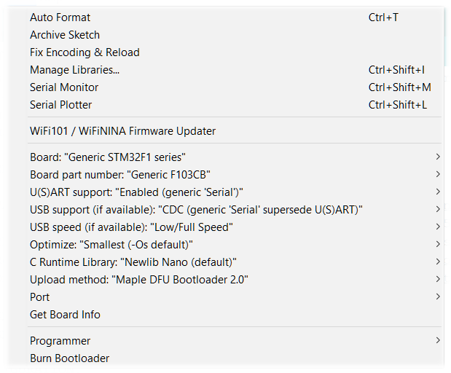
Next you have to choose some parameters for the STM32F103CBT6 microcontroller in the Tools menu

Board: Generic STM32F1 Series
Board part number: “Generic F103CBTx”

USART support: Enabbled (generic Serial)

USB support: CDC (Generic Serial supersede USART)

USB speed: Low/Full Speed

Optimize: Whatever you like, possibly Smallest

C Runtime Library: NewLib Nano

Upload method: depends on the upload method you will choose. We will explain here after the methods:
- STM32CubeProgrammer (SWD)
- Maple DFU Bootloader 2.0

Programming

SWD programming using an STLINK probe
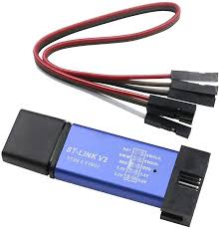

Installation

If you want to use an STLINK v2.0 programmer that looks like the picture on the right, you will need to

- Install the driver https://www.st.com/en/development-tools/stsw-link009.html

- Install the STM32CubeProgrammer that will provide the driver to the Arduino IDE: please refer and download the STM32CubeProgrammer from https://www.st.com/en/development-tools/stm32cubeprog.html

Once installed the device should be seen as “STM32 STLink” by your system is device manager.

In some cases you might need to upgrade the firmware to be able to download your program. If you get errors please make sure your probe has the latest firmware https://www.st.com/en/development-tools/stsw-link007.html

Setup

  - As explained above choose in the Arduino IDE menu Tools > Upload method > STM32CubeProgrammer (SWD)

  - Connect the STLINK device to the USB and these 4 wires from the STLINK to ClockGen:

    - 3.3V to 3.3V
    - SWDIO to SIO
    - SWCLK to SWK
    - GND to G

The board is powered so the power LED should be lit.

If you want to check that the microcontroller is properly connected, you can launch the STM32CubeProgrammer and you should be able to connect to the device.

When you want to upload a program from the Arduino IDE you just need to press the upload button as usual.

USB/DFU programming

Installation

To program the board through the USB using DFU, you need to download the DFU bootloader v2.0 “generic_boot20_pb0.bin” that you will find at https://github.com/rogerclarkmelbourne/STM32duino-bootloader/tree/master/bootloader_only_binaries

This bootloader allows your system to recognize the MCU as a DFU peripheral and once found it will enumerate a COM port.

You need to

- Get the DFU bootloader
- Have a programmer like STLINK (see SWD programming using an STLINK probe) that does work with a programming software
- Install the programming software for example https://www.st.com/en/development-tools/stm32cubeprog.html
- Connect the board to your computer by USB
- From the programming software load the bootloader file and download it on the board. See the STM32CubeProgrammer user’s manual if needed.

Once the booloader is installed, when you plug the device through the USB
- the LED flashes a couple of times showing that the device is in DFU mode
- the device is listed as a “Libusb-win32 devices” in the computer peripheral manager
- under windows it is then enumerated as a COM port device named “STMicroelectronics Virtual COM Port (COM xxx)”

If the device is not listed, or listed with a wrong name, you might need to install the proper STM32 driver for your system. Check https://www.st.com/en/development-tools/stsw-stm32102.html

Setup

If everything is ok you can setup the Arduino environment download parameter. In the Arduino IDE menu choose Tools > Upload method > Maple DFU bootloader 2.0

Exposed functions

Each clock is identified in the program by its id from 0 to 2 but they are displayed with a number from 1 to 3 (on the TFT etc).

The Pandauino_Clock_Generator.h includes a class ClockGeneratorClass with an instance named ClockGenerator.

The class encapsulates these functions that can be called by the user in an Arduino program (after adding #include <Pandauino_Clock_Generator.h> in the .ino).

For example ClockGenerator.setFrequency(0, 10000); will set clock 0 to 10 KHz.

void begin(); initialises the program: Si5351A, retrieves values from EEPROM etc
void run(); to be called in the loop to check the interaction with buttons etc

The basic program only calls begin() in the setup and run() in the loop.

void setFrequency(int clockId, uint32_t frequency); frequency in Hz

uint32_t getFrequency(int clockId);

void getPLLSettings(int clockId, si5351_pll& pll, uint64_t& pllFr ); allows to know wich pll is affected to a clock and the PLL frequency

void setPhase(int clockId, byte phaseIndice); phase indice = 0 to 127. Angle = phase indice * phaseStep and depends on the frequency

float getPhaseStep(int clockId); returns the current phase step

float getPhase(int clockId); returns the current phase angle

void setDrive(int clockId, byte drive); drive 0 = 2 mA, 1= 4 mA, 2 = 6 mA, 3 = 8mA

byte getDrive(int clockId);

void changeClockOutputState(int clockId); circular state ON / inverted / OFF

void configureSi5351(); // Will compute PLLA and PLLB settings and setup all clocks

void setNbSweep(int nbSweep); sets the number of sweep steps

void setSweepPeriod(float sweepPeriod); sets the sweep period in seconds

void getSweepParam(int& nbSweep, float& sweepPeriod); gets the current sweep parameters

void setSweepParamCx(int clockId, long startFreq, long stopFreq, boolean sweepActive);
sets one clock start and stop frequency and activates or desactivates sweep for this clock

void getSweepParamCx(int clockId, long& startFreq, long& stopFreq, boolean& sweepActive);

boolean initSweep(); starts sweep

void stopSweep(); stops sweep

void setCalibration(float cal); sets the calibration positive or negative in ppm

float getCalibration();

void setPhaseTiedClocks(byte phTied); sets the clocks that are phase related i.e. affected to PLLA

byte getPhaseTiedClocks();

void displayAllClocks(); Refresh the main screen displaying all 3 clocks info

Loading the minimum program

The minimum program is

#include <Pandauino_Clock_Generator.h>

// SETUP
void setup()
{
ClockGenerator.begin();
}

void loop()
{
ClockGenerator.run();
}

Programming examples

There is an example of a serial interface programming named “clockGen_serial_control.ino” in the /examples directory of the repository https://github.com/mrguen/ClockGen

Schematics

Troubleshooting

Problem | Possible solution
The clock signal shape is not good enough.  The clock is too noisy | Depending on the frequency, the load, the cable to the load and other sources of capacitance, the shape of the clock changes from square to sine like and might be noisy or distorted. This is not such a problem for many clocking applications but if needed but you might try to:  - Use Clock “1” for VHF clocks since the PCB trace is shorter.  - Modify the drive setting  - Use a better / shorter cable  - Modify the load characteristics  - Add a signal attenuator between ClockGen and the load  - Add a Schmidt trigger between ClockGen and the load  - Isolate the module from EMI parasites by placing it in a Faraday enclosure.
The signal has too much jitter | Do not use the default program. Program your own PLL and output frequencies using only integer dividers. See the example blabla
The clock frequency is not accurate enough | Calibrate the device in the Options screen
The screen remains blank | - If Serial com is activated in the program, it loops until it has established the Serial communication: open the serial monitor.  - Check the proper connection of the TFT to the board including the VCC voltage at 3.3V.  - Try to download the minimum program to the board in case the memory was corrupted or you downloaded another program.

