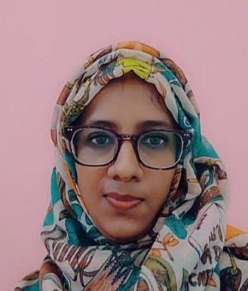
SHAHANAZ AKHTER
39, West Agargaon
Sher-E-Bangla Nagar, Dhaka-1207
Phone: +880 1711906122
Email : shahanazpopy549@gmail.com

Professional Summary
Childcare supervisor with over nine years of progressive experience in managing daycare operations, supervising staff, and maintaining safe, structured, and developmentally supportive environments for children. Skilled in administrative coordination, child receiving and handover management, and implementing effective early childhood development practices. Trained in Early Childhood Education, personal support care, and first aid. Known for strong organizational ability, reliability, and a consistent commitment to delivering high-quality childcare services.

Work Experience
- Supervisor April 2023-Present
Golden Eagle Kids Learning Day Care
Dhaka, Bangladesh

- Centre Manager Sep. 2022–Mar. 2023
Little Ducklings Day Care,
Dhaka Ahsania Mission
Dhaka, Bangladesh

- In-charge & Admin Dec. 2015–Aug. 2022
Wee Learn Daycare
Dhaka, Bangladesh

Special Projects / Professional Contributions
- CBLM Writer, Daycare Services Level-3 – Bangladesh Technical and Education Board (BMET-ILO Project)
- Developed learning materials and guidelines for daycare services.
- Focused on the management of child receiving and handover procedures.

Professional Training
- Early Childhood Educator (ECE) – Dhaka Ahsania Mission
- First Aid Training – Dhaka Ahsania Mission
- Personal Support Worker (PSW) – Wee Learn Day Care
- Teacher Styles, Learning, and Play in Early Childhood Education – Conducted by Dr. Annica Kallebo, Doctoral Researcher, Stockholm University; Organized by Bangladesh Institute of Lifelong Learning

Education
- M.A. in Library & Information science Passing year: 2016 Lalmatia Mohila College Result: 1st Class
- B.A.(Pass) in Library & Information science Passing year: 2013 Lalmatia Mohila College Result: 2nd Class
- H.S.C. (Higher Secondary Certificate) Passing year: 2007 Chatkhil women’s college GPA: 2.90 / 5.00
- S.S.C. (Secondary School Certificate) Passing year: 2004
Shahapur High school
GPA: 2.38 / 5.00

Skills
- Tools: Microsoft Office, Canva
- Soft Skills: Leadership, Adaptability, Communication, Management
- Languages Proficiency: English (Semi-Fluent), Bangla (Native)

References
- Dr. Kamran -ul- Baset
Dean & Associate Professor
Department of SPPH
Independence University of Bangladesh
Phone: 01704450257

- Farzana Selina
Child Care Expert
Little Ducklings Day Care
Dhaka Ahsania Mission
Phone: 01913420184
Email: farzana83aara@gmial.com

