SQL Server 2008 Tutorial

Source: http://www.quackit.com/sql_server/tutorial/
This tutorial is adopted from www.quackit.com. It is part of the complete tutorial posted at the above source. The tutorial offers additional information than what we need for the course at this time. For now, you should practice at least the first 7 lessons.
This SQL Server tutorial is for anyone who wants to learn how to use SQL Server 2008. It assumes a basic understanding of databases and how they work.
To get the most out of this tutorial, you should have a copy of SQL Server installed on your computer, so that you can go through the examples yourself. The examples in this tutorial are all done using the free version of SQL Server - SQL Server 2008 Express. You can download SQL Server 2008 Express from the Microsoft website.
If you don't currently have SQL Server yet, that's OK. The tutorial is straight forward and contains plenty of screenshots.

Table of Contents
This tutorial consists of the following lessons:
- About SQL Server
- SQL Server Editions
- SQL Server - Management Studio
- SQL Server - Create a Database
- SQL Server - Create a Table
- SQL Server - Adding Data
- SQL Server – SQL Scripts
- SQL Server - Query Designer
- SQL Server Views
- SQL Server Stored Procedures
- User Logins

1. About SQL Server
Microsoft SQL Server is a Relational Database Management System (RDBMS) designed to run on platforms ranging from laptops to large multiprocessor servers. SQL Server is commonly used as the backend system for websites and corporate CRMs and can support thousands of concurrent users.
SQL Server comes with a number of tools to help you with your database administration and programming tasks.
SQL Server is much more robust and scalable than a desktop database management system such as Microsoft Access. Anyone who has ever tried using Access as a backend to a website will probably be familiar with the errors that were generated when too many users tried to access the database!
Although SQL Server can also be run as a desktop database system, it is most commonly used as a server database system.

Server Database Systems
Server based database systems are designed to run on a central server, so that multiple users can access the same data simultaneously. The users normally access the database through an application.
For example, a website could store all its content in a database. Whenever a visitor views an article, they are retrieving data from the database. As you know, websites aren't normally limited to just one user. So, at any given moment, a website could be serving up hundreds, or even thousands of articles to its website visitors. At the same time, other users could be updating their personal profile in the members' area, or subscribing to a newsletter, or anything else that website users do.
Generally, it's the application that provides the functionality to these visitors. It is the database that stores the data and makes it available. Having said that, SQL Server does include some useful features that can assist the application in providing its functionality.

SQL Server Editions
SQL Server comes in many editions. Some are paid versions others are free. The examples in this tutorial were done using the free Express version of SQL Server.
The next lesson discusses the various editions of SQL Server 2008.

2. SQL Server 2008 Editions
If you are serious about installing (or upgrading) SQL Server, this page provides a quick overview of your options.
SQL Server 2008 comes in many different editions. The edition you choose will depend on your requirements. If you are looking for a free database management system, you will need to choose one of the Express editions or the Compact edition. You could also try the Evaluation edition, which allows you to trial SQL Server 2008 for 180 days.

The Editions
Here are the different editions available for SQL Server 2008.
- Enterprise Edition
Data management and business intelligence platform providing enterprise class scalability, high availability, and security for running business-critical applications
- Standard Edition
Data management and business intelligence platform providing ease of use and manageability for running departmental applications
- Workgroup Edition
Data management and reporting platform providing secure, remote synchronization, and management capabilities for running branch applications
- Developer Edition
May be installed and used by one user to design, develop, test, and demonstrate your programs on as many systems as needed
- Web Edition
A low-TCO, scalable, and manageable database option for web hosters and end customers looking to deploy publicly facing web applications and services
- Express Edition
A free edition of SQL Server ideal for learning and building desktop and small server applications and for redistribution by ISVs
- Compact Edition
A free, SQL Server embedded database ideal for building stand-alone and occasionally connected applications for mobile devices, desktops, and web clients
- Evaluation Edition
This edition may be installed for demonstration and evaluation purposes until an expiration period of 180 days.

SQL Server Edition in this Tutorial
The examples in this tutorial were made using the (free) Express edition of SQL Server 2008. To be more precise, it is SQL Server 2008 Express with Advanced Services.
SQL Server 2008 Express with Advanced Services includes the following features:
- SQL Server database engine - create, store, update and retrieve your data
- SQL Server Management Studio Basic - visual database management tool for creating, editing and managing databases
- Full-text Search - powerful, high-speed engine for searching text-intensive data
- Reporting Services - integrated report creation and design environment to create reports
The Express edition also comes as SQL Server 2008 Express with Tools, which only includes the SQL Server database engine and the SQL Server Management Studio Basic, and SQL Server 2008 Express (Runtime Only) which doesn't include the SQL Server Management Studio.
While the free version of SQL Server does have its limitations, it is a good start for those starting out with SQL Server. You can download SQL Server 2008 Express from Microsoft's website.

3. SQL Server Management Studio (SSMS)
SQL Server Management Studio (SSMS) is the main administration console for SQL Server. SSMS enables you to create database objects (such as databases, tables, views etc), view the data within your database; you can configure user accounts, transfer data between databases, and more.
Here's what SQL Server Management Studio looks like when you first open it up:
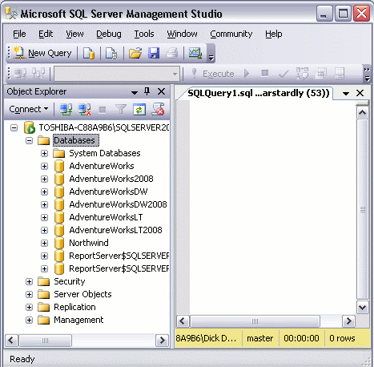
The left pane contains the Object Explorer. The Object Explorer provides navigation to databases, server objects (such as triggers), log files, and more.
The right pane allows you to write queries against the database and view the results. In this screenshot I have opened a blank query by clicking the "New Query" button. You can also bring up other windows, such as the Properties window.
Note that I have minimized the size of the window for this screenshot. Once maximized, you have much more room to play with. You can use SQL Server Management Studio to create as many databases as you like. You can also connect to as many databases on as many servers as you like.
Most of the tasks performed with SQL Server Management Studio are initiated either from the top menu, or by right-clicking on an icon/object. Throughout most of this tutorial, we'll be looking at the various things you can do via SQL Server Management Studio.

4. SQL Server - Create a Database
One of the first things we should look at with SQL Server/Management Studio is how to create a database. After all, most of the tasks you perform with SQL Server will evolve around one or more databases.

System Databases
If you've only just installed SQL Server, you might notice that some databases have already been created. These are system databases.
Database | Type | Description
master | System database | Stores system level information such as user accounts, configuration settings, and info on all other databases.
model | System database | This database is used as a template for all other databases that are created.
msdb | System database | Used by the SQL Server Agent for configuring alerts and scheduled jobs etc
tempdb | System database | Holds all temporary tables, temporary stored procedures, and any other temporary storage requirements generated by SQL Server.
We will now create another database for our own use.

Creating a New Database
The following steps demonstrate how to create a database in SQL Server using SQL Server Management Studio.
- Right click on the "Databases" icon and select "New Database...":
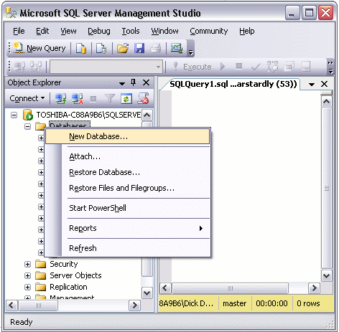

- Name your database and click "OK":
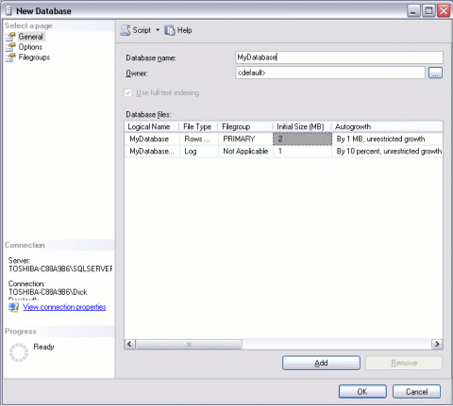

Your New Database
You will now notice your new database appears under the "Databases" section of SQL Server Management Studio.
Your new database is based on the "Model" database. The Model database is a system database which is used as a template whenever a new database is created. If you use the left pane to navigate to your database and expand the tree, you will notice that your database already contains a number of objects. For example, it already contains system functions, system views, system stored procedures, and (hidden) system tables. These are system objects which provide information about the database.
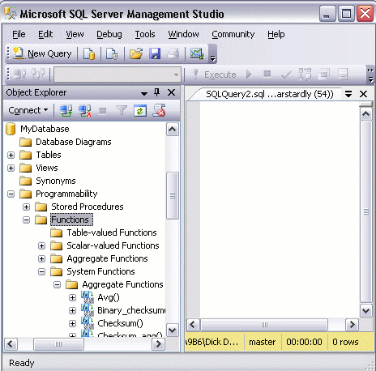

Other Options
We have just created a database using the default options. When we created the database, a "Data File" and a "Transaction Log" were created. They were created in the default location for our server.
If we'd wanted to, we could have specified a different location for these files. We also could have changed specifications on whether to allow the file to grow automatically (as it stores more and more data), and if so, how that growth should be managed. We could have done that at step 2. But all is not lost. We can still do it now that we've created the database. We can do it via the Properties dialog box.
To view or change the database properties, simply right click on the database and select "Properties":
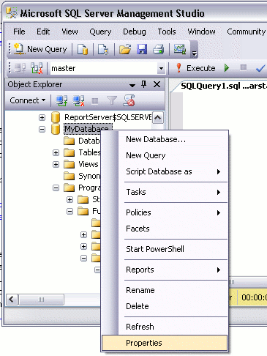
The Properties dialog contains a large number of options for changing the configuration of your database. For now, we can leave everything at its default setting.
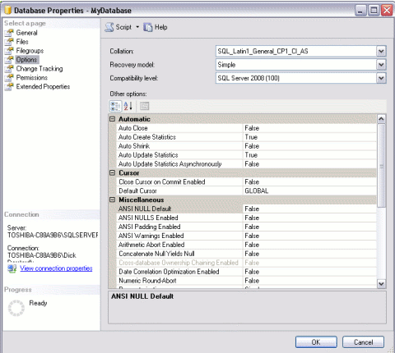

5. SQL Server - Create a Table
This lesson demonstrates how to create a table in a SQL Server database using SQL Server Management Studio (SSMS).
- Ensuring you have the right database expanded, right click on the "Tables" icon and select "New Table...":
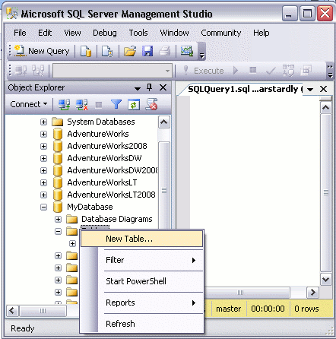
- While you have this screen open, do the following:
  - Using the values in the screenshot, complete the details in the "Column Name" column, the "Data Type" column, "Length" column, and "Allow Nulls" column.
  - Make the IndividualId column an "identity column", by setting "Is Identity" to "Yes" (this option is under the "Identity Specification" section in the bottom pane). Note that to set values in the bottom pane, you need to select the column name in the top pane first). This column is going to be an auto-number column - it will contain an incrementing number for each record that is created.
  - Set the "Default Value" of the DateCreated column to (getdate()). (This will automatically insert the current date into that field for each new record).
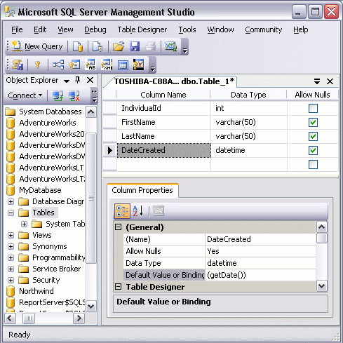
What we are doing at this stage, is creating the column names, specifying the type of data that can be entered into them, and setting default values. Restricting the data type for each column is very important and helps maintain data integrity. For example, it can prevent us from accidentally entering an email address into a field for storing the current date.
- Save the table by selecting File > Save Table_1:
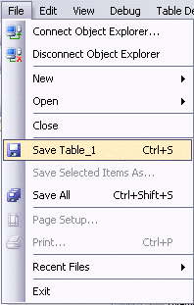
- When prompted, name your table:
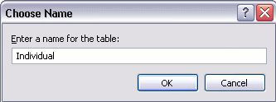

Your New Table
Now that you've created a new table, it will appear under your database in the "Tables" section.
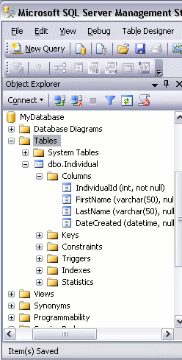

6. SQL Server - Adding Data
In the previous lesson, we created a new table in our database. We now have a database table, columns and all, but with no data.

Editing Table Rows
We can use the "Edit Top 200 Rows" option to add data to our table.
- To use this option, right click on the table you wish to open, and select "Edit Top 200 Rows":
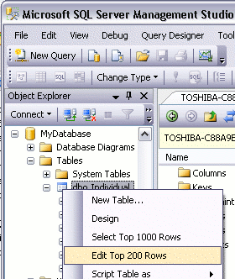

- You can now start entering the data directly into your table.
Note that you don't need to enter data into the IndividualId and DateCreated columns. This is because the they will be populated automatically (remember, we set IndividualId to "Is Identity" and DateCreated to "GetDate()"))
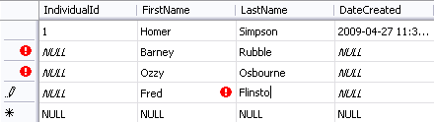

Disadvantages of Entering Data Directly to your Table
The above method is fine if you only have a small amount of data to enter or update. If you have a lot of data to enter, this could become very tedious. Also, if you have multiple environments (for example, a development environment, staging environment, and production environment), with duplicate databases configured in each environment, you will need to re-enter the same data into each environment.
When you're first learning SQL Server, this may not be a major concern. However, in an environment such as described, entering data directly into the table becomes quite inefficient.

A Better Method - SQL Scripts
In most cases, you will probably find it more efficient to write a SQL script. Using a script enables you to re-enter the data as many times as you like. If you need to rebuild your database for any reason, you can simply run your script to enter the data. If you have multiple environments, once again you can run your script against each environment.
Once you get used to writing and running scripts, you will probably find it quicker than entering data directly into the table.

Database Driven Websites
When you create a database driven website, you actually write SQL scripts to insert data into the database. You also use SQL scripts to read data, update data, and delete data. These SQL scripts can be placed directly into your website code (PHP, ColdFusion etc), or they can be stored in the database as Stored Procedures or Views.

7. SQL Server - SQL Scripts
In the previous lesson, we added data to our database table using the "Edit Top 200 Rows" option. In this lesson, we will look at how to write SQL scripts to update and run queries against our database.

Create a New Query
Before we generate our SQL script, we need somewhere to enter it into. This part is easy. Just click the "New Query" button:
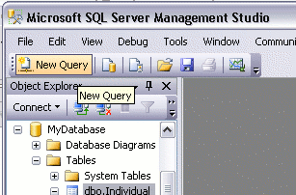
A blank, white sheet should now appear on the right pane.

Write/Run Your SQL Script
You are now ready to write SQL queries against your database. You can use this interface to create database objects (such as databases, tables, views etc), insert data into a database table, select data, update data, delete data.
To run an SQL query:
- Type your query into the workspace on the right pane
- Click "Execute" (you can also press F5)
The following screenshot shows an example of using a SQL 'select' statement to select data from a database:
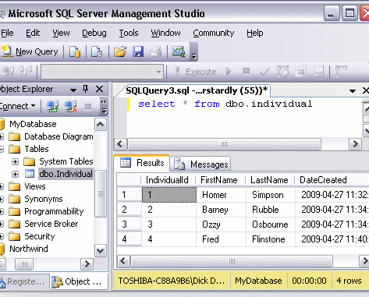
As you can see, the results of the query are displayed in the bottom pane.
As a shortcut, you can click on a table in the left pane and drag it to the right pane when building your query. This can save you time - especially if you have many tables to add to your query.
The above 'select' statement is an example of a SQL query. Apart from the occasional example, SQL queries are outside the scope of this tutorial. If you'd like to learn more about writing SQL queries, check out the SQL tutorial.

Database Administration Tasks
Most of the database administration tasks that can be performed in SSMS via the graphical user interface can be performed programmatically via SQL scripts. This tutorial concentrates on using the graphical user interface, mainly because it's usually a lot easier for new users to get their head around. Once you become more familiar with SQL Server, you may find yourself using SQL scripts to perform many of the tasks that you started out doing via the graphical user interface.

8. SQL Server - Query Designer
In the previous lesson, we created a SQL script using SQL Server Management Studio (SSMS). In this lesson, we will look at how to write SQL scripts using the graphical query designer.

About The Query Designer
The graphical query designer is a graphical user interface that allows you to build queries to run against your SQL Server database. This can be particularly useful when building complex queries that involves many tables, views etc.
The query designer can also be beneficial for those who are learning how to write SQL. This is because you don't need to remember the SQL syntax in order to write queries against your database - the query designer generates the SQL for you.

Building Your Queries
To build a query with the query designer:
- Select Query > Design Query in Editor...:
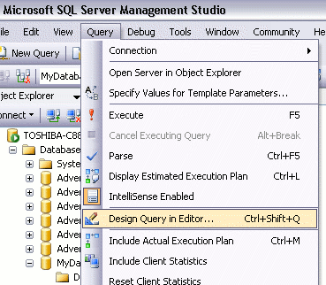
- Add the tables you want to run the query against. In this case, we only have one table to choose from.
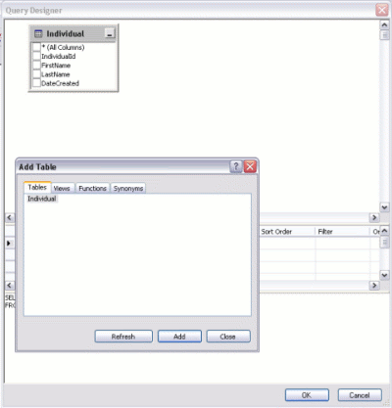
- Select the column/s you want to display in your query:
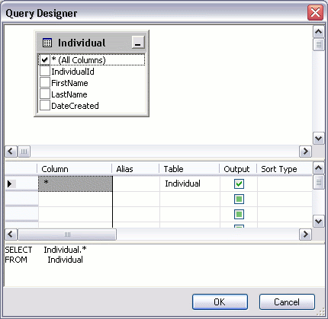
- Click "OK"
Once you've clicked OK, you will find the query has been added to your workspace. You can then run it as you would any other query.

9. SQL Server - Views
In SQL Server, a view is a pre-written query that is stored on the database. A view consists of a SELECT statement, and when you run the view, you see the results of it like you would when opening a table. Some people like to think of a view as a virtual table. This is because a view can pull together data from multiple tables, as well as aggregate data, and present it as though it is a single table.

Benefits of Views
A view can be useful when there are multiple users with different levels of access, who all need to see portions of the data in the database (but not necessarily all of the data). Views can do the following:
- Restrict access to specific rows in a table
- Restrict access to specific columns in a table
- Join columns from multiple tables and present them as though they are part of a single table
- Present aggregate information (such as the results of the COUNT function)

Accessing Views
Any view that you create ends up being located under the "Views" folder of your database.
The following screenshot shows a number of views that are located within the "AdventureWorks2008" database:
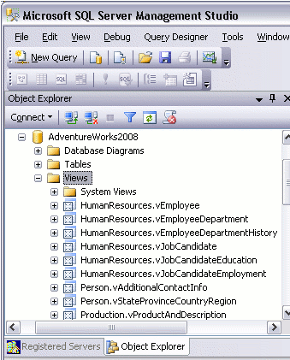

Creating a View
You create a view by using the CREATE VIEW statement, followed by the SELECT statement.
CREATE VIEW ViewName AS
SELECT ...
Example:
CREATE VIEW "Alphabetical list of products" AS
SELECT Products.*, Categories.CategoryName
FROM Categories INNER JOIN Products ON Categories.CategoryID = Products.CategoryID
WHERE (((Products.Discontinued)=0))

Modifying a View
You can modify an existing view by using using ALTER instead or CREATE.
Example:
ALTER VIEW "Alphabetical list of products" AS
SELECT Products.*, Categories.CategoryName
FROM Categories INNER JOIN Products ON Categories.CategoryID = Products.CategoryID
WHERE (((Products.Discontinued)=0))
You can also right click on the view and select "Design".

Running a View
You run a view by using a SELECT statement.
SELECT TOP 1000 *
FROM [AdventureWorks2008].[Sales].[vIndividualCustomer]
You can also right-click on the view and select "Select Top 1000 Rows".
Running the above view results in this:
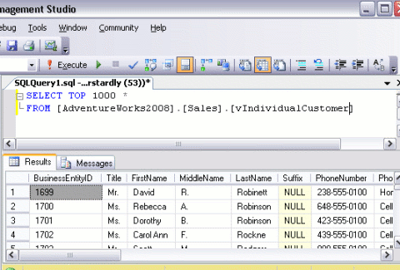
As you can see, it looks just like you've selected rows from a table. The difference is that, each column could potentially be coming from a different table.

10. SQL Server - Stored Procedures
Stored procedures are a powerful part of SQL Server. They can assist programmers and administrators greatly in working with the database configuration and its data.
A stored procedure is a precompiled group of Transact-SQL statements, and is saved to the database (under the "Stored Procedures" node). Programmers and administrators can execute stored procedures either from the SQL Server Management Studio or from within an application as required.
Transact-SQL, which is based on SQL (Structured Query Language), is the programming language used to interface between applications and their databases. Transact-SQL is a relatively easy language to learn and I highly recommend becoming familiar with it.

Benefits of Stored Procedures
Here are some key benefits in using stored procedures:
Benefit | Explanation of benefit
Modular programming | You can write a stored procedure once, then call it from multiple places in your application.
Performance | Stored procedures provide faster code execution and reduce network traffic.  Faster execution: Stored procedures are parsed and optimized as soon as they are created and the stored procedure is stored in memory. This means that it will execute a lot faster than sending many lines of SQL code from your application to the SQL Server. Doing that requires SQL Server to compile and optimize your SQL code every time it runs.  Reduced network traffic: If you send many lines of SQL code over the network to your SQL Server, this will impact on network performance. This is especially true if you have hundreds of lines of SQL code and/or you have lots of activity on your application. Running the code on the SQL Server (as a stored procedure) eliminates the need to send this code over the network. The only network traffic will be the parameters supplied and the results of any query.
Security | Users can execute a stored procedure without needing to execute any of the statements directly. Therefore, a stored procedure can provide advanced database functionality for users who wouldn't normally have access to these tasks, but this functionality is made available in a tightly controlled way.

Creating a Stored Procedure
You create stored procedures in the SQL Server Management Studio using the CREATE PROCEDURE statement, followed by the code that makes up the stored procedure.
CREATE PROCEDURE StoredProcedureName AS
...
The following code creates a stored procedure called "MyStoredProcedure":
CREATE PROCEDURE MyStoredProcedure AS
SET ROWCOUNT 10
SELECT Products.ProductName AS TenMostExpensiveProducts, Products.UnitPrice
FROM Products
ORDER BY Products.UnitPrice DESC
Once you run this code in the SQL Server Management Studio, the stored procedure is created and appears under the "Stored Procedures" node.

Modifying a Stored Procedure
If you need to modify an existing stored procedure, you simply replace the CREATE with ALTER.
ALTER PROCEDURE MyStoredProcedure AS
...

Running a Stored Procedure
You can run a stored procedure by using EXECUTE or EXEC. For example, to run the above stored procedure, type the following:
EXEC MyStoredProcedure
If the stored procedure has spaces in its name, enclose it between double quotes:
EXEC "My Stored Procedure"
If your stored procedure accepts any parameters, they are placed after the procedure name:
EXEC MyStoredProcedure @ParameterName="MyParameter"
So, here's an example:
EXEC SalesByCategory @CategoryName ="Beverages"

Using The GUI
You can also use the graphical user interface to initiate the execution of a stored procedure. To initiate a stored procedure this way:
- Navigate to the stored procedure
- Right click on the stored procedure and select "Execute Stored Procedure...":
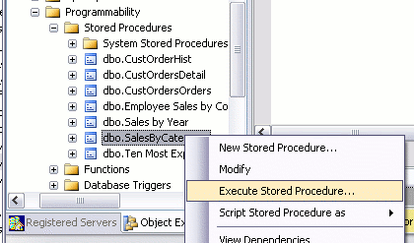
- A dialog will appear. Enter your chosen parameter values etc:
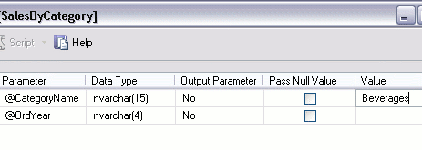
- Click "OK"
- SQL Server will now generate the SQL code and execute the stored procedure:
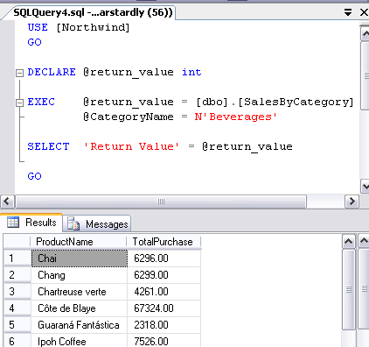

Parameters
A parameter is a value that your stored procedure uses in order to perform it's task. When you write a stored procedure, you can specify the parameters that need to be supplied from the user. For example, if you write a stored procedure to select the address details about an individual, your stored procedure needs to know which individual to select. In this case, the user can provide an IndividualId or UserId to tell the stored procedure which individual to look up.

System Stored Procedures
SQL Server includes a large number of system stored procedures to assist in database administration tasks. Many of the tasks you can perform via SQL Server Management Studio can be done via a system stored procedure. For example, some of the things you can do with system stored procedures include:
- configure security accounts
- set up linked servers
- create a database maintenance plan
- create full text search catalogs
- configure replication
- set up scheduled jobs
- and much more.

11. SQL Server - User Logins
SQL Server allows for the creation of user logins. Each individual who needs access to SQL Server can be given their own user account.
When the administrator configures these user logins, he/she can assign them to any number of roles and schemas, depending on the access that the individual is entitled to.
In this lesson, we will walk through the steps in creating a user login.

To Create a New User Login
- Using SQL Server Management Studio, expand the "Security" option and right click on "Logins"
- Click on "New Login"
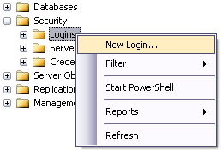
- Complete the login properties in the "General" tab by providing a name for the login, choosing the Authentication method (providing a password if you choose "SQL Server authentication"), and selecting the database to use as a default. If you don't choose a language, it will use the default for the current installation of SQL Server.
If you get an error that reads "The MUST_CHANGE option is not supported by this version of Microsoft Windows", simply uncheck the "User must change password at next login" option. The error occurs because your operating system doesn't support this option.
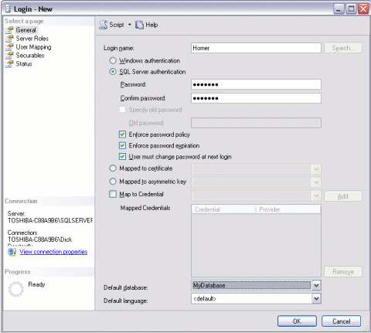
- Click the "Server Roles" tab if you need to apply any server-wide security privileges.
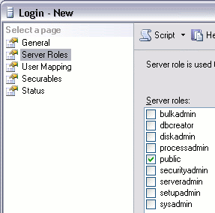
- Click the "User Mapping" tab to specify which databases this user account is allowed to access. By default, the login will be assigned to the "Public" role, which provides the login with basic access. If the login needs more access in one or more databases, it can be assigned to another role with greater privileges.
Note that these roles are "Database Roles" and are different to the server roles in the previous tab. Server roles are for administering the SQL Server. Database roles are created within each database and specify what the login can do within that database.
