CS 3310/01
Assignment #5: Database Design
Group Assignment

Description:

The goal is to practice database design using normalization.

Work the Morgan Importing Problem described as described below. No database development is required for this assignment, just the table design. The assignment involves concepts covered in chapter 4 and its slides. Pay attention to the following guidelines for Assessing Table Structure from Figure 4-1 of Chapter 4.
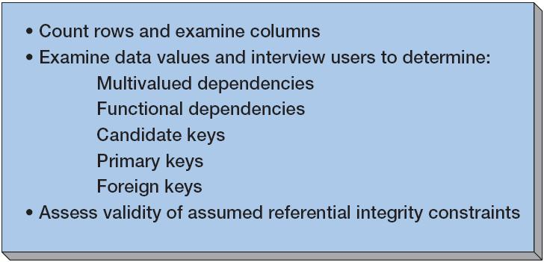

Assessing Table Structure

Morgan Importing Problem:

Phillip Morgan, the owner of Morgan Importing, makes periodic buying trips to various countries. During the trips, he keeps notes about the items he purchases and basic data about their shipments. He hired a college student as an intern, and she transformed his notes into the spreadsheets in Figure 4-9. This is just sample data. Phillip has purchased hundreds of items over the years, and they have been shipped in dozens of different shipments.

Phillip wants to enter the information age, thus he has decided to develop a database of his inventory. He wants to keep track of the items he has purchased, their shipments, and eventually customers and sales. To get started, he has asked you to create a database for the data in Figure 4-9.

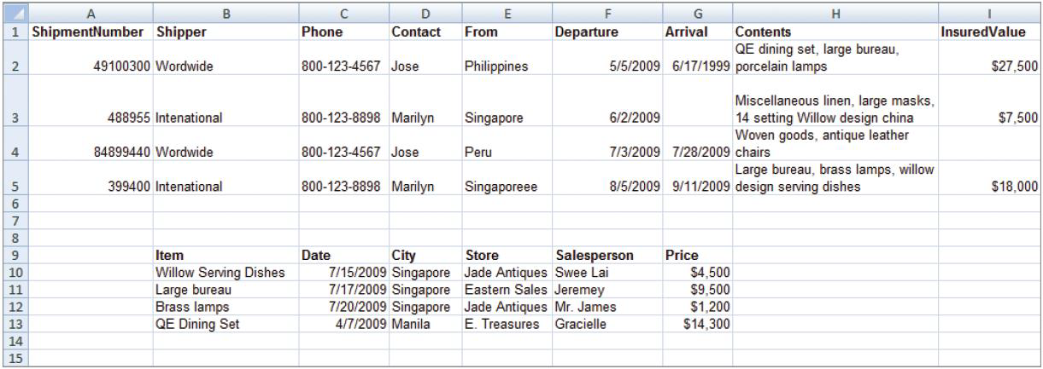
Figure 4-9 – Spreadsheets from Morgan Importing

To complete this assignment, you must complete following instructions and provide detailed answers for each item:

- Follow the “Assessing Table Structure” procedure shown. List multivalued dependencies, functional dependencies, candidate keys, primary keys, and foreign keys. State your assumptions.
- List questions you would ask Phillip to verify your assumptions.
- Create tables as necessary to eliminate multivalued dependencies, if any.
- The relationship between shipment and item data could be inferred by matching values in the From cells to values in the City cells. Describe two problems with that strategy.
- Describe a change to this spreadsheet that does express the shipment/item relationship.
- Assume that Phillip wishes to create an updateable database from this data. Design tables you think are appropriate. State all referential integrity constraints.
- Assume that Phillip wishes to create a read-only database from this data. Design tables you think are appropriate. State all referential integrity constraints.
- Do these data have the multivalue, multicolumn problem? If so, how will you deal with it?
- Do these data have the inconsistent data problem? If so, how will you deal with it?
- Do these data have a null value data problem? If so, how will you deal with it?
- Do these data have the general-purpose remarks problem? If so, how will you deal with it?

For part A, make sure you state your assumptions.

For part B, list at least 6 questions to verify your assumptions stated in part A.

For part C, describe the tables using the textbook format (the PK is underlined and the FK is italicized). For example, SKU_DATA (SKU, SKU_Description, Department, Buyer)

For part D, focus on the FK usage and the issue of data consistency when addressing this part.

For Parts F and G, , describe the tables using the textbook format (underlined PK and italicized FK) with referential integrity statements. For example,

SKU_DATA (SKU, SKU_Description, Department, Buyer)
BUYER (BuyerName, Department)
Where SKU_DATA.Buyer must exist in BUYER.BuyerName

Include all of your answers for all parts in one MS Word document. Add a cover page as indicated below. See other useful hints below.

Submission Criteria:

- The assignment is due Wednesday 3/20/2013.
- One submission per team.
- Add a cover page: course number and name, the assignment #, and list the names of your team members.
- Submit your assignment through D2L.

