CS 3310/01
Assignment #6: Database Design
Group Assignment

Description:

The goal is to learn how to build the Data Model for your ShoppingCart Website. Your team will turn in a document that describes what products your Website will sell and how those products will be broken up into different tabs based on type-categories that your products will fall into. Each tab of your website must have at least 5 products that are connected to a particular type. And each member of your team is responsible for at least one tab. Explain all of this in a General Description document that only one member of your team will turn in.

Your Data Model will consist of 5 entities that store information about the customers, the products and the purchases. The entities will be related according to the Line-Item Pattern discussed in Chapter 5. Each member of your team will create a Data Model diagram showing how the entities are related using MS Visio 2010. Your diagram should use Crows Foot Notation. The following are details describing the five entities of your database:

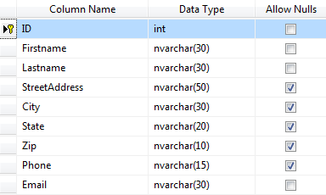

The Customers Entity

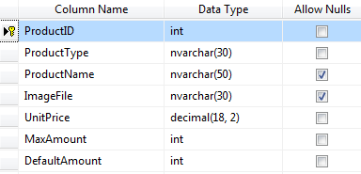

The Products Entity

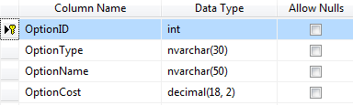

The Options Entity

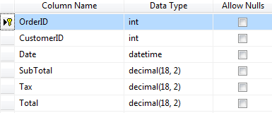

The PurchaseOrders Entity

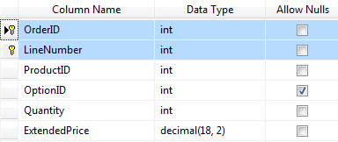

The LineItems Entity

Submission Criteria:

- The assignment is due Wednesday 3/27/2013.
- Each member of your team is to turn in a Visio Diagram document called ShoppingCart.vsd with your Data Model in it that uses the Line-Item Pattern from Chapter 5.
- One General Description of your Website will be turned in per team.
- Add a cover page: course number and name, the assignment #, and list the names of your team members to your General Description.
- Submit your assignment through D2L.

