CS 3310/01
Assignment #5: Database Design
Group Assignment

Description:

The goal is to practice database design using normalization.

Work the Morgan Importing Problem described as described below. No database development is required for this assignment, just the table design. The assignment involves concepts covered in chapter 4 and its slides. Pay attention to the following guidelines for Assessing Table Structure from Figure 4-1 of Chapter 4.
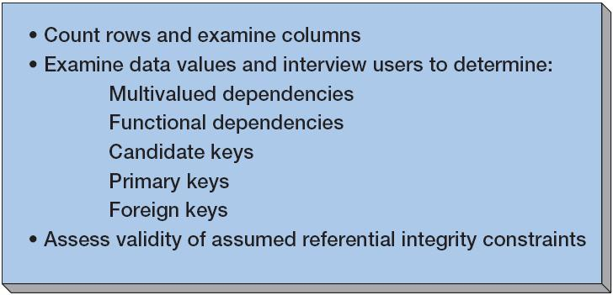

Assessing Table Structure

Morgan Importing Problem:

Phillip Morgan, the owner of Morgan Importing, makes periodic buying trips to various countries. During the trips, he keeps notes about the items he purchases and basic data about their shipments. He hired a college student as an intern, and she transformed his notes into the spreadsheets in Figure 4-9. This is just sample data. Phillip has purchased hundreds of items over the years, and they have been shipped in dozens of different shipments.

Phillip wants to enter the information age, thus he has decided to develop a database of his inventory. He wants to keep track of the items he has purchased, their shipments, and eventually customers and sales. To get started, he has asked you to create a database for the data in Figure 4-9.

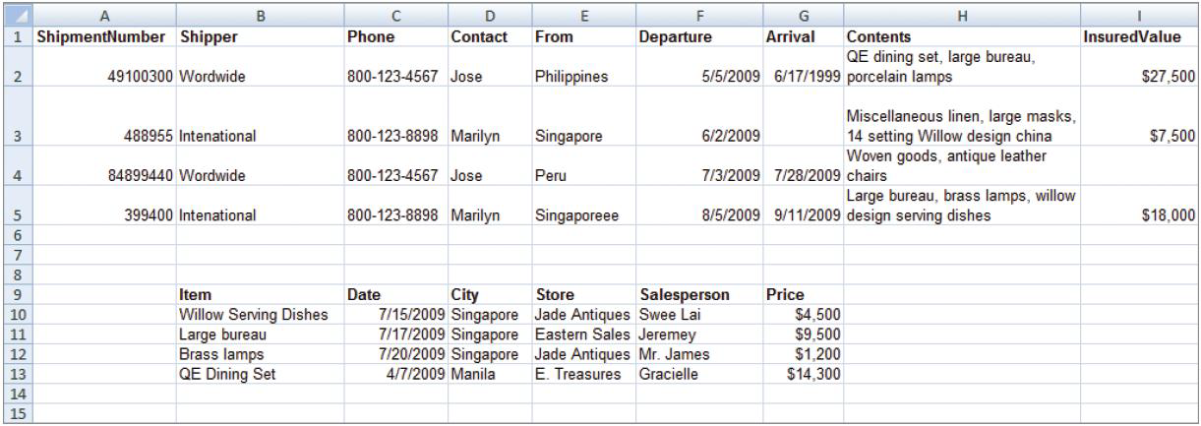
Figure 4-9 – Spreadsheets from Morgan Importing

To complete this assignment, you must complete following instructions and provide detailed answers for each item:

- Follow the “Assessing Table Structure” procedure shown. List multivalued dependencies, functional dependencies, candidate keys, primary keys, and foreign keys. State your assumptions.

- List questions you would ask Phillip to verify your assumptions.
Can you get more than one shipment on the same day to the same location? Can a shipper ship from different countries? Does each item have multiple salespersons?
- Create tables as necessary to eliminate multivalued dependencies, if any.
Create the following tables : SHIPMENT, SHIPPER, TRANSALESPERSON, ITEM, MOENY
- The relationship between shipment and item data could be inferred by matching values in the From cells to values in the City cells. Describe two problems with that strategy.
There is no column named shipment or item data, so assume shipment means ShipmentNumber and item data means item. The From column seems to indicate the originating county of the shipment, and the city column seems to indicate the city of purchase. The problem is that something could be bought in one city and shipped from another.
- Describe a change to this spreadsheet that does express the shipment/item relationship.
ShipmentNumer could directly identify the item.
- Assume that Phillip wishes to create an updateable database from this data. Design tables you think are appropriate. State all referential integrity constraints.
Create the following tables : SHIPMENT, SHIPPER, SALSPERSON, ITEM, MONEY
SHIPMENT
ShipmentNumber(PK) → Shipper(FK), Departure, Arrival, From, Item, InsuredValue
SHIPPER
Shipper(K) → Phone, Contact
Item
ShipmentNumber →Item THIS MIGHT NEED WORK
SALESPERSON
Salesperson → City, Store
PRICE
Item, Salesperson, Date → Price
- Assume that Phillip wishes to create a read-only database from this data. Design tables you think are appropriate. State all referential integrity constraints.
In a read-only database, you can just have one table with one primary key(ShipmentNumber) this will make it quicker
- Do these data have the multivalue, multicolumn problem? If so, how will you deal with it?
Only if I could consider Item and contents to be equal; otherwise each column is dedicated to unique data.
- Do these data have the inconsistent data problem? If so, how will you deal with it?
Yes, the Item and contents seems inconsistent or redundant or not desriptve.
- Do these data have a null value data problem? If so, how will you deal with it?
Possibly, does each item have to be shipped, does each item have to have a salesperson?
- Do these data have the general-purpose remarks problem? If so, how will you deal with it?
Yes, there are no remarks. Some of the data is unclear. Add remarks to data that may be confusing to deal with.

For part A, make sure you state your assumptions.

For part B, list at least 6 questions to verify your assumptions stated in part A.

For part C, describe the tables using the textbook format (the PK is underlined and the FK is italicized). For example, SKU_DATA (SKU, SKU_Description, Department, Buyer)

For part D, focus on the FK usage and the issue of data consistency when addressing this part.

For Parts F and G, , describe the tables using the textbook format (underlined PK and italicized FK) with referential integrity statements. For example,

SKU_DATA (SKU, SKU_Description, Department, Buyer)
BUYER (BuyerName, Department)
Where SKU_DATA.Buyer must exist in BUYER.BuyerName

Include all of your answers for all parts in one MS Word document. Add a cover page as indicated below. See other useful hints below.

Submission Criteria:

- The assignment is due Wednesday 3/20/2013.
- One submission per team.
- Add a cover page: course number and name, the assignment #, and list the names of your team members.
- Submit your assignment through D2L.

