CS 3610: Software Engineering

Spring 2014

Software Design Document (SDD)

Group # 3
Theater Reservation System

Michael Hug hmichae4@students.kennesaw.edu
James Kimani jkimani2@students.kennesaw.edu
Justin Krynicki jkrynick@students.kennesaw.edu

Due Date: Wednesday 4/23/2014

Revision History
Date | Version | Description | Author
23-April-14 | 0.9 | Initial Submission | Hug, Kimani, Krynicki

Table of Contents
1. Introduction 4
1.1 Purpose 4
1.2 Scope 4
1.3 Definitions, Acronyms and Abbreviations 4
1.4 References 4
2. Object Descriptions 5
2.1 Objects Class Diagram 5
2.2 Objects in Subsystem 6
2.3 Pseudocode 13
3. Sequence Diagrams 14
4. Object Collaboration 22
5. Object behavior 24
6. Data Design and Database Design 25
7. Other Design Requirements 28

Software Requirements Specification

1. Introduction
The Software Design Document is a document to provide documentation which will be used to aid in software development by providing the details for how the software should be built. Within the Software
Design Document(SDD) are narrative and graphical documentation of the software design for the project including use case models, sequence diagrams, collaboration models, object behavior models, and other supporting requirement information.

1.1 Purpose
The purpose of the software Design Document (SDD) is to provide a description of the design of a system fully enough to allow for software development to proceed with and understanding of what is to be necessary to provide a description of the details for the software and system to be built.

1.2 Scope
This Software Design Document is for a base level system which will work as a proof of concept for the use of building a system provides a base level of functionality to show feasibility for large scale production use. This Software Design is focused on the base level system and critical parts of the system. For this particular Software Design Document (SDD), the focus is placed on generation of the documents and modification of the documents. The system will be used in conjunction with other pre-existing systems and will consist largely of a document interaction facade that abstracts document interactions and handling of the document objects.

1.3 Definitions, Acronyms and Abbreviations
- SRS – Software Requirements Specification
- NFC - Near field communication
- ECMA - International association associated with the standardization of communication systems.
- Biometric – Identification of humans based on their biological uniqueness
- QR code – two dimension bar codes that can contains information or hyperlinks
- ITSC - Information Technology Support Center
- App – programs designed for mobile electronic devices, user authentication is occurs before installation and is persistent
- Kiosk – Free standing terminal that a person can use to access constrained software systems

1.4 References
- ECMA NFC specification - http://www.ecma-international.org/publications/files/ECMA-ST/ECMA-352.pdf
- ITSC QR code specification - www.itsc.org.sg/pdf/synthesis08/Three_QR_Code.pdf

2. Object Descriptions

2.1 Objects Class Diagram
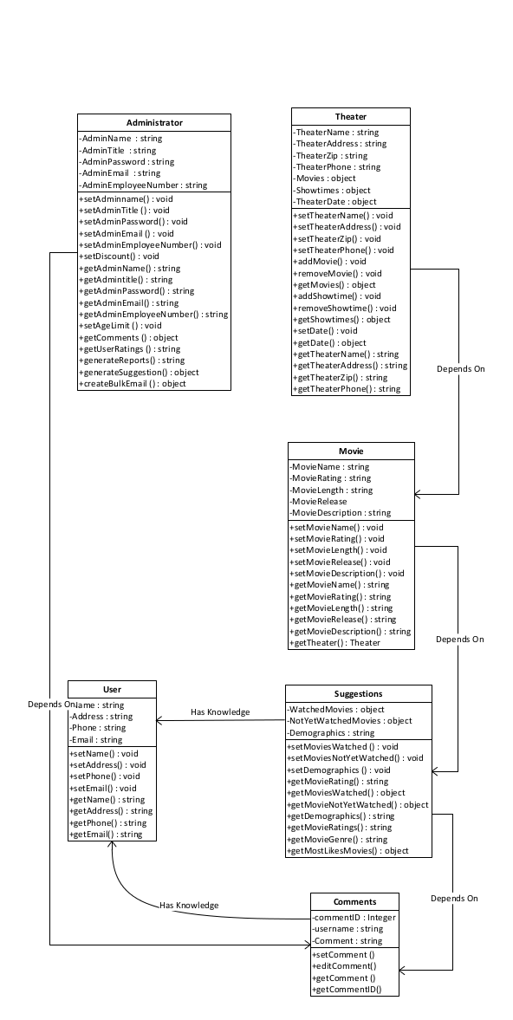

2.2 Objects in Subsystem

Class Name: User
Description: Representation of a user which will contain individual user information required for authentication.
Attribute | Data Type | Access Level | Default | Description
Name | String  Length 1 … 25 | Private | “Anonymous” | Holds name of user
Address | String  Length 1 … 25 | Private | “123 ABC Place Kennesaw GA, 30144” | Holds address of user
Phone | String  Length 10 | Private | “000-000-0000” | Holds phone 10-digit phone number of user (allows the entry of hyphens)
Email | String  Length 7…32 | Private | “Anonymous@abc.com” | Holds email address of user
Methods | Return Type | Access Level | Restrictions | Description
setName | Void | Public | Name not null | Sets user name
setAddress | Void | Public | Address not Null | Sets user address
setPhone | Void | Public | Phone not null | Sets user phone
setEmail | Void | Public | Email not null | Sets user email
getName | String | Public | None | Returns user name
getAddress | String | Public | None | Returns user address
getPhone | String | Public | None | Returns user phone
getEmail | String | Public | None | Returns user email

Class Name: Theater
Description: Contains information on a theater
Attributes | Data Type | Access Level | Default | Description
TheaterName | String  Length 1 … 25 | Private | “ABC Main Theater” | Holds the theater name
TheaterAddress | String  Length 1 … 25 | Private | “123 ABC Place Kennesaw GA” | Holds the theater address
TheaterZip | String  Length 5 | Private | “30144” | Holds the zip code of a theater
TheaterPhone | String  Length 10 | Private | “000-000-0000” | Holds the theater phone number
Movies | List  Dynamic List Max 100 | Private | Initialize an empty list  Run $movieshowing = mysql_query(select all from MOVIE table where release date is not more than 21 days from today)  for each in $movieshowing add to list  Return list
Showtimes | List  Dynamic List Max 100 | Private | Initialize an empty list  Run $Showtime = mysql_query(select movieShowtime from MOVIE where showDate is TODAY)  for each in $Showtime add to list  Return list
TheaterDate | Date  DateTime Format | Private | January 1, 1970 | Holds the date to search within for movies playing in the theater
Function | Return Type | Access Level | Restrictions | Method Description
setTheaterName | Void | Public | Theater name not null | Sets theater name
setTheaterAddress | Void | Public | Theater address not null | Sets theater address
setTheaterZip | Void | Public | Theater zip not null | Sets theater zip
setTheaterPhone | Void | Public | Theater phone not null | Sets theater phone number
addMovie | Void | Public | Movie name not null | Adds movie to the theater
removeMovie | Void | Public | Movie name not null and must exist in collection | Removes movie from the theater
getMovies | List  Dynamic List Max 100 | Public | Initialize an empty list  Run $movie = mysql_query(select idMovie from MOVIE where movieName = "(user's choice)"  for each in $movie add to list  Return list
addShowtime | Void | Public | Run $newShowtime= mysql_query(insert into MOVIE values ‘(showtime)’ where movieID = ‘xxxx’)
removeShowtime | Void | Public | Run $newShowtime= mysql_query(delete MOVIE where movieID = ‘xxxx’)
getShowtimes | List  Dynamic List Max 100 | Public | Initialize an empty list  Run $Showtime = mysql_query(select Showtimes from THEATER where movieName = ‘(user's choice)’  for each in $Showtime add to list  Return list
setDate | Void | Public | Date must be in format : January 1, 1970 | Sets date for user to search within
getDate | Date  DateTime Format | Public | None | Returns the date to search within
getTheaterName | String  Length 1 … 45 | Public | None | Returns theater name
getTheaterAddress | String  Length 1 … 25 | Public | None | Returns theater address
getTheaterZip | String  Length 5 | Public | None | Returns theater zip
getTheaterPhone | String  Length 10 | Public | None | Returns theater phone number

Class Name: Administrator
Description: Defines administrator responsibilities and capabilities
Attributes | Data Type | Access Level | Defaults | Description
AdminName | String  Length 1 … 45 | Private | “John Do” | Holds the name of the Admin
AdminTitle | String  Length 1 … 45 | Private | “Intern” | Holds the Admin title or position in the company
AdminPassword | String  Length 6 … 45 | Private | “0000000” | Holds the admin password
AdminEmail | String  Length 6 … 45 | Private | “admin@abc.com | Holds the admin email
AdminEmployeeNumber | String  Length 1 … 45 | Private | “-1” | Hold the admin employee ID number
Function | Data Type | Access Level | Restrictions | Method Description
setAdminname | Void | Public | Admin name not null | Set the admin name
setAdminTitle | Void | Public | Admin title not null | Set the admin Title
setAdminPassword | Void | Public | Admin password not null and must be six characters long | Set the admin password
setAdminEmail | Void | Public | Admin email not null | Set the admin email
setAdminEmployeeNumber | Void | Public | Employee number not null | Set the admin employee ID number
setDiscount | Void | Public | Discount not null | Set the discount rate or value
getAdminName | String  Length 1 … 45 | Public | None | Return the admin Name
getAdmintitle | String  Length 1 … 45 | Public | None | Return admin Title
getAdminPassword | String  Length 6 … 45 | Public | None | Return the admin password
getAdminEmail | String  Length 6 … 45 | Public | None | Return the admin Email
getAdminEmployeeNumber | String  Length 1 … 45 | Public | None | Return the admin Employee ID number
setAgeLimit | Void | Public | Age limit must be > 18. | Sets the age limit for movie goers based on the MPAA rating
getComments | String  Length 10 … 45 | Public | Comment Must exist | Returns the user comments of a movie
getUserRatings | String  Length 6 … 10 | Public | User Rating must exist | Returns the user ratings
generateReports | String  Length 10 … 100 | Public | Report Must exist | Returns the generalized report of a movie
generateSuggestion | String  Length 10 … 100 | Public | None | Returns suggestions of movies based on user’s previously watched movies, demographics and unwatched movies
createBulkEmail | String  Length 6 … 45 | Public | Must be valid email address format | Return a bulk email to users about new movies showing or suggestions

Class Name: Movie
Description: Contains information on a movie
Attributes (fields) | Data Type | Access Level | Defaults | Description
MovieName | String  Length 4 … 25 | Private | “ABC” | Holds the name of the movie
MovieRating | String  Length 1 | Private | “0” | Holds the MPAA rating of the movie
MovieLength | String  Length 1 … 5 | Private | “90” | Holds the running time of the movie
MovieRelease | Date  DateTime | Private | “Jaunary 1, 1970” | Holds the release date of the movie
MovieDescription | String  Length 1 … 100 | Private | “Description not yet added” | Hold a brief description of the movie
Methods (operations) | Data Type | Access Level | Restrictions | Description
setMovieName | Void | Public | Movie name not null | Sets the name of the movie
setMovieRating | Void | Public | Movie rating not null | Sets the rating of the movie
setMovieLength | Void | Public | Movie length not null | Sets the running time of the movie
setMovieRelease | Void | Public | Movie release not null | Sets the release date of the movie
setMovieDescription | Void | Public | Movie description not null | Sets the description of the movie
getMovieName | String  Length 1 … 25 | Private | Movie must exist | Returns the name of the movie
getMovieRating | String  Length 1 … 5 | Private | Movie must exist | Returns the rating of the movie
getMovieLength | String  Length 1 … 5 | Private | Movie must exist | Returns the running time of the movie
getMovieRelease | Date  DateTime | Private | Move release must exist and must be in correct DateTime format | Returns the release date of the movie
getMovieDescription | String  Length 1 … 100 | Private | Movie description must exist | Returns the description of the movie
getTheater | String  Length 1 … 25 | Private | Theater must exist | Returns a designated theater

Class Name: Comments
Description: Contains of a movie
Attributes | Data Type | Access Level | Default | Description
commentID | Integer  32 bit unsigned int | Private | 0 | Holds the auto generated comment ID
username | String  Length 6 … 25 | Private | “Anonymous” | Holds the commenter’s username or screenName
Comment | String  Length 1 … 100 | Public | “Comment has not yet been added” | Holds the comment from end-user
Function | Return Type | Access Level | Restrictions | Description
setComment | Void | Public | Comment not null.  Run $newComment = mysql_query(insert into COMMENT (commentDescription) values (“(user comment)”) where movieID = ‘xxxx’)
editComment | Void | public | Comment not null and must already exist to be edited  update COMMENT  set commentDescription='new comment'  where commentID = xxx;
getComment | String  Length 6 … 100 | Public | None | Returns the comment for a movie
getCommentID | Integer  32 bit unsigned int | Public | None | Return the auto-generated commentID

Class Name: Suggestions
Description: Contains suggestions of a movie based on previously watched movies and demographics
Attributes | Data Type | Access Level | Default | Description
WatchedMovies | List  Dynamic List Max 100 | Private | Empty list | Holds the names of the previously watched movies
NotYetWatchedMovies | List  Dynamic List Max 100 | Private | Empty list | Holds the name of movies of movies not yet watched
Demographics | String  Length 5 … 40 | Private | “dems not yet added” | Holds the user’s demographic information
Function | Return Type | Access Level | Restrictions | Description
setMoviesWatched | Void | public | Movies watched not be null  Run $movieWatched = mysql_query(insert into USER (userMoviesWatched) values (“(movie watched)”))
setMoviesNotYetWatched | Void | public | Movies not yet watched not null | Sets the movies not yet watched
setDemographics | Void | public | Demographics not null | Sets the user demographics
getMovieRating | String  Length 5 | Public | Movie Rating must exist | Returns the rating of the movie
getMoviesWatched | List  Dynamic List Max 100 | Public | Run $moviesWatched = mysql_query(select userMoviesWatched from USER where userName = “Jane Doe”
getMovieNotYetWatched | List  Dynamic List Max 100 | Public | None | Returns a List of not yet watched movies
getDemographics | String  Length 5 … 40 | Public | None | Returns the user Demographics
getMovieRatings | String  Length 5 | Public | Run $movieRating = mysql_query(select movieRating from MOVIE where MovieName = ‘xxxxxx’;
getMovieGenre | String  Length 5… 10 | Public | None | Returns the movie
getMostLikesMovies | List  Dynamic List Max 100 | Public | None | Return a list of user’s most liked movies or movies with good ratings that the user has not watched yet

3. Sequence Diagrams
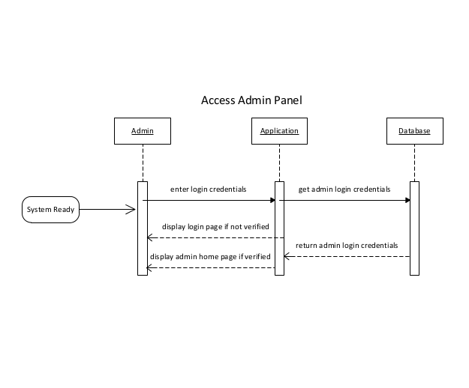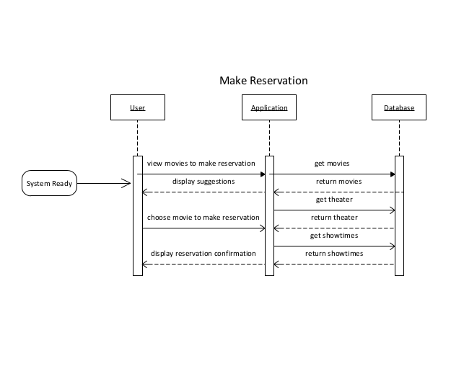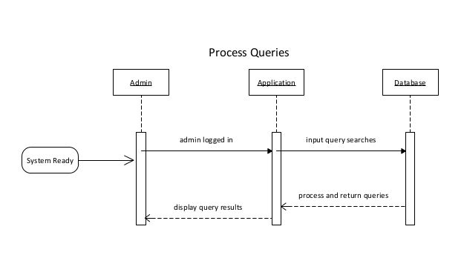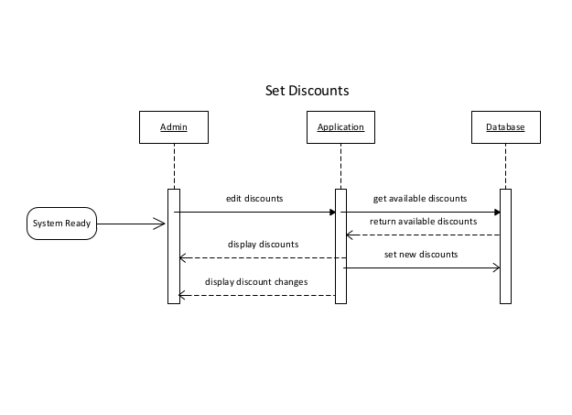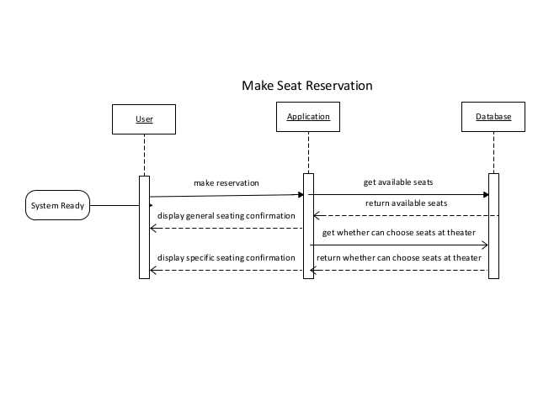
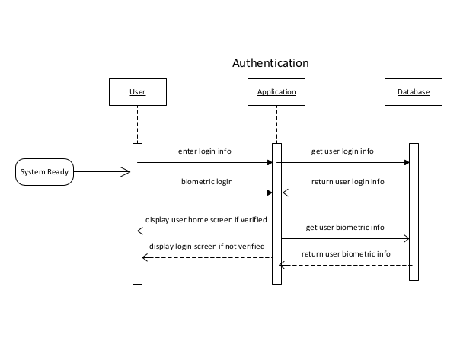
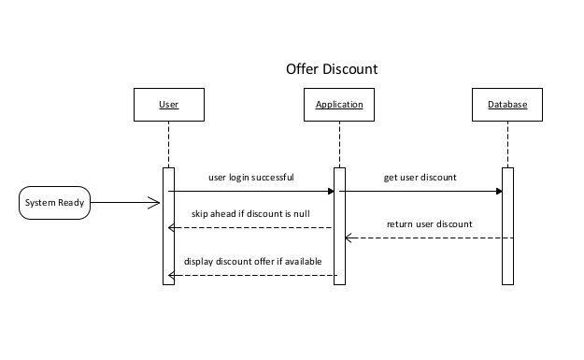
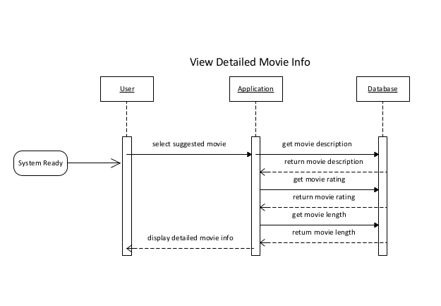
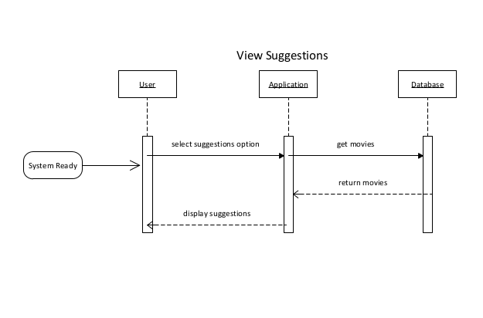

4. Object Collaboration

4.1 Kiosk

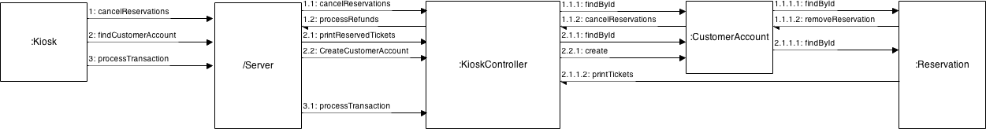

4.2 Mobile app/ Website

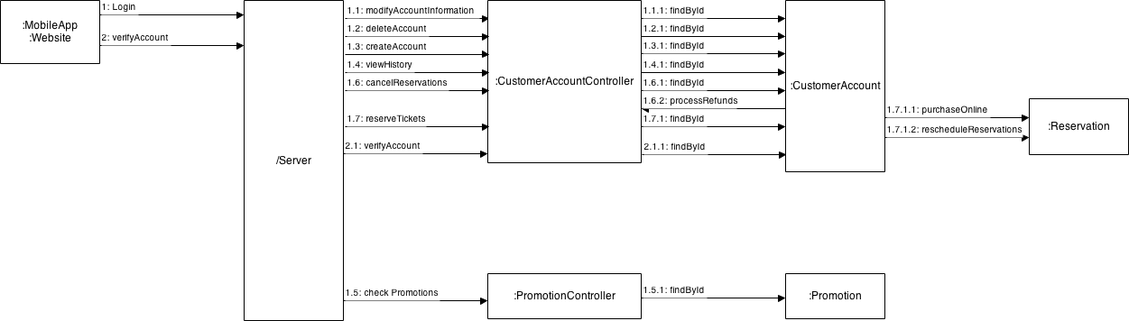

4.3 Administrator

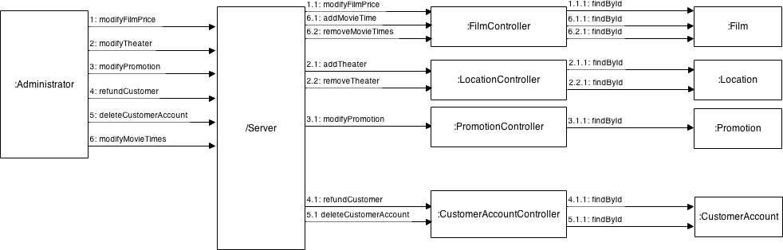

5. Object behavior
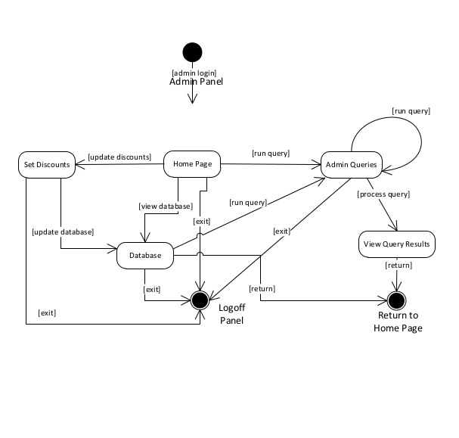
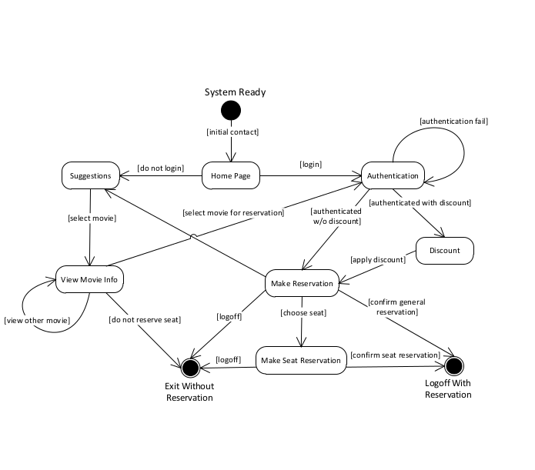

6. Data Design and Database Design

6.1 Internal Software Data Structure

ABC’s internal structure is divided into two parts: server-side and client-side. On the client side, data will reside locally in memory and will be organized based on the classes defined earlier in this document. Since the ABC reservation program may be considered data-centric, the classes that handle the data will be isolated and will be accessed by way of a model view controller system. The data on the local mobile client / kiosk will be requested from the server at application initialization and refreshed as necessary based on user actions. The data structure on the server will essentially mirror the structure of the local Android client in terms of member fields of the classes. The server will be implemented using PHP. Permanent storage of user information will be accomplished using a MySQL database. Section 3.8 (Server Component) covers this subject in further detail. The server and mobile client will exchange data using the JSON format. JSON is a lightweight object description language that is similar to XML. JSON is being used due to its versatility and because of the fact that an implementation is available for both PHP and JAVA.

6.2 Global Data Structure

The global data structure of this application is best characterized by the database. The database structure shows the data involved in the application in its purest sense. The local mobile client of ABC will never access this database directly; it will instead issue requests to the server.

6.3 Temporary Data Structure

Temporary data structures, as they relate to ABC, refer to the data objects that are created on the local Android client, and also to the JSON objects that interchanged between the server and the client. The data objects created on the local device will only exist for the duration of time that the application is running, and will subsequently be destroyed. The JSON objects will only exist for the duration of the transaction between the client and server. The server will destroy the objects after sending them, and the client will destroy the
JSON objects once they have been parsed.

6.4 EER Database Design
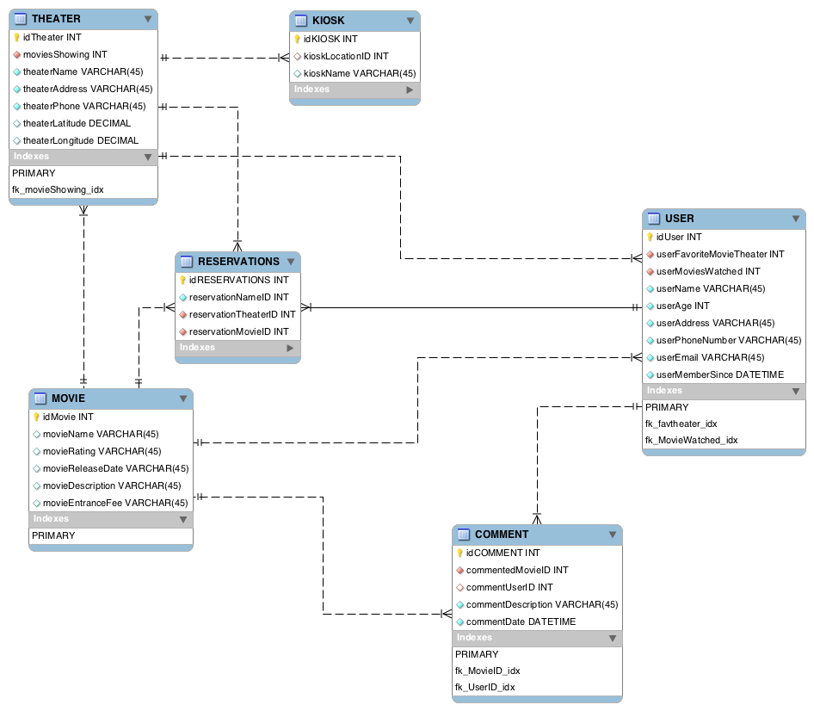

7. Other Design Requirements

7.1 Help Menu

- Displays a list of topics covering the different components of ABC Theater reservation System
- Offers detailed information on each feature, menu, etc.
- Can be accessed at any time via the Settings menu

7.2 Settings Menu

- Allow user to customize his/her preference
- Enables the user to modify certain features and functionalities
- Can be accessed at any time using the built-in Settings button on Android phones

7.3 PayPal Integration

- Incorporates a mechanism for initiating real transactions
- Facilitates secure, hassle-free transactions between members
- Automatically updates member balances as transactions occur

7.4. GPS Tracking

- Stores location data associated with certain events
- Utilizes Google Maps to display transaction locations
- Creates an expense map which can be viewed by all members of a group

7.5. Receipt Imaging

- Utilizes the camera built into mobile devices
- Records and stores a snapshot of receipts associated with different expenses
- Provides a method of checking/verifying expenses posted to a group

7.6. E-Mail/SMS Notifications

- Extends the standard notifications service built into the software
- Automatically delivers notifications via e-mail and/or text message
- Enables individuals without accounts to receive group notifications

7.7. Tutorial

- Provides an abridged version of the Help menu for first-time users
- Offers a step-by-step run through of each feature, menu, etc.
- Enables any user to quickly and easily take advantage of all the reservation system’s functionalities

