CS 3610: Software Engineering

Spring 2014

Software Requirements Specification Document

Project Title
Theater Reservation System

Michael Hug hmichae4@students.kennesaw.edu
James Kimani jkimani2@students.kennesaw.edu
Justin Krynicki jkrynick@students.kennesaw.edu

Due Date: Wednesday 3/28/2014

Revision History
Date | Version | Description | Author
12-FEB-14 | 0.9 | Initial Submission
28-MAR-14 | 1.0 | Final Draft

Table of Contents
1. Introduction 4
1.1 Purpose 4
1.2 Scope 4
1.3 Definitions, Acronyms and Abbreviations 4
1.4 References 4
1.5 Overview 5
2. Overall Project Description 5
2.1 Use-Case Model Survey 5
2.2 Assumptions and Dependencies 17
3. Specific Requirements 18
3.1 Classes/Objects 19
3.2 Object Collaboration Diagrams 24
3.3 Sequence Diagrams 27
3.4 Object Behavior Diagrams 36
3.5 Performance Requirements 37
3.6 Other Requirements 38
4. Supporting Information 38

Software Requirements Specification

1. Introduction

1.1 Purpose
The Software Requirements Specification (SRS) provides and overview of the Theater Reservation System requirements. The SRS is the foundational document for how the Theater Reservation System will be constructed and utilized. Additionally, the SRS defines the relationships amongst various components and provides details of their interactions.

1.2 Scope
Currently, theater reservation systems horribly lag behind today's modern media advancements. Films are shown in the theaters using the latest technologies to grab audience attention; yet the very same reservation systems used to fill out the audience are outdated, unfriendly, and limited in their use. Theater reservation systems need to make available the entertainment, simplicity, and social integration that draw movie goers to films in the first place. The reservation system can be the movie-goer’s first interaction with a film, and it is only beneficial to make the enjoyment and advancements of that experience as close to those of the film, itself. This is precisely where our Theater Reservation System can succeed and grab a large market share.

Potential theater customers will be able to access the theater system via Web page, kiosk, or app. The system will be able to provide not only reservations to the theater, but also reservations to specified seats if they are available. In order to assist and encourage undecided users in the movie selection process, the system will also provide suggestions, movie trailers, and user-generated content including, but not limited to, peer reviews, social media trends, and location sharing.

1.3 Definitions, Acronyms and Abbreviations
- SRS – Software Requirements Specification
- NFC - Near field communication
- ECMA - International association associated with the standardization of communication systems.
- Biometric – Identification of humans based on their biological uniqueness
- QR code – two dimension bar codes that can contains information or hyperlinks
- ITSC - Information Technology Support Center
- App – programs designed for mobile electronic devices, user authentication is occurs before installation and is persistent
- Kiosk – Free standing terminal that a person can use to access constrained software systems

1.4 References
- ECMA NFC specification - http://www.ecma-international.org/publications/files/ECMA-ST/ECMA-352.pdf
- ITSC QR code specification - www.itsc.org.sg/pdf/synthesis08/Three_QR_Code.pdf

1.5 Overview
The remaining section of this document will contain the following :
- Diagram of Use-Cases (with description tables)
- Analysis classes (with description tables)
- UML Sequence Diagrams
- UML Behavior Diagrams

2. Overall Project Description
The objective of this project is the development of a web-based theater ticket reservation system for the ABC Entertainment Company. The product will allow customers to create reservations online for specified movie showings at all ABC Entertainment Company Theaters. The product will be accessible through internet-connected computers, tablets, and mobile devices. Customers will have the option to purchase their tickets at the time of reservation. If no purchase is made initially, customers may choose to pick-up tickets at the specified theater’s box office. With this option, customers will have until thirty minutes prior to schedule show time to claim their reservations in-person at the theater and complete their purchase. If the reservation is not claimed thirty minutes prior to schedule show time, the reservation will be canceled and the allotted seats will be released for purchase by the general public. Customers may also choose to complete their purchase for previously reserved seats online and print their tickets at home up to one hour prior to schedule show time. If customers choose the print option and do not complete purchase by the specified time, the reservation will be canceled and the seats will be released to the general public.

2.1 Use-Case Model Survey
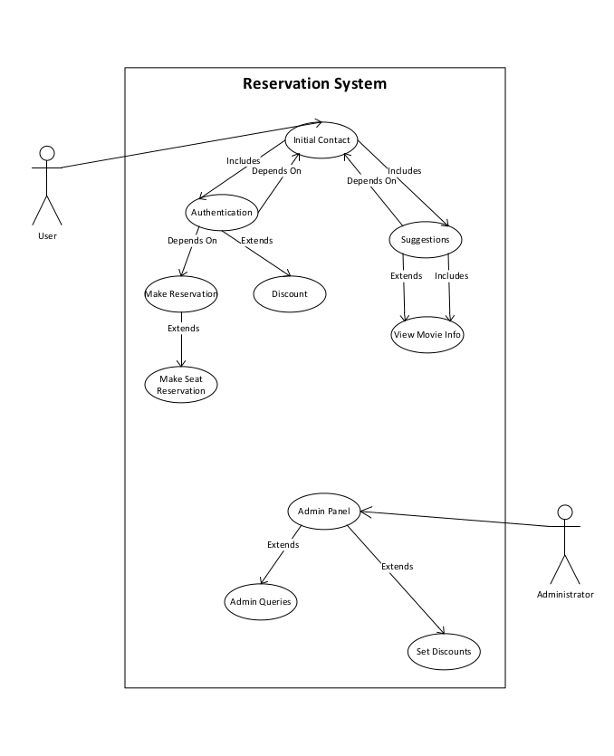

Use case name: Initial contact |  | ID: 001 |  | Priority: High
Primary actor:  Unknown user | Source:  User |  | Use case type: Technical
Interested Stakeholders: Movie Theater
Brief description: An unknown user opens the app / requests the web site / engages a kiosk. The user is then given the option to authenticate or continue anonymously
Precondition: App / web site / kiosk is in a ready state
Trigger: An unknown user opens the app / requests the web site / engages a kiosk
Relationships:
Include: Suggestions, View detailed movie information
Extends: None
Depends On: None
Typical flow of events:
- An unknown user opens the app / requests the web site / engages a kiosk
  - The user chooses to authenticate
    - Current flow is terminated and ID 003 is initiated
  - The user chooses to not authenticate
    - Current flow is terminated and ID 002 is initiated
Assumptions: App / web site / kiosk can connect to the theater server through a secure connection
Implementation Constraints and Specifications:
Apps may be left in an authenticated state. Apps will always have initial contact as the first step, but if the user never logs out, the app stays authenticated.

Use case name: Suggestions |  | ID: 002 |  | Priority: High
Primary actor:  Anonymous user | Source:  User |  | Use case type: Technical
Interested Stakeholders: Movie Theater
Brief description: Suggestions are generated by the system and displayed to the user
Precondition: None
Trigger: User opts to view suggestions
Relationships:
Include: View detailed movie information
Extends: None
Depends On: Initial contact
Typical flow of events:
- Suggestions are made based on prior anonymous data collected at that location or user data
  - The location will be relative, multiple kiosks at the same postage address will be considered the same location
  - Mobile location data will be considered the same location if it is within 10 miles
  - Locations will overlap and share relative data
- User is given the option to view detailed movie information.
- User is given the option to view more suggestions
Assumptions: The GUI is designed in a manner that an option to authenticate or make a reservation is always available
Implementation Constraints and Specifications:
The options to authenticate or make a reservation are mutually exclusive

Use case name: View detailed movie information |  | ID: 003 |  | Priority: Low
Primary actor:  User | Source:  User |  | Use case type: Technical
Interested Stakeholders: Movie Theater
Brief description: A user opts to view detailed movie information
Precondition: Suggestions have been shown
Trigger: User clicked on suggestion
Relationships:
Include: None
Extends: Suggestions
Depends On: None
Typical flow of events:
- The selection of the movie is kept in a database and associated with either the user or location
- A screen is displayed where
  - User can authenticate to make a reservation or add a comment
    - If the user is already authenticated, this option is now to make reservation
  - User can view suggestions
  - User can watch movie trailer
  - User can view movie synopsis
  - User can view user generated comments
    - If user is authenticated, user can add comment
Assumptions: The movie details are interesting enough for the user to want to then make a movie reservation
Implementation Constraints and Specifications:
The user may enter an infinite loop of viewing detailed information and suggestions

Use case name: Authentication |  | ID: 004 |  | Priority: High
Primary actor:  User | Source:  User |  | Use case type: Technical
Interested Stakeholders: Movie Theater
Brief description: A user will attempt to authenticate with the system
Precondition: User have selected the option to authenticate
Trigger: User has selected the option to authenticate
Relationships:
Include: Initial contact
Extends: Discount
Depends On: None
Typical flow of events:
- Authentication options will be given based on the device used to authenticate
- User attempts to authenticate
  - If authentication is unsuccessful
    - the user is given the option to restart authentication, this will force a new check of environmental variables
    - The user is given the option to cancel authentication
  - If authentication is successful
    - The system checks for a discount
    - The user is given the option to view suggestions
Assumptions: Every app / computer / kiosk will allow at least user name / password authentication, devices have environmental variables that will be checked at runtime. These environmental variables are handled at the operating system level thus they are abstracted from this software
Implementation Constraints and Specifications:
Mobile devices, computers and kiosk technology are advancing constantly. Every device will have the software available to authenticate with all three methods.

Use case name: Discount |  | ID: 005 |  | Priority: Low
Primary actor:  User | Source:  User |  | Use case type: Technical
Interested Stakeholders: Movie Theater
Brief description: A user is offered a discount
Precondition: User is authenticated
Trigger: User authentication
Relationships:
Include: None
Extends: Authentication
Depends On: None
Typical flow of events:
- Authentication options will be given based on the device used to authenticate
- User attempts to authenticate
  - If authentication is unsuccessful
    - the user is given the option to restart authentication, this will force a new check of environmental variables
    - The user is given the option to cancel authentication
  - If authentication is successful
    - The system checks for a discount
    - The user is given the option to view suggestions
    - The user is given the option to make reservation
Assumptions: Discounts will be offered globally, based on location or based on user
Implementation Constraints and Specifications:
The user is given a discount at one time and must enter the discount at payment time. Payment is outside the scope of this software.

Use case name: Make reservation |  | ID: 006 |  | Priority: High
Primary actor:  User | Source:  User |  | Use case type: Technical
Interested Stakeholders: Movie Theater
Brief description: A user wants to make a reservation
Precondition: User is authenticated
Trigger: User selects the option to make reservation
Relationships:
Include: None
Extends: None
Depends On: Authentication
Typical flow of events:
- User opts to make a reservation
- List of movies available are displayed
- User clicked on movie to reserve
- User is given option to reserve seat
- User is given option to view suggestions
Assumptions: System is secure and working
Implementation Constraints and Specifications:
The list of movies available in theaters is small enough to be displayed.

Use case name: Make seat reservation |  | ID: 007 |  | Priority: Low
Primary actor:  User | Source:  User |  | Use case type: Technical
Interested Stakeholders: Movie Theater
Brief description: A user wants to make a seat reservation
Precondition: User has a reservation
Trigger: User has made reservation and opts to reserve a seat
Relationships:
Include: None
Extends: Make reservation
Depends On: None
Typical flow of events:
- User opts to make a seat reservation
- List of seats available are displayed
- User clicked on seat to reserve
- User is given option to view suggestions
Assumptions: There is a seat available
Implementation Constraints and Specifications:
The list of seats available in theaters is small enough to be displayed.

Use case name: Admin panel |  | ID: 008 |  | Priority: Low
Primary actor:  Administrator | Source:  Administrator |  | Use case type: Technical
Interested Stakeholders: Movie Theater
Brief description: An administrator wants to log on to the administrator panel
Precondition: None
Trigger: Administrator connects via the admin terminal
Relationships:
Include: Set discounts
Extends: None
Depends On: None
Typical flow of events:
- Administrator connect via a secure ssh connection to the administrator panel
- Administrator panel is command line only
- The administrator panel authenticates the administrator using only a SHA-256 fingerprint
  - Passwords or any other type of authentication will not be available.
    - Remote connections will only connect with SHA fingerprint
    - Physical access to the server will be securely restricted to authorized personnel
- Administrator can query the list of all user generated and anonymous generated data
- Administrator sets up discount trigger
Assumptions: Physical access to the server is only used to add remote admin access to the server
Implementation Constraints and Specifications:
Physical access to the server is securely restricted

Use case name: Set discounts |  | ID: 009 |  | Priority: Low
Primary actor:  Administrator | Source:  Administrator |  | Use case type: Technical
Interested Stakeholders: Users
Brief description: An administrator is able to set discount triggers
Precondition: None
Trigger: Administrator opens discount interface
Relationships:
Include: None
Extends: Admin panel
Depends On: None
Typical flow of events:
- Administrator will set discounts based on location or user
- Location discounts will be be available to every user in a location
- User discounts will only be extended to groups of users
Assumptions: Marketing department has given administrator an order for the system to offer discounts
Implementation Constraints and Specifications:
None

Use case name: Admin queries |  | ID: 010 |  | Priority: Low
Primary actor:  Administrator | Source:  Administrator |  | Use case type: Technical
Interested Stakeholders: Marketing department
Brief description: An administrator can run SQL queries for the marketing department
Precondition: Administrator is logged on
Trigger: Administrator enters a SQL query
Relationships:
Include: None
Extends: Admin panel
Depends On: None
Typical flow of events:
- Administrator enters the SQL command line interface.
- Administrator runs query
- Data is returned to the marketing department however it is desired
  - Administrator has the option to verbally return data, generate reports, output CSV files
Assumptions: Marketing department wants data from the server
Implementation Constraints and Specifications:
The administrator will return raw that to the marketing department. The marketing department is responsible for all data analysis, interpretation and presentation.

2.2 Assumptions and Dependencies
- The product must be delivered by the deadline.
- The budget cannot be exceeded.
- Customer information must be secured and held to the strictest privacy constraints.
- The product must be easily accessible for all users with an internet-connected device.
- The product must be user-friendly and reliable.
- The product must have forward compatibility.
- App / web site / kiosk can connect to the theater server through secure connections.
- Apps may be left in an authenticated state. Apps will always have initial contact as the first step, but if the user never logs out, the app stays authenticated.
- The GUI is designed in a manner that an option to authenticate or make a reservation is always available.
- The options to authenticate or make a reservation are mutually exclusive.
- The movie details are interesting enough for the user to want to then make a movie reservation.
- The user may enter an infinite loop of viewing detailed information and suggestions.
- Every app / computer / kiosk will allow at least user name / password authentication, devices have environmental variables that will be checked at run-time. These environmental variables are handled at the operating system level thus they are abstracted from this software.
- Mobile devices, computers and kiosk technology are advancing constantly. Every device will have the software available to authenticate with all three methods.
- Discounts will be offered globally, based on location or based on user.
- The user is given a discount at one time and must enter the discount at payment time. Payment is outside the scope of this software.
- System is secure and working.
- The list of movies available in theaters is small enough to be displayed.
- Physical access to the server is only used to add remote admin access to the server.
- Physical access to the server is securely restricted.
- Marketing department has given administrator an order for the system to offer discounts.
- The marketing department asks for the data in a reasonable manner.
- The administrator will return raw that to the marketing department. The marketing department is responsible for all data analysis, interpretation and presentation.

3. Specific Requirements
External Interface Requirements

User Interfaces
The project is designed to be an application that can be accessed from several different types of devices. A user will access the application via a kiosk, app, or web browser. Each device will be only a front end to the same behind the scenes work. Each user interface will access the same content.
Hardware Interfaces
Servers will be necessary to host the system. Most servers will need to be added as the theater system grown and expands with user content and user data.
Software Interfaces
The software will be designed to be used by an app, a website, or through a kiosk. Each interface will appear the same to the user and no different to the system.

3.1 Classes/Objects
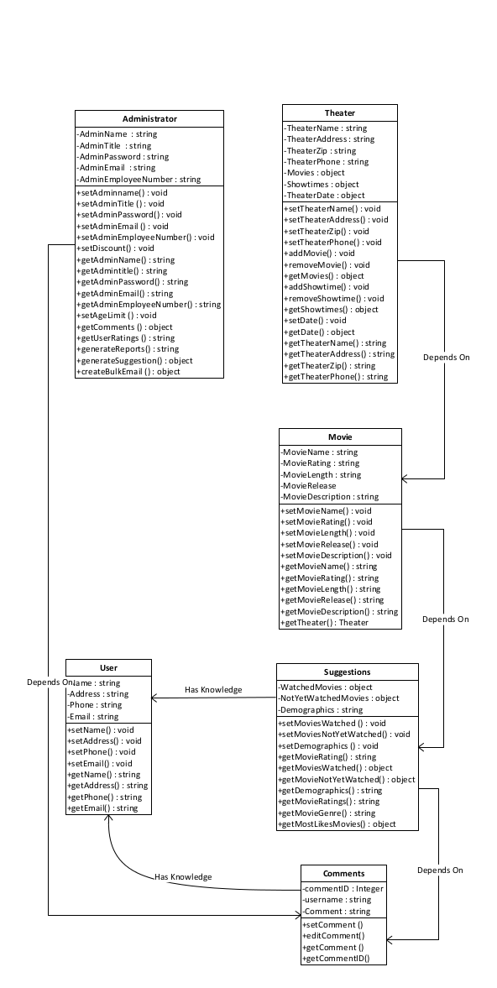

Class Name: User
Description: Representation of a user which will contain individual user information required for authentication.
Attribute | Data Type | Access Level | Restrictions | Description
Name | String | Private |  | Holds name of user
Address | String | Private |  | Holds address of user
Phone | String | Private |  | Holds phone 10-digit phone number of user (allows the entry of hyphens)
Email | String | Private |  | Holds email address of user
Methods (operations) | Return Type | Access Level | Restrictions | Description
setName | Void | Public | Name not null | Sets user name
setAddress | Void | Public | Address not Null | Sets user address
setPhone | Void | Public | Phone not null | Sets user phone
setEmail | Void | Public | Email not null | Sets user email
getName | String | Public |  | Returns user name
getAddress | String | Public |  | Returns user address
getPhone | String | Public |  | Returns user phone
getEmail | String | Public |  | Returns user email

Class Name: Theater
Description: Contains information on a theater
Attributes (fields) | Data Type | Access Level | Restrictions | Description
Private string TheaterName | String | Private |  | Holds the theater name
Private string TheaterAddress | String | Private |  | Holds the theater address
Private string TheaterZip | String | Private |  | Holds the zip code of a theater
Private string TheaterPhone | String | Private |  | Holds the theater phone number
Private list Movies | List | Private |  | Holds the set of all movies showing at the theater on a present or future date
Private list Showtimes | List | Private |  | Holds the set of show times of a selected movie on a given date
Private Date TheaterDate | Date | Private |  | Holds the date to search within for movies playing in the theater
Methods (operations) | Return Type | Access Level | Restrictions | Method Description
Public void setTheaterName | Void | Public | Theater name not null | Sets theater name
Public void setTheaterAddress | Void | Public | Theater address not null | Sets theater address
Public void setTheaterZip | Void | Public | Theater zip not null | Sets theater zip
Public void setTheaterPhone | Void | Public | Theater phone not null | Sets theater phone number
Public void addMovie | Void | Public | Movie name not null | Adds movie to the theater
Public void removeMovie | Void | Public | Movie name not null andmust exist in collection | Removes movie from the theater
Public list getMovies | List | Public |  | Returns the list of all movies at the theater
Public void addShowtime | Void | Public |  | Adds show time to a movie at the theater
Public void removeShowtime | Void | Public |  | Removes show time to a movie at the theater
Public list getShowtimes | List | Public |  | Returns the list of show times for a movie at the theater
Public void setDate | Void | Public |  | Sets date for user to search within
Public Date getDate | Date | Public |  | Returns the date to search within
Public string getTheaterName | String | Public |  | Returns theater name
Public string getTheaterAddress | String | Public |  | Returns theater address
Public string getTheaterZip | String | Public |  | Returns theater zip
Public string getTheaterPhone | String | Public |  | Returns theater phone number

Class Name: Administrator
Description: Defines administrator responsibilities and capabilities
Attributes (fields) | Data Type | Access Level | Restrictions | Description
Private String AdminName | String | Private |  | Holds the name of the Admin
Private String AdminTitle | String | Private |  | Holds the Admin title or position in the company
Private String AdminPassword | String | Private |  | Holds the admin password
Private String AdminEmail | String | Private |  | Holds the admin email
Private String AdminEmployeeNumber | String | Private |  | Hold the admin employee ID number
Methods (operations) | Data Type | Access Level | Restrictions | Method Description
Public void setAdminname | Void | Public | Admin name not null | Set the admin name
Public void setAdminTitle | Void | Public | Admin title not null | Set the admin Title
Public void setAdminPassword | Void | Public | Admin password not null and must be six characters long | Set the admin password
Public void setAdminEmail | Void | Public | Admin email not null | Set the admin email
Public void setAdminEmployeeNumber | Void | Public | Employee number not null | Set the admin employee ID number
Public void setDiscount | Void | Public | Discount not null | Set the discount rate or value
Public string getAdminName | String | Public |  | Return the admin Name
Public string getAdmintitle | String | Public |  | Return admin Title
Public string getAdminPassword | String | Public |  | Return the admin password
Public string getAdminEmail | String | Public |  | Return the admin Email
Public string getAdminEmployeeNumber | String | Public |  | Return the admin Employee ID number
Public void setAgeLimit | Void | Public |  | Sets the age limit for movie goers based on the MPAA rating
Public comment getComments | Comment | Public |  | Returns the user comments of a movie
Public string getUserRatings | String | Public |  | Returns the user ratings
Public string generateReports | String | Public |  | Returns the generalized report of a movie
Public suggestion generateSuggestion | Suggestion | Public |  | Returns suggestions of movies based on user’s previously watched movies, demographics and unwatched movies
Public email createBulkEmail | Email | Public |  | Return a bulk email to users about new movies showing or suggestions

Class Name: Movie
Description: Contains information on a movie
Attributes (fields) | Data Type | Access Level | Restrictions | Description
Private string MovieName | String | Private |  | Holds the name of the movie
Private string MovieRating | String | Private |  | Holds the MPAA rating of the movie
Private string MovieLength | String | Private |  | Holds the running time of the movie
Private string MovieRelease | String | Private |  | Holds the release date of the movie
Private String MovieDescription | String | Private |  | Hold a brief description of the movie
Methods (operations) | Data Type | Access Level | Restrictions | Description
Public void setMovieName | Void | Public | Movie name not null | Sets the name of the movie
Public void setMovieRating | Void | Public | Movie rating not null | Sets the rating of the movie
Public void setMovieLength | Void | Public | Movie length not null | Sets the running time of the movie
Public void setMovieRelease | Void | Public | Movie release not null | Sets the release date of the movie
Public void setMovieDescription | Void | Public | Movie description not null | Sets the description of the movie
Public String getMovieName | String | Private |  | Returns the name of the movie
Public string getMovieRating | String | Private |  | Returns the rating of the movie
Public string getMovieLength | String | Private |  | Returns the running time of the movie
Public string getMovieRelease | String | Private |  | Returns the release date of the movie
Public string getMovieDescription | String | Private |  | Returns the description of the movie
Public Theater getTheater | Theater | Private |  | Returns a designated theater

Class Name: Comments
Description: Contains of a movie
Attributes (fields) | Data Type | Access Level | Restrictions | Description
Private integer commentID | Integer | Private |  | Holds the auto generated comment ID
Private string username | String | Private |  | Holds the commenter’s username or screenName
Private string Comment |  |  |  | Holds the comment from end-user
Methods (operations) | Return Type | Access Level | Restrictions | Description
Public void setComment | Void | Public | Comment not null | Sets the comment for a movie
Public void editComment | Void | public | Comment not null and must already exist to be edited | Sets the new comment for a movie and replaces the old one from same user
Public string getComment | String | Public |  | Returns the comment for a movie
Public integer getCommentID | Integer | Public |  | Return the auto-generated commentID

Class Name: Suggestions
Description: Contains suggestions of a movie based on previously watched movies and demographics
Attributes (fields) | Data Type | Access Level | Restrictions | Description
Private list WatchedMovies | List | Private |  | Holds the names of the previously watched movies
Private list NotYetWatchedMovies | List | Private |  | Holds the name of movies of movies not yet watched
Private string Demographics | String | Private |  | Holds the user’s demographic information
Methods (operations) | Return Type | Access Level | Restrictions | Description
Public void setMoviesWatched | Void | public | Movies watched not be null | Sets the name of the movies watched
Public void setMoviesNotYetWatched | Void | public | Movies not yet watched not null | Sets the movies not yet watched
Public void setDemographics | Void | public | Demographics not null | Sets the user demographics
Public string getMovieRating | String | Public |  | Returns the rating of the movie
Public list getMoviesWatched | List | Public |  | Returns a List of already watched movies
Public list getMovieNotYetWatched | List | Public |  | Returns a List of not yet watched movies
Public string getDemographics | String | Public |  | Returns the user Demographics
Public string getMovieRatings | String | Public |  | Returns the movie rating
Public string getMovieGenre | String | Public |  | Returns the movie
Public list getMostLikesMovies | List | Public |  | Return a list of user’s most liked movies or movies with good ratings that the user has not watched yet

3.2 Object Collaboration Diagrams
Administrator Collaboration
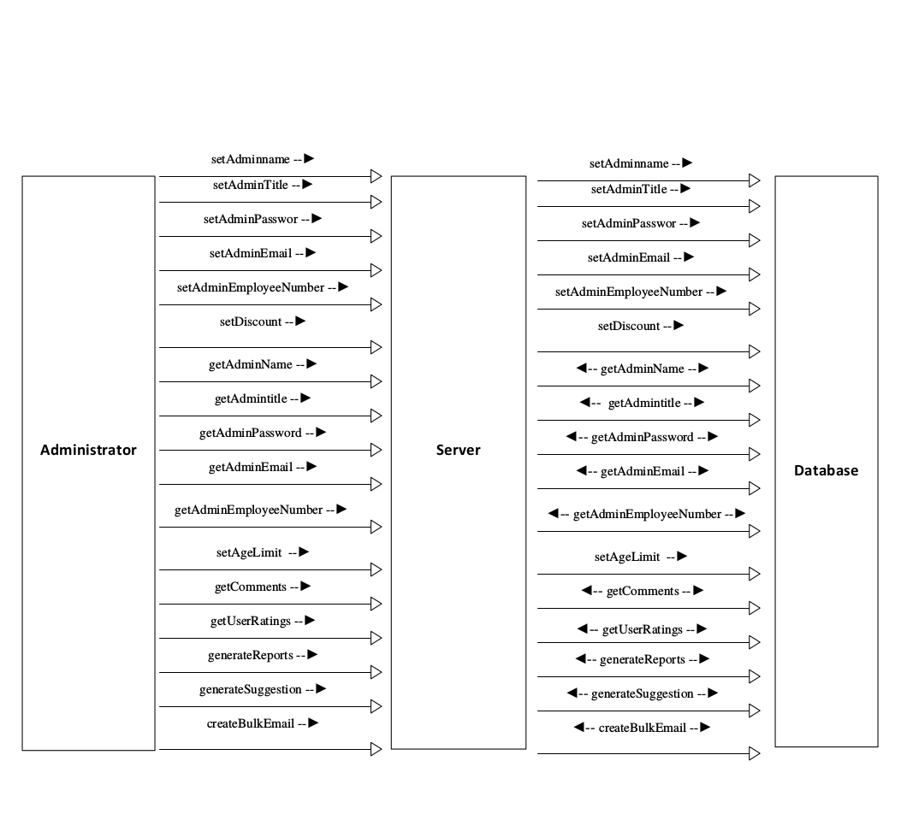
User Collaboration
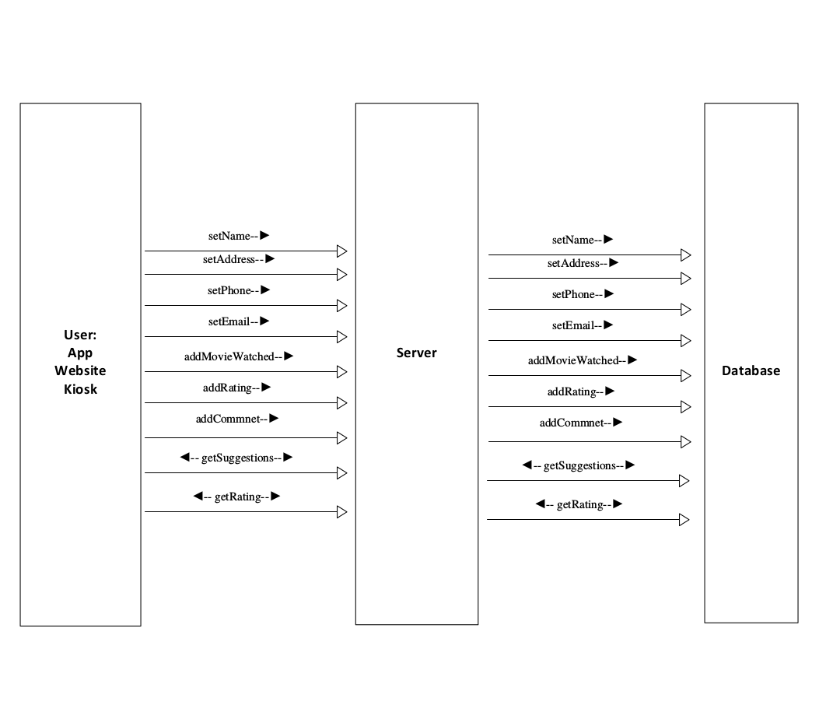

3.3 Sequence Diagrams
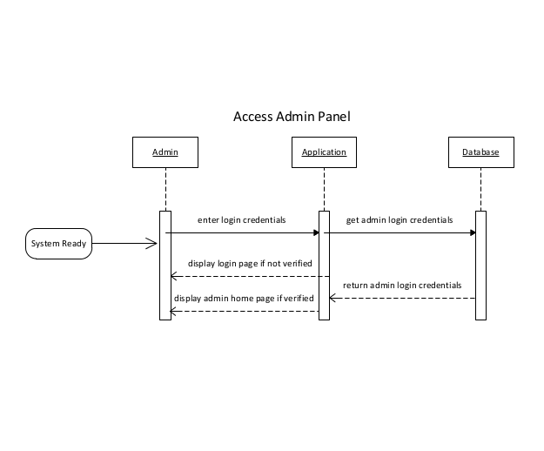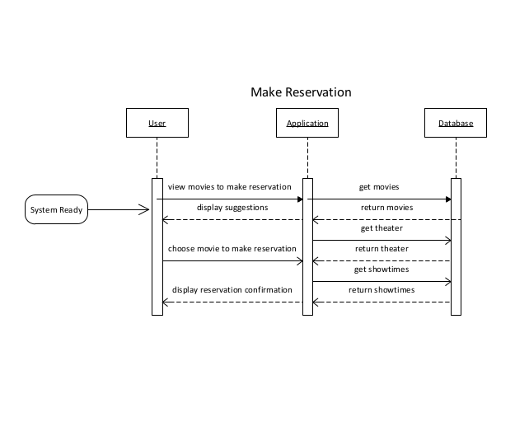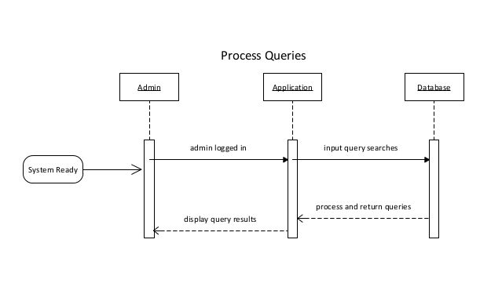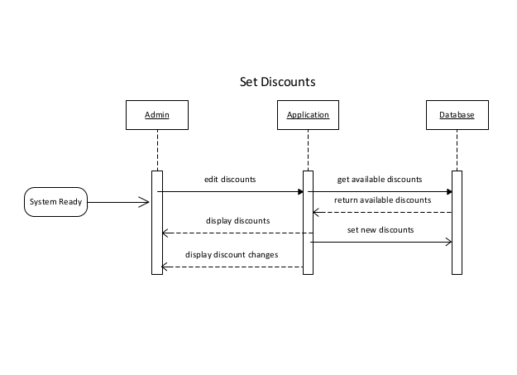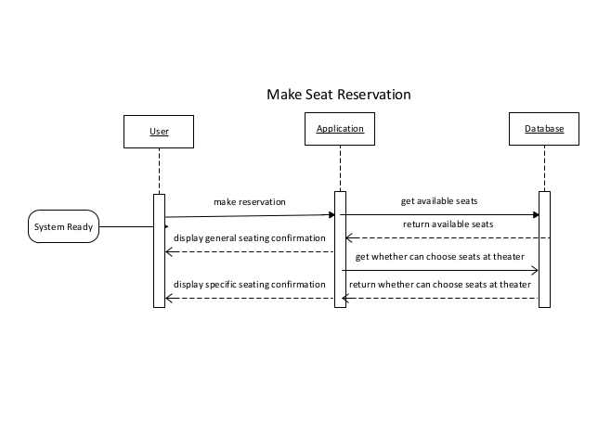
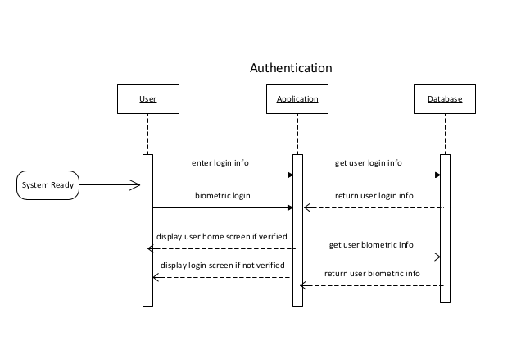
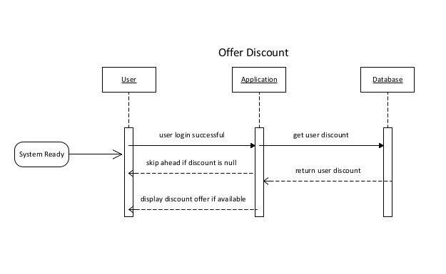
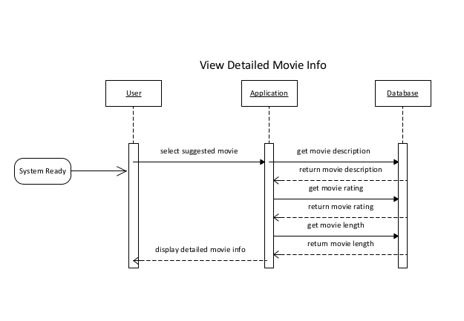
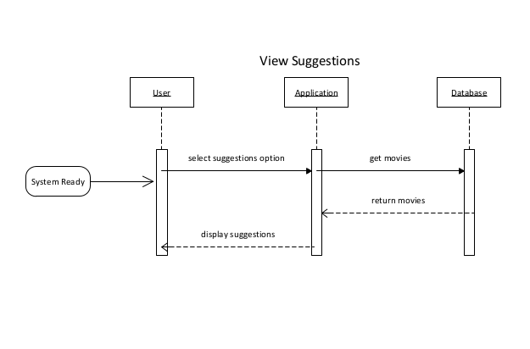

3.4 Object Behavior Diagrams
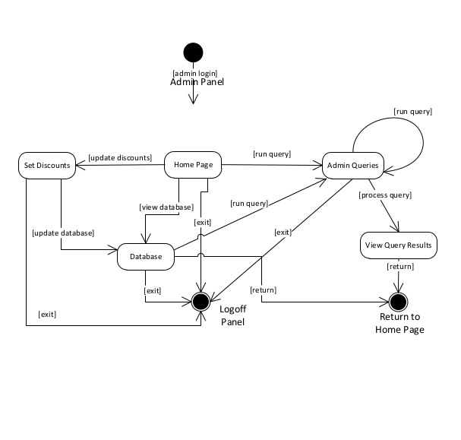
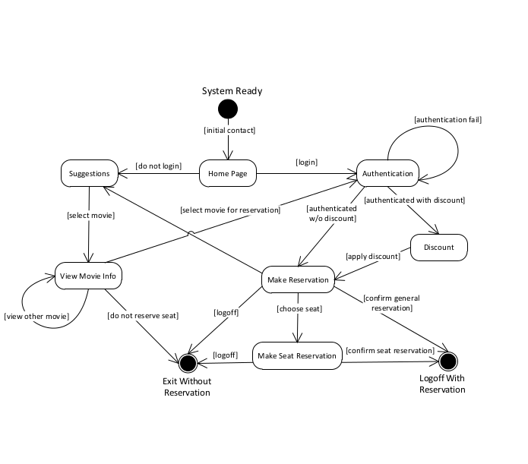

3.5 Performance Requirements
- The kiosk need to be NFC enabled and have biometric reader.
- The database must be secure.
- The database needs to be indexed and cache enabled for faster query rate times
- Scheduled server maintenance must be made in a manner that the server operations are not disrupted.
- The web server must offer SSL for authentication.
- The server must have ample storage space.
- The server must be capable of handing high traffic

3.6 Other Requirements
- The chairs in the theater must be clearly marked.
- The staff will be required to put a card on the seats that become reserved.

4. Supporting Information
    - http://en.wikipedia.org/wiki/Near_field_communication
    - http://newtech.about.com/od/mobile/a/Near-Field-Communications-NFC.htm
    - http://en.wikipedia.org/wiki/Biometrics
    - http://technet.microsoft.com/en-us/library/ms171908(v=sql.90).aspx
    - http://blogs.telerik.com/kendoui/posts/13-09-04/creating-a-mobile-site-for-your-sql-server-data
    - http://developer.android.com/index.html
    - https://developer.apple.com/technologies/ios/
    - http://msdn.microsoft.com/en-us/library/aa479073.aspx

