Hugging Face, Transformers, Datasets, Tokenizers, and Fine-Tuning
Master Study Manual for Complete Beginners
Prepared from the provided Class 20 video transcript, handwritten notes, Huggingface_Live_Class_updated.ipynb notebook, and the additional PersonalNotes.docx file. The goal is not to memorize code, but to understand what each concept means, why it exists, and how it fits into a real AI workflow. This Version 3 adds a practical Hugging Face UI and lab walkthrough based on the personal notes.
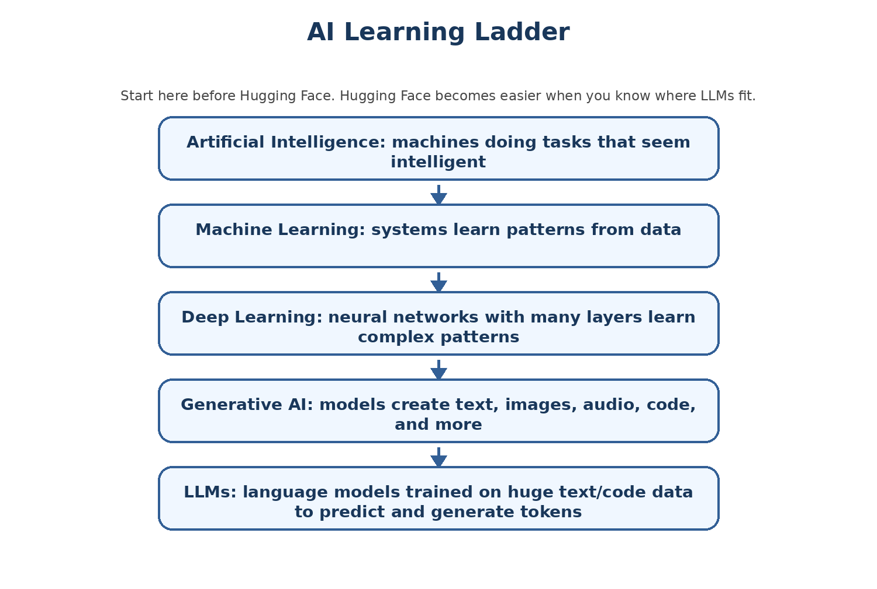
Figure 1 - AI learning ladder: where LLMs fit before we study Hugging Face.
Reading promise: This manual starts from ABC-level AI foundations and gradually moves to the actual notebook code. A student should be able to read it even without prior AI experience, then revisit it later as a technical reference.

Chapter 0: How to Use This Manual
This is a learning manual, not a quick summary. Read it in order the first time. Later, use the code walkthrough and revision chapters for fast review.

Recommended learning path
- Read Chapters 1 to 3 slowly. These chapters build the foundation: AI, text as numbers, training, inference, fine-tuning, and RAG.
- Read Chapters 4 to 9 to understand Hugging Face Hub, datasets, training data types, and tokenization.
- Read Chapters 10 to 15 to understand transformers, BERT, model heads, and generation.
- Read Chapters 16 to 20 to understand fine-tuning, LoRA/QLoRA/DoRA, RLHF/DPO, Unsloth, and full pipeline thinking.
- Use Chapters 21 to 24 as the practical notebook walkthrough and debugging guide.
- Use the appendix for glossary, revision, and practice projects.

What this manual covers
- Hugging Face ecosystem: Hub, models, datasets, tokenizers, APIs, and libraries.
- HfApi, model_info, list_models, list_repo_files, dataset_info, repo creation, and upload workflow.
- InferenceClient and LangChain Hugging Face wrappers at a conceptual level.
- Hugging Face Datasets: public datasets, custom datasets, streaming, map/filter/shuffle/select, and push_to_hub.
- Pretraining data, SFT/instruction-tuning data, preference data, RLHF/DPO data, custom raw documents, and enterprise data.
- Tokenization: tokens, token IDs, attention masks, token_type_ids, BPE, WordPiece, SentencePiece, and custom tokenizer training.
- Transformer architecture: embeddings, positional encoding, self-attention, Q/K/V, feed-forward layers, encoders, decoders, and decoder-only models.
- BERT architecture: BERT Base, BERT Large, encoder layers, hidden size, attention heads, and model internals from the notebook.
- Model heads: AutoModel, AutoModelForMaskedLM, AutoModelForCausalLM, sequence classification, token classification, QA, and sentence embeddings.
- Fine-tuning concepts: SFT, LoRA, QLoRA, DoRA, RLHF, DPO, Unsloth, and RAG vs fine-tuning.
- Notebook code walkthrough, common mistakes, practice assignments, and interview-style review questions.
Important note: The notebook demonstrates core Hugging Face concepts and model internals. It mentions LoRA, QLoRA, DoRA, RLHF, DPO, and Unsloth as upcoming/fine-tuning topics; this manual explains those concepts so the student is ready for later classes.

Chapter 1: AI Foundations for Someone Who Does Not Know ABC of AI

Figure 2 - The AI learning ladder used throughout this manual.

Artificial Intelligence
Plain English: AI is a broad field where we build systems that can perform tasks that normally require human intelligence, such as understanding language, recognizing images, making predictions, or planning steps.
Why it matters: Hugging Face is full of AI models. Without knowing what AI is, the rest feels like random tools.
Analogy: A calculator follows fixed rules. An AI model learns patterns from examples and then applies those patterns to new inputs.
Technical view: AI is not one algorithm. It is a family of methods, including rules, machine learning, deep learning, and modern generative models.

Machine Learning
Plain English: Machine learning is a way of building systems that learn patterns from data instead of being explicitly programmed for every case.
Why it matters: Modern language models are trained with machine learning. They learn by seeing huge amounts of examples.
Analogy: Instead of writing every rule for spam detection, we show the system examples of spam and non-spam emails.
Technical view: A model has parameters or weights. Training adjusts these weights to reduce error on examples.

Deep Learning
Plain English: Deep learning uses neural networks with many layers. These layers transform input data step by step into useful representations.
Why it matters: Transformers, BERT, and LLMs are deep learning models.
Analogy: Think of each layer as a worker that adds one level of understanding: characters -> words -> phrases -> meaning -> answer.
Technical view: A neural network layer receives numbers, performs matrix operations, applies nonlinear functions, and passes new numbers to the next layer.

Generative AI
Plain English: Generative AI creates new content: text, code, images, audio, video, or structured outputs.
Why it matters: LLMs are generative AI models because they can write answers, explanations, code, and summaries.
Analogy: Autocomplete on a phone predicts a few words. An LLM is like a much more powerful autocomplete trained on huge data.
Technical view: A text-generation model predicts tokens one by one. The generated output appears intelligent because the model has learned statistical and semantic patterns from training data.

Large Language Models
Plain English: An LLM is a model trained on large amounts of text/code to understand and generate language.
Why it matters: Hugging Face hosts many LLMs and tools to use, fine-tune, and evaluate them.
Analogy: A library gives you access to many books. An LLM compresses patterns from many texts into weights, but it does not store the text like a database.
Technical view: Most LLMs work by converting text into tokens, converting tokens into vectors, passing them through transformer layers, and predicting output tokens.

Important vocabulary
Term | Beginner meaning | Where you will see it
Model | A trained AI system that takes input and produces output. | BERT, TinyLlama, Qwen, T5, all-MiniLM.
Weights / parameters | Numbers learned during training. | Model files on Hugging Face Hub.
Dataset | Examples used for training, fine-tuning, evaluation, or retrieval. | load_dataset("imdb"), Alpaca, Wikitext.
Tokenizer | Converts text into token IDs for the model. | AutoTokenizer.from_pretrained(...).
Embedding | A numeric vector that represents meaning or token identity. | BERT outputs, SentenceTransformer outputs.
Inference | Using a trained model to get an answer. | InferenceClient, model.generate.
Fine-tuning | Training an existing model further on a specific task or behavior. | SFT, LoRA, QLoRA, Unsloth.

What to remember: AI is the broad field. Machine learning learns from data. Deep learning uses neural networks. Generative AI creates new content. LLMs are transformer-based language models that operate on tokens.

Practice tasks
- Explain AI, ML, deep learning, generative AI, and LLMs to a non-technical friend.
- Pick one model from Hugging Face and identify whether it is for text generation, embeddings, classification, or another task.
- Write one example of training and one example of inference in your own words.

Chapter 2: How Computers Understand Text: Numbers, Vectors, and Patterns
A human reads the sentence "I love AI" and immediately understands it. A computer cannot directly understand the sentence as meaning. A neural network receives numbers. Therefore, text must be converted into a numeric form before a model can process it.
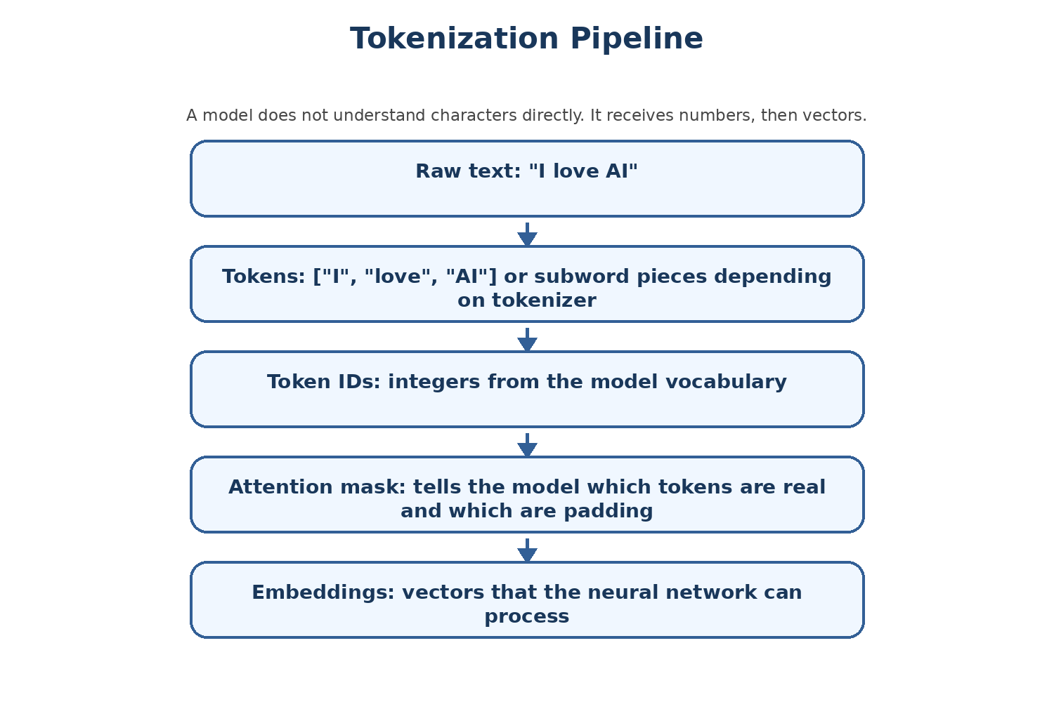
Figure 3 - Text becomes tokens, then token IDs, then vectors.

Text must become numbers
Plain English: Every piece of text is transformed into token IDs. These IDs are integers from a vocabulary.
Why it matters: Neural networks perform math. They cannot directly process English, Hindi, Gujarati, Python, or any other language as raw characters.
Analogy: A restaurant order must be converted into kitchen tickets. The model needs a numeric ticket for each token.
Technical view: The tokenizer maps text pieces to IDs. The model then maps IDs to embedding vectors.

Vectors
Plain English: A vector is a list of numbers. In AI, vectors can represent tokens, sentences, images, or documents.
Why it matters: Embeddings and hidden states are vectors. Similar meanings often have vectors that are close together.
Analogy: A location on a map can be represented by coordinates. A word meaning can be represented by many coordinates in a high-dimensional space.
Technical view: A BERT Base token vector has size 768. SentenceTransformer all-MiniLM-L6-v2 produces 384-dimensional sentence embeddings.

Patterns instead of memorized rules
Plain English: A model learns patterns from examples. It does not follow a hand-written grammar book for every answer.
Why it matters: This explains both the power and the limitation of LLMs. They generalize, but they can also be wrong.
Analogy: A student who solved many math problems starts recognizing problem patterns. A model does something similar with numbers.
Technical view: Training adjusts weights so that the model becomes better at predicting outputs from inputs.

The simple text-to-model pipeline
Raw text: "Hello, how are you?"
Tokens: ["[CLS]", "hello", ",", "how", "are", "you", "?", "[SEP]"]
Token IDs: [101, 7592, 1010, 2129, 2024, 2017, 1029, 102]
Embeddings: one vector per token
Model output: contextual vector or prediction depending on model head

Why this matters before code
- When you see input_ids in the notebook, you should think: token IDs.
- When you see attention_mask, you should think: which token positions should the model pay attention to?
- When you see outputs.last_hidden_state, you should think: contextual vectors for each input token.
- When you see logits, you should think: raw prediction scores before converting to probabilities or choosing tokens.
What to remember: Text becomes tokens. Tokens become token IDs. Token IDs become embeddings. Embeddings flow through transformer layers. Outputs depend on which model head you use.

Chapter 3: Training, Inference, Fine-Tuning, and RAG: The Big Picture
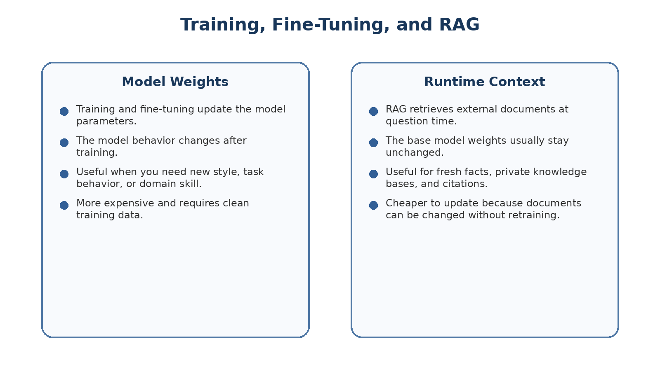
Figure 4 - Fine-tuning changes weights; RAG changes runtime context.

Training
Plain English: Training is the process of teaching a model by showing it many examples and adjusting its weights.
Why it matters: The original capabilities of a model come from training.
Analogy: Training is like a long education process where the student learns general knowledge.
Technical view: During training, the model makes predictions, calculates loss, and updates weights using backpropagation.

Inference
Plain English: Inference means using a trained model to answer a prompt, classify text, create an embedding, or generate output.
Why it matters: Most everyday AI usage is inference, not training.
Analogy: Asking ChatGPT a question is inference. The model answers using already-learned weights plus the current context.
Technical view: No model weights are updated during normal inference.

Fine-tuning
Plain English: Fine-tuning starts from an existing model and trains it further on a smaller, more specific dataset.
Why it matters: It is used when you want the model to learn a task style, domain behavior, or instruction-following pattern.
Analogy: A doctor already knows medicine generally, then specializes in cardiology. Fine-tuning is specialization.
Technical view: Fine-tuning updates weights or adapter weights. SFT, LoRA, QLoRA, and DoRA are common fine-tuning-related approaches.

RAG
Plain English: RAG means Retrieval-Augmented Generation. The system searches documents and gives relevant information to the model at answer time.
Why it matters: RAG is often better than fine-tuning for company documents, fresh facts, policies, and knowledge bases.
Analogy: Instead of forcing a student to memorize a manual, give the student the right page during the exam.
Technical view: RAG usually uses embeddings, vector search, retrieved chunks, and a generation model.

When to use what
Goal | Recommended approach | Reason
Teach a model broad language knowledge | Pretraining | Needs huge raw text and compute. Most users do not do this from scratch.
Teach a model to follow your response style or task format | SFT / instruction tuning | Examples show desired input-output behavior.
Fine-tune with limited GPU memory | LoRA or QLoRA | Train small adapter weights or quantized base model instead of full model.
Align outputs to preferred responses | RLHF or DPO | Uses human/preference signals.
Answer from private documents or changing facts | RAG | Documents can be updated without retraining the model.
Use a model immediately | Inference | No training required.

Class connection: The class is moving from Hugging Face basics into fine-tuning. The handwritten notes mention SFT/instruction tuning, LoRA, QLoRA, DoRA, RLHF, DPO, Unsloth, and RAG. This chapter gives the map before the details.

Chapter 4: What Hugging Face Is and Why It Matters
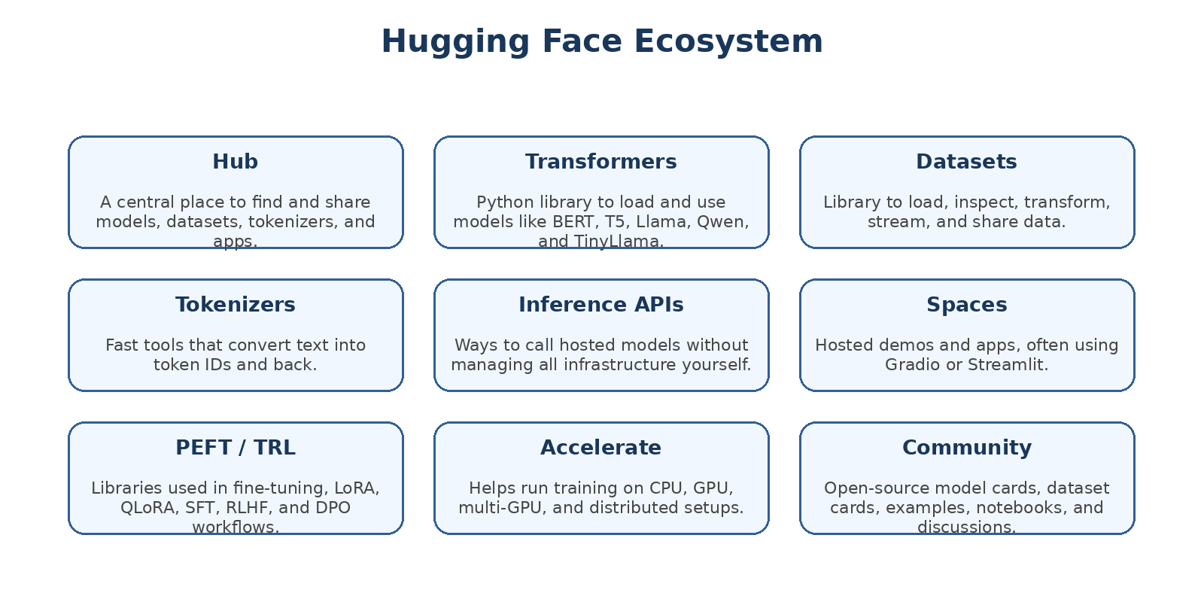
Figure 5 - Hugging Face is an ecosystem, not just a website.
Hugging Face is often described as GitHub for machine learning models, but it is more than that. It is a hub, a set of Python libraries, a model-sharing ecosystem, and a workflow for using public and private AI assets.

The mental model
Imagine you are building an AI application. You need a model, a tokenizer, a dataset, maybe an embedding model, maybe a fine-tuning library, and a place to save or share your work. Hugging Face tries to provide all of these pieces in one ecosystem.

Important pieces
Piece | What it does | Notebook/class examples
Hub | Stores models, datasets, tokenizers, repos, model cards, and files. | model_info("bert-base-uncased"), list_repo_files("google/flan-t5-base").
huggingface_hub | Python library to interact with the Hub. | HfApi, create_repo, upload_file, dataset_info.
transformers | Loads pretrained models/tokenizers and runs inference/training. | AutoTokenizer, AutoModel, AutoModelForMaskedLM, AutoModelForCausalLM.
datasets | Loads and processes datasets efficiently. | load_dataset("imdb"), map, filter, shuffle, streaming.
tokenizers | Fast tokenizer training and execution. | Tokenizer(models.BPE()), BpeTrainer.
sentence-transformers | Creates sentence/document embeddings. | SentenceTransformer("all-MiniLM-L6-v2").
LangChain wrapper | Lets LangChain applications call Hugging Face endpoints. | ChatHuggingFace, HuggingFaceEndpoint.

Examples of model organizations
The handwritten notes list examples such as DeepSeek from China, Sarvam AI from India, Mistral from France, and OpenAI from the USA. The point is that modern AI development is global. Hugging Face is a place where many organizations publish models, datasets, tokenizers, demos, and research artifacts.

Why a student should care
- You do not need to train everything from scratch. You can start from existing models.
- You can inspect model metadata before downloading large files.
- You can use public datasets to learn data processing workflows.
- You can convert your own data into Hugging Face-compatible datasets.
- You can use the same mental model for experiments, fine-tuning, evaluation, and deployment.

Chapter 5: Hugging Face Accounts, Tokens, Hub API, and Repositories

Read token vs write token
A Hugging Face token is like a key. A read token lets your code read private or gated resources that your account can access. A write token can create or modify repositories, upload files, and push datasets or models. A write token is more powerful and should be protected carefully.
Token type | What it allows | Safety rule
Read token | Read private/gated resources that your account has access to. | Use for downloading or inference when write is not needed.
Write token | Create repos, upload files, push models/datasets. | Never hardcode in notebooks that may be shared.
No token | Access public resources only. | Works for many public demos, but not private/gated resources.

Security rule: Do not paste real tokens into code cells, GitHub, screenshots, or shared notebooks. Use environment variables, Colab userdata, or notebook_login().

Notebook setup
from google.colab import userdata

READ_TOKEN = userdata.get("HF_TOKEN_READ")
WRITE_TOKEN = userdata.get("HF_TOKEN_WRITE")
This pattern keeps secrets outside the visible notebook. The notebook asks Colab for stored user data instead of writing the token in plain text.

Using HfApi
from huggingface_hub import HfApi

api = HfApi() # works for many public operations
# api = HfApi(token=WRITE_TOKEN) # needed for write operations
HfApi is a Python object that communicates with Hugging Face Hub. Think of it as a remote-control object for the Hub.

Inspecting a model without downloading it
model_info = api.model_info(repo_id="bert-base-uncased")

print("Tags:", model_info.tags)
print("Commit SHA:", model_info.sha)
print("Files:", [f.rfilename for f in model_info.siblings])
Object | Meaning
model_info.tags | Labels that describe the model, tasks, libraries, language, and other metadata.
model_info.sha | Exact version/commit of the repository. Useful for reproducibility.
model_info.siblings | Files present in the model repo, such as config, tokenizer files, and weights.

Listing models
models = api.list_models(search="llama", limit=50)

for model in models:
print(model.modelId, "-", model.downloads)
This is useful for discovery. However, downloads alone do not prove a model is best for your use case. Always inspect the model card, license, intended task, size, and constraints.

Listing repository files
from huggingface_hub import list_repo_files

files = list_repo_files("google/flan-t5-base")
print(files)
This tells you what files exist in a repo. It is useful before downloading a model because model repos can be large.

Creating a repo and uploading a file
api = HfApi(token=WRITE_TOKEN)

api.create_repo(
repo_id="your-username/your-repo-name",
repo_type="model",
private=False
)

api.upload_file(
path_or_fileobj="/content/testfile/config.json",
path_in_repo="config.json",
repo_id="your-username/your-repo-name"
)
Important: private=False means the repo is public. For company or personal sensitive work, use private=True and confirm organization policies.

Practice tasks
- Create a small private test repo in Hugging Face.
- List files in a public model repo before downloading it.
- Explain why a write token should not be used when a read token is enough.

Chapter 6: Using Hosted Models: InferenceClient and LangChain Wrapper

Why hosted inference exists
Large models may require GPU memory, disk space, and setup time. Hosted inference lets you call a model through an API-like interface so you can experiment without running the model locally. This is convenient for learning and prototypes, but you must understand cost, rate limits, privacy, and model availability.

InferenceClient example
from huggingface_hub import InferenceClient

client = InferenceClient(
model="Qwen/Qwen2.5-7B-Instruct"
)

response = client.chat.completions.create(
messages=[
{"role": "user", "content": "Explain Hugging Face in simple words"}
],
max_tokens=200
)

print(response.choices[0].message.content)
This code uses a chat-completion style interface. The model receives a message list and returns a generated response. The exact provider/backend and token requirements can differ depending on your Hugging Face setup.

LangChain Hugging Face wrapper
from langchain_huggingface import ChatHuggingFace, HuggingFaceEndpoint

llm = HuggingFaceEndpoint(
repo_id="deepseek-ai/DeepSeek-R1",
task="text-generation",
max_new_tokens=512,
do_sample=False,
repetition_penalty=1.03,
)

chat_model = ChatHuggingFace(llm=llm)
LangChain is an application-building framework. Hugging Face provides models. LangChain helps you connect models with prompts, tools, memory, retrievers, chains, and application logic. The model is the engine; LangChain is part of the plumbing around the engine.
Question | Answer
Does LangChain train the model? | No. It usually orchestrates calls to models and tools.
Does Hugging Face provide models? | Yes. It provides model hosting, files, libraries, and APIs.
Can LangChain call Hugging Face models? | Yes, through wrappers such as HuggingFaceEndpoint and ChatHuggingFace.
Is the model quality decided by LangChain? | No. Model quality depends on the selected model, prompt, data, and application design.

Chapter 7: Hugging Face Datasets: The Foundation of Training and Evaluation
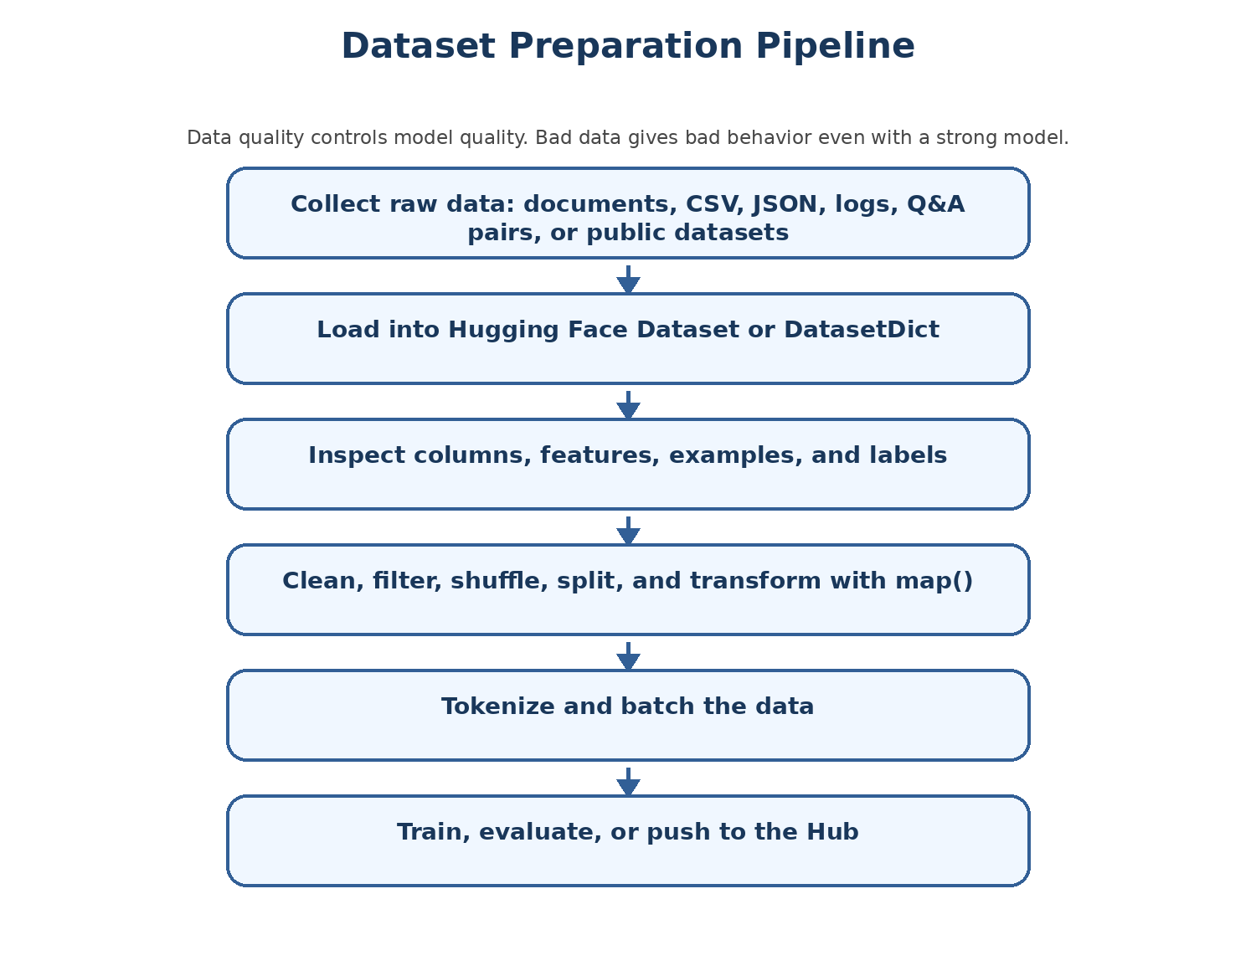
Figure 6 - Dataset preparation pipeline.

Why datasets matter
Every serious AI workflow depends on data. A strong model with bad data will perform badly. A smaller model with clean task-specific data may perform surprisingly well. The datasets library gives a consistent way to load, inspect, transform, and share data.

Dataset
Plain English: A Dataset is a table-like collection of examples. Each row is one example. Each column is a field such as text, label, instruction, input, output, chosen, or rejected.
Why it matters: Most training and evaluation loops expect structured examples.
Analogy: A dataset is like a spreadsheet for AI examples, but optimized for ML workflows.
Technical view: Hugging Face Dataset is backed by efficient Apache Arrow-style storage and supports transformations such as map, filter, shuffle, and select.

DatasetDict
Plain English: A DatasetDict is a dictionary of datasets, usually with splits such as train, validation, and test.
Why it matters: Splits help train on one part and evaluate on another without cheating.
Analogy: A school has practice questions and exam questions. You should not study from the exact exam answers.
Technical view: load_dataset("imdb") returns a DatasetDict with train/test or other splits depending on dataset.

Loading Wikitext for pretraining-style raw text
from datasets import load_dataset

pretrain_dataset = load_dataset(
"Salesforce/wikitext",
"wikitext-2-raw-v1",
split="train"
)

print(pretrain_dataset)
print(pretrain_dataset[0])
Wikitext examples are raw text. This kind of data resembles pretraining data because the model learns general language patterns from plain text.

Loading Alpaca for instruction tuning/SFT
sft_dataset = load_dataset(
"tatsu-lab/alpaca",
split="train"
)

print(sft_dataset[0])
Alpaca-style data usually contains fields such as instruction, input, and output. This is the shape of supervised fine-tuning data where we show the model how it should respond.

Loading preference data
preference_dataset = load_dataset(
"Anthropic/hh-rlhf",
split="train"
)

print(preference_dataset[0])
Preference datasets contain a better response and a worse response for the same or related prompt. These are used in alignment workflows such as RLHF or DPO.

Inspecting IMDB
dataset = load_dataset("stanfordnlp/imdb")

print(dataset)
print(dataset["train"].features)
print(dataset["train"].column_names)
print(dataset["train"].features["label"].names)
print(dataset["train"].shape)
The IMDB dataset is useful for learning because it has text reviews and labels. It helps you practice classification-style dataset operations without immediately training a giant LLM.

Dataset operations
Operation | Code pattern | Purpose
shuffle | dataset["train"].shuffle(seed=42) | Randomize examples. Use seed for repeatability.
select | dataset["train"].select(range(5000)) | Create a smaller subset for experiments.
filter | dataset["train"].filter(lambda x: len(x["text"]) < 100) | Keep only examples that satisfy a condition.
map | dataset.map(function) | Add or transform columns.
features | dataset["train"].features | Understand column types and labels.

Adding a word_count column with map
def add_word_count(example):
example["word_count"] = len(example["text"].split())
return example

dataset = dataset.map(add_word_count)
print(dataset["train"][0]["word_count"])
map applies a function to each example. This is one of the most important dataset operations because it is used for cleaning, formatting, tokenization, and feature creation.

Streaming large datasets
big_data = load_dataset(
"Skylion007/openwebtext",
streaming=True
)

for i, row in enumerate(big_data["train"]):
print(row)
if i == 4:
break
When streaming=True, the full dataset is not downloaded to disk first. Instead, examples are streamed one at a time. This is useful for very large datasets such as OpenWebText.

Common confusion and mistakes
- Do not process the full large dataset before testing code on a small subset.
- Do not assume every dataset has train/validation/test splits. Print the dataset object first.
- Do not assume column names. Print column_names and features.
- Do not shuffle without seed if you need reproducible experiments.
- Do not push private or sensitive data to a public Hub repo.

Chapter 8: Custom Datasets and Enterprise Data
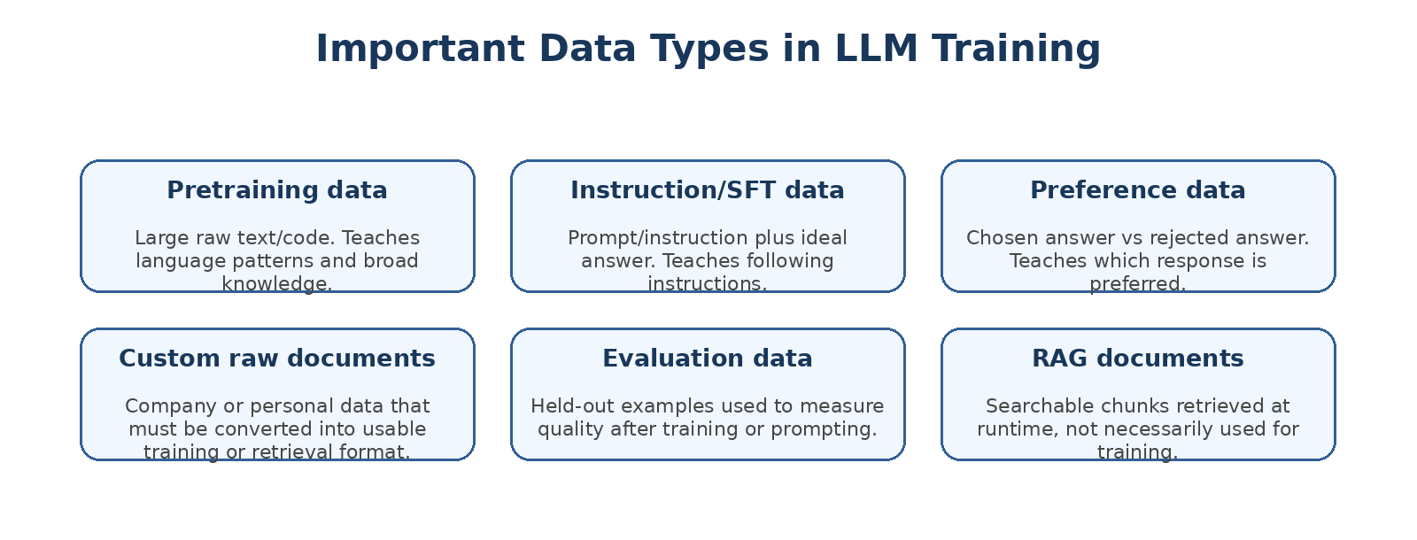
Figure 7 - Data types used in training and retrieval workflows.

Why custom data matters
Public datasets are excellent for learning. Real projects often depend on custom data: company documents, customer-support conversations, product catalogs, internal policies, database outputs, FAQs, code repositories, or domain-specific examples. The class notes emphasize custom raw data: personal data, enterprise data, documents, CSV, XLSX, TSV, JSON, Parquet, ORC, and binary formats.

Creating a small custom dataset from pandas
from datasets import Dataset
import pandas as pd

data = {
"text": [
"I love this product! Works great",
"Terrible experience, I want a refund.",
"Fast delivery and excellent packaging."
],
"label": [1, 0, 1]
}

df = pd.DataFrame(data)
dataset = Dataset.from_pandas(df)
print(dataset)
This converts a normal pandas DataFrame into a Hugging Face Dataset. Once it is a Dataset, you can use dataset operations such as map, filter, shuffle, select, and push_to_hub.

Instruction tuning format
from datasets import Dataset

data = {
"instruction": [
"Translate English to Hindi",
"Summarize the text",
"Explain Machine Learning"
],
"input": [
"I love India",
"Artificial Intelligence is transforming industries.",
""
],
"output": [
"Mujhe Bharat pasand hai",
"AI is changing many industries.",
"Machine learning lets computers learn patterns from data."
]
}

dataset = Dataset.from_dict(data)
This shape is common for SFT/instruction tuning. The model receives an instruction and optional input, then learns to produce the output.

Pushing a dataset to the Hub
from huggingface_hub import notebook_login
from huggingface_hub import whoami

notebook_login()
print(whoami())

dataset.push_to_hub("your-username/mycustomlivedata")
Pushing to the Hub makes the dataset available in a repository. Use private repos for sensitive or non-public data.

How to convert raw documents into training or RAG data
Raw source | For SFT/fine-tuning | For RAG
PDF/manual/policy | Create instruction-answer examples from the content. | Chunk document, embed chunks, store in vector database.
Support chat logs | Clean conversations and create prompt/response examples. | Index resolved cases for retrieval.
Database/business rules | Create examples of question -> desired response or tool call. | Store schema/docs/examples and retrieve relevant context.
Code repository | Create code instruction examples or bug-fix examples. | Index code and documentation for code search.

Important distinction: Putting a document into a dataset does not automatically make it good fine-tuning data. Fine-tuning data must teach behavior. RAG data must be searchable and trustworthy.

Data quality checklist
- Remove duplicates and low-quality examples.
- Remove secrets, passwords, keys, personal data, and confidential content unless approved and protected.
- Normalize column names and formats.
- Keep a validation/test set separate from training examples.
- Check license and usage rights for every dataset.
- Document exactly how data was created so future students or teammates can reproduce it.

Chapter 9: Tokenization: The Bridge Between Text and Models

Figure 8 - Tokenization is the bridge between human language and model tensors.

Why tokenization exists
A model cannot directly process the sentence "I love AI". The tokenizer breaks text into tokens and maps tokens to token IDs. The model then turns these IDs into embeddings. Tokenization is therefore the first serious step in the language-model pipeline.

Notebook example
from transformers import AutoTokenizer

tokenizer = AutoTokenizer.from_pretrained("bert-base-cased")
text = "I love AI"
output = tokenizer(text)

print(output)
print(tokenizer.convert_ids_to_tokens(output["input_ids"]))

Important tokenizer outputs
Field | Meaning | Beginner explanation
input_ids | Token IDs from vocabulary. | The numeric representation of tokens.
attention_mask | 1 for real tokens, 0 for padding. | Tells the model what to pay attention to.
token_type_ids | Sentence segment IDs for some models like BERT. | Helps separate sentence A from sentence B in pair tasks.

Special tokens
Token | Used by | Meaning
[CLS] | BERT-style models | Classification/start token. Output can represent whole sequence.
[SEP] | BERT-style models | Separator/end of sentence or pair boundary.
[MASK] | Masked language models | Position to predict during MLM.
<pad> or [PAD] | Many models | Padding shorter sequences to same length.
BOS/EOS | Many generation models | Beginning/end of sequence markers.

Tokenizing sentence pairs
output = tokenizer("I love AI", "I love ML")
print(output)
BERT-style models may use token_type_ids to distinguish the first sentence from the second sentence. This matters for tasks such as sentence-pair classification or question-answering formats.

Tokenizer algorithms
Algorithm | Used by examples | Simple idea
WordPiece | BERT | Break rare words into known subword pieces using a vocabulary.
BPE / Byte Pair Encoding | GPT-2 and many tokenizers | Start with characters/bytes and merge frequent pairs.
SentencePiece | T5, Llama, Mistral style tokenizers | Language-independent subword tokenization often trained directly from raw text.
Custom tokenizer | Qwen and other models may use custom variants | Tokenizer behavior can differ by model family.

Rule: Use the tokenizer that belongs to the model. A tokenizer mismatch can create incorrect IDs, poor outputs, or shape/config problems.

Tokenizer list from notebook
tokenizers = [
"bert-base-uncased",
"bert-base-cased",
"roberta-base",
"distilbert-base-uncased",
"gpt2",
"google/flan-t5-small",
"t5-small",
"sentence-transformers/all-MiniLM-L6-v2",
"Qwen/Qwen2.5-0.5B",
"mistralai/Mistral-7B-v0.1",
]

for model_name in tokenizers:
tokenizer = AutoTokenizer.from_pretrained(model_name)
print(model_name, "->", tokenizer.__class__.__name__)
This code teaches an important lesson: different model families have different tokenizer classes. Do not assume all models tokenize text the same way.

Hindi tokenizer example
hindi_tokenizer = AutoTokenizer.from_pretrained("ai4bharat/indic-bert")
tokens = hindi_tokenizer.tokenize("मुझे एआई पसंद है।")
print(tokens)
Access note: The notebook showed a gated/access issue for ai4bharat/indic-bert. That is a permissions/repository access issue, not a failure of the tokenization concept.

Chapter 10: Training a Custom Tokenizer

When would you train a tokenizer?
Most students should first use the tokenizer that comes with the model. You train a custom tokenizer only when you have a strong reason: a special language, domain-specific terms, unusual symbols, code/data formats, or a model being trained from scratch.

Custom tokenizer pipeline
Raw Text Corpus
-> Train BPE Tokenizer
-> Save custom-tokenizer.json
-> Wrap with PreTrainedTokenizerFast
-> Save Hugging Face-compatible tokenizer folder
-> Load with AutoTokenizer.from_pretrained(...)

Notebook code: train BPE tokenizer
from tokenizers import Tokenizer, models, trainers, pre_tokenizers

corpus = [
"I love transformers!",
"Tokenizers are amazing.",
"Build your own.
"
]

tokenizer = Tokenizer(models.BPE())
tokenizer.pre_tokenizer = pre_tokenizers.Whitespace()
trainer = trainers.BpeTrainer(vocab_size=100)

tokenizer.train_from_iterator(corpus, trainer)
tokenizer.save("custom-tokenizer.json")
Line | Explanation
Tokenizer(models.BPE()) | Creates a tokenizer object using BPE model.
Whitespace() | Splits text on whitespace before BPE processing.
BpeTrainer(vocab_size=100) | Learns up to 100 vocabulary entries from corpus.
train_from_iterator | Trains on examples from Python iterable/list.
save("custom-tokenizer.json") | Stores the trained tokenizer definition.

Wrap as a Hugging Face tokenizer
from transformers import PreTrainedTokenizerFast

hf_tokenizer = PreTrainedTokenizerFast(
tokenizer_file="/content/custom-tokenizer.json",
unk_token="[UNK]",
pad_token="[PAD]",
cls_token="[CLS]",
sep_token="[SEP]",
mask_token="[MASK]"
)

hf_tokenizer.save_pretrained("my_tokenizer_hf")
PreTrainedTokenizerFast makes the tokenizer compatible with the Transformers library. Special tokens tell downstream models how to handle unknown words, padding, classification, separation, and masking.

Load it back
from transformers import AutoTokenizer

tokenizer = AutoTokenizer.from_pretrained("my_tokenizer_hf")
output = tokenizer("I love transformers!")
print(output)

Common confusion and mistakes
- Do not train a custom tokenizer on a tiny corpus and expect production quality.
- Do not use a custom tokenizer with an existing pretrained model unless you understand embedding/vocabulary compatibility.
- Do not forget special tokens if your downstream model expects them.
- Do not compare token IDs across different tokenizers as if they mean the same thing.

Chapter 11: Embeddings: The First Step Inside the Model

What is an embedding?
An embedding is a vector representation. For language models, token IDs are converted into token embeddings. Later, contextual embeddings represent the meaning of tokens inside a sentence. Sentence embedding models produce one vector for a full sentence or document chunk.

BERT embedding facts from the notebook
Embedding(30522, 768)

BERT vocabulary size = 30,522 tokens
Each token vector size = 768
"hello" -> 768-dimensional vector

position_embeddings: Embedding(512, 768)
BERT can represent up to 512 token positions.
The embedding table is like a lookup table. If the token ID is 7592, the model retrieves row 7592 from the embedding matrix. That row is a 768-dimensional vector in BERT Base.

Token embedding vs sentence embedding
Type | Represents | Used for
Token embedding | One token before or after context processing. | Transformer model input or hidden states.
Contextual token vector | A token after transformer layers; meaning depends on sentence context. | BERT output, token classification, QA.
Sentence/document embedding | One vector for a sentence, paragraph, or chunk. | Semantic search, RAG, clustering, similarity.

SentenceTransformer example
from sentence_transformers import SentenceTransformer
import torch.nn.functional as F

sentence1 = "I love AI"
sentence2 = "I love car"

model = SentenceTransformer("all-MiniLM-L6-v2")
embedding1 = model.encode(sentence1, convert_to_tensor=True)
embedding2 = model.encode(sentence2, convert_to_tensor=True)

similarity = F.cosine_similarity(
embedding1.unsqueeze(0),
embedding2.unsqueeze(0)
)

print(similarity.item())
Correction from notebook comment: all-MiniLM-L6-v2 produces 384-dimensional embeddings. The notebook comment mentioning [768] for unsqueeze is a general-style comment, but for this model the vector length is 384.

Cosine similarity
Cosine similarity compares the direction of two vectors. If two sentence embeddings point in a similar direction, the sentences are considered semantically similar. RAG systems often use this idea to retrieve documents that are close to the user question.

Chapter 12: Transformer Architecture: The Core Idea Behind Modern LLMs
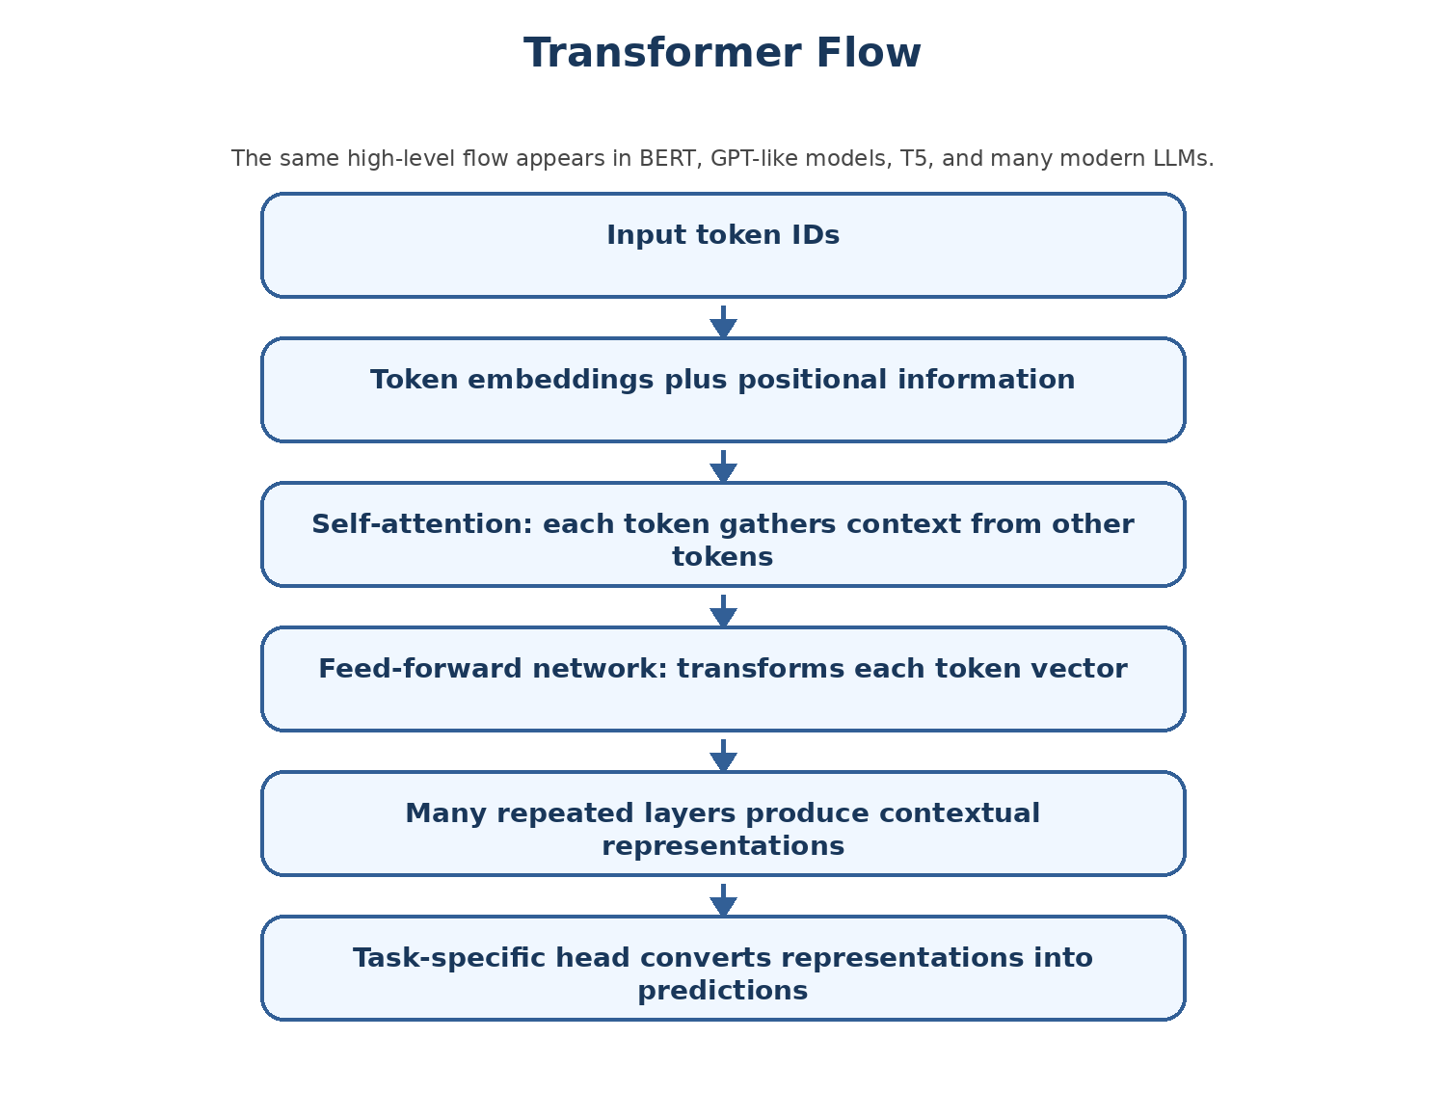
Figure 9 - Transformer flow from token IDs to task-specific output.

Why transformers changed NLP
Before transformers, many NLP systems processed text sequentially. Transformers process tokens in parallel and use attention to connect each token with other relevant tokens. This made training efficient and allowed models to learn long-range relationships better.

The transformer pipeline from handwritten notes
Transformer training flow:
Text -> Tokens -> Token IDs -> Word Embedding -> Positional Encoding -> Self-Attention -> FFN -> Output

Positional encoding / position embeddings
Plain English: The model needs to know token order. Without position information, the words "dog bites man" and "man bites dog" would contain the same words but different meaning.
Why it matters: Transformers process tokens in parallel, so they need a way to represent position.
Analogy: A sentence is like a train. The same passengers in different seat order can change meaning.
Technical view: BERT uses learned position embeddings. Other models may use sinusoidal, rotary, ALiBi, or other positional methods.

Self-attention
Plain English: Self-attention lets each token look at other tokens in the same sequence and decide what is relevant.
Why it matters: Language meaning depends on context. The word "bank" means different things in "river bank" and "bank account".
Analogy: In a group discussion, each person listens more to the speakers who are most relevant to their question.
Technical view: Attention uses query, key, and value projections. Attention scores compare queries and keys, then weighted values produce contextual representations.

Query, Key, Value
Plain English: Q/K/V are learned projections of token vectors used in attention.
Why it matters: They are the mechanism that lets tokens decide what information to take from other tokens.
Analogy: Query is a search question, key is an index label, value is the actual content.
Technical view: For each token, query asks what it needs, key says what it contains, and value carries the information to pass along.

Feed-forward network
Plain English: After attention, each token vector passes through a small neural network independently.
Why it matters: Attention gathers context; the feed-forward network transforms and enriches each token representation.
Analogy: After a meeting, each person processes the information internally and updates their understanding.
Technical view: In BERT Base, the feed-forward intermediate size is 3072 and returns to hidden size 768.

Encoder, decoder, and decoder-only models
Architecture | Simple meaning | Examples | Best for
Encoder-only | Reads and understands full input bidirectionally. | BERT, RoBERTa, DistilBERT. | Classification, embeddings, token classification, masked prediction.
Decoder-only | Generates text left-to-right by predicting next token. | GPT, Llama, TinyLlama, Qwen. | Chat, completion, code generation, next-token generation.
Encoder-decoder | Encoder reads input; decoder generates output. | T5, BART, Flan-T5. | Translation, summarization, text-to-text tasks.

Chapter 13: BERT Architecture and Internals
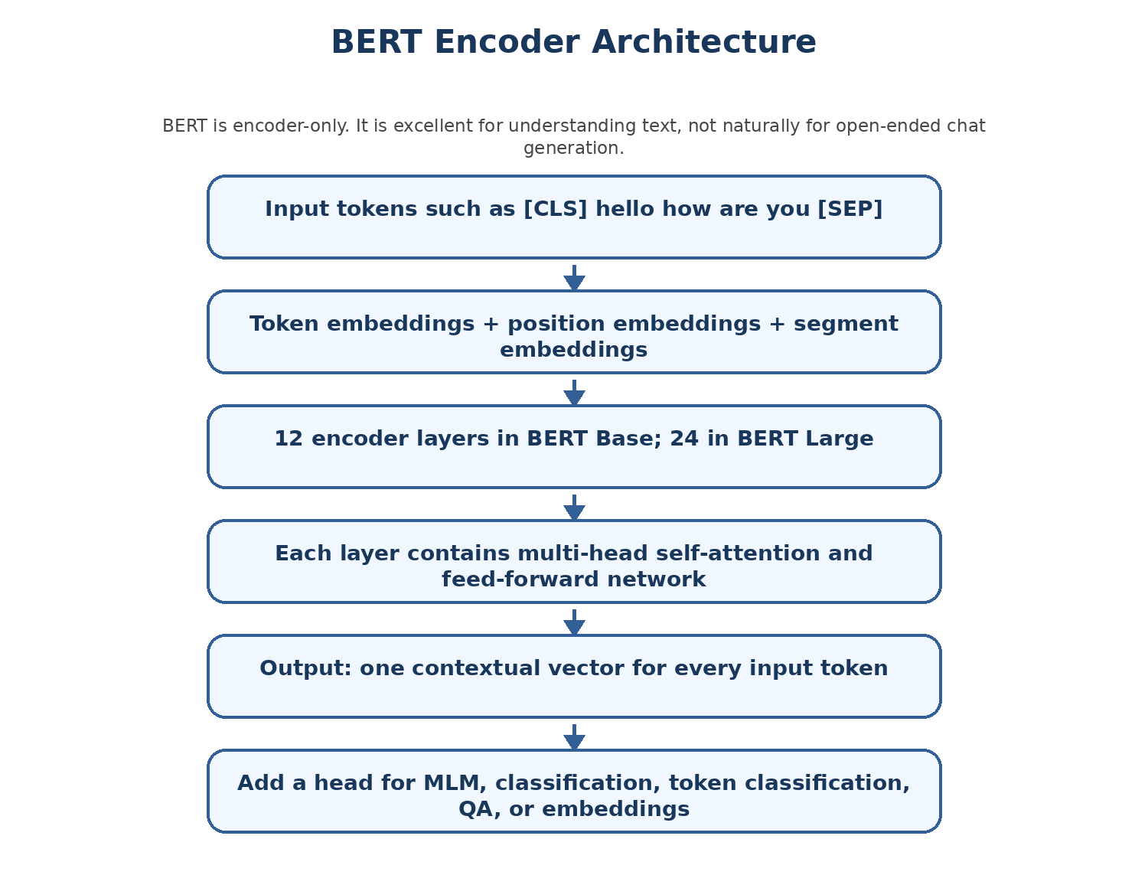
Figure 10 - BERT is an encoder-only transformer.

What BERT is
BERT stands for Bidirectional Encoder Representations from Transformers. It is encoder-only. It reads the full input text and creates contextual vectors for each token. It is strong for understanding tasks such as classification, embeddings, question answering, and masked word prediction.

BERT Base vs BERT Large
Model | Transformer layers | Hidden size | Attention heads | Approx parameters
BERT Base | 12 | 768 | 12 | about 110M
BERT Large | 24 | 1024 | 16 | about 340M

Load BERT from Transformers
from transformers import AutoTokenizer, AutoModel

tokenizer = AutoTokenizer.from_pretrained("bert-base-cased")
inputs = tokenizer("Hello, how are you?", return_tensors="pt")

model = AutoModel.from_pretrained("bert-base-uncased")
print(model)
Best-practice correction: The notebook uses a cased tokenizer and uncased model in this demo. For real work, normally use matching tokenizer and model names, such as bert-base-uncased with bert-base-uncased.

Inspecting layers
print(len(model.encoder.layer))
print(model.encoder.layer[0].attention)

for i, layer in enumerate(model.encoder.layer):
print(f"Layer {i}")
print("Query:", layer.attention.self.query)
print("Key: ", layer.attention.self.key)
print("Value:", layer.attention.self.value)
This code helps you see that the model is not magic. It is a structured collection of PyTorch modules: embeddings, encoder layers, attention layers, query/key/value projections, feed-forward layers, and output components.

Inspecting config
print("Hidden size:", model.config.hidden_size)
print("Number of layers:", model.config.num_hidden_layers)
print("Attention heads:", model.config.num_attention_heads)
print("Intermediate size:", model.config.intermediate_size)
Config field | BERT Base value | Meaning
hidden_size | 768 | Each token vector has 768 numbers.
num_hidden_layers | 12 | BERT Base has 12 transformer encoder layers.
num_attention_heads | 12 | Attention is split into 12 heads.
intermediate_size | 3072 | Feed-forward layer expands 768 -> 3072 -> 768.

Running model and reading output
import torch

with torch.no_grad():
outputs = model(**inputs)

print(outputs.last_hidden_state.shape)
For BERT Base, the shape is usually [batch_size, sequence_length, hidden_size]. If there is one sentence with eight tokens, the shape is [1, 8, 768].

Printing token vectors
tokens = tokenizer.convert_ids_to_tokens(inputs["input_ids"][0])

for token, vector in zip(tokens, outputs.last_hidden_state[0]):
print(token, vector[:5])
This prints the first few numbers of each contextual token vector. The vector for "hello" is not just a dictionary meaning of hello; it is hello in this specific sentence context.

Chapter 14: Model Heads: Why AutoModel, MaskedLM, and CausalLM Are Different
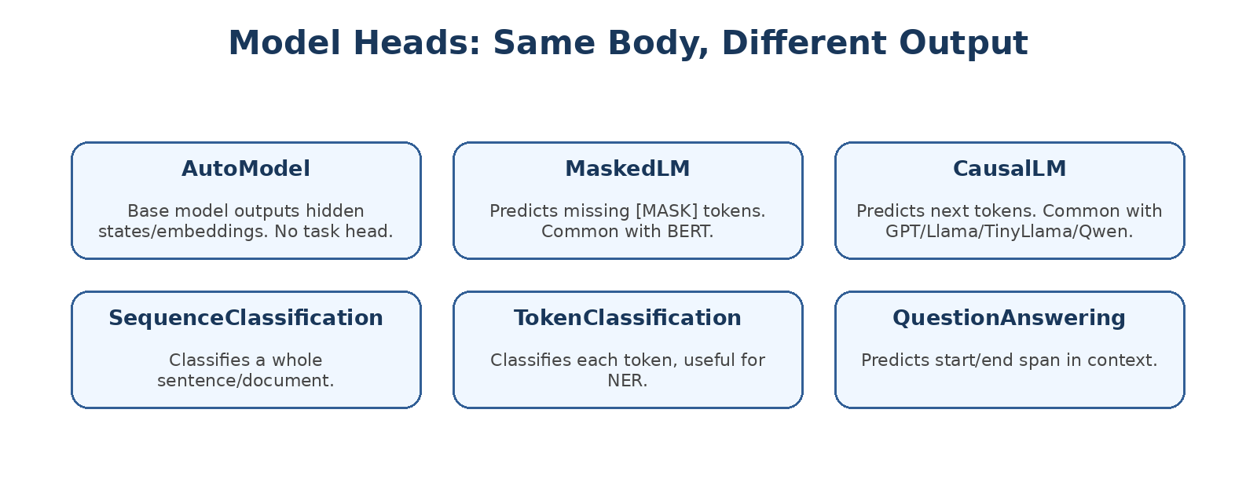
Figure 11 - Different heads turn the same kind of backbone into different task outputs.

The key idea
A transformer body creates representations. A model head converts those representations into a task-specific output. Choosing the wrong AutoModel class is a common beginner mistake.

Model head table
Class | What it returns/does | Use case
AutoModel | Base hidden states without task head. | Embeddings, feature extraction, custom head.
AutoModelForMaskedLM | Predicts masked token positions. | BERT-style fill-mask tasks.
AutoModelForCausalLM | Predicts next tokens. | GPT/Llama/TinyLlama/Qwen generation.
AutoModelForSequenceClassification | Classifies whole input. | Sentiment, topic, intent.
AutoModelForTokenClassification | Classifies each token. | Named entity recognition.
AutoModelForQuestionAnswering | Predicts answer span. | Extractive QA.
AutoModelForSeq2SeqLM | Encoder-decoder generation. | Translation, summarization, T5/Flan-T5.

Masked language modeling example
from transformers import AutoTokenizer, AutoModelForMaskedLM
import torch

model_name = "bert-base-uncased"
tokenizer = AutoTokenizer.from_pretrained(model_name)
model = AutoModelForMaskedLM.from_pretrained(model_name)

text = "Hello, how are [MASK]?"
inputs = tokenizer(text, return_tensors="pt")

with torch.no_grad():
outputs = model(**inputs)

mask_token_index = (inputs.input_ids == tokenizer.mask_token_id)[0].nonzero(as_tuple=True)[0]
logits = outputs.logits[0, mask_token_index, :]
predicted_id = logits.argmax(dim=-1)
print(tokenizer.decode(predicted_id))
The MaskedLM head produces vocabulary scores for each token position. We look at the [MASK] position and choose the highest-scoring token.

Causal language modeling example
from transformers import AutoTokenizer, AutoModelForCausalLM

model_name = "TinyLlama/TinyLlama-1.1B-Chat-v1.0"

tokenizer = AutoTokenizer.from_pretrained(model_name)
model = AutoModelForCausalLM.from_pretrained(model_name)

prompt = "Explain reinforcement learning in simple words."
inputs = tokenizer(prompt, return_tensors="pt")

generated_ids = model.generate(
**inputs,
max_new_tokens=50
)

print(tokenizer.decode(generated_ids[0], skip_special_tokens=True))
A CausalLM predicts next tokens. Generation repeatedly chooses a next token, appends it to the sequence, then predicts again.

Logits shape
with torch.no_grad():
outputs = model(**inputs)

print(outputs.logits.shape)
# [batch_size, sequence_length, vocab_size]
For each input position, the model produces a score for every token in the vocabulary. These raw scores are logits.

Chapter 15: Generation: How Decoder-Only Models Produce Text

Next-token prediction
A decoder-only language model generates by predicting the next token given previous tokens. It does not produce a full paragraph in one step. It repeats next-token prediction many times until it reaches a stop condition or max token limit.

Generation loop concept
prompt = "Explain AI"

while not done:
logits = model(prompt_tokens)
next_token = choose_token(logits)
prompt_tokens = prompt_tokens + [next_token]

Common generation controls
Parameter | Meaning | Beginner effect
max_new_tokens | Maximum number of tokens to generate. | Prevents endless output.
do_sample | Whether to sample randomly from probabilities. | False is more deterministic; True is more creative.
temperature | Controls randomness when sampling. | Higher = more random; lower = safer.
top_p | Nucleus sampling threshold. | Limits sampling to likely tokens.
repetition_penalty | Penalty for repeating tokens. | Can reduce repetitive text.

Why BERT is not normally used for chat generation
BERT is encoder-only and trained with masked language modeling. It is excellent at understanding text and predicting masked words, but it is not naturally a left-to-right chat generator. Chat-style models are usually decoder-only or encoder-decoder models trained for generation.

Chapter 16: Fine-Tuning: From General Model to Task-Specific Model
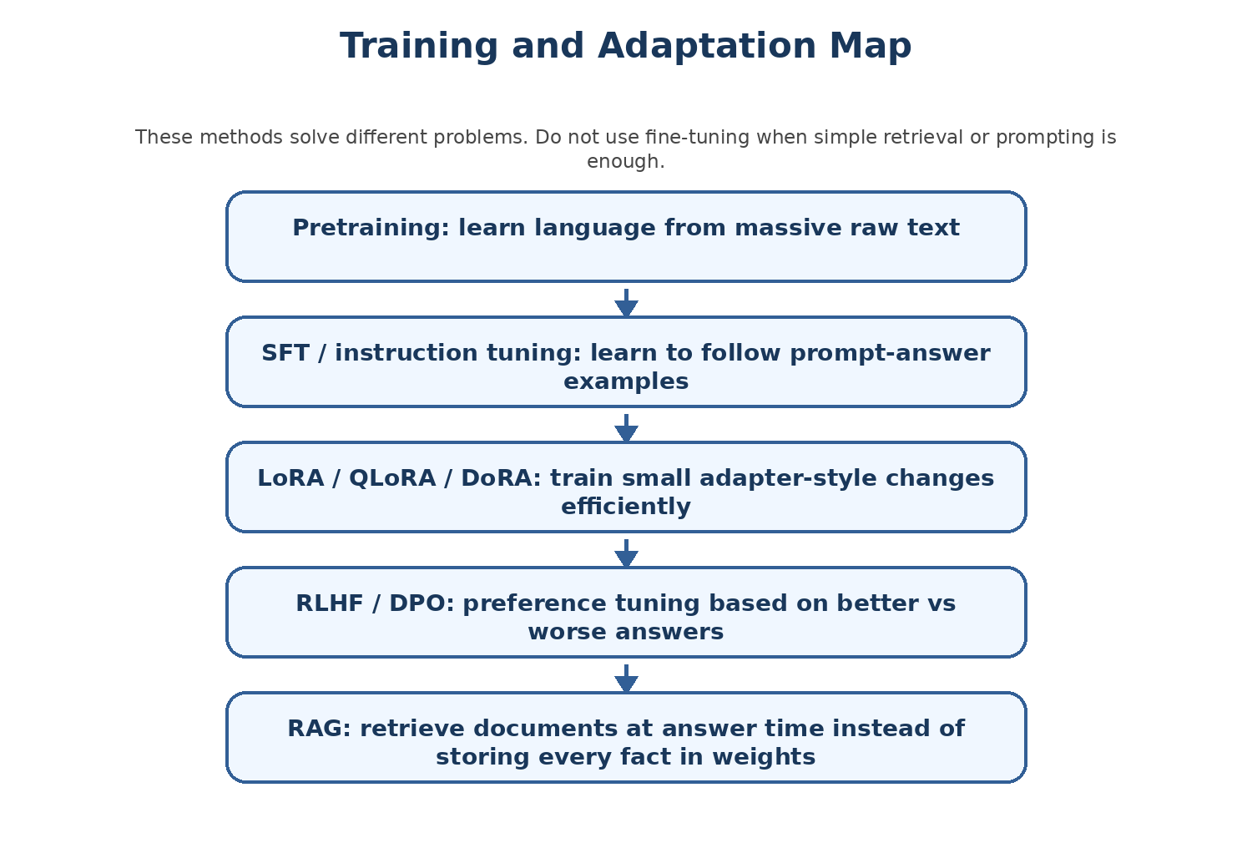
Figure 12 - Map of pretraining, SFT, LoRA, QLoRA, DoRA, RLHF/DPO, and RAG.

Why fine-tune?
A base model may know general language, but your use case may require a specific style, output format, domain vocabulary, or task behavior. Fine-tuning teaches the model through examples.

Pretraining vs SFT vs preference tuning
Stage | Data shape | What the model learns
Pretraining | Huge raw text/code. | General language patterns and world/code knowledge.
SFT / instruction tuning | Instruction/input/output examples. | How to follow instructions and produce desired answers.
Preference tuning | Chosen vs rejected answers. | Which style or response quality is preferred.
RAG | External documents retrieved at runtime. | Does not train weights by default; provides context.

Instruction tuning from custom raw data
The handwritten notes mention custom raw data such as documents, personal data, and enterprise data. Raw data must be transformed into an instruction-tuning format if you want SFT. For example, a company policy document can become many examples like:
{
"instruction": "Answer the question using the company leave policy.",
"input": "How many days of annual leave can an employee carry forward?",
"output": "According to the policy, employees can carry forward ..."
}
The quality of this conversion is critical. If the output is vague, inconsistent, or wrong, the fine-tuned model will learn vague, inconsistent, or wrong behavior.

SFT training objective in simple terms
During SFT, the model is shown a prompt and the correct answer. It learns to make the correct answer more likely token by token. This does not mean it memorizes only those examples. Good SFT teaches a response pattern that generalizes to similar prompts.

Fine-tuning is not always the right answer
Problem | Usually better solution
Need to answer from frequently changing documents | RAG.
Need exact SQL query for a known business question | Tool routing or trusted query mapping, possibly with RAG/tool use.
Need response tone/format changed consistently | SFT or prompting, depending on complexity.
Need domain-specific terminology and examples | SFT or continued pretraining, depending on goal.
Need latest facts | RAG or live tools, not fine-tuning alone.

Chapter 17: LoRA, QLoRA, DoRA, and Efficient Fine-Tuning

The memory problem
Full fine-tuning updates all model weights. For large models, this can require a lot of GPU memory and compute. Parameter-efficient fine-tuning methods reduce cost by training a much smaller number of parameters.

LoRA
Plain English: LoRA means Low-Rank Adaptation. Instead of updating the original large weight matrices directly, LoRA adds small trainable matrices that learn task-specific changes.
Why it matters: It makes fine-tuning cheaper and easier while keeping the base model mostly frozen.
Analogy: Instead of rewriting an entire textbook, you attach correction notes to the important pages.
Technical view: LoRA injects low-rank adapters into target modules such as attention projections. At inference, adapters can be loaded with the base model or merged depending on workflow.

QLoRA
Plain English: QLoRA combines quantization with LoRA. The base model is loaded in a lower-precision format, while small LoRA adapters are trained.
Why it matters: It allows fine-tuning larger models on limited GPU memory.
Analogy: Compress the big book to save space, then write small high-quality notes on top.
Technical view: Commonly uses 4-bit quantization for the base model and trains adapter weights in higher precision.

DoRA
Plain English: DoRA is a LoRA-related method that separates direction and magnitude components in weight updates.
Why it matters: It aims to improve adaptation quality while keeping parameter efficiency.
Analogy: Instead of only saying where to move, also learn how strongly to move.
Technical view: The class notes list DoRA as an assignment/related concept beyond LoRA and QLoRA.

Conceptual LoRA setup
# Conceptual skeleton only; exact arguments depend on model/task/library versions.
from peft import LoraConfig, get_peft_model

lora_config = LoraConfig(
r=16,
lora_alpha=32,
target_modules=["q_proj", "v_proj"],
lora_dropout=0.05,
task_type="CAUSAL_LM"
)

model = get_peft_model(base_model, lora_config)
model.print_trainable_parameters()

How to choose
Method | Use when | Trade-off
Full fine-tuning | You have enough compute and need maximum control. | Expensive, large checkpoints.
LoRA | You want efficient adaptation and can load base model normally. | Need base model plus adapter unless merged.
QLoRA | You want to fine-tune a larger model on limited GPU memory. | Quantization complexity and possible speed/precision tradeoffs.
DoRA | You want a newer parameter-efficient method to experiment with. | May require more careful library support.

Class connection: The handwritten notes mention LoRA, QLoRA, and DoRA. The uploaded notebook does not implement them yet, so this manual explains the concepts and provides a skeleton, not a class-executed training script.

Chapter 18: Unsloth Fine-Tuning Pipeline

What Unsloth is for
Unsloth is a fine-tuning framework focused on making LLM fine-tuning faster and more memory-efficient. The class notes refer to a fine-tuning pipeline using Unsloth. Even before seeing the full Unsloth notebook, you should understand the pipeline steps.

Typical Unsloth-style pipeline
1. Choose a supported base model.
2. Load model and tokenizer with memory-efficient settings.
3. Prepare instruction/SFT dataset.
4. Convert examples into prompt format.
5. Configure LoRA/QLoRA-style adapters.
6. Train with an SFT trainer.
7. Evaluate sample prompts.
8. Save adapter or merged model.
9. Push to Hub if appropriate.

Example prompt formatting
def format_example(example):
instruction = example["instruction"]
input_text = example.get("input", "")
output = example["output"]

prompt = f"""### Instruction:
{instruction}

### Input:
{input_text}

### Response:
{output}"""
return {"text": prompt}
Fine-tuning requires a consistent prompt template. If training examples use one format and inference uses another format, the model may perform poorly.

What to check before training
- Does every example have the required fields?
- Are outputs high quality and correct?
- Is the prompt template consistent?
- Is the dataset split into train and validation?
- Are sensitive data and licenses handled correctly?
- Does the tokenizer pad/truncate correctly?
- Are training parameters reasonable for your GPU memory?

Chapter 19: RLHF and DPO: Preference Tuning

Why preference tuning exists
SFT teaches the model to imitate desired answers. But sometimes there are multiple possible answers, and humans prefer one over another. Preference tuning methods teach the model what kind of answer is better.

RLHF
Plain English: RLHF means Reinforcement Learning from Human Feedback. Humans compare model responses, a reward model is trained, and the language model is optimized to produce preferred responses.
Why it matters: It is a major alignment technique for improving helpfulness, harmlessness, and response quality.
Analogy: A student writes two answers; a teacher says which is better; over time the student learns the teachers preference.
Technical view: Classic RLHF often includes SFT model, reward model, and reinforcement learning optimization such as PPO.

DPO
Plain English: DPO means Direct Preference Optimization. It trains from chosen/rejected pairs more directly without the full separate reinforcement learning loop used in classic RLHF.
Why it matters: It is simpler to implement than full RLHF in many workflows.
Analogy: Instead of building a complex scoring game, directly teach: choose answer A over answer B.
Technical view: DPO uses pairs of preferred and rejected responses and optimizes the model to prefer chosen over rejected.

Preference data shape
{
"prompt": "Explain tokenization simply.",
"chosen": "Tokenization breaks text into pieces and converts them into IDs...",
"rejected": "It is just AI magic."
}

RLHF vs DPO
Aspect | RLHF | DPO
Data | Human preference comparisons, often used to train reward model. | Chosen/rejected pairs.
Complexity | Higher. May involve reward model and RL algorithm. | Lower. Direct optimization from preference pairs.
Use case | Large-scale alignment workflows. | Practical preference tuning when pairs are available.
Beginner view | Teach using feedback scores/preferences. | Teach directly using better vs worse responses.

Chapter 20: RAG, Multimodal RAG, and How It Differs from Fine-Tuning

RAG explained simply
RAG stands for Retrieval-Augmented Generation. The model does not need to memorize all documents. Instead, the system retrieves relevant document chunks and inserts them into the prompt so the model can answer using that context.

Basic RAG pipeline
Documents
-> split into chunks
-> create embeddings for each chunk
-> store embeddings in vector database
-> user asks a question
-> embed the question
-> retrieve similar chunks
-> send chunks + question to LLM
-> generate answer

RAG vs fine-tuning
Question | RAG answer | Fine-tuning answer
Where is knowledge stored? | In external documents/vector store. | In model or adapter weights.
How to update facts? | Update documents/re-index. | Retrain or fine-tune again.
Best for? | Policies, manuals, changing company knowledge. | Behavior, style, task pattern, output format.
Can it cite sources? | Yes, if chunks are tracked. | Not naturally.
Does it require training? | Not necessarily. | Yes.

Multimodal RAG
Multimodal RAG extends the idea beyond plain text. A system may retrieve images, tables, charts, PDFs, slides, audio transcripts, or video-derived text. The exact design depends on the model and data types.
Source note: The transcript clearly mentions RAG and multimodal RAG as upcoming topics. The handwritten page appears to include RAG and possibly another shorthand. This manual treats RAG and multimodal RAG as the confirmed concepts.

Chapter 21: Notebook Walkthrough Part 1: Hub API and Repositories

What this part teaches
- How to load Hugging Face tokens safely in Colab.
- How to create an HfApi object.
- How to inspect model metadata.
- How to list models and repo files.
- How to create a repo and upload a file.
- How to inspect dataset files.

Code recipe: model metadata
from huggingface_hub import HfApi

api = HfApi()
model_info = api.model_info(repo_id="bert-base-uncased")

print("Model Card Metadata:", model_info.card_data)
print("Tags:", model_info.tags)
print("Commit SHA:", model_info.sha)
print("Files:", [f.rfilename for f in model_info.siblings])
This teaches you to investigate a model before blindly downloading or using it. In real projects, always check model card, license, intended use, limitations, and files.

Code recipe: dataset info
dataset = api.dataset_info("imdb")
print("Files:", [f.rfilename for f in dataset.siblings])
This is the dataset version of repo inspection. It tells you what files exist behind a dataset repository.

Code recipe: create repo and upload
api = HfApi(token=WRITE_TOKEN)

api.create_repo(
repo_id="sunny199/sunnyrepotest",
repo_type="model",
private=False
)

api.upload_file(
path_or_fileobj="/content/testfile/dataset_info.json",
path_in_repo="dataset_info.json",
repo_id="sunny199/sunnyrepotest"
)
This demonstrates write operations. In your own work, replace the username/repo with your own, and use private=True for sensitive experiments.

Chapter 22: Notebook Walkthrough Part 2: Dataset Operations

The dataset journey

Figure 13 - Dataset operations from loading to training.

Pretraining, SFT, and preference datasets in the notebook
Notebook variable | Dataset | Learning purpose
pretrain_dataset | Salesforce/wikitext | Understand raw text/pretraining-style data.
sft_dataset | tatsu-lab/alpaca | Understand instruction/input/output SFT data.
preference_dataset | Anthropic/hh-rlhf | Understand chosen/rejected preference data.
dataset | stanfordnlp/imdb | Practice common dataset operations.

IMDB operations
dataset = load_dataset("stanfordnlp/imdb")

shuffled = dataset["train"].shuffle(seed=42)
subset_train = dataset["train"].shuffle().select(range(5000))
short_reviews = dataset["train"].filter(lambda x: len(x["text"]) < 100)
short_positive = dataset["train"].filter(lambda x: x["label"] == 1 and len(x["text"]) < 200)
These operations teach you how to control data. This is essential before training because training code is only as good as the data pipeline feeding it.

Streaming
big_data = load_dataset("Skylion007/openwebtext", streaming=True)

for item in big_data["train"].take(5):
print(item)
take(5) is a safe way to inspect only a few streaming examples. This prevents accidentally iterating through huge data.

Chapter 23: Notebook Walkthrough Part 3: Tokenizers and Custom Tokenizer

AutoTokenizer
from transformers import AutoTokenizer

tokenizer = AutoTokenizer.from_pretrained("bert-base-cased")
output = tokenizer("I love AI")
print(output)
print(tokenizer.convert_ids_to_tokens(output["input_ids"]))
AutoTokenizer chooses the correct tokenizer class based on the model repo configuration. This is why it can load many different tokenizer families with one API.

Tokenization fields from notebook markdown
Field | Detailed meaning
input_ids | IDs of tokens from the model vocabulary. For BERT, special tokens such as [CLS] and [SEP] are included.
token_type_ids | Segment IDs. Often 0 for first sentence and 1 for second sentence in BERT pair inputs.
attention_mask | Shows which positions are real tokens and which are padding.

Custom BPE tokenizer
from tokenizers import Tokenizer, models, trainers, pre_tokenizers

corpus = ["I love transformers!", "Tokenizers are amazing.", "Build your own.
"]

tokenizer = Tokenizer(models.BPE())
tokenizer.pre_tokenizer = pre_tokenizers.Whitespace()
trainer = trainers.BpeTrainer(vocab_size=100)
tokenizer.train_from_iterator(corpus, trainer)
tokenizer.save("custom-tokenizer.json")
The notebook uses a tiny corpus only for demonstration. A real tokenizer needs much larger and representative text.

Chapter 24: Notebook Walkthrough Part 4: BERT, Model Heads, Local Download, and Embeddings

BERT AutoModel
from transformers import AutoTokenizer, AutoModel

model_name = "bert-base-uncased"
tokenizer = AutoTokenizer.from_pretrained(model_name)
inputs = tokenizer("Hello, how are you?", return_tensors="pt")
model = AutoModel.from_pretrained(model_name)

with torch.no_grad():
outputs = model(**inputs)

print(outputs.last_hidden_state.shape)
This is the clean version where tokenizer and model match. It returns contextual vectors for each token.

MaskedLM and CausalLM
The notebook shows both BERT masked language modeling and TinyLlama causal language generation. This contrast is very important: BERT predicts masks; TinyLlama generates next tokens.
Model type | Notebook class | Output idea
BERT MaskedLM | AutoModelForMaskedLM | Vocabulary scores for masked token positions.
TinyLlama CausalLM | AutoModelForCausalLM | Next-token scores and generated text.

snapshot_download
from huggingface_hub import snapshot_download

snapshot_download(
repo_id="bert-base-uncased",
local_dir="/content/test",
local_dir_use_symlinks=False
)

tokenizer = AutoTokenizer.from_pretrained("/content/test")
model = AutoModel.from_pretrained("/content/test")
This downloads a whole repo snapshot locally. Loading from a local folder is useful when you need reproducibility, offline work, or controlled deployment.

Sentence embeddings and similarity
from sentence_transformers import SentenceTransformer
import torch.nn.functional as F

model = SentenceTransformer("all-MiniLM-L6-v2")
embedding1 = model.encode("I love AI", convert_to_tensor=True)
embedding2 = model.encode("I love car", convert_to_tensor=True)

similarity = F.cosine_similarity(embedding1.unsqueeze(0), embedding2.unsqueeze(0))
print(similarity.item())
This is the foundation for semantic search and many RAG systems. Instead of exact keyword match, embeddings help compare meaning.

Chapter 25: Common Errors and Debugging Guide
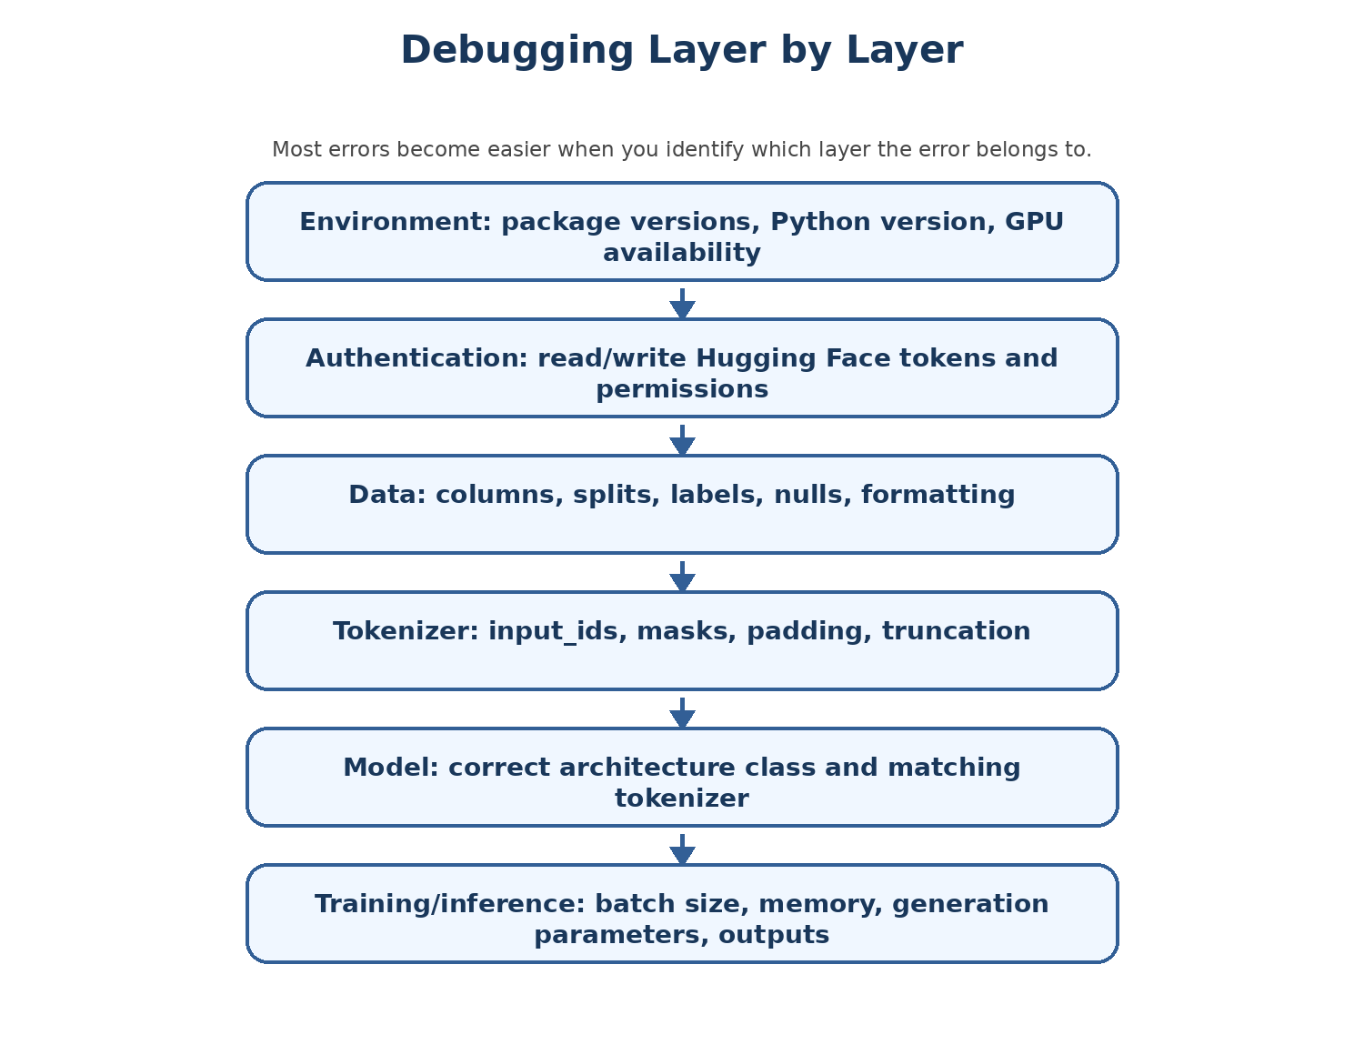
Figure 14 - Debug layer by layer instead of guessing.

Authentication errors
Symptom | Likely cause | Fix
401 Unauthorized | Missing/invalid token or no permission. | Login again, check token, request access for gated repo.
Write operation fails | Using read token for upload/create repo. | Use write token only when needed.
Gated model/dataset error | Repo requires approval or license acceptance. | Visit model/dataset page and request/accept access.

Tokenizer/model mismatch
If you load tokenizer from one model and model from another, the IDs may not match the model vocabulary. Sometimes code runs but quality is wrong. Use the same model name unless you have a deliberate advanced reason.
# Better pattern
model_name = "bert-base-uncased"
tokenizer = AutoTokenizer.from_pretrained(model_name)
model = AutoModel.from_pretrained(model_name)

Shape confusion
Shape | Meaning
[batch_size, sequence_length] | input_ids or attention_mask.
[batch_size, sequence_length, hidden_size] | BERT hidden states.
[batch_size, sequence_length, vocab_size] | CausalLM or MaskedLM logits.
[embedding_dim] | One sentence embedding vector.
[1, embedding_dim] | One embedding converted into batch form by unsqueeze(0).

Memory errors
- Use a smaller model for learning.
- Reduce batch size.
- Use streaming or smaller dataset subsets.
- Use quantization or QLoRA for larger models.
- Avoid loading multiple large models in the same notebook session.

Dataset errors
- Print dataset and dataset["train"][0] before writing transformations.
- Check column_names before map/filter.
- Handle missing values.
- Test map/filter on a small subset first.
- Use deterministic seeds when debugging.

Generation output problems
- If output is too short, increase max_new_tokens.
- If output is repetitive, try repetition_penalty or adjust sampling.
- If output is random, lower temperature or set do_sample=False.
- If model ignores instruction format, use the correct chat template or prompt format for that model.
- If response is poor, confirm model is instruction-tuned/chat-tuned, not just a base model.

Chapter 26: Full Pipeline View: From Raw Data to Useful AI System
By now, you have seen many pieces. This chapter combines them into end-to-end workflows.

Workflow A: Use an existing model for inference
Choose model -> Load tokenizer -> Load model -> Tokenize prompt -> Run model -> Decode output
- Good for quick experiments.
- Requires no custom training.
- Quality depends heavily on selected model and prompt.

Workflow B: Build a text classification model
Load labeled dataset -> inspect labels -> tokenize -> choose AutoModelForSequenceClassification -> train ->
evaluate -> save
- Good for sentiment, intent, category prediction.
- Requires labeled data.
- BERT-style models are often good for this.

Workflow C: Build an SFT fine-tuned assistant
Collect instruction-output data -> clean -> format prompts -> choose base model -> LoRA/QLoRA config -> train
-> evaluate -> save adapter/model
- Good for task-specific assistant behavior.
- Requires high-quality examples.
- Do not use this just to store changing facts.

Workflow D: Build a RAG system
Collect documents -> chunk -> embed chunks -> store in vector DB -> retrieve relevant chunks -> send context +
question to LLM -> answer
- Good for private documents and changing knowledge.
- Requires chunking and retrieval quality.
- Can provide source-grounded answers.

Workflow E: Hybrid system
Many production systems combine methods. For example, a model may be instruction-tuned for company response style and also use RAG to retrieve current policy documents. Fine-tuning teaches behavior; RAG supplies facts.

Chapter 27: Revision Sheets

One-page mental model
AI system using Hugging Face:

Data -> Dataset -> Tokenizer -> Model -> Head -> Output

Training path:
Raw/SFT/preference data -> tokenize -> train/fine-tune -> evaluate -> save/push

RAG path:
Documents -> chunks -> embeddings -> retrieval -> prompt context -> LLM answer

Cheat sheet: Hugging Face classes
Class/function | Library | Use
HfApi | huggingface_hub | Interact with Hub metadata/repos/uploads.
list_repo_files | huggingface_hub | List files in repo.
snapshot_download | huggingface_hub | Download repo snapshot locally.
InferenceClient | huggingface_hub | Call hosted inference/chat API.
load_dataset | datasets | Load public/local dataset.
Dataset.from_pandas | datasets | Convert DataFrame to Dataset.
AutoTokenizer | transformers | Load tokenizer for model.
AutoModel | transformers | Load base model hidden states.
AutoModelForMaskedLM | transformers | BERT-style masked prediction.
AutoModelForCausalLM | transformers | GPT/Llama-style generation.
SentenceTransformer | sentence-transformers | Create sentence/document embeddings.

Cheat sheet: data types
Data type | Columns/example | Used for
Raw text | text | Pretraining/continued pretraining.
Classification | text, label | Classifier training/evaluation.
Instruction/SFT | instruction, input, output | Instruction tuning.
Preference | prompt, chosen, rejected | DPO/RLHF-like training.
RAG chunks | chunk_text, source, embedding | Retrieval.

Cheat sheet: shapes
Object | Typical shape | Meaning
input_ids | [batch, seq_len] | Token IDs.
attention_mask | [batch, seq_len] | Real tokens vs padding.
last_hidden_state | [batch, seq_len, hidden] | Contextual token vectors.
logits | [batch, seq_len, vocab] | Raw token prediction scores.
sentence embedding | [384] or [768] etc. | One vector for semantic similarity/search.

Chapter 28: Interview Questions and Self-Test

Beginner questions
- What is the difference between AI, ML, deep learning, generative AI, and LLM?
- Why does text need to be converted into numbers before going into a model?
- What is a tokenizer?
- What are input_ids, attention_mask, and token_type_ids?
- What is the difference between training and inference?
- What is the difference between fine-tuning and RAG?

Hugging Face questions
- What is Hugging Face Hub?
- What is HfApi used for?
- Why should you inspect model_info before downloading a model?
- What is the difference between a read token and a write token?
- What does list_repo_files show?
- Why should sensitive datasets be pushed only to private repos?

Dataset questions
- What is a DatasetDict?
- What is the purpose of train/validation/test splits?
- What is the difference between map and filter?
- Why is streaming useful?
- What is the difference between pretraining data, SFT data, and preference data?
- How would you convert a company PDF into SFT data? How would you convert it into RAG data?

Transformer/BERT questions
- What is self-attention?
- What are query, key, and value?
- Why does a transformer need positional information?
- What is the difference between encoder-only, decoder-only, and encoder-decoder models?
- Why is BERT good for understanding tasks but not naturally a chat generator?
- What is the shape of BERT last_hidden_state?

Fine-tuning questions
- What is SFT?
- What problem does LoRA solve?
- How is QLoRA different from LoRA?
- What is DoRA at a high level?
- What is preference data?
- How is DPO simpler than classic RLHF?
- What are the major steps in an Unsloth-style fine-tuning pipeline?

Chapter 29: Practice Projects

Project 1: Hugging Face Explorer
Goal: build a notebook that searches models, prints metadata, lists files, and explains whether a model is suitable for a chosen task.
- Use HfApi.list_models.
- Use model_info.
- List repo files.
- Write a short model selection report.

Project 2: Dataset Cleaning Lab
Goal: load IMDB, inspect columns, create short-review subset, add word_count, and save a small cleaned dataset.
- Use load_dataset.
- Use features and column_names.
- Use filter and map.
- Use select for a small reproducible subset.

Project 3: Tokenizer Comparison
Goal: compare how BERT, GPT-2, T5, and Qwen tokenize the same sentences.
- Print tokenizer class.
- Print tokens.
- Print input IDs.
- Explain differences in plain English.

Project 4: BERT Internals Report
Goal: load BERT, print config, inspect attention modules, run one sentence, and explain output shape.
- Use AutoModel.
- Print hidden_size, layers, heads, intermediate_size.
- Explain [batch, seq_len, hidden].

Project 5: Mini RAG Prototype
Goal: create a tiny semantic search system with 10 short paragraphs and SentenceTransformer embeddings.
- Encode documents.
- Encode query.
- Compute cosine similarity.
- Return top matching paragraph.
- Explain how this becomes RAG when connected to an LLM.

Project 6: SFT Data Design
Goal: convert a small FAQ or policy document into 20 instruction/input/output examples.
- Ensure answers are correct.
- Use consistent prompt format.
- Create train/validation split.
- Do not include sensitive information.

Chapter 30: Glossary
Term | Meaning
Adapter | Small trainable module added to a frozen or mostly frozen base model.
Attention mask | Array that tells the model which tokens are real and which are padding.
AutoModel | Transformers class that loads a base model without a task head.
BERT | Encoder-only transformer model strong for text understanding tasks.
BPE | Byte Pair Encoding, a tokenization method that merges frequent pieces.
CausalLM | Model head/class for left-to-right next-token generation.
Cosine similarity | Measure of vector direction similarity, used in embeddings/RAG.
DatasetDict | Collection of dataset splits such as train/test.
DPO | Direct Preference Optimization, preference tuning from chosen/rejected pairs.
Embedding | Vector representation of a token, sentence, or document.
Fine-tuning | Further training an existing model on specific data.
HfApi | Python interface to Hugging Face Hub operations.
Hidden size | Number of dimensions in a model hidden vector.
Inference | Using a trained model to produce output without updating weights.
Instruction tuning | Training on instruction/input/output examples.
LoRA | Low-Rank Adaptation, an efficient fine-tuning method.
MaskedLM | Model trained/headed to predict masked tokens.
PEFT | Parameter-Efficient Fine-Tuning.
QLoRA | Quantized LoRA, memory-efficient fine-tuning with quantized base model.
RAG | Retrieval-Augmented Generation.
RLHF | Reinforcement Learning from Human Feedback.
SFT | Supervised Fine-Tuning.
Token | Text piece used by tokenizer.
Tokenizer | Converts text to token IDs and back.
Transformer | Neural architecture using attention and feed-forward layers.
Unsloth | Framework used to speed up and reduce memory usage in LLM fine-tuning workflows.
WordPiece | Tokenization method used by BERT.

Chapter 31: Final Summary
The class material is not only about code. It is about learning the complete mental model of modern LLM workflows. Hugging Face provides the ecosystem. Datasets provide the training and evaluation examples. Tokenizers convert language into numbers. Transformers process vectors with attention. Model heads convert representations into task outputs. Fine-tuning adapts behavior. RAG supplies external knowledge at runtime.

The final mental model
For model understanding:
Text -> Tokenizer -> Token IDs -> Embeddings -> Transformer layers -> Model head -> Output

For training/fine-tuning:
Data -> Format -> Tokenize -> Train/adapt -> Evaluate -> Save/push/deploy

For RAG:
Documents -> Chunks -> Embeddings -> Retrieval -> Context + Question -> LLM answer

What you should be able to explain now
- What Hugging Face is and how Hub, transformers, datasets, tokenizers, and APIs connect.
- How to inspect models and datasets before downloading or using them.
- How datasets are loaded, inspected, transformed, streamed, and pushed.
- How pretraining data, SFT data, and preference data differ.
- How tokenization turns text into input_ids, attention masks, and embeddings.
- How BPE, WordPiece, and SentencePiece differ at a beginner level.
- How transformer layers use embeddings, positional information, self-attention, and feed-forward networks.
- Why BERT is encoder-only and what BERT Base dimensions mean.
- Why AutoModel, MaskedLM, CausalLM, classification heads, and embedding models are different.
- How LoRA, QLoRA, DoRA, RLHF, DPO, Unsloth, and RAG fit into the fine-tuning/GenAI roadmap.
Final advice: Do not try to memorize every syntax line. Learn the pipeline and the purpose of each object. Once the mental model is clear, the syntax becomes searchable and understandable.

Chapter 32: Practical Lab Walkthrough from Personal Notes
This chapter integrates the additional personal notes from the class. The earlier chapters already explain Hugging Face, datasets, tokenizers, transformers, BERT, and fine-tuning conceptually. This chapter adds a hands-on, screenshot-driven walkthrough of what the instructor demonstrated: creating repositories, inspecting model files, uploading files, creating/pushing custom datasets, training a custom tokenizer, comparing tokenizers, and relating all of this back to BERT.
Learning goal: After this chapter, a beginner should not only know the theory, but also understand what they are seeing inside the Hugging Face website and why each repository file exists.

32.1 What the Personal Notes Add to the Manual
The personal notes emphasize the practical side of Hugging Face: how to create a model repository from the website, how trained model files appear in the “Files and versions” tab, how to use the Python API to create a repo and upload files, how custom datasets are pushed to the Hub, and how custom tokenizer training connects to BPE and BERT.
- Hugging Face is not only a Python library; it is also a hosting platform for models, datasets, tokenizers, metadata, and demos.
- A model repository is like a GitHub repository for model artifacts: weights, configuration files, tokenizer files, README/model card, and metadata.
- A dataset repository stores dataset files and dataset metadata. When pushed through the datasets library, the data is often stored as Parquet shards on the Hub.
- A tokenizer is a separate but essential component. A model cannot correctly understand text unless the correct tokenizer converts that text into token IDs in the format expected by the model.
- BERT is an encoder model. Its dimensions such as hidden size, number of layers, and number of attention heads explain the shape of tensors seen in the notebook.

32.2 Creating a Hugging Face Model Repository from the Website
A repository on Hugging Face is a place where you store the files related to a model, dataset, or Space. The personal notes show the web-based path for creating a new model repository. This is useful because beginners often think all Hugging Face work must happen through Python, but the website is equally important for browsing, validating, sharing, and managing artifacts.
1. Go to the Hugging Face website and sign in.
2. Open your profile menu.
3. Choose New Model when you want to create a model repository.
4. Enter a model name.
5. Choose a license if you plan to share the model. The license tells others what they are allowed to do with it.
6. Choose whether the repository should be public or private.
7. Click Create Model.
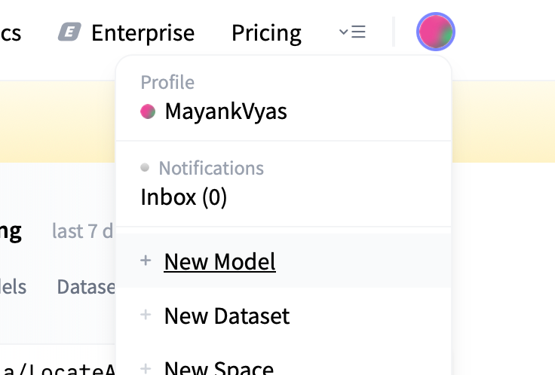
Figure 32.1 - Personal notes screenshot: profile menu showing the New Model option.
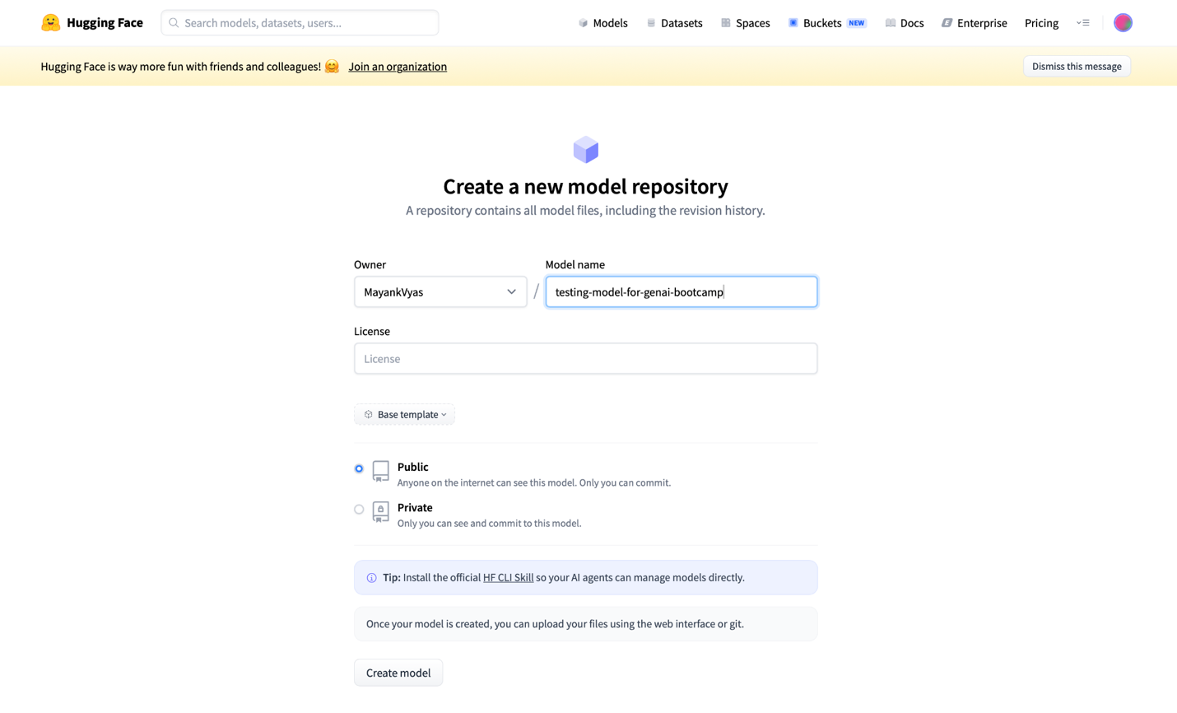
Figure 32.2 - Personal notes screenshot: model repository creation screen.
Plain English analogy: Think of a Hugging Face model repository like a labeled folder in the cloud. If you train a model on your laptop or in Colab, the trained files need to live somewhere. The repository is where those files can be stored, versioned, downloaded, and reused.

32.3 Model Repository Files: What You See in “Files and versions”
After a repository is created, the important tab is “Files and versions.” This is where the actual model-related files appear. In a trained model repository, you may see files such as:
- model weight files, often in .safetensors format
- config.json, which describes model architecture settings
- tokenizer.json or tokenizer.model, depending on the tokenizer type
- tokenizer_config.json and special_tokens_map.json
- README.md, often called the model card
- generation_config.json for generation-related defaults in some model families
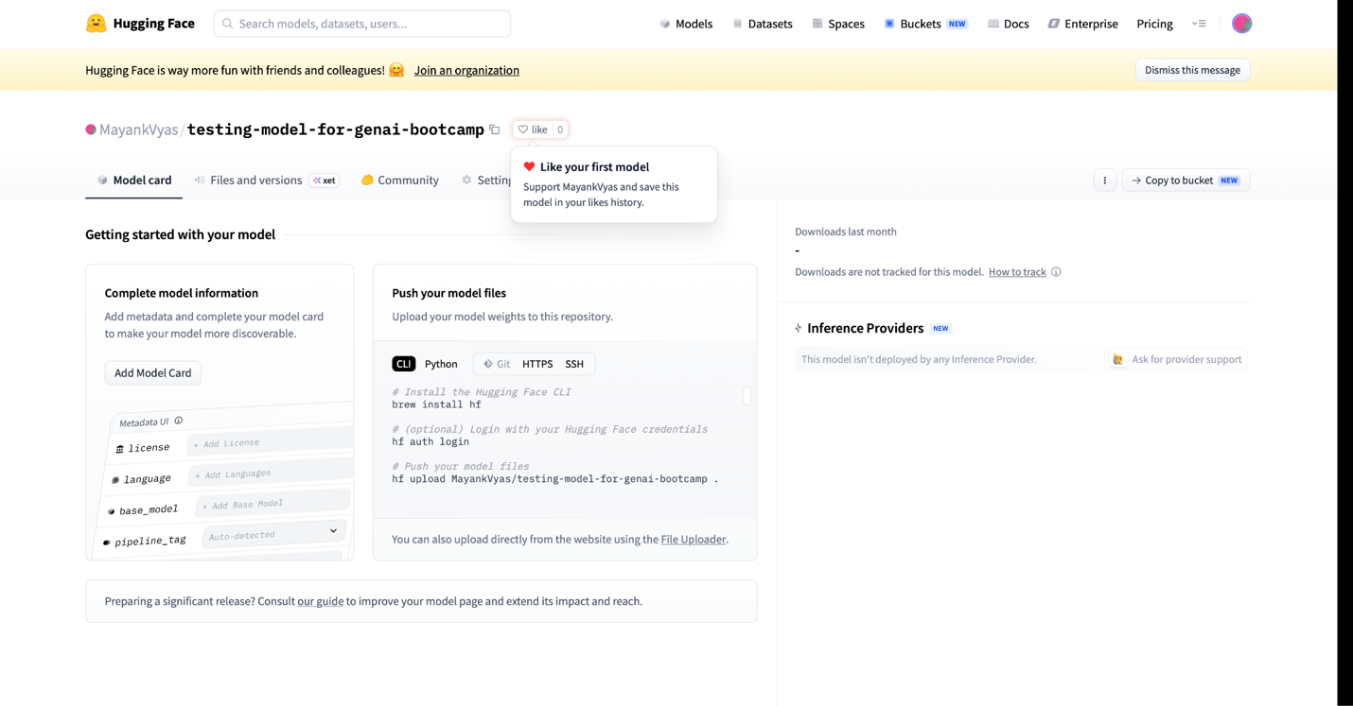
Figure 32.3 - Personal notes screenshot: model repository metadata and Files and versions area.
Important correction and clarification: The personal notes say that “why so many files” may be because the model has different versions. That can be partly true because repositories maintain version history. However, in large model repositories, many files often exist because the model is sharded. A very large model may be split into several .safetensors files so that each file remains manageable.
Factually accurate interpretation:
- .safetensors files usually contain trained model weights in a safer and efficient tensor serialization format.
- Multiple .safetensors files may represent shards of one model, not necessarily different models.
- .json files usually contain configuration or metadata. For example, config.json tells Transformers how to construct the model architecture before loading weights.
- The repository’s commit history gives versioning, similar to Git.

32.4 Creating a Model Repository Using Python
The same repository can also be created through code using HfApi from the huggingface_hub library. This is useful when you want to automate model publishing from Colab, a training script, or a CI/CD pipeline.
from huggingface_hub import HfApi

api = HfApi()

api.create_repo(
repo_id="MayankVyas/mytestingrepoformodel", # full namespace/repo-name
repo_type="model", # model repo; default is also model
private=False # True means only authorized users can see it
)
Line-by-line explanation:
- HfApi is the Python client used to talk to the Hugging Face Hub.
- repo_id includes the username or organization name plus the repository name.
- repo_type="model" tells Hugging Face that this is a model repository, not a dataset or Space.
- private=False makes the repository public. Use private=True for private company or personal work.
Practical reminder: To create or upload files to a repository, your environment must be authenticated with a Hugging Face token that has write permission. In Colab, this is commonly done with login() or by setting HF_TOKEN as an environment variable.

32.5 Uploading a File to the Model Repository
After a repository exists, you can upload files programmatically. The personal notes show uploading dataset_info.json into the repository. In real model publishing, you may upload model weights, tokenizer files, configuration files, or any supporting artifact.
api.upload_file(
path_or_fileobj="/content/test_file/dataset_info.json",
path_in_repo="dataset_info.json",
repo_id="MayankVyas/mytestingrepoformodel"
)
- path_or_fileobj is the local path to the file in your Colab/runtime machine.
- path_in_repo is the path and filename that should appear inside the Hugging Face repository.
- repo_id identifies the target repository.
- If the upload succeeds, the file appears in the repository’s Files and versions tab.
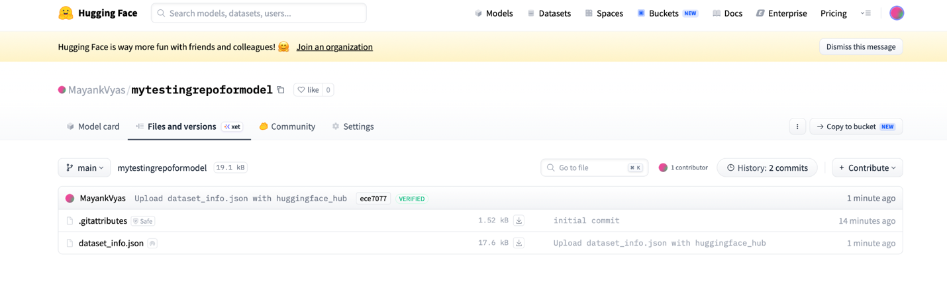
Figure 32.4 - Personal notes screenshot: uploaded file visible in the Hugging Face repository.
Beginner mental model: The Python API is doing the same thing you might do manually in the website upload screen. It is simply easier to automate when working from notebooks or training scripts.

32.6 Custom Dataset: From Local Data to Hugging Face Dataset Repository
The personal notes also demonstrate creating a custom dataset and pushing it to Hugging Face. This is one of the most important workflows for training, evaluation, RAG experiments, and fine-tuning.
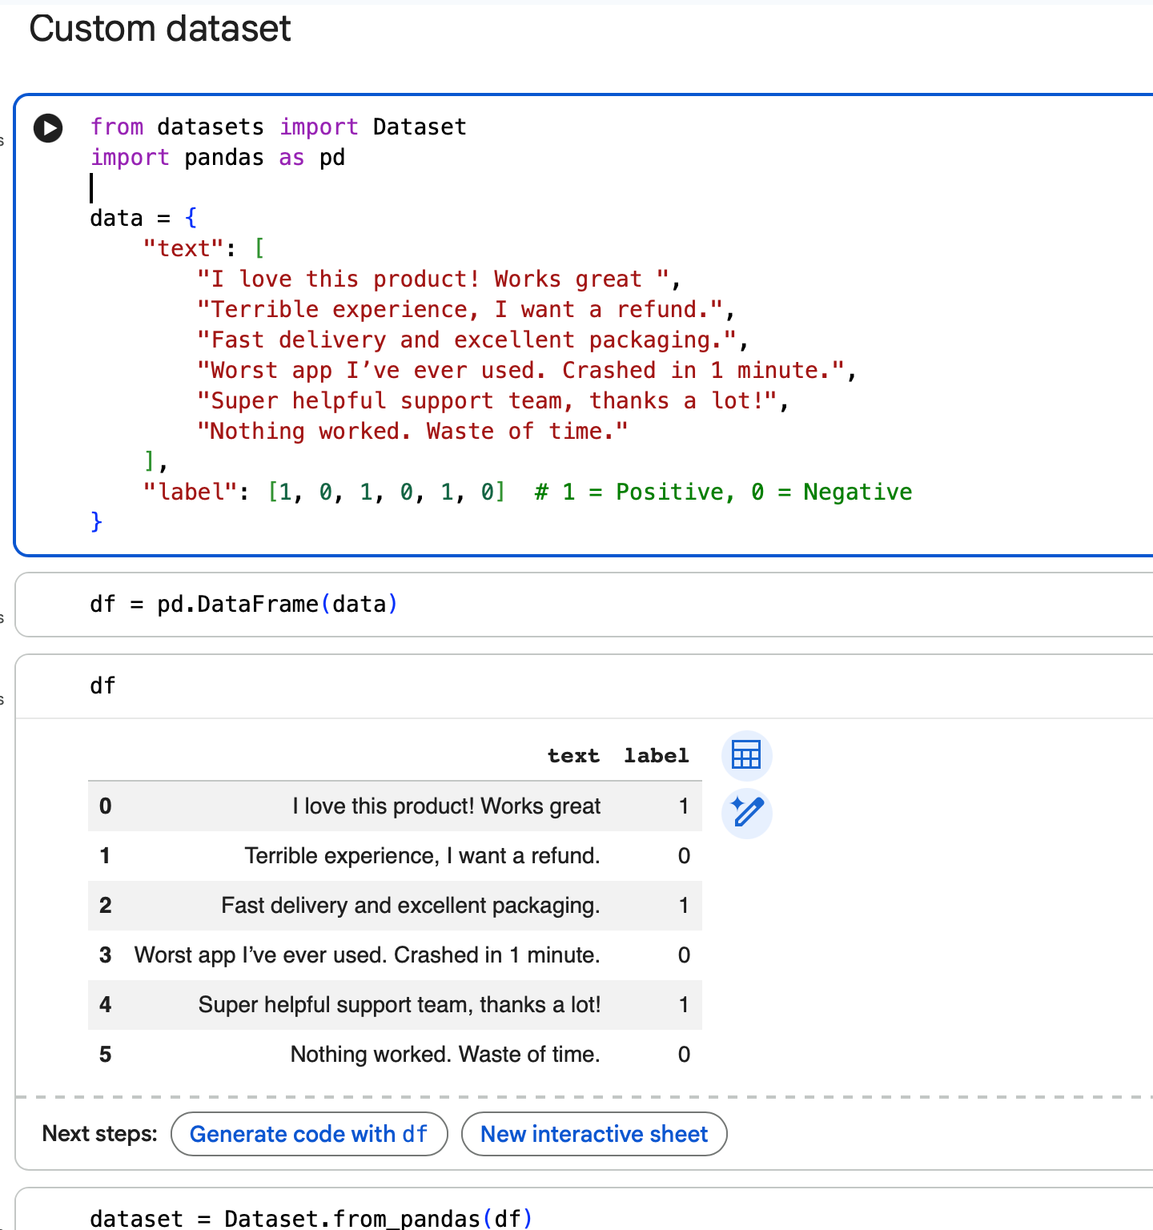
Figure 32.5 - Personal notes screenshot: small custom dataset structure.
A custom dataset can start as a Python dictionary, a pandas DataFrame, a CSV file, a JSON file, or another structured source. The important requirement is that the final structure should be clear and consistent.
from datasets import Dataset
import pandas as pd

# Example local data
df = pd.DataFrame({
"text": [
"I love transformers.",
"Hugging Face makes model sharing easier."
],
"label": [1, 1]
})

# Convert pandas DataFrame into a Hugging Face Dataset
dataset = Dataset.from_pandas(df)

# Push the dataset to the Hub
dataset.push_to_hub("MayankVyas/mytestingdataset")
Why this matters: A model learns from examples. If your company or project has its own examples, you often need to convert that data into a dataset format that training or evaluation code can consume.
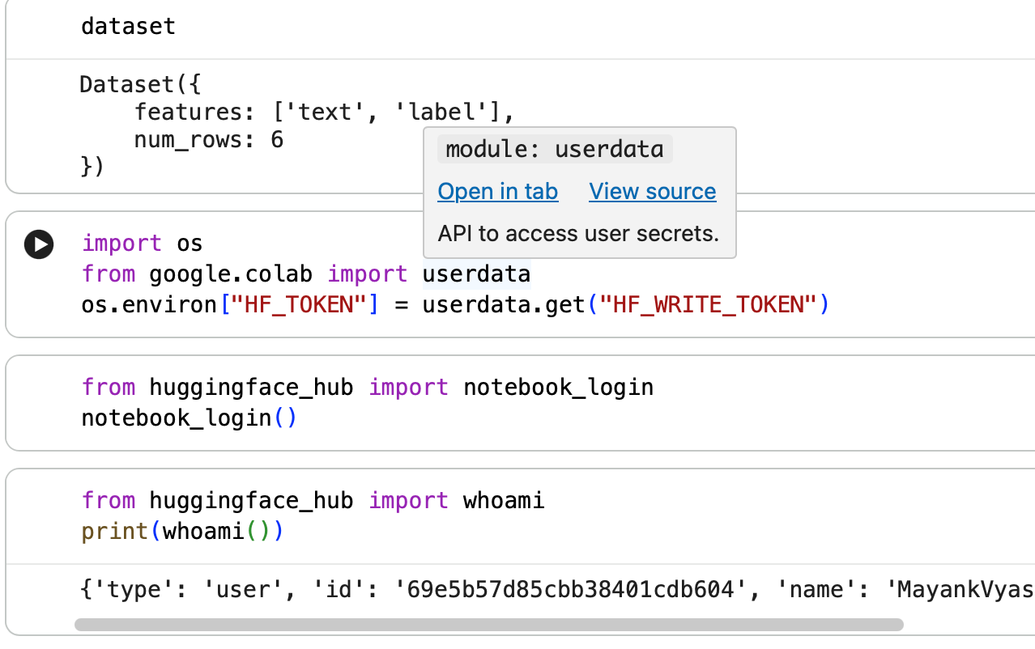
Figure 32.6 - Personal notes screenshot: dataset push-to-hub workflow from notebook.
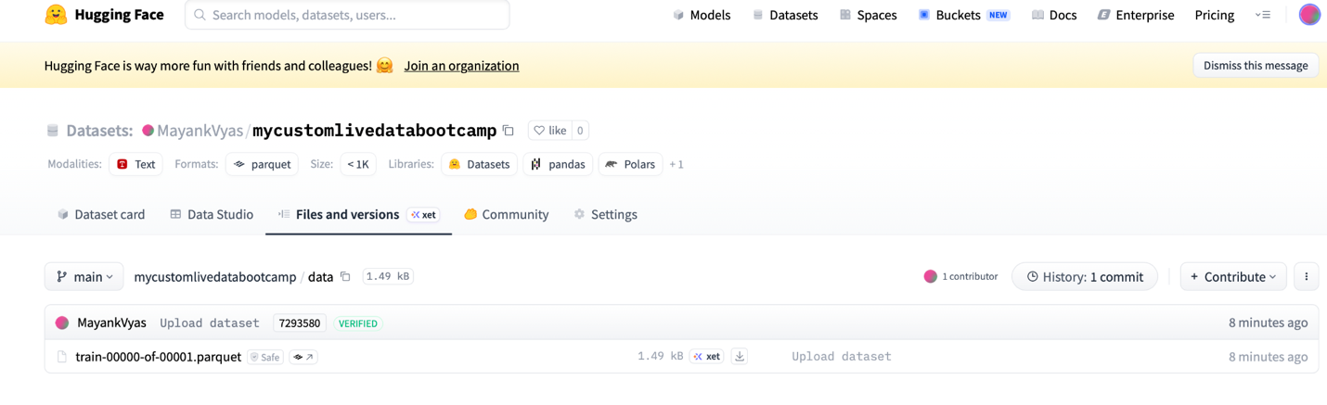
Figure 32.7 - Personal notes screenshot: dataset repository files after push.

32.7 Dataset File Formats: What Is Correct and What to Remember
The personal notes list CSV, XLSX, TSV, JSON, Parquet, ORC, and binary formats. The practical, factually careful way to remember this is: Hugging Face can work with many data sources, but the most common and directly supported formats in Hugging Face Datasets workflows are CSV, JSON, Parquet, text files, image folders, and audio folders. Excel files are common in business, but usually you read them with pandas first and then convert them into a Dataset.
Format | How to think about it | Common use
CSV / TSV | Simple tabular text files | Small and medium datasets, quick experiments
JSON / JSONL | Structured records; JSONL is common for one example per line | Instruction tuning, chat data, logs
Parquet | Columnar big-data format; efficient for storage and reading | Large datasets on the Hub; push_to_hub often stores dataset shards as Parquet
XLSX | Excel workbook format | Business source data; usually read with pandas before converting
Arrow | Columnar in-memory/on-disk format used internally by datasets | Efficient processing behind the scenes
Images/audio folders | Folder-based media datasets | Vision/audio/multimodal tasks
Key clarification: When you call push_to_hub on a Dataset, the Hub may display Parquet files under Files and versions. That does not mean your original file had to be Parquet. It means the dataset was stored efficiently for hosting and loading.

32.8 Custom Tokenizer Training Pipeline
The personal notes contain a separate section on the custom tokenizer training pipeline. This is important because tokenization is the first step in almost every text model pipeline. If tokenization is wrong, the model receives the wrong numbers.
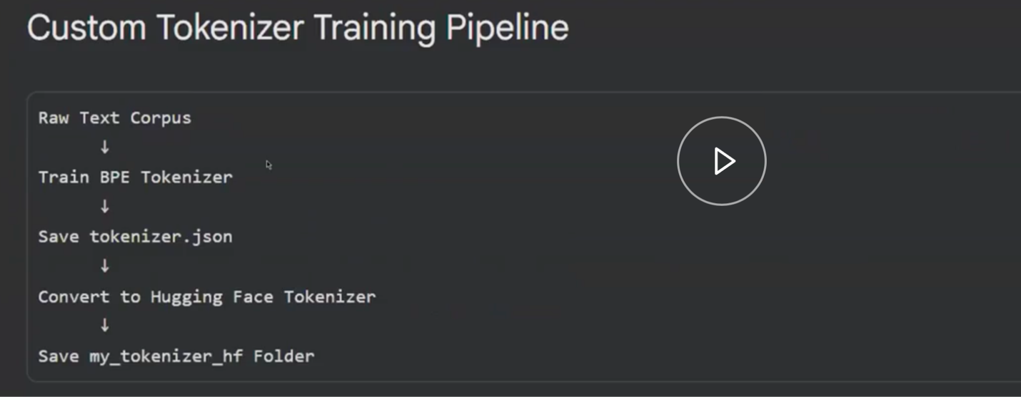
Figure 32.8 - Personal notes screenshot: custom tokenizer training pipeline overview.
The high-level tokenizer training pipeline is:
- Collect training text that represents your domain.
- Choose a tokenizer algorithm, such as BPE, WordPiece, or SentencePiece/Unigram.
- Train the tokenizer vocabulary on the text.
- Save the tokenizer files.
- Wrap or load the tokenizer in Hugging Face-compatible format.
- Use the tokenizer consistently with the model that will be trained or fine-tuned.

32.9 What BPE Means
BPE stands for Byte Pair Encoding. The intuition is simple: start with small pieces, then repeatedly merge frequent neighboring pieces into bigger pieces. Over time, common words or word parts become tokens.
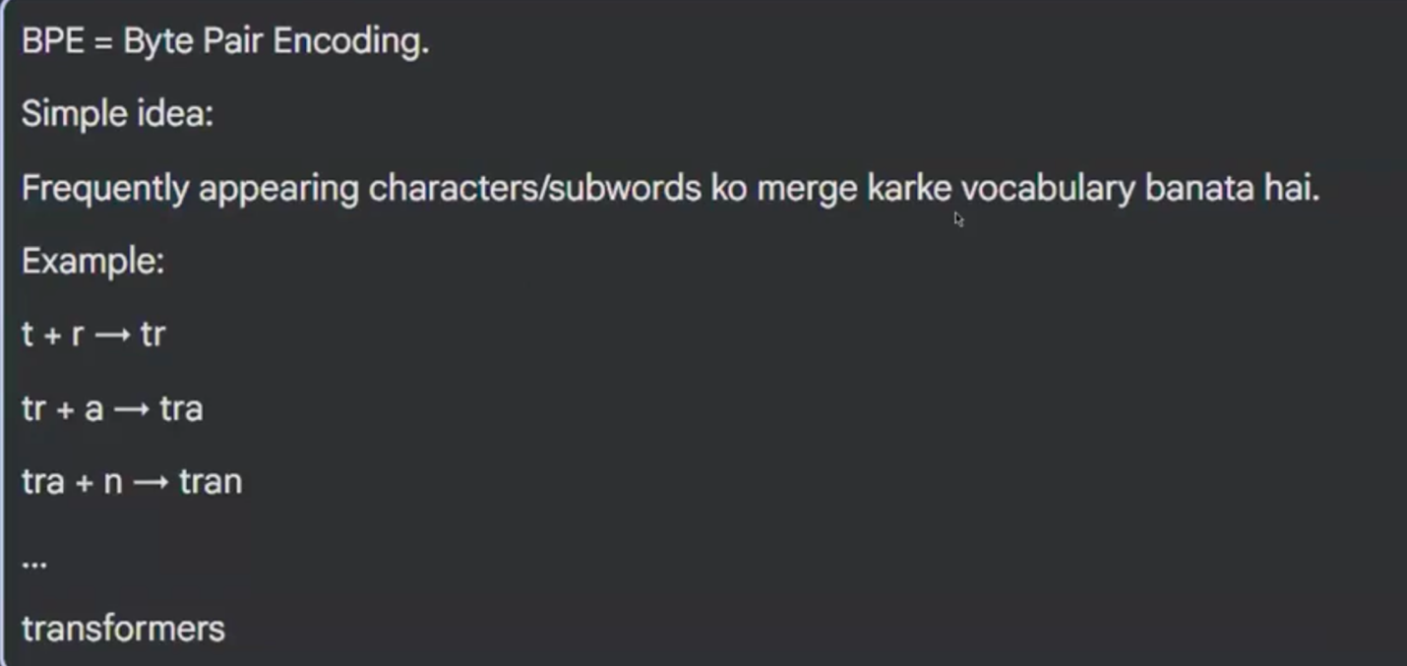
Figure 32.9 - Personal notes screenshot: BPE intuition with repeated character/substring merges.
Simple example:
Suppose the training corpus contains these words many times:
transformer
transformers
transformed

A tokenizer may learn useful pieces such as:
transform
er
ers
ed

Then an unseen word like "transforming" may still be represented using known pieces.
Why this is useful: The model does not need a separate token for every possible word. It can represent rare or new words using subword pieces. This is one reason modern LLMs can handle many words that were not explicitly seen as complete words during training.

32.10 Actual Custom Tokenizer Code: What Each Part Does
The personal notes include screenshots of the actual tokenizer code. The following cleaned version shows the same conceptual pipeline in a beginner-friendly way.
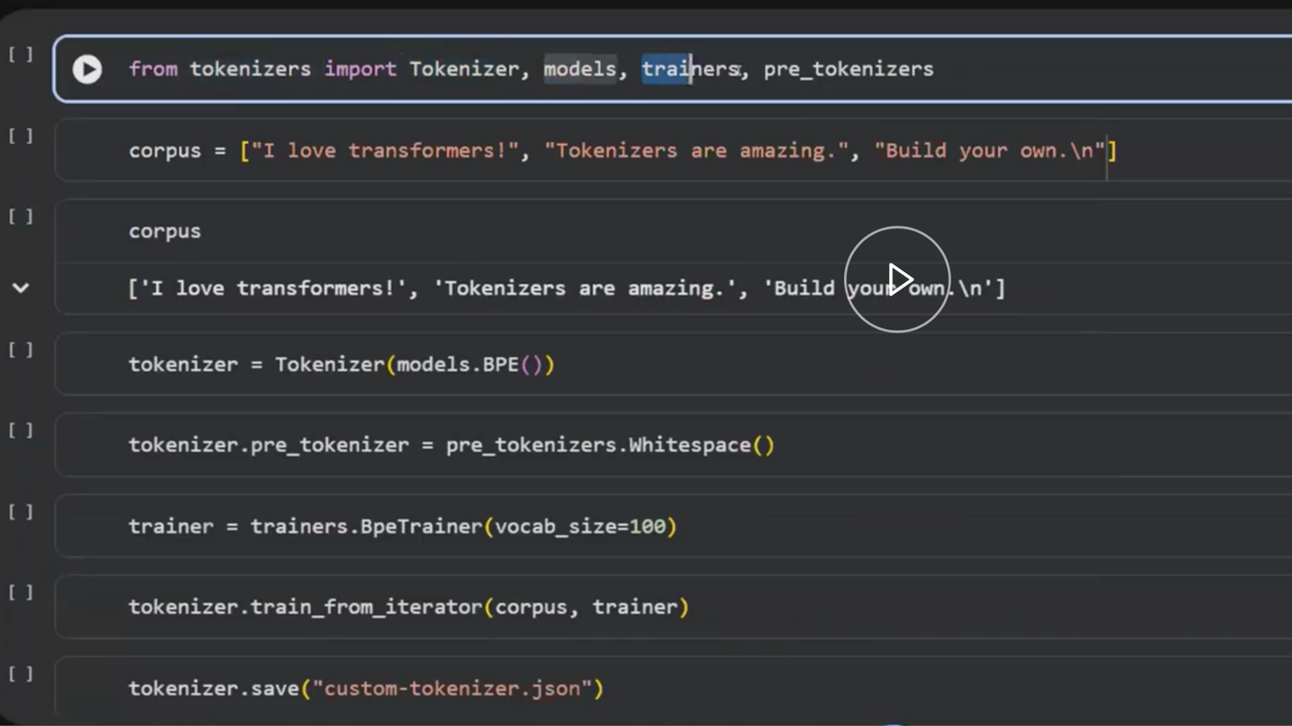
Figure 32.10 - Personal notes screenshot: tokenizer training code using BPE.
from tokenizers import Tokenizer, models, trainers, pre_tokenizers

# 1. Create a BPE tokenizer model.
tokenizer = Tokenizer(models.BPE(unk_token="[UNK]"))

# 2. Decide how raw text is first split before BPE merges are learned.
tokenizer.pre_tokenizer = pre_tokenizers.Whitespace()

# 3. Configure the trainer.
trainer = trainers.BpeTrainer(
vocab_size=1000,
special_tokens=["[UNK]", "[CLS]", "[SEP]", "[PAD]", "[MASK]"]
)

# 4. Train on text files.
tokenizer.train(files=["training_data.txt"], trainer=trainer)

# 5. Save tokenizer to disk.
tokenizer.save("custom-tokenizer.json")
- models.BPE creates the BPE algorithm object.
- unk_token="[UNK]" tells the tokenizer what to use when it cannot represent something.
- Whitespace pre-tokenization first splits text by spaces before BPE learns merges.
- vocab_size controls how many tokens the tokenizer is allowed to learn.
- special tokens are reserved tokens used by many transformer models.
- tokenizer.train learns the vocabulary and merge rules from the training corpus.
- tokenizer.save writes the trained tokenizer to a JSON file.

32.11 Saving the Custom Tokenizer in Hugging Face-Compatible Format
A tokenizer trained with the tokenizers library can be wrapped with PreTrainedTokenizerFast so that it behaves like a normal Hugging Face tokenizer. This is important because Transformers models expect tokenizers to expose standard methods and files.
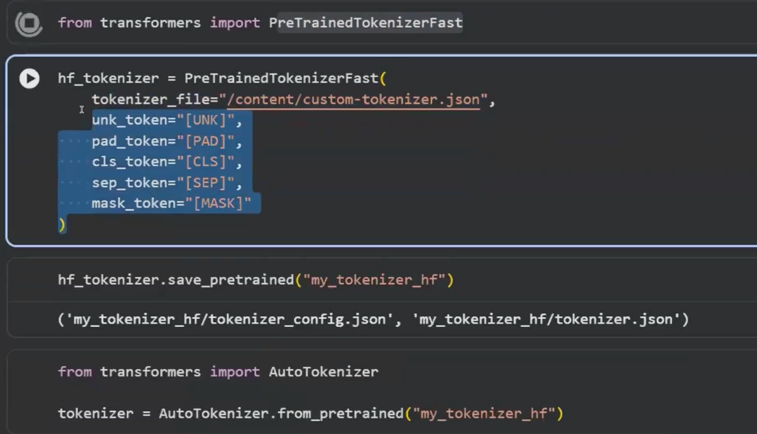
Figure 32.11 - Personal notes screenshot: wrapping and saving a tokenizer as PreTrainedTokenizerFast.
from transformers import PreTrainedTokenizerFast

hf_tokenizer = PreTrainedTokenizerFast(
tokenizer_file="custom-tokenizer.json",
unk_token="[UNK]",
cls_token="[CLS]",
sep_token="[SEP]",
pad_token="[PAD]",
mask_token="[MASK]"
)

hf_tokenizer.save_pretrained("my_custom_tokenizer")
The save_pretrained folder can later be loaded with AutoTokenizer.from_pretrained if it is saved locally or pushed to the Hugging Face Hub.
from transformers import AutoTokenizer

tokenizer = AutoTokenizer.from_pretrained("my_custom_tokenizer")

32.12 Tokenizer Comparison: Why Different Models Tokenize Differently
The personal notes include a tokenizer comparison table. The important learning point is that tokenizers are model-specific. BERT, GPT-style models, T5, Llama, Qwen, and Mistral may not split the same sentence in the same way.
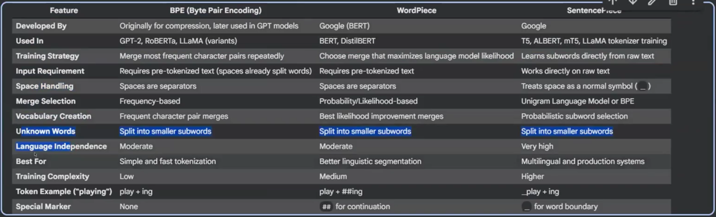
Figure 32.12 - Personal notes screenshot: tokenizer comparison across model families.
- BERT commonly uses WordPiece tokenization in the original BERT family.
- GPT-style models commonly use BPE-style tokenization.
- Many multilingual or modern models use SentencePiece or tokenizer variants designed for multiple languages.
- The exact tokenizer must match the model because token IDs are tied to the model’s embedding table.
Common mistake: Loading a tokenizer from one model and weights from another model can produce misleading results or errors. For example, using a cased tokenizer with an uncased BERT model is usually not the right setup unless you are intentionally experimenting.

32.13 BERT Model Notes from the Personal Notes
The personal notes also include a BERT reminder. BERT is an encoder model. It is excellent for understanding tasks such as classification, masked word prediction, semantic similarity, named entity recognition, and question answering. It is not normally used as a chat-style text generator because it was not trained as a left-to-right causal language model.
Figure 32.13 - Personal notes screenshot: BERT Base and BERT Large size notes.
- BERT Base has 12 transformer encoder layers, hidden size 768, 12 attention heads, and about 110 million parameters.
- BERT Large has 24 transformer encoder layers, hidden size 1024, 16 attention heads, and about 340 million parameters.
- The hidden size explains why BERT Base token vectors often have length 768.
- The number of layers explains why BERT processes text through repeated attention + feed-forward blocks.
- The number of attention heads explains how each layer can attend to multiple types of relationships in parallel.
Beginner translation: If BERT Base receives a sentence of 10 tokens, its final hidden output has a vector for each token. Each vector has 768 numbers. That is why model outputs often look like [batch_size, sequence_length, 768].

32.14 Practical Lab Checklist
Use this checklist when repeating the lab yourself.
- Can you create a Hugging Face model repository from the website?
- Can you identify the Files and versions tab?
- Can you explain what .safetensors, config.json, tokenizer files, and README.md are used for?
- Can you create a model repository with HfApi.create_repo?
- Can you upload a file with HfApi.upload_file?
- Can you create a small Dataset from pandas or a Python dictionary?
- Can you push that dataset to the Hub?
- Can you explain why dataset files may appear as Parquet on the Hub?
- Can you train a tiny BPE tokenizer on a small text file?
- Can you save and reload the tokenizer using Hugging Face-compatible APIs?
- Can you explain why tokenizers must match models?
- Can you explain the meaning of BERT Base: 12 layers, 768 hidden size, 12 attention heads?

32.15 Fact-Check and Clarification Table
The following table converts quick personal notes into precise technical understanding.
Personal-note idea | Correct interpretation | Why it matters
.safetensors are model binary files | Correct: .safetensors commonly store model tensor weights in a safe serialization format. | These are usually the largest and most important trained model files.
Many files may mean different versions | Sometimes, but many files may also be weight shards, tokenizer files, configs, or metadata. Versioning is handled through repository history. | Avoid confusing shards/files with model versions.
.json contains metadata | Often correct, but different JSON files have different roles: config.json describes architecture, tokenizer_config.json describes tokenizer behavior, generation_config.json describes generation defaults. | Each JSON file supports loading or using the model correctly.
Custom dataset pushed to Hub appears as Parquet | Common and expected: datasets pushed with the datasets library are often stored as Parquet shards. | Parquet is efficient for hosting and loading large datasets.
CSV/XLSX/TSV/JSON can be used | CSV/TSV/JSON are common direct formats. XLSX is usually read through pandas and converted to a Dataset. | Business data often begins as Excel, but training pipelines prefer cleaner structured formats.
BPE learns tokenization | Correct: BPE learns frequent subword merges from training text. | This allows models to handle rare and unseen words using subword pieces.
BERT has 768 hidden units | For BERT Base, hidden size is 768. BERT Large uses 1024. | This explains tensor shapes and embedding dimensions in BERT outputs.

32.16 Mini Assignment Based on the Personal Notes
Complete this assignment to convert passive reading into active skill.
1. Create a private test model repository on Hugging Face.
2. Upload a small text file or JSON file using HfApi.upload_file.
3. Create a tiny dataset with two columns: text and label.
4. Push the dataset to a dataset repository.
5. Open the repository in the browser and inspect Files and versions.
6. Train a tiny BPE tokenizer on 10 to 20 sentences.
7. Save it with save_pretrained.
8. Reload it with AutoTokenizer.from_pretrained.
9. Tokenize the sentence: "I love transformers" and explain input_ids and attention_mask.
10. Write a one-page explanation of why tokenizer and model should normally match.

32.17 Chapter Summary
The personal notes make the class more practical. They show that Hugging Face is not just theory and not just a Python library. It is a complete workflow: create repositories, store model artifacts, push datasets, train tokenizers, inspect files, and connect all these pieces to real transformer models such as BERT. The correct mental model is:
Raw data / trained model files
↓
Local notebook or training script
↓
Hugging Face API or website
↓
Model repository / dataset repository / tokenizer folder
↓
Reusable AI artifact for inference, fine-tuning, evaluation, or sharing
Once this workflow is clear, later topics such as SFT, LoRA, QLoRA, Unsloth, RLHF, DPO, and RAG become easier because they all depend on the same foundations: clean data, correct tokenizer, correct model, and well-managed artifacts.
Version note: Hugging_Face_Class_20_Master_Study_Manual_v3 incorporates the additional PersonalNotes.docx material into the Class 20 master study manual.

