TEACHER TIME BACK LAB | FLAGSHIP DEMONSTRATION
What a teacher actually builds
The complete Weekly Lesson Setup Assistant story, from rough notes to a reviewed, reusable result.
Bring one task you keep doing. Leave with one assistant you can use again.
This demonstration is designed for teachers who are new to AI and school leaders deciding whether the lab is worth their staff's time. It shows the finished product before introducing the method.

The whole story in four states
State | What the visitor sees
1. Rough notes | A blank weekly format, uneven notes, and two short practice sources Andrew supplies.
2. Saved instructions | Five plain-language decisions that define one job and its limits.
3. First result | A useful draft with one source mistake to catch and several missing choices clearly marked.
4. Teacher revision | A corrected week, completed teaching choices, and instructions ready to reuse.
Safety boundary: This introductory lab uses no real student information, student work, grades, rosters, family records, personnel matters, or confidential files.

STATE 1 OF 4

Start with work a teacher recognizes
Andrew hands teachers a complete practice example, so the first learning step is not hunting for content or deciding what is safe to upload.
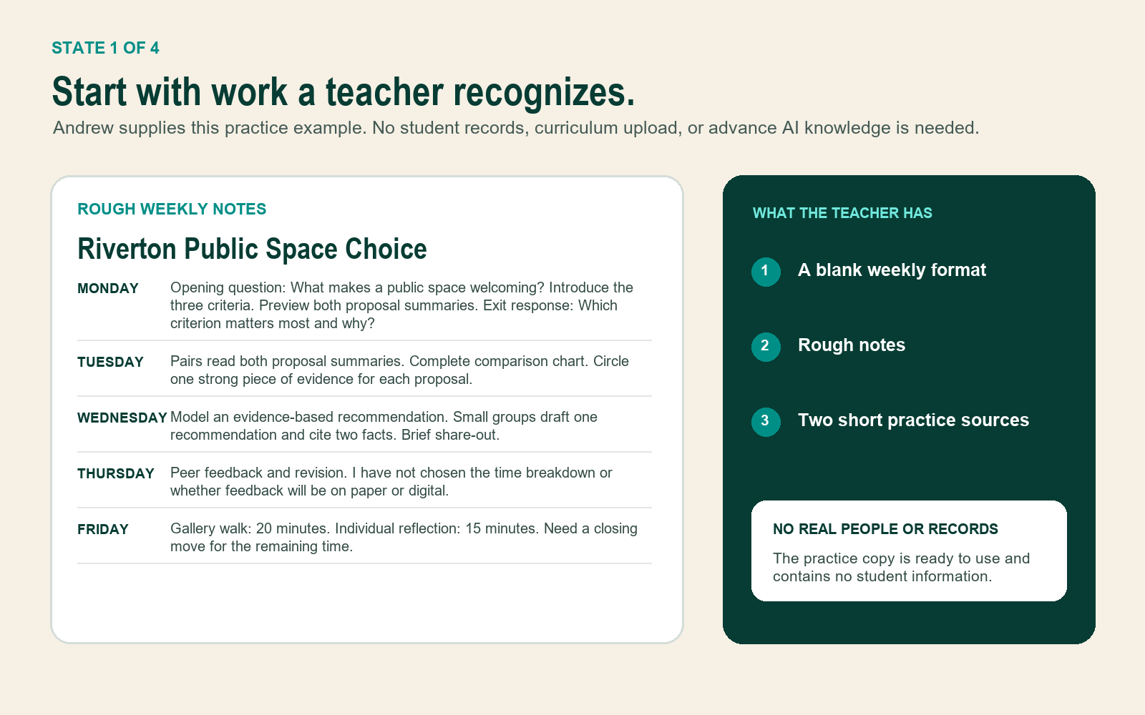
The teacher begins with a blank weekly format, rough notes, and two short practice sources.

STATE 2 OF 4

Build five instructions and save them once
The setup is a reusable set of instructions inside the AI tool and account the school allows. It is not code, a public bot, or a new platform.
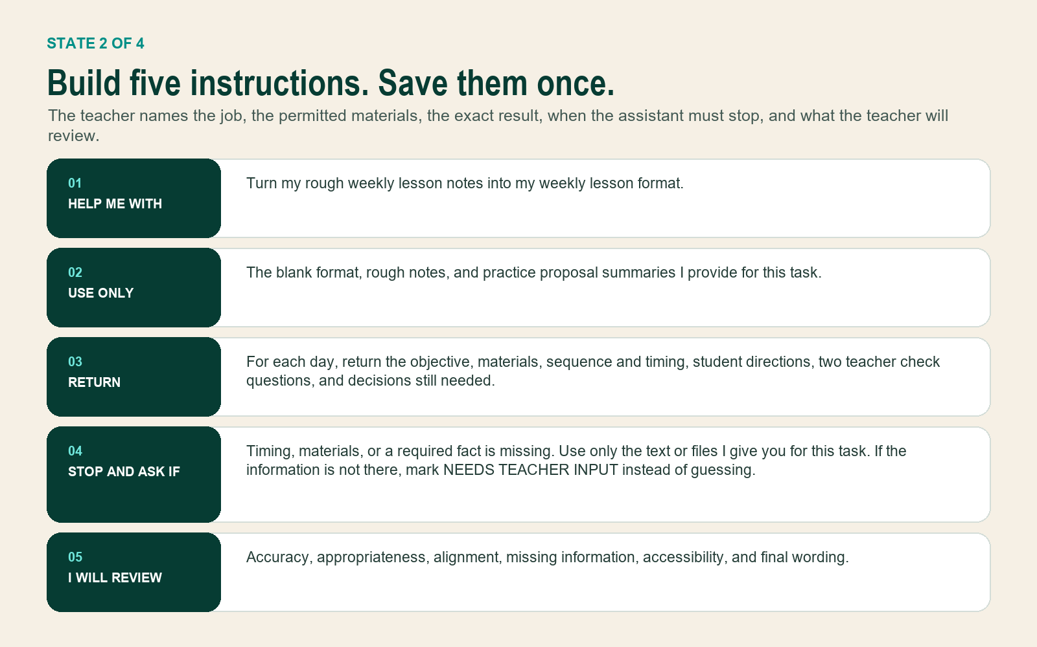
The five-part setup keeps the job, materials, result, stop rule, and teacher review visible.

The exact request used in the demonstration
Use my saved Weekly Lesson Setup Assistant instructions. Complete the blank weekly format from the rough notes and the two practice proposal summaries. Keep every claim tied to the material I provided. Mark missing decisions as NEEDS TEACHER INPUT.

STATE 3 OF 4

Inspect the first result
The first result is intentionally realistic: useful enough to reduce rebuilding, imperfect enough to prove why teacher review is non-negotiable.
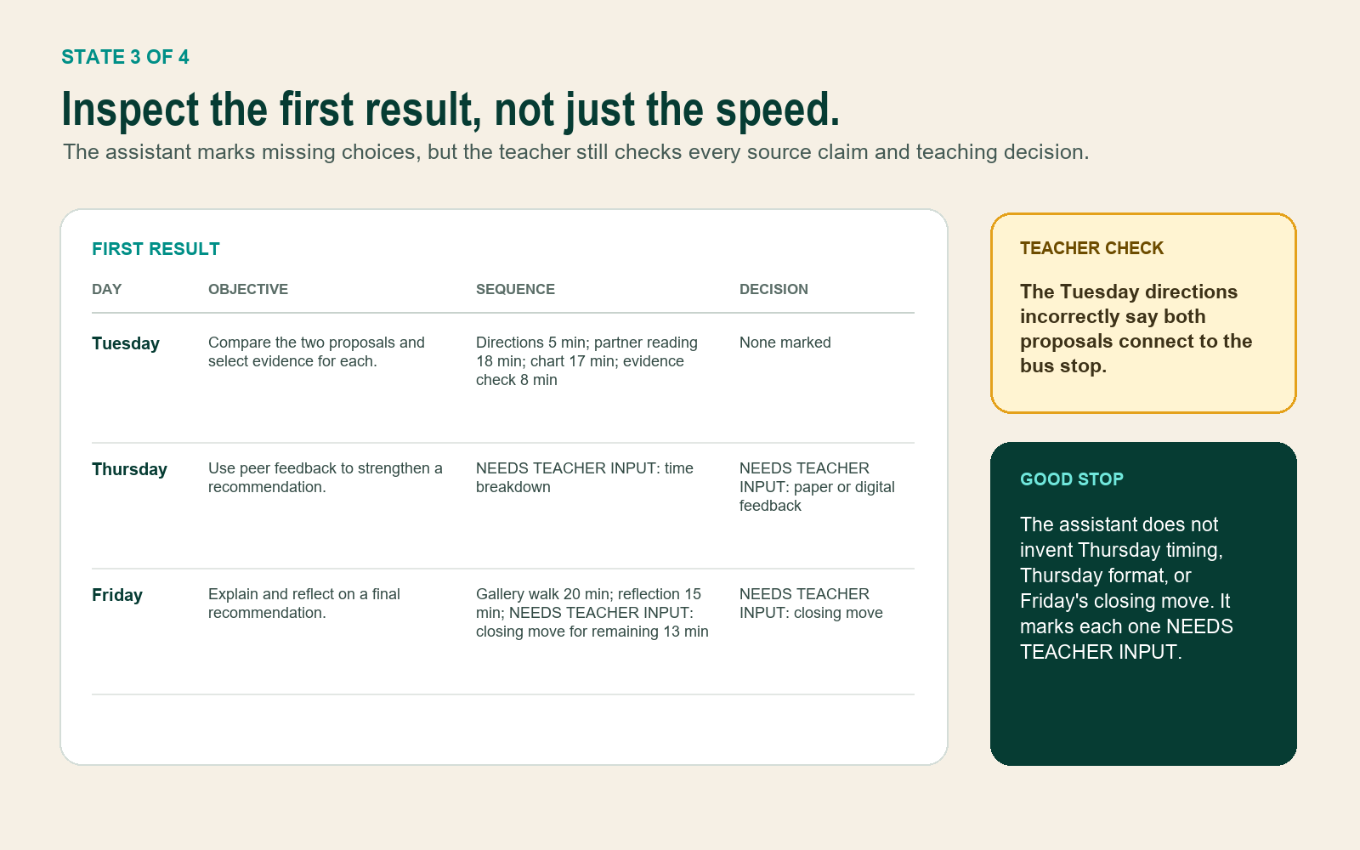
The gold note marks a source mistake to catch. The dark note shows decisions the assistant correctly left to the teacher.

What the teacher notices
- The Tuesday draft says both proposals connect directly to the bus stop. Only Library Link Plaza does.
- The assistant correctly marked Thursday timing, Thursday format, and Friday closing as teacher decisions instead of inventing them.

TEACHER REVIEW

Correct the result and complete the teaching choices
Andrew does not ask teachers to accept the first output. He models a five-question review: Is it accurate? Appropriate? Aligned? Complete? Ready in my own words?
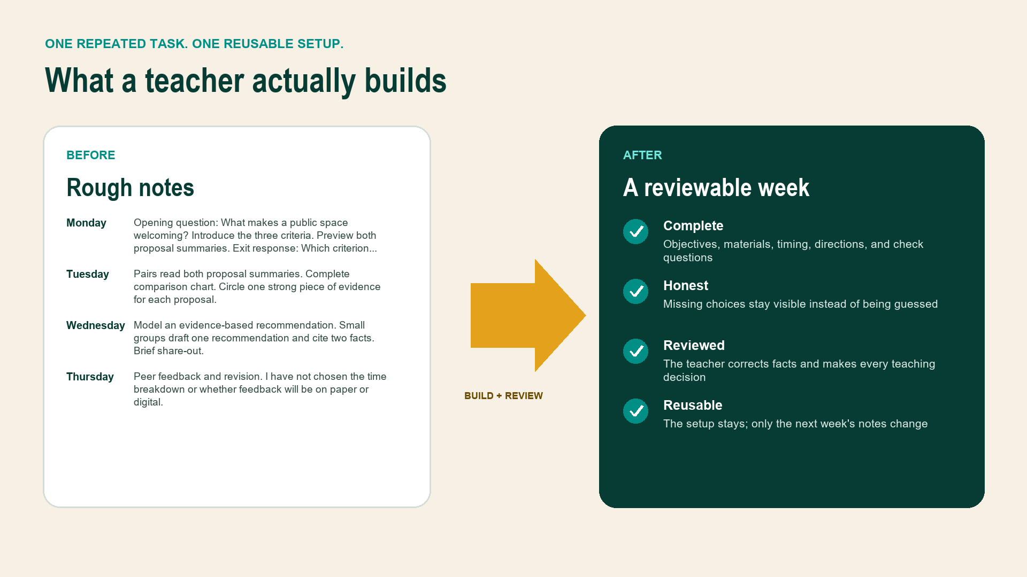
The value is not an instant answer. The value is a faster route from rough notes to a first draft the teacher can judge.

Teacher decisions in this example
- Correct Tuesday's bus-stop statement.
- Use paper feedback on Thursday.
- Set Thursday timing to 6 minutes directions, 12 minutes partner feedback, 22 minutes revision, and 8 minutes closing check.
- Use Friday's remaining 13 minutes for a 5-minute partner debrief, a 5-minute whole-group synthesis, and a 3-minute exit check.
- Display directions and read them aloud before independent work.

STATE 4 OF 4

Save the reviewed setup for next week
The teacher corrects the source mistake, fills the open choices, and keeps the same five-part setup. Next week, only the notes and task materials change.
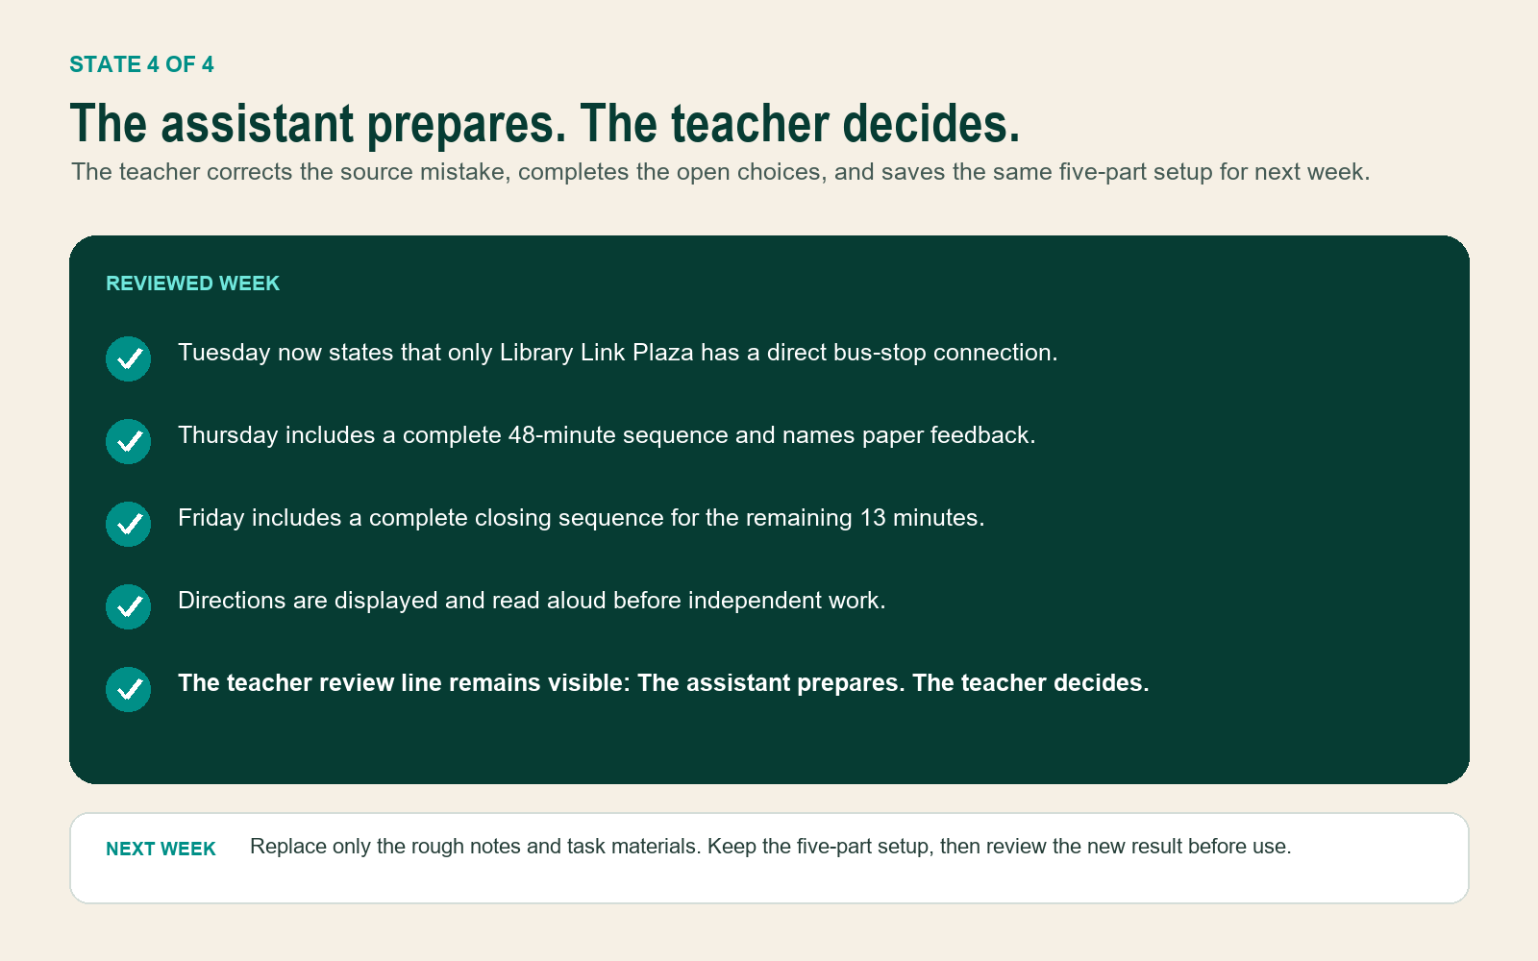
The assistant prepares. The teacher decides.

Two-week usefulness test
For two weeks, compare the usual planning time with assistant time plus correction and review time. Keep, revise, or stop based on actual usefulness.

PRESENTATION LOGIC

How Andrew presents this in the first ten minutes
1. Show the after state first
Open with the reviewed weekly plan and say, 'This is what a teacher leaves with.'
2. Reveal the rough notes
Show the small, uneven input and explain that Andrew supplies the first practice example.
3. Name the five decisions
Walk through the saved setup without using unexplained AI terms.
4. Inspect the first result
Invite teachers to find the source mistake and the choices marked NEEDS TEACHER INPUT.
5. Show the teacher's revision
Make the human decision line visible, then show how the same setup is reused next week.

What the demonstration proves
- Teachers do not need coding or previous AI experience.
- Teachers do not need to use real student information or student work.
- The lab creates a finished, inspectable setup during the session.
- The assistant does not replace teacher judgment or local school rules.
- Usefulness is measured as assistant time plus correction and review time, not as a marketing promise.
Next build gate: Use these exact demonstration assets to establish the visual and interaction system before rebuilding ai-schools.html. Do not return to generic cards or broad AI explanations.

