Ex.No. : 3

Date:

**DML Commands – INSERT, SELECT, UPDATE, DELETE**

**Aim:**

To perform Data Manipulation Language (DML) Commands such as INSERT, SELECT, UPDATE, DELETE in the table

**Questions**:

1. Populate all the five tables with your own data.

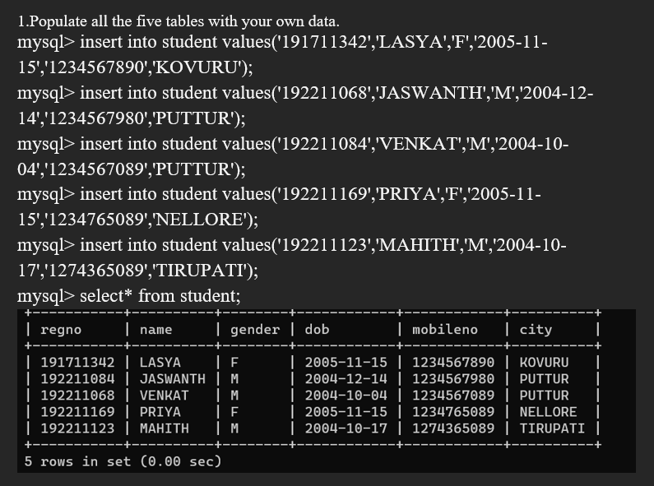

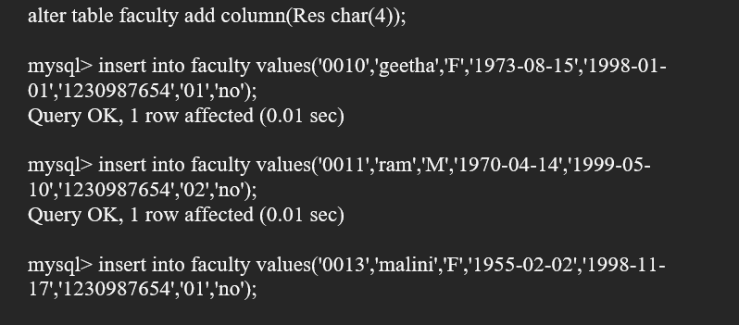

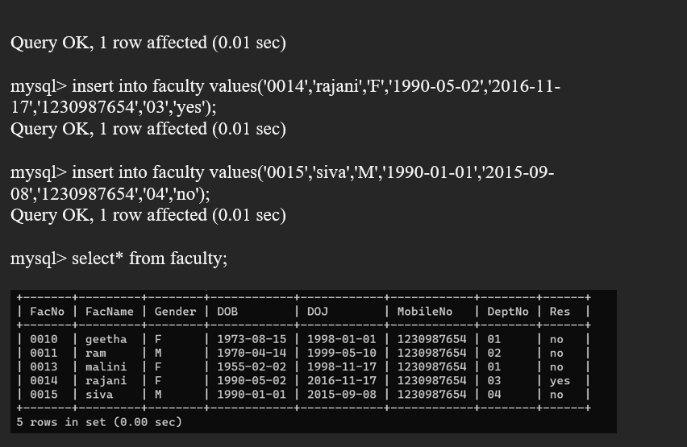

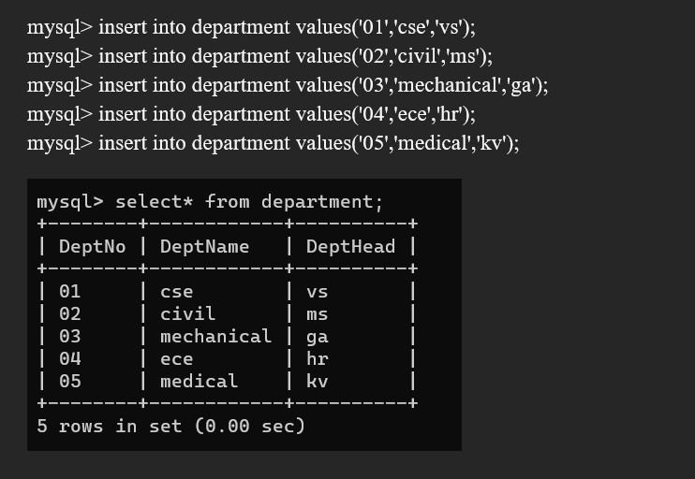

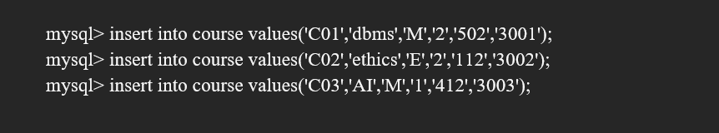

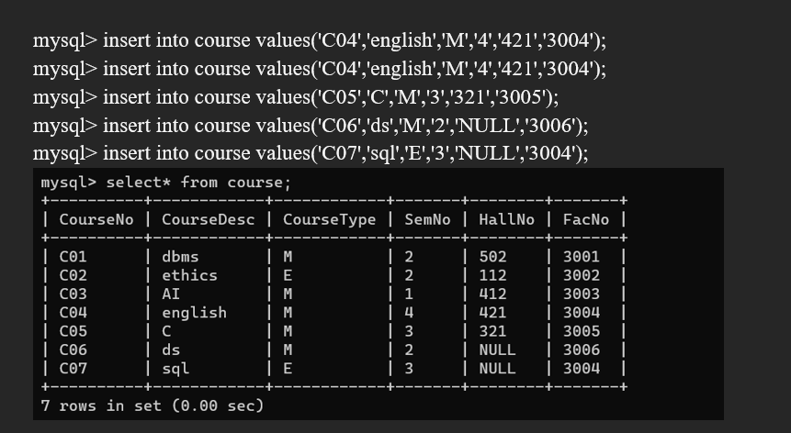

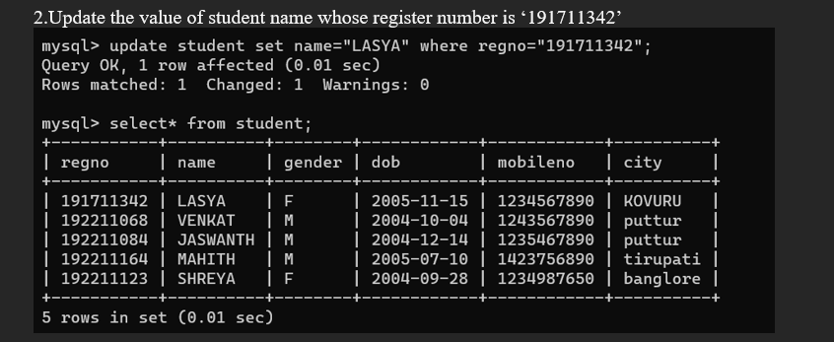

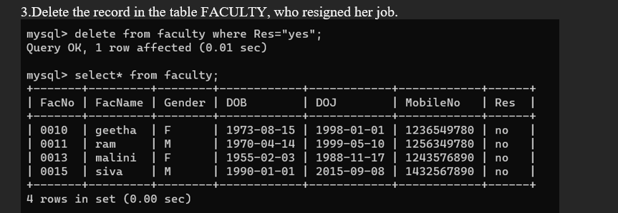

4.Modify the date of birth for the faculty whose name is 'RAM' with a value ‘1983-05-01’.

