Ex. No. : 5

Date:

**SELECT with various clause – BETWEEN, IN, Aggregate function**

**AIM:**

To view the records from the tables using SELECT commands with BETWEEN, IN, Aggregate functions.

**IN & BETWEEN**

1. List the type of the courses “Statistics” and “Programming”

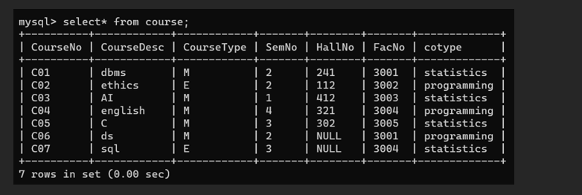

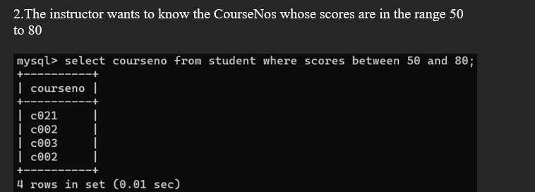

**AGGREGATE**

1. Find the average mark of “C002”.

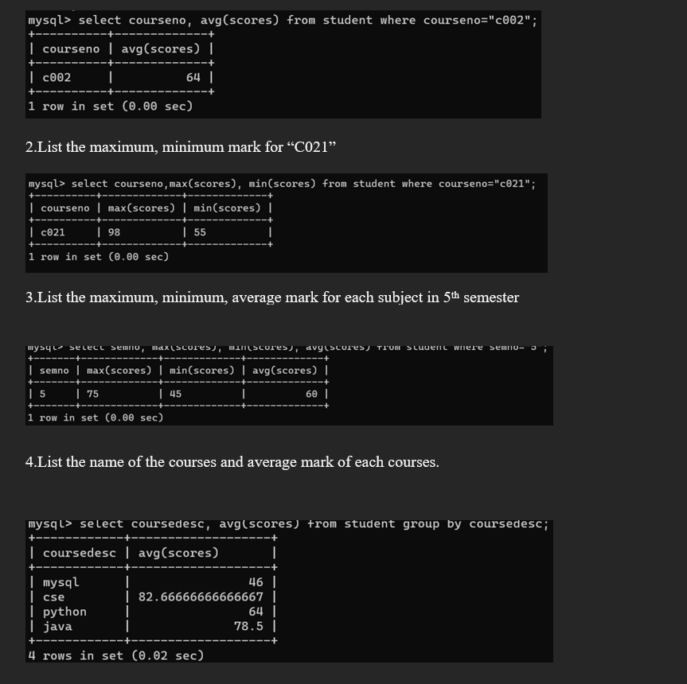

5.Calculate the sum of all the scores.

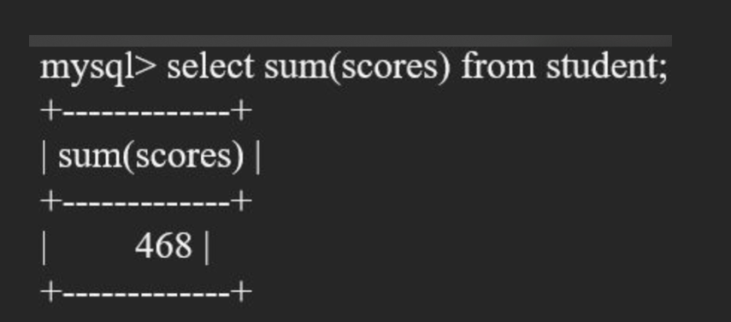

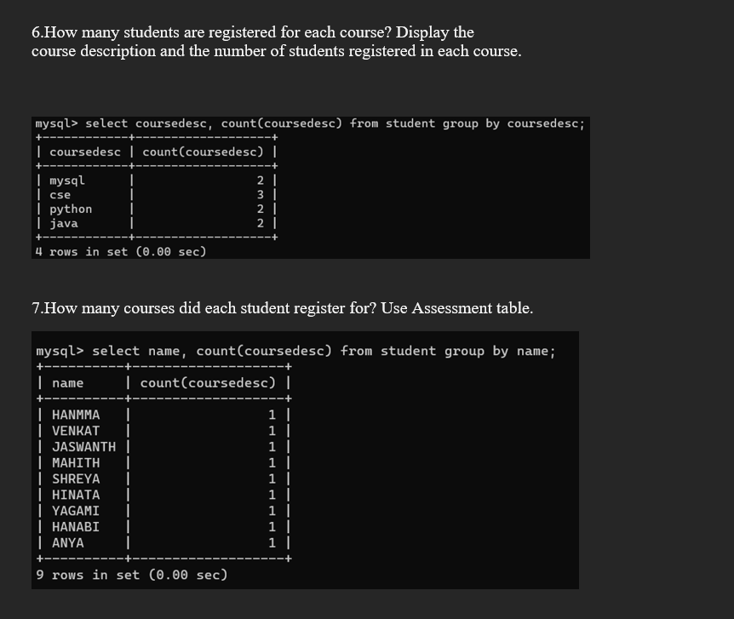

**RESULT**: