Ex. No.: 6

Date:

**SELECT with various clause – GROUP BY, HAVING, ORDER BY**

**AIM:**

To view the records from the tables using SELECT commands with Group By, Having, Order By

**GROUP BY - HAVING**

1. How many students are registered for each course? Display the course description and the number of students registered in each course.

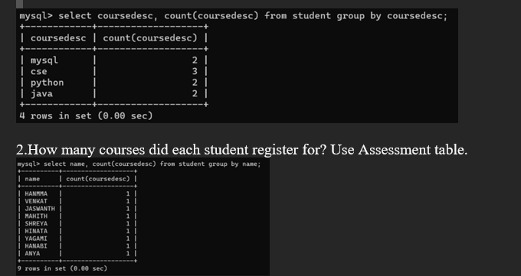

**ORDER BY**

1. Retrieve Name, Gender, MobileNo of all the students in ascending order of RegNo

