

Product Dissection for YouTube

1. Company Overview
YouTube is a leading online video-sharing platform launched in 2005 and acquired by Google in 2006. It enables users to upload, watch, share, comment on, and interact with videos across categories such as education, entertainment, music, gaming, technology, and news. YouTube connects creators with audiences around the world and provides tools for discovering content, building communities, and organizing videos.

2. Product Dissection and Real-World Problems Solved by YouTube
YouTube addresses several real-world challenges through video publishing, search, recommendations, subscriptions, and audience interaction. It gives people convenient access to educational resources, entertainment, practical demonstrations, and information that can be watched at a time and pace that suits them.
Its search and recommendation features help users navigate a huge volume of content. Subscriptions make it easier to follow preferred creators, while playlists and watch history help users organize and revisit videos. For creators, channels provide a place to publish work, reach audiences, build a community, and—when eligible—earn revenue.
Overall, YouTube combines content discovery, publishing, and interaction in one platform. Its features help people learn, find entertainment, share knowledge, and connect with creators and viewers across geographic boundaries.

3. Case Study: Real-World Problems and YouTube's Solutions

Problem 1: Limited Access to Learning Resources
Real-World Challenge: People may not have easy access to tutors, training centres, demonstrations, or affordable learning materials. Some skills are also difficult to learn through text alone.
YouTube's Solution: Educational channels and tutorial videos let users watch explanations, demonstrations, and lectures on a wide range of topics. Users can pause, replay, and revisit videos, supporting self-paced learning. Playlists can group lessons into a more structured learning path.

Problem 2: Difficulty Finding Relevant Content
Real-World Challenge: The large amount of online video content can make it difficult for users to find videos that are useful or interesting to them.
YouTube's Solution: Search helps users find videos using keywords, while recommendations and discovery surfaces suggest content based on signals such as viewing activity and interactions. These features can reduce the effort required to discover relevant videos, although recommendations may not always match a user's intent.

Problem 3: Limited Reach for Independent Creators
Real-World Challenge: People with creative skills, expertise, or useful knowledge may struggle to reach a broad audience through traditional media.
YouTube's Solution: Creators can create channels and publish videos for a potentially global audience. Subscribers can follow a channel, and likes and comments provide feedback. Eligible creators may also access monetization features, subject to YouTube's policies and requirements.

Problem 4: Difficulty Organizing and Revisiting Videos
Real-World Challenge: Users may want to save useful videos for later, arrange learning materials, or return to a video they watched previously.
YouTube's Solution: Playlists allow users to group videos by topic or purpose, and watch history can help users find previously viewed content when history is enabled. These features make it easier to organize and revisit videos.

Problem 5: Limited Interaction Between Creators and Viewers
Real-World Challenge: In traditional one-way media, audiences often have few ways to respond directly to the people creating the content.
YouTube's Solution: Comments and likes enable viewers to react to videos and participate in discussions. Subscriptions help viewers keep up with channels they enjoy. Creators can use audience feedback to better understand viewers' interests, while moderation tools help manage interactions.

Conclusion
YouTube has grown from a video-sharing website into a platform used for learning, entertainment, discovery, and creator-audience interaction. Its search and recommendation features help users find content; channels and subscriptions support creator communities; and comments, likes, playlists, and watch history improve engagement and organization. This case study shows how product features can address user problems and how a well-planned data schema can represent the relationships behind those features.

4. Top Features of YouTube

User Accounts and Channels
Users can access YouTube with a Google account. Channels provide a public home for a creator's videos, channel information, and audience activity.

Video Uploading and Management
Creators can upload videos and manage details such as titles, descriptions, thumbnails, visibility, and publication information.

Search and Recommendations
Search helps users locate videos by query, while recommendations suggest content that may be relevant to each viewer.

Subscriptions
Users can subscribe to channels to follow creators and more easily find new content from them.

Likes and Comments
Viewers can express reactions and, where enabled, comment on videos. These features support engagement and feedback.

Playlists and Watch History
Playlists organize videos into collections, while watch history helps users revisit previously watched content when the feature is enabled.

5. Schema Description
The following is a simplified educational schema based on YouTube's visible features. It is a proposed design for this case study, not a representation of Google's actual internal database.

User Entity
Stores basic account information.
- UserID (Primary Key): Unique identifier for a user in this proposed schema.
- Username: Display or account name used in the application.
- Email: Email address associated with the account, if stored in this system.
- RegistrationDate: Date the user record was created.

Channel Entity
Stores information about a YouTube channel.
- ChannelID (Primary Key): Unique identifier for a channel.
- UserID (Foreign Key): User associated with or managing the channel.
- ChannelName: Name displayed for the channel.
- Description: Information about the channel.
- CreatedDate: Date the channel was created.

Video Entity
Stores metadata about videos published to channels.
- VideoID (Primary Key): Unique identifier for a video.
- ChannelID (Foreign Key): Channel that published the video.
- Title: Video title.
- Description: Text describing the video.
- VideoURL: Location or reference for the video media.
- UploadDate: Date the video was uploaded or published.
- DurationSeconds: Length of the video in seconds.
- VisibilityStatus: Whether the video is public, unlisted, or private in this simplified model.

Comment Entity
Stores comments posted on videos.
- CommentID (Primary Key): Unique identifier for a comment.
- VideoID (Foreign Key): Video receiving the comment.
- UserID (Foreign Key): User who wrote the comment.
- CommentText: Text of the comment.
- CommentDate: Date and time the comment was posted.

Like Entity
Stores user likes on videos.
- LikeID (Primary Key): Unique identifier for a like record.
- VideoID (Foreign Key): Video that was liked.
- UserID (Foreign Key): User who liked the video.
- LikeDate: Date and time the like was registered.

Subscription Entity
Stores the relationship between a user and a channel they subscribe to.
- SubscriptionID (Primary Key): Unique identifier for the subscription record.
- UserID (Foreign Key): User subscribing to a channel.
- ChannelID (Foreign Key): Channel being subscribed to.
- SubscriptionDate: Date the subscription began.

Playlist Entity
Stores playlists created by users.
- PlaylistID (Primary Key): Unique identifier for a playlist.
- UserID (Foreign Key): User who created or owns the playlist.
- PlaylistName: Name of the playlist.
- Description: Optional playlist description.
- CreatedDate: Date the playlist was created.

PlaylistVideo Entity
Connects videos to playlists and stores their order within each playlist.
- PlaylistVideoID (Primary Key): Unique identifier for the playlist-video association.
- PlaylistID (Foreign Key): Playlist containing the video.
- VideoID (Foreign Key): Video included in the playlist.
- Position: Order of the video within the playlist.

6. Relationships Between Entities
- Users and Channels: One user can be associated with one or more channels in this simplified model; each channel is associated with a user record.
- Channels and Videos: One channel can publish many videos; each video belongs to one channel.
- Users and Comments: One user can write many comments; each comment is written by one user.
- Videos and Comments: One video can receive many comments.
- Users and Videos through Likes: A user can like many videos, and a video can receive likes from many users. A unique constraint on (UserID, VideoID) can prevent duplicate likes in this model.
- Users and Channels through Subscriptions: A user can subscribe to many channels, and a channel can have many subscribers. A unique constraint on (UserID, ChannelID) can prevent duplicate subscriptions.
- Users and Playlists: One user can create many playlists.
- Playlists and Videos: A playlist can contain many videos, and a video can appear in many playlists. PlaylistVideo represents this many-to-many relationship.

7. Rationale Behind the Schema Design
The schema separates users, channels, videos, comments, likes, subscriptions, and playlists because each represents a different object or interaction. Primary keys identify individual records, while foreign keys connect related records and help preserve referential integrity.
The Channel and Video relationship supports creators publishing multiple videos. Comments and Likes are separate entities because each video can receive many interactions from different users. Subscriptions represent the many-to-many relationship between users and channels. PlaylistVideo is a junction entity that supports videos appearing in multiple playlists and preserves the order of videos within a playlist.
This structure reduces unnecessary duplication and makes it easier to query questions such as which videos belong to a channel, which comments are attached to a video, which channels a user follows, and which videos are included in a playlist. Additional tables would be required to model features such as views, watch sessions, ads, live streams, reports, and recommendation signals in greater detail.

8. ER Diagram
Create an ER diagram in a tool such as Miro, Lucidchart, or diagrams.net using the entities and relationships described above. Show primary keys (PK), foreign keys (FK), and cardinality.
Suggested relationships: User 1—many Channel; Channel 1—many Video; User 1—many Comment; Video 1—many Comment; User 1—many Like; Video 1—many Like; User 1—many Subscription; Channel 1—many Subscription; User 1—many Playlist; Playlist 1—many PlaylistVideo; Video 1—many PlaylistVideo.
9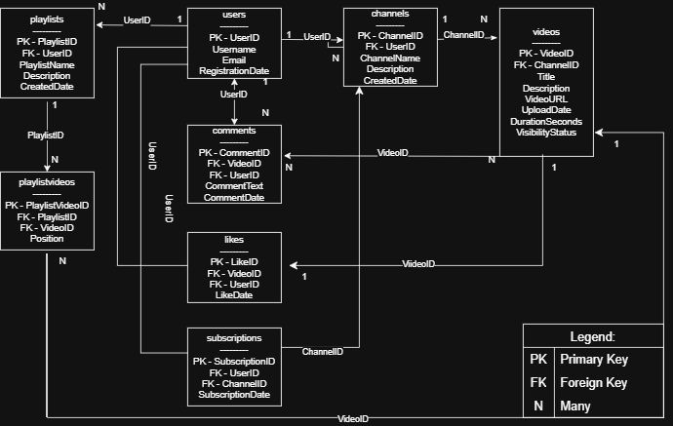
9. SQL Schema Validation and Results
Test 1: Table Row Count Validation
Purpose: To verify the number of records stored in all eight database tables.
SELECT 'users' AS table_name, COUNT(*) AS total_rows FROM public.users
UNION ALL
SELECT 'channels', COUNT(*) FROM public.channels
UNION ALL
SELECT 'videos', COUNT(*) FROM public.videos
UNION ALL
SELECT 'comments', COUNT(*) FROM public.comments
UNION ALL
SELECT 'likes', COUNT(*) FROM public.likes
UNION ALL
SELECT 'subscriptions', COUNT(*) FROM public.subscriptions
UNION ALL
SELECT 'playlists', COUNT(*) FROM public.playlists
UNION ALL
SELECT 'playlistvideos', COUNT(*) FROM public.playlistvideos;
OUTPUT
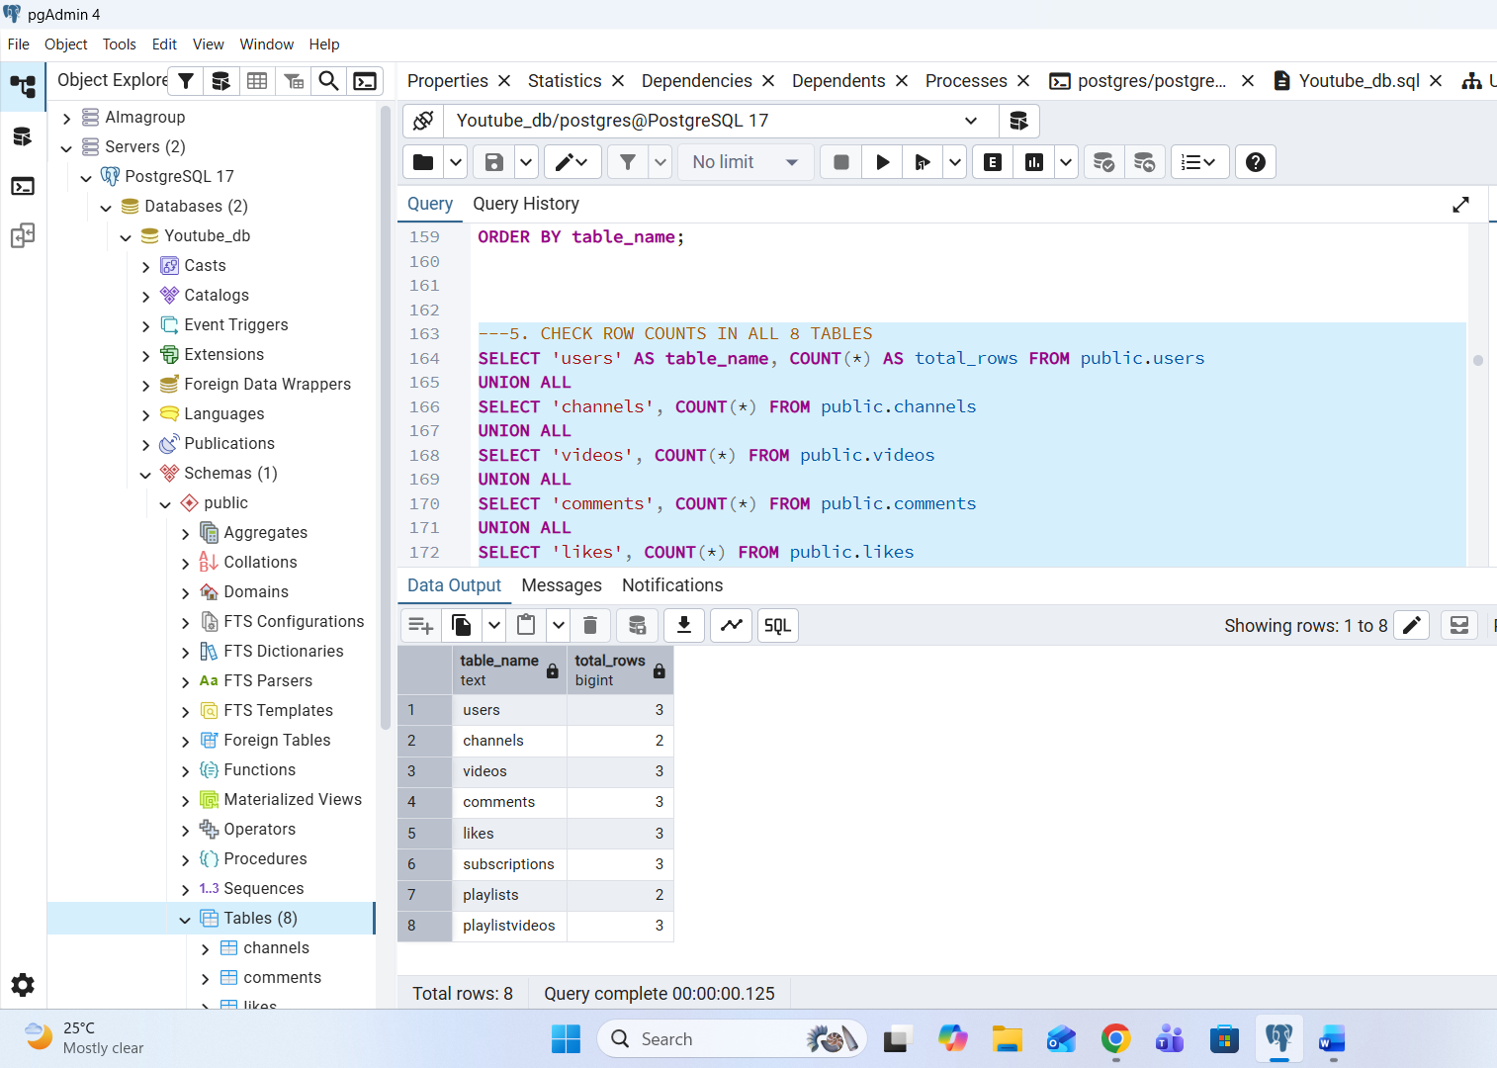
Test 2: Primary and Foreign Key Validation
Purpose: To verify the primary key and foreign key constraints defined in the database.
SELECT
tc.table_name,
tc.constraint_name,
tc.constraint_type,
kcu.column_name
FROM information_schema.table_constraints AS tc
LEFT JOIN information_schema.key_column_usage AS kcu
ON tc.constraint_catalog = kcu.constraint_catalog
AND tc.constraint_schema = kcu.constraint_schema
AND tc.constraint_name = kcu.constraint_name
AND tc.table_name = kcu.table_name
WHERE tc.table_schema = 'public'
AND tc.constraint_type IN ('PRIMARY KEY', 'FOREIGN KEY')
ORDER BY tc.table_name, tc.constraint_type;

OUTPUT

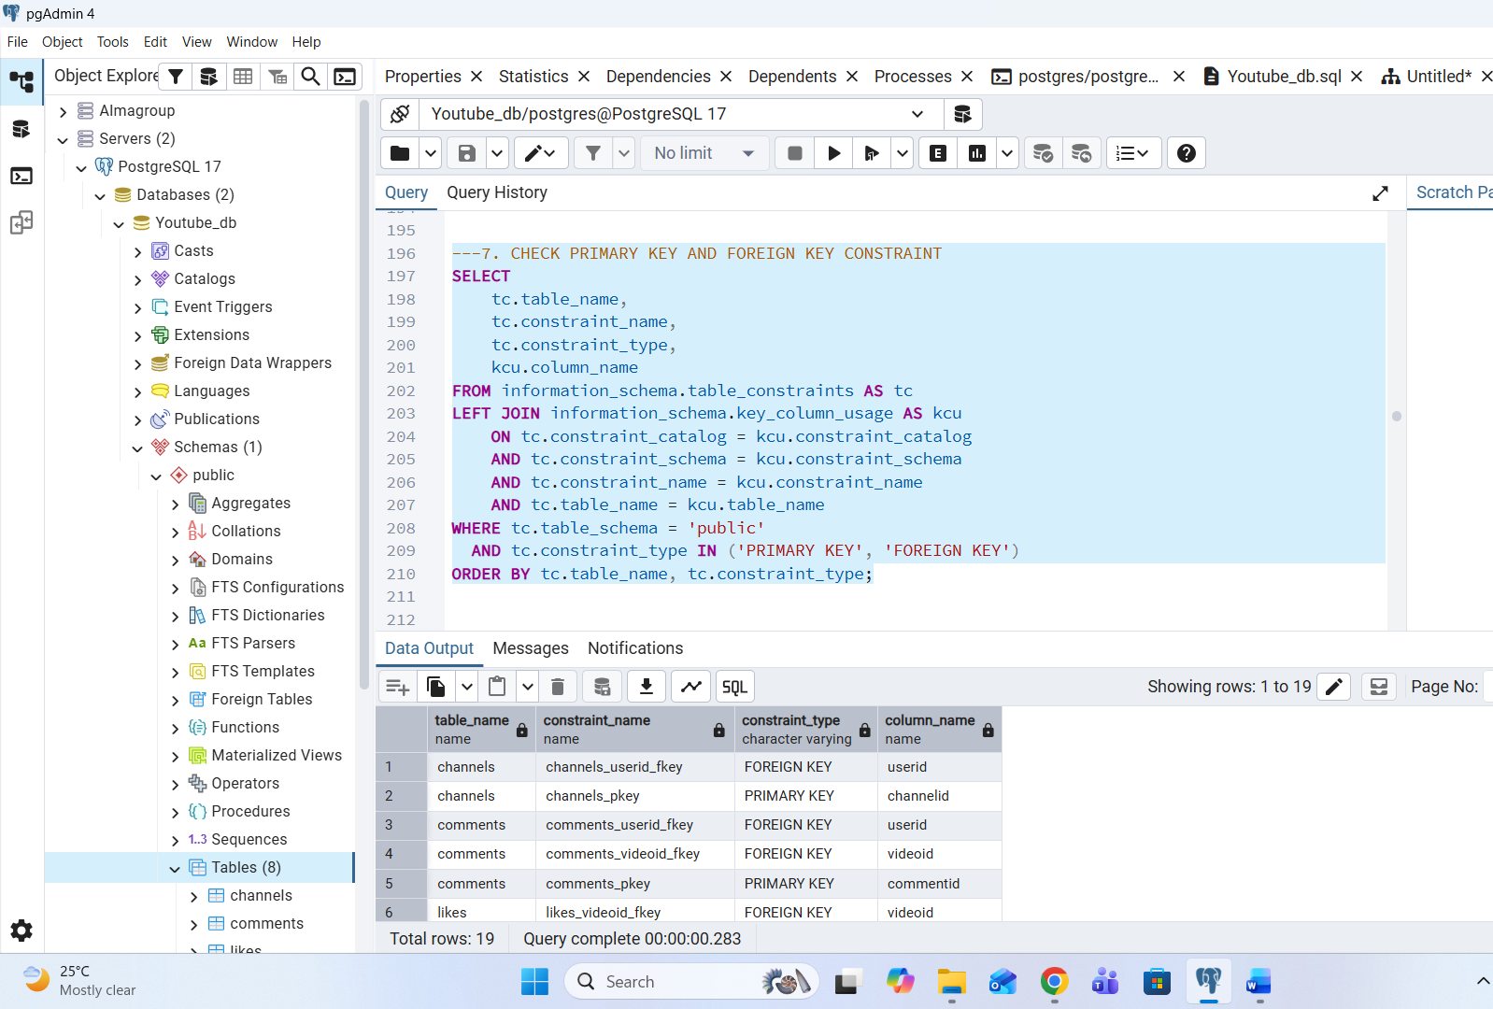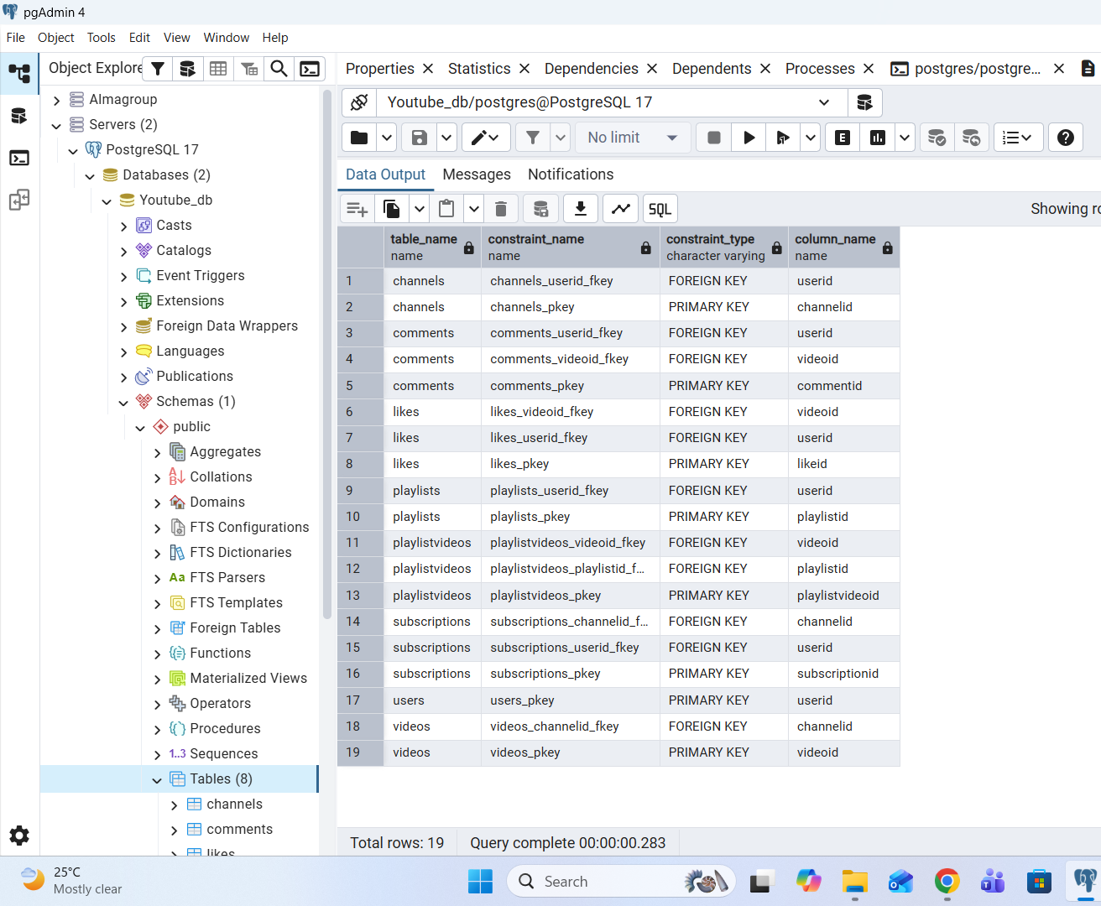

Test 3: Duplicate Email Validation

Purpose: To identify duplicate email addresses in the users table.
SELECT
email,
COUNT(*) AS total
FROM public.users
GROUP BY email
HAVING COUNT(*) > 1;

OUTPUT
The query returned 0 rows, indicating that no duplicate email addresses were found in the users table. All email addresses in the sample data are unique.

Test 4: Data Quality Validation
Purpose: To identify invalid video durations, visibility statuses, and playlist positions.
4.1. Check Invalid Video Durations —
SELECT *
FROM public.videos
WHERE durationseconds < 0;

4.2. Check Invalid Visibility Status —
SELECT *
FROM public.videos
WHERE visibilitystatus IS NULL
OR LOWER(visibilitystatus) NOT IN ('public', 'unlisted', 'private');

4.3. Check Invalid Playlist Positions —
SELECT *
FROM public.playlistvideos
WHERE position <= 0;

OUTPUT
All three data quality validation queries returned 0 rows. No invalid video durations, invalid visibility statuses, or invalid playlist positions were found in the database. Therefore, the sample data passed all three data quality validation checks.

Test 5: Foreign Key Reference Validation
Purpose: To verify that records in child tables have corresponding records in their parent tables.
-- 5.1. Validate Channels → Users
SELECT c.channelid AS invalid_channel_id
FROM public.channels c
LEFT JOIN public.users u ON c.userid = u.userid
WHERE u.userid IS NULL;

-- 5.2. Validate Videos → Channels
SELECT v.videoid AS invalid_video_id
FROM public.videos v
LEFT JOIN public.channels c ON v.channelid = c.channelid
WHERE c.channelid IS NULL;

-- 5.3. Validate Comments → Videos and Users
SELECT cm.commentid AS invalid_comment_id
FROM public.comments cm
LEFT JOIN public.videos v ON cm.videoid = v.videoid
LEFT JOIN public.users u ON cm.userid = u.userid
WHERE v.videoid IS NULL OR u.userid IS NULL;

-- 5.4. Validate Likes → Videos and Users
SELECT l.likeid AS invalid_like_id
FROM public.likes l
LEFT JOIN public.videos v ON l.videoid = v.videoid
LEFT JOIN public.users u ON l.userid = u.userid
WHERE v.videoid IS NULL OR u.userid IS NULL;

-- 5.5. Validate Subscriptions → Users and Channels
SELECT s.subscriptionid AS invalid_subscription_id
FROM public.subscriptions s
LEFT JOIN public.users u ON s.userid = u.userid
LEFT JOIN public.channels c ON s.channelid = c.channelid
WHERE u.userid IS NULL OR c.channelid IS NULL;

--5. 6. Validate Playlists → Users
SELECT p.playlistid AS invalid_playlist_id
FROM public.playlists p
LEFT JOIN public.users u ON p.userid = u.userid
WHERE u.userid IS NULL;

--5. 7. Validate PlaylistVideos → Playlists and Videos
SELECT pv.playlistvideoid AS invalid_playlistvideo_id
FROM public.playlistvideos pv
LEFT JOIN public.playlists p ON pv.playlistid = p.playlistid
LEFT JOIN public.videos v ON pv.videoid = v.videoid
WHERE p.playlistid IS NULL OR v.videoid IS NULL;

OUTPUT
All seven foreign key reference validation queries returned 0 rows. No invalid foreign key references were found. All records in the child tables have corresponding records in their respective parent tables, indicating that referential integrity is maintained in the sample database.

Video Link
Add the link to your completed case-study explanation video here before final submission: [Insert video link]

