Media Arts – Year 8

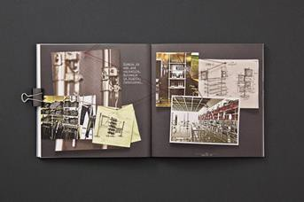
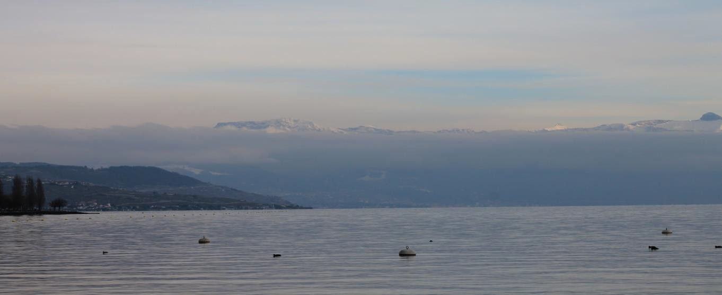
TASK 3: Photography Folio Task
Assessment Type: Making Weighting: 40% Date Due: Week 7 (first lesson)

The Task
Over the term, you will be learning the basics of photography, focusing on how light can be manipulated through a camera using Aperture, Shutter Speed and ISO.
The goals of the unit are to foster an appreciation of (and hopefully love for!) photography and to develop technical camera skills that will allow you to take a photo using Manual mode rather than Auto.
Each week, you will learn a new photography technique and will then demonstrate your knowledge by creatively taking multiple photographs using this technique. Your photos should be unique to you and be ones that you are proud of. You will then upload your best photo/s to a Photography Folio that you will create in Canva (the structure of this folio is on the next page), and this Canva portfolio will be submitted as a PDF document in Week 7 to be marked.

Photography Folio Marking Rubric
EACH OF YOUR PHOTOS SHOULD HAVE:
Purposeful composition and framing of the subject.
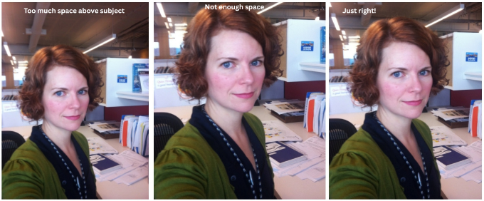

Purposeful exposure (not too light and not too dark).
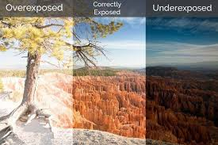

The subject purposefully in focus

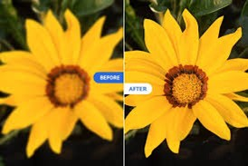
MARKING GUIDE
2 marks = Excellent: Strong technical skill and clear artistic intention
1 mark = Good: Sound understanding of the technique with minor improvement needed (for example, improvements for subject focus, framing composition, or exposure).
0 marks = Not Demonstrated: Technique missing or unclear.
WEEK AND  FOLIO LABEL REQUIREMENTS | PHOTO TASKS TO BE LABELLED | Excellent  (2 marks) | Good  (1 mark) | Not Demonstrated  (0 marks)
Week 1: COVER PAGE  Create a visually appealing cover page that has:  - Title saying, “Student Name - Photography Folio.”  - Five photos (or more) that inspire you. | N/A
Week 1: PAGE 1 – Shots and Angles  Label your best photo of:  - Shot type 1 (e.g. “close up shot of flower”)  - Angle type 1 (e.g. “high angle of my friend”) | Photo 1 of student’s choice of shot photo | ☐ | ☐ | ☐
 | Photo 1 of student’s choice of angle photo | ☐ | ☐ | ☐
Week 2: PAGE 2 – Composition  Label your best photo of:  - Leading Lines (e.g. “Leading Lines created by stairs”)  - Rule of Thirds (e.g. “Rule of Thirds with tree as the subject”) | Photo 1 of Leading Lines | ☐ | ☐ | ☐
 | Photo 2 of Leading Lines | ☐ | ☐ | ☐
 | Photo 1 of Rule of Thirds | ☐ | ☐ | ☐
 | Photo 2 of Rule of Thirds | ☐ | ☐ | ☐
Week 3: PAGE 3 – Aperture  Label your best photo of the following with the specific aperture value:  - Photo with Wide Aperture/Shallow Depth of Field 1 (e.g. “Wide Aperture – f / 2.8)  - Photo with Wide Aperture 2/Shallow Depth of Field 2  - Photo with Narrow Aperture/Deep Depth of Field 1 (e.g. “Narrow Aperture – f / 36)  - Photo with Narrow Aperture/Deep Depth of Field 1 | Photo 1 with Wide Aperture/Shallow Depth of Field | ☐ | ☐ | ☐
 | Photo 2 with Wide Aperture/Shallow Depth of Field | ☐ | ☐ | ☐
 | Photo 1 with Narrow Aperture/Deep Depth of Field | ☐ | ☐ | ☐
 | Photo 2 with Narrow Aperture/Deep Depth of Field | ☐ | ☐ | ☐
Week 4: PAGE 4 – Shutter Speed  Label your best photo of the following with the specific shutter speed value:  - Photo with fast shutter speed 1 (e.g. “Fast Shutter Speed - 1/4000 secs”)  - Photo with fast shutter speed 2  - Photo with slow shutter speed 1 (e.g. “Slow Shutter Speed – 1 second”)  - Photo with slow shutter speed 2 | Photo 1 with Fast Shutter Speed to capture fast motion | ☐ | ☐ | ☐
 | Photo 2 with Fast Shutter Speed | ☐ | ☐ | ☐
 | Photo 1 with Slow Shutter Speed to capture motion blur | ☐ | ☐ | ☐
 | Photo 2 with Slow Shutter Speed | ☐ | ☐ | ☐
(Time Permitting): Week 5: PAGE 5 – ISO  Label your best photo of the following with the specific ISO value:  - Photo with low ISO (e.g. “Low ISO - 100 ISO”)  - Photo with balanced ISO (e.g. “Balanced ISO - 1600 ISO”)  - Photo with high ISO (e.g. “High ISO - 6400 ISO”) | 1x photo with Low ISO | ☐ | ☐ | ☐
 | 1x photo with Balanced ISO | ☐ | ☐ | ☐
 | 1x photo with High ISO | ☐ | ☐ | ☐
Week 5: PAGE 6 – Macro & Texture  Label your best photo of:  - Photo with Macro Subject 1 (e.g. “Macro photo of tree branch”)  - Photo with Macro Subject 2  - Photo with Macro Subject 3 | Photo 1 of Macro Subject | ☐ | ☐ | ☐
 | Photo 2 of Macro Subject | ☐ | ☐ | ☐
 | Photo 3 of Macro Subject | ☐ | ☐ | ☐
Week 6: Portfolio Due with the above 7 pages. |  | N/A
TOTAL MARKS: _____/40

