CHSS Data Environment
Hive User Guide
Intake, de-identification, review, preparation and release of CHSS data
For CRQ staff, analysts, researchers and administrators
Follows the protocol CHSS Data Environment Modernization
Version 1.0 · October 2026

Contents
1. About this guide 1
1.1 Who should read what 1
1.2 How to read the guide 1
2. The CHSS data environment 2
2.1 Zones 2
2.2 How data moves 2
2.3 Patient codes (UBRS) 3
2.4 Document names 3
3. Roles and access 4
3.1 Getting access 4
3.2 Roles 4
4. Getting started 7
4.1 Opening Hive 7
4.2 The screen 7
4.3 Tables 7
4.4 When Hive is locked 8
5. Zone 1: intake and review 9
5.1 How files arrive 9
5.2 De-Identifier 11
5.3 Applications 15
5.4 Rejected documents 23
5.5 Rejections and manual redaction 23
5.6 Archived originals 25
5.7 Files 26
5.8 Metadata 27
5.9 Leaded images 28
5.10 Patients 29
5.11 REDCap exchange 31
5.12 Follow-up 33
5.13 Data quality check 35
6. Zone 1X: preparation 36
6.1 Consent matrix 36
6.2 Abstraction folders 37
6.3 Projects 39
7. Zone 2: release and analysis 46
7.1 Zone 2 inbox (CHSS Manager) 46
7.2 Working with released data (researchers) 48
7.3 Analysis environment 49
8. Zones 3 and 4 51
8.1 Zone 3: SharePoint 51
8.2 Zone 4: REDCap and the patient portal 51
9. Administration 53
9.1 Users 53
9.2 Roles 54
9.3 Security 55
9.4 Audit log 58
9.5 Access log 58
10. Reference 60
10.1 Retention and time limits 60
10.2 Document types 60
10.3 Where files are kept 61
10.4 Permissions 61
10.5 Common questions 62
10.6 Glossary 63

1. About this guide
Hive is the application that runs the CHSS data environment on Cloudera. It takes patient documents in from the sites, removes identifying information, files the documents under each patient’s code, and moves de-identified data on to approved research projects. This guide explains how to use every part of Hive, step by step, and how each step follows the protocol CHSS Data Environment Modernization.

1.1 Who should read what
You only need the chapters that match your work. Your role decides which pages you see in Hive (chapter 3).
If you are… | Read these chapters
Everyone | 1 About this guide, 2 The CHSS data environment, 3 Roles and access, 4 Getting started
CRQ intake staff | 5 Zone 1: intake and review, 6.1 Consent matrix
Senior data analyst | 5.7–5.8 Files and Metadata, 6 Zone 1X: preparation
Researcher or analyst on a project | 7 Zone 2: release and analysis, 6.3 Projects (Members and Safe copy)
CHSS Manager | All chapters; especially 5.6 Originals, 7.1 Zone 2 inbox, 9 Administration
CHSS Application Specialist | All chapters; especially 9 Administration and 10 Reference

1.2 How to read the guide
- Names of buttons, fields and pages are written in bold, exactly as they appear on screen.
- Numbered lists are steps to follow in order.
- Protocol boxes quote the rule from the protocol that a step follows, with its section number (for example §9.1.2).
- Boxes marked Not yet available in Hive describe parts of the protocol that are not built yet. They explain how the step will work, with a placeholder where its picture will go.
Note
All patients, documents, users and projects in the screenshots are made up for this guide (for example patient AVSD0136 “Liam Practice”). No real patient data is shown.

2. The CHSS data environment

2.1 Zones
The protocol splits the environment into zones. Each zone has its own purpose, its own users and its own rule on identifying information (PHI). Data only moves forward, from Zone 1 to Zone 2, and becomes less identifying at every step.
Zone | Purpose | Who can use it | PHI | In Hive
Zone 1 | Data intake, integration and storage | CRQ staff | Yes | Sidebar group Zone 1 · Intake & review
Zone 1X | Data cleanup and preparation, one area per project (1A, 1B, …) | Approved project staff | Minimal or incidental only | Sidebar group Zone 1X · Preparation
Zone 2 | Analysis of an approved study | Approved members of that study | None | Sidebar group Zone 2 · Release, and the project’s Zone 2 folder
Zone 3 | Document repository (SharePoint) | CHSS team | None | Outside Hive
Zone 4 | Internet: REDCap, site uploads, patient portal | Sites, patients | No identifiers | Outside Hive (REDCap exchange in Zone 1)

[ Picture to be added ]
Copy Figure 1 of the protocol here: site upload → Zone 1 storage → Zone 1X cleaning → temporary storage → analysis preparation → Zone 2 storage.
Figure 1. The zones of the CHSS data environment (protocol Figure 1)

2.2 How data moves
- Sites send files. Sites upload each patient’s documents (PDFs, images, forms). Files arrive in the intake folder (chapter 5.1).
- De-identification. Hive reads each file, covers identifying text with black boxes, gives it a standard name, and files it under the patient’s code (chapter 5.2).
- Review. CRQ staff check each patient’s documents against the four-point enrolment checklist and submit or reject the application (chapter 5.3).
- Preparation (Zone 1X). For an approved project, analysts pick the patients, build a workspace and clean the data (chapter 6).
- Safe copy. Hive removes the remaining PHI, shifts dates, gives every patient a project-only ID and places the safe copy in the Zone 2 inbox (chapter 6.3).
- Release (Zone 2). The CHSS Manager checks the safe copy and releases it to the project’s Zone 2 folder, where the researchers work (chapter 7).

2.3 Patient codes (UBRS)
Every patient is known by a code, never by name, outside Zone 1. In Hive the code is read from the file’s folder or file name. The accepted format is shown at the top of the De-Identifier page: two to four letters followed by three or four digits, for example AA0001 or AVSD0001. Files without a valid code are not de-identified; they are listed as Excluded (chapter 5.2).
Important
A typing mistake that still looks like a valid code (AVSD0137 instead of AVSD0136) cannot be caught by Hive. Always check that the code shown on screen is the right patient.

2.4 Document names
Every de-identified file gets a standard name made of the patient code, the document type, the document date and a unique 16-digit serial number, followed by the redaction mark:
AVSD0136_ECHO_REPORT_20190520_1793379635294000_R.pdf
Part | Example | Meaning
Patient code | AVSD0136 | The UBRS code of the patient
Document type | ECHO_REPORT | Enrolment form, contact form, consent, operative report, discharge summary, echo, angiography, MRI, ECG, image, STS extract or other. Images use their DICOM modality (US, MR, CT…). UNKNOWN if not found.
Document date | 20190520 | Date of the document (YYYYMMDD), or UNKNOWN
Serial | 1793379635294000 | 16-digit number, unique for every document
Redaction mark | _R | _R = redacted automatically by Hive. _RR = redacted again by hand (chapter 5.5).

Protocol
§9.1.2 and §9.1.4: files are renamed with the UBRS prefix, document type, document date and a 16-digit serial number; the automatically redacted file gets the suffix “_R”, and a file redacted again by hand gets an extra “R”.

3. Roles and access

3.1 Getting access
Access to each zone is given only on approval, need and completed training.
- Training. Before access is given you must complete TCPS2 and the iLearn privacy training (or the US equivalent). The CHSS Manager keeps the proof.
- Sign-in. Hive has no password of its own. You open it from Cloudera, which signs you in with your hospital account (Entra ID with multi-factor authentication). Zones 1 and 1X also need the hospital VPN.
- Account. The CHSS Manager or Application Specialist creates your Hive account and gives it a role (chapter 9.1). If you can open Cloudera but Hive says you have no account, ask for one.
- Review. The CHSS Manager reviews who has access. Zone 2 access is limited to one project and ends when the project ends; it is reviewed every 6 months.
Not yet available in Hive
§5: Zone 2 access is revoked automatically every 6 months unless it is extended.
In Hive today, the CHSS Manager removes access by hand: remove the person from the project’s Members (chapter 6.3) or change their role on the Users page.

3.2 Roles
A role is a set of permissions. The table shows the roles used in this guide. The CHSS Manager can rename them, change what each one may do, or add new ones on the Roles page (chapter 9.2).
Role | Typical person | What the role does in Hive
CHSS Manager | Program manager | Everything. Approves access, grants access to archived originals, reviews the Zone 2 inbox and releases data, manages security incidents.
CHSS Application Specialist | Runs the platform | Everything except granting originals and releasing to Zone 2: users and roles, De-Identifier runs, REDCap exchange, projects and workspaces, security monitoring.
CRQ Intake Staff | Intake and follow-up staff | Zone 1: copies files in, runs the De-Identifier, reviews applications and the enrolment checklist, handles rejections, patients, REDCap exchange and the consent matrix. Gets the intake emails.
Senior Data Analyst | Senior analysts, biostatisticians | Reads de-identified Zone 1 documents and metadata; Zone 1X: abstraction folders, projects, cohorts, workspaces and preparing the safe copy.
Researcher | Analysts on an approved study | Sees the projects they are a member of and their own abstraction folders. Works on the released data in the project’s Zone 2 folder.
Viewer (read-only) | Auditor | Can look at patients, applications, files and logs but change nothing.

What you see depends on your role. Pages you have no permission for are not in your sidebar. The pictures below show the same Dashboard for two different roles.
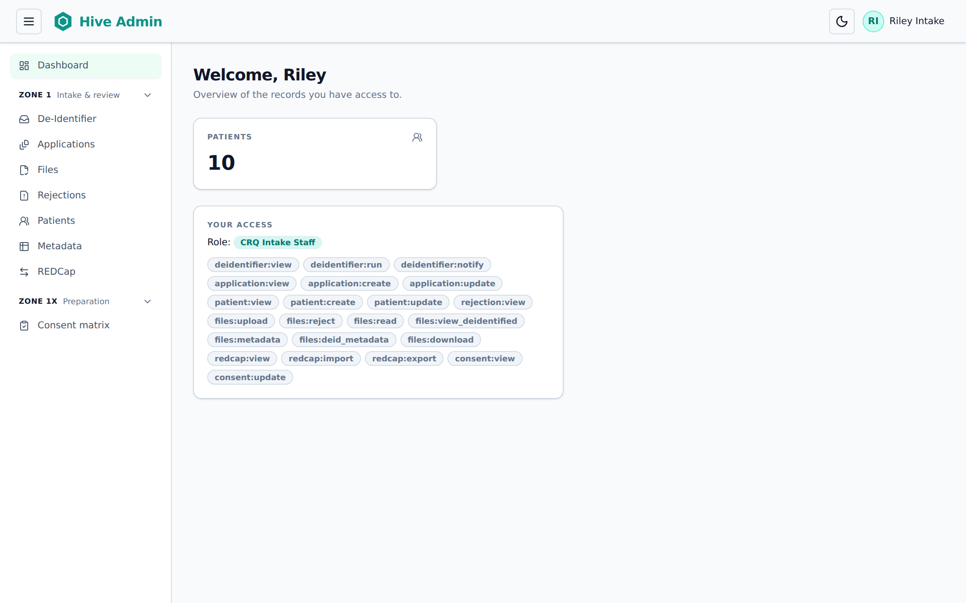
Figure 2. Dashboard for CRQ Intake Staff: Zone 1 pages and the consent matrix
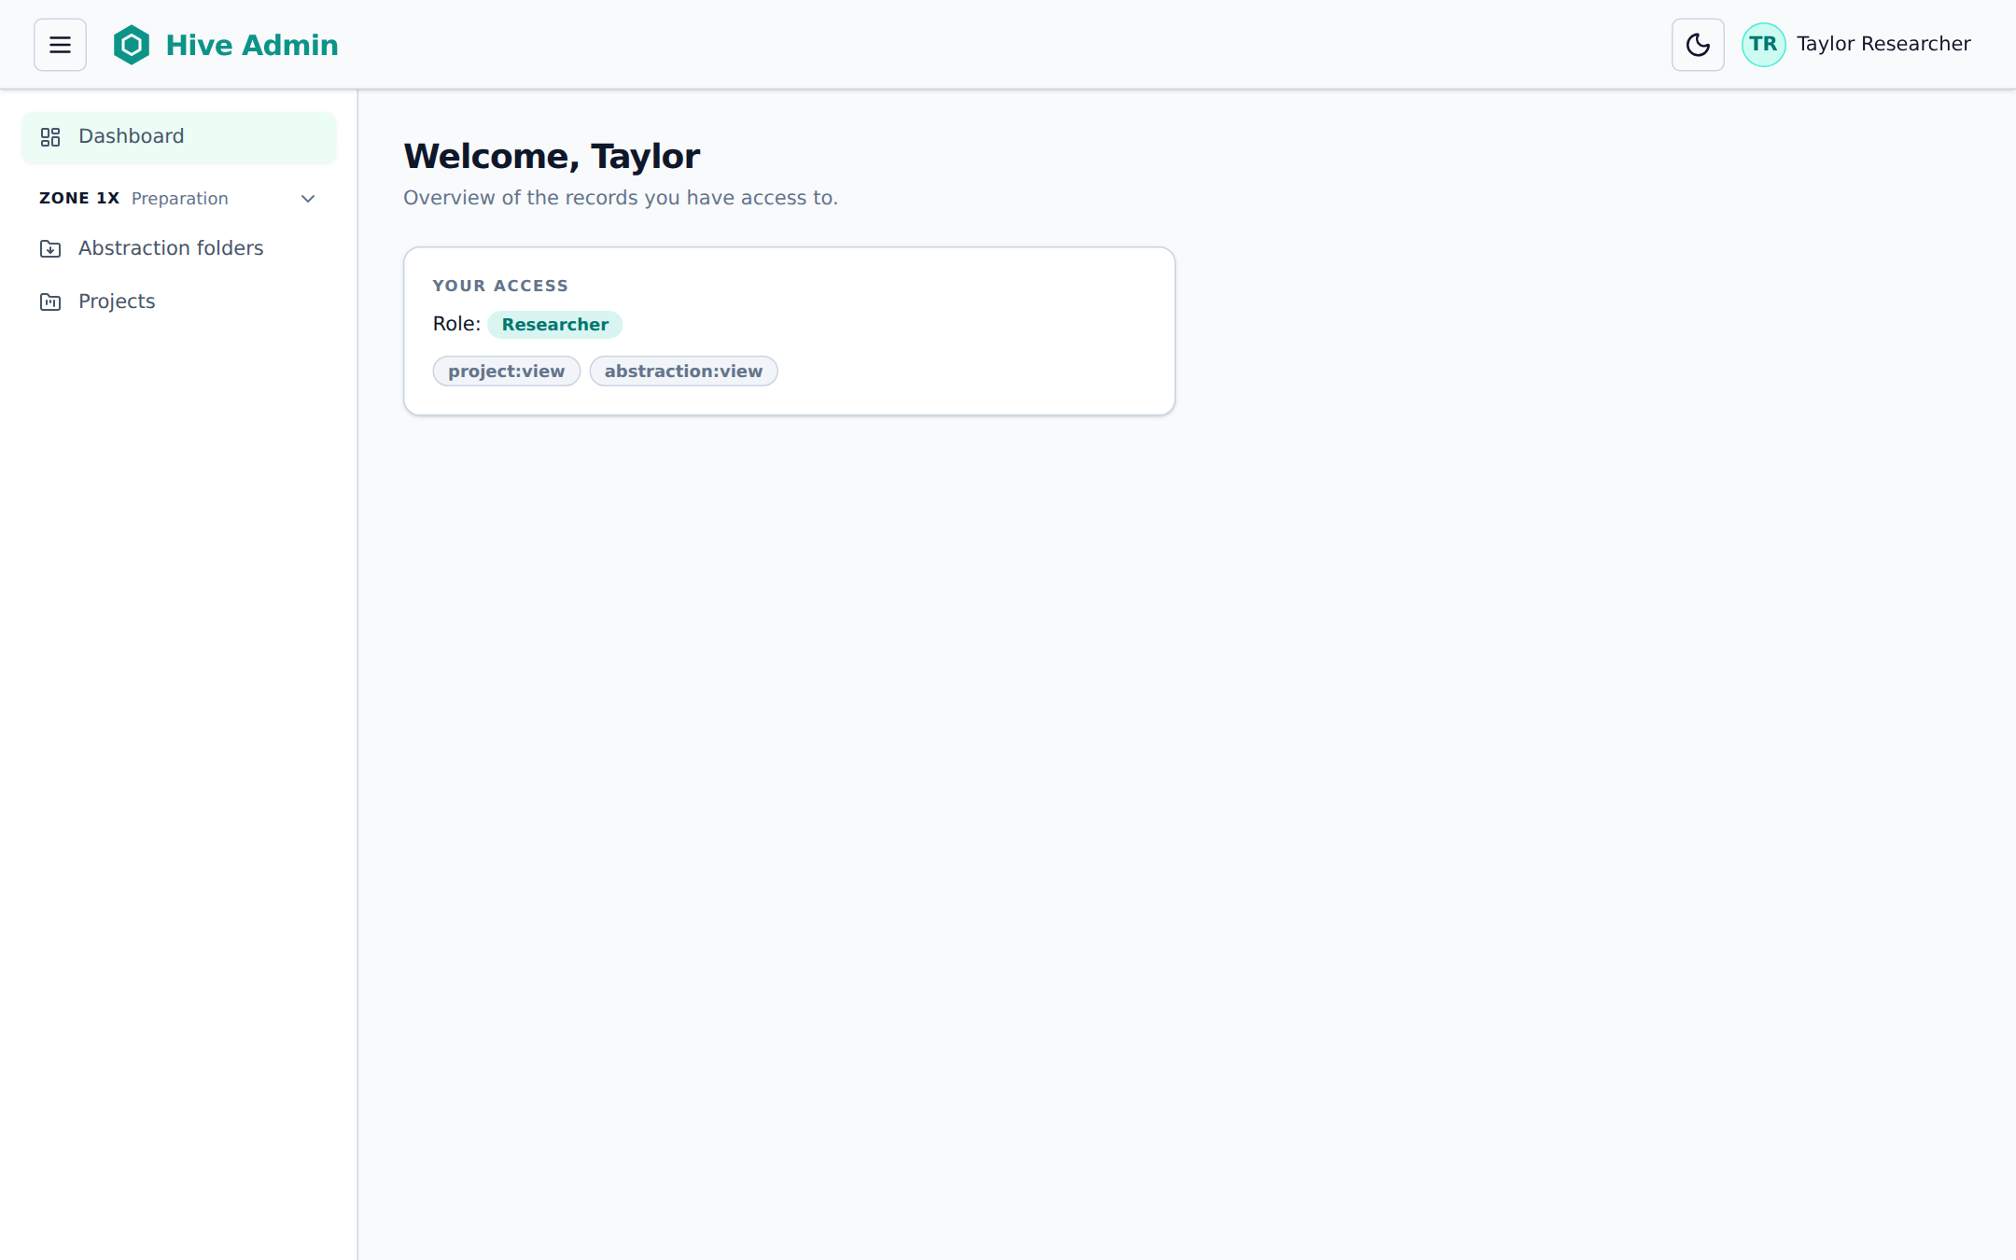
Figure 3. Dashboard for a Researcher: only Abstraction folders and Projects

4. Getting started

4.1 Opening Hive
- Connect to the hospital VPN (needed for Zones 1 and 1X).
- Open Cloudera and sign in with your hospital account and multi-factor authentication.
- Open the Hive application from the CHSS project. Hive opens on the Dashboard.

4.2 The screen
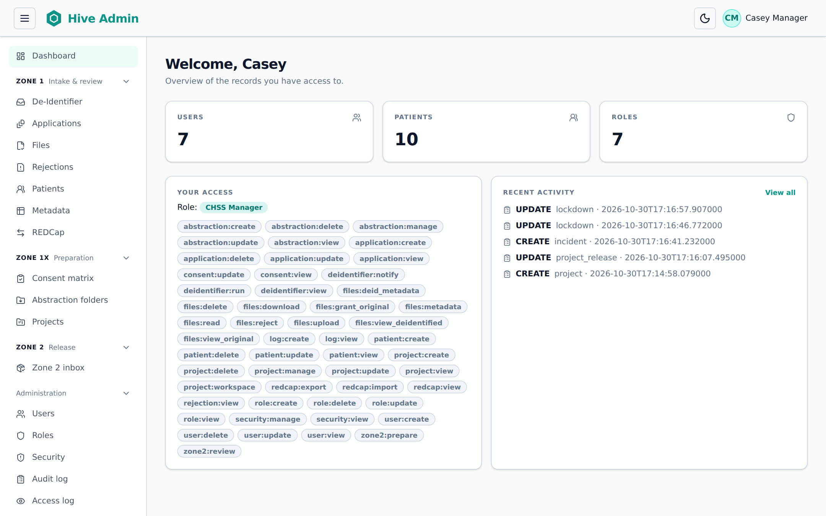
Figure 4. The Dashboard for the CHSS Manager
- Sidebar (left). Pages grouped by zone: Zone 1 · Intake & review, Zone 1X · Preparation, Zone 2 · Release and Administration. Click a group name to fold it. The ☰ button at the top hides the sidebar.
- Top bar (right). The moon button switches between light and dark colours. Your name opens Your Profile, which shows your role and permissions.
- Zone badge. Every page title has a coloured badge (for example Zone 1 · Intake & review) so you always know which zone you are working in.
- Dashboard. Counts of users, patients and roles, your access, and the most recent changes.

4.3 Tables
Most pages show a table. You can search with the box above it, sort by clicking a column name, choose how many Rows to show and move between pages at the bottom. The ⋯ button at the end of a row opens the actions for that row.

4.4 When Hive is locked
During a security incident the CHSS Manager can lock Hive (chapter 9.3). A red banner then appears on every page and nothing can be opened or changed. Wait until it is unlocked; do not try to work around it.
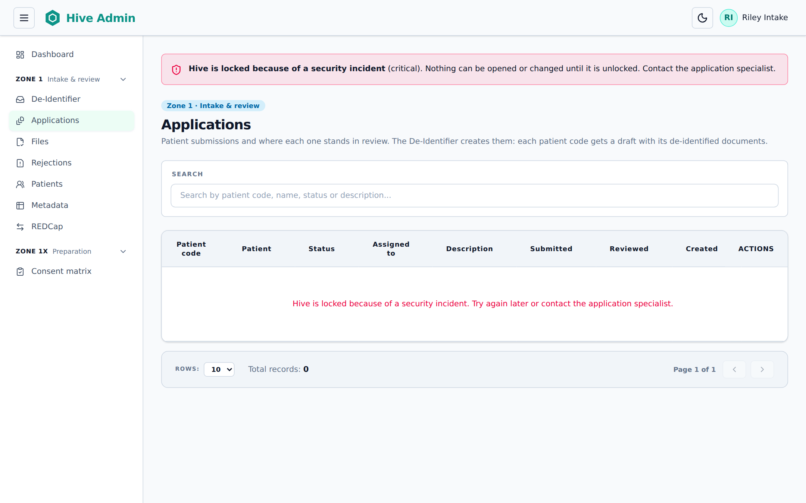
Figure 5. What staff see while Hive is locked

5. Zone 1: intake and review
Zone 1 is where identified data is received and turned into de-identified, named and checked documents. Only CRQ staff work here.

5.1 How files arrive

From the sites: the SFTP inbox
Sites send each patient’s files securely by SFTP. Files land in the intake folder (the inbox). Only the Hive application reads this folder; no person opens it.
Protocol
§9.1.1: Each upload (transaction) is one patient. Incoming files are scanned for malware and checked for integrity. Files of a known patient carry the UBRS as the file name prefix.
If a file fails the scan or has a missing or wrong UBRS, it is deleted and the person who sent it is emailed. CRQ staff are emailed when new data has been processed.

Not yet available in Hive
The SFTP connection for sites and the malware scan are set up outside Hive and are not running yet.
Today: files with a missing or wrong code are not deleted; Hive lists them as Excluded on the De-Identifier page (chapter 5.2) so the site can send a corrected file. Hive emails CRQ staff (not the site) when a run finishes.

[ Picture to be added ]
Picture of the site’s SFTP upload screen and the inbox folder, once the SFTP connection is in place.
Figure 6. SFTP upload by a site

From the Carbon share: Copy from Carbon
Historical documents and images kept on the Carbon research share are brought in with Copy from Carbon on the De-Identifier page. Hive copies the folders you pick into the intake folder; the files on Carbon are not changed.
- Open De-Identifier in the sidebar.
- In the Copy from Carbon card, click Browse Carbon.
- Click a folder name to open it, or use the path at the top to go back. Tick the folders or files you want. Select everything in this folder ticks all of them.
- Click Check. Hive counts the new files and their size. Files already in the intake folder or already processed are skipped and counted separately.
- Click Copy N files. A progress bar shows the copy. You can leave the page; the copy continues.
- When the copy is done, start de-identification (chapter 5.2).
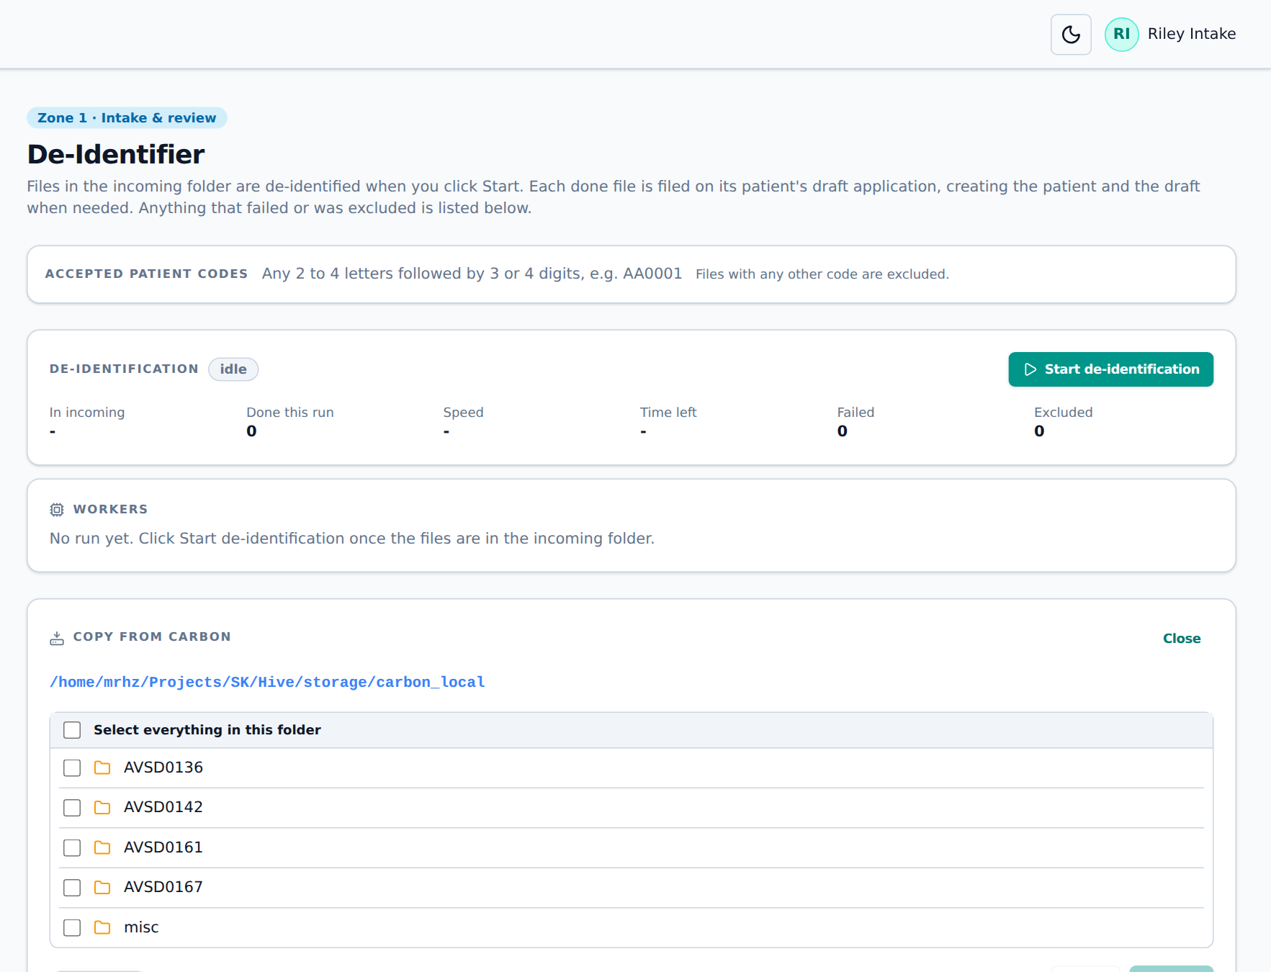
Figure 7. Browsing the Carbon share
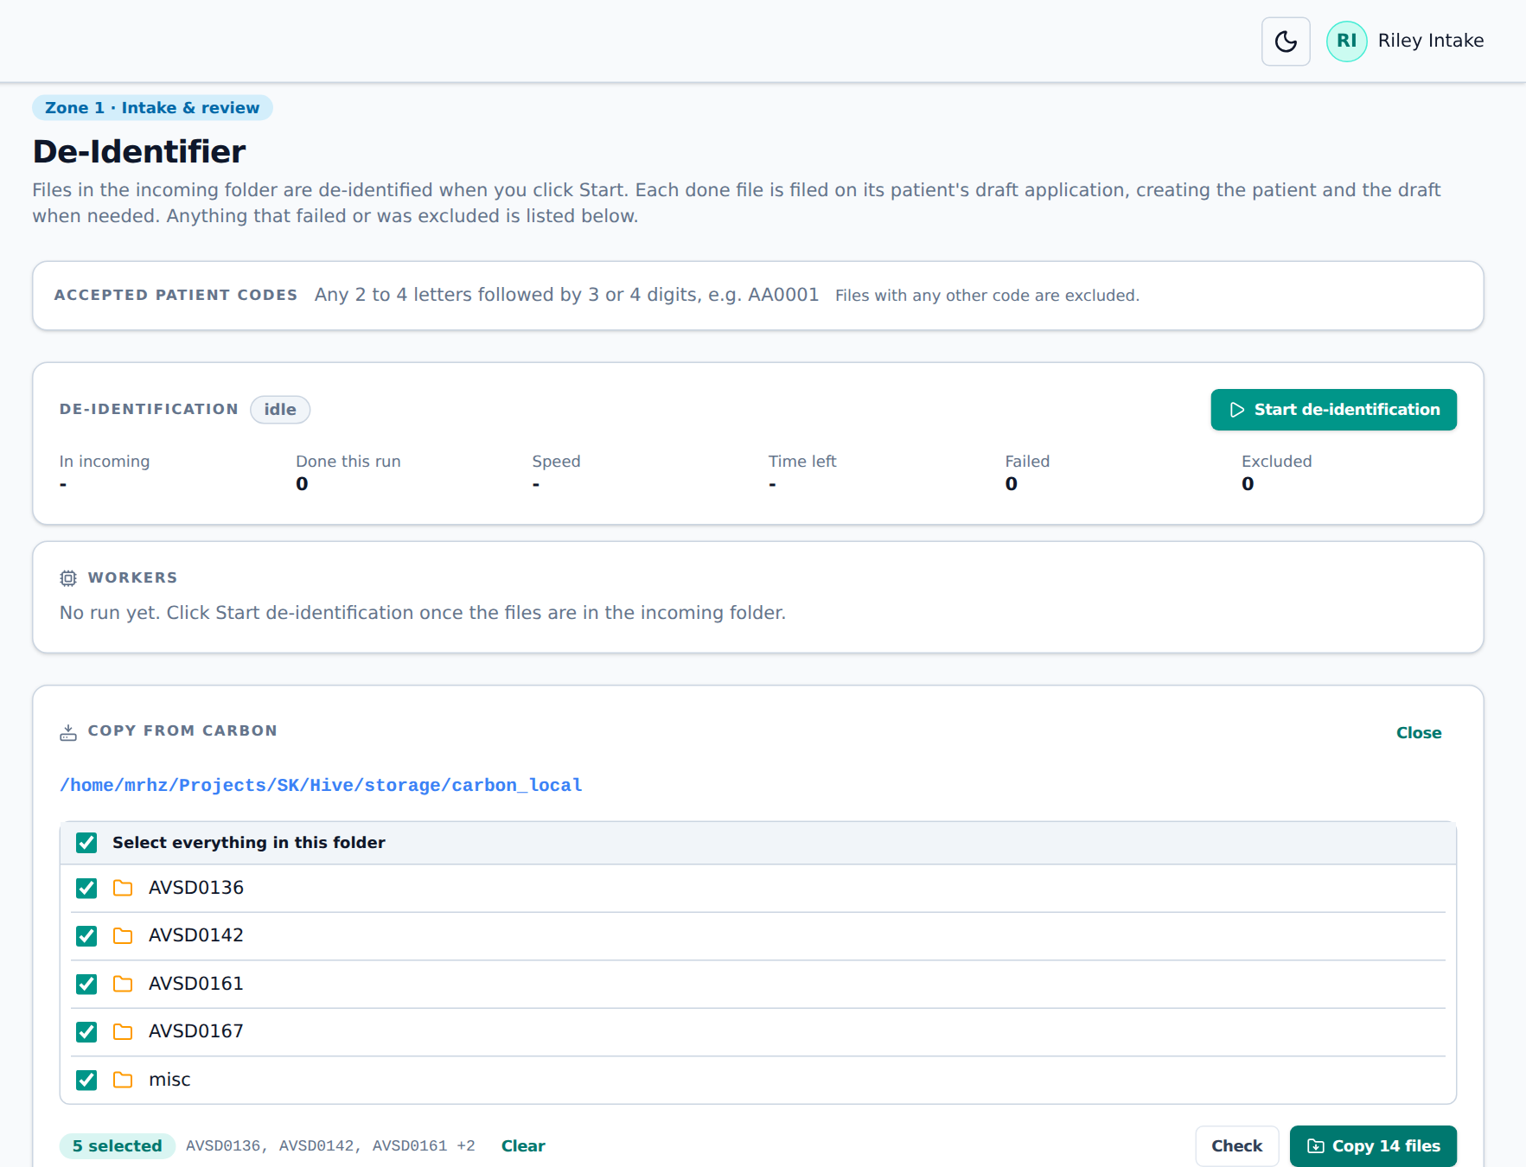
Figure 8. After Check: 14 new files are ready to copy

5.2 De-Identifier
The De-Identifier page de-identifies everything waiting in the intake folder. Each finished file is filed on its patient’s draft application. If the patient does not exist yet, Hive creates the patient (code only) and the draft application.
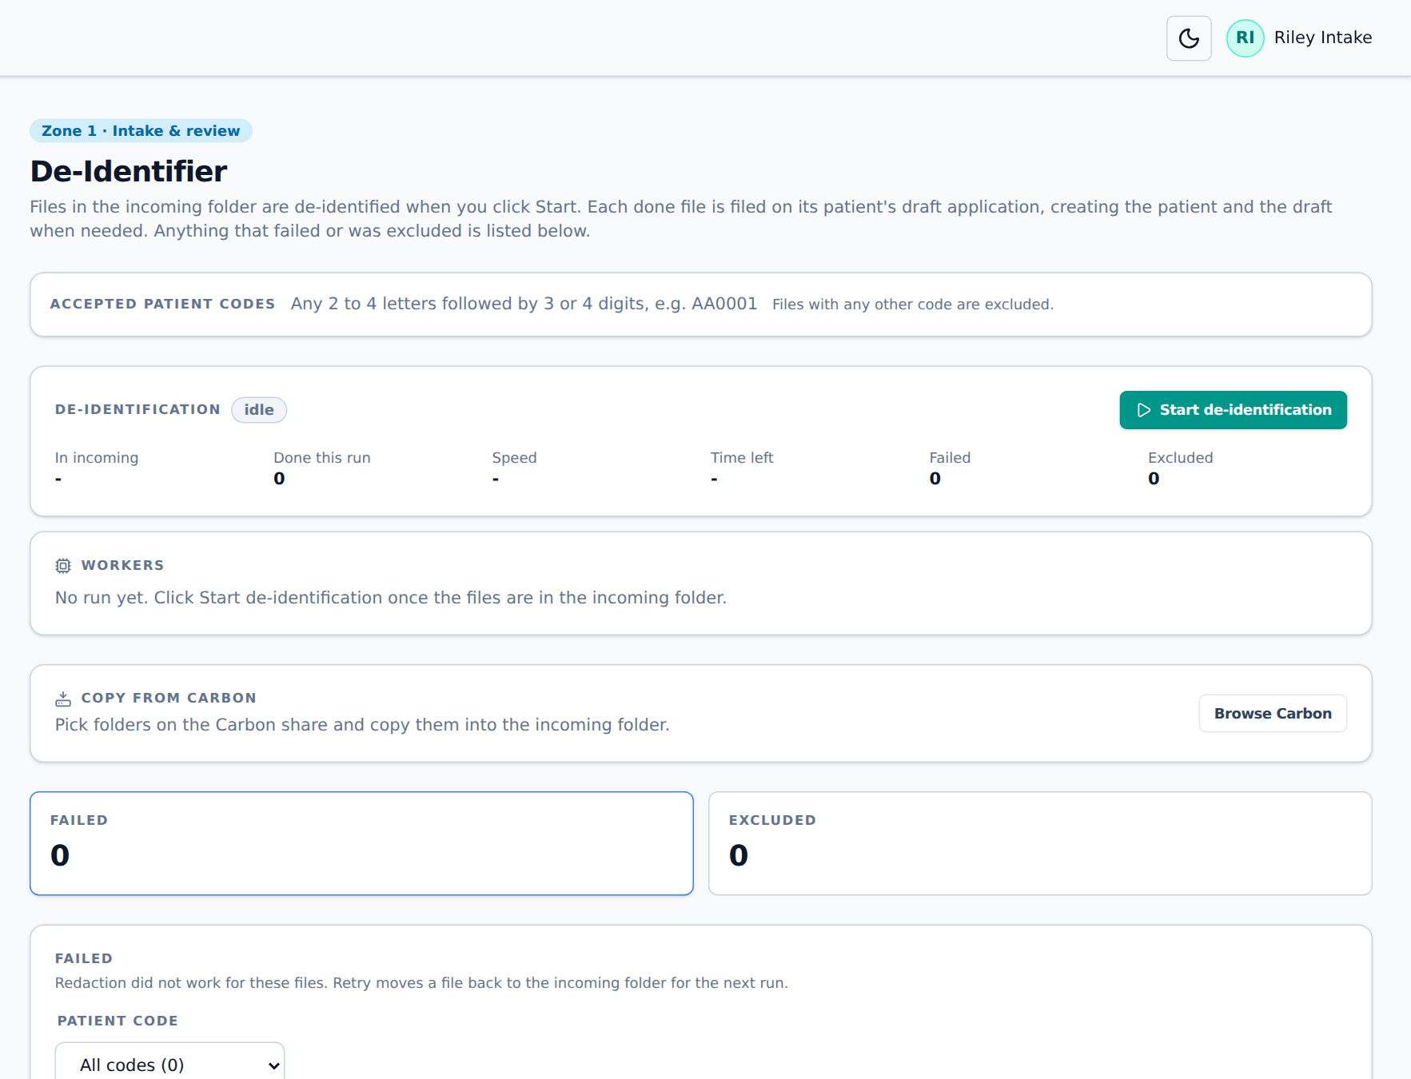
Figure 9. The De-Identifier page

Running de-identification
- Check Accepted patient codes at the top. Files with any other code are excluded.
- Click Start de-identification. The status changes to running.
- Follow the progress: In incoming (still waiting), Done this run, Speed, Time left, Failed and Excluded. Workers shows the machines doing the work, and Finished this run lists each file as it is done.
- When the status is back to idle, the run is finished. Staff who get intake emails receive an Intake run finished email with the counts.
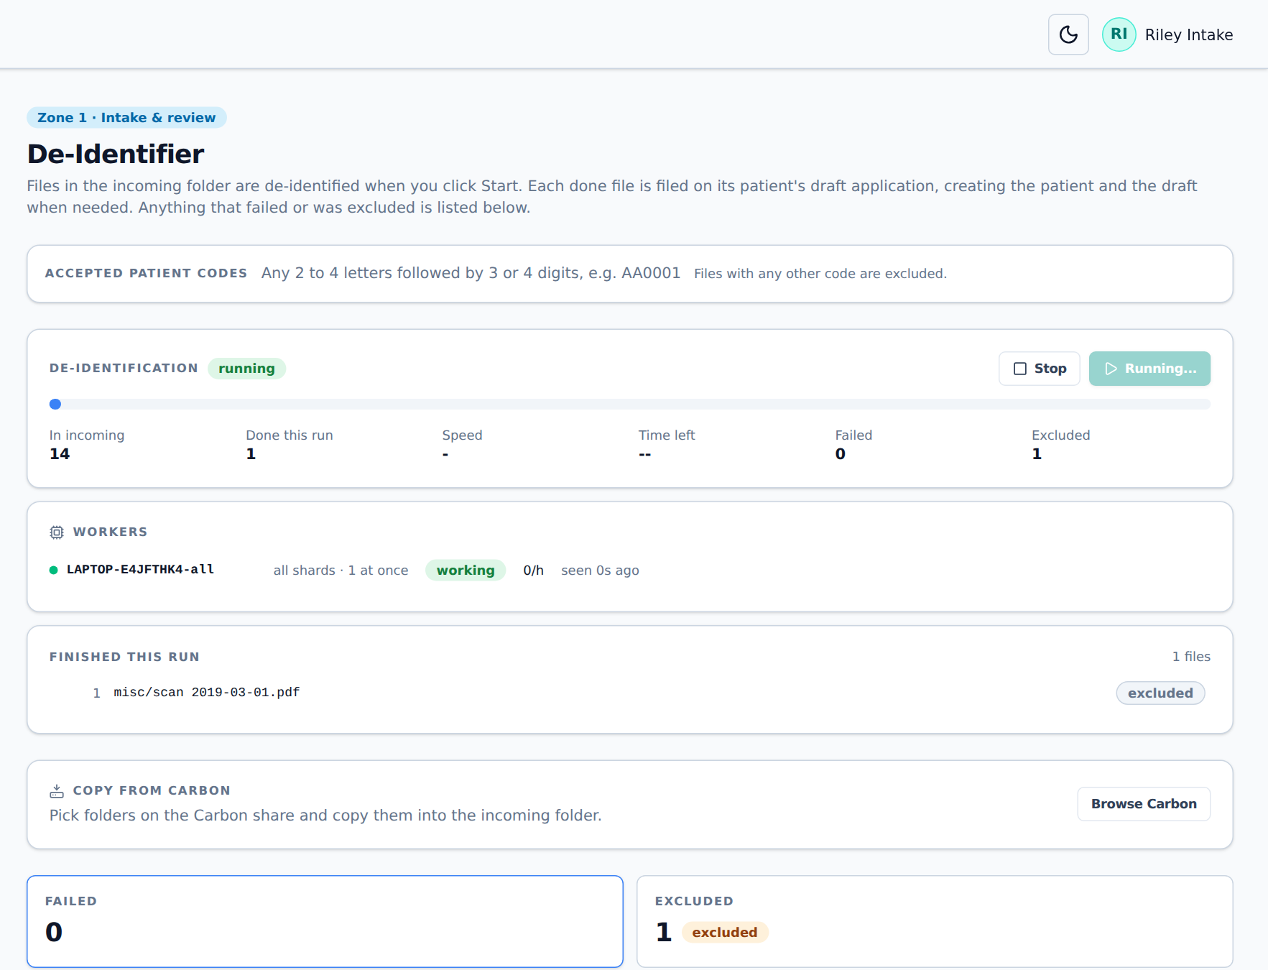
Figure 10. A run in progress: one file done, one excluded
Tip
You can click Stop at any time. The file being worked on is done again in the next run; files already finished are kept. Click Start de-identification again to continue.

What de-identification does
- PDF and Word documents. Text is read from every page with PaddleOCR, including scanned pages. Names, dates, record numbers, addresses, phone numbers and other identifiers are found with Presidio (spaCy and the Stanford de-identifier model) and covered with black boxes using MuPDF. The text under each box is removed, not just hidden. The document’s properties (author, title) are cleaned too.
- DICOM images. Identifying header fields are removed or blanked, private tags are removed, the image IDs (UIDs) are replaced, and text burned into the picture is covered.
- JPG, PNG, TIFF and other pictures. They are first converted to DICOM with the patient code, modality and date, then treated like DICOM images.
- Name. The copy gets its standard name ending in _R (chapter 2.4). The original is kept in the archive (chapter 5.6).
Protocol
§9.1.4: all PDFs go through automated redaction. Python with PaddleOCR finds typed and handwritten text with its location; Presidio with spaCy en_core_web_sm and StanfordAIMI stanford-deidentifier-base finds PHI; MuPDF redacts it. The redacted PDF, with the suffix “_R”, is the approved version for abstraction and analysis. §9.1.8: non-DICOM images are converted to DICOM.

Failed and Excluded files
The two cards under the progress show files that need attention. Click a card to see its list.
List | Why a file is here | What to do
Failed | Redaction did not work (for example a damaged file, or the run was stopped by a fault). | Click Retry on the row, or Retry all. The file goes back to the intake folder for the next run.
Excluded | No patient code; a format Hive cannot read; an exact copy of a file already processed; or the folder and the file name have different codes. | For a code conflict, click the right code on the row (it shows whether the code came from the path or the name). For everything else, ask the site to fix and resend the file, then click Retry.

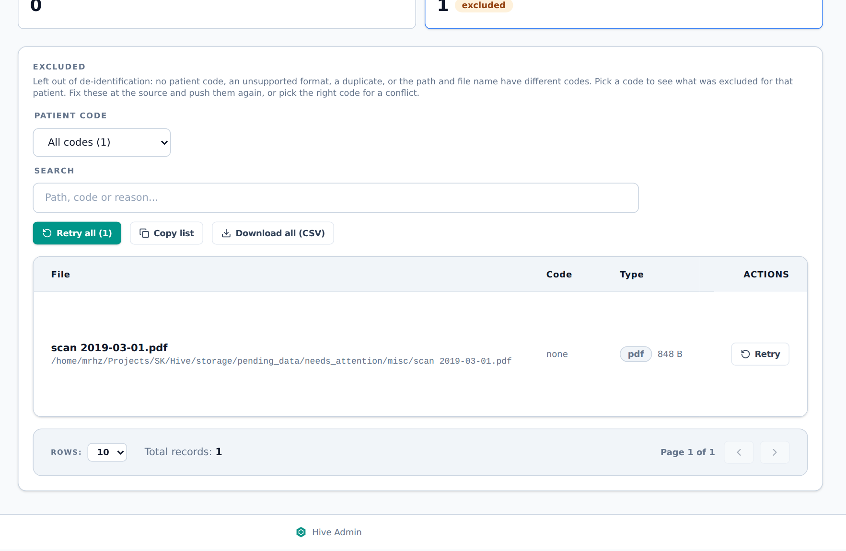
Figure 11. An excluded file with no patient code
Copy list copies the list to the clipboard (full path, reason and detail), and Download all (CSV) saves every file in the list, not just the ones shown.

5.3 Applications
An application holds one patient’s submission: the patient’s details and their documents. The De-Identifier creates a draft application for each patient code. CRQ staff then review it and either submit or reject it.
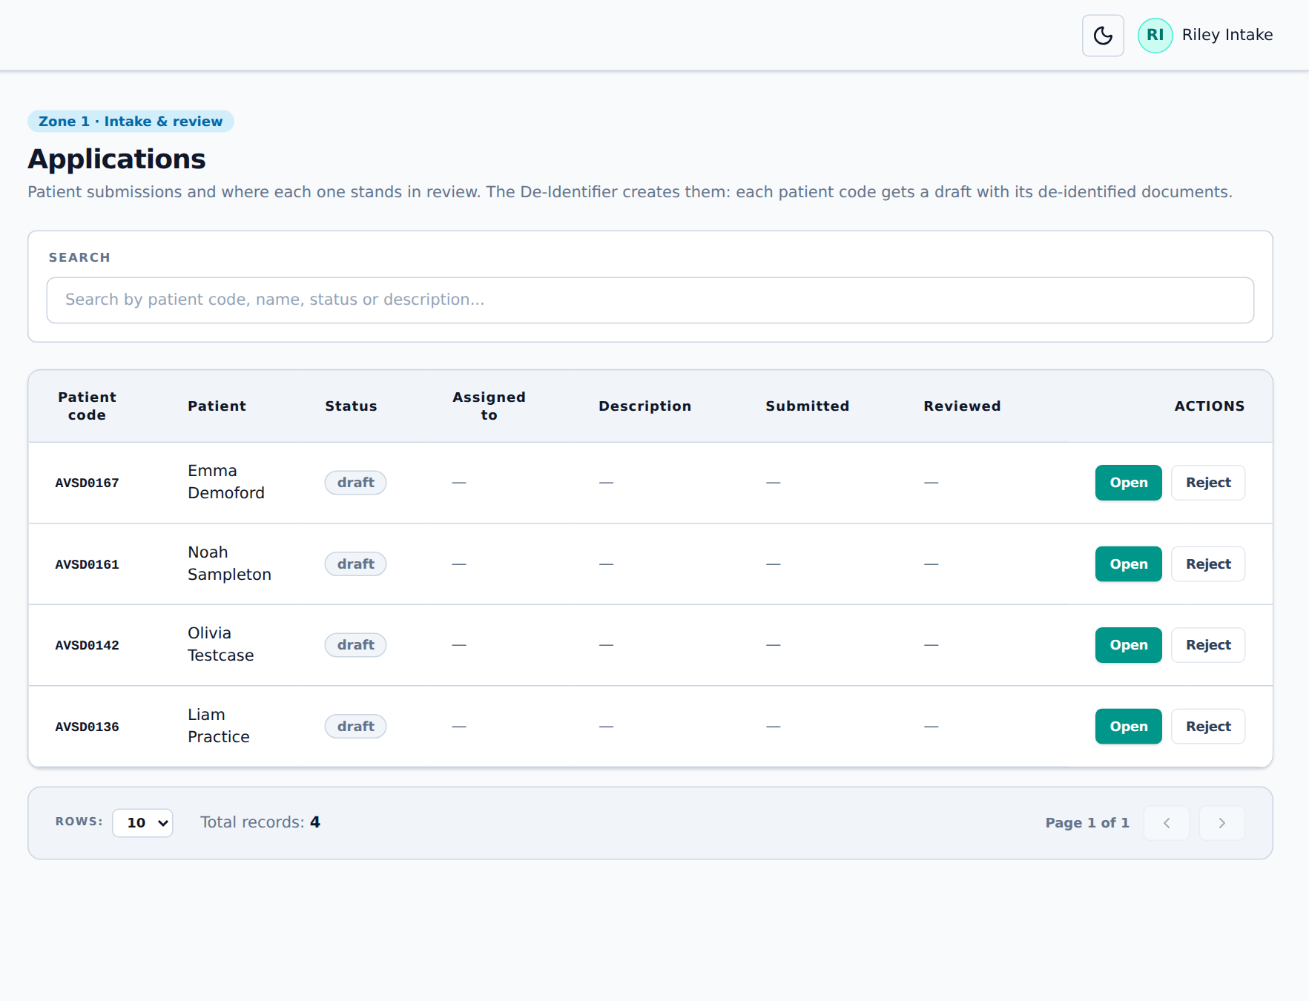
Figure 12. The Applications page
Status | Meaning
draft | Created by the De-Identifier; waiting for review
submitted | Checked and accepted. Cannot be changed any more.
rejected | Turned down with a reason. Listed on the Rejections page until it is fixed or deleted.
deleted | Its documents were deleted (for example patient not eligible). Only the record and reason remain.

Click Open on a row to review it. An application has three steps shown at the top: 1. Patient, 2. Documents and 3. Summary.

Step 1: Patient
- Under Assignment, pick who is reviewing this application in Assigned to. That person is emailed about uploads to it.
- Check the patient’s details. If the patient came from the bulk import or the old data, a yellow box says Patient details not checked yet. Correct anything wrong, then click Details are correct. This is asked only once per patient.
- If the site does not share records or contact details, tick Site does not share records or contact details. The patient then needs no name and is not held for the details check.
- Click Save and continue.
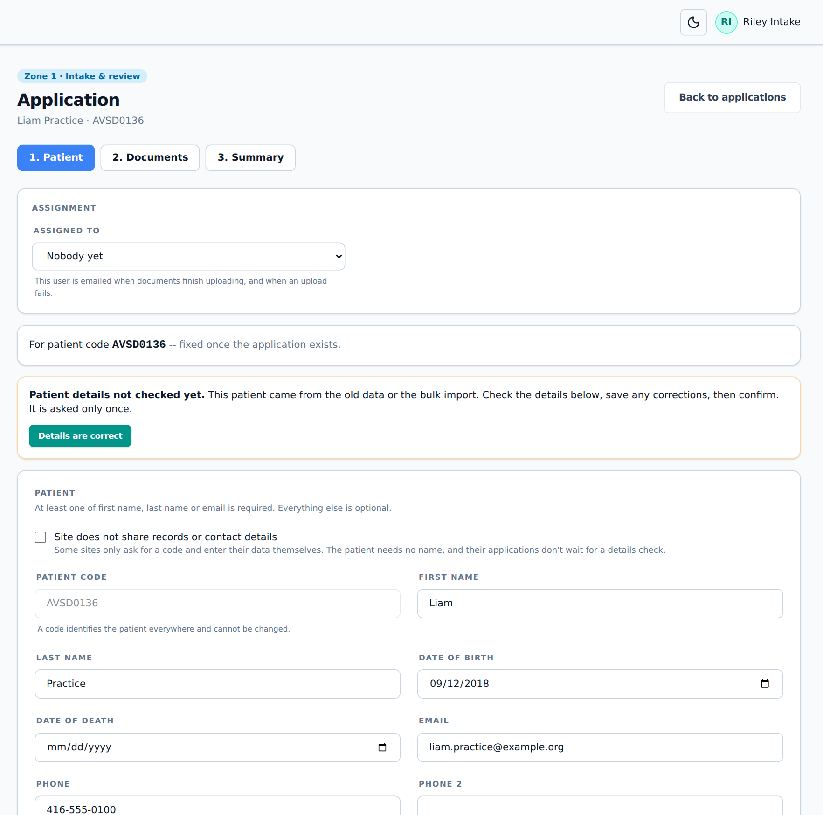
Figure 13. Step 1: checking the patient’s details
Protocol
§9.1.2: for an existing patient, check for a change-of-contact form and update the information; for a new patient, record the contact information. Sites that do not share PHI use the “no records / no ID” option and get no missing-information queries.

Step 2: Documents
This step lists the patient’s documents with their type and date, review status and de-identification status. The bar at the top counts documents, how many are de-identified and how many are approved.
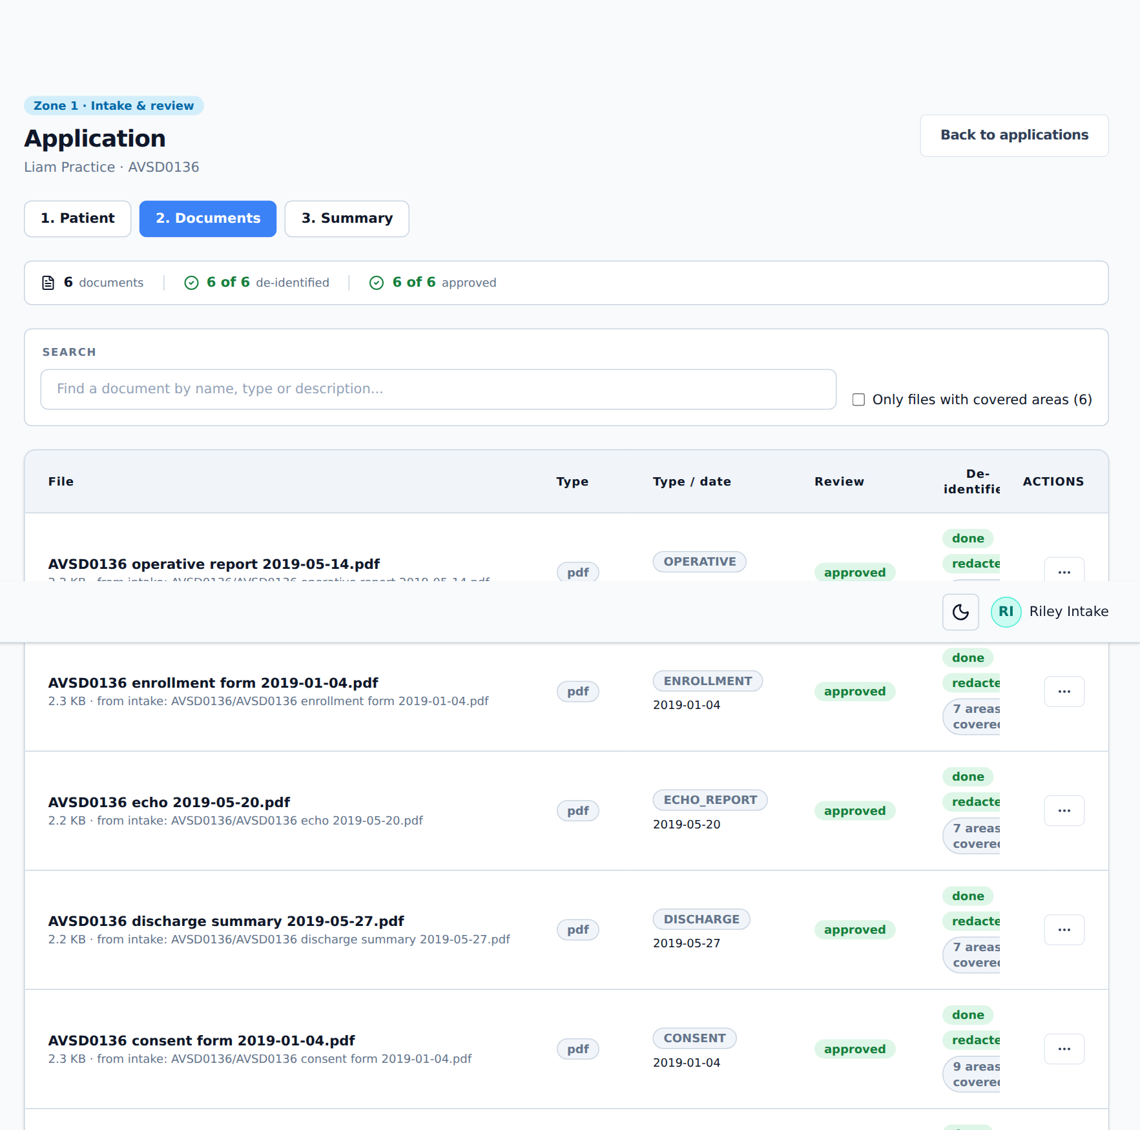
Figure 14. Step 2: the documents of an application
- Type / date shows what Hive read from the file name. type? or date? in yellow means it was not found.
- De-identified shows redacted, by hand (an _RR copy) and how many areas were covered. Tick Only files with covered areas to see only those.
- leaded · not for Zone 2 in red marks an image with identifiers in lead letters (chapter 5.9).
Click ⋯ on a document to see its actions. Which ones you see depends on your role.
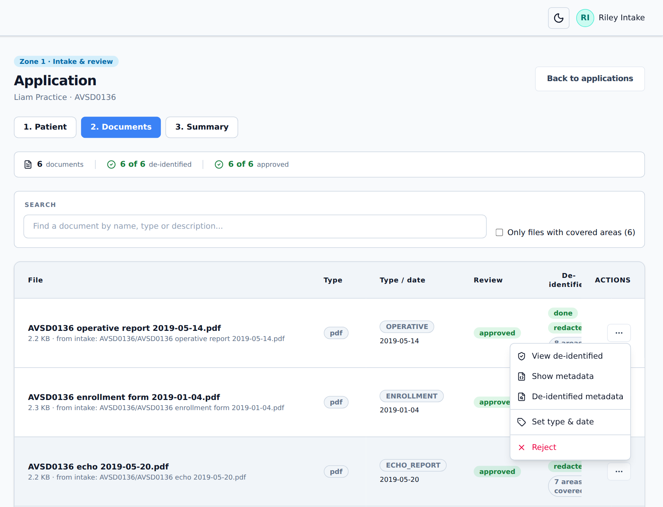
Figure 15. The actions for a document
Action | What it does
View de-identified | Opens the redacted copy. Use it to check that no identifier is left.
View original | Opens the original (only roles allowed to see originals, and only before submission; afterwards see chapter 5.6).
Show metadata / De-identified metadata | Shows the information stored inside the file, before and after de-identification.
Set type & date | Corrects the document type and date. The copy is renamed to match.
Mark as leaded | For images only (chapter 5.9).
Reject | Turns the document down with a reason (for example an identifier is still readable). It goes to Rejections.

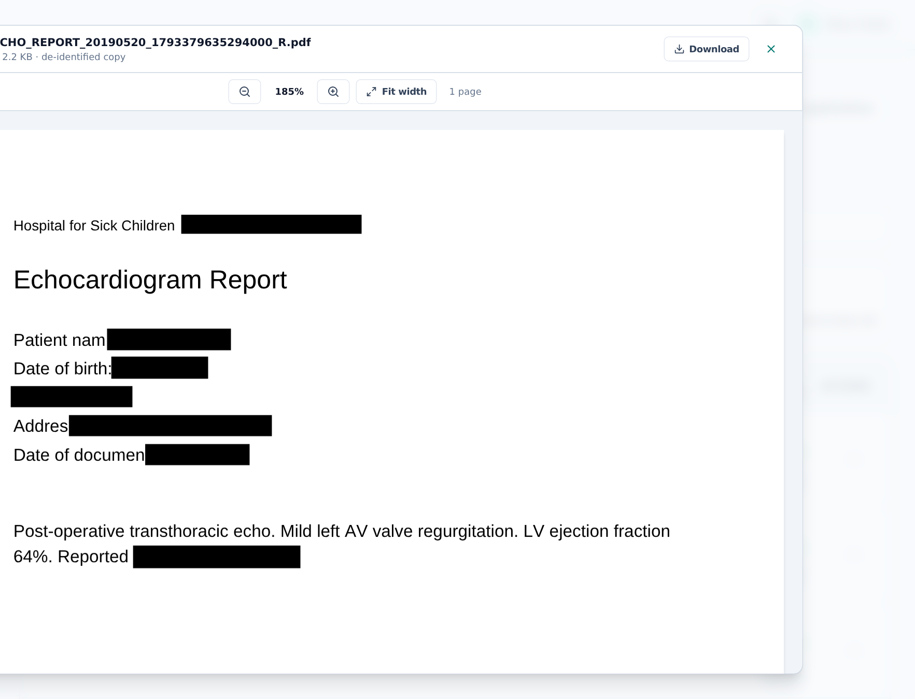
Figure 16. Checking the de-identified copy: identifiers are covered with black boxes

Correcting the type and date
- Click ⋯ → Set type & date.
- Pick the Document type / modality. Reports and forms get a document type (for example Echocardiogram report (ECHO_REPORT)); DICOM images their modality.
- Enter the Document date, or tick Date unknown.
- Click Save. The de-identified copy is renamed.
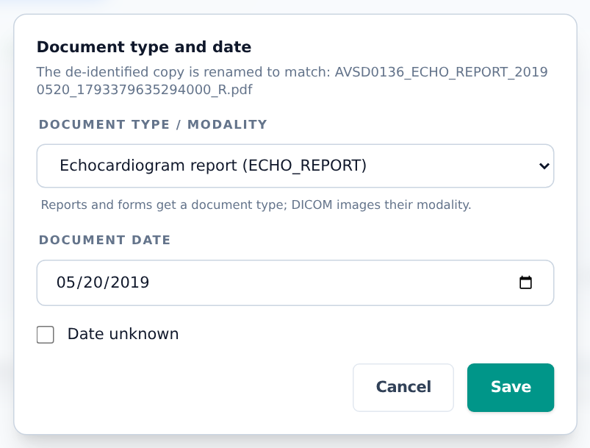
Figure 17. Setting the document type and date
Protocol
§9.1.2: Python extracts the document type and date; staff validate and correct them, and verify that no identifiers remain.

Step 3: Summary, checklist and submit
The summary shows the patient and every document. Submit application only works when the patient’s details are confirmed and every document is approved (none undecided or rejected).
- Click 3. Summary, then Submit application.
- The Enrollment checklist opens. Tick each point only if it is true: All required files were submitted, The patient is eligible, The right consent form is present, No identifiers were found.
- Click Submit application. The status becomes submitted, the patient code is stamped on every page of the redacted PDFs, and the documents move to the archive.
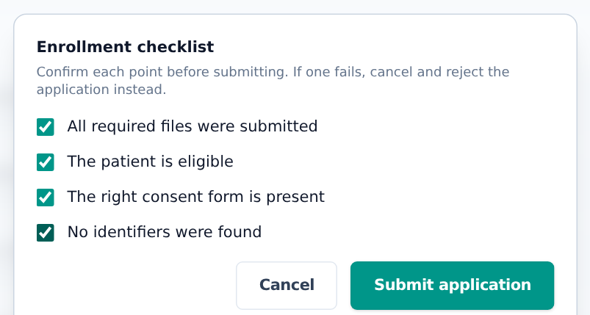
Figure 18. The four-point enrolment checklist
Protocol
§9.1.2: before a patient is enrolled, staff confirm that (1) all required files were submitted, (2) the patient is eligible, (3) the proper consent forms are present and (4) no identifiers are present.

Rejecting an application
If any checklist point fails, do not submit. Reject the application instead.
- In 3. Summary, click Reject application (or Reject on the Applications list).
- Under What failed?, tick every point that failed.
- Write the Reason so whoever fixes it knows what is wrong.
- Click Reject application.
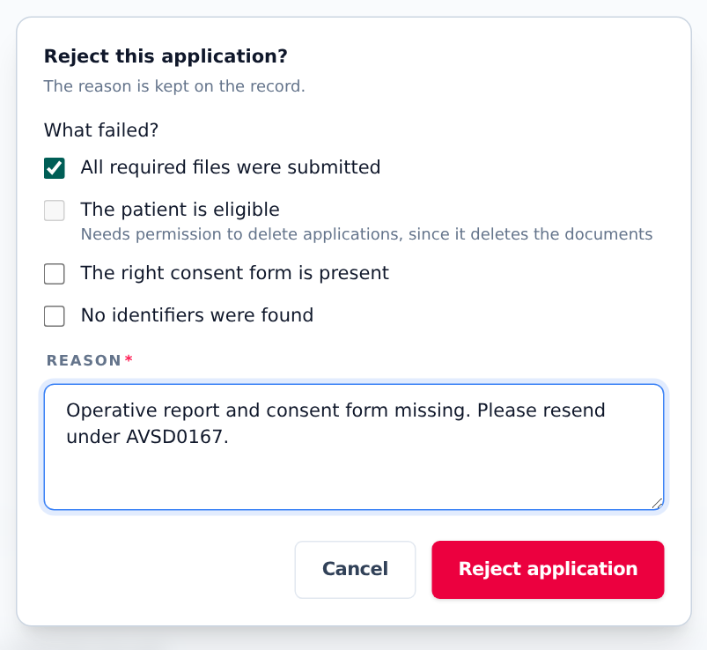
Figure 19. Rejecting an application: missing files
Failed point | What happens
1. Not all required files | Rejected. Files stay in Rejections so the missing ones can be added. Tell the site, quoting the patient code, so they resend.
2. Patient not eligible | All documents of the application (originals and copies) are deleted at once and the application becomes a deleted record. This cannot be undone. Only roles allowed to delete applications can choose it.
3. Consent form missing or wrong | Rejected. Tell the site, quoting the patient code, so they send the right form.
4. Identifiers found | Rejected. Redact again by hand (chapter 5.5) or ask the site to resend.

Protocol
§9.1.2: when an application is rejected the site coordinator is emailed with the reason; for reasons 1, 3 and 4 the email includes the UBRS so the site can resubmit. If the patient is not eligible (reason 2), all data is purged.

Not yet available in Hive
Hive emails the rejection (failed points and reason) to CRQ staff who get intake emails, not to the site. CRQ staff pass it on to the site coordinator.

5.4 Rejected documents
When one document is rejected (in step 2 or from the Zone 2 inbox), the rest of the application is kept. The application cannot be submitted until the document is fixed.
- In step 2, click ⋯ → Reject on the document.
- Write why (for example “Sonographer name still readable in footer”).
- Click Reject file. The document now shows rejected and appears on the Rejections page.
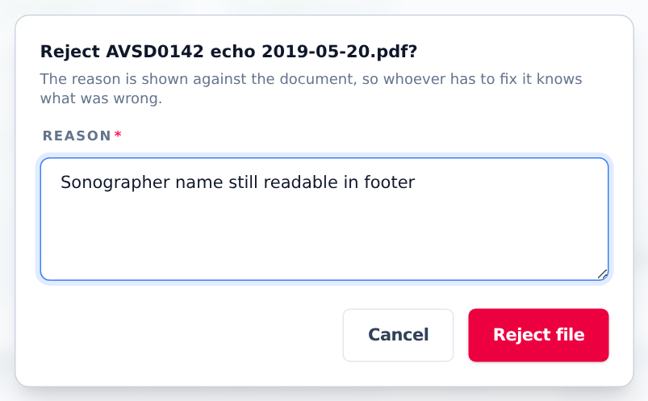
Figure 20. Rejecting one document

5.5 Rejections and manual redaction
The Rejections page lists everything turned down: Rejected applications at the top and Rejected documents below, each with the reason.
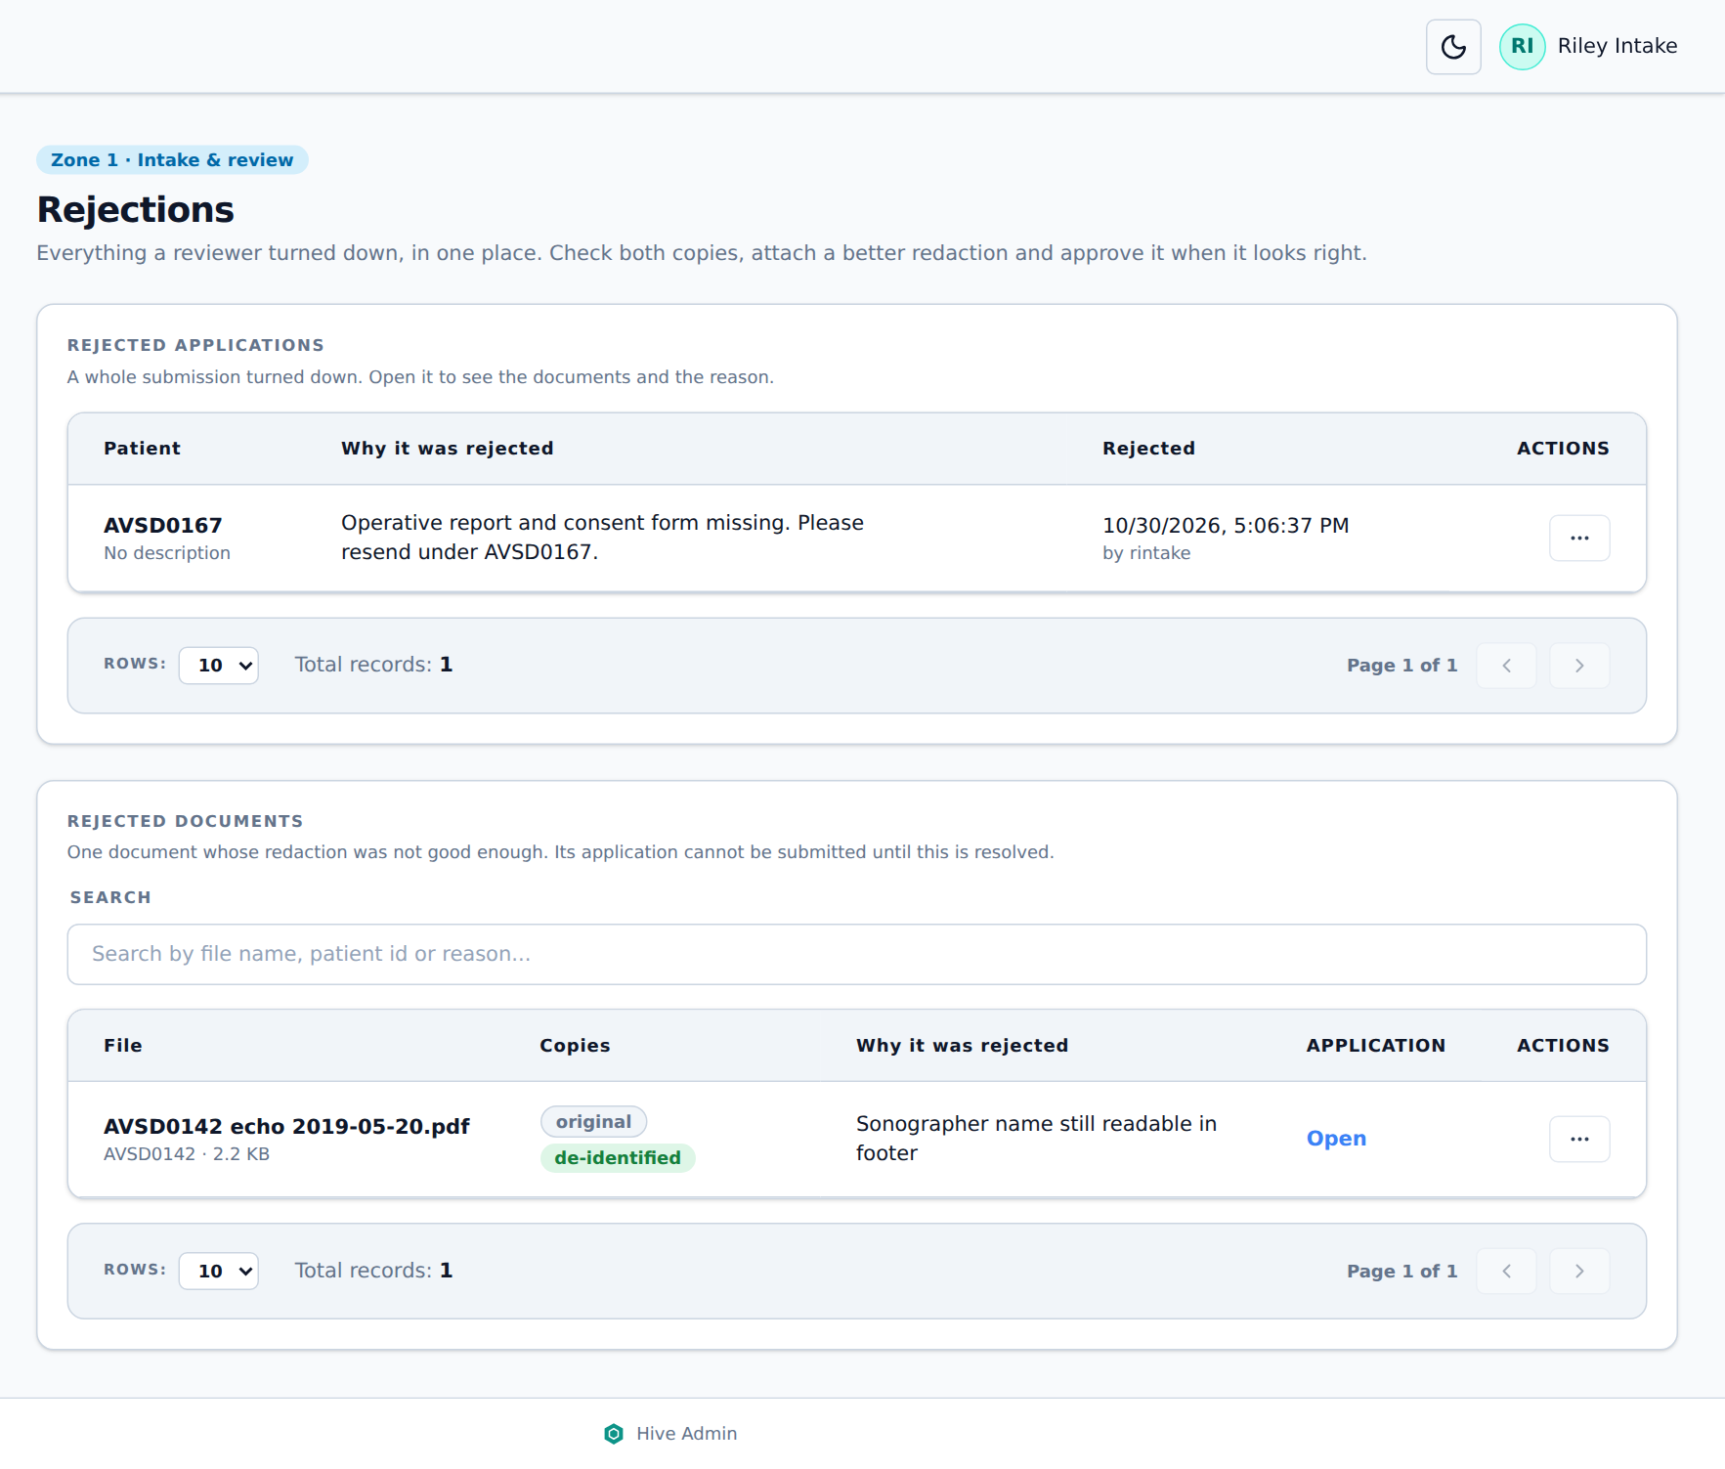
Figure 21. The Rejections page

Redacting a document by hand
- On the rejected document, click ⋯ → Download original (or Download de-identified).
- Open it in Adobe Acrobat Pro and redact what was missed with the Redact tool. Save it.
- Back in Hive, click ⋯ → Replace de-identified copy, choose your file and click Replace.
- The new copy keeps its place in the application, is named with _RR and is marked by hand. It goes back to review; check it and approve it.
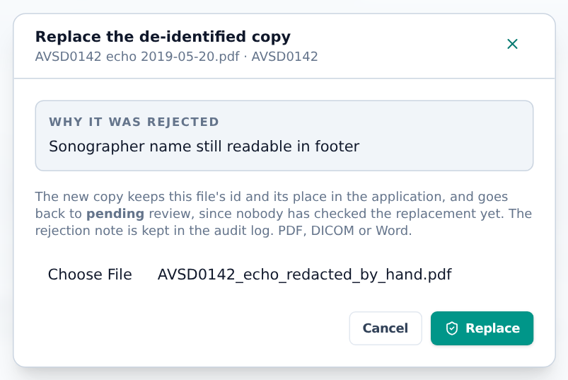
Figure 22. Replacing the de-identified copy with one redacted by hand
Protocol
§9.1.7: documents with remaining PHI are redacted manually with Adobe Pro, re-uploaded with an extra “R” in the suffix, and their redaction status is updated.

Other actions on the Rejections page: View and Download either copy, Approve (clear the rejection without replacing the copy), Open application, Delete file and Delete application (removes the files from disk for good; the record and reason stay).

5.6 Archived originals
After an application is submitted, its originals are kept in the archive and nobody can open them, not even staff who could before. The CHSS Manager can give one person access to one original, for example when the redacted copy looks damaged.
- The CHSS Manager opens the submitted application, goes to 2. Documents, and clicks ⋯ → Access to the original….
- In Give access to, pick the person. In Why, write the reason.
- Click Give access. The person can now use View original on that document. Access can be removed in the same window.
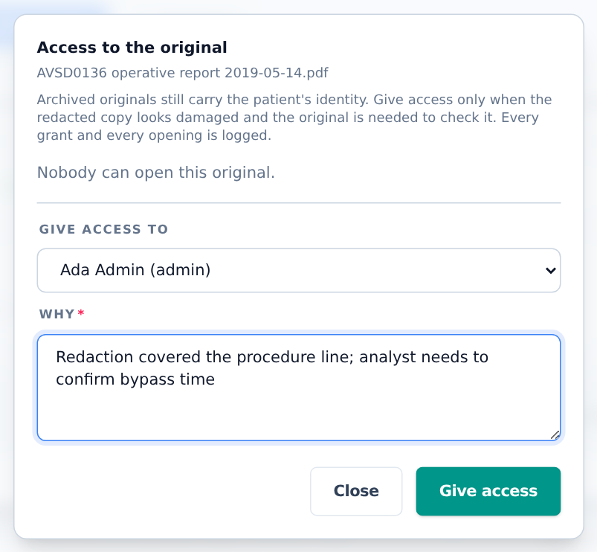
Figure 23. Giving one person access to an archived original
Protocol
§9.1.3: the archival storage holds all original PDFs. Access needs a specific permission granted only by the CHSS Manager, only for files suspected to be damaged by redaction. Every grant and every opening is logged (Audit log and Access log).

5.7 Files
The Files page lists every de-identified document across all patients. It is read-only; documents arrive through the De-Identifier. Use the search box to find a document by name, then Open, Metadata or (with permission) Delete.
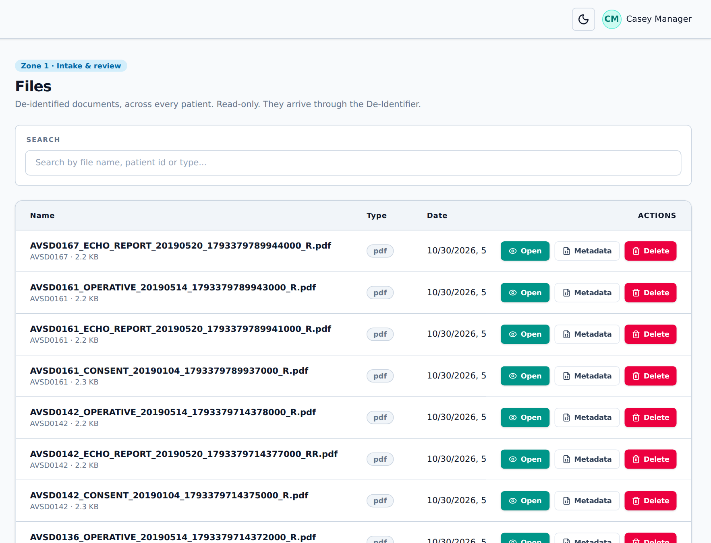
Figure 24. The Files page
Protocol
§9.1.5–9.1.6: the active storage holds every redacted PDF and is the main source for abstraction. Only senior analysts may see the whole of it.

5.8 Metadata
The Metadata page lists what Hive read from every document (type, dates, DICOM tags, PDF properties). Filter by Status and Type, or search. Export to Excel saves the list.
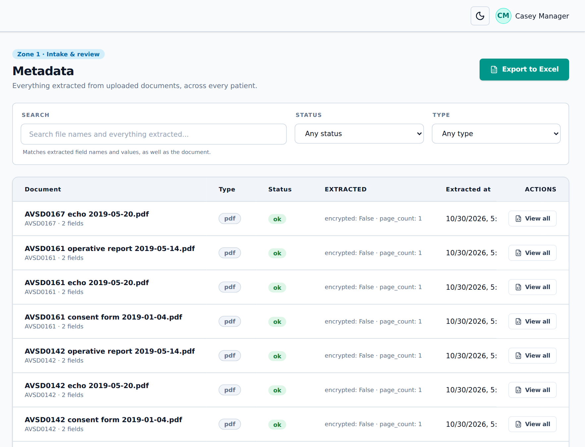
Figure 25. The Metadata page
Protocol
§9.1.2, §9.1.8: document and image metadata is stored so documents can be searched and retrieved.

5.9 Leaded images
Some images show identifiers in lead letters inside the picture, which cannot always be covered automatically.
- In the application, click ⋯ → Mark as leaded on the image.
- The image shows leaded · not for Zone 2 in red. It can still be used in Zones 1 and 1X but can never go to Zone 2: preparing a safe copy with documents is refused while a patient in the cohort has one.
- Once the image has been cleaned by hand and replaced, click ⋯ → Clear leaded mark.
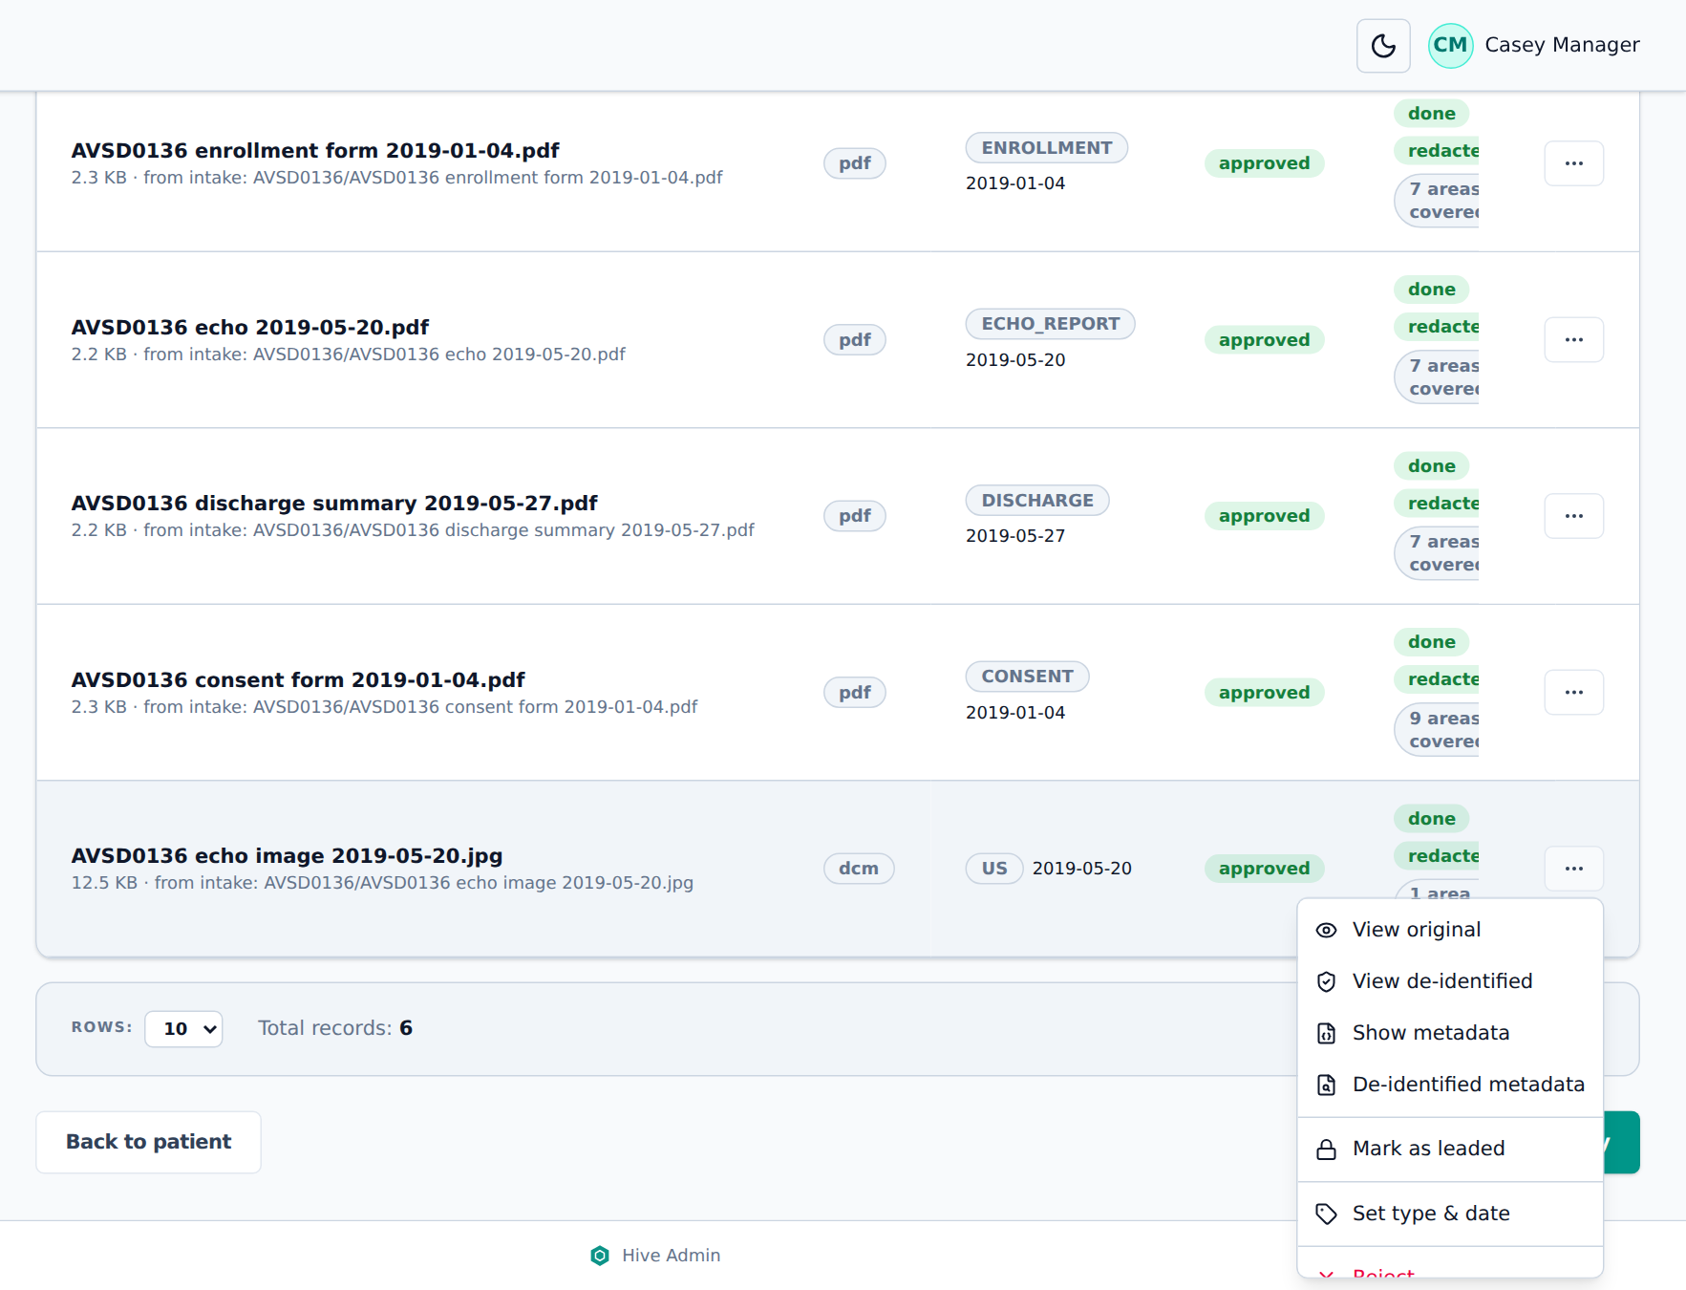
Figure 26. Mark as leaded, on an image
Protocol
§9.1.9: leaded images are marked in their metadata and kept in Zones 1 and 1X only.

Not yet available in Hive
§9.1.2: images and their metadata are sent to PACS. Hive keeps images in its own image storage; there is no PACS link.

5.10 Patients
The Patients page holds each patient’s identity and contact details. This is the only place where names appear, and only in Zone 1.
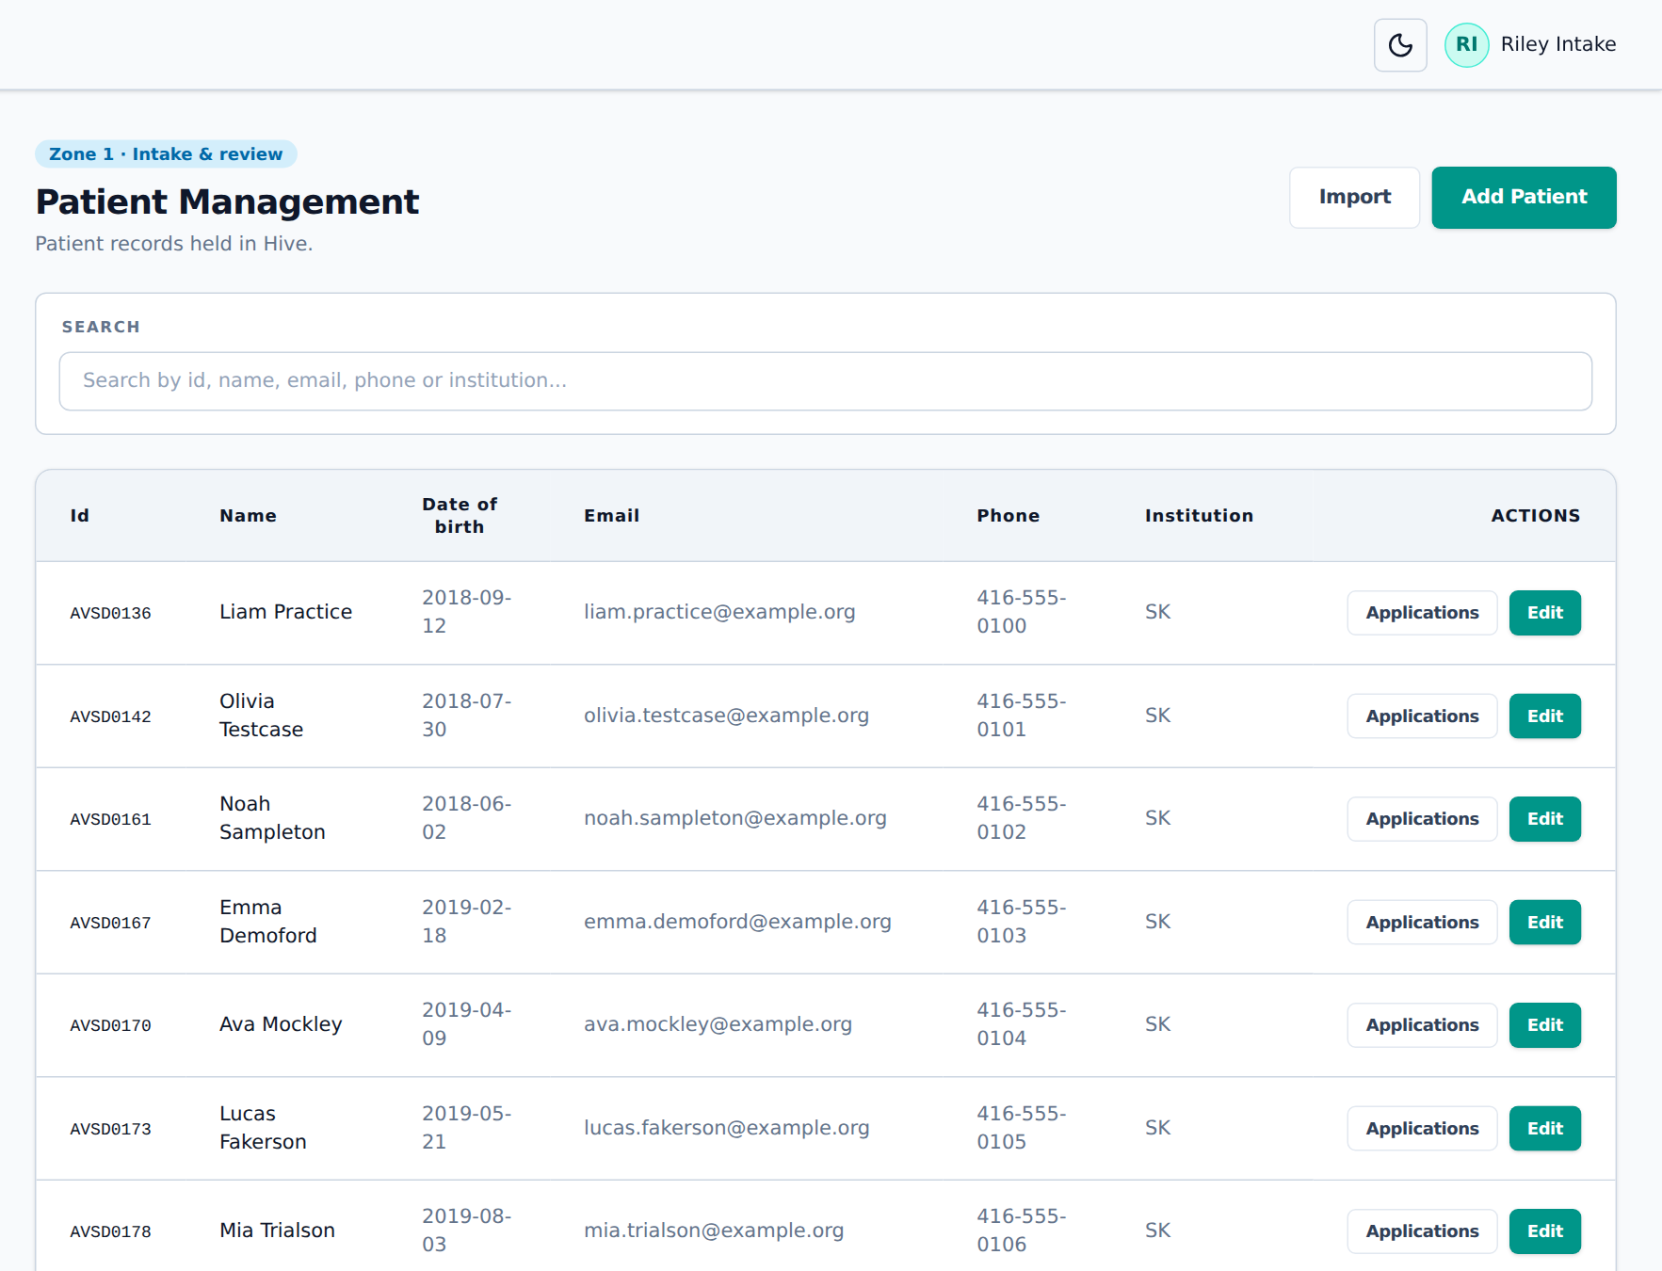
Figure 27. The Patients page
- Add Patient creates one patient. The code cannot be changed later.
- Edit changes the details. Applications lists the patient’s applications.
- Tick Site does not share records or contact details for sites that only ask for a code (chapter 5.3).

Importing many patients
- Click Import.
- Click Download template to get the columns. Only Patient code is required; dates are Excel dates or YYYY-MM-DD.
- Fill it in, choose the file (.xlsx or .csv) and click Preview. Nothing is changed yet. The preview shows what will happen to each row, and any problems or conflicts.
- Click Import N patients. New codes are created; patients already in Hive only get their empty fields filled.
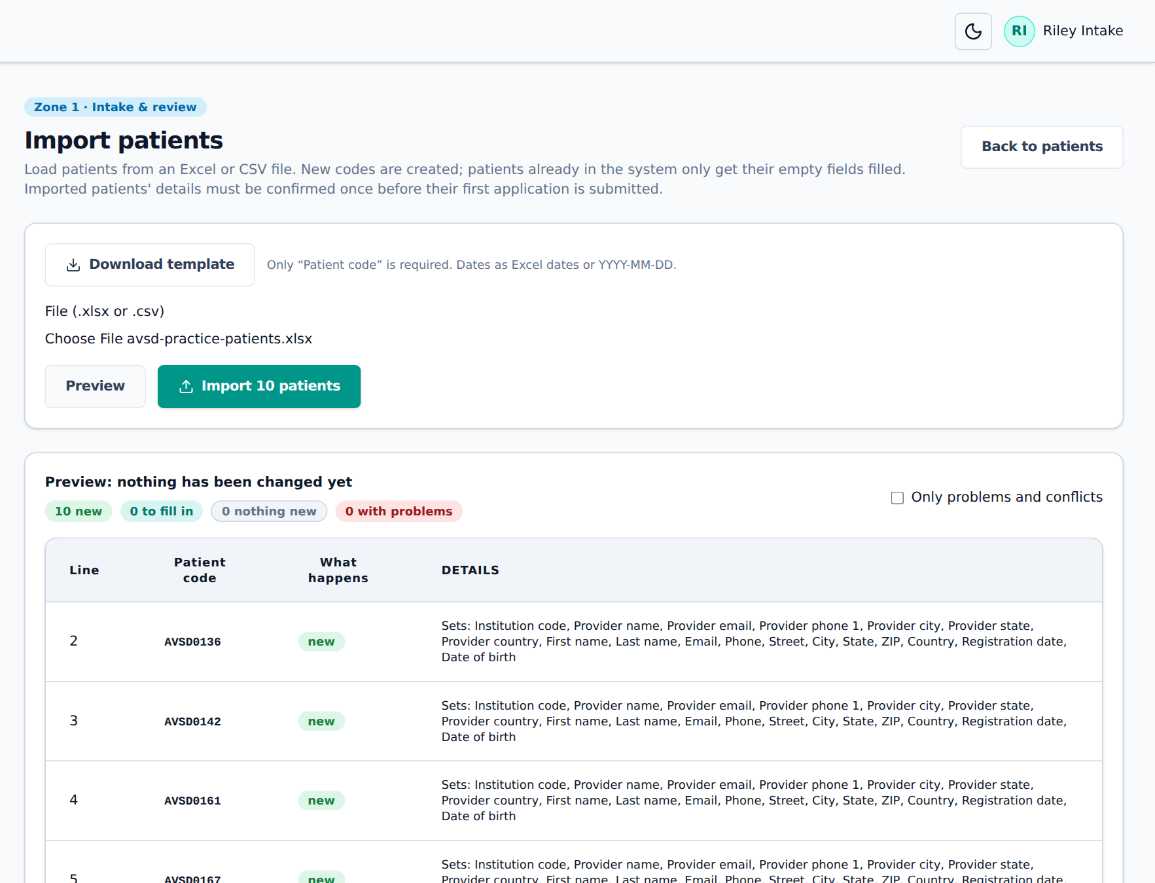
Figure 28. Preview of a patient import
Note
Imported patients must have their details confirmed once (Details are correct, chapter 5.3) before their first application can be submitted.

5.11 REDCap exchange
REDCap is the main tool for clinical data. The REDCap page brings REDCap data into Hive and sends lists back.
Protocol
§9.1.12: Python REDCap import APIs run every night and bring in the data, the data dictionary and the log (record creation and updates, queries, variable history).

Not yet available in Hive
The direct REDCap API connection is not set up yet. The page shows Simulated: files: someone with REDCap access exports the files from REDCap and imports them here. Once the API is connected, the same import runs every night by itself.

Importing from REDCap
- In REDCap, export the Data dictionary, the Records (raw) and, if needed, the Logging as CSV.
- In Hive, under Import a REDCap export, choose What: start with Data dictionary. It decides which fields may ever go to Zone 2 (coded, number and date fields; never identifier or free-text fields).
- Enter the Dataset (REDCap project) name, for example avsd_clinical (one dataset per cohort, §9.5.2).
- Choose the file and click Preview, then Import.
- Repeat for Records (data), then Logging (audit trail). Records whose code is not a patient in Hive are skipped and listed.
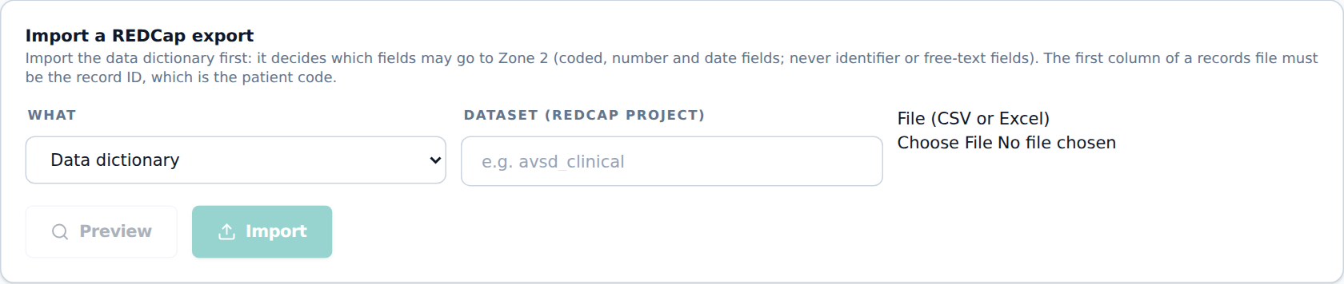
Figure 29. Importing a REDCap export
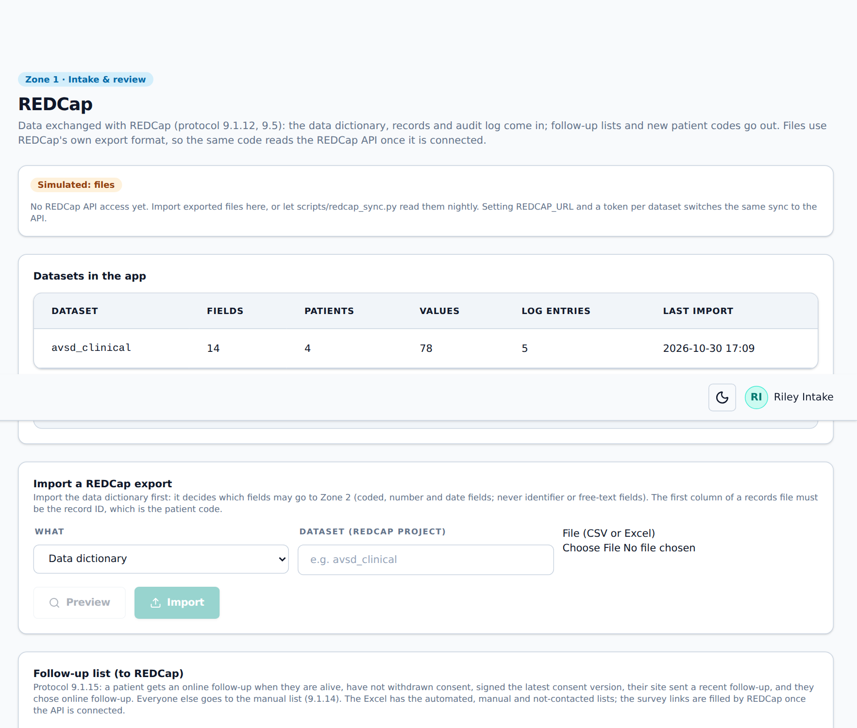
Figure 30. After the import: the dataset with its fields, patients and log entries

New patient codes (to REDCap)
Lists patients in Hive with no record yet in a REDCap dataset, as a REDCap import file. Enter the Dataset, click Download CSV and import it in REDCap, so sites enter data only against a valid code.
Protocol
§9.1.2: no data is entered without a valid UBRS.

5.12 Follow-up
Patients are followed up periodically, online where possible.
Protocol
§9.1.15: a patient gets an automated online follow-up when they are alive and have not withdrawn consent, and (1) signed the latest consent version, (2) their site’s follow-up is current, and (3) they chose online follow-up in the consent matrix. They receive a personalised REDCap link by email.
§9.1.14: everyone else goes on the manual follow-up list.

- On the REDCap page, in Follow-up list (to REDCap), enter the Latest consent version (for example v3) and how many days count as a Recent follow-up from the site.
- Click Check to see how many patients are automated, manual or not contacted, and why.
- Click Download list (Excel). It has the Automated, Manual and Not contacted lists, with the reason for each patient and whether a consent update is due (for example turning 18).
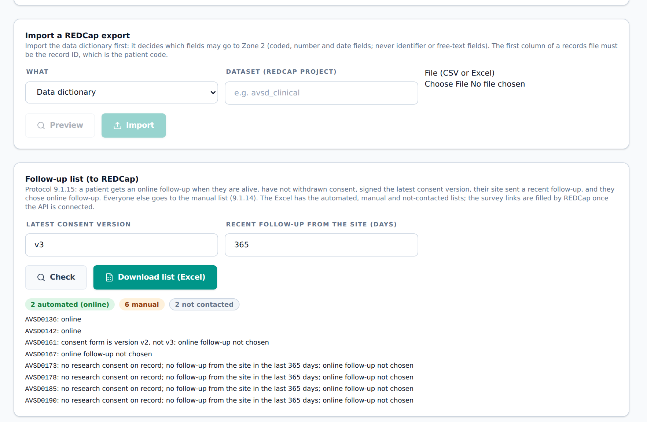
Figure 31. Checking who gets an online follow-up
Not yet available in Hive
Sending the follow-up: the personalised REDCap survey links and invitation emails (§9.5.4), and running the check on a schedule.
Manual follow-up (§9.1.14): pulling contact details and printing personalised forms into a follow-up folder.
Today Hive produces the lists only.

[ Picture to be added ]
Picture of the REDCap invitation email and survey, once the REDCap API is connected.
Figure 32. REDCap follow-up survey invitation

5.13 Data quality check
Protocol
§9.1.13: after each import an automatic Python quality check looks for missing critical variables, impossible values and conflicting information. It produces a PDF report per cohort for the designated staff. Issues that were checked and accepted are suppressed so they are not raised again.

Hive’s data quality check runs as a scheduled job (not a page). It checks patients (for example missing date of birth, death before birth, age over 100), applications (submitted without documents or checklist), documents (unknown type or date, dated before birth or after death, failed de-identification) and consent (no research consent, withdrawn consent in an active project). The report comes as PDF and Excel, and staff are emailed the counts. Accepted issues are listed in a suppression file so they are not raised again.
Not yet available in Hive
A page in Hive to see the report, one report per cohort, and checks that compare Hive with REDCap.

[ Picture to be added ]
Picture of the first page of the data quality PDF report.
Figure 33. Data quality report

6. Zone 1X: preparation
Zone 1X is where data is prepared for one approved project. It holds de-identified data with CHSS codes, so nothing in Zone 1X may leave it. Only the safe copy (chapter 6.3) goes on to Zone 2.

6.1 Consent matrix
The Consent matrix records each patient’s consent decisions. Hive applies it everywhere: a patient whose research consent is refused or withdrawn cannot be in any project; for projects approved for PDFs and images, the same applies to the documents consent.
Consent | Meaning
Research use of data | The patient’s data may be used for research
PDFs and images | The patient’s documents and images may be used
Online follow-up preferred | The patient chose online follow-up (chapter 5.12)

Each decision is granted, refused or withdrawn, with the form version and date. Decisions are never changed or deleted; the latest one of each type counts and earlier ones are kept as history (Show the full history).

Recording one decision
- Under Record a decision, enter the Patient code, pick the Consent and the Decision.
- Enter the Form version, the Consent date and, if useful, a Note.
- Click Record.
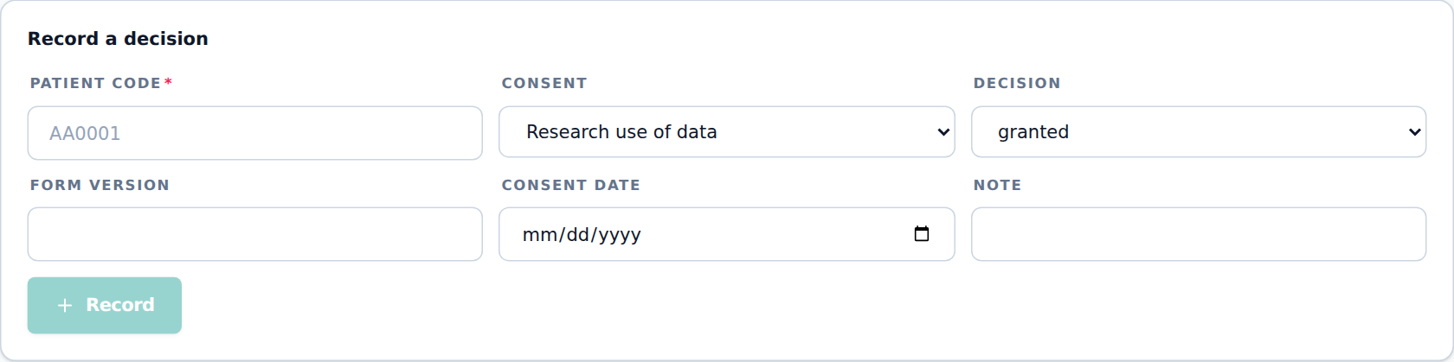
Figure 34. Recording a consent decision

Importing from a spreadsheet
- Under Import from a spreadsheet, click Template for the columns: Patient code, Consent type, Status, Version, Consent date, Note.
- Choose the file and click Preview. Rows that match the latest decision are skipped.
- Click Record N decisions.
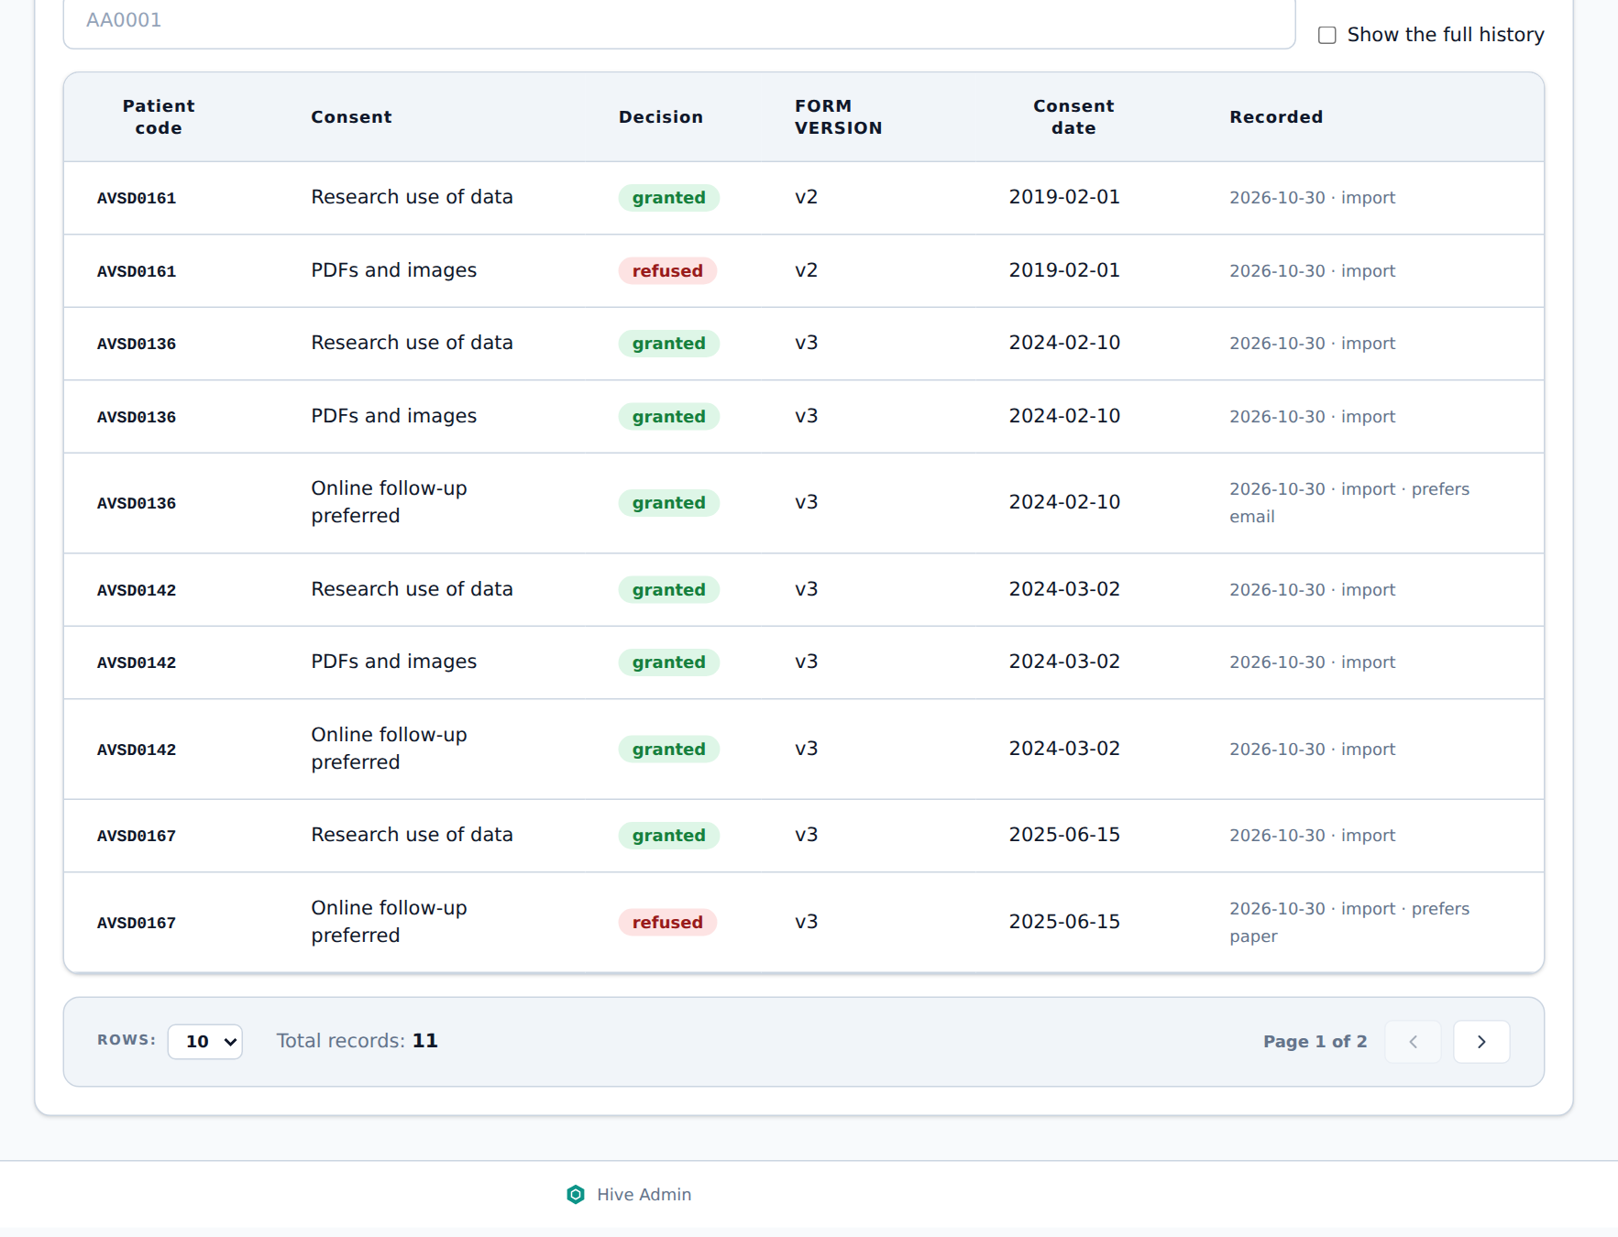
Figure 35. The consent matrix
Protocol
§9.5.1: the consent and contact matrix is kept in REDCap in a machine-readable form, with each patient’s consent status, version and restrictions, and is applied whenever data is extracted.

Not yet available in Hive
Reading the consent matrix straight from REDCap (today it is imported from a REDCap export).
§6.7: when consent is withdrawn, the patient’s documents and copies are deleted. Today Hive keeps a withdrawn patient out of every new project, workspace and release, but does not delete their documents.

6.2 Abstraction folders
An abstraction folder is a temporary, read-only copy of de-identified documents for one person’s task, for example abstracting echo results into REDCap. Only documents of submitted applications can be used.
- Open Abstraction folders and click New folder.
- Describe the documents you need. Leave a field empty to take any value: Patient codes, Types / modalities (for example ECHO_REPORT, MR), Document date from / to, Text in the file name or metadata, and the file types.
- Click Find documents. Hive shows how many documents for how many patients match.
- Enter a Folder name and the Purpose. In Assign to, pick the person doing the work, or leave Myself.
- Click Make folder. The folder location is shown in the list; only you and the assigned person can open it.
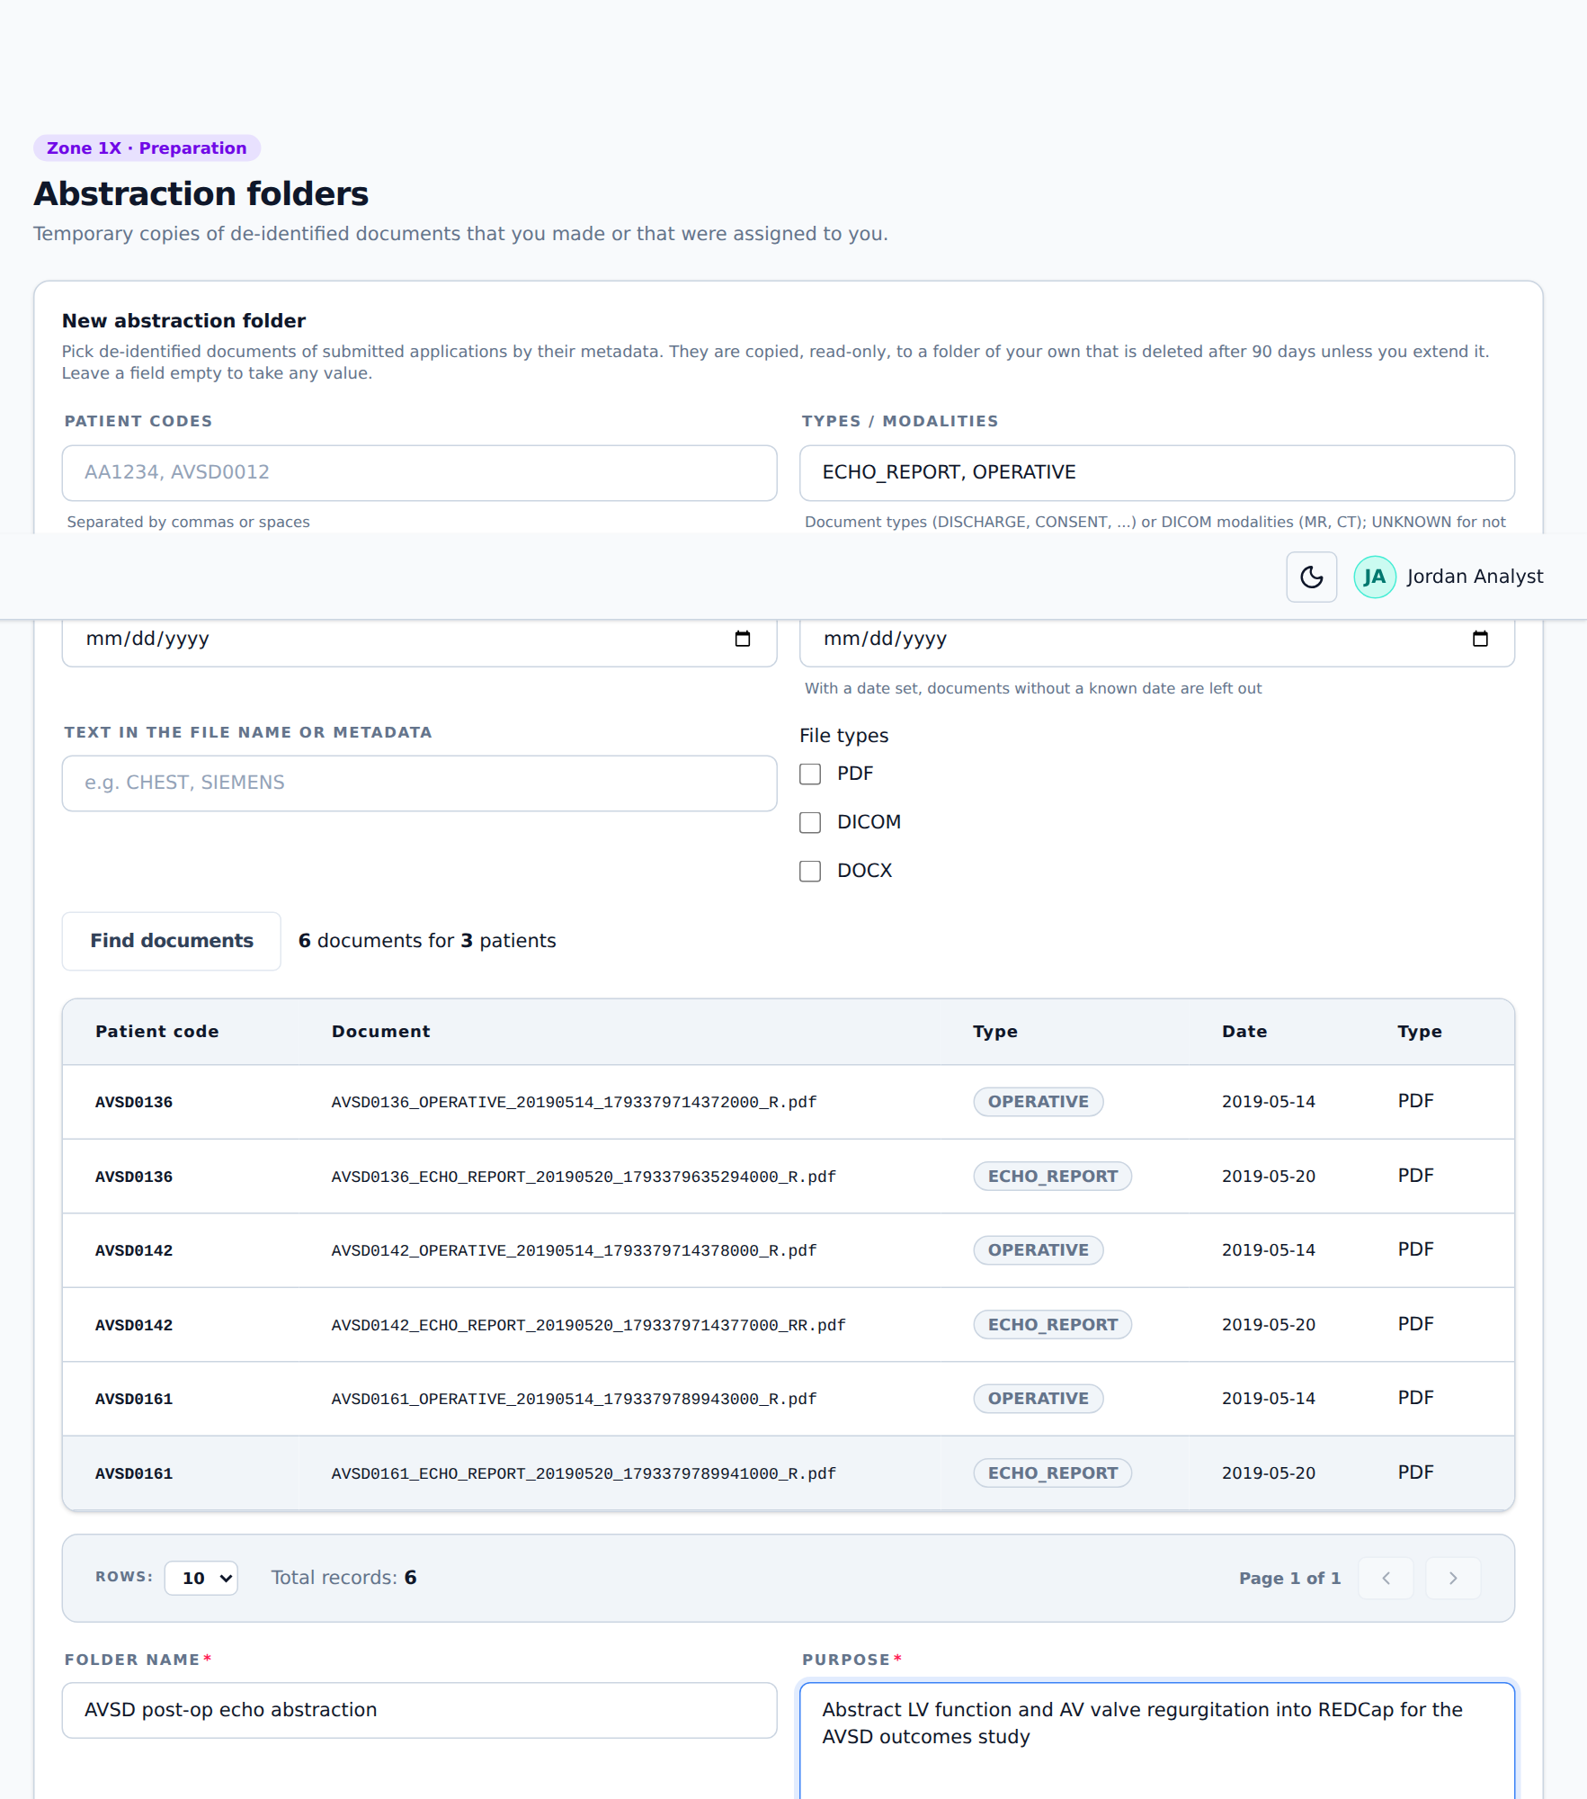
Figure 36. Making an abstraction folder
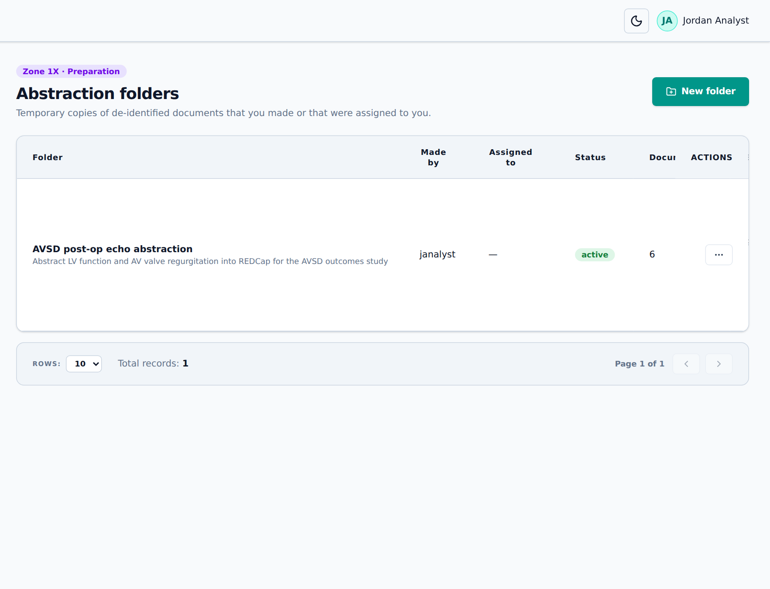
Figure 37. An active abstraction folder, deleted automatically after 90 days
Click ⋯ on a folder for: Show documents, Extend 90 days, Copy again (copies the same documents with a new 90 days) and Delete (removes the copy; the record stays).
Protocol
§9.1.6, §9.1.9: documents needed for a task are copied to a temporary folder chosen by their metadata, accessible only to the end user. No new data is added to it. It is deleted when the task is done, or automatically after 3 months unless extended, and can be regenerated.

6.3 Projects
A project is an approved study that needs data. Each project picks its patients, has its own workspace in Zone 1X, and ends with a safe copy released to Zone 2. Only members can open a project.
[ Picture to be added ]
Copy Figure 6 of the protocol here: request received → check approvals → define cohort → check consent → extract → clean → Zone 2 preparation → manager review → release.
Figure 38. Zone 2 data release workflow (protocol Figure 6)

Creating a project
- Open Projects. Under New project, type the name and click Create project. Hive gives it a code (for example P2BE6) and opens it.
- In Project and approvals, enter the Approval reference (the ethics or data access approval, for example the REB number) and a Description.
- Tick Patient consent confirmed once consent has been checked. Patients refused or withdrawn in the consent matrix are always kept out.
- Tick Approved for documents (PDFs and images) only if the project has a demonstrated need for the files (for example machine learning). Without it, the safe copy lists the documents but does not include them.
- Click Save.
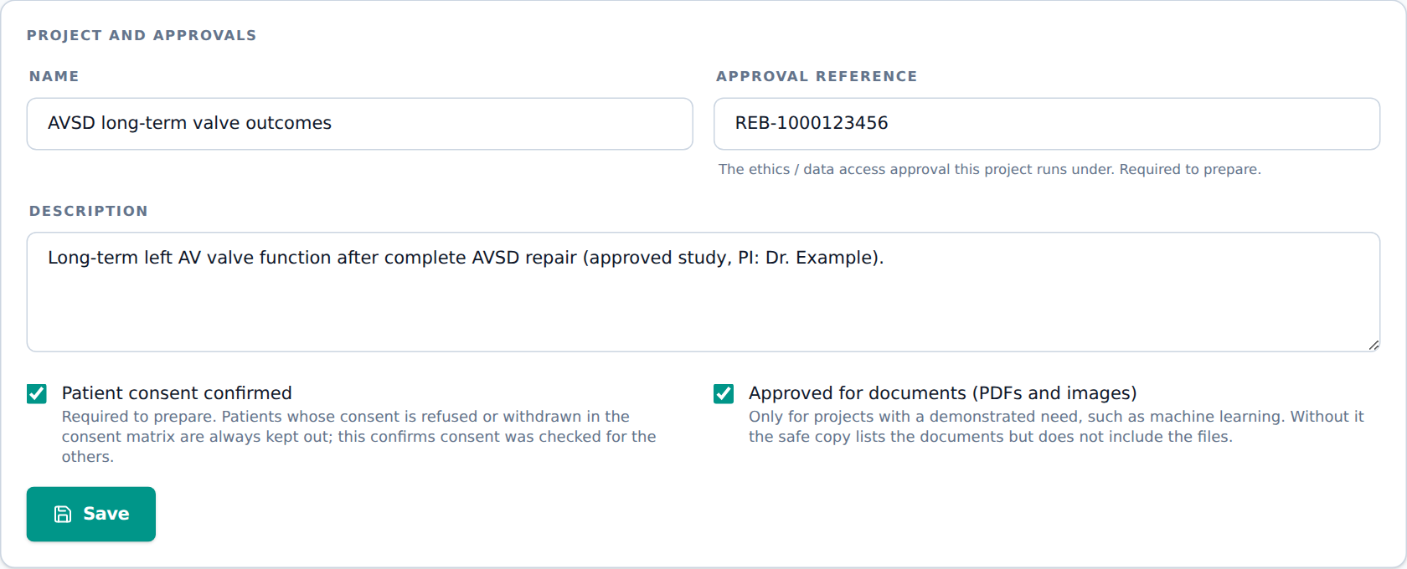
Figure 39. Project and approvals
Protocol
§9.3 (Figure 6): a request is checked for its approvals; an incomplete request is returned to the requester. The approvals (REB, agreements, training) are checked by the CHSS Manager outside Hive.

Members
Under Members, pick a person in Add a member and click Add. Only members can open the project and its workspace. Click Remove to take someone off. Adding and removing members needs the right to manage all projects (CHSS Manager or Application Specialist).
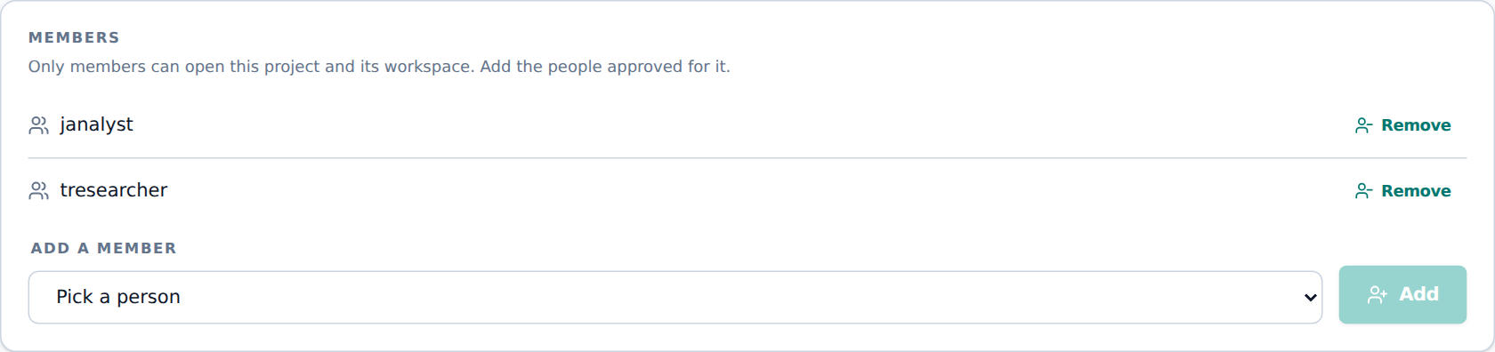
Figure 40. Project members

Choosing the patients (cohort)
- Under Patients, click Choose patients. Only patients with at least one submitted application are offered.
- Tick patients by hand, or click Find by criteria to select them by inclusion and exclusion criteria: Cohort (code prefixes), Registered from / to, Age at registration, Institution codes, Countries, States / provinces, Has documents of type or modality, Document dated from / to, Exclude these codes and Living patients only.
- Click Find. Hive shows the matches and, separately, patients that matched but are kept out by the consent matrix, with the reason.
- Click Select only the matches (or Add matches to the selection), then Save patients.
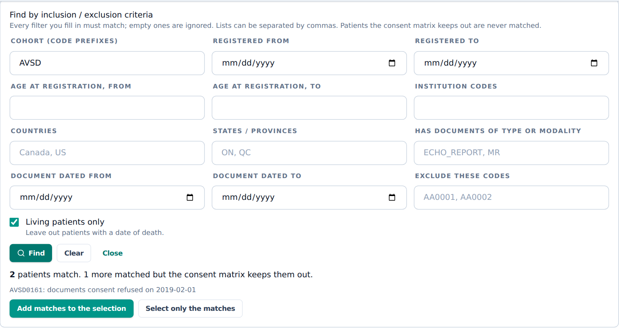
Figure 41. Finding patients by criteria; one patient is kept out by the consent matrix
Each patient gets a project-only ID (for example P2BE6-FE77G5) and a random date shift. Both are kept in Hive and never released.
Protocol
§9.2.1: the cohort explorer selects patients by named cohort or by inclusion and exclusion criteria, and the consent matrix removes patients who did not authorise the use.

Workspace (Zone 1X)
The workspace is the project’s own folder for data cleanup. It holds the cohort’s tables and, if wanted, their de-identified PDFs and images. CHSS codes stay in it, so nothing in the workspace goes to Zone 2.
- Tick Copy the PDFs and images if the project needs the files.
- Click Build workspace. The folder location and date are shown. Rebuild workspace builds it again after changes.
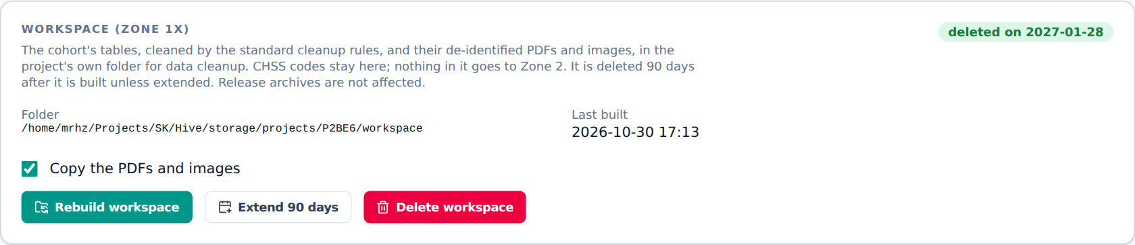
Figure 42. A built workspace
File | Contents
patients.csv, applications.csv, documents.csv | The cohort, their submitted applications and documents (no names or contact details)
redcap_<dataset>.csv | REDCap data of the cohort, one file per dataset (identifier fields left out)
documents/ | The de-identified files, by patient code (if copied)
cleaning_log.csv | The standard cleanup rules applied and how many rows each changed
profile.xlsx | For each column: missing values, distinct values, range, frequencies and outliers

The workspace is deleted 90 days after it was first built. To keep it longer, click Extend 90 days and record which approval allows it. Delete workspace removes it now; release archives are not affected.
Protocol
§9.2.2: project storage holds the patients’ data and, if needed, their PDFs and images. It is provided by the Application Specialist or Manager and kept 90 days unless extended by approval.
§9.2.3: correct data in the right place, never in Excel. (1) A single error is fixed at the source (REDCap). (2) A recurring error is fixed by a rule in the dataset builder, applied at every build. (3) An analysis-specific change goes in the analysis-ready script.

Note
Recurring corrections (rule 2) are written as cleaning rules by the Application Specialist and kept in GitLab. Ask them when the same error keeps appearing.

Safe copy (Zone 2)
Prepare safe copy makes the data that may go to Zone 2. It needs an approval reference, consent confirmed and at least one patient.
- Remaining PHI is removed: names, addresses, phone numbers, emails and dates of birth are left out (age at registration is given instead).
- Every date of a patient is shifted by that patient’s own random number of days, between −1826 and +1826 (up to 5 years either way). Intervals between dates stay true.
- Free-text fields are removed; only coded, number and date fields defined in the data dictionary go.
- PDFs and images are included only if the project is approved for documents, and never leaded images.
- Every patient, application and document gets a project-specific ID that cannot be matched to the CHSS code.
- A data_dictionary.csv explains every column.
- Click Prepare safe copy.
- If a patient is kept out by the consent matrix, Hive refuses and names the patient. Take them out of the cohort and try again.
- The release appears with status waiting for review. It is now in the Zone 2 inbox for the CHSS Manager.
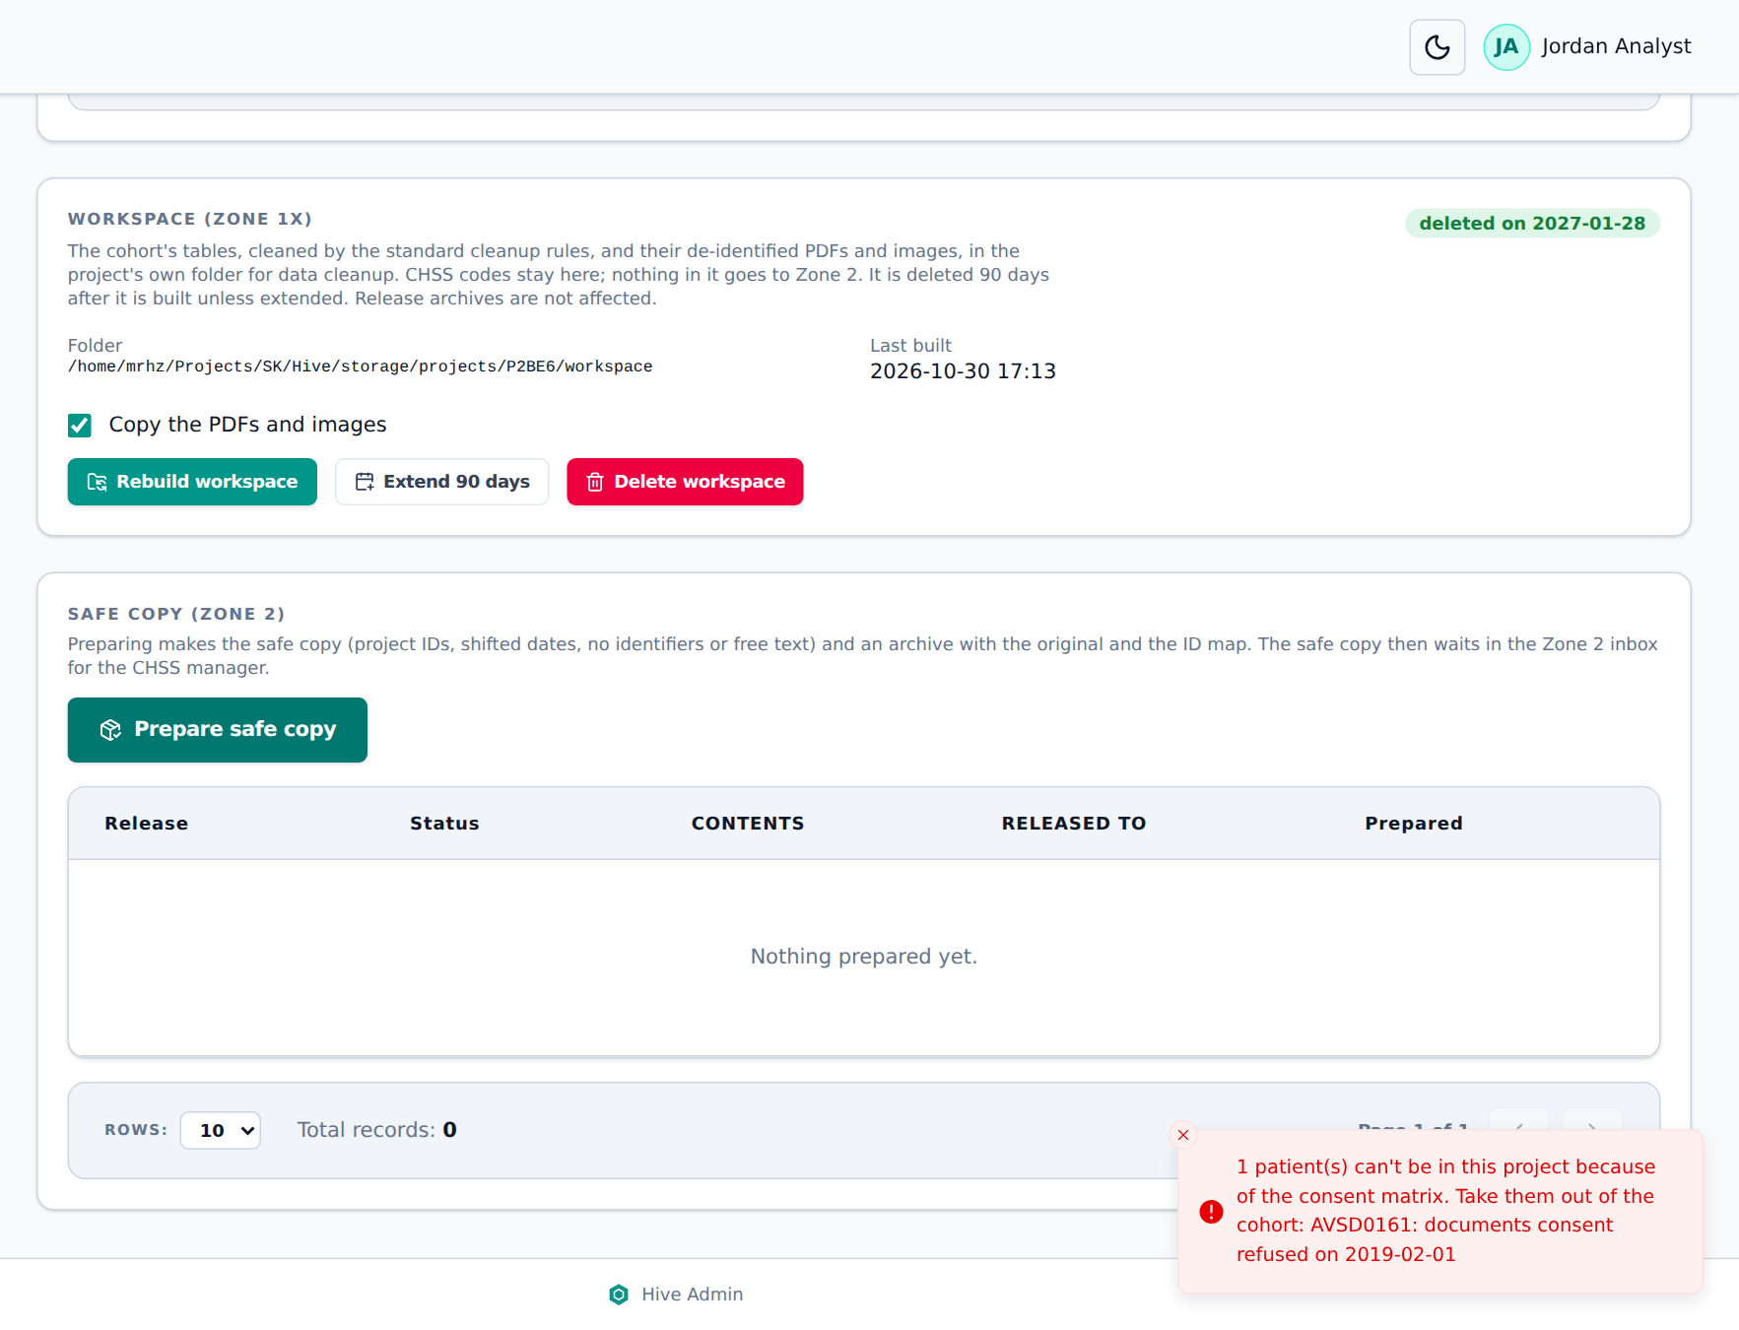
Figure 43. Prepare is refused: one patient refused the documents consent
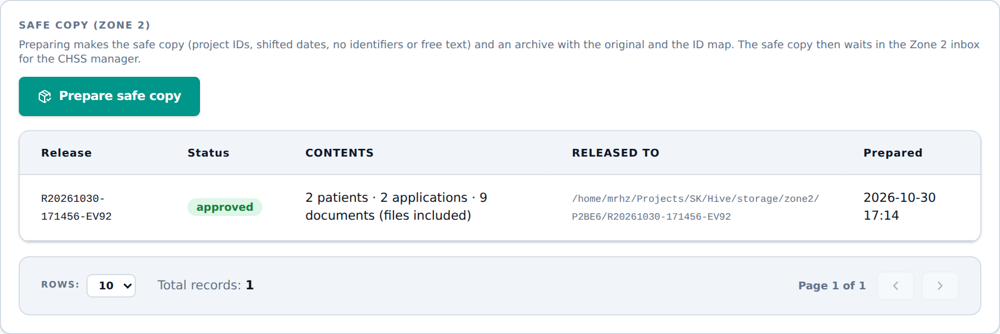
Figure 44. The safe copy after release
Protocol
§9.2.4: the Zone 2 preparation script is applied to every release: (1) remove remaining PHI, (2) shift dates by a random whole number of days per patient between −1826 and +1826, (3) remove free-text fields, (4) delete PDFs and images unless approved, (5) create project-specific patient IDs. The original data, the ID map and the approved data are archived.

Ending a project
When the study is finished, click End project and give the reason. No more safe copies can be prepared. The Zone 2 copy and the archive stay. Remove the researchers’ access in Members and on the Users page.

7. Zone 2: release and analysis

7.1 Zone 2 inbox (CHSS Manager)
The Zone 2 inbox holds safe copies waiting for the CHSS Manager. Check that they are free from identifiers and that the preparation was applied properly, then release them or send them back.
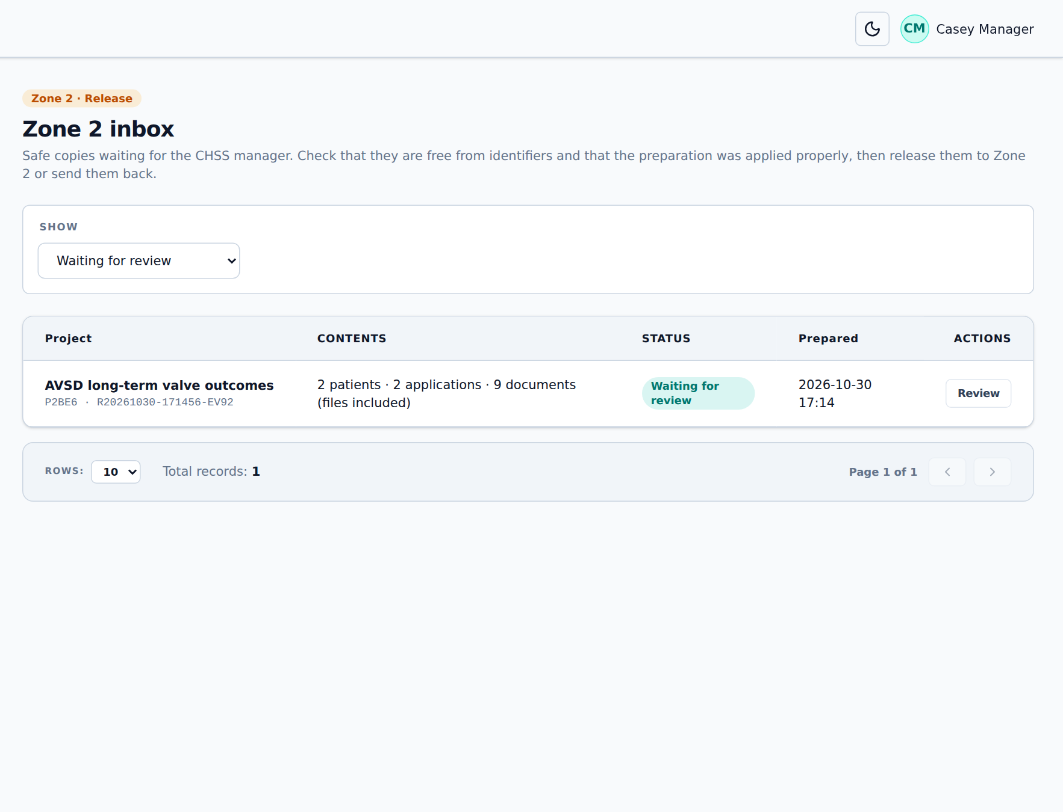
Figure 45. The Zone 2 inbox
- Under Show, pick Waiting for review. Click Review on the release.
- Check the tables: Hive shows the first rows of patients.csv, applications.csv and documents.csv. Look for anything that could identify someone.
- If documents are included, open some of them. Pick 5 at random chooses a sample; Open shows a document. Every opening is logged.
- If a document still identifies someone, click Flag and give the reason. The whole release is sent back and the document goes to Rejections to be redacted again by hand (chapter 5.5).
- If something else is wrong, click Send back with the reason. The project returns to the analyst to fix and prepare again.
- If everything is right, click Release to Zone 2. The safe copy is copied to the project’s Zone 2 folder.
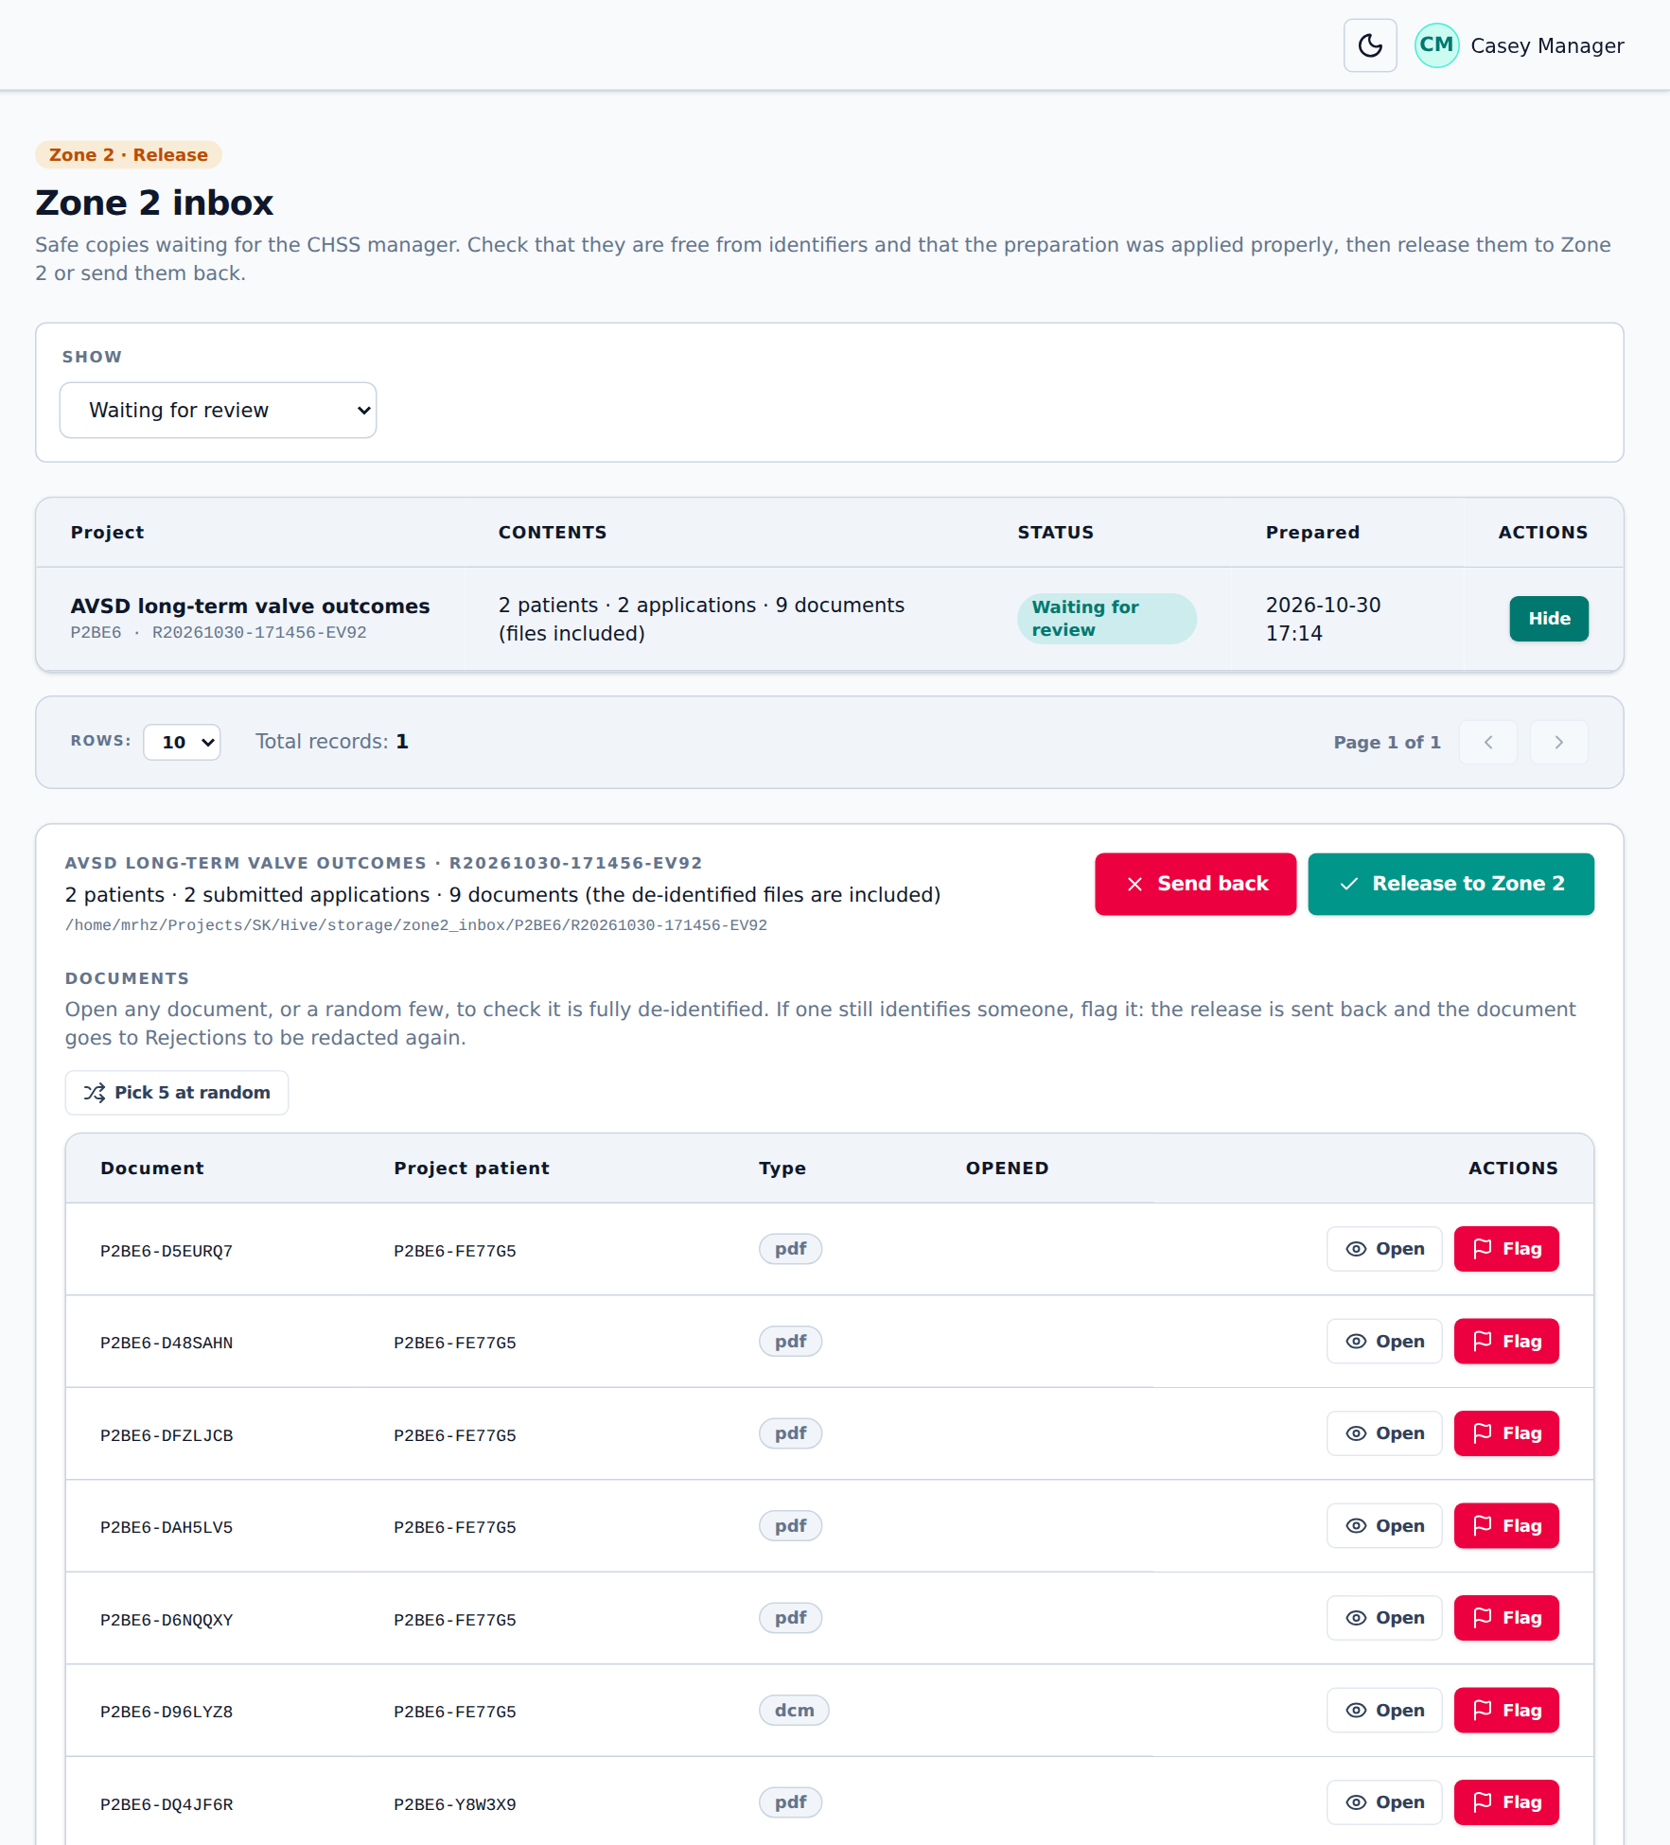
Figure 46. Reviewing a safe copy
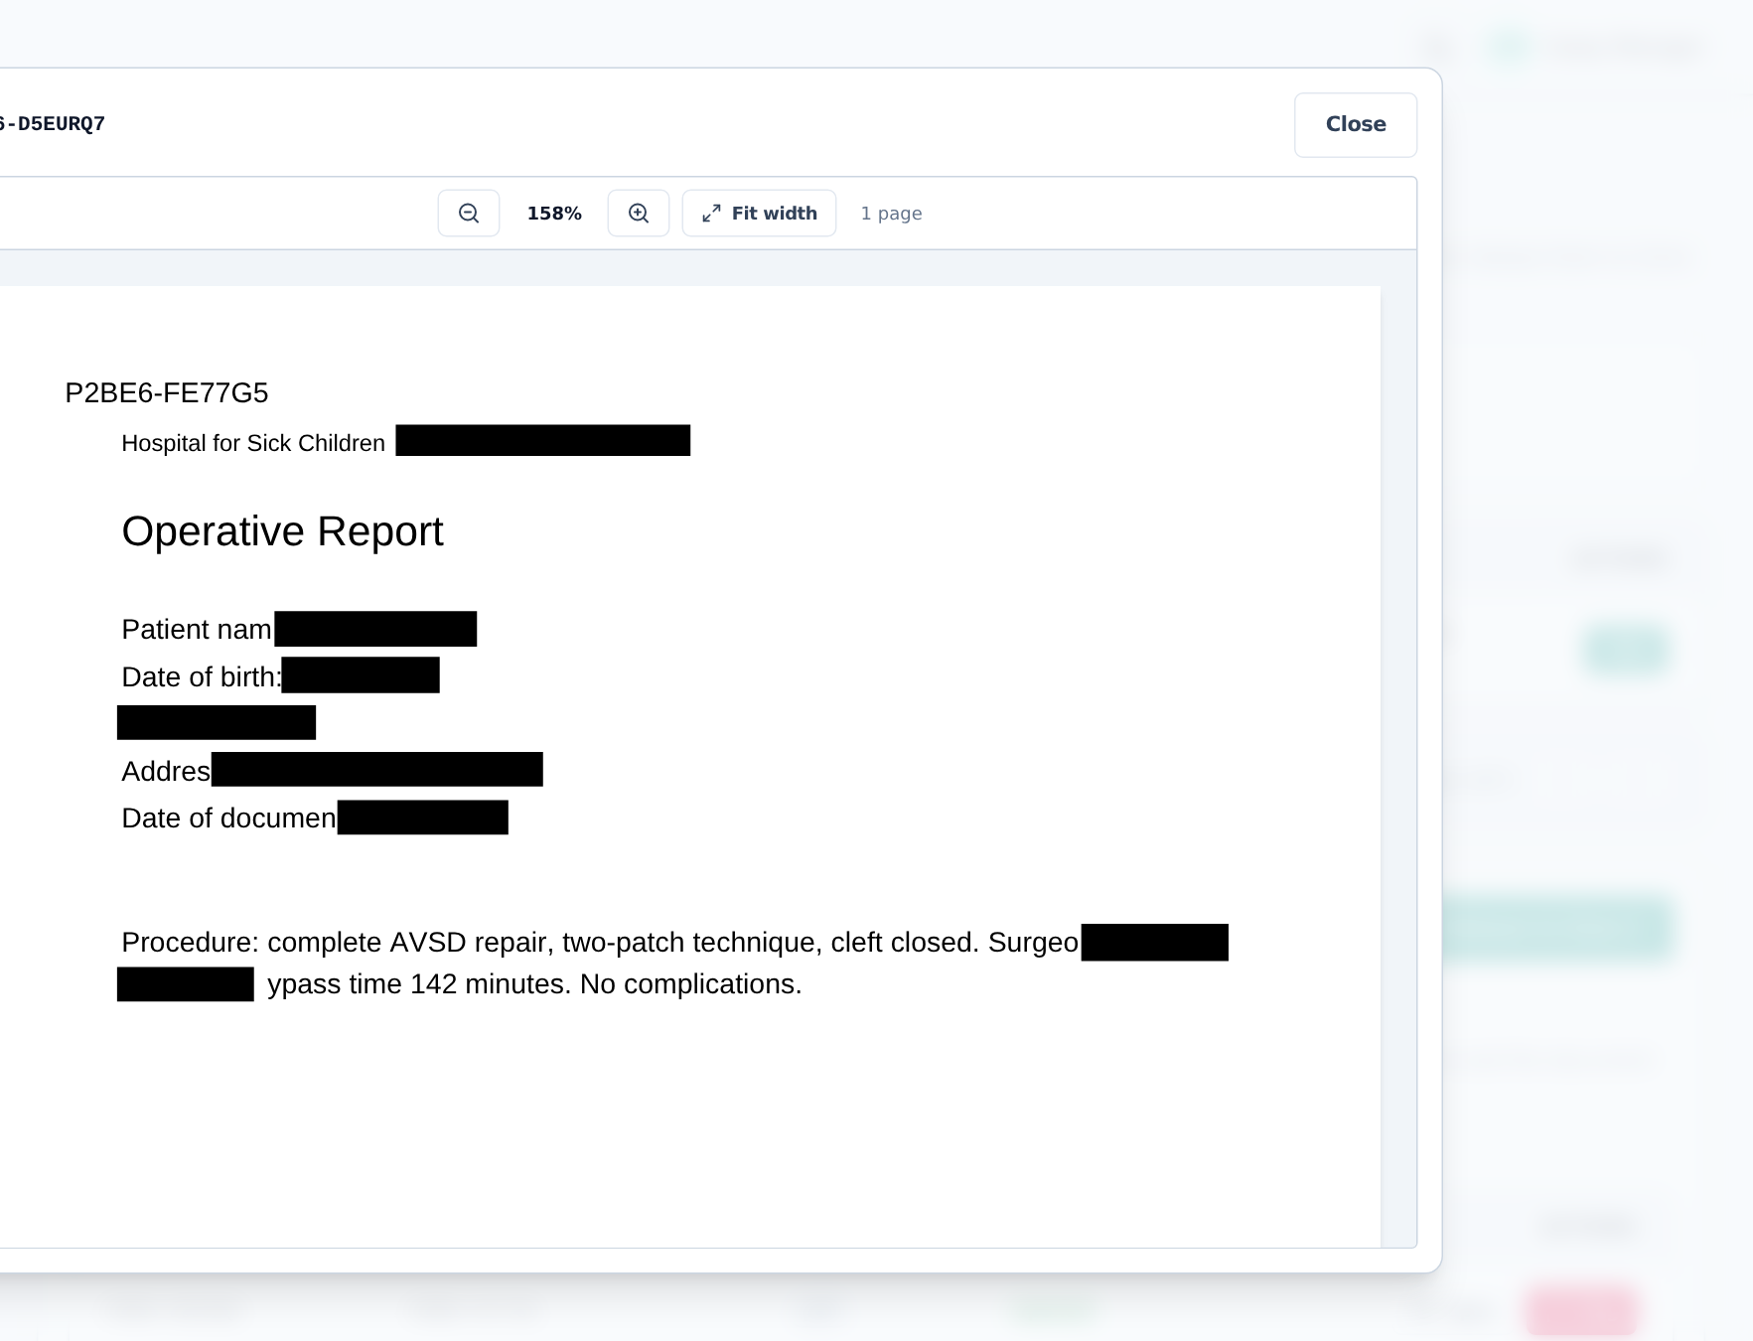
Figure 47. Spot-checking a released document: the name is the project ID
Protocol
§9.3.1: the Zone 2 inbox is an isolated area where the CHSS Manager or data manager checks that there are no identifiers and that the preparation was applied, before the data is released. §9.3.3: images and PDFs go to Zone 2 only with a demonstrated need and a full review.

7.2 Working with released data (researchers)
After release, project members find the data in the project’s Zone 2 folder on Cloudera. In Hive, Projects shows the project with status released.
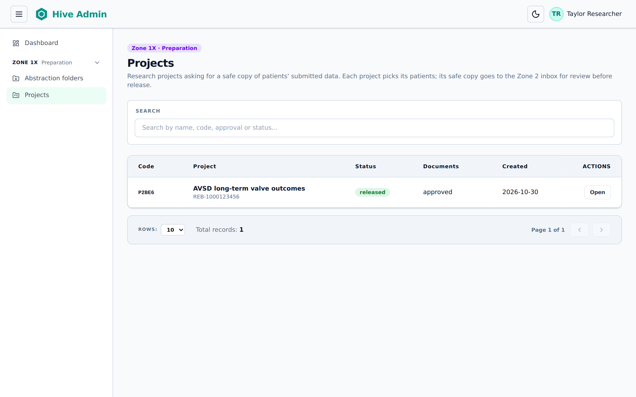
Figure 48. What a researcher sees: their released project
File | Contents
patients.csv | Project patient ID, age at registration, shifted dates, state and country
applications.csv | Project application IDs and shifted dates
documents.csv | Project document IDs, type, shifted date, size and file name
redcap_<dataset>.csv | Approved REDCap fields only (coded, number and date)
documents/ | The de-identified files named by project ID (only if approved for documents)
data_dictionary.csv | The meaning, type and values of every column

Important
Never try to work out who a patient is, and never combine Zone 2 data with data from other sources to do so. Dates are shifted on purpose: intervals are true, calendar dates are not.

7.3 Analysis environment
Protocol
§9.3.2: approved users analyse data on standard analysis virtual machines (Anaconda, R, Python, GitLab, Office 365); custom machines (more memory, GPU, SAS Viya) on request.
§9.3.4: desktop SAS 9.4 linked to the project storage.

Not yet available in Hive
The analysis machines and SAS are provided by Cloudera and RIT, outside Hive. Today analysts use Cloudera sessions on the project’s Zone 2 folder.

[ Picture to be added ]
Picture of starting an analysis session on the project’s Zone 2 folder.
Figure 49. Opening the Zone 2 analysis environment

8. Zones 3 and 4

8.1 Zone 3: SharePoint
Protocol
§9.4: Zone 3 is the CHSS document repository on SharePoint, signed in with Entra ID. It must never hold PHI.

Not yet available in Hive
Zone 3 is outside Hive.

[ Picture to be added ]
Zone 3 SharePoint site
Figure 50. Zone 3 SharePoint site

8.2 Zone 4: REDCap and the patient portal
Protocol
§9.5.1: REDCap holds the consent and contact matrix; sites enter their own data through data access groups.
§9.5.2: one REDCap clinical dataset per active cohort.
§9.5.3: a standard periodic follow-up questionnaire (consents, transition at 18, health status, PedsQL, CHQ, ASQ, DASS21, SCORE15).
§9.5.4: the REDCap email client and survey tool send personalised links to patients (Figure 7).

Not yet available in Hive
The patient portal, the follow-up questionnaire and the survey invitations are in REDCap, outside Hive. Hive exchanges data with REDCap as described in chapters 5.11 and 5.12.

[ Picture to be added ]
Copy Figure 7 of the protocol here.
Figure 51. Patient follow-up workflow (protocol Figure 7)

9. Administration
Administration pages are for the CHSS Manager and the Application Specialist.

9.1 Users
The Users page lists everyone with a Hive account. Everyone must already be able to sign in to Cloudera.
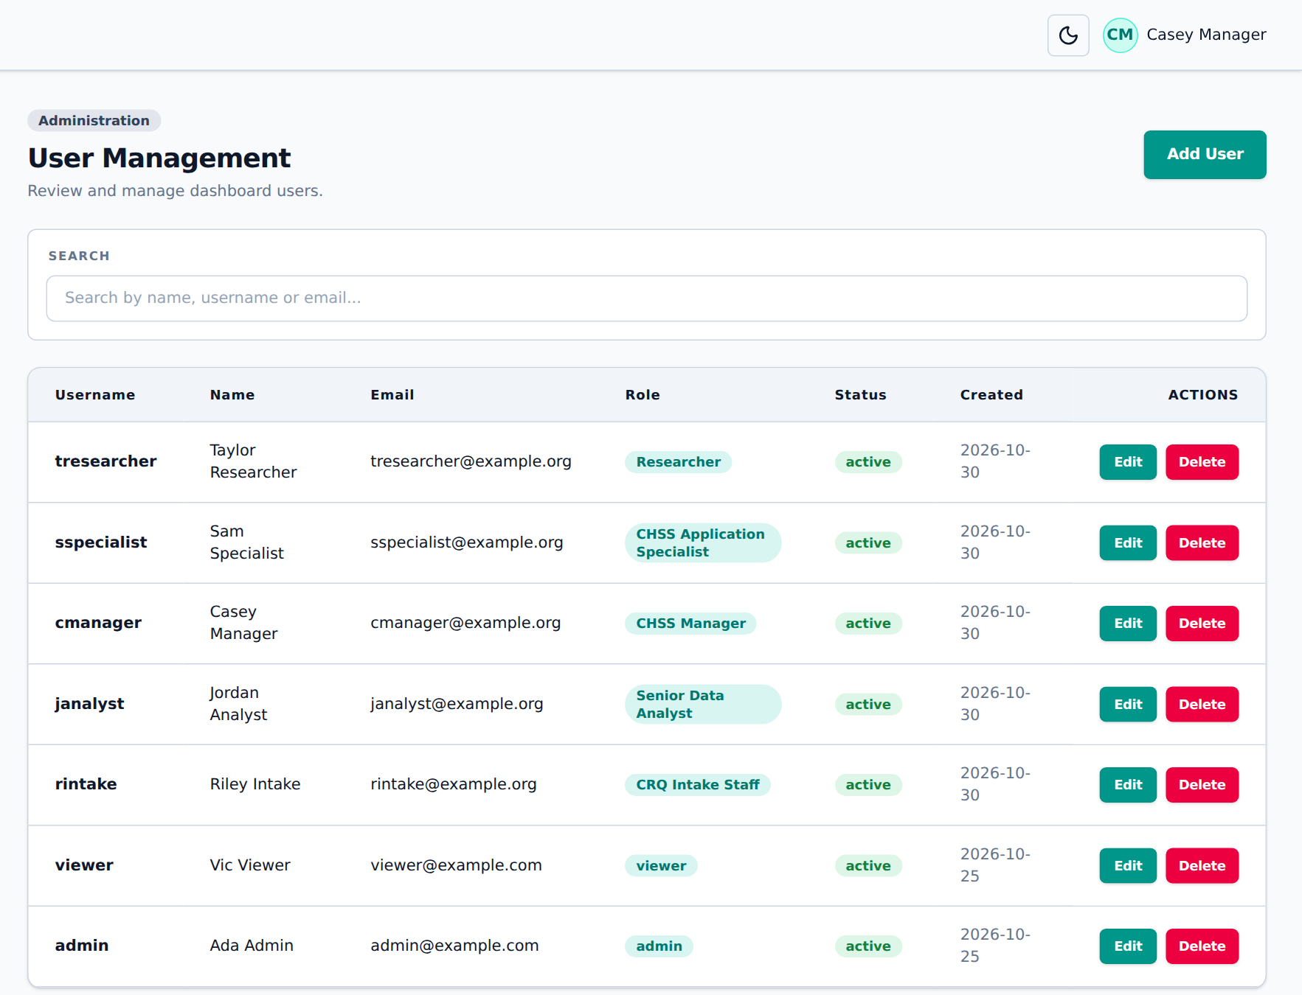
Figure 52. User Management
- Click Add User.
- Enter the Username exactly as Cloudera knows it, the email, first and last name.
- Pick the Role and leave Active ticked.
- Click Create user.
To change someone’s role or take away their access, click Edit and change the Role, or untick Active. Inactive and unknown accounts are refused and the attempt is logged in the Access log.
Protocol
§6.1: role-based access with least privilege. The CHSS Manager reviews access requests, documents compliance and reviews the user directory.

9.2 Roles
The Roles page lists the roles with the permissions each one has. Click Add Role for a new one, or Edit to change one. Permissions are grouped by zone; tick what the role may do. Changes take effect immediately.
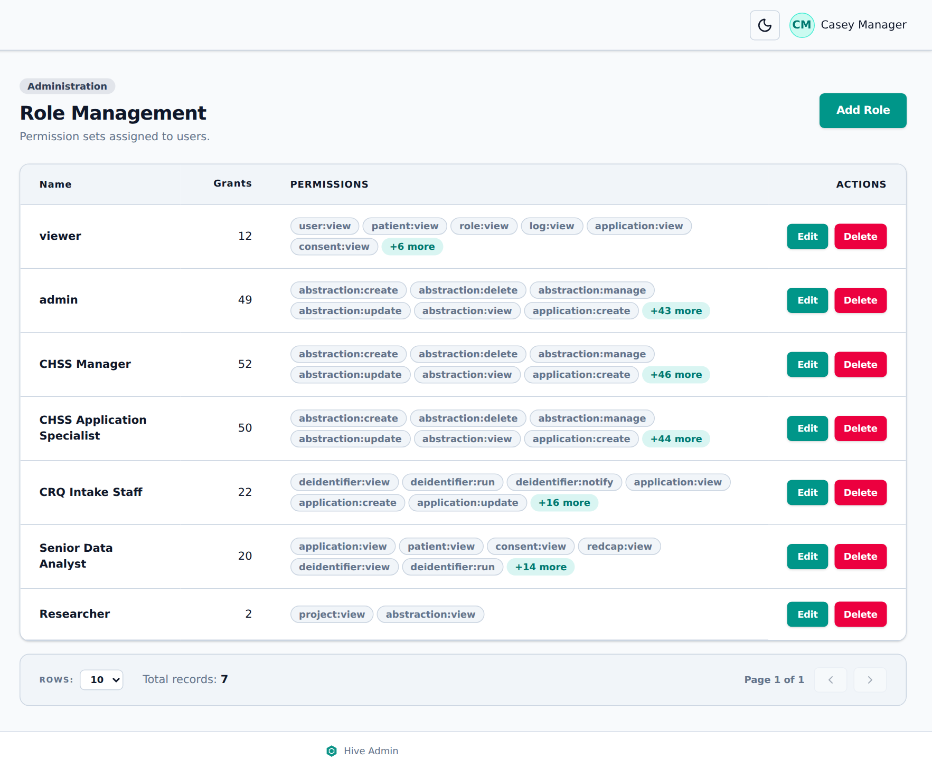
Figure 53. Role Management
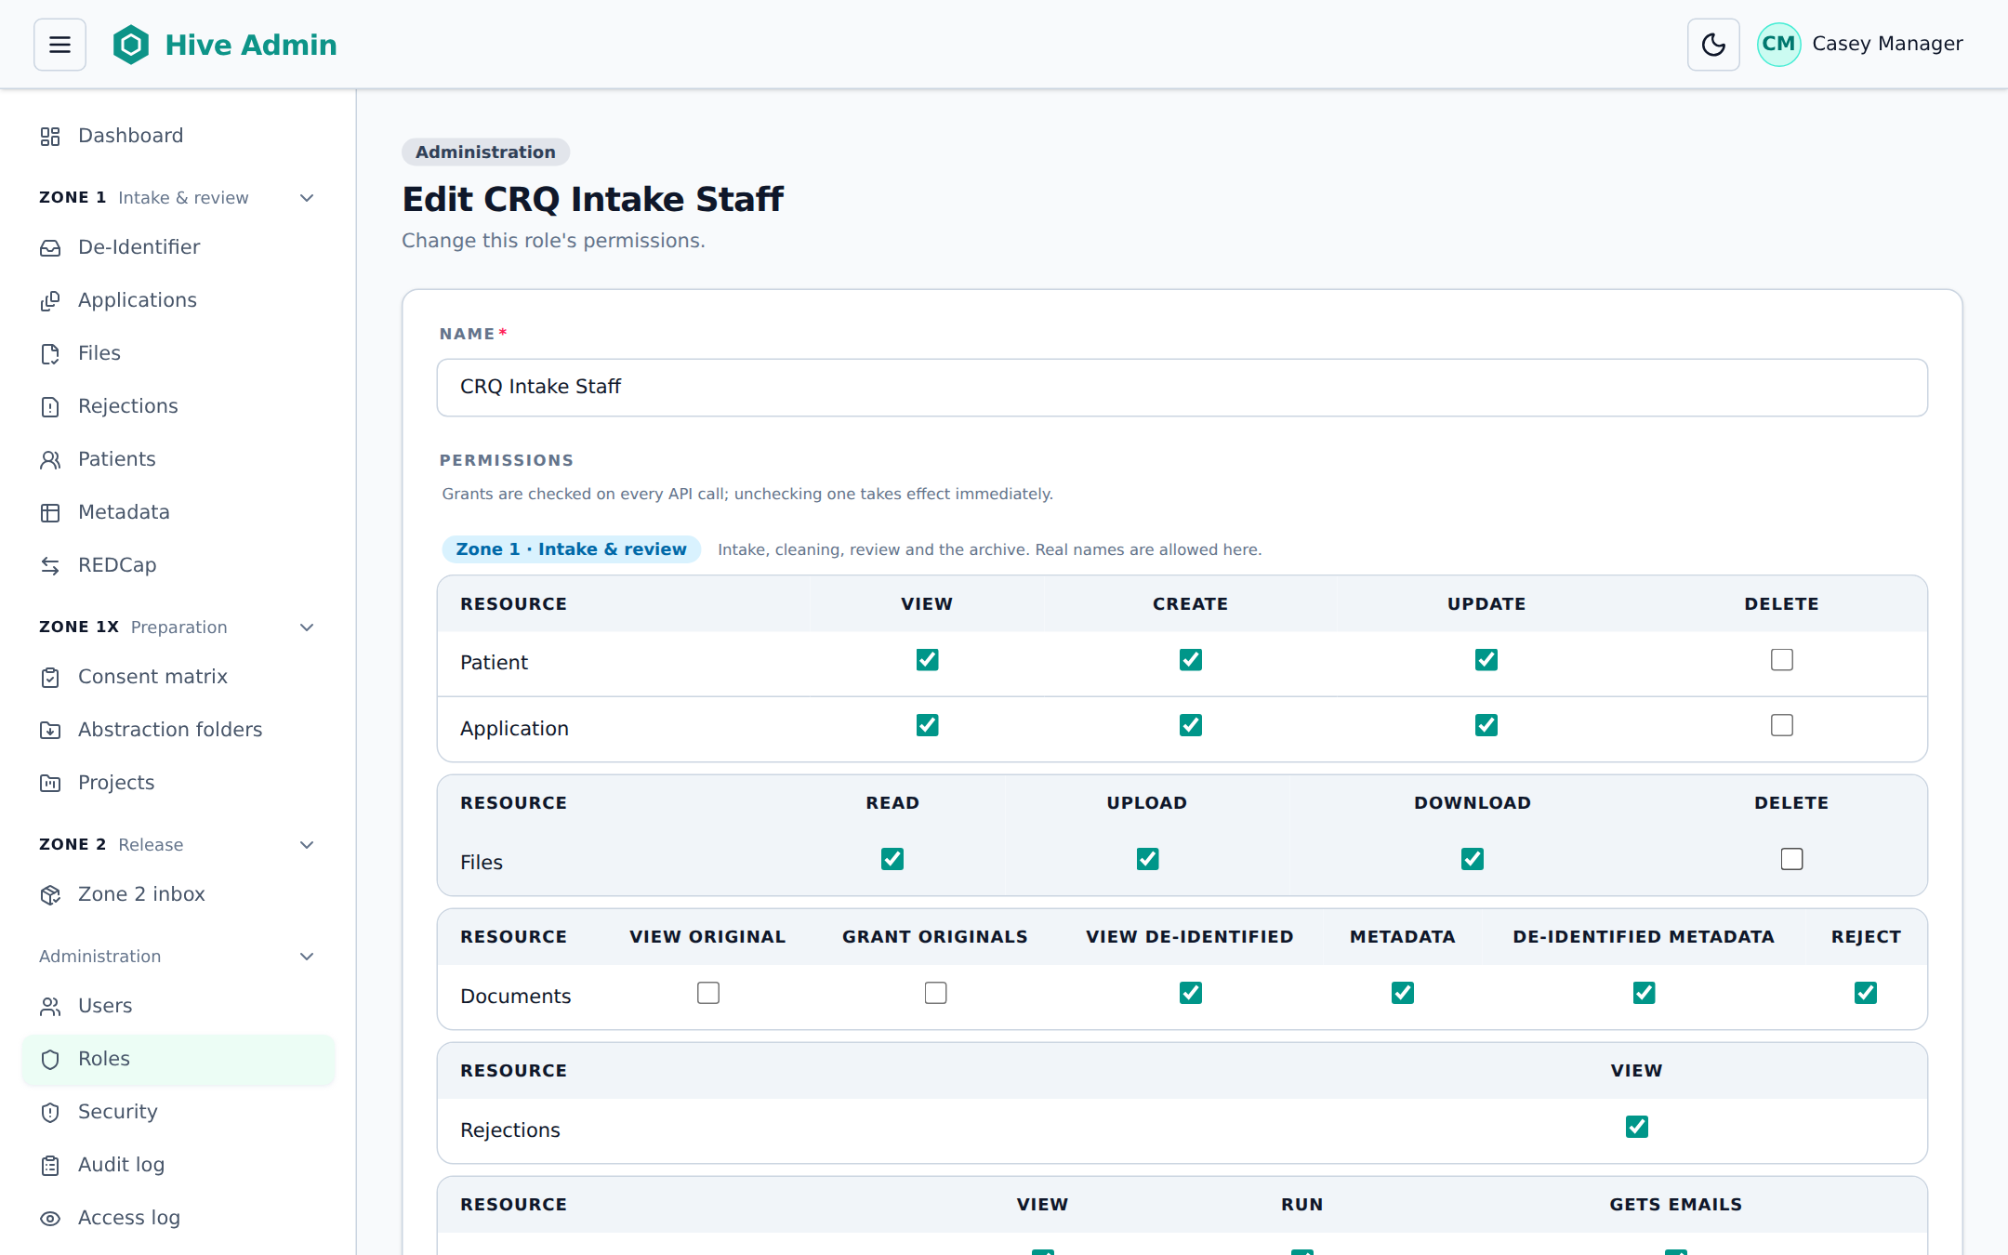
Figure 54. Editing a role: permissions grouped by zone
The full list of permissions is in chapter 10.4.

9.3 Security
The Security page is used during a security incident.

Locking Hive
- Under Lock the app, write the Reason and pick the Level.
- Click Lock now. Everyone without security management is stopped at once and sees the red banner. The CHSS Manager, Application Specialist and Host IT are emailed.
- To unlock, click Unlock in the red banner and give the reason. The lock and unlock are recorded in the Audit log and emailed.
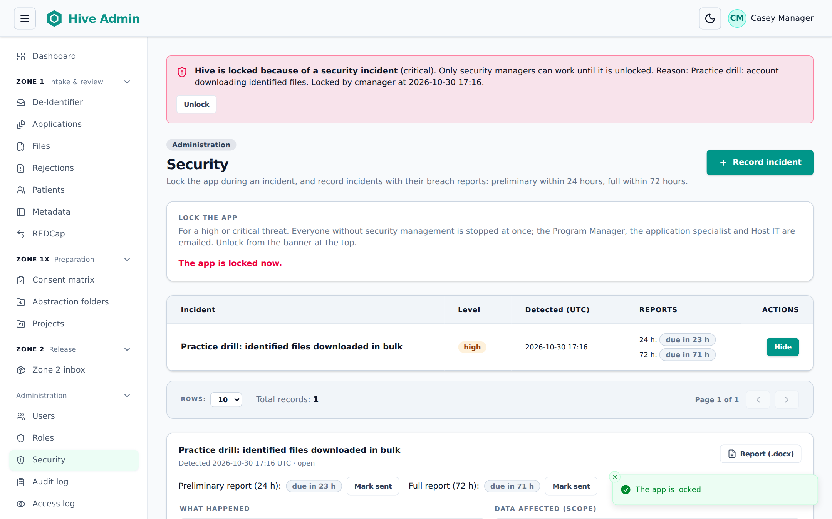
Figure 55. Hive locked: the manager can still work and unlock
Hive also watches for unusual activity every hour (many downloads of identified files, large exports, refused requests, failed sign-ins). Low alerts are emailed to the Application Specialist; high and critical alerts to the CHSS Manager, Application Specialist and Host IT. At the critical level Hive locks itself.

Recording an incident and the breach reports
- Click Record incident. Enter the Title, Level, Detected at (the 24 and 72 hours count from here) and What happened. Click Record incident.
- Open the incident and fill in Data affected (scope), Risk assessment, Containment actions and Affected parties. Click Save.
- Click Report (.docx) to download the breach report. Send the preliminary report within 24 hours and click Mark sent; send the full report within 72 hours and click Mark sent.
- When everything is done, click Close incident.
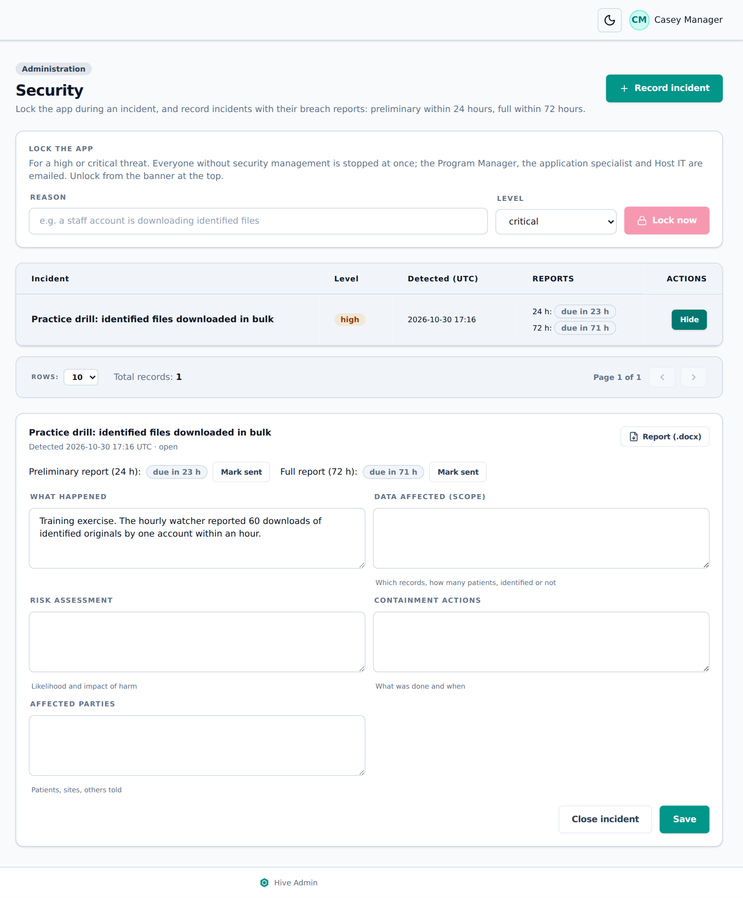
Figure 56. An incident with its 24-hour and 72-hour report deadlines
Protocol
§6.5: a breach report includes the time of detection, scope, risk assessment, containment and affected parties. The preliminary report is due within 24 hours and the full report within 72 hours.

Not yet available in Hive
§6.5: incidents are created automatically when a breach is detected. Today the hourly watcher emails and can lock Hive, but a person records the incident.

9.4 Audit log
The Audit log records every change: who did what, to which record, and when. It cannot be edited or deleted. Filter by Entity type, Record id, Who, Action, From and To. Click a row to see the values before and after.
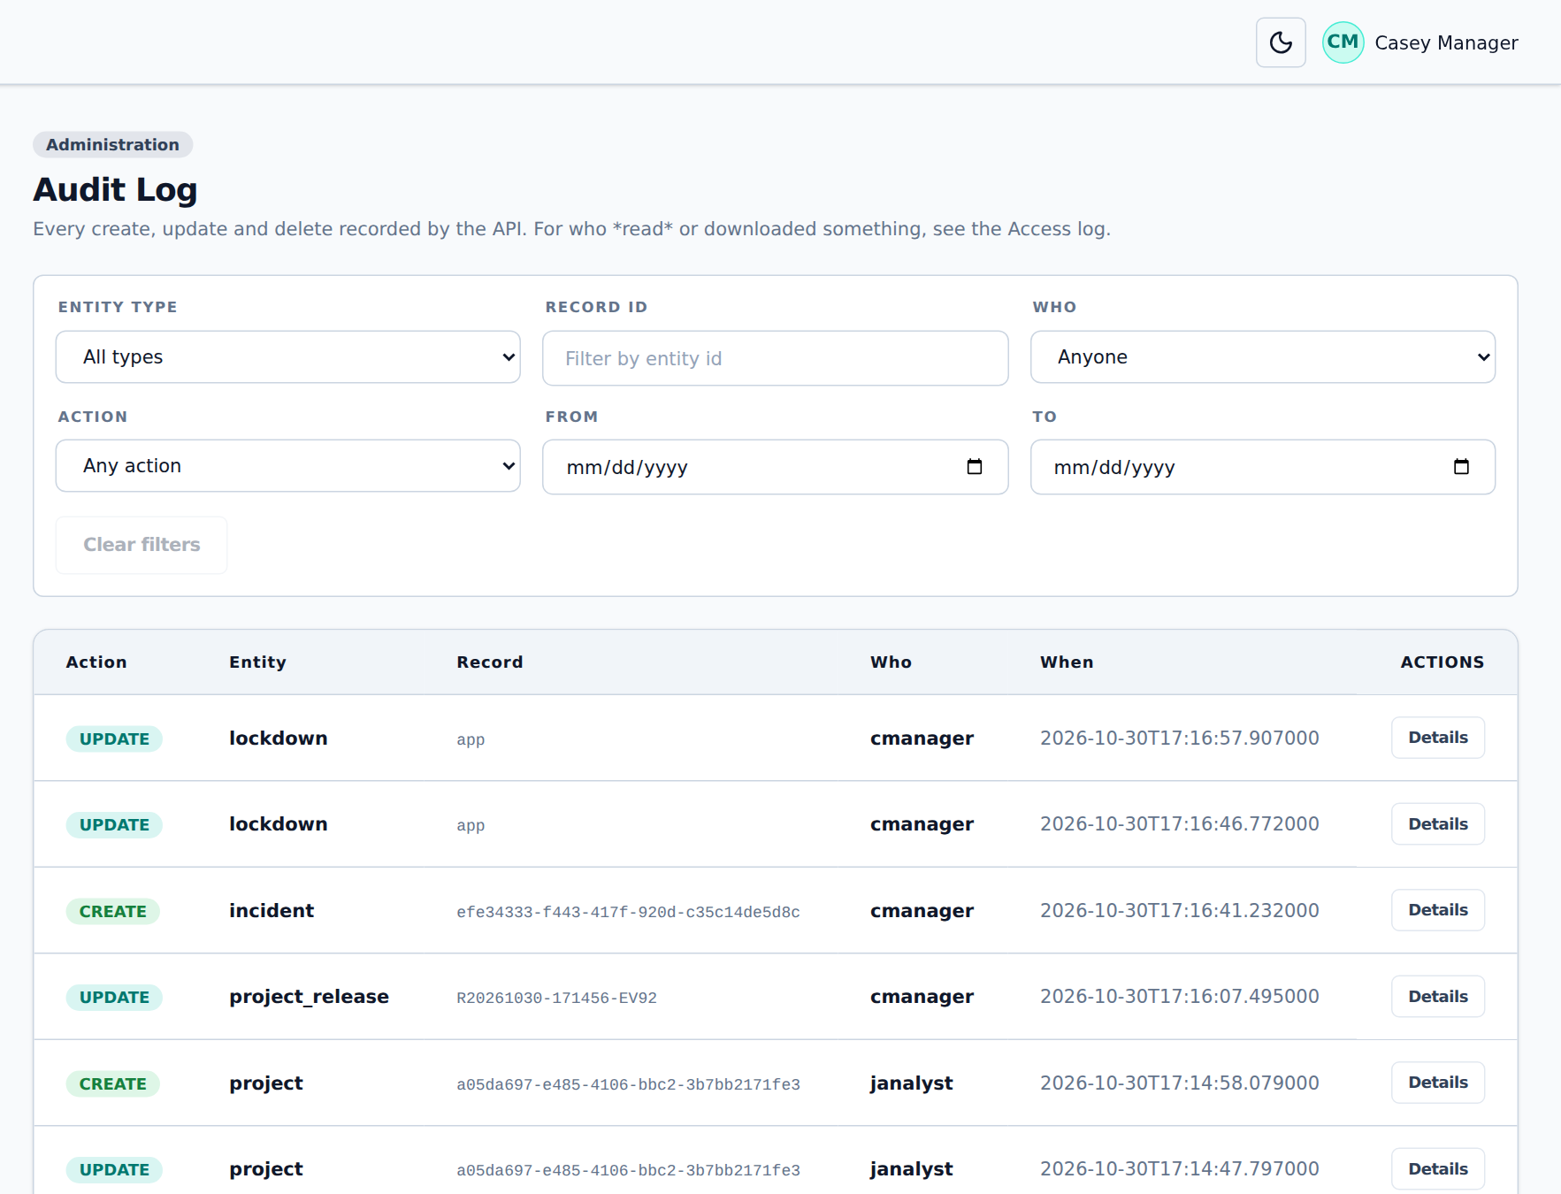
Figure 57. The Audit log

9.5 Access log
The Access log records who read, downloaded or exported what, and who was refused. Identified shows whether an original (with PHI) was opened. Tick Disclosures only to see only reads where identified PHI left Hive.
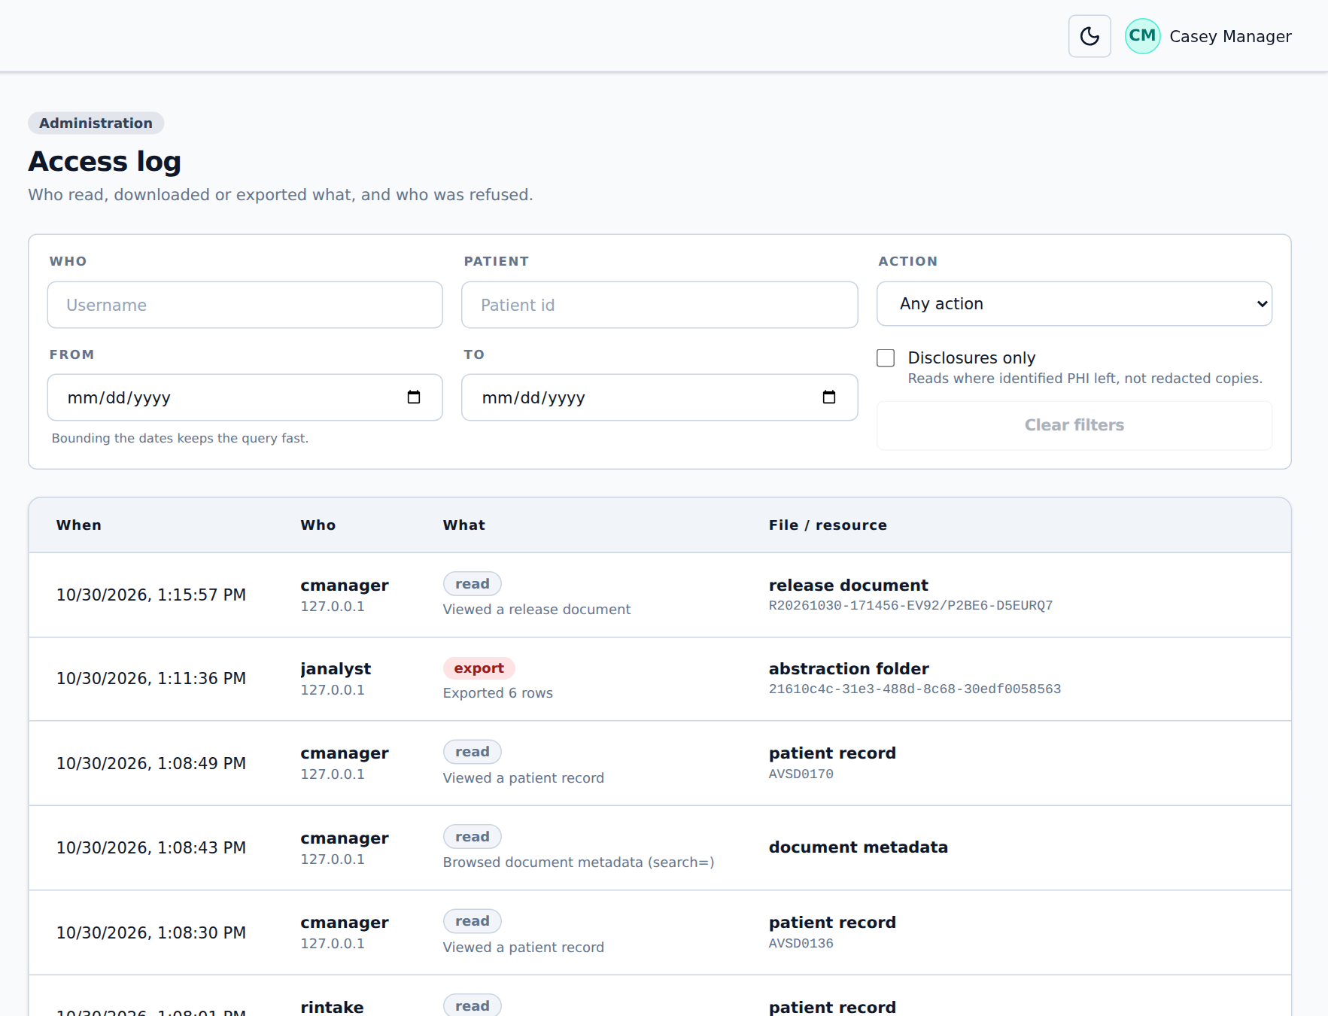
Figure 58. The Access log
Protocol
§6.5–6.6: user activity, data access and changes are logged with user, action, record and time; unauthorised attempts are logged; the log cannot be changed. Data movements and transformations are traceable (lineage).

10. Reference

10.1 Retention and time limits
What | Time limit | Section
Abstraction folder | Deleted after 90 days (3 months) unless extended | §9.1.6
Project workspace (Zone 1X) | Deleted 90 days after first built unless extended with approval | §9.2.2
Zone 2 access | Limited to one project; reviewed every 6 months; removed when the project ends | §5
Breach report | Preliminary within 24 hours, full within 72 hours of detection | §6.5
Date shift in Zone 2 | Random per patient, −1826 to +1826 days | §9.2.4

10.2 Document types
Code | Document | Found from words in the file name
ENROLLMENT | Enrolment form | enrollment, enrolment, registration form
CONTACT | Contact form | contact form, change of contact, contact
CONSENT | Consent form | consent, assent
OPERATIVE | Operative report | operative, op note, surgical report
DISCHARGE | Discharge summary | discharge, dc summary
ECHO_REPORT | Echocardiogram report | echo, echocardiogram, TTE, TEE
ANGIO_REPORT | Angiography report | angio, angiogram, cath
MRI_REPORT | MRI report | MRI, CMR, cardiac MRI
ECG_REPORT | ECG report | ECG, EKG
IMAGE | Image | JPG, PNG and other pictures
STS_EXTRACT | STS extract | Excel or CSV with “sts”
OTHER / UNKNOWN | Anything else / not found | Set by hand with Set type & date

10.3 Where files are kept
Stage | Storage
Waiting for de-identification | Intake folder (inbox)
De-identified, application still a draft | Pending storage: original/ and de_identified/ under the patient code
Failed or excluded | Pending storage: failed/ and needs_attention/
Application submitted | Archive (originals) and active storage (de-identified copies)
Abstraction folder | Abstraction storage, one folder per user
Project workspace | Project storage: <project code>/workspace/
Release archive | Project storage: original data, id_map.csv, the safe copy
Waiting for review | Zone 2 inbox
Released | Zone 2: <project code>/<release>/

10.4 Permissions
Permission | Allows
patient: view / create / update / delete | See, add, change and delete patients
application: view / create / update / delete | See and review applications; delete is needed to reject as “not eligible”
files: read / upload / download / delete | Files page, adding, downloading and deleting documents
files: view original | Open originals (before submission, or with a grant after)
files: grant originals | Give access to an archived original (CHSS Manager only)
files: view de-identified / metadata / de-identified metadata | Open redacted copies and the metadata of either copy
files: reject | Reject documents, mark leaded images
rejection: view | Rejections page
deidentifier: view / run / gets emails | De-Identifier page, start runs and Copy from Carbon, receive intake emails
redcap: view / import / export | REDCap page, imports, follow-up and code lists
consent: view / update | Consent matrix, record and import decisions
project: view / create / update / delete | Projects you are a member of
project: workspace storage | Build, extend and delete workspaces
project: all projects + members | See every project, add and remove members
abstraction: view / create / update / delete / everyone’s folders | Your own folders; everyone’s folders with the last one
zone2: prepare | Prepare a safe copy
zone2: review | Zone 2 inbox: release or send back (CHSS Manager)
user / role: view / create / update / delete | Users and Roles pages
log: view | Audit log and Access log
security: view / manage | Security page; lock and unlock, record and close incidents

10.5 Common questions
Question | Answer
A page I need is not in my sidebar. | Your role does not include it. Ask the CHSS Manager to review your role.
A file was excluded with “no patient code”. | The code is missing or not in the accepted format in both the folder and the file name. Ask the site to resend it with the code, then Retry.
Submit application stays grey. | Confirm the patient’s details in step 1, and make sure no document is undecided or rejected. Hover over the button to see why.
I can no longer open an original. | After submission, originals need a grant from the CHSS Manager (chapter 5.6).
Prepare safe copy is refused. | Read the message: an approval reference, consent confirmed and at least one patient are needed, and patients kept out by the consent matrix must be removed from the cohort.
The red “Hive is locked” banner is showing. | A security incident is being handled. Wait until it is unlocked.
I see a real identifier in a de-identified copy. | Reject the document with the reason (chapter 5.4). Never copy or share it.

10.6 Glossary
Term | Meaning
Application | One patient’s submission: their details and documents
CRQ | The team that receives and checks the data in Zone 1
De-identified copy | The redacted copy of a document, named with _R or _RR
DICOM | The standard format for medical images
Leaded image | An image with identifiers in lead letters; kept out of Zone 2
PHI | Personal health information that can identify a patient
Project ID | A patient’s ID in one project only; cannot be matched to the CHSS code
Safe copy | The de-identified, date-shifted data prepared for Zone 2
UBRS | The patient code used instead of the patient’s identity
Workspace | The project’s Zone 1X folder for data cleanup

