

**NUST**

**School of Mechanical & Manufacturing Engineering**

**FOP Assignment:**

**Name:** Muhammad Muzammil Riaz

**Qalam:** 467817

**Batch:** ME-15

**Section:** A

**Course Instructor:** Dr. Jawad

**Lab instructor:** Sir. Saqib

1. **Write a program using break or continue statement that only adds prime numbers from 1 to 50 and display the sum on screen.**

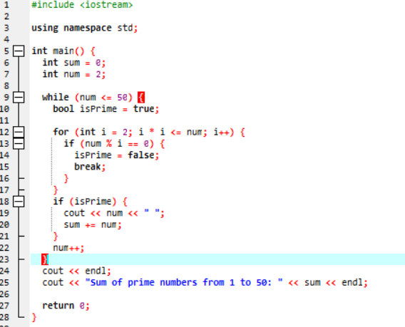

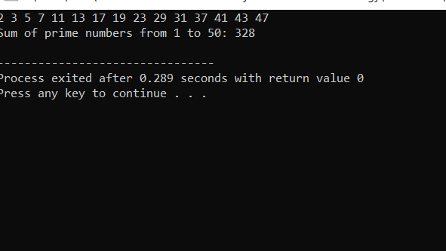

1. **Write a program in C++ to create the following pattern.**

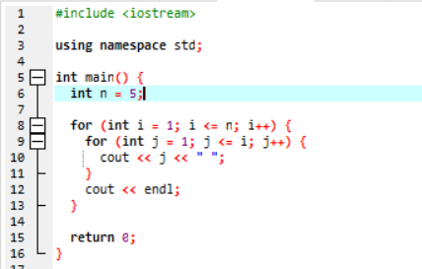

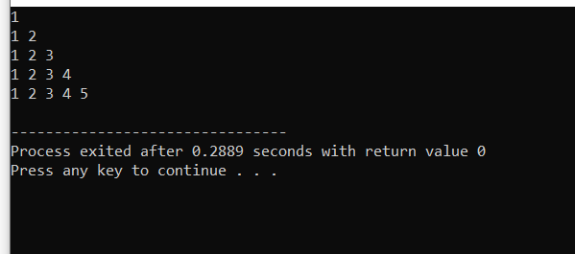

1. **Write a C++ program to print:**



