

**NUST**

**School of Mechanical & Manufacturing Engineering**

**FOP Assignment:**

**Name:** Muhammad Muzammil Riaz

**Qalam:** 467817

**Batch:** ME-15

**Section:** A

**Course Instructor:** Dr. Jawad

**Lab instructor:** Sir. Saqib

1. **Generate the Fibonacci sequence using nested loops**.

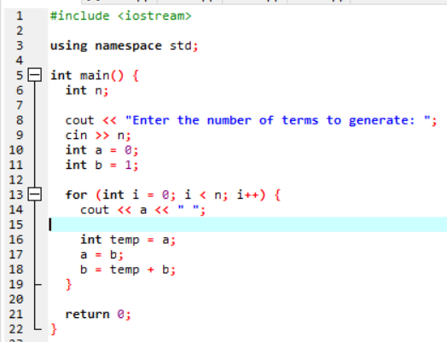

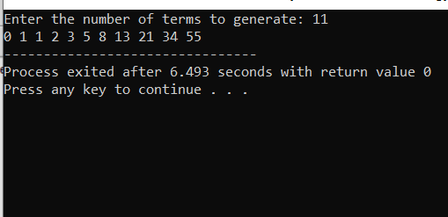

1. **Create Pascal's triangle with nested loops.**

