

**NUST**

**School of Mechanical & Manufacturing Engineering**

**FOP LAB TASK-08:**

**Name:** Muhammad Muzammil Riaz

**Qalam:** 467817

**Batch:** ME-15

**Section:** A

**Course Instructor:** Dr. Jawad

**Lab instructor:** Sir. Saqib

1. **Write a C++ program to calculate average of numbers of array.**

#include <iostream>

using namespace std;

int main(){

int wee[5];

for( int i=0; i<5; i++){

cout<<"Enter 5 numbers: ";

cin>>wee[i];}

double sum = 0;

for(int i=0; i<5; i++){

sum += wee[i];

}

double ave = sum/5;

cout<<"Average of the Arrays elements: "<<ave<<endl;

}

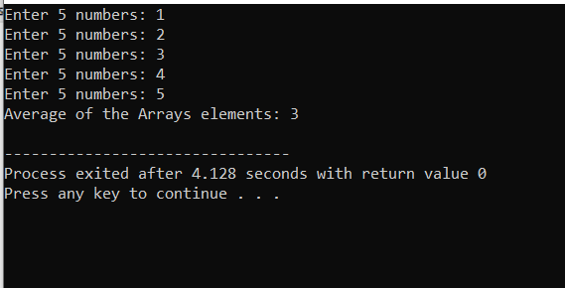

1. **Implement Bubble sort on an array of 5 integers.**

#include<iostream>

using namespace std;

int main(){

int hmm[5];

int temp, i,j;

for(i=0; i<5; i++){

cout<<"Enter a Value: ";

cin>>hmm[i];

}

for(i=0; i<5; i++){

for(j=0; j<5; j++){

if(hmm[j]>hmm[j+1]){

temp=hmm[j+1];

hmm[j+1]=hmm[j];

hmm[j]=temp;

}

}

}

for(i=0; i<4; i++){

cout<<hmm[i]<<", ";

}

cout<<hmm[4];

}

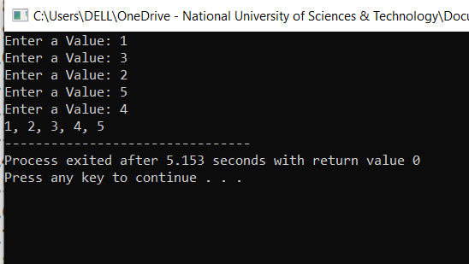

1. **Implement Selection Sort on an array of 5 integers.**

#include<iostream>

using namespace std;

int main(){

int hee[5];

int i,j, temp;

for( i=0; i<5; i++ ){

cout<<"Enter a Value: ";

cin>>hee[i];

}

for( i=0; i<5; i++ ){

for( j=i; j<5; j++ ){

if( hee[i] > hee[j] ){

temp = hee[i];

hee[i] = hee[j];

hee[j] = temp;

}

}

}

for( i=0; i<4; i++ ){

cout<<hee[i]<<", ";

}

cout<<hee[4];

}

