**Electric Eel Wheel 5.2 User Guide**October 19, 2018

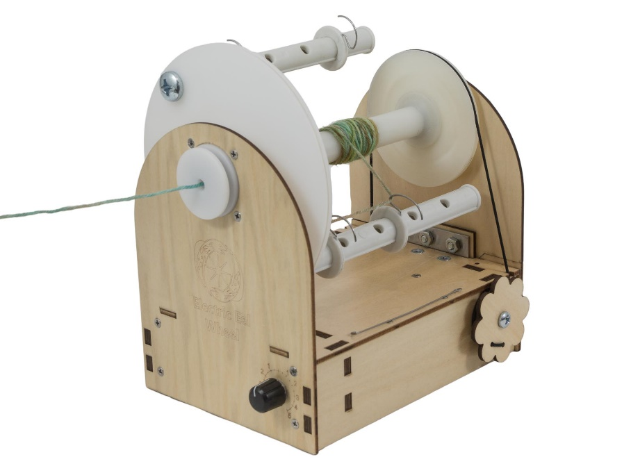

Thank you for joining the Electric Eel Wheel community! The Electric Eel Wheel 5.2 (EEW) is an amazing electric spinning wheel that is revolutionizing the fiber world.

Much effort was put into making the EEW as easy to use as possible. Once you have used it a few times the controls will seem like second nature. This guide will help you get started with your EEW.

**Safety Warning**

**The EEW has moving parts and if used improperly can result in injury. When you plug in the EEW make sure the speed control is off (dial pointing straight up). Then slowly turn it to a speed at which you can comfortably spin. Be mindful of your surroundings and don’t let any foreign objects touch the EEW while it is running.**

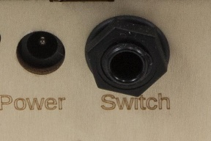**Turning on the EEW**

* Insert the foot pedal (optional). This should be done first if it will be used. It plugs in the back “Switch” port.
* 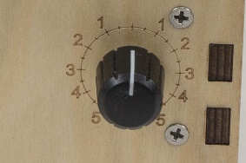Turn the speed dial to the 0 (vertical) position. This is the off position.
* Plug the power supply into the wall. You will see a blue light on the power supply light up.
* Insert the other end of the power supply into the EEW. You will see a green light on the back blink 3 times and then stay on.
* Slowly turn the speed dial clockwise and watch the flyer spin.
* Press the foot pedal to start and stop the wheel.

**Threading the Flyer**

Tape (or tightly tie) a piece of yarn onto your bobbin to use as a lead for your roving. Use the orifice hook to thread the lead out to the front of the wheel. Now tie your roving to the lead yarn and you are ready to spin. See the image below for details on how to thread the lead yarn through the EEW’s flyer.

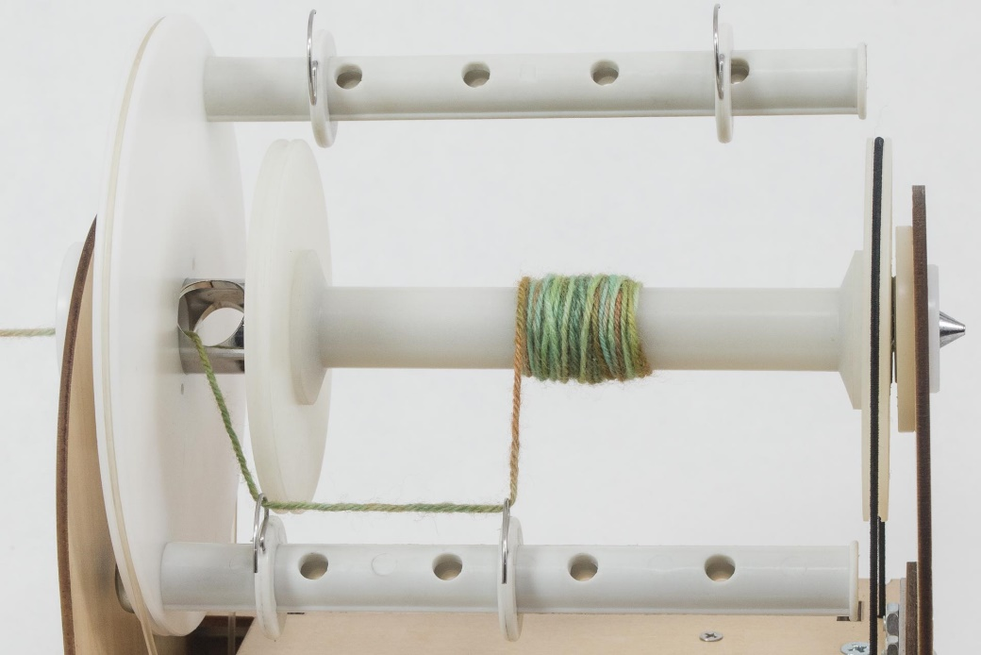

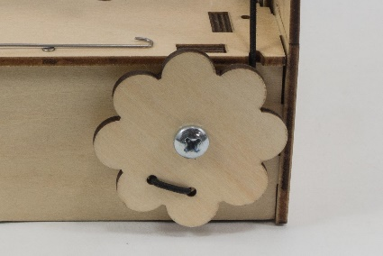**Adjusting Uptake**

The flower shaped dial on the side adjusts the uptake via the EEW’s scotch tension system. Uptake determines how hard the spinning wheel pulls the roving from your hands. A good place to start is with light tension. If the yarn twists upon itself, it has too much twist and needs more uptake. If the yarn drifts apart (leading to breaking), then it has too little twist and needs less uptake. See the “Spin Card” section for more information. One way to think about it is the faster the roving leaves your hand the fewer twists the yarn will have.

|  |  |  |  |
| --- | --- | --- | --- |
| **Tension Dial** | **Effect on Tension Band** | **Effect on Uptake** | **Effect on Yarn Twist** |
| Clockwise | Tightens band | More uptake | Less twists |
| Counter-clockwise | Loosens band | Less uptake | More twists |

**Speed Dial (Plying Yarn)**

Turning the speed dial clockwise causes a Z-Twist, and counter-clockwise causes a S-Twist. Usually we recommend Z-Twist for spinning yarn and S-Twist for plying yarn to help with consistency. However, the only actual requirement is that the yarn is spun and plied with opposite twists.

**Sliding the Yarn Guide**

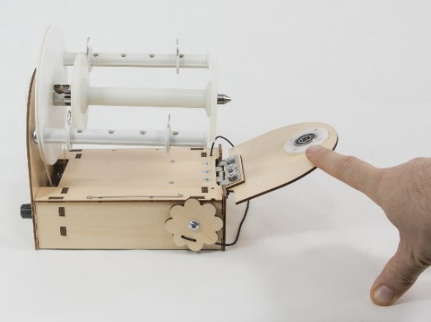When the bobbin starts to get a bump of yarn on it, it is time to move the yarn guide. Stop the wheel using either the speed dial or the foot pedal. With one hand hold the base of the EEW in place. With the other hand slide the guide. Make sure to press on both the top and bottom of the guide and it will slide easily. If you press on only one side of the guide it will lock into place and be hard to move.

**Changing Bobbins**

Take the elastic tension band and place it on the outside back of the EEW. This frees the bobbin end of the flyer. You can now flip the hinged back down and slide off the bobbin.

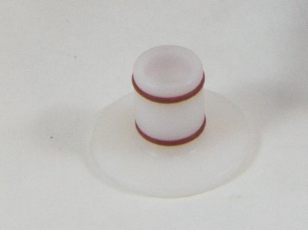**Orifice Reducer**

This is the white plug that fits into the front of the flyer. It can be used when spinning fine yarn and will help reduce the amount the single wobbles when going into the flyer. Others don’t mind the wobble and prefer spinning without it. It is up to you whether you use it or not.

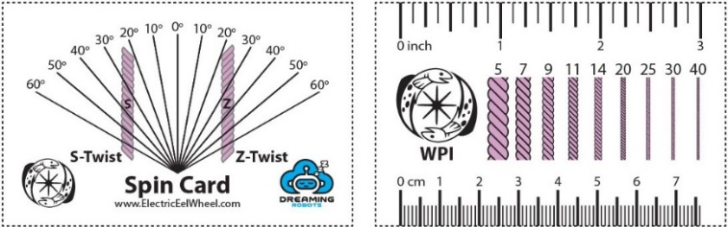**Spin Card**

The front of the spin card is used to measure angle of the yarn and to see if it’s S-Twist or Z-Twist. The pink yarn example on the card has a twist of 45 degrees. The amount of twist you want will vary for different fibers. It can range from 20 degrees for yarn with long fibers to 45+ degrees on yarns with short fibers.

The back of the card helps measure wraps per inch, or WPI. The WPI is listed above each example yarn segment so find your WPI by comparing your yarn width to those examples.

There is no one correct twist angle or WPI so go with what you like. These tools help you measure your yarn, so you can spin it more consistently.

**Other Resources**

* [www.DreamingRobots.com](http://www.DreamingRobots.com) is the home for the EEW. It has many useful links and videos.
* [www.ravelry.com/groups/electric-eel-wheel](http://www.ravelry.com/groups/electric-eel-wheel) is a great online community for the EEW.
* [www.facebook.com/groups/ElectricEelWheel](http://www.facebook.com/groups/ElectricEelWheel) is the official Facebook group for the EEW.