**Electric Eel Wheel 5 User Guide**January 18, 2017

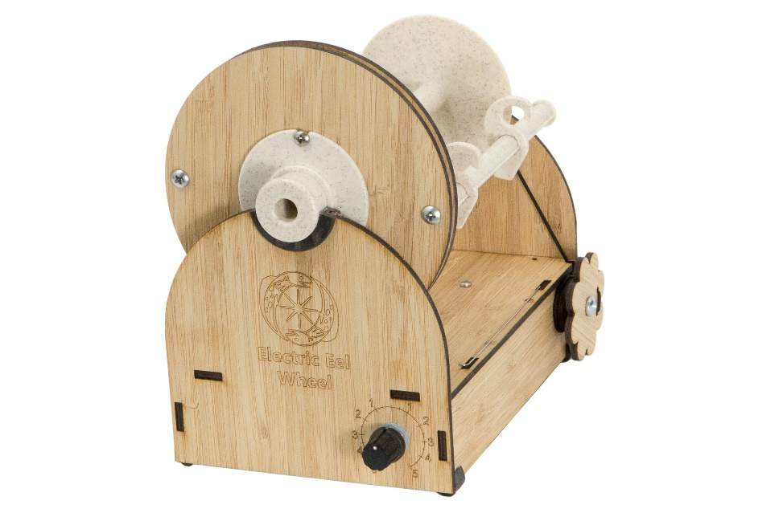

Thank you for joining the Electric Eel Wheel community! The Electric Eel Wheel (EEW) is an amazing electric spinning wheel that is revolutionizing the fiber world.

Much effort was put into making the EEW as easy to use as possible. Once you have used it a few times it will seem like second nature. This guide will help you get started with your EEW.

**Safety Warning**

**The EEW has moving parts and if used improperly can result in injury. When you plug in the EEW make sure the speed control is off (dial pointing straight up). Then slowly turn it to a speed at which you can comfortably spin. Be mindful of your surroundings and don’t let any foreign objects touch the EEW while it is running.**

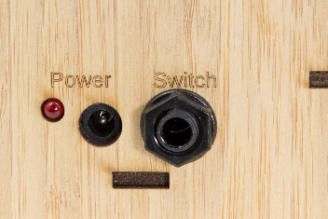**Turning on the EEW**

* Insert the foot pedal (optional). This should be done first if it will be used. It plugs in the back “Switch” port.
* 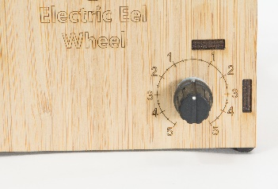Turn the speed dial to the 0 (vertical) position. This is the off position.
* Plug the power supply into the wall. You will see a blue light on the power supply light up.
* Insert the other end of the power supply into the EEW. You will see a red light on the back light up.
* Slowly turn the speed dial clockwise and watch the flyer spin.
* Press the foot pedal to start and stop the wheel.

**Threading a Bobbin**

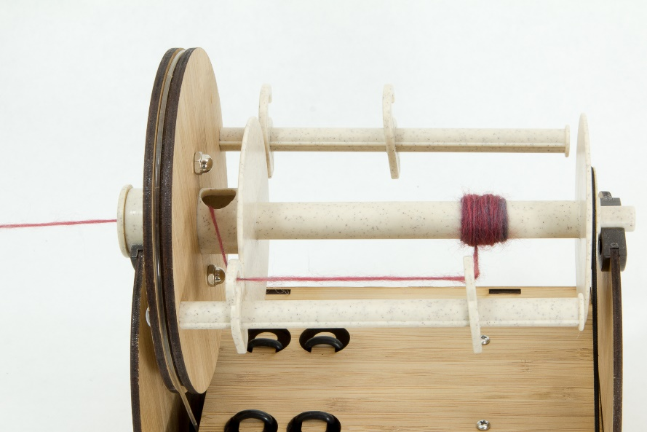Tape (or tightly tie) a scrap piece of yarn onto your bobbin to use as a lead for your roving. Use the orifice hook to thread the lead out to the front of the wheel. Now tie your roving to the lead yarn and you are ready to spin. See the image below for details on how to thread the lead yarn through the EEW.

**Adjusting Uptake**

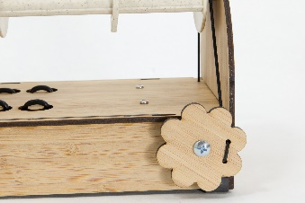The flower shaped dial on the side adjusts the uptake via the EEW’s scotch tension system. Uptake determines how hard the spinning wheel pulls the roving from your hands. A good place to start is with light tension. If the yarn twists upon itself, it has too much twist and needs more uptake. If the yarn drifts apart (leading to breaking), then it has too little twist and needs less uptake. See the “Spin Card” section for more information. One way to think about it is the faster the roving leaves your hand the fewer twists the yarn will have.

|  |  |  |  |
| --- | --- | --- | --- |
| **Tension Dial** | **Effect on Tension Band** | **Effect on Uptake** | **Effect on Yarn Twist** |
| Clockwise | Tightens band | More uptake | Less twists |
| Counter-clockwise | Loosens band | Less uptake | More twists |

**Speed Dial (Plying Yarn)**

Turning the speed dial clockwise causes a Z-Twist, and counter-clockwise causes a S-Twist. Usually we recommend Z-Twist for spinning yarn and S-Twist for plying yarn to help with consistency. However, the only actual requirement is that the yarn is spun and plied with opposite twists.

**Sliding Yarn Hooks**

When the bobbin starts to get a bump of yarn on it, it is time to move the yarn hook. Stop the wheel using either the speed dial or the foot pedal. With one hand hold the base of the EEW in place. With the other hand slide the hook. Make sure to press on both the top and bottom of the hook and it will slide easily. If you press on only one side of the hook it will lock into place and be hard to move.

**Changing Bobbins**

Take the elastic tension band and place it on the outside back of the EEW. This frees the bobbin end of the flyer. You can now lift the bobbin end of the flyer and slide off the bobbin.

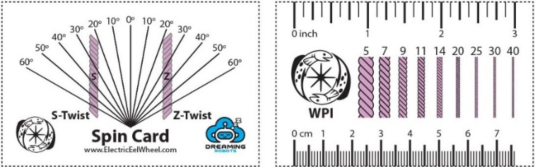**Spin Card**

The front of the spin card is used to measure angle of the yarn and to see if it’s S-Twist or Z-Twist. The pink yarn example on the card has a twist of 45 degrees. The amount of twist you want will vary for different fibers. It can range from 20 degrees for yarn with long fibers to 45+ degrees on yarns with short fibers.

The back of the card helps measure wraps per inch, or WPI. The WPI is listed above each example yarn segment so find your WPI by comparing your yarn width to those examples.

There is no correct answer for twist angle or WPI so go with what you like. These tools help you measure your yarn to be more consistent.

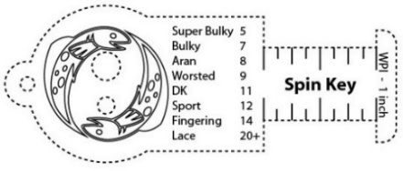**Spin Key**

This tool is another way to measure WPI. Wrap the yarn around the ruler section and the number of wraps is your WPI. There are common names for various WPI measurements listed too.

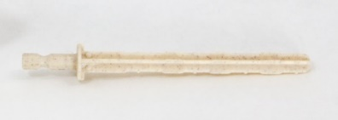**Bobbin Driver**

Use this tool to transfer yarn between bobbins using a hand drill.

1. Slide the bit into the bobbin’s whorl end while aligning the posts on the bit with the grooves of the bobbin. **It will lock into place.**
2. Load the bobbin in the drill chuck and tighten.
3. Tie the yarn **tightly** to the bobbin shaft.
4. Load the bobbin by guiding the yarn with your finger at a comfortable speed.

Check out [www.ElectricEelWheel.com](http://www.ElectricEelWheel.com) for more information and videos.