MapStore Guide

# Summary

Summary 1

Figures 1

Introduction 1

Layers Panel 2

Map Panel 10

# Figures

Figure 1: Layer panel drag-and-drop 2

Figure 2: Layer tab toolbar 2

Figure 3: Available Layers dialog 3

Figure 4: Layer's abstract 3

Figure 5: Selection of multiple layers 3

Figure 6: Add New Server 4

Figure 7: A new OGC WMS Layer added to the map 4

Figure 8: Add Layers Dialog filtered list 5

Figure 9: Remove Layer 5

Figure 10: Add new group to layer tree 6

Figure 11: Selecting a layer group 6

Figure 12: Group Properties 7

Figure 13: Layer Properties 7

Figure 14: Layer Properties details 8

Figure 15: Layer Properties - About tab 8

Figure 16: Layer Properties - Display tab 8

Figure 17: Layer Properties - Cache tab 9

Figure 18: Layer Properties - Styles tab 9

Figure 19: Legend tab 10

Figure 20: Map Panel and toolbar 11

Figure 21: Toolbar 11

Figure 22: Reporting Tool - Print Preview Dialog 12

Figure 23: Reporting Tool – Legend Panel 13

Figure 24: Feature Info popup 14

Figure 25: Active Feature Into on selected layer 14

Figure 26: Scalebar. Graphic Scale and Mouse Position Tools 15

# Introduction

The purpose of this document is to provide a guidance to the MapStore's tools, providing an useful description of the main functionalities. Inside the chapters below, the MapStore's panels will be illustrated and for each tool a brief descriptions and a link to the WIKI page will be provided, if available, in order to give more details about the plugin configuration. More missing sections will be added in future releases.

# Layers Panel

##### Layers Tab

This panel contains the grouped list of available layers. Checkboxes are available next to the layer name. By enabling a checkbox, the corresponding layer will be displayed on the map. A drag-and-drop functionality allows the user to change the order of the layers on the map, as shown in Figure 1 :

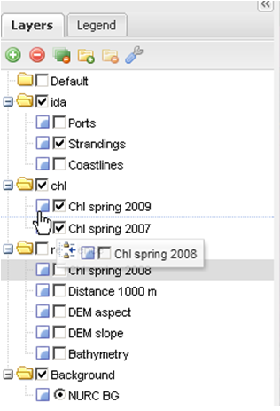

Figure 1: Layer panel drag-and-drop

On the top of Layers tab a small toolbar can be used to manage the layer tree (Figure 2).



Figure 2: Layer tab toolbar

The controls available on the toolbar are:

#### Add Layer Button

 “Add Layers” functionality allows adding layers from local/external OGC services to the layer tree. By clicking on this button, a small dialog window will appear over the Viewport:

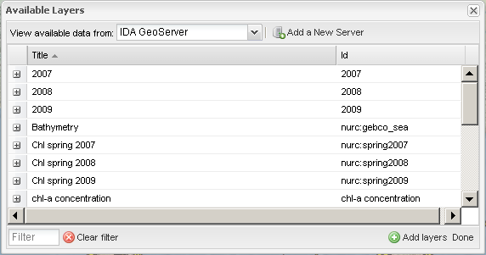

Figure 3: Available Layers dialog

By default the dialog shows the list of all available layers from the selected WMS. The list of layers is presented as a table with two columns; the first one contains the layer's “title”, while the second one the layer “id” - or name - as reported by the real OGC service. By clicking on the small “+” button it is possible to see the “abstract” of the layer *if* present in the OGC service metadata (Figure 4).

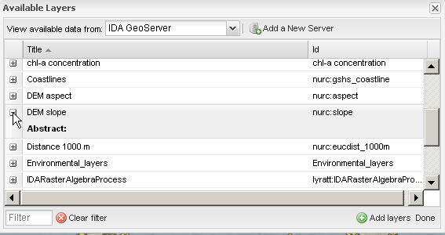

Figure 4: Layer's abstract

In order to add multiple layers to the layer tree, it is possible to select layers from the dialog window by CTRL+Left-Mouse clicking over the layer names:

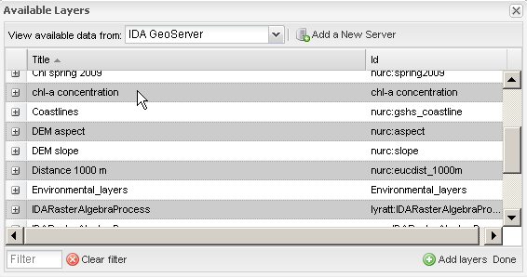

Figure 5: Selection of multiple layers

And then clicking on the “Add layers” button on the bottom of the dialog box:



The new layers will be added to the “Default” group of the layer tree and selected by default.

When finished, to close the dialog box simply click on the “Done” button on the bottom of the dialog box: 

**NOTE**: The user can also add a single layer to the map with a double right click of the mouse. In this case a zoom to the layer will be performed.

It is also possible to add layers from other/external OGC WMS servers. For this, click on “Add a New Server” (Figure 6):

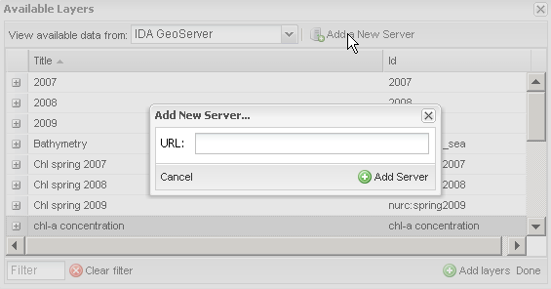

Figure 6: Add New Server

The location of a *valid* OGC WMS GetCapabilities 1.1.0+ or 1.3.0[1] server needs to be inserted . If no errors are detected, the top combo box will be populated with the name of the new OGC Server, and by selecting the latter, the table will be updated with the new server’s list of layers:

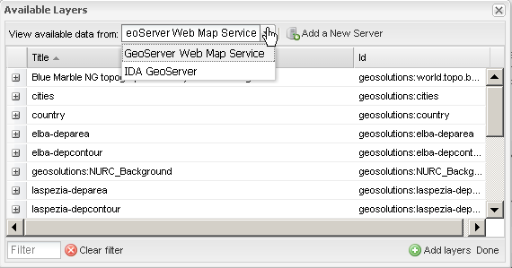

Figure 7: A new OGC WMS Layer added to the map

In the example above, the following OGC WMS GetCapabilities request was used:

<http://demo1.geo-solutions.it/geoserver-enterprise/ows?service=wms&version=1.3.0&request=GetCapabilities>

**NOTE**: The user can use also a more restricted URL (the mandatory parameters for this request will be added from MapStore). Something like:

<http://demo1.geo-solutions.it/geoserver-enterprise/wms>

Finally, it is possible to filter the list of available layers by using the “Filter” box on the bottom bar (see Figure 8). The filter is textual: provide here the partial or full Title or Id/Name of the layer. The list is filtered at runtime while inserting text.

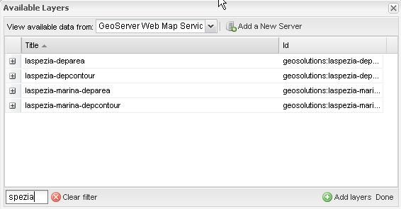

Figure 8: Add Layers Dialog filtered list

Use the “Clear filter” option to reset the table to the full list.

#### Remove Layer Button

“Remove Layer”; this button is activated only when clicking with the left mouse button over the name of a layer present in the layer tree. It allows to completely remove a layer from the tree and from the Map (Figure 9). The removed layer can be added back later by using the “Add New Layer” dialog as descripted above.



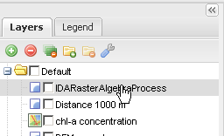

Figure 9: Remove Layer

#### Remove All Button

The  “Remove all overlays from the map” button completely purges the entire layer tree. By clicking this button, all the layers (except the backgrounds), will be removed from the list (and consequently from the map). A dialog box will pop up on the viewport asking for user confirmation.

#### Add Group Button

The  “Add a new group in the layer tree” button creates a new custom group in the layer tree. A small text dialog will appear on the viewport asking the user to specify a new free-text custom name for the new group (Figure 10).

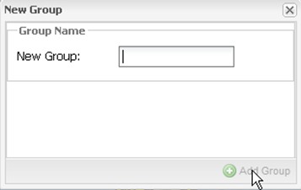

Figure 10: Add new group to layer tree

The new group will appear in the layer tree.

#### Remove Group Button

The  “Removes group from the layers tree” functionality is enabled only when clicking over the name of a group on the layer tree *except* the “Default” and “Background” groups (Figure 11).

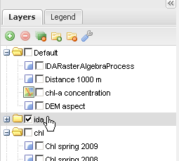

Figure 11: Selecting a layer group

This button allows the user to completely remove the selected group and all its component layers from the layer tree.

#### Group Properties Button

The  “Group Properties” button can be used to change the name of a group of layers. The functionality is enabled only when clicking over a group name. A small text dialog is shown on the viewport allowing the user to change/update the name of the group (Figure 12).

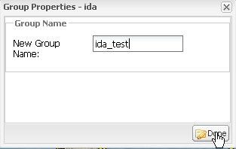

Figure 12: Group Properties

#### Layer Tree Context Menu

By clicking with the right mouse button on a layer, a context menu appears, allowing access to a set of advanced functionalities (Figure 13).

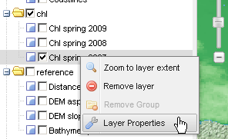

Figure 13: Layer Properties

The user can zoom directly to the layer extent, completely remove the layer from the map or modify layer properties:

1. ; by clicking this option the map is automatically zoomed in/out in order to include the layer's full extent. The map is also panned to the layer centroid.
2. ; by clicking this option the layer is removed from the layer tree. The change is not permanent and the layer will be restored at the next interface refresh/reload.
3. ; this option opens a “Layer Properties” dialog window on the main viewport which allows the user to view or modify several layer options such as the opacity, the style or the description:

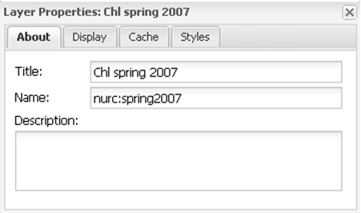

Figure 14: Layer Properties details

The “Layer Properties” dialog box has four tabs:

“About” tab (Figure 15): The tab shows the Title, Name (actual name on the OGC WMS Server) and description (or Abstract) of the selected layer. The properties are all read-only except for the “Title”. Changes for this value are reflected in the layer tree.



Figure 15: Layer Properties - About tab

“Display” tab (Figure 16):

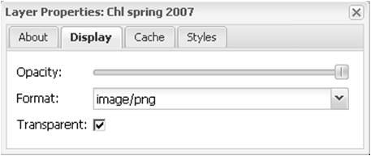

Figure 16: Layer Properties - Display tab

The tab contains several controls that allow the user to modify display options for the selected layer:

* **Layer opacity**; by default the layer if fully opaque (except for the image transparent areas). This slider allows to adjust layer transparency.
* **Image format**; the default is “image/png”; the dropdown list is populated with the available image output formats from the OGC Server. Be aware that “image/jpeg” is usually faster and smaller, but does not allow transparency adjustments and image quality may be lower.
* It is possible to set a layer to “Transparent”; In OGC terms a “Transparent” layer is an overlay, otherwise it is a background layer.

None of the changes detailed above are permanent; they will all be reset to the original values at the next refresh or reload.

“Cache” tab (Figure 17):

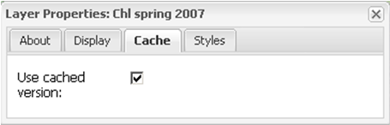

Figure 17: Layer Properties - Cache tab

*If* available from the OGC Server, this option allows to use the client cached images, whenever possible, through the HTTP Cache HEADERs. Be aware that not all servers have these capabilities. Consequently, checking/unchecking this option will often not impact on the interface.

“Styles” tab (Figure 18):

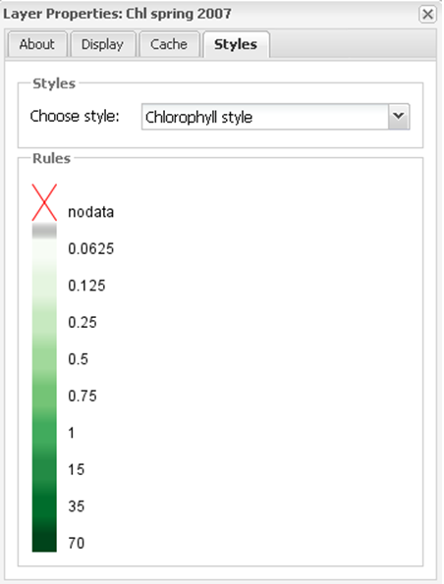

Figure 18: Layer Properties - Styles tab

OGC WMS Servers allow listing of a set of available styles (SLDs[2]) for each layer. A layer must have a default style, and optionally zero or more available styles. The tab allows selecting one of the available styles, displayed in the dropdown list. When selecting a style, a color legend is loaded in the bottom 'Rules' part of the dialog box, in order to give to the user a visual representation of the selected style. Note that style selection is not permanent; the style will be reset to its original value at the next interface refresh/reload.

##### Legend Tab

This tab shows the used style's legend for each layer loaded on the map viewport. The legends are generated by the OGC WMS Server through a *GetLegendGraphic*  HTTP request, and the output strictly depends on the type of layer and the defined SLD rules. More details are available in the SLD OGC Specification.

The tab is depicted in Figure 19:

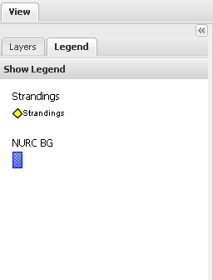

Figure 19: Legend tab

By default, the tab displays legends for the preloaded layers. Adding a new layer to the layer tree (see previous section for details on how to add a new layer).

# Map Panel

The Map Panel (Figure 20), is the primary data display interface, containing map navigation and query tools. Other than the classical pan/zoom functionalities, this panel also contains an info tool which allows the user to interactively get information on the values of the available layers, for a certain location.

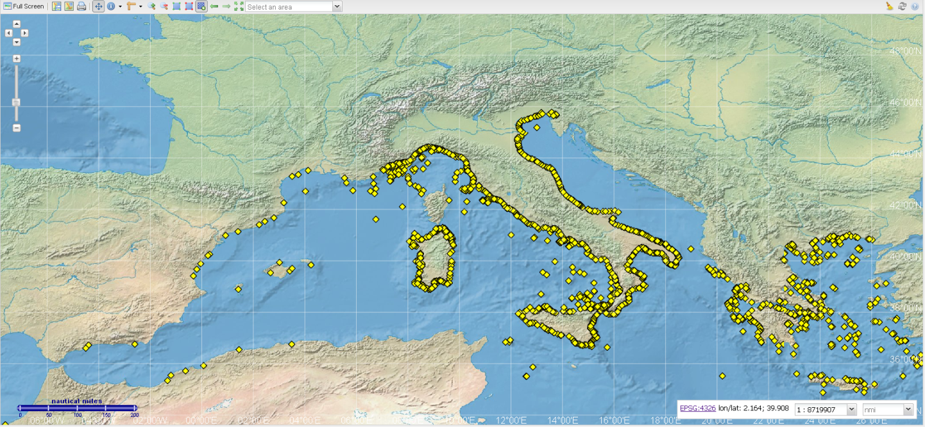

Figure 20: Map Panel and toolbar

On the top side of the panel, there is a toolbar (Figure 21) containing the whole set of available tools (the type and the number of this tools depends from the used MapStore’s configuration, see the [WIKI](https://github.com/geosolutions-it/mapstore/wiki/mapStoreConfig-File) for more details about that):



Figure 21: Toolbar

1. ; maximizes the map by collapsing all the other panels.
2.  ; allows to export an XML configuration of the *map*. This file can be provided to MapStore statically in order to load a map configuration automatically.
3.  ; imports an existing XML configuration of the *map* or allows the user to import a KML file which can be loaded/generated in Google Earth.

**NOTE**: For a detailed explanation of the Import/Export tool configuration we recommend to see the MapStore’s [WIKI](https://github.com/geosolutions-it/mapstore/wiki/Import-Export).

*The exported map context is a plain XML text file containing the whole configuration of the interface. The save button of the client, stores the current configruation of each panel on the map. The layers loaded and visible on the map and the current extent. This functionality allows a user to save the actual state of the map in order to be loaded later or shared with others clients.*

1. ; Printing (or Reporting) tool. This tool allows a user to create a PDF depicting the current map. By clicking the “Print Map” button, a “Print Preview” dialog window is shown to the user (Figure 22).

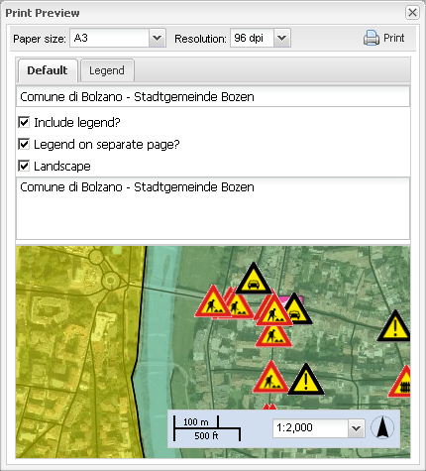

Figure 22: Reporting Tool - Print Preview Dialog

*  Paper size and Resolution allow to select the PDF output layout.
*  this textbox can be edited with a custom value. The text will be printed on the bottom of the PDF pages.
* a checkbox that allows to include or not the legend on the PDF.
* 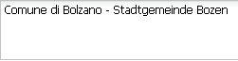 free textbox which can be edited in order to insert a small custom abstract.
* 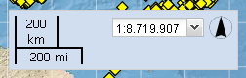 changing the scale the map is zoomed in/out on the final PDF, reflecting the Preview one.
* **Legend Panel:**  advanced panel that allow the user to set more fine setting for the legend rendering.

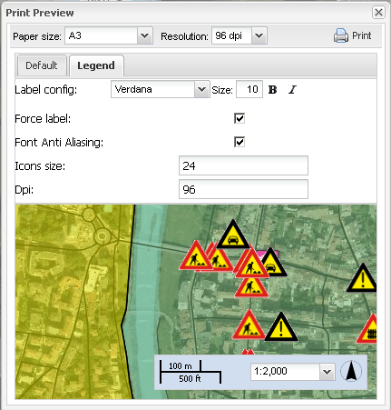

Figure 23: Reporting Tool – Legend Panel

*  Starts the PDF generation; be patient, the generation of the map may require several instants.

**NOTE**: More specific information about the Print plugin configuration will be found inside the MapStore’s [WIKI page](https://github.com/geosolutions-it/mapstore/wiki/Print-Plugin).

1. ; Snapshot Tool, allows to save a png snapshot of the current map. Actually the snapshot saves just the current map without the legends or other panels configuration. It is always possible for a user get a screenshot of the entire interface by using the “Print” windows button.

**WARNING**: This functionality may not work properly on old browsers.

**NOTE**: More specific information about the PrintStapshot plugin configuration will be found inside the MapStore’s [WIKI page](https://github.com/geosolutions-it/mapstore/wiki/PrintSnapshot).

1.  ; Pan Tool, allows to move the map around by clicking the mouse over it.
2.  ; Layer Info Tool. When selected opens a pop-up () containing all the values for the layer stack.

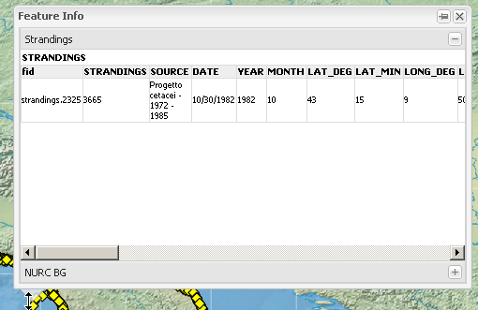

Figure 24: Feature Info popup

The pop-up contains a set of “accordion” or “tabs” (it depends by the configuration) sub-panels named after the relative layer; when expanded, the values of the specific layer at the position of the mouse pointer are displayed on the screen. The tool applies only on **visible** layers.

**NOTE**: More specific information about the GetFeatureInfo plugins configuration will be found inside the MapStore’s [WIKI page](https://github.com/geosolutions-it/mapstore/wiki/WMS-Get-Feature-Info).

It is also possible to allow the Layer Info Tool to provide on the fly information on a single **selected and visible** layer. In order to do that select a layer from the layer tree (make it gray) and be sure it is also visible. Click on the small arrow of the Layer Info Tool and select from the drop down “Active Feature Info on selected layer” as depicted on Figure 25.

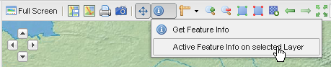

Figure 25: Active Feature Into on selected layer

When this option is active, it is possible to move the mouse over the map. After one second it will automatically show a pop-up containing the values of the selected layer corresponding to the current mouse position.

**NOTE**: More specific information about the GetFeatureInfoMenu plugins configuration will be found inside the MapStore’s [WIKI page](https://github.com/geosolutions-it/mapstore/wiki/WMS-Get-Feature-Info-Menu).

1.  ; Measuring Tool. It can be used to measure not only linear distances but also areas and bearings, accordingly to the projection in use.
2.  ; Zooming Tools. They are used to zoom in/out or box zoom in/out the map:
   1. ; zoom in one level
   2. ; map zoom out one level.
   3. ; draw a box on the map viewport. The map will then be zoomed in accordingly.
   4. ; draw a box on the map viewport. The map will be then zoomed out accordingly to the box dimension.
3.  ; enables/disables the lon/lat grid.

**NOTE**: More specific information about the Graticule plugin configuration will be found inside the MapStore’s [WIKI page](https://github.com/geosolutions-it/mapstore/wiki/Graticule).

1.  ; undo/redo zooms and pans. Stores the zoom/pan history.

Finally the map viewport presents a scale widget on the bottom-right corner of the map, the mouse positions coordinates at the top-right corner and finally the graphical scale and the left-bottom (Figure 26). This widget not only shows the current map scale in nautical miles and kilometers, but can also be used to quickly zoom at a predefined scale level.

  

Figure 26: Scalebar. Graphic Scale and Mouse Position Tools

As shown in Figure 26, the widget is composed of four components:

1.  the mouse position espressed in *lon/lat* coordinates (optionally the Spatial Reference System can be settes, by default is the map CRS).

**NOTE**: More specific information about the MousePosition plugin configuration will be found inside the MapStore’s [WIKI page](https://github.com/geosolutions-it/mapstore/wiki/MousePosition-Plugin).

1.  the map scale with a graphical reference.
2.  the scale value. Moreover this dropbox contains the list of available/allowed scale levels. Changing the value of this widget will immediately zoom the map to the selected scale preserving the current map center.

1. <http://www.opengeospatial.org/standards/wms>
2. <http://www.opengeospatial.org/standards/sld>