Chapter 1 Introduction

1.1 Motivations and Problems
A Reactive Distributed Computing is a distributed computing that corresponding to a computing environment that is Homogenous (where every entity in the environment has same software and algorithm installed), Autonomous (where the environment is de-centralized) and Anonymous (where every entity is indistinguishable). The reactive means that every entity computing cycle obeys the rule of STATE x INPUT → ACTION(S) and ACTION may leads to a new STATE.

In modern technology, there are many systems, beside distributed system, that use reactive distributed algorithm such as communication services, security control, system coordination, pervasive applications etc. These systems are commonly used and very crucial to the existing of modern world, and reactive distributed algorithms are commonly used and very crucial to the existing of the systems as well.
The distributed systems, which are based on reactive distributed algorithm, consist of a large number of entities that are located remote physically in distances and varieties of communication time delay etc that make the development of the algorithm may increasingly harder than any other algorithms. The development of algorithm is not just writing a protocol but also testing the correctness as well, in which the later part becomes increasingly bigger problem because of the nature of the system. Therefore, it is important to find a simple, cost effective and efficient way of testing the algorithm rather than a conservative way of testing in a fixed and limited environment that is far from real environment.

Several existing technologies such as PMV, MPI, MRI or COBRA etc. have provided communication tools and infrastructure to develop the algorithms. Unfortunately the learning curve is too steep and the libraries that provided are very general and mainly for network layer, in which user have to responsible for creating higher level of libraries specifically for reactive distributed computing. Furthermore, these technologies do not provide a testing mechanism for the algorithm. Another group of computer scientists may use many existing Network Simulation Tools to test the algorithms, however, as the name said, network simulations tool are focused on testing the network communication and data transferring rather than reactive distributed algorithm which cover wider range than network communication and data transferring.

However, there are some existing tools and simulations that have been built for reactive distributed computing specifically but some systems are limited in term of usage, capability, efficiency etc. which we will discuss in later chapter.

1.2 Contribution
DisJ is a single process discrete event simulation tool for developing a reactive distributed algorithm in Java. DisJ provides a full life-cycle of reactive distributed algorithm development from writing codes to generate report of simulation results. The objective of DisJ is to help user to develop and test reactive distributed algorithm more efficiently which mean DisJ provides various tools and features that help user to be more productive in developing a reactive distributed algorithm.

DisJ is an Eclipse Plug-in that allows user to develop an algorithm in Java language with provided Java IDE (Integration Development Environment) and Topology Editor to create network structure and environment for a simulation. DisJ currently supports three different communication models under Netscape network; Message Passing, Mobile Agent with Whiteboard and Mobile Agent with Token models. During simulation execution, DisJ provides animation playback the changes of network status and allows user to provide adversary interruption to validate an executed algorithm. At the end of simulation, DisJ provides analysis and statistic report of the executed algorithm, also a replay function to playback a saved execution from a persistence storage.

Finally, DisJ does not require unnecessary knowledge such as network layer communication, hardware configuration, statistic profiling etc. in order to develop a reactive distributed algorithm, which means user can fully concentrate on the algorithm development without worrying about physical infrastructures and configuration administration and management.

1.3 Thesis Layout
The rest of the thesis is organized as follow. In Chapter2 we present some existing works on simulation systems for reactive distributed algorithm. Chapter3 we discuss about an ideal simulation system model for reactive distributed algorithm. In Chapter4 discuss about DisJ, our proof of concept simulation tool, architecture and implementations. Chapter5 we show a basic example of how to develop an algorithm with DisJ, and finally, we conclude in Chapter6.

Chapter 3 Simulation System Model
In this chapter discusses about an ideal simulation tool that provides a full life-cycle of reactive distributed algorithm development tool from writing a programming code to generate analysis report of simulation results. This simulation tool objective is to help user to develop and test reactive distributed algorithm more efficiency which mean the simulation tool provides various tools and features that help user to be more productive in developing a reactive distributed algorithm and helping user to understand behaviors and characteristics of the algorithm that user is developing quickly and clearly.

Reactive distributed system is a system that can be simulated by using a discrete event simulation model. A discrete event simulation model is a physical model that represents the changes of state at precise points of time [ref*]. Since events of reactive distributed algorithm are discrete, the number of states is finite, and at any given point in time state of the system can be observed, therefore, a discrete event simulation model is a suitable model for the simulation of reactive distributed system. Moreover, a discrete event simulation model can be implemented as a single processor simulation or parallel/distributed processors simulation [ref*] in which this thesis does not cover the detail but reader can find interesting articles for further reading in the references section.

From now to the rest of this chapter we will use a shorter term that refers to an ideal reactive distributed simulation tool as “simulation tool”, also the word “algorithm” and “protocol” will be interchangeably used for the rest of chapter.

Output
Input
Simulation Tool
Network Topology

Logging Data

Network Status

Simulation Reports
User
Protocol
Adversary Instructions
Network Environment Parameters

Figure 3.1 Ideal Reactive Distributed Simulation Tool
Simulation Tool (System) in high level view is a simulation tool that allows user to input necessary information that requires for reactive distributed algorithm simulation and produces output that provides useful information about the simulation results and help user to understand behavior and characteristic of the algorithm as well. In our opinion the input of the simulation tool in high level are, network topology, user protocol, network environment parameters, and adversary instructions. For output of the simulation tool in high level are, updating of network status, logging data, and simulation report. The inputs and outputs for a simulation tool are shown in figure 3.1. However, inputs and outputs of the simulation tool are basic necessary things that we believe they are vital, there can be more but it is based on the context and requirements of user environment. The following discussion describes a brief detail of each component of input and output of a simulation tool.

Input

- User Protocol, the simulation tool is a simulation machine (software system) that simulating reactive distributed protocol, therefore, the acceptance of user protocol as an input is the most trivial requirement that simulation needs to have. User protocol is computer programming codes that describe reactive distributed algorithm by writing it in a common computer programming language. User protocol is a programming codes that user willing to test and verify correctness and its efficiency by using the simulation tool as a mechanism. The simulation tool will execute the input protocol in a way that based on the programming language was written, for example, reading codes, checking syntax, convert it into executable codes, then executing it in a Turing machine fashion. Therefore, user input protocol, computer programming language, has to be understandable by the simulation tool since there are many computer programming languages that have been used in this world eventhough it finally will be converted into a Turing machine code (* in general).

- Network Topology, every reactive distributed protocol are created for running in a network topology, which it is trivial that another input of the simulation is a network topology that a protocol was planning to be executed. In generally a reactive distributed protocol that has been developed are specifically bounded to execute on certain structure of network in which the algorithm may only work with certain network structure and may not work with others topology. Moreover, the size of the network has a very important impact to the algorithm in term of efficiency and performance of the algorithm. Therefore, capability of user to input verity of network topology is very important because provided general topology may no suite user protocol purposes, so let user provides his/her own topology for the simulation. The presentation of network topology is also very important since it is far easier for human to understand a topology when it was presented in form of visual presentation. A visual presentation of network connection between entities that form up a network, not a topology that being presented in text descriptions that describes connection of entities in a network, which are extremely difficult to understand and picturing how the network is really look like. Also it is very time consuming to search for information of specific element in a network through the texts when the size of network is large.

- Network Environment Parameters, a network can have several environment configuration parameters such as reliability of connection, communication delay time, availability of entity, visibility of entity, and mobility capability of entity etc. in which these environment configuration parameters definitely have effect to a reactive distributed algorithm in term of correctness, behaviors, efficiency, performance and limitation. Therefore, user capability of controlling and adjusting a simulating network environment is very important and powerful feature because it allows user to be able to command the simulation tool to create environment as user need. By allowing user to input environment configuration parameters into the simulation tool would be sufficient means for controlling a simulating network environment during runtime. Moreover, this network environment control would allow user to save development time and be able to focus in certain perspective of algorithm where it is needed, instead of randomly hope that certain environment conditions will happen during simulation execution in order to test and verify the algorithm.

- Adversary Instructions, every computer science algorithm, include reactive distributed algorithm, has limitation(s) in performance and correctness capability in such a way that different environment and contexts scenarios yield different outcomes, for example, in term of performance the algorithm has best case running scenario and worst case running scenario in which the algorithm must need to be tested and verified that the analysis of the algorithm are corrected. In order to test and verify that the analysis of algorithm is correct, user must to be able to create/repeat expected scenario. Then the algorithm will be able to execute under such scenarios, and the outcome of the execution will be a proof of correctness of the analysis. Therefore, an input of adversary instruction into the simulation is very important feature that allows user to control and create scenario for an algorithm during an execution in order to test the algorithm without randomly hope that the scenario may occurs at some point during the simulation.

Outputs

- Updating of Network Status, network topology is one of the main inputs of the simulation tool because execution of user protocol requires a network topology as we discuss earlier. When the simulation is running, user protocol is executing, and each execution of the protocol instruction may crate a change of network status, and the change needs to be informed and updated in order to synchronous between actual states of the protocol and network topology. The updating of network topology state and data is important and the simulation tool has to notify and inform user since it describes the behavior and characteristic of the protocol, because it is the objective of the simulation tool that we discussed earlier. These update information in generally are short information but quickly changed due to the speed of execution of the protocol instructions that effects the change of network states. Moreover, the number of network element generally is large and relatively corresponding to the size of network defined by user when it first input into the simulation. Eventhough, the simulation tool accepts an input network topology in form of visual presentation which are easy for human to accept and understand information that the simulation tool is presenting. However, an updating of each piece of information at each change of network status are extremely challenge due to the overwhelming of information data in a short period of time and continuously updating throughout the execution of the simulation. Therefore, a presentation of network update status is a big challenge when it comes to graphical user interface design.

- Logging Data, the simulation tool also provides a logging mechanism in persistence storage like any software system in order to be able to record any important information that relate to an internal system and user execution related program. These logging records are very useful for the simulation tool developers to use it to improve the simulation tool and fixing bugs, and for users who developing reactive distributed algorithm with the simulation tool can use logging information to study and analyze behaviors and characters of the algorithm. In generally, there are two types of logging data, system log and execution log, in which the prior log is for the simulation tool internal record that records about internal system status, warning and error message, and reports it to simulation tool developers. These messages and reports will help the simulation tool developers to improve the system and fixing bugs that may cause the failure or miss-functional characteristic of the system. The second type of logging data, execution log, is for user who developing reactive distributed algorithm by using the simulation tool. The logging information may contain the progressing status of simulation execution, change of states of algorithm, change of states of network topology, important information related to an execution of user protocol and error/warning messages while the simulation of user protocol is running etc. These logging data will help user to have more understanding of an algorithm that user is developing because user can read it offline and it provides a great detail of the executions information compare to an update information presented by GUI display while the execution is in progress.

- Provide Analysis Reports, reporting results of simulation execution is a crucial output information for the simulation tool, since the objective of the simulation tool is to help user to understand behaviors and characteristics of developing algorithm quickly. The report is a processed data from raw data that the simulation tool has been collected during the simulation execution, and the report definitely helps user to be able to find interesting information related to the behavior and characteristic of the algorithm that user is developing. The report can be represented in form of statistical report that provides statistical data related to network entities and characteristic of protocol in term of resource usages. The statistical information of network entities are, for example, number of node in the network, number of agent at the beginning of the simulation in the network, number of link in the network, number of agent has been killed during the simulation of algorithm, node’s state transition during the simulation of algorithm etc. The statistical information of characteristic of protocol are, for example, number of message has been sent, number of message has been lost, number of agent that visited at a node, number of node that an agent has been visiting, an agent with a longest distance travel, a node that sent the most number of messages, an edge that has the most accumulate delay time, an agent that use a largest memory for computing etc. The statistical report is very useful for user to use it to analyze the algorithm correctness and efficiency and help user to improve and fix the algorithm quickly because the report shows the outcome of the protocol execution in writing and it can be read offline instead of counting number of message from visual presentation in GUI while the simulation is running or counting from reading logging data that has a lot of information and lengthy.

Based on a high level perspective of an ideal simulation tool that we discussed above, we divided the simulation tool internal system into four subsystems that contain various logical components shown in figure 3.2. The four subsystems will be discussed in four different subsections and listed below
Runtime Execution
Primary System Input

Simulation Report
Protocol Development Editor

Distributed Communication Models

Topology Editor
Adversary Interruption
Visualization
Network Environment Control
Logging System

Figure 3.2 Ideal Distributed Simulation Tool Logical Components

3.1 Primary System Input
3.2 Distributed Communication Models
3.3 Runtime Execution
3.4 Presentation and Reports

3.1 Primary System Input
A simulation tool is a reactive distributed algorithm simulation tool that simulating a reactive distributed algorithm protocol that run in a distributed network topology. There are two primary inputs that are very important and cannot be omitted in order to run the simulation tool, user protocol and network topology. User protocol is a piece of computer programming codes that describes a reactive distributed algorithm that user wants to simulate, and network topology is a representation of distributed network structure that the protocol will be executed on during the simulation. Therefore, the simulation tool provides editors to help user to produce these two inputs in efficiency way, protocol development editor and topology editor.

3.2.2 Protocol Development Editor
Protocol development editor is an editor tool that allows user to write a programming code for reactive distributed protocol in a common computer programming language. Since there are many computer programming languages that can be used in development of reactive distributed algorithm, in which a simulation tool need to be able to adapt various programming languages. In order to adapt different programming languages, the editor must provide a canvas for user to write codes, a compiler that can validate the programming language syntax, necessary libraries that required by the programming language, and development environment while coding an algorithm with such programming language, which it can increase efficiency for user in developing an algorithm. The simulation tool defines five components that are necessary for protocol development editor.

Protocol Editor
Topology Information Connection
Allow to Import External API Libraries
Provide Internal Necessary API Libraries
Integration Development Environment Support
Common Programming Languages

Figure 3.5 Protocol Editor
- Support common programming languages. Developer of reactive distributed algorithm are people who knows how to write computer programming language such as computer scientist, engineer, and computer programmer etc, which they know some programming languages that learned from school, university, work place or self studies. There are some programming languages that are widely and commonly used in programming community such as Java, C/C++, Python, Ruby, C-Sharp etc, in which each programming languages has it own syntax, libraries and design structure of how the languages can be used and process. Eventhough at the end each programming languages will end up to be a machine code with sequence of 0 and 1. However, there are advantages and disadvantages between different programming languages when it comes to software development perspective and it is out of scope of this thesis to discuss advantages or disadvantages of one programming language to another. However, the focus of the simulation tool for protocol development editor is to provide an editor for a common use programming language for user to develop a reactive distributed algorithm, and the editor must able to expand or adapt other programming language when it is possible.

- Provide an Integration Development Environment (IDE). Developer who developing reactive distributed algorithm deserves a high standard editor to support their software development as any other software developers have. Integration Development Environment (IDE) is a standard editor tool for software development community, in which it provides an environment that helps developers to develop software more efficiency and friendly. In general, writing a programming code, developer can write their codes in a simple text editor as simple as Notepad. However, unlike machine, human capability of memorizing, making mistakes, careless etc are unavoidable, these weaknesses create difficulties and tiresome for human to write codes in simple text editor, since there are syntax, structure, API libraries etc of programming languages that developers must write and use it in specific way in order to make programming codes valid. Software programming become even more difficult when the size of program is large, the complexity of system is high, and number of developer involve in developing are more than one person, then a simple text editor will not work for sure. An IDE is a tool that provides many features and functions that help developers to coupe with such difficulties in developing software, for examples, syntax correction that helps developer to identify syntax and structure errors while writing codes, debugging tool that helps developer identify runtime errors of a written codes, code assists that provides a list of API that valid for usage while writing codes, versioning system that helps developer to save, versioning, synchronize, and recovering codes that have been written or lost etc. These features that are listed here are only few from famous IDE currently provided, and used in software development community, therefore, the simulation tool insists that it is vital for protocol development editor must contain IDE support.

- Provide internal necessary libraries. Protocol development editor requires more than just a support of programming languages which is cover only syntax and structure of programming development. In developing reactive distributed algorithm is different than any other single process algorithm development, due to the context and environment of algorithm that run, in which it is distributed and requires network topology to be part of algorithm development. Therefore, a library that provides reactive distributed computing API (Abstract Programming Interface) is very important and unavoidable for developers to use in developing reactive distributed programming codes. A reactive distributed computing library API is a set of programming interface functions that allow developers to use internal implemented functions related to reactive distributed computing in developer programming codes such as communication API that instructs a node to send message to another node, and data access API that instructs an agent to access a host node information when an agent visits the host node etc. These functions are specifically implemented for specific programming languages and reactive distributed communication model. The detail of reactive distributed communication model will be discussed in later section of this chapter. In theory, a protocol development editor does not require any access to any library while writing programming codes such as Notepad, and simple text editor, but when the programming codes need to be compiled and executed, accessibility of library has to be available. Therefore, since the simulation tool provides protocol development editor that contains IDE which mean the editor must be able to access internal libraries in order to use library information in IDE features such as code assist, dynamic compilation, and debugging etc.

- Allow to import custom API libraries. The field of study in distributed computing is less than century old field in computer science but not yet a solid field as many other fields of study in computer science. Therefore, definitions, terms and scopes of studies are not yet solid and fully drawn an agreement among computer scientists, in which the simulation tool has to accept these differences and need to support these differences. The simulation tool allows an editor to provide a way for user to import and use custom libraries with the simulation tool instead of using default libraries provided by the simulation tool. The editor provides a command or configuration option for user to specify required libraries that user willing to use in development of reactive distributed algorithm and simulation execution. The simulation tool will check the configuration and connect the internal system to the libraries before it proceed the execution. This mechanism allows the simulation tool to be an open platform for difference implementation of reactive distributed algorithm development libraries, for example, reactive distributed communication model and random generator model, the detail of these libraries will be discussed in later section of this chapter.

- Topology information connection. The simulation of reactive distributed algorithm mandatory requires both reactive distributed protocol and network topology that the protocol will be executed on. The execution of the protocol cannot be done a lone without knowledge of network entities of topology when it needs to access data of the entities. The simulation tool allows protocol development editor to provide information access to network topology via visual graphical view and internal API. The editor provides a visual graphical view that allows user to access network topology information such as name of the node, a list of communication port of a node, a list of connected neighbors, and number of agent in the network etc. Accessing information via visual graphical view can be done while developing the protocol and the information can be used statically fixed into the protocol, for example, the protocol may use a name of a node to validate a condition, if a node has a name equal to “n1” do this, otherwise do that etc. The editor also provides an internal API for user to access network topology information via programming code during runtime, it means that the information can be access at runtime dynamically by the protocol, for example, the protocol checks number of agent at a node, get number of agent from a node, if the number is more than 2 do this, otherwise do that etc. These accesses allow user to be able to use information of topology in the protocol in which these information, in general, definitely reduces complexity of the protocol computing and in some cases it does make the protocol feasible to solve the problem. For example ?????.

Above five requirements for protocol development editor are powerful features that will definitely improve efficiency and user friendly to user who use the editor in developing a reactive distributed protocol. The requirements allows user to writing a code directly without learning new programming language or easy to learn since it is a common programming language, user able to write code quickly by the support of IDE functions that takes care tedious tasks and let user focus on developing algorithm. User can directly access various reactive distributed API functions that requires by the simulation without reinventing or implementing reactive distributed infrastructure API, and able to connect custom libraries that related to the protocol into the simulation when the default libraries do not support. Also user can access network topology information and data while developing algorithm via provided API in which topology information may reduce the complexity of the protocol computing. However, these requirements are not limited to, and there are many other useful requirements can be added on in order to improve the editor which we leave it for future works.

3.2.1 Topology Editor
As previous section mentioned that the simulation of reactive distributed algorithm requires two main input, user protocol and network topology, in order for the simulation can proceed. Therefore, a network topology input is important input for user to be able to create and provide it to the simulation. Network topology input is a set of data that contain information of network structure, which it can be represented, in generally, in two forms, text and visual graphic. Network topology that represented in text form is very difficult for human to visualize how the network structure looks like, and very hard to find any literature in computer science that use texts to represent and describe a network structure. Therefore, the simulation tool will discuss only network topology structure represented in visual form.
Topology editor is a tool that allows user to create network topology structure that will be used by the simulation and user protocol while the simulation is running. The editor supports a software development model of reusability by allows user to create and define network topology independently from user protocol, which mean the topology can be used in different simulation of different protocol. The topology that has been created can be saved in a persistence storage, a file format, in which user can open file, save file, edit file contents, delete file, and, transfer file to different devices in the same way as any other data file in computer system. The topology editor is more than a drawing canvas that allow user to draw a network topology and able to open and save it in a file format. The following are a discussion of the editor, which we divided the editor into three different logical components for easier understanding as shown in figure 3.4.

- Canvas. A canvas is a main playground of topology editor that displays a topology that has been created or opened, and also it is a place where user can delete and modify a topology that shown on the canvas as well. The canvas allows user to draw and create topology structure in visual way like any other drawing software, by selecting an element that available and shown on the side of the canvas, then click and drag etc in order to form a structure of networks. The editor provides two ways of creating topology visually, drawing and connecting element from scratch and using topology wizard that provide common use topology.
  - To create a topology from scratch, the editor provides basic elements are node, link and obstacle etc for user to connect and form a network. A node is a symbol icon that represents a computing entity such as computer machine, robot or sensor etc, a link is a line that represent a wired communication link that connected between two immobility nodes, a link has two types, one is directional link and another is bi-directional link, and obstacle is a geometric shape that represents an area that inaccessible by a mobility node (robot or sensor). For example to create a random Netscape network, which it is a set of immobility nodes that connected with links randomly, so, user need to create random number of immobility node on canvas and draw a link to connect two nodes together, a link requires exact two immobility nodes in order to connect it together, but an immobility node can have many links as user requires the immobility node to connect to.
  - To create a topology from topology wizard, the editor provides common use topology structures in reactive distributed computing for user to select from, for example in Netscape topology, Ring, Tree, Mesh, Hypercube, Spatial, Random, Torus, and Complete etc. In order to create a topology with wizard option, user requires to select topology structure, and provides number of node that a topology will contain and type of connection etc, then click on the canvas and a selected topology structure will be created with a given number of nodes on the clicked location.
The elements in topology editor that used for forming network topology can resized, adjust color, and relocated as any graphical editor tool. The editor also provides basic functions for graphic editing such as undo, redo, select, delete and drag etc.

- Info View and Editing. Topology that has been created is not just an image of network structure, the topology also contain information that describes a topology and elements that it contains because the information describe properties of element and topology in which it will be used by the simulation and user protocol while the simulation is running. For example, a link that connected between two immobility nodes in Netscape network, the link needs to have ports label that describe a port that it connected to a node in order for user protocol to specify for sending/receiving message through the connected link. Moreover, the information also needs to be able to be modified because user may need to modify some properties of elements or topology based on the requirement of user protocol and execution environment. Topology editor provides views that allows user to view information of topology and elements that it contains. The information is editable and can be saved into persistence storage (file system) for future usages. The editor provides two levels of topology viewing, topology level and element level
  - Topology level view provides information related to topology as a whole, such as name of topology, number node that the topology contains, number of connected link that the topology contains, and number of agents that topology has etc.
  - Element level view provides information related to a selected element in a topology, such as a name of selected element, current status of selected element, current value of selected element and various properties of selected element etc

- Runtime Execution Link. Topology that has been created by the topology editor contains information about the topology and network environment that used by the simulation during an execution. The information will be used along with user protocol for the simulation in order to produce an outcome of network status and algorithm results. For example, a user protocol instructs a node to broadcast message to all connected neighbors, the information about a node and all neighbors that connected to the node need to be available for the simulation because the simulation has to generate events corresponding to the request of the protocol. Therefore, the topology editor needs to provide a mechanism to link topology and network environment information to the simulation by creating data structure that contains these information, and allows the simulation to access while it is running. While the simulation is running if there is any information update on the topology or its elements, the simulation will update the information inside data structure, and the topology information will be automatically updated based on the changes of data in the data structure. The updated information during the simulation execution can be saved into a file system by user during the simulation is running or after the simulation is ended. Therefore, accessibility of topology information to simulation engine is very important feature that will reduce an extra step for user to provide network information into the simulation manually and separately. Visibility of information update from the simulation made to a topology also help user from manually update and matching data from the simulation results and topology display.

Canvas
Basic Elements: e.g. Node, Link, Obstacle etc.
Topology Editor
Element Level: e.g. Name, Status, Value etc.
Topology Level: e.g. Name, Connection Type etc.
Info Editing
Topology Wizard: e.g. Ring, Tree, Mesh etc.
Execution Link
Information Update Visibility
Accessible by Simulation Engine
Figure 3.4 Topology Editor

3.1 Distributed Communication Models
In reactive distributed computing environment, entity has no direct access to other entities information, in which an entity has to communicate to other entities in order to obtain information. The communication is a way and only way that entity can obtain others information and uses it for internal computing and/or for tasks collaboration that entities are trying to achieve. A reactive distributed computing environment can be described into two major computing environment, Netscape network environment and sensor network environment. A Netscape network environment is a network of a set of immobility nodes that connected together with communication links and form a network, for examples computers network, internet, computing grid etc. A sensor network environment is a network formed on a plain landscape that contains a set of mobility nodes that can move around the plain and communicate with each others by a predefined method (e.g. wireless, radar, camera etc) and within a predefined range, for example robot, sensor device, car etc.
In each network environment has its own set of distributed communication models, in this chapter we focus on common communication models that we believe it has been widely used in reactive distributed computing community based on number of literatures have been published and number of courses have been taught in school. Netscape network environment has Message Passing model, Mobile Agent with Token model and Mobile Agent with Whiteboard model. For sensor network environment has Message Passing model, Face to Face model and Visualizing model as shown in figure 3.3.

Interactive Distributed Communication
Message Passing
Mobile Agent with Token
Sensor Network
Mobile Agent with Whiteboard
Netscape Network
Face to Face
Message Passing
Visualizing

Figure 3.3 Distributed Communication Models

3.1.1 Netscape Network
Netscape network is a connected network that contains a set of immobility nodes that connected together with communication links, and it may contain a software agent that can travel within the network e.g. computer network, internet, computing grid etc. Netscape network can be a fixed network (where structure of network connection is fixed through out the simulation execution) or dynamic network (where structure of network connection can be changed dynamically during simulation execution). In general, nodes in Netscape network have more computing power and resources compare to mobility nodes in sensor network. Netscape network is the most common network environment that has been used and studied, not just for reactive distributed computing community but also in human daily life applications such as internet. Moreover, there are many researches and literatures that have been discussing about reactive distributed computing in Netscape network. Therefore, we found that it is necessary for the simulation tool to support the simulation for Netscape network environment for user who developing reactive distributed algorithm.

Figure 4.2 Netscape Network

There are three common communication models for Netscape network that the simulation tool supports and are briefly discussed about each model below

- Message Passing Model is the most common model that has been used in reactive distributed computing model. Message passing model in Netscape network is a model that a node use message as a means for communication between nodes in the network to perform task in order to achieve a goal. A node is a computing entity that has four types of operations, local storage and processing, transmission of message, changing the state, and (re)setting internal alarm clock [ref*]. A message is a finite sequence of bits that contains information understandable by a node in the network. A node can transmit messages between any connected nodes via communication link e.g. cable, wireless connection etc, and message plus node’s current state drives computing actions as we discussed earlier chapter about a life cycle of reactive distributed computing model; STATE x INPUT → ACTION. There are many common and widely use protocols for this model are information broadcasting, leader election, routing, and shortest path etc.

- Mobile Agent with Whiteboard Model is a model that a node may contain agent(s) that can travel from node to node within a connected network, and a main computing entity in this model is agent in which it performs action and uses node as computing resource and target. An agent is a piece of software that act as computing entity for reactive distributed computing for this model, the agent has its own state, memory, internal alarm clock and protocols. An agent can perform action if and only if it resides within a node, in order to use processing power from a node, and it has ability to access information of a node that it currently resides. Every agent needs to have a host node, home base, where the agent resides at the beginning of the simulation. A node is the same as node described in Message Passing model, but the node is not a main computing entity because it has no reactive distributed algorithm install and it does not need to communicate with other nodes and perform computation to achieve a goal. However, a node in this model contains a Whiteboard for agent to use it as a communication means between agent and agent. A Whiteboard is a fair mutual exclusive access bounded memory holder that belongs to a node, and it visible and accessible only by agent that resides within a node that owns the Whiteboard. An agent can read and write to a Whiteboard in order to leave messages for other agents. An agent also able to access node internal memory that it currently resides via a predefined APIs. The information that agent obtains from a Whiteboard and node are input under reactive distributed computing model, STATE x INPUT → ACTION. This model is very useful when the size of network is large and physically remote and difficult to access by human at its location, because human can access to a certain location and deploy agent(s) to travel throughout the network and perform a task at different location on their behalf. There are common protocols that use this model are map construction, dangerous network search, contamination problems etc.

- Mobile Agent with Token Model is similar model to mobile agent with Whtieboard that a node may contain agent(s) that can travel from node to node within a connected network, and a main computing entity is agent in which it performs action and uses node as computing resource and target. An agent is a main computing entity as described in Mobile Agent with Whiteboard model except the agent in this model can carry certain amount of Token and use it as communication means between agents instead of using Whiteboard. A Token is an indistinguishable bit of memory that agent can carry and able to drop and pickup inside a node that it resides. A node in this model is also the same as node in Mobile Agent with Whiteboard model except it provides locations for agent to drop off and/or pickup Token(s) such as center of a node, at incoming and/or outgoing ports of the node instead of providing a Whiteboard. The visibility of Token can be detected by an agent if and only if the agent resides within a node that contains its. The accessing of Token is a fair and mutual exclusive control by a node. Token(s) in a node plus a node information are input under reactive distributed computing model, STATE x INPUT → ACTION. This model is very useful when the size of network is large and physically remote and difficult to access by human at its location, because human can access to a certain location and deploy agent(s) to travel throughout the network and perform a task at different location on their behalf. However, this model has less computing power than Mobile Agent with Whiteboard model due to the lesser of resource requirements, and common protocols that use this model are resource access control, dangerous network search etc.

3.1.2 Sensor Network
Sensor network is network of a set of mobility nodes that locate on a plane landscape. Mobility nodes can move around the plain, see and/or communicate with each others within its range. In this network, the size of network is generally large and nodes have more specific tasks assigned due to the nature of application usages such as forest fire detector, mine sweeper, and weather forecasting etc because the nodes have to cover a large area, physically challenge, and risk of being out of function. Therefore, nodes in this network are pervasive and moveable which mean it has a limit of computing power and resources such as processor power, memory size, power supple etc. Mobility needs extra energy consumption and lack of energy supply, and pervasive nodes have small computing power and memory size in order to make a cost of production low. Another big difference between sensor network and Netscape network is the structure of sensor network is dynamic structure because of the mobility and range of communication, in which the change of location of node can form a new structure of connection between nodes, and the range of communication change the connection coverage between nodes. Sensor network environment becoming famous in daily life applications due to the manufacture cost of device is getting cheaper, communication technology is getting more advances, and people increasingly give higher level of important of application contexts that requires sensor network. Common sensor network applications are forest fire detector, weather forecasting, mine sweeper, and many applications in defense industry etc. There are three common communication models for this platform and briefly discussed below

- Wireless Message Passing model is the most common model that has been used in reactive distributed computing under sensor network. Wireless message passing model in sensor network is a model that a node use message as a means for communication between nodes in the network to perform task in order to achieve a goal via a wireless communication. A node is a computing entity that has five types of operations, local storage and processing, transmission of message, changing the state, (re)setting internal alarm clock, and moving (ref*). A message is a finite sequence of bits that contains information understandable by a node in the network. A node can transmit messages between any connected nodes via communication link, wireless connection, and message plus node’s current state drives computing actions as we discussed earlier chapter about the life cycle of reactive distributed computing model; STATE x INPUT → ACTION. Examples for common and widely use protocols for this model are information broadcasting, leader election, routing, and shortest path etc.

- Face to Face model is a model that mobility node can communicate with other mobility nodes by locating close to each other at specific predefined range; usually it is a very close range in order to transmit information from one to another e.g. Bluetooth wireless, cable plug etc. The node in this model also has visibility detection, e.g. camera, radar etc, attached in order to detect and/or identify others mobility nodes in the plane. This model generally design for advance mobility devices that able to move easily within an environment and have high level of energy power reserve or energy consumption is very efficient. However, application context and usage has an important role in decision of adapting this model, such as a node requires less inter-node communication, a node requires moving very often during performing a task, and a node requires to cover and perform a task independently at each zone or location. There are common applications the using this model for example area search, in which mobile nodes constantly moving in the area to search for a target whether it locates in it responsible zone etc.

- Visualizing model is a model that mobility node use visual detecting as a main input for computing. The computing cycle of this model is “Look → Compute → Move” which means a node requires visibility detection attached e.g. camera, sonar radar etc in order to detect environment around it. After a visual of current environment has been captured, a node will use the captured visual for computing such as location of other nodes etc, and then the node moves to a location based on the computing result and objective goal. This model is commonly used for application that does not require information exchange between nodes except information that can be obtained from visualizing such as location. Also, in this model, it is important for node to have common coordinating system and common visual signal in order that algorithm computation can be done successfully since the visual and location of node are used intensively in application computing, for example, robot formation, mind sweeping etc.

3.3 Runtime Execution
In perspective of discrete event simulation model; once a simulation starts execution, a simulation starts reading inputs and generate initial set of events, then a life-cycle of simulation execution begin from {execute event – update network status – (might) generate new event(s) – execute event} and so on in a loop until no more event left to execute which leads to an end of the simulation.
In perspective of reactive distributed simulation tool; a simulation keeps {reading inputs – execute user protocol – update network status – animate visual playback – logging necessary info – reading input} and so on in a loop until the simulation is ended.
During the simulation execution the flow of the event is something like this, the simulation read current network environment (parameters) and executes user protocol which will define current network status, and network status will trigger an update of visual animation playback and network environment, and synchronously a logging system will log the changes of network environment information and status that will later be used in replay and analysis reports.
Protocol Execution
Visual Animation Playback
Network Status
Adversary
Interruptions
User Interaction
Replay
Network Environment
Topology
Information
Logging System
User Protocol
Input

Figure 3.6 Distributed Simulation at Runtime Overview
However, during the execution of the simulation, we define simulation inputs into two types, pre-execution input and during execution input. Pre-execution inputs are inputs that user has to provide to the simulation before the simulation starts execution, which we already discussed in section 3.1 Primary System Input. During execution inputs are inputs that are injected into the simulation while the simulation is executing, playback and adversary control that we will discuss in following subsections.

Playback is an interaction function to the simulation and animation display that allows user to play, pause, and stop current execution process that the simulation is simulating. Playback provides advantages for user to be able to control the simulation process execution via graphical user interface (GUI) by slow down, speed up, start, stop and continue the process.
Primary Input
Execution Engine

Topology Information
User Protocol
Output Results
Playback
Adversary Control
Figure 3.7 Input and Output at Runtime Execution

Adversary Control is a mechanism that the simulation allows user to validate the correctness of a protocol by allowing an adversary to issue instructions to control behavior of network environment and/or execution selections without breaking network rules and protocol instructions. The adversary control provides an internal library that delegates the simulation execution engine on behalf of user, in which user can write an adversary script (codes) in order to control and inject instructions into the simulation execution engine while the simulation is executing a protocol.

4.3.1 Playback
The simulation playback is a GUI control of simulation execution and animation display of changing of state of network and entities. During the simulation execute user protocol, user can visually observe the changes on screen like the change of node state, agent states and location, and the value of curtain variable etc. The following subsections discuss a list of functionalities of playback that the simulation supports.

Play/Resume
This function commands the simulation to start or continue execution user protocol on a give topology; the Play command can be issued via GUI button and/or menu. When the simulation is under play mode, the simulation executes user protocol, update information based on the results of the execution, then update visual display and information, and at the same time commanding a logging system to record necessary data into persistence storage.

Pause
This function commands the simulation to discontinue any activity and execution of the simulation but the simulation does not end and it can be continued when Resume command has been issued. The Pause command can be issued via GUI button and/or menu. Under this pause command, user is able to observe and investigate some values and status of the simulation with ease such as state of node and agent, raw record of activities (number of message, token, agent etc.) and progress of the protocol execution.

Stop
This stop function does two steps actions, one after another, first, it stops simulation execution process regardless of the progress and state of an execution, and second, it resets the state of the simulation execution into original state and topology display into a last saved state in persistence storage. There are two ways of issue Stop command, via GUI button and/or menu, and another way is close down a topology viewer of a processing topology. The first way will end the simulation normally by performing two steps as we said earlier, while the later way kill a processor thread that running the simulation directly. However, both way of issuing stop commands will not affect a saved topology file in persistence storage, but a replay record file of such execution will be corrupted and will not have a complete record.

4.3.2 Adversary Control
Adversary Control is a mechanism that the simulation allows user to validate and verify the correctness of protocol by injecting instructions into the simulation during runtime. It is impractical to provide a GUI for user to inject instructions into the simulation during runtime due to the speed of execution of the simulation and speed of typing instruction are very different, beside the design of GUI would be very complex for human interaction since there are many events and activities occurring at a same time. Therefore, adversary control provides an adversary script as an input option that user may use it to interrupt and dictate how the simulation execute the protocol.

The adversary control acts as a module that delegates between user adversary scripts, a common computer programming code, and the simulation internal execution engine. The simulation has defined mapping table between internal simulation API function calls and the module scripts API. The mapping table will be used when an internal function call has been invoked (by the simulation), first the mapping table will redirected the call to the module in order to check user adversary script whether there is any instruction related to this call. If there is, the simulation will perform the function call with given parameters from the script, otherwise it will use the simulation default configuration parameters.

However, the adversary control module requires user to write a script in a common programming language by make use of provided internal library functions in order to verify and test the protocol. The module supports basic four common control groups; arrival control, initiate control, time control and lost control.

Arrival Control
Adversary module allows adversary script to control message/agent conditions when it is arriving at a node. This control function allows adversary to modify and block message/agent before it actually arrive at a target node. Ability of modifying and blocking on arriving message/agent has a big effect in behavior of algorithm, since order and contents of message/agent are vital for computing, any modification and miss ordered of contents may strongly effect the correctness of the algorithm. And in real world network environment is unreliable and this kinds of situation can occur, therefore, an algorithm must have capability of handling it. The function provides two argument parameters; message/agent that is arriving and a node that it is arriving, so that user can access both entities (message/agent and node) data.

For example in Java programming language, public void arrivalControl(Node node1, Message msg), when msg is arriving at node1, this function call will be executed and user can access msg and node1contents and do whatever adversary suppose to do (e.g. modify msg content from “Hi” to “Bye” if msg has ID equal to 123) so that when msg actually arrives at node1, the content of msg that has ID 123 will be “Bye” otherwise msg’s content still be “Hi”.

Initiate Control
Adversary module allows adversary script to specify a time and/or condition when node/agent should be initiated. This control allows user to dictate certain node/agent when it should be initiated, for examples, by checking current simulation time or environment conditions etc before initiation. The time of initiation of node/agent is vital because in many reactive distribute algorithm, number of entities activated and starting time of computing are severely effect the outcome of the algorithm. Also the difference in number of agent/node creates different structure of environment e.g. network structure, assigned zone structure etc. This function provides one argument parameter, node/agent that needs to be initialized.

For example in Java programming language, public void initControl(Agent agent1), when the simulation needs to initialize agent1, this function will be executed and user can check the environment of the network before decide to initialize agent1 (e.g. count number of agents have been initialized and alive, if there are 3 or more agents alive, don’t initialize agent1otherwise do it).

Time Control
Adversary module allows adversary script to control and dictate time of travelling of message/agent in a target edge. This allows adversary to define a time that message/agent will spent in traveling in a link/edge. The controlling of travel time of message/agent is very important since the delay time of message/agent arrival can change the outcome of reactive distributed algorithm and it also affects the correctness of the algorithm as well. In many protocols, arrival time of message/agent from different connection ports to a node is definitely effect the order of message/agent processing that arrived, and results in different outcomes. The function provides two argument parameters, an edge and message/agent on the edge.

For example in Java programming language, public void timeControl(Edge edge1, Message msg), when a message msg has been sent into an edge edge1, this function will be executed and user can specify and override arrival time of msg that entering edge1 (e.g. if msg has message type equal to “T1” and if edge1 has ID equal to “E5”, then let msg arrives at a target now).

Lost Control
Adversary module allows adversary script to control and specify any message/agent to be lost during transmission on a target edge. This allows adversary to kill message/agent, if necessary, in order to check behavior of the algorithm that may effect from the lost of messages/agents. In reality, network communication is unreliable, which mean the lost of message/agent during transmission can occur anytime, and it may never arrived to a target node. So, the lost of message/agents is definitely affect the behavior and correctness of the algorithm as well because the algorithm of a node expects the arrival of message/agent, and if message/agent does not arrive, the algorithm must be able to handle it correctly. This function provides two arguments parameters, an edge and message/agent on the edge.

For Example, public void dropControl(Edge edge1, Agent agent1), when agent1entering edge1, this function will be executed and user can kill agent1if adversary decides (e.g. if agent1has status equal to “search”, and edge1has ID equal to “E5”, then kill agent1)

Note
The adversary control is a double sward feature that adversary script may break a protocol even the protocol is actually correct because the script can directly change decision making of the protocol and the network states. Adversary module has no mechanism to validate and control the use of adversary script in such a way that it will know that the script will break a protocol.
For example, Lost Control, where a protocol requires 100% reliability on network connection, but somehow the script drops messages on some specific edges, which mean there will be messages lost and the protocol didn’t expected and the protocol may fail. Therefore, the use of adversary script is highly recommended to be very cautious by making sure that script does not break protocol rules and assumptions.

In addition, an adversary script is fixed to a protocol and a topology since the script needs to know information of topology and protocol in order to specify and verify it. Therefore, a script may or may not work on different combination of protocol and topology.

4.3.3 Replay
Replay of past execution is another mechanism of the simulation that helps user to have a better understanding of behavior and characteristic of an executed algorithm. The replay is a visual function that allows user to replay a visual animation of past execution, the replay will demonstrate exact of what really happening in the past execution.

The replay function works based on reading a record of algorithm activities that the simulation has recorded during an actual execution of an algorithm. This record is stored in persistence storage such as file I/O system or Database while the simulation is running without delay until the simulation is ended. The record can be retrieved in later time from the storage after the simulation is ended, and provide to the simulation replay engine in order to replay. The replay engine will read a record and generate visual animation based on activities recorded in a record without any re-computing an algorithm. Therefore, a visual animation and information screen will show exactly what was happening when an algorithm was executed.

This replay function is very useful when a nature of behavior of an algorithm is inconsistence for instance, an algorithm’s result based on speed and reliability of network connection in which the outcome will always different in unreliable network. Therefore, if an algorithm does not work correctly, in order to observe algorithm and find error(s) by keep executing the algorithm in different round would yield into different set of activities and results, which it will be very hard for user to really understand and find a true cause of problem. However, the Replay can reproduce exact set and sequence of activities of past execution in which the outcome and results will always be the same. That means a lot easier for user to understand and find a true cause and flow of the algorithm failure.

3.4 Presentation and Reports
A simulation tool provides mechanism to display information during an execution of the simulation and also provides simulation reports after the simulation is ended. Information report during the simulation execution is a feedback of the simulation status while it is running, the information are about user protocol that is executing, which are raw and in simple format in order to be easily understood. Simulation report is feedback information after the simulation is ended, the report is a collective of filtered information from a simulated algorithm and are interesting for user. The report contains information in form of statistic aggregation that had been analyzed from collected raw data during simulation execution. These reports are very important feedback for user, since it contains statistic information and state transitions etc in which it does help user to understand characters and behaviors of user algorithm while it is executing, beside the report also save time for user from reading information directly from a log which is time consuming and tedious works. The information that are presented during an execution and a report presented after execution are from logging subsystem that collects four types of data which are discussed as follow

- Network Elements (e.g. Node, Edge and Agent) information and status that had been happened or changed during the simulation execution. The information of network element, such as element properties and status, is important information because it describes characters, statuses and behaviors of a protocol that is simulating or simulated. For example, node element provides information relates to node states, node connection, element inside a node etc, edge element provides information that related to transmission of element on an edge, and agent element provides information about agent state, traveling etc.

- Communication Cost information is information about amount of communication activities [ref*] has been done by an algorithm. In reactive distributed computing environment, communication is an activity of information exchanging between entities (node) that are connected with communication link (wire or wireless), and it is a core activity that a node is required in order to compute an algorithm. Any transmission of message/agent between nodes within a network via a communication link is count as communication cost event there are loses during the transmission. The cost can be counted by number of hops that each message/agent has been transmitted, and it may include the size of message/agent into an account as well since the communication link has limitation of a size of information that can be transmitted at a time. Communication cost is very important since transmitting information in network requires both resources and time, beside network traffic is heavily depends on number of transmission in the network, therefore, an efficiency of algorithm has to keep communication cost into account.

- Mobility Cost information is information about moving distance of mobility node that has been used by an algorithm. In sensor network environment, a mobility node can move within a plane, and in order for a node to move, it needs to consume some resources in order to mobilize itself, and mobilizing from one point to another point also takes time. By the nature of sensor network environment, a node has limited resources and capability due to the cost of device production. Therefore, amount of power that a node needs to consume in order to mobilize, and time that a node spent in order to reach a destination, are major factor in mobility cost that an algorithm cannot over look. Mobility cost can be counted by measuring distance covered by a node and also it may include the size of a node since a bigger node size requires more power consumption and may take longer time to arrive at destination. Therefore, an efficiency of an algorithm has to keep mobility cost into account.

- Memory Cost information is information about amount of memory that algorithm requires to use for computing. Amount of memory is a size of memory that algorithm needs to allocate in order to compute a task. Memory cost plays the same role in reactive distributed computing environment as any other computer science computing environment but in reactive distribute computing environment it is more vital because a device has limit resources due to the size and cost of device production. The size of memory has direct effect not just to an amount of information can be stored but also accessing time to information, such as memory context switch, memory page swapping etc in which these activities requires longer time for information access. Therefore, memory consumption has direct impact to an efficiency of algorithm in reactive distributed computing.
Figure 3.8 Information Collection Group
Distance Cover
Mobility Cost
Agent Transmission
Message Transmission
Node
Element Info
Data Type Collection
Communication Cost
Edge
Agent
Memory Cost
Agent Usage
Node Usage

How to present information is as important as what information is presented because the way to present information has direct effect to user on the understanding of the information contents. Therefore, in the following subsections discuss about information presentation as a mechanism to describe the way how the simulation tool should present information to user. We defined the way of information presentation into two categories, live presentation and final presentation. Live presentation is a presentation of information while the simulation is running, and final presentation is a presentation of information after the simulation is ended.
Collected Data
Final Presentation
Live Presentation
Data Grid
Visual Animation
Statistical Graph
Data Grid
Colorizing Chart
Text

Figure 3.8 Information Presentation

3.4.1 Live Presentation
Live presentation is a presentation about information during the simulation execution. The nature of information obtain during an execution of simulation are high data volume and high frequency of update, therefore, the information that display to user must be simple, short, easy to understand, and easy to present. An example of information for live presentation is network element information update such as current state, current location etc, which are constantly updated simultaneously in the network since algorithm are synchronously, independently and continuously computing. The presentation of live information while the simulation is running is important due to user needs to know what is going on during the execution in order to observe behaviors of an algorithm that is executing. By observing live information presentation user may understand overall view of algorithm behavior and patterns in which it may point out a strength and weakness of the algorithm without looking into logging information or reports at the end. The information can be displayed in a simple form and format of presentation such as a grid of number, color chart of aggregate data, and visual animation etc.

3.4.2 Final Presentation
Final presentation is a presentation of information after the simulation execution is ended. The information presents by the simulation tool at this stage is collective information that covers from the beginning of execution to the end of an execution. The information presents in final presentation is more in depth and more detail than what have been presented in live presentation since it is a collection of information throughout a lifetime of the simulation execution. The information presented can be raw information (e.g. list of state transition of element), and can be post processing information (e.g. statistical data, analysis data). Information that presents in final presentation is important for user since the information provides is an in depth information of an algorithm execution results, and statistical information that related to an algorithm behaviors. This information is vital for user because it helps user to understand the algorithm in great detail due to the amount of data collected. Moreover, the information also can be used as a proof of correctness of the algorithm, for example, information about state transition of elements in network in which it should be as the algorithm intended-- by observing from a report that records every states changes of the network. The information display in this stage can be presented in different form of presenting such as data text, data grid, and statistical graph etc.

Chapter 4 Simulation Tool Implementation

4.1 DisJ Simulation Tool
DisJ Simulation Tool is an implementation of an ideal reactive distributed simulation tool that we discussed in previous chapter. The reason for this implementation is to proof the concepts that the ideal simulation tool can be made and serves the purpose of the simulation tool. Therefore, DisJ Simulation Tool is a subset of the ideal simulation tool, in which we believe that it should be enough to demonstrate the concepts and idea of reactive distributed simulation tool. For a full implementation and upgrade of DisJ Simulation Tool will be leaved for future works since we have time and resource constrain to do it now. From now on we will use the word “DisJ” to represent a short form of DisJ Simulation Tool.

4.1.1 Primary System Input
DisJ was implemented to provide editors, protocol editor and topology editor, for user to write protocol and creating topology respectively, in order to provide primary system input, user protocol and topology, into a simulation. Protocol editor supports Java language and has been integrated with Eclipse IDE that will increase efficiency of coding a protocol, while topology editor provides graphical user interface for user to create topology in visual way and topology’s element information can be viewed and modified. These editors have proved that it has offloaded amount of works and time that user usually required to produce input for the simulation.

4.1.2 Distributed Communication Models
DisJ implements only communication model for Netscape network environment (Message passing, agent with Whiteboard, and agent with Token) because Netscape network environment is a most common environment that reactive distributed computing has been studied and used in real life applications to date. Therefore, every component of DisJ will support only within scope of this model, for examples, topology editor will have no creation tool for sensor network and it elements, there is no support for adversary library for sensor network, there is no mobility cost include in presentation and reports etc.

4.1.3 Runtime Execution
DisJ provides a basic playback function (play, pause and stop) for simulation execution control while an algorithm is executing and for Replay from a record file I/O. DisJ also provides a basic adversary control library that allows user to write adversary script in order to validate and verify correctness of algorithm during simulation execution however the script has to be injected into DisJ before the start of simulation execution.

4.1.4 Presentation and Reports
DisJ has implemented to collect element information from node, agent and link, and communication cost, and supports both Live presentation and Final presentation. Live presentation shows element information grid, visual animation and colorizing charts. Final presentation provides basic statistic report in graphical and text from, and detail logging text in separated file that can be used in Replay mode. These presented information that DisJ implemented would be enough to help user to understand behavior and characteristic of algorithm faster than reading from logging data. Furthermore, DisJ provides only a report on communication cost because it is the most vital in reactive distributed computing than memory cost since a transmission of information between entities in network has a major impact in an algorithm correctness and efficiency.

4.2 Architecture Overview
DisJ simulation tool has been developed as an Eclipse Plug-in application in which DisJ takes advantage of reusing many existing applications in Eclipse platform. Eclipse is an extendable platform that provides a building blocks and frameworks to facilitate developing new seamlessly-integrated applications. These frameworks and building blocks are exposed via well-defined API interfaces, classes, and methods that become mechanisms to use and rules to follow. Plug-in is a smallest unit of Eclipse Platform that can be developed, it consists of Java code Java Archive library, some read-only files, and other resources such as images, web templates, message catalogs, native code libraries etc like any normal Java applications. Plug-in is similar to a small Java application that performs a specific task based on the requirement and design. However, the main difference between regular Java application and plug-in is that plug-in can reuse any others plug-in that have been developed before, and it can be integrated into a new plug-in without to rewrite codes of existing plug-in. Therefore, the intention of Eclipse platform is to reuse existing applications and frameworks for future application in order to save time and resources in developing an application, in which DisJ embraces and adopts this idea.

There are many existing plug-ins that DisJ requires and reuses, for examples, Eclipse Core plug-in that provides many foundation components that required by DisJ such as runtime management, file system, networking, data binding, resource management etc, Eclipse JDT plug-ins that provides Java development tool or an IDE for Java that facilitates many coding environment such as Java code editor, Java code assists, Java compiler etc, GEF plug-in is Graphical Editor Framework that provides 2D graphical drawing tools that used by topology editor to draw, display, and edit topology. There are many more existing plug-in that DisJ makes use of that can be seen in a high level architecture has been shown in Figure 5.1
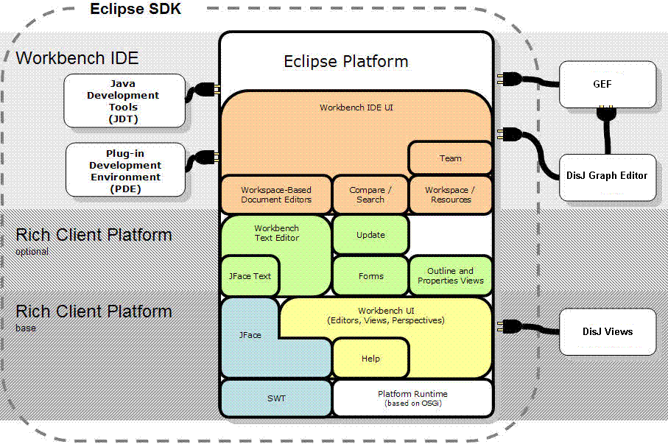
Figure 5.1 DisJ Plug-in with Eclipse Plug-ins

4.3 Architecture and Design
DisJ Simulation Tool has been designed with multiple components, in which reduces the complexity of the system by breaking it into small components with less complexity that will make development and maintenance easier for developers as shown in Figure 5.2

DisJ Simulation Tool
Runtime Components
Loading Components
Graph Editor
Java Editor

Execution Engine
Visualization
Configuration Parameters
Internal Libraries
Logger
Adversary Conrol
Probability Models
Figure 5.2 DisJ at High Level View

Loading Components
Loading components are components that responsible for loading data from user input and other necessary data into a workspace of the simulation before execution engine starts. A workspace is a space created for storing necessary data required by the simulation in order to perform an execution, and each execution has it own workspace that are not shared. The workspace contains many important data that derives from different loading components such as topology data, user protocol, API libraries, and configuration parameters and these data are corresponding from different four subcomponents under loading components as follow.

4.3.1 Graph Editor Component

Topology editor or Graph editor is a component that allows user to create, load, view and modify a network topology that will be used during the simulation. This component extracts and store necessary data of a network topology into a data structure and being used by the simulation during an execution. Topology editor has implemented and reused existing GEF plug-in and RCP plug-ins for creating 2D graphical of network element and various views for display.

4.3.2 Java Editor Component

Java editor is a component that DisJ provides user a space for writing a Java code to describe a reactive distributed algorithm. The editor is an inherited editor from Java Development Tool that developed by Eclipse as a plug-in, the editor is full feature IDE environment that has been used by many hi-tech industries and software development community. The editor will compile the protocol to meet standard Java libraries compilation and link the protocol with DisJ internal libraries that have been set and configured before start writing a Java code at the editor preferences setting.

4.3.3 DisJ Internal Libraries Component

DisJ provides libraries to support Netscape network environment with Message Passing model, Agent with Whiteboard model, and Agent with Token model, in which user protocol and the simulation can access it. User protocol can access by inheriting certain Java class that provide necessary API for usage based on a reactive distributed computing model that the protocol is implementing, while the simulation is able to access via polymorphism of Java object instances created by the simulation when it starts.

4.3.4 Environment Configurations Component

DisJ allows user to input environment configuration parameters that related to the execution of the simulation such as probability rate of reliability of link, number of agents, number of token etc. These configuration parameters are related to network configuration, reactive distributed model, protocol implementation etc in which the data must be provided before the starting of the simulation and cannot be modified once the simulation started.

Runtime Components
Runtime components are components that responsible for activities performing during the execution of simulation. There are five subcomponents that are defined to be under runtime of the simulation, execution engine, logger, visualization, adversary control, and probability model

4.3.5 Execution Engine
The execution engine is a core simulation engine that drives and manages the execution of the simulation. The execution engine creates a virtual processor in one to one mapping to a workspace, a space that stores all necessary data from loading components. The processor has been implemented with discrete event processing technique that has been used by a discrete event simulation. The processor virtually contains five components that processing user protocol as shown in figure 5.3 and following by a brief discussion of each subcomponent within the processor.

Event Queue
Time Generator
Event Generator

Event Processor
Event
Event
Simulation Clock
Figure 5.3 DisJ Simulation Processor

Event
An event is a collection of data that will be executed by a processor, in which it contains necessary information required for an execution of the event, and a simulation Timestamp that indicates a time to execute the event.

Event Queue
An event queue is an ordered queue of events, the queue is ordered by Timestamp from smallest to biggest Timestamp. The queue provide a sequence of executed events based on a simulation time that event will be occurred and executed. When a new event arrives, the queue will insert the event into an appropriated position based on the Timestamp assigned to the event. However, the Timestamp will never be smaller than a Timestamp of a top event in the queue, which mean that at a top of the queue is a current simulation time or a smallest future simulation time.

Time Generator
Time generator is a generator that generates a Timestamp, Timestamp is label represents a simulation time that defined by the simulation, called a simulation time unit. DisJ defines a time of the simulation is a positive integer number that always is in an increasing order from the starting of the simulation to the end. The time generator will assign a new Timestamp to a newly created event based on a Simulation Clock and a request from Event Generator.

Simulation Clock
Simulation clock is a local clock of a processor that tells a current simulation time. A time of simulation clock is always increasing and based on current executing event and a top event in an Event Queue. The Simulation Clock will increase a simulation time value to be as same as Timestamp assigned into a current popped event from an Event Queue.

Event Generator
Event generator is a generator that crates new events for the simulation based the result of event execution processed by Event Processor. After new event(s) have been generated, the generator will push it into an Event Queue for further processing.

Event Processor
Event processor is an engine that executes event(s) that are in the top of the Event Queue. The Event Processor will remove all events that have Timestamp equal to a time in a Simulation Clock and execute it in sequence of insertion. An execution of event may lead to a change of network status and protocol states etc, and each execution of an event may or may not proceed to a creation of new event(s), which entirely based on the results of the execution. Once there is no event left in Event Queue for Event Processor to execute, the simulation is normally ended.

4.3.6 Logger
A logger is a unit that logs necessary information for the simulation, there are two type of information logged by DisJ, system log and simulation log.

System Log
System log is a log that reports about DisJ internal system in form of warning message and error message that are directly involve in software bugs. This system log has adapted and used Eclipse logging system as part of plug-in development.

Simulation Log
Simulation log is a log that logs any changes of network elements status and value while the simulation is running into a persistence storage e.g. I/O file system. This logging information will be used in a Replay function, and displayed in live presentation and final presentation during and after the simulation execution.

4.3.7 Visualization
Visualization of DisJ can be categorized into two separate parts, Editor Part and View Part that are discussed below

Editor Part
DisJ Graph Editor is a main playground for user to create, view, and modify topology that will be used by the simulation during simulate user protocol. The editor is an extension of GEF graphical editor that provides many tools for 2D graphical drawing. The editor consists of three parts.

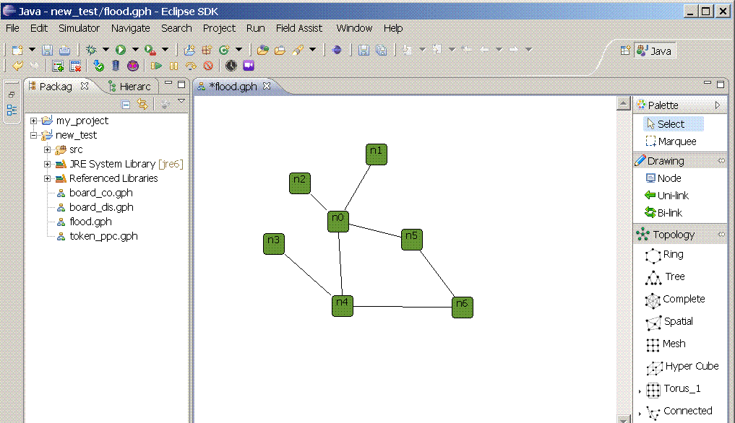
Figure 5.4 DisJ: Graph Editor

- A drawing canvas that allows user to draw a 2D graphical of nodes and links
- A Palette is a container that contains tools and figures for drawing objects
- A Menu bar and buttons for user to issue commands to the simulation

DisJ Java Editor is a main playground for user to write Java code that describes a reactive distributed algorithm. The editor is a fully inherit editor from JDT plug-in developed by Eclipse community.

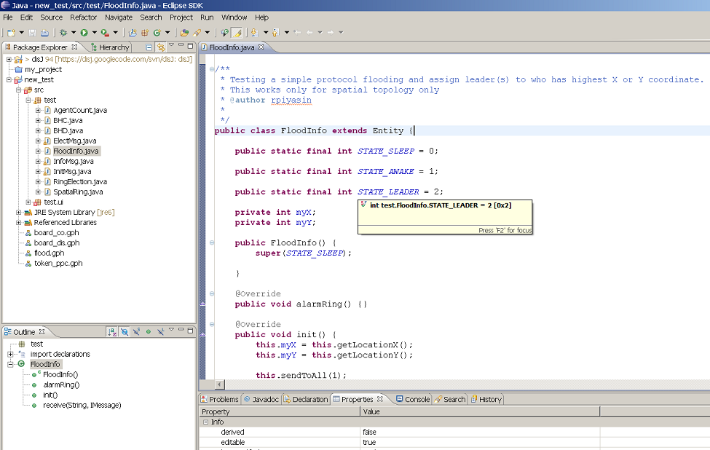
Figure 5.4 DisJ: Java Editor

View Part
Eclipse platform provides a view extension that allows DiJ to create multiple views to display difference objects and perspectives of the simulation. DisJ currently provides six separate views that display difference type of information to user as follow

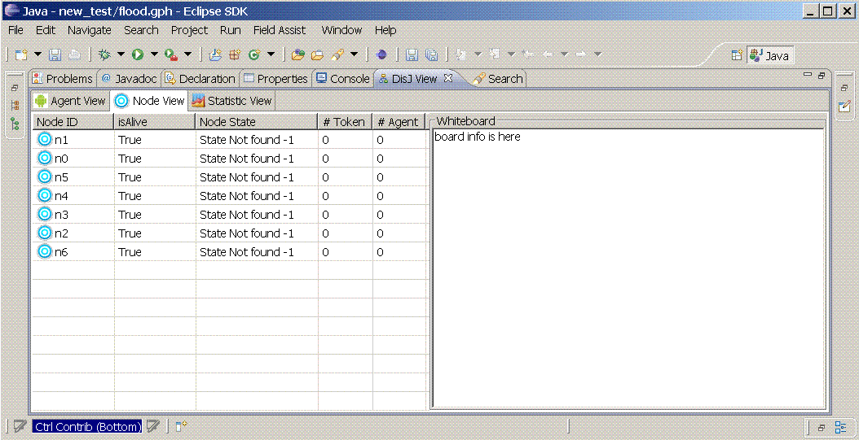
Figure 5.5 DisJ Simulation: Node View
- An Outline view that capture overall canvas into a read-only view that fit into a screen
- A Properties view is a view that display properties of a selected object in Graph Editor canvas
- A Node view is a view that display nodes current information in real time
- An Agent view is a view that display agents current information in real time
- A Console view is a view that display system information and exclusive report in text format
- A Statistic view is a view that display statistical bar and chart information of protocol execution in real time

Playback and Replay
Playback is a DisJ simulation control with animation display while the simulation is executing. The display is updated based on the change of network states and information during the execution of a protocol. DisJ records states and information changes during the execution of algorithm into persistence storage, file I/O, in order for Replay function to read and replay the execution in later time. The records are stored in a plain text with a predefined format of text structure in order for the replay system can read and parse the data and execute the replay correctly.
Execution Engine
Replay Engine

File I/O
Visualization

Network and Elements
Model
Figure 5.6 Playback and Replay

4.3.8 Adversary Control
Adversary control is a module that DisJ allows user to inject an adversary script into a simulation in order to verify and test correctness of an algorithm during an execution. The simulation provide interface for the adversary script to access environment information and control certain parts of the simulation system in order to control and direct environment and its behavior for testing and verifying the correctness and responses of the algorithm. However, it is user responsible to make sure that adversary code does not break certain rules and definitions of the environment, since adversary code has control of environment behaviors.

DisJ provides abstract classes for user to extend and internal API for adversary classes to access environment information and issue commands. The abstract classes have some functions that user can implement and override in order to control and verify the protocol as adversary suppose to do, instead of using default implementation of the system.

Execution Engine
Adversary Scripts
Default Instructions
User Protocol
Topology
Network Status
Figure 5.7 Adversary Work Flow

Execution Engine acts as a delegate between user adversary scripts and DisJ default instruction. Before the execution engine executes any instruction from simulation event, it will check execution instruction based on user implemented adversary codes, if there is no specific instruction defined by adversary scripts, otherwise internal default instruction will be executed by the engine.

4.3.9 Probability Model
Probability Model is a module that DisJ provides an option for user to plug-in custom probability model into the simulation. Since, DisJ provides only two types probability models, Uniform Random and Poisson Random, in which they are basic and general probability model. By default DisJ uses Uniform Random model in controlling and making decision of environment.
DisJ Simulation Engine
Default Probability Models
Random Uniform
Random Poisson
Custom Random
Figure 5.8 Probability Model Extension

DisJ provides an interface class for user to implement, and the simulation engine uses programming polymorphism technique by the engine always execute interface functions within the class when the probability model is required during the simulation execution. Therefore, user can connect external model into DisJ by using GUI option on Graph Editor Toolbar or Menu to load a given implemented class.

This design works even an external model library was not writing in Java language, as long as user implements an interface class, and inside the implemented class, user fines a way to redirect function calls to an external model library. For example, external library was written in C/C++, user either uses JNI to redirect function calls or uses socket communication to an interface of the library.

