   
  
  
  
  
  
  
  
  
  
  
  
American International University-Bangladesh (AIUB)  
**Department of Computer Science  
Faculty of Science &Technology (FST)  
Summer 19_20**

**Course: Object Oriented Programming-02**

**Mentor: Victor Stany Rozario**

**Section: G**

**Assignment:**

**“A Digital Diary”**

**Name: Hossain, Md. Mridul**

**ID: 18-38670-3**

**Problem**

A diary is a record (originally in handwritten format) with discrete entries arranged by date reporting on what has happened over the course of a day or other period. A personal diary may include a person's experiences, thoughts, and/or feelings, pictures, comments on event based on writer's direct experience. Create a Digital Diary replacing the old hand-written system where person can store/create his/her event description with date specified. Picture can be added to any specific event. A person can create multiple events. A person can modify the existing events and can delete any specific event from his/her diary. Last Modification date is also recorded in the system. One unique feature of the system is a user can set the importance (high, moderate, less important) of any event. Each person can be uniquely identified by the system. After a successful login his/her diary of events are displayed on home screen.

**Database**

**LoginInfo Structure:**

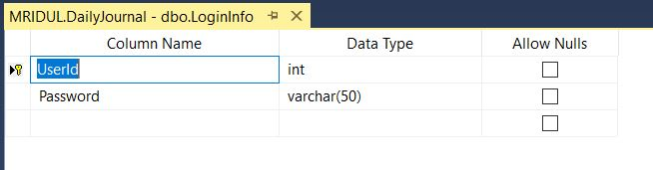

**LoginInfo Datatable:**

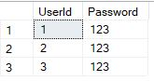

**Journals Structure:**

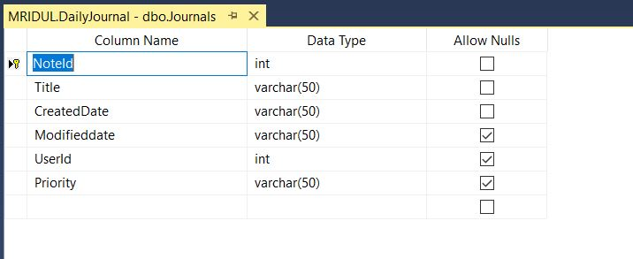

**Journals Datatable:**

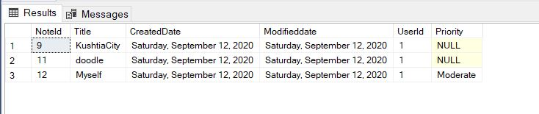

**Output**

**Login Interface: (Before typing User Id & Password)**

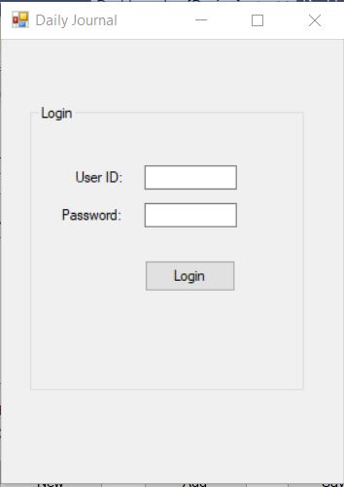

**Login Interface: (After typing User Id & Password)**

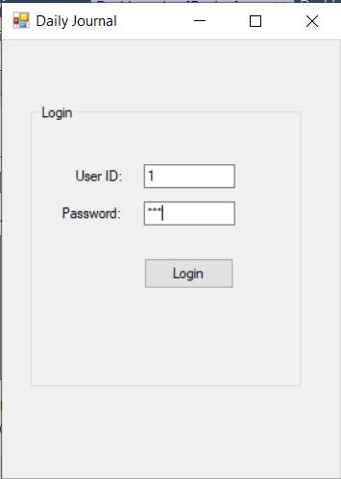

**Dashboard Interface:**

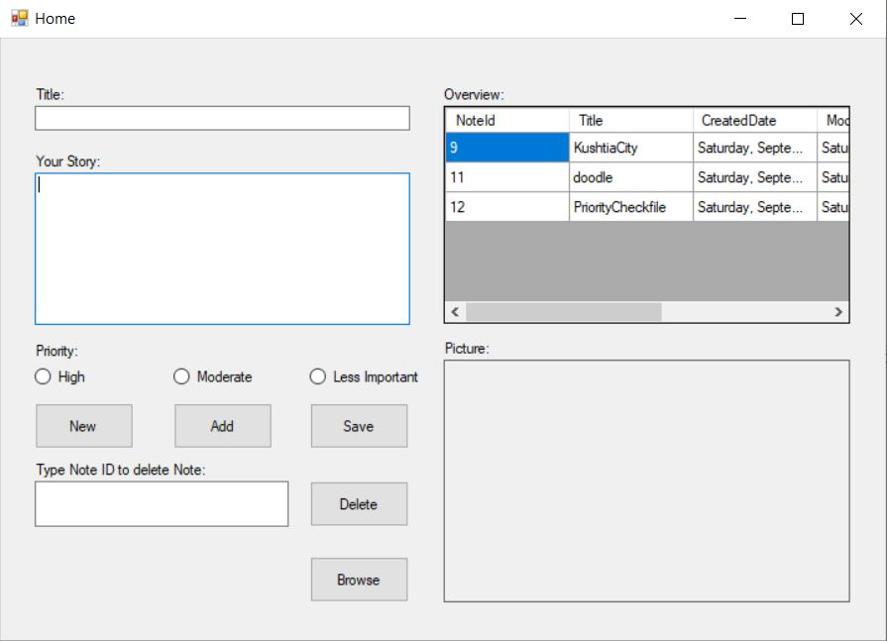

**Dashboard Interface: (After clicking GridView cell)**

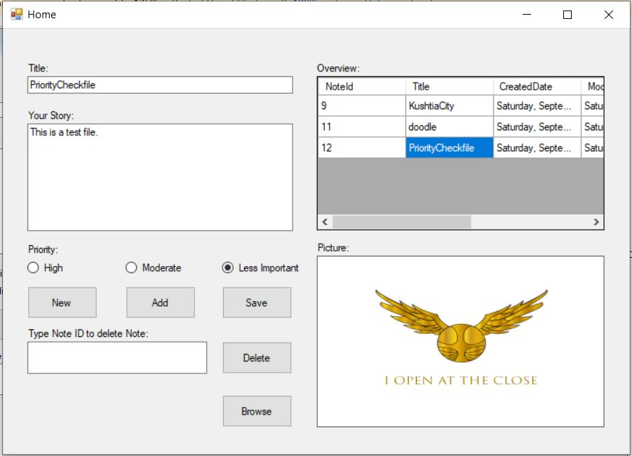

**Dashboard Interface: (After clicking Add)**

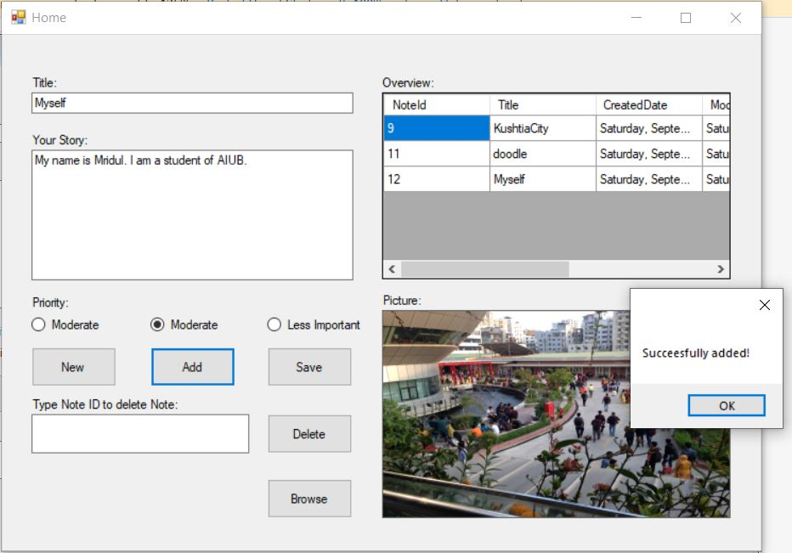

**Dashboard Interface: (After clicking OK)**

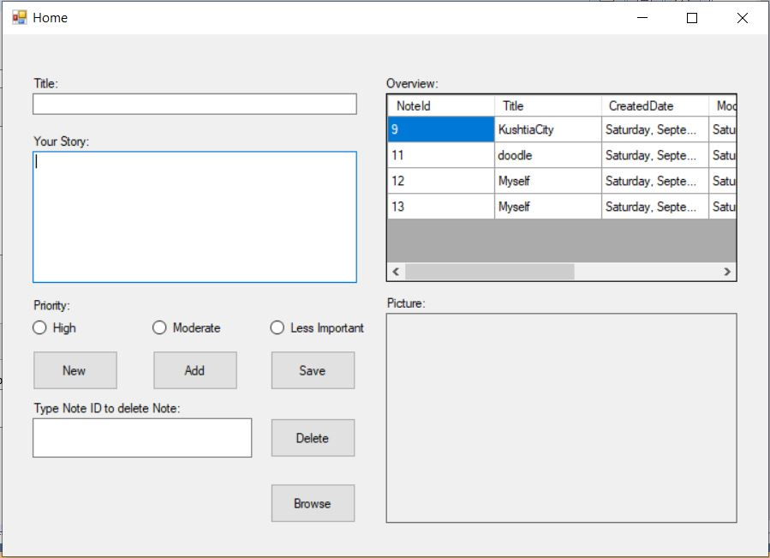

**Dashboard Interface: (Before clicking Save)**

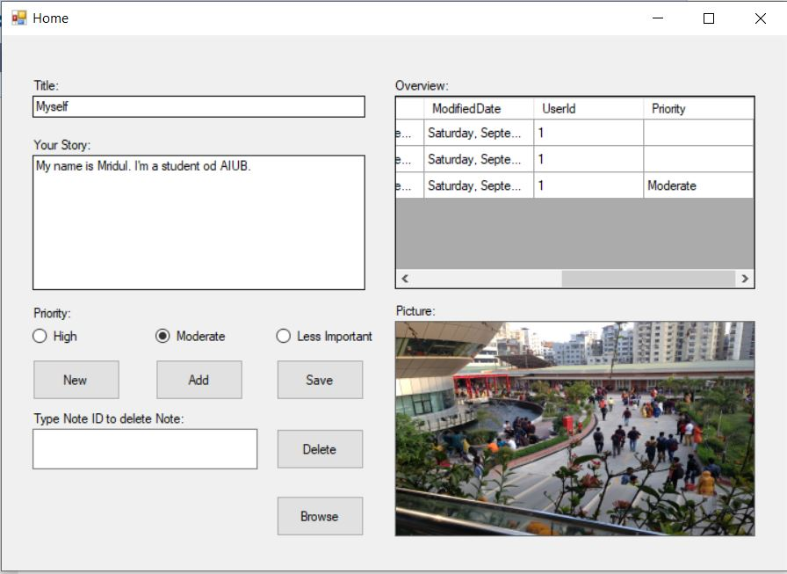

**Dashboard Interface: (After clicking Save)**

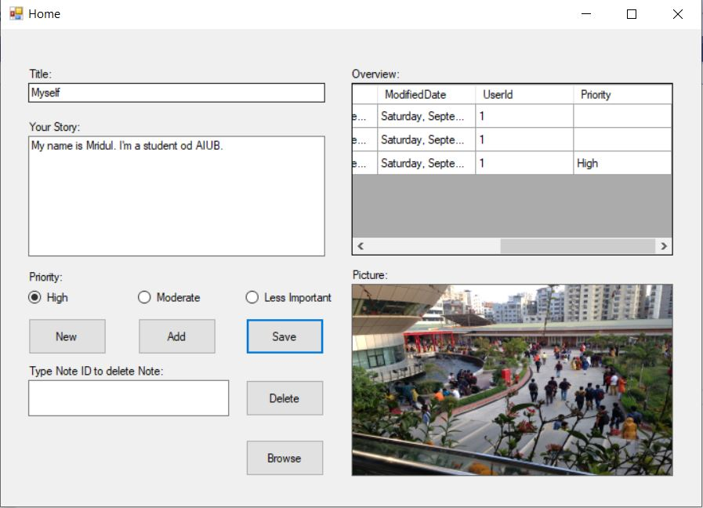

**Dashboard Interface: (After clicking Delete)**

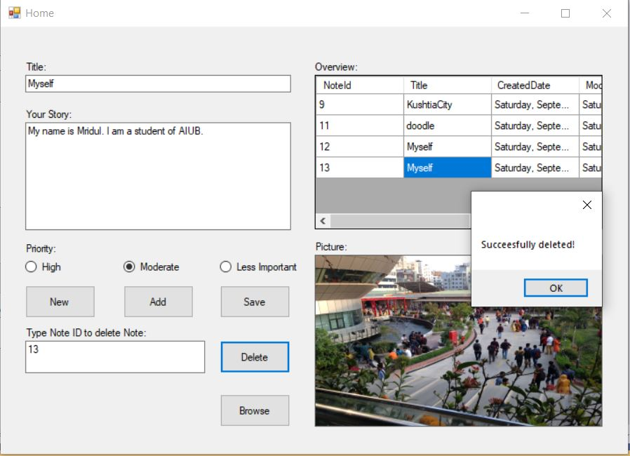

**Dashboard Interface: (After clicking OK)**

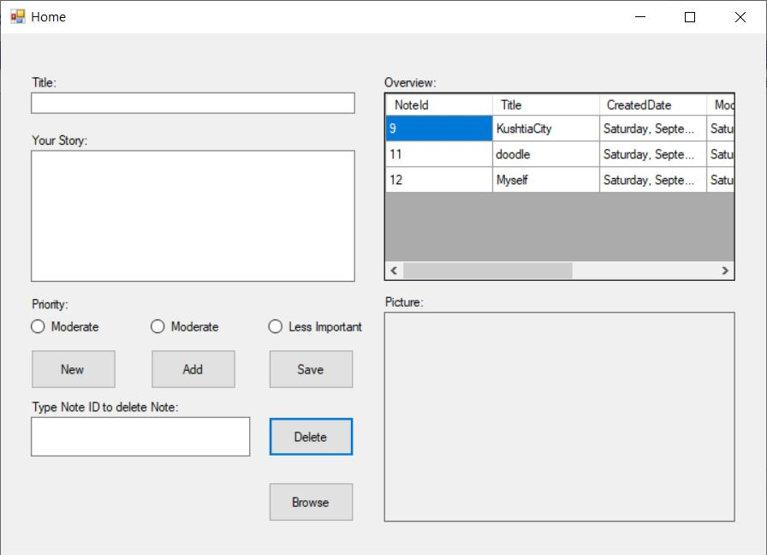

**Dashboard Interface: (After clicking New)**

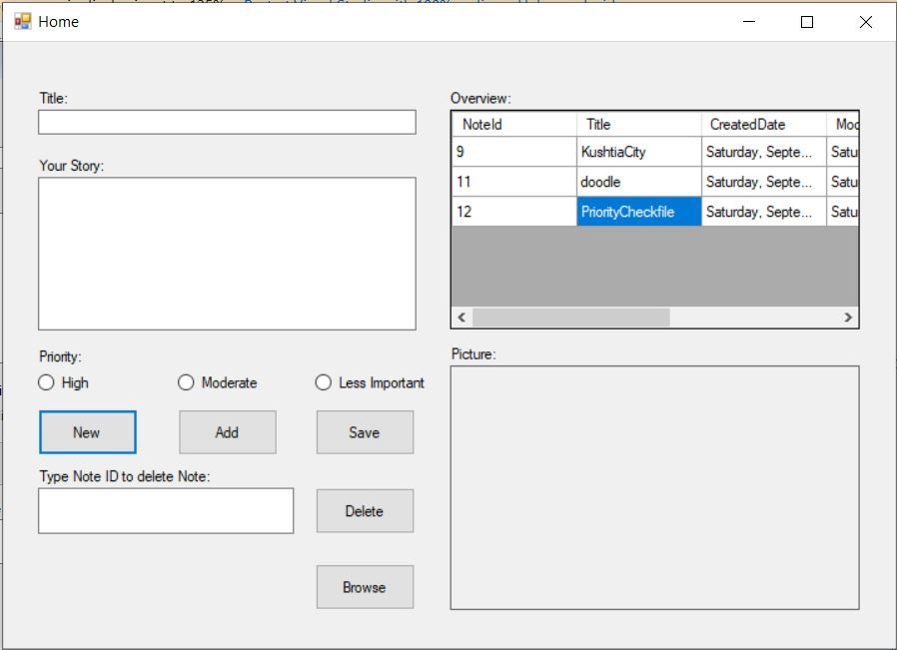

**Folder: DailyJournalNotes (Where all the stories is been saved as .txt file)**

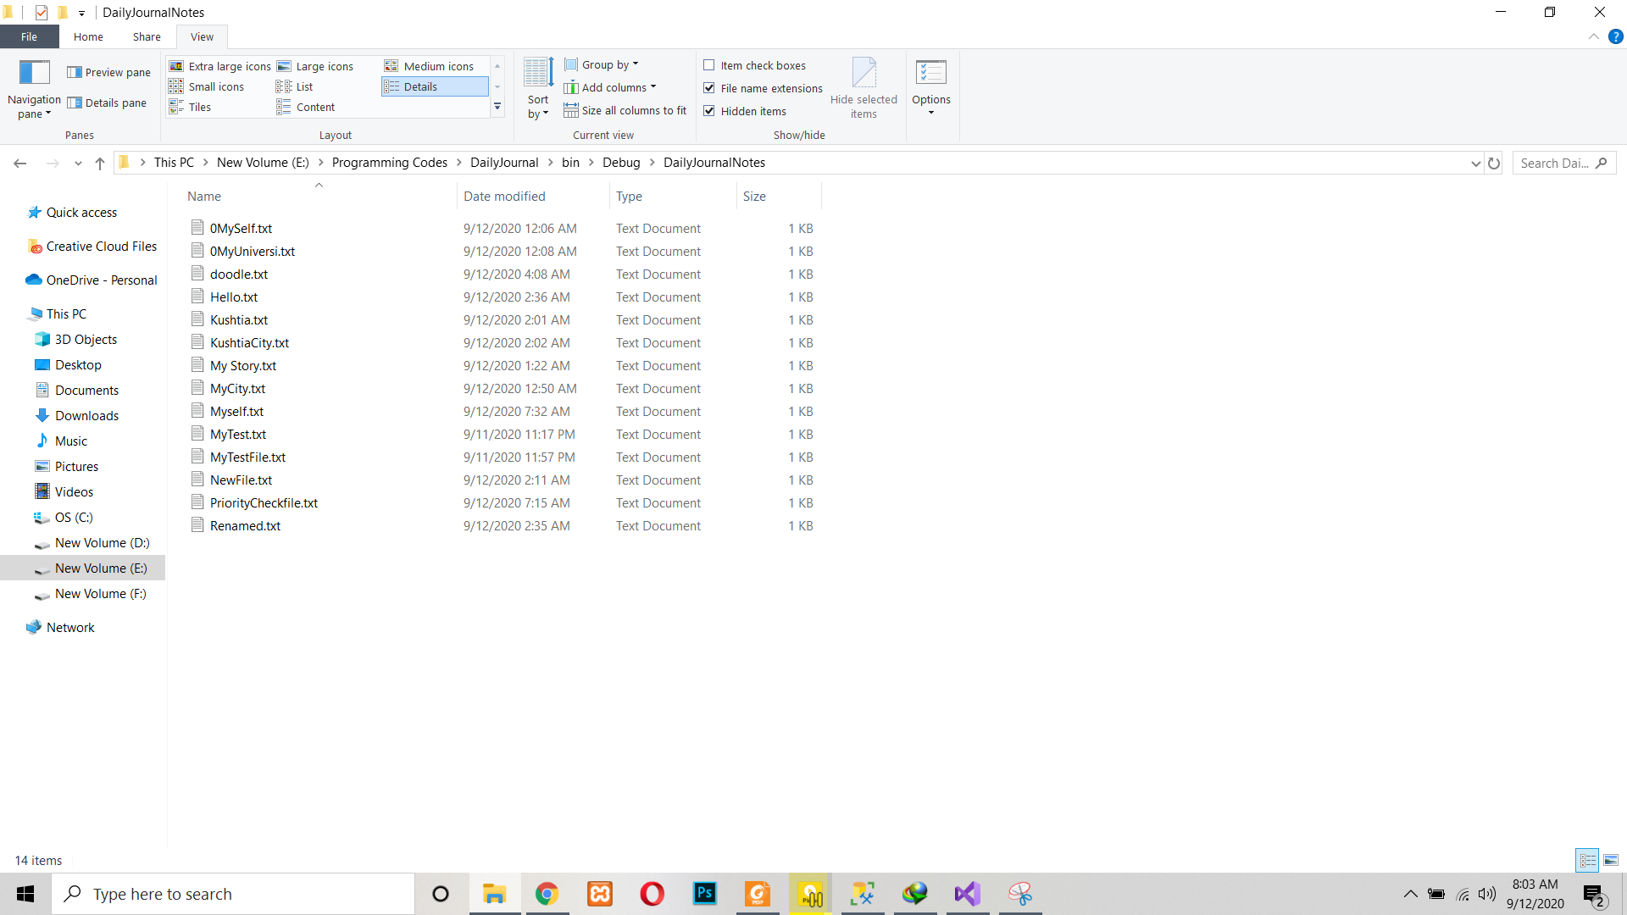

**Folder: DailyJournalPictures(Where all the pictures is been saved as .jpg file)**

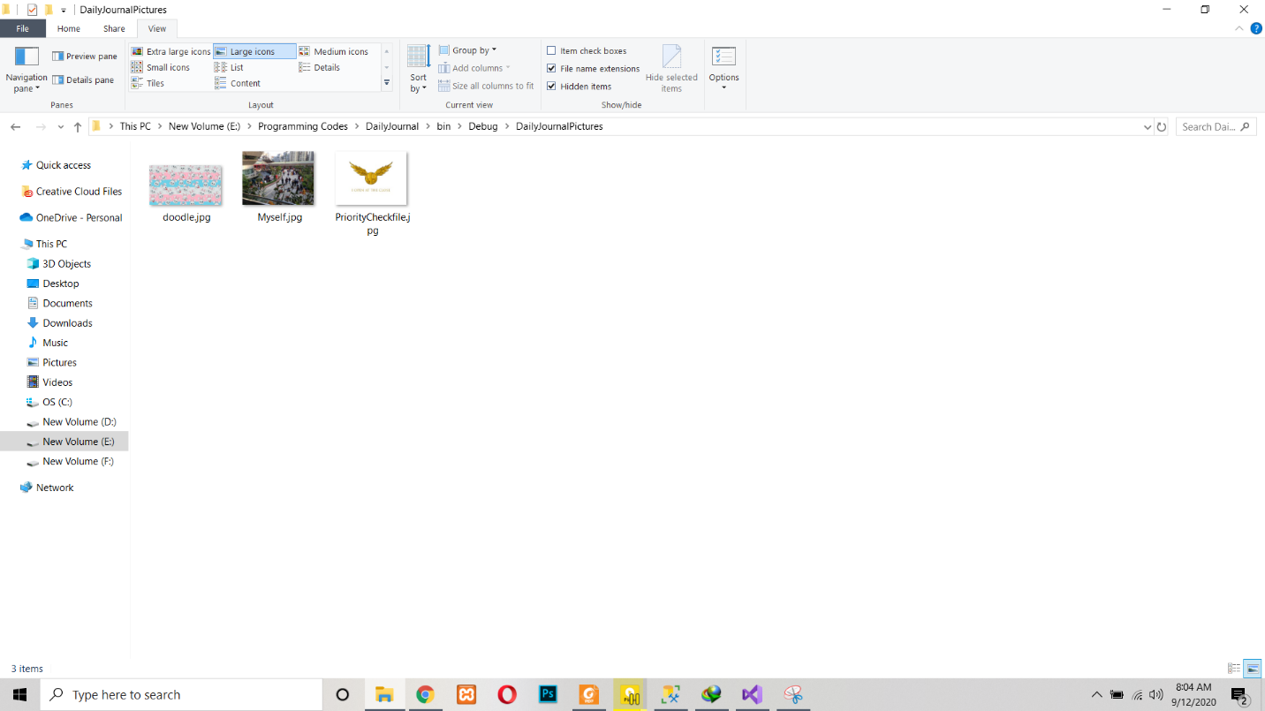

**Source Code**

**Program Class:**

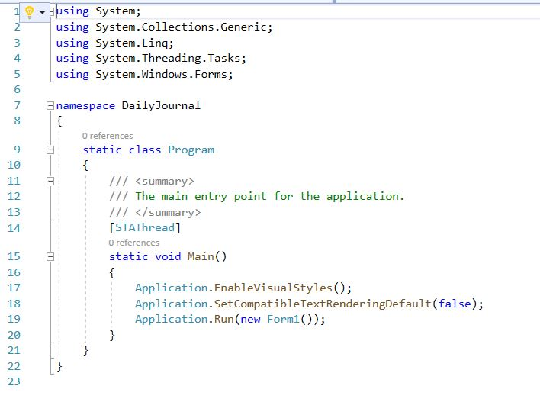

**DataAccess Class:**

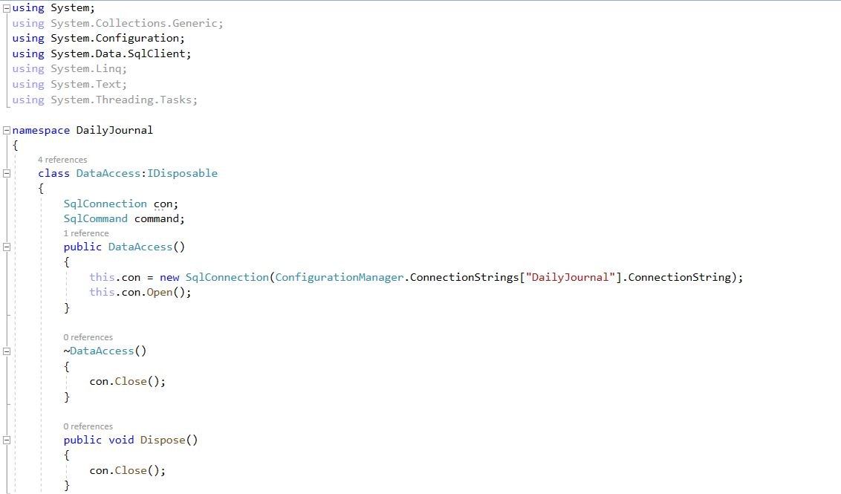

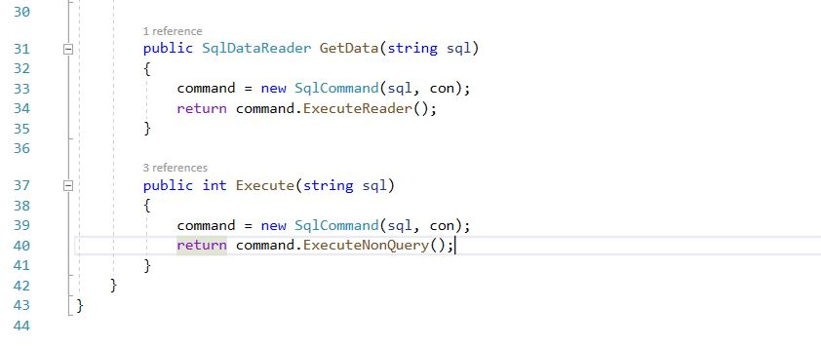

**AppConfig:**

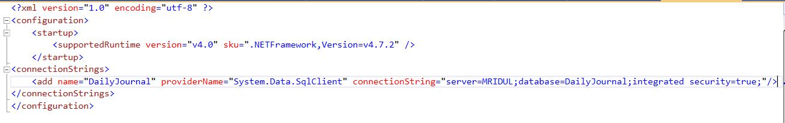

**Global Class:**

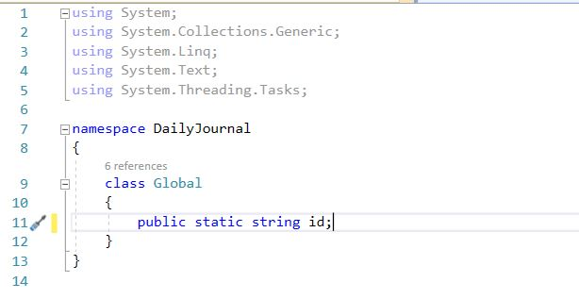

**Form1 Class:**

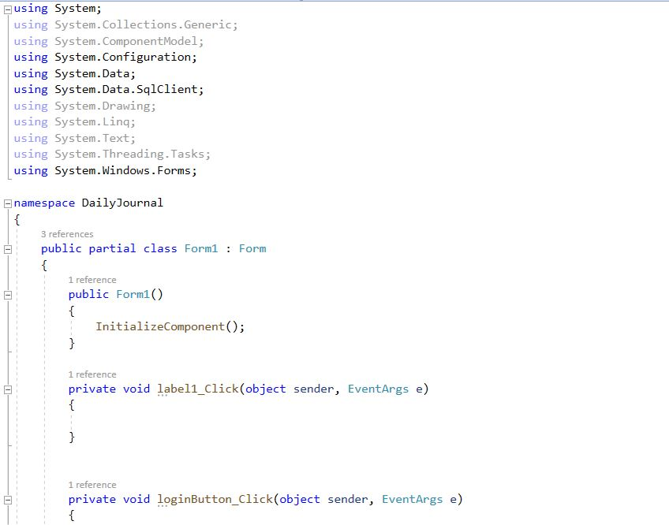

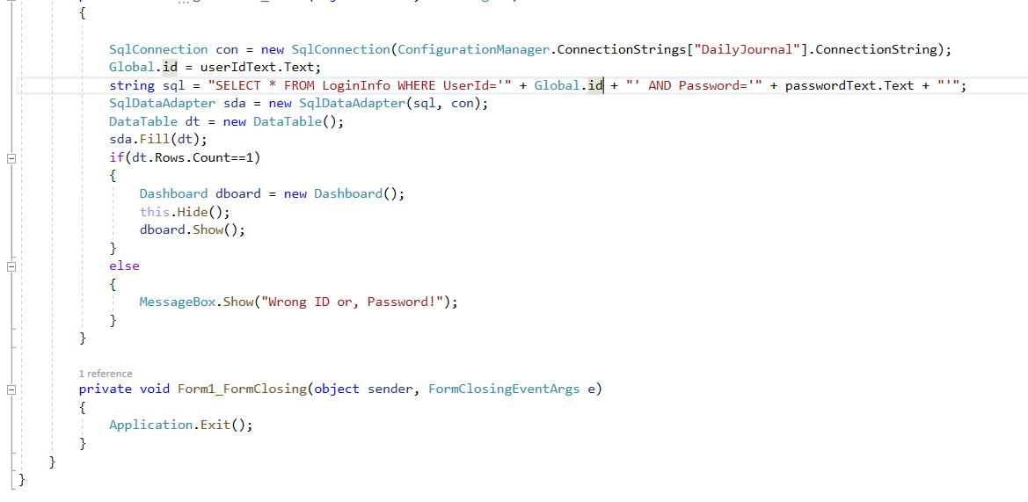

**Dashboard Class:**

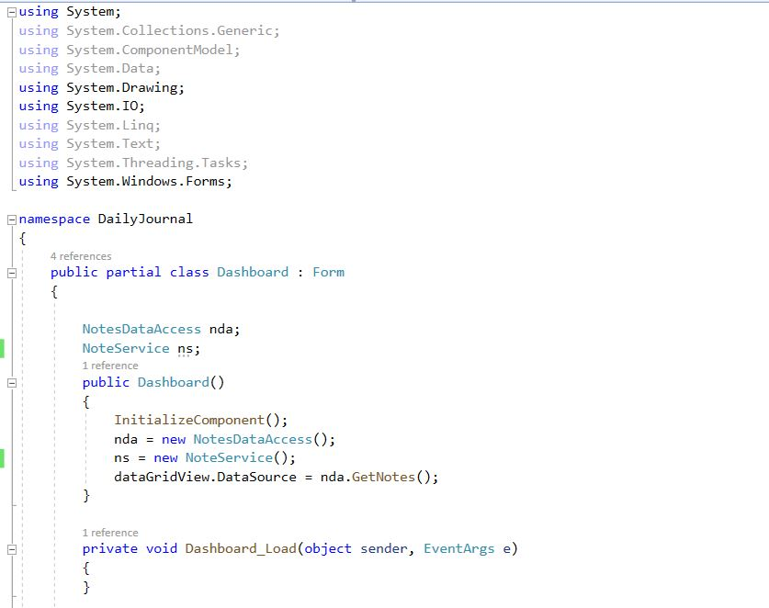

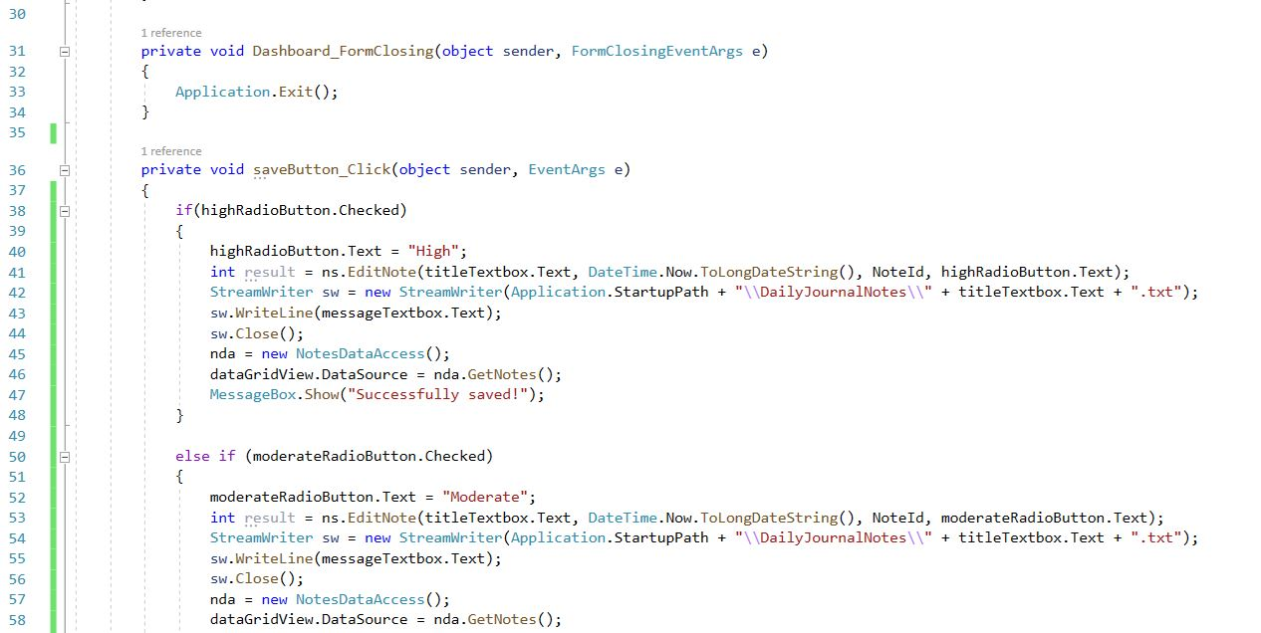

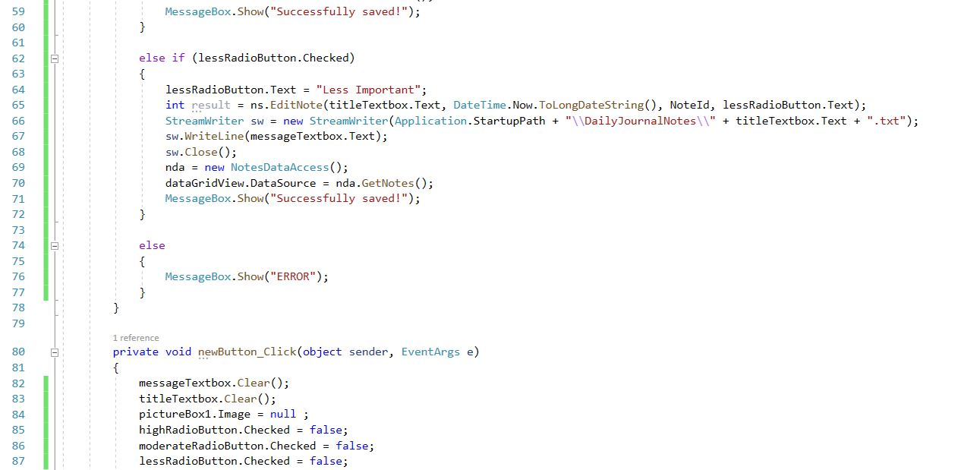

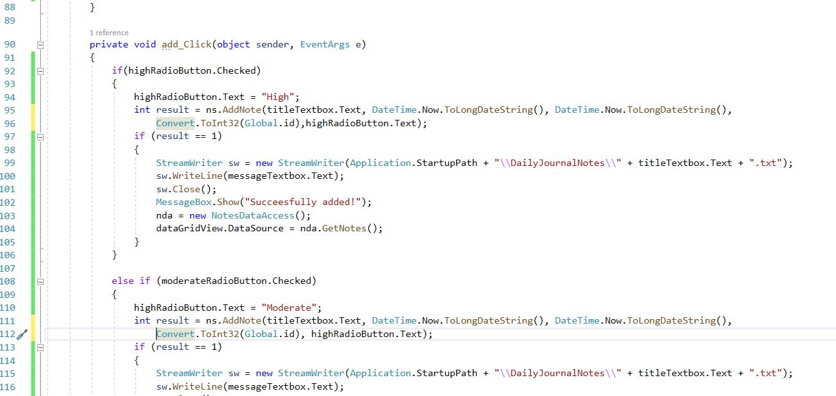

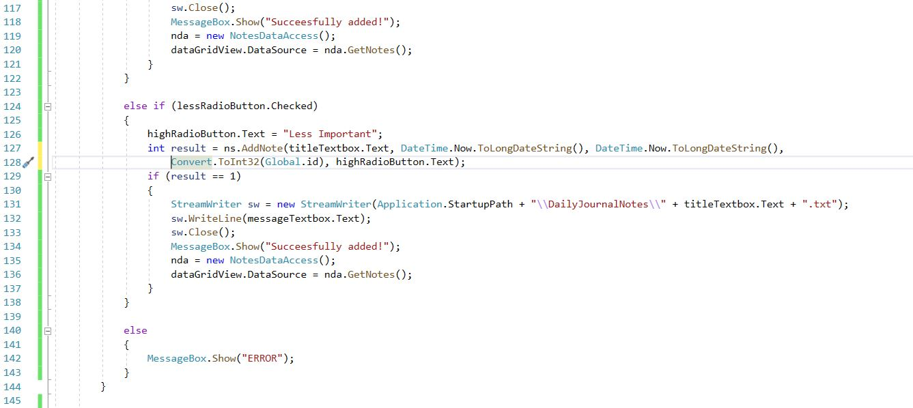

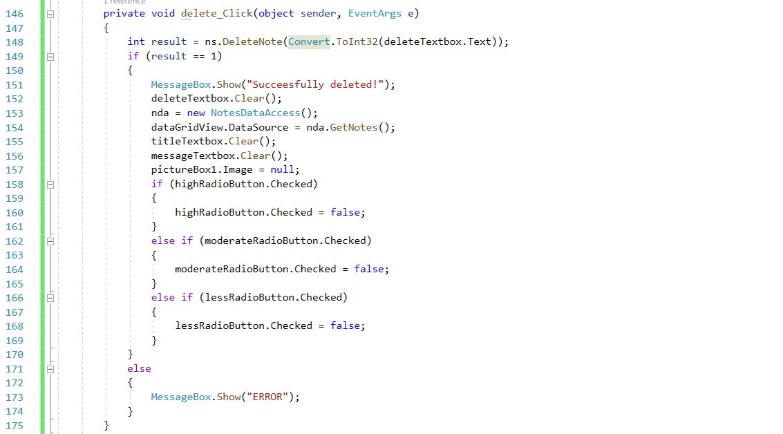

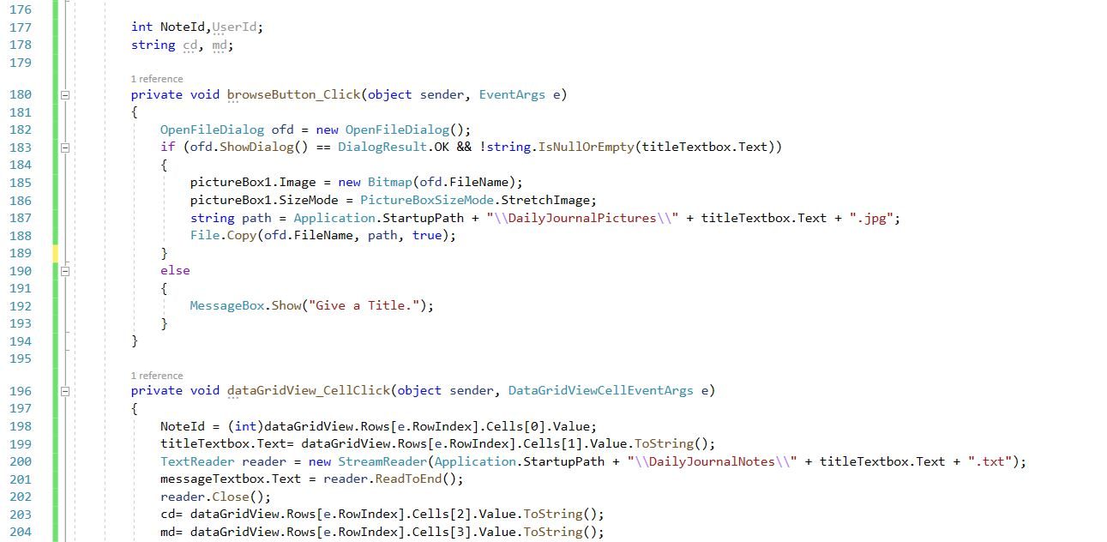

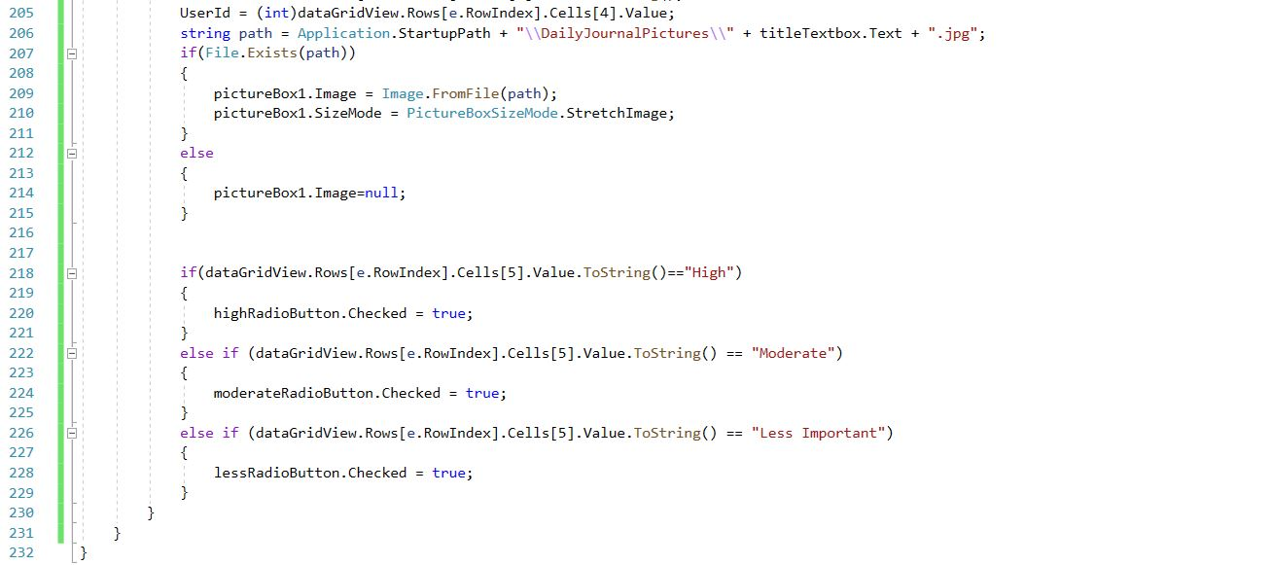

**NotesDataAccess Class:**

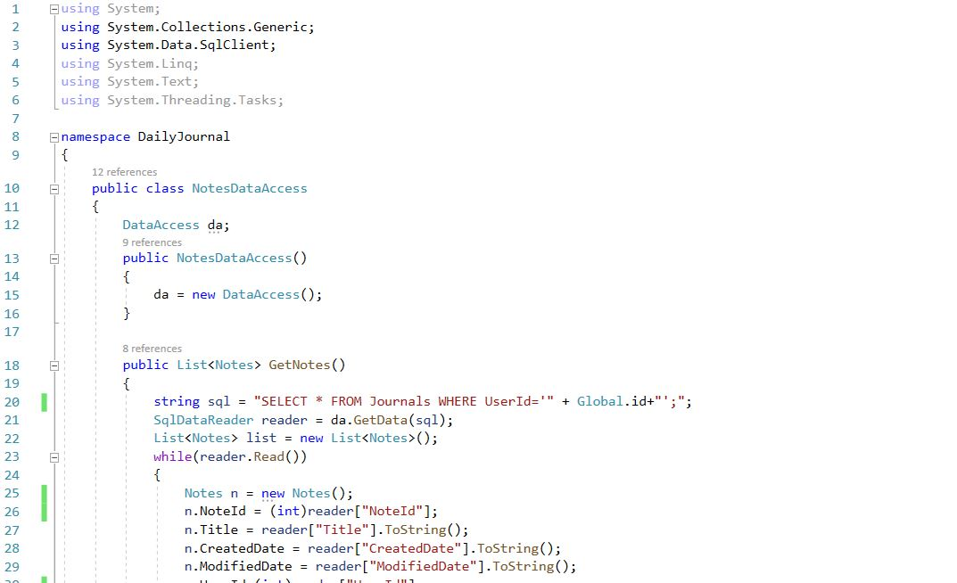

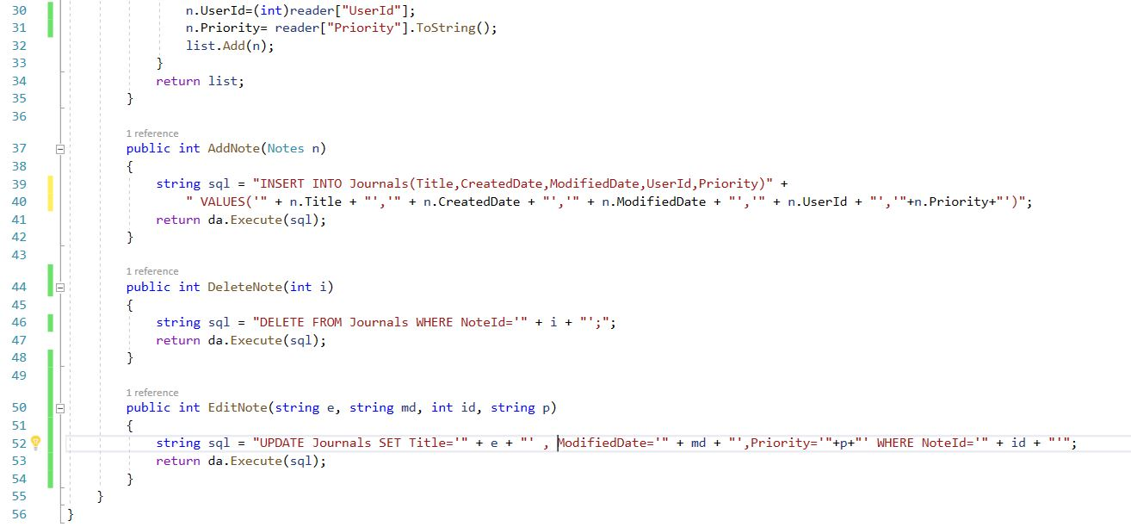

**NoteService Class:**

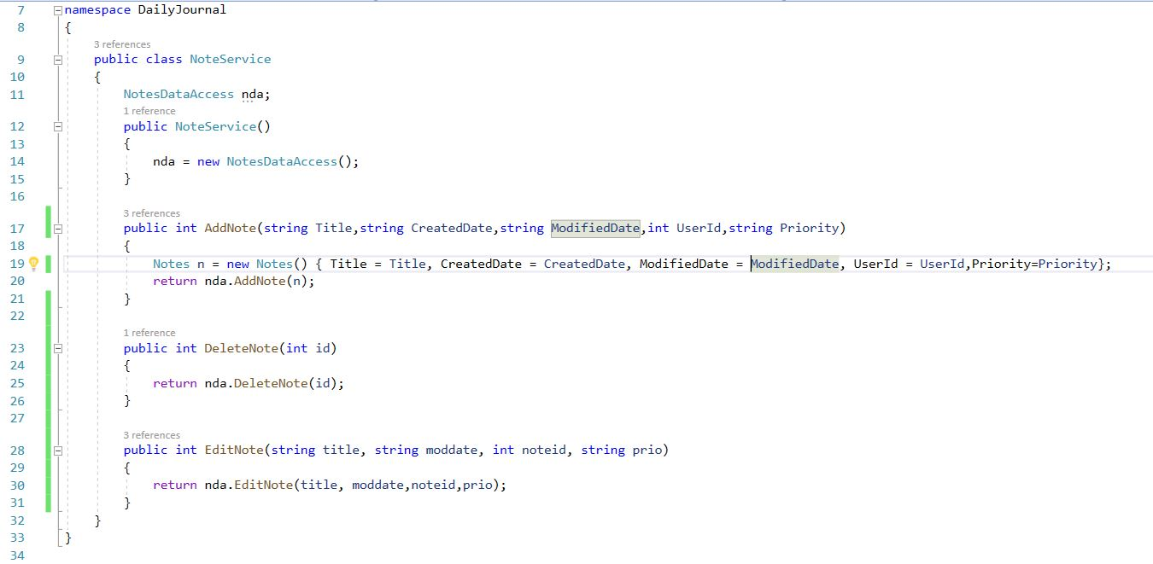

**Notes Class:**

