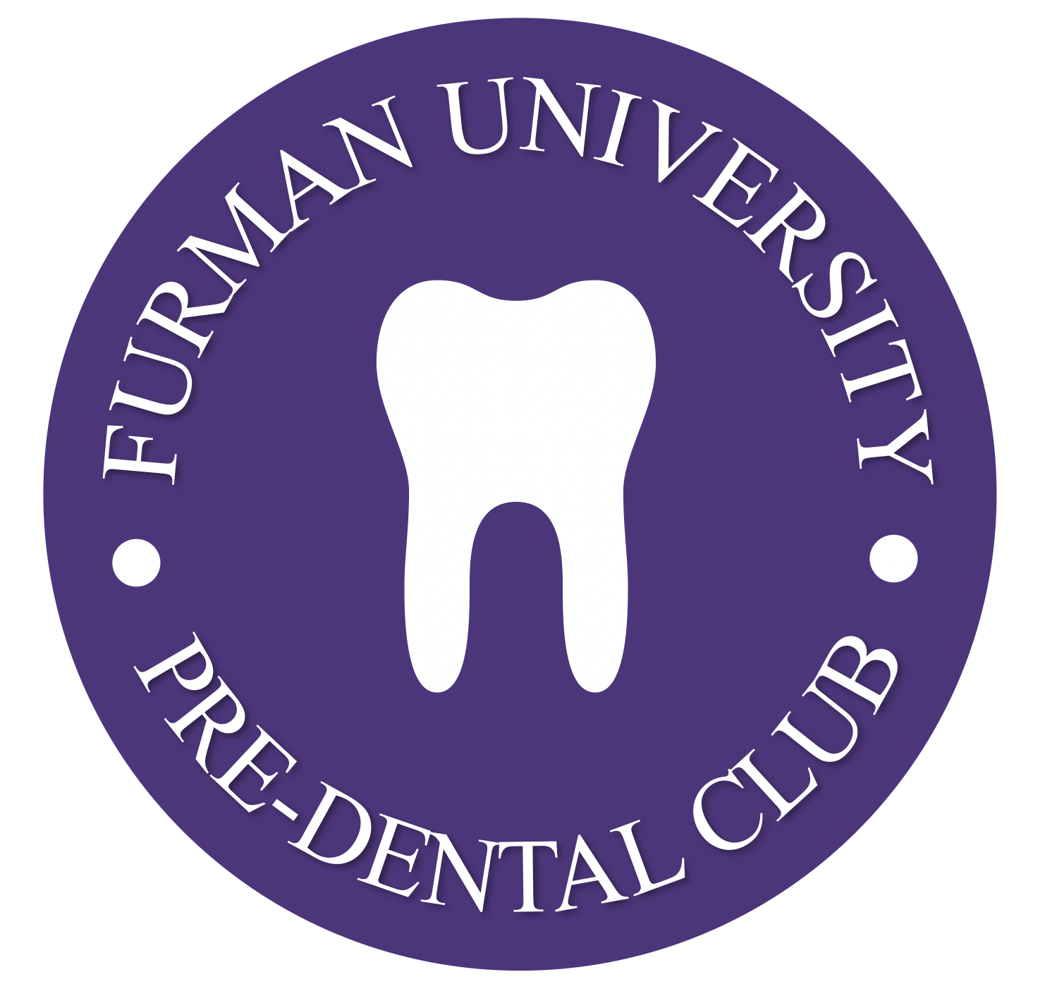
Constitution of the Furman University Pre-Dental Club (FUPDC)

Mission Statement
The mission of the Furman University Pre-Dental Club (FUPDC) is to promote and improve oral care, treatment, and education by providing dental programs and education seeking to help patients accept the best care possible and invest in oral care to improve overall well-being.

Values Statement:
As an organization, FUPDC ascribes to the values of PRIDE: professionalism, respect, integrity, diversity, and excellence. We seek to embody these values in our efforts to better both FUPDC and the community.

Vision Statement
As an organization, FUPDC is guided by the belief that everyone should have access to quality dental care to improve his/her own overall health. We believe that this vision can provide a brighter future for everyone in our university and in our community. It is sustained by compassion, knowledge, and dedicated volunteers.

CONSTITUTION
Article I. Name of Organization
The formal name of this organization shall be the Furman University Pre-Dental Club (FUPDC).

Article II. Purpose
The purpose of the Furman University Pre-Dental Club (FUPDC) shall be to serve as a resource for students to explore a potential future career in dentistry. The club shall also serve to educate and serve the Furman community as well as the Greenville community.

Article III. Affiliations
The Furman University Pre-Dental Club (FUPDC) is not affiliated with any University departments or other organizations.

Article IV. Membership
In keeping with Furman University’s non-discrimination policies, membership shall be open to all undergraduate, day students. Our organization will not discriminate on the basis of race, sex, handicap, age, sexual orientation, political affiliation, or religious affiliation.

Article V. Officers
The officers shall include:
  - FUPDC President
  - FUPDC Vice President
  - FUPDC Treasurer
  - FUPDC Secretary
  - FUPDC Social Media Manager
All students of Furman University who pay the student government fee, obtain a minimum of one-year active membership in FUPDC, and maintain a 3.0 or higher GPA are eligible to serve as officers of FUPDC. The term of office for all members will run for one academic year after the club has been active for two consecutive years.

Article VI. Advisor
The advisor shall solely have the job of overlooking the club. He or she may make suggestions or comments at any time. He or she is not required to attend meetings, programs, or events, but is expected to provide assistance when uncompromised issues arise or if advice is needed.

Article VII. Meetings
Meetings will be held monthly for approximately one hour in Patrick Lecture Hall. Additional meetings may be scheduled for special events, programs, etc.

Article VIII. Finance
The organization will receive funding via the Student Government Association (SGA).

Article IX. Amendments
Amendments to this constitution may be proposed by any member of FUPDC.
Amendments become part of the constitution with the approval of at least two-thirds (2/3) of FUPDC after two readings of the proposed amendment and on ratification by a two- thirds (2/3) majority vote of the student body, provided at least twenty percent (20%) of the student body votes in such a referendum, and that the proposed amendments have been posted at least one week prior to the vote by the secretary of the student body. If an amendment successfully meets all of the above requirements two times, except for the requirement that twenty percent (20%) of the student body votes, the amendment will be considered passed.

BY-LAWS
Article I: Membership
There will be nonactive and active memberships. Every student is considered a nonactive member. To be established as an active member, a student must meet the minimum requirement of obtaining 3 points per semester. A nonactive member is deemed active after meeting the minimum requirement for two consecutive semesters. An active member will be deemed nonactive after one semester of not meeting the minimum requirement and must regain membership through the same process. Only active members are able to run for office if all additional requirements are met. Points are reflective of attendance at various meetings, programs, events, etc. Members will be removed if they violate any of Furman’s academic or conduct policies via unanimous agreement upon officers.

Article II: Selection of Officers
The term of office for all members will run for the entire academic year. Upperclassmen
and executive officer elections will take place in the spring term of the previous academic
year. Those elected will meet with the current members until the end of the year and will
be sworn in on the last meeting. All officers require a minimum of one-year active
membership in FUPDC prior to running for any elected position. There will be an annual
election to vote on new officers following two years of the club’s establishment. Nothing
prohibits an officer from holding the same office for the following academic year(s).

A. Procedure
- The election calendar for the academic year will be prepared by the officers in consultation with the FUPDC President. This calendar shall include the date of the election for officer positions for the following academic year. All voting will be by secret ballot.
B. Office Duties
  - FUPDC President: The President is the chief executive officer for the club. The primary responsibilities of this role involve the general supervision and operation of the club. The President presides at club meetings and directs the club in meeting the members' needs for educational growth and leadership. In cooperation with the other officers, the President establishes long-term and short-term goals for the club.
  - FUPDC Vice President: The Vice President manages all educational programs within the club. The primary responsibilities of this role involve ensuring that all members continue their progress toward their own individual educational goals. The VP plans, organizes, and implements meeting schedules to include speeches, educational modules, and other events sufficient to meet both individual and club objectives.
  - FUPDC Treasurer: The Treasurer manages the club's financial health. The primary responsibilities of this role involve handling the club's finances, including the collection of club dues and the payment of all bills. The Treasurer receives and disburses funds to further the operation of the club and its officers. All club accounts are managed by this office.
  - FUPDC Secretary: The Secretary manages all record-keeping and correspondence. The primary responsibilities of this role involve handling administrative details among the club. The Secretary maintains the club's records, including club by-laws and the club constitution.
  - FUPDC Social Media Manager: The Social Media Manager will design and implement social media strategy to align with club goals. He or she will generate, edit, publish and share engaging content biweekly (e.g. original text, photos, videos and news), communicate with followers, respond to queries in a timely manner, and monitor customer reviews. He or she will oversee all social media accounts’ design (e.g. Facebook timeline cover, profile pictures and blog layout) and suggest and implement new features to develop brand awareness, like promotions and competitions.

In the event of the vacancy of the President, the Vice President will take over. If there is a Vice President vacancy, the secretary will fill this role. Treasurer and social media manager then follow if necessary. An officer will be removed from the position after two unexcused vacancies over the academic school year and unanimous agreement among all officers.

Article III: Selection of Advisor
The advisor is selected based upon relevance of the club and unanimous agreement upon officers. Pre-health advisors are preferred to act as advisors as FUPDC is a pre-health-related club. An advisor shall be removed if he or she violates his or her agreements with the club and officers unanimously agree upon the decision.

Article IV: Committees
Committees for speakers, events, and projects will be established. The speaker committee will search out varying speakers in different dental disciplines to provide the club with knowledge of varying aspects of dentistry. The events committee will seek out opportunities wherein Furman can be represented at other schools such as Dental Days and Impressions Days which are open house opportunities for aspiring dental students. The projects committee will work on preparing and packaging dental hygiene kits and will work on power points presentations to be given to local title I schools. This committee will also prepare for toothbrush drives and on campus interactive student events such as the student involvement fair. The process for establishing Ad-hoc committees is to appoint a committee chair person and in some cases a co-chair individual who will organize the agenda for the committee and will meet with its committee members as necessary and when needed to fulfill the committee’s objectives.

Article V: Rules of Order
Business will be conducted based on Robert’s Rules of Order. A parliamentary procedure will be followed wherein the majority rules. Any internal conflicts will be resolved by the majority vote.

Article VI: Amendments
Amendments to the by-laws of the FUPDC will be proposed by any member of
the FUPDC. Amendments will become part of the by-laws on approval by a two-thirds (2/3) majority vote of the FUPDC after two readings.

