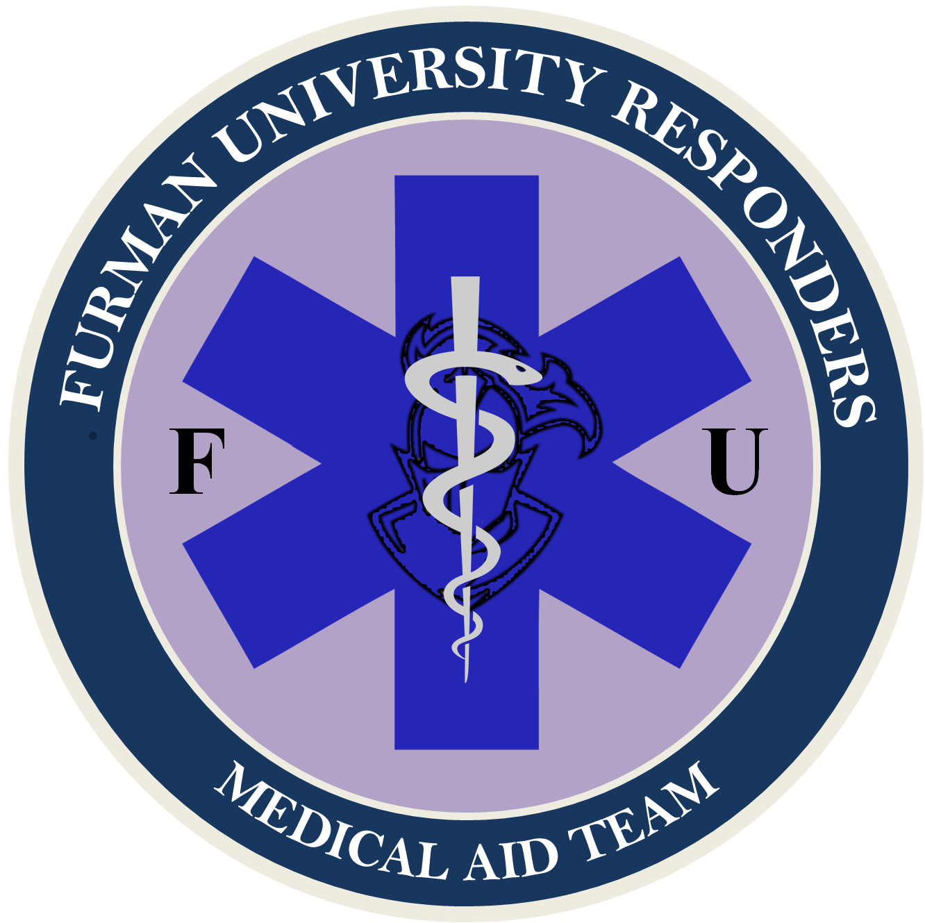

ARTICLE I: NAME & PURPOSE

Section A: Name – The name of this club shall be Furman University Responders.

Section B: Purpose – The purpose of this club shall be:
- To provide students interested in medicine a place to learn and explore the intricate procedures and precautions of Emergency Medicine
- To provide First-Aid/CPR/AED and Emergency Medical Technician (EMT) training opportunities to all members of Furman University, allowing students to achieve hands-on medical experience and increase the number of First Responders on Furman's campus.
- Provide scholarships for First-Aid/CPR/AED and EMT classes to as many Furman students as possible.
- Grant students larger opportunities for employment during undergraduate education at higher pays than most college jobs.
- To present leadership opportunities in the field of emergency medicine to students on Furman's campus.

ARTICLE II: MEMBERSHIP & DUES

Section A: Eligibility – Membership shall be open to all students at Furman University who express interest in emergency medicine.

Section B: Dues – Dues will be $0 per year for all members.

Section C: Membership Maintenance Requirements - No mandatory meeting will be required of members. Members are expected to contribute meaningfully to any events they attend, either through insight, helpfulness, or self-reflection in learning. Members are not to engage in malice, and are to be respectful of their fellow members and student during the conduction of club activities.

ARTICLE III: FUNDING STRATEGY

Section A: SGA Funding Budget - Apply for a yearly budget from the SGA, outlining what costs we will likely incur, from what sources, and how much funding is needed. Lobby for additional funding as need.

Section B: Training Cost – Furman University Responders will do its best to subsidize the cost of training for all members. If funding is not available, there may be a nominal fee for certain training courses or opportunities.

Section C: Speakers – All guest speakers should be volunteers.

Section D: Fundraising – Furman University Responders will hold fundraisers as needed for supplemental funding.

Section E: Sponsorship – Furman University Responders will also attempt to receive Sponsorship from private medical services in the Greenville area and abroad. Furman University Responders will also attempt to acquire training equipment through this avenue.

ARTICLE IV: OFFICERS

Section A: Executive Council – The officers shall consist of a President, VP Operations, VP Communications, and VP Finance.

Section B: Programming Council – The officers shall consist of Training Lead, Medical Aid Team Captain, FUPO Liaison, Public Relations Chair, and Community Outreach Chair.

Section C: Eligibility – Officers must be full-time students at Furman University. Officers must have a reasonable interest in the pursuit of medicine. Officers should be in good standing with campus administration and police.

Section D: Election – Programming Council officers shall be appointed by the Executive Council via majority agreement when vacancy arises (either at the beginning of the Fall semester or as needed when vacancy occurs). Executive Officers shall be appointed by Programming Council via majority agreement, or via appointment by club Advisor, when vacancy arises.
Section D-1 − In order to ensure a smooth and quick construction of the club all Council appointments of both branches will be made by the President in the academic year of 2023-2024. The presidential position will be filled via appointment by the club’s advisor.

Section D: Term – The officers shall serve until voluntary vacancy, graduation from Furman, or a voted removal by vote of Council.

Section E: Vacancy – If a vacancy occurs in any position of council, an application process will be issued to club membership. The opposing council branch of the vacant position shall then appoint the officer by majority agreement. Alternatively, a vacancy in the executive council can also be filled via appointment by club advisor. Preferred method of appointment is via Council vote.

Section F: Removal of Officers – Any concerns members have with an Council member should be sent to the Club President or another Council member. The officer in concern will be notified of the complaint and will have 1 week to remedy any concerns. If any members are unsatisfied with an executive member, an officer can be removed from office at any time by a 2/3 vote of members. Members of Council may also call for this vote to be held.

ARTICLE V: DUTIES OF EXECUTIVE OFFICERS

Section A: President – it shall be the duty of the President to:
- Preside at Council meetings.
- Coordinate with appropriate entities to establish partnerships and connections.
- Represent the club in all Furman related events.
- Serve as an ex-officio member of all committees except the nominating committee.
- Oversee club as a whole in an administrative position.

Section B: VP Operations – It shall be the duty of the VP Operations to:
- Serve in the capacity of the President in his or her absence.
- Begin planning for club procedures.
- Plan meetings and events dates.
- Continue coordination with appropriate entities.

Section C: VP Communications – It shall be the duty of the VP Communications to:
- Oversee and serve as chair of the Programming Council.
- Keep a file of the club's records.
- Maintain a current roster of membership and skill level
- Notify members and the public of training opportunities supported by the club.
- Notify any member of upcoming lapses in members’ certifications.
- Issue notices of meetings and conduct the general correspondence of the club.

Section D: VP Finance – It shall be the duty of the VP Finance to:
- Create club budgeting, and plan spending for year.
- Help source funding for club projects and events.
- Receive all funds and process Request for Payment, Deposit Slip, and Officer Signature Forms.
- Keep an itemized account of all receipts and expenditures and make reports as directed.
- Receive and manage all payments for the EMT Class and other Club activities (i.e., CPR Class or Suturing Workshop).

ARTICLE VI: DUTIES OF PROGRAMMING COUNCIL

Section A: Training Lead – It shall be the duty of the Training Liaison to:
- Communicates with potential training sources for club members, to include but not be limited to, EMT classes (outside campus facilities), stop the bleed courses, first aid courses, ect. The training lead will also be responsible for working with the Community Outreach Chair, for planning and facilitation of on campus training.

Section B: Medical Aid Team Captain – It shall be the duty of the Medical Aid Team Captain to:
- Run the Medical Aid Team, and facilitate the planning and execution of the First Aid Station at applicable campus events. Maintain approval with appropriate entities for operation of station. Recruit volunteers for team and maintain a high standard of care.

Section C: FUPO Liaison – It shall be the duty of the FUPO Liaison to:
- Communicates with FUPO about on campus volunteering opportunities, authorization for events and training, and authorization for first aid volunteer work.

Section D: Public Relations Chair – It shall be the duty of the Public Relations Chair to:
- Runs the Furman Responders Instagram page and creates advertisement fliers. Advertises events to club members and campus population via multifaceted media.

Section E: Community Outreach Chair – It shall be the duty of the Community Outreach Chair to:
- In charge of planning community events, coordination of speakers, and coordination of training courses. Additionally, The Community Outreach Chair will be responsible for the planning and logistics for club events. Recruits past alumni and other potential guest speakers. Additionally lobbies alumni and their organizations for sponsorship.

ARTICLE VII: MEETINGS

Section A: Meetings – Council meetings shall be held on a need basis. However, a minimum of two meetings must be held per semester.

Section B: Special Meetings – Special meetings may be called by any member of the Council, with sufficient reasoning.

Section C: Quorum – A minimum of 2/3 the Council must be present. Councilmember attendance is mandatory for all meetings, except in reasonable circumstance.

ARTICLE VIII: ADVISOR

Section A: Selection – there shall be a faculty/staff advisor who shall be selected and approved by a majority vote of the Council, at the beginning of each academic year.

Section B: Duties – The responsibilities of the faculty advisor shall be to:
- Maintain an awareness of the activities, events, and programs sponsored or run by the club.
- Meet on a regular basis with President to discuss upcoming meetings, long-range plans, goals, and problems of the club.
- Attend Council meetings as often as schedule allows. (Must attend a minimum of one Council meeting per semester)
- Assist in the orientation of new officers. Explain and clarify campus policy and procedures that apply to the club.
- Maintain contact with the Student Life Office.
- Assist the Council Officers when needed.

ARTICLE IX: AMENDMENTS

Section A: Proposal - Proposal of additions, redactions, or changes of club bylaws may be called for by any member of Council. Suggestions from club members should be made to a member of Council. Once proposed, the proposed change will undergo a vote.

Section B: Vote and Implementation – These bylaws may be amended by a two-thirds majority vote of the Executive and Programming Council. If the vote fails, the proposing Council Officer may either edit and resubmit their proposal, or redact it.

Section C: Notice – All members shall receive notice of the approved amendment at least 72 hours after implementation.

