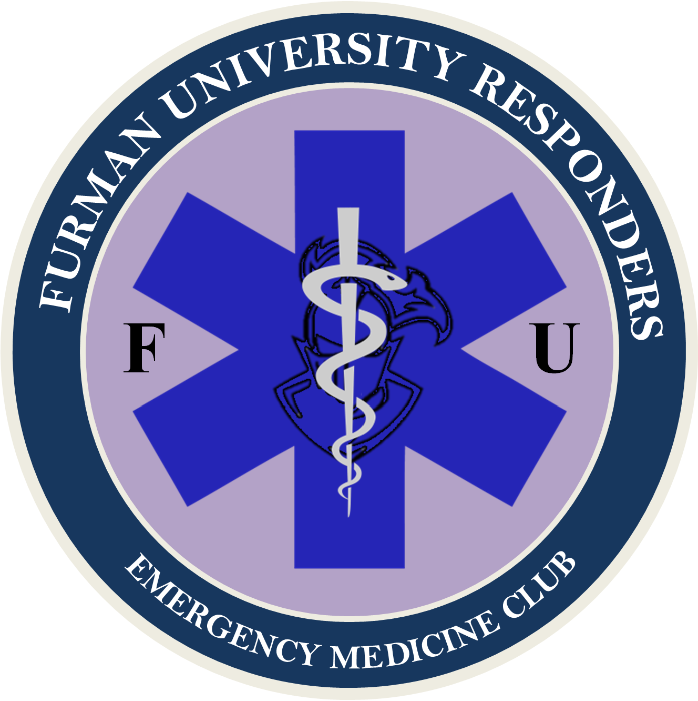

ARTICLE I: NAME & PURPOSE

Section A: Name – The name of this club shall be Furman University Responders.

Section B: Purpose – The purpose of this club shall be:
- To provide students interested in medicine a place to learn and explore the intricate procedures and precautions of Emergency Medicine.
- To provide First-Aid/CPR/AED and Emergency Medical Technician (EMT) training opportunities to all members of Furman University, allowing students to achieve hands-on medical experience and increase the number of First Responders on Furman's campus.
- Provide scholarships for First-Aid/CPR/AED and EMT classes to as many Furman students as possible.
- To provide Furman with qualified medical assistance, and student lead emergency medicine.
- To present leadership opportunities in the field of emergency medicine to students on Furman's campus.
- To connect students with like-minded individuals, in order to foster a shared interest and community of students at Furman.

ARTICLE II: MEMBERSHIP & DUES

Section A: Eligibility – Membership shall be open to all students at Furman University who express interest in medicine. Membership candidates should be in good standing with the university and campus police.

Section B: Dues – Dues will be $0 per year for all members. FUR should not charge fees for general club membership.

Section C: Membership Maintenance Requirements - No mandatory meeting will be required of members. Members are expected to contribute meaningfully to any events they attend, either through insight, helpfulness, or self-reflection in learning. Members are not to engage in malice, and are to be respectful of their fellow members and students during the conduction of club activities. Failure to do so is grounds for expulsion from Furman University Responders at the discretion of the Council.

Section D: Membership Benefits – Members of Furman University Responders will have access to free training opportunities, volunteer opportunities, and special events. While some club events may be open to the public, club members are the primary concern of the council, and the club shall operate in the best way to serve its members.

ARTICLE III: FUNDING STRATEGY

Section A: Primary Budget – A yearly budget should be applied for from the Student Government Association (SGA), outlining what costs we will likely incur, from what sources, and how much funding is needed. Funding should not be requested in excess of anticipated costs. The president and VP finance are responsible for creating a budget and applying for a budget through SGA. The council should provide input for budget plans.

Section B: Supplemental Funding – Lobbying SGA for additional funding should be performed as needed. Requests for additional money from SGA should be made only when necessary.

Section C: Training Cost – Furman University Responders will do its best to subsidize the cost of training for all members. If funding is not available, there may be a nominal fee for certain training courses or opportunities.

Section D: Speakers – All guest speakers should be volunteers, and should not require funding from FUR. In the event of hosting a speaker who requests payment, a special vote should be held by the council.

Section E: Fundraising – Furman University Responders will hold fundraisers as needed for supplemental funding. Fundraising is at the discretion of the current council. Fundraising should not be malicious.

Section F: Sponsorship – Furman University Responders should attempt to receive Sponsorship from private medical services in the Greenville area and abroad. This may include funds, training, equipment, or other useful items or services that private entities may offer. FUR should not compromise complete ownership over the organization for any sponsorships.

ARTICLE IV: OFFICERS

Section A: Council – The club's officers shall consist of a general council. The general council is responsible for planning and execution of club events and services. The council is to be comprised of an unspecified number of Councilmembers. The number of Councilmembers that will be selected in any given year is at the discretion of the election committee and the council. The only requirement is that the number of Councilmembers be an odd number, to ensure no tie voting. All general Councilmembers have the same level of authority.

Section B: Executive Committee - Within the council, an executive committee shall operate with additional roles to a general council member. The committee shall be comprised of Councilmembers. The committee shall consist of a President, Vice President (VP) Operations, VP Communications, VP Finance, VP Training, VP Public Relations, and a Medical Aid Team Captain.

Section C: Eligibility – Applies to all council positions: Councilmembers must be full-time students at Furman University. Councilmembers must have a reasonable interest in the pursuit of medicine. Councilmembers should be in good standing with campus administration and police. Councilmembers must be a Furman University Responders member. Applies to Executive Committee: Member must have served on the council in any capacity for at least one year prior to taking any position on the executive council.

Section D: Election of New Councilmembers – Election for vacant Council positions are to be conducted by the Election Committee. A typical Election Committee is comprised of the President, and two other Councilmembers. The two additional Councilmembers on the Election Committee can be any other member of Council, and are to be selected at random.

Section D-1: Candidate Application – The Election Committee is to create and distribute an application for the vacant position(s). This can be a new application, or a previously distributed application, as long as it is relevant and comprehensive in selecting qualified candidates. The application is to be distributed to all club members in an inclusive and well-advertised format, preferably using a diversity of distribution methods. At the ends of an established application period, applications are to be reviewed.

Section D-2: Candidate Nomination – The Election Committee nominates one candidate per open council position from the pool of potential candidates. In the event that no candidates are selected for a position, or all candidates are rejected by the Council upon voting, the position will remain vacant until which time a qualified candidate for the position is identified, and approved by the council.

Section D-3: Candidate Selection – The Council votes, by majority, to either select the nominated candidate for the position or reject them. A majority ‘yes’ vote establishes the candidate as a member of council in that position. A majority ‘no’ vote rejects the candidate, in which case the Election Committee must select a new candidate for that position; a new vote for that position must be held for the new candidate.

Section D-4: Special Election Committee – In the event the President’s position is to be filled, and the current president cannot participate in the selection of a successor due to either incapacitation or is otherwise no longer affiliated with the club, such as via voted removal or explusion from Furman, than a typical Election Committee cannot be established. In its place, all active Councilmembers will become a Special Election Committee, only for the selection of a new President. This special committee will operate under the same guidelines set forth for a typical Election Committee as stated in Article IV, Section D, Subsection D-1, D-2, and D-3. A Special Election Committee operates with all current members of council at the time of the selection.

Section E: Executive Council Election – Election of Councilmembers into an executive committee position is to be conducted upon vacancy of any position within the committee. An election will take place based on a majority vote by the entirety of the current council. Councilmembers who are interested in taking a position should submit a request to be on the ballot to the current club president, or VP Operations in the event the club president’s position is vacant. In the event of a tie vote, a runoff shall occur between only the tied Councilmembers. Candidates for any position should pitch to the entire council a general outline of why they believe they would be a good fit for the given position. A vote should take place within four weeks of a position becoming vacant, but no sooner than one week after initial campaigning.

Section F: Term – Councilmember terms are indefinite until one of the following occurs: a voluntary vacancy, graduation from Furman, a forfeiture of position as outlined in Bylaws, or a removal by vote of Council.

Section G: Vacancy – If a vacancy occurs in any position of council, an application process will be issued to club membership, as outlined in Article IV, Section D.

Section G-1: Extended Absence - An extended absence vacancy is said to occur in a position if a Councilmember is absent from meetings and duties greater than one semester without Council permission, or one year regardless of authorization, and the Councilmember is presumed to have forfeited their position. An election will then be held as normal for the vacant position.

Section G-2: Temporary Vacancy - If a vacancy occurs due to temporary leave of absence for any given amount of time less than one year (i.e. illness, vacation, study away, ect.), then the Councilmember may appoint a temporary acting Councilmember into their position. This may be another Councilmember, or a member of FUR, however, it cannot be a student who is not a member of FUR.

Section H: Removal of Officers – Any concerns members have with a Councilmember should be sent to the Club President or another Councilmember. The officer in concern will be notified of the complaint and will have 1 week to remedy any concerns. If any members are unsatisfied with an executive member, an officer can be removed from office at any time by a majority vote of Councilmembers. Members of Council may also call for this vote to be held.

ARTICLE V: DUTIES OF COUNCILMEMBERS

Section A: General Councilmember - Councilmembers are responsible for running Furman University Responders. It is the duty of Councilmembers to plan, facilitate, and execute events and services for club membership and the Furman community. It shall be the duty of Councilmembers to:
- Create ideas for events related to medicine; ensure they are as accessible as possible to student membership.
- Plan, facilitate, and execute events.
- Create and facilitate medically related services for the Furman community.
- Assist and support other Councilmembers in the facilitation of their events.
- Lobby for campus support where necessary.
- Promote the club and its ideals to the Furman community.

Section B: Executive Committee - Additional council duties of the executive committee by position.

Section B-1: President – it shall be the duty of the President to:
- Preside at Council meetings.
- Coordinate with appropriate entities to establish partnerships and connections.
- Represent the club in all Furman related events.
- Serve as an ex-officio member of all committees.
- Oversee club and its members as a whole in an administrative position.

Section B-2: VP Operations – It shall be the duty of the VP Operations to:
- Serve in the capacity of the President in his or her absence.
- Plan and create club procedures.
- Coordinate Councilmembers and ensure smooth operation of club affairs.
- Coordination club affairs with appropriate entities.

Section B-3: VP Communications – It shall be the duty of the VP Communications to:
- Schedule and plan regular club meetings.
- Keep a file of the club's records.
- Maintain a current roster of membership and skill level.
- Notify members and the public of training opportunities supported by the club.
- Notify any member of upcoming lapses in members’ certifications.
- Issue notices of meetings and conduct the general correspondence of the club.

Section B-4: VP Finance – It shall be the duty of the VP Finance to:
- Create club budgeting, and plan spending for year.
- Help source funding for club projects and events.
- Receive all funds and process Request for Payment, Deposit Slip, and Officer Signature Forms.
- Keep an itemized account of all receipts and expenditures and make reports as directed.
- Receive and manage all payments for the EMT Class and other Club activities (i.e., CPR Class or Suturing Workshop).

Section B-5: VP Training – It shall be the duty of the Training Liaison to:
- Communicate with potential training sources for club members, to include but not be limited to, EMT classes (outside campus facilities), stop the bleed courses, first aid courses, ect.
- The training lead will also be responsible for working with the Community Outreach Chair, for planning and facilitation of on campus training.
- Maintain and upkeep all necessary training equipment.
- Coordinate locations for conduction of training.
- Plan and organize relevant training.

Section B-6: Medical Aid Team Captain – It shall be the duty of the Medical Aid Team Captain to:
- Run the Medical Aid Team.
- Facilitation, planning, and execution of the First Aid Station at applicable campus events.
- Maintain approval with appropriate entities for operation of station.
- Recruit volunteers for team and maintain a high standard of care.

Section B-7: VP Public Relations – It shall be the duty of the Public Relations Chair to:
- Run the Furman University Responders Instagram page.
- Create advertisement fliers for club, and club events.
- Advertise events to club members and campus population via multifaceted media.
- Maintain a positive image of club to community.

ARTICLE VI: MEETINGS

Section A: Meetings – Council meetings shall be held on a bi-monthly basis, incorporating all members of the council. They should be held in a reliable location when possible. The president is responsible for presiding at and running meetings. Councilmembers should use meetings to plan events/services and event/service logistics. Additionally, meetings should be used to facilitate club structure, goals, and future vision.

Section B: Special Meetings – Special meetings may be called by any member of the Council, with sufficient reasoning. Reasons for calling a special meeting include but are not limited to: large event planning, executive committee meeting, elections committee meeting, MAT training or briefing, budget meeting, ect.

Section C: Quorum – A minimum of 2/3 the Council must be present. Councilmember attendance is mandatory for all meetings, except in reasonable circumstance.

Section C-1: Absence - In the event a Councilmember is absent from two or more meetings in a row, then a review must be held by the Council to either establish a Temporary Vacancy (as outlined in Article IV, Section E, Subsection E-2), or place the Councilmember on probation for grounds of a potential Extended Absence violation as outlined in Article IV, Section E, Subsection E-1.

ARTICLE VII: ADVISOR

Section A: Selection – there shall be a faculty/staff advisor who shall be selected and approved by a majority vote of the Council, at the beginning of each academic year.

Section B: Duties – The responsibilities of the faculty advisor shall be to:
- Maintain an awareness of the activities, events, and programs sponsored or run by the club.
- Meet on a regular basis with President to discuss upcoming meetings, long-range plans, goals, and problems of the club.
- Attend Council meetings as often as schedule allows. (Must attend a minimum of one Council meeting per semester)
- Assist in the orientation of new officers. Explain and clarify campus policy and procedures that apply to the club.
- Maintain contact with the Student Life Office.
- Assist the Council Officers when needed.

ARTICLE VIII: MEDICAL AID TEAM

Section A: Purpose - The goal of the Medical Aid Team (MAT) is to provide medical aid to students and members of the public on Furman’s campus. FUR-MAT aims to provide general first aid for low acuity injuries and provisional assistance for critical patients as a bridge before the arrival of higher levels of EMS care. MAT members are qualified Furman students, who have been trained in and meet specific requirements as set forth in this document. The Medical Aid Team is to act in supplement to or as a bridge for a higher level of professional medical care. The Medical Aid team is not a substitute for existing EMS. Should a higher level of medical aid become incapacitated or otherwise unavailable, the Medical Aid Team is expected to provide care to the extent of its capabilities to injured parties. The Medical Aid Team is expected to yield care to higher level providers when available.

Section B: Practical Application - The MAT is designed to provide medical aid to students and the general public within Furman’s campus. MAT will do so by operating a well-equipped and professionally run First Aid Station, ran by a vetted group of volunteers, who possess appropriate medical certifications through accredited training programs. MAT operates as a supplement in care for low acuity injuries, and assistance for high acuity injuries as outlined. MAT volunteers are all required to possess an in date medical certification from an accredited training program. The operation of MAT is conducted under oversight from Furman University Police (FUPD), and with the express consent of the university. The Medical Aid Team should not put themselves in any unnecessary danger, and is expected to follow the typical structure of EMS safety priorities: safety of self, then partner, then public, then patient.

Section C: Operating Procedures – For operating procedures and other information regarding the Medical Aid Team, please consult the Furman University Medical Aid Team Protocols.

ARTICLE IX: AMENDMENTS

Section A: Proposal - Proposal of additions, redactions, or changes of club bylaws may be called for by any member of Council. Suggestions from club members should be made to a member of Council. Once proposed, the proposed change will undergo a vote.

Section B: Vote and Implementation – These bylaws may be amended by a two-thirds majority vote of the Council. Quorum must be met in order to hold a vote. If the vote fails, the proposing Councilmember may either edit and resubmit their proposal, or redact it.

Section C: Notice – All members shall receive notice of the approved amendment at least 72 hours after implementation.

