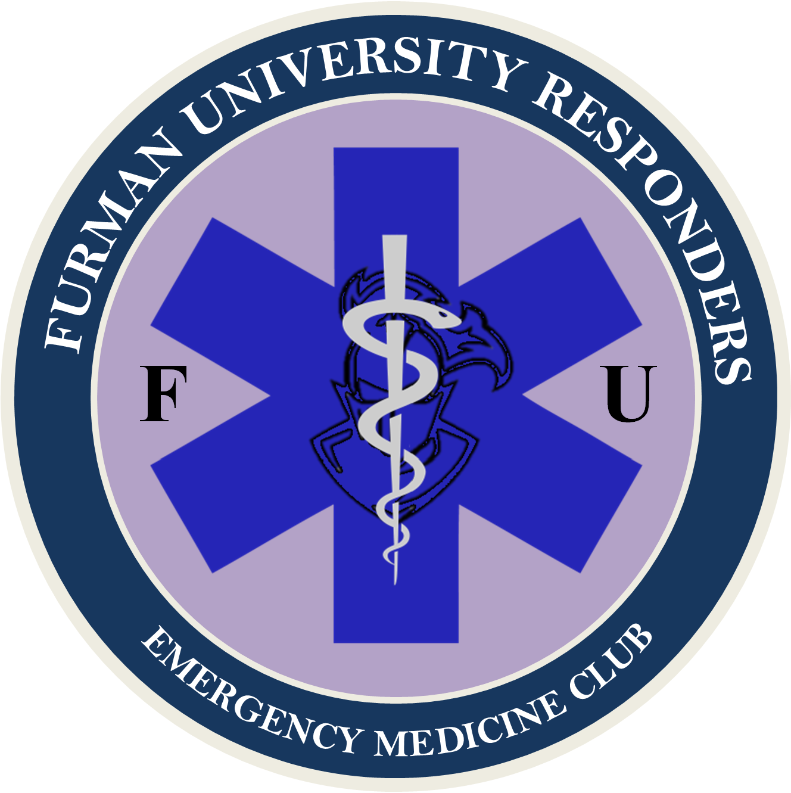

ARTICLE I: NAME & PURPOSE

Section A: Name – The name of this club shall be Furman University Responders.

Section B: Purpose – The purpose of this club shall be:
- To provide students interested in medicine a place to learn and explore the intricate procedures and precautions of Emergency Medicine.
- To provide First-Aid/CPR/AED and Emergency Medical Technician (EMT) training opportunities to all members of Furman University, allowing students to achieve hands-on medical experience and increase the number of First Responders on Furman's campus.
- Provide scholarships for First-Aid/CPR/AED and EMT classes to as many Furman students as possible.
- To provide Furman with qualified medical assistance, and student lead emergency medicine.
- To present leadership opportunities in the field of emergency medicine to students on Furman's campus.
- To connect students with like-minded individuals, in order to foster a shared interest and community of students at Furman.

ARTICLE II: MEMBERSHIP & DUES

Section A: Eligibility – Membership shall be open to all students at Furman University who express interest in emergency medicine.

Section B: Dues – Dues will be $0 per year for all members.

Section C: Membership Maintenance Requirements - No mandatory meeting will be required of members. Members are expected to contribute meaningfully to any events they attend, either through insight, helpfulness, or self-reflection in learning. Members are not to engage in malice, and are to be respectful of their fellow members and students during the conduction of club activities. Failure to do so is grounds for expulsion from Furman University Responders at the discretion of the Council.

ARTICLE III: FUNDING STRATEGY

Section A: SGA Funding Budget - Apply for a yearly budget from the SGA, outlining what costs we will likely incur, from what sources, and how much funding is needed. Lobby for additional funding as needed.

Section B: Training Cost – Furman University Responders will do its best to subsidize the cost of training for all members. If funding is not available, there may be a nominal fee for certain training courses or opportunities.

Section C: Speakers – All guest speakers should be volunteers.

Section D: Fundraising – Furman University Responders will hold fundraisers as needed for supplemental funding.

Section E: Sponsorship – Furman University Responders will also attempt to receive Sponsorship from private medical services in the Greenville area and abroad. Furman University Responders will also attempt to acquire training and other equipment through this avenue.

ARTICLE IV: OFFICERS

Section A: Council – The club officers shall consist of a President, Vice President (VP) Operations, VP Communications, VP Finance, Training Lead, Medical Aid Team Captain, FUPO Liaison, Public Relations Chair, and Community Outreach Chair. These positions make up the Council, and Furman University Responder club officers are Councilmembers.

Section B: Eligibility – Applies to all council positions: Councilmembers must be full-time students at Furman University. Councilmembers must have a reasonable interest in the pursuit of medicine. Councilmembers should be in good standing with campus administration and police. Councilmembers must be a Furman University Responders member. Applies to President's position: Must have served on the council in any capacity for at least one year prior to taking position as president.

Section C: Election of New Councilmembers – Election for vacant Council positions are to be conducted by the Election Committee. A typical Election Committee is comprised of the President, and two other Councilmembers. The two additional Councilmembers on the Election Committee can be any other member of Council, and are to be selected at random.

Section C-1: Candidate Application – The Election Committee is to create and distribute an application for the vacant position(s). This can be a new application, or a previously distributed application, as long as it is relevant and comprehensive in selecting qualified candidates. The application is to be distributed to all club members in an inclusive and well-advertised format, preferably using a diversity of distribution methods. At the ends of an established application period, applications are to be reviewed.

Section C-2: Candidate Nomination – The Election Committee nominates one candidate per open council position from the pool of potential candidates. In the event that no candidates are selected for a position, or all candidates are rejected by the Council upon voting, the position will remain vacant until which time a qualified candidate for the position is identified, and approved by the council.

Section C-3: Candidate Selection – The Council votes, by majority, to either select the nominated candidate for the position or reject them. A majority ‘yes’ vote establishes the candidate as a member of council in that position. A majority ‘no’ vote rejects the candidate, in which case the Election Committee must select a new candidate for that position; a new vote for that position must be held for the new candidate.

Section C-4: Special Election Committee – In the event the President’s position is to be filled, and the current president cannot participate in the selection of a successor due to either incapacitation or is otherwise no longer affiliated with the club, such as via voted removal or explusion from Furman, than a typical Election Committee cannot be established. In its place, all active Councilmembers will become a Special Election Committee, only for the selection of a new President. This special committee will operate under the same guidelines set forth for a typical Election Committee as stated in Article IV, Section C, Subsection C-1, C-2, and C-3. A Special Election Committee operates with all current members of council at the time of the selection.

Section D: Term – Councilmember terms are indefinite until one of the following occurs: a voluntary vacancy, graduation from Furman, a forfeiture of position as outlined in Bylaws, or a removal by vote of Council.

Section E: Vacancy – If a vacancy occurs in any position of council, an application process will be issued to club membership, as outlined in Article IV, Section C.

Section E-1: Extended Absence - An extended absence vacancy is said to occur in a position if a councilmember is absent from meetings and duties greater than one semester without Council permission, or one year regardless of authorization, and the Councilmember is presumed to have forfeited their position. An election will then be held as normal for the vacant position.

Section E-2: Temporary Vacancy - If a vacancy occurs due to temporary leave of absence for any given amount of time less than one year (i.e. illness, vacation, study away, ect.), then the councilmember may appoint a temporary acting councilmember into their position. This may be another councilmember, or a member of FUR, however, it cannot be a student who is not a member of FUR.

Section F: Removal of Officers – Any concerns members have with a Council member should be sent to the Club President or another Council member. The officer in concern will be notified of the complaint and will have 1 week to remedy any concerns. If any members are unsatisfied with an executive member, an officer can be removed from office at any time by a majority vote of councilmembers. Members of Council may also call for this vote to be held.

ARTICLE V: DUTIES OF COUNCILMEMBERS

Section A: President – it shall be the duty of the President to:
- Preside at Council meetings.
- Coordinate with appropriate entities to establish partnerships and connections.
- Represent the club in all Furman related events.
- Serve as an ex-officio member of all committees.
- Oversee club and its members as a whole in an administrative position.

Section B: VP Operations – It shall be the duty of the VP Operations to:
- Serve in the capacity of the President in his or her absence.
- Plan and create club procedures.
- Coordinate councilmembers and ensure smooth operation of club affairs.
- Coordination club affairs with appropriate entities.

Section C: VP Communications – It shall be the duty of the VP Communications to:
- Schedule and plan regular club meetings.
- Keep a file of the club's records.
- Maintain a current roster of membership and skill level.
- Notify members and the public of training opportunities supported by the club.
- Notify any member of upcoming lapses in members’ certifications.
- Issue notices of meetings and conduct the general correspondence of the club.

Section D: VP Finance – It shall be the duty of the VP Finance to:
- Create club budgeting, and plan spending for year.
- Help source funding for club projects and events.
- Receive all funds and process Request for Payment, Deposit Slip, and Officer Signature Forms.
- Keep an itemized account of all receipts and expenditures and make reports as directed.
- Receive and manage all payments for the EMT Class and other Club activities (i.e., CPR Class or Suturing Workshop).

Section E: Training Lead – It shall be the duty of the Training Liaison to:
- Communicate with potential training sources for club members, to include but not be limited to, EMT classes (outside campus facilities), stop the bleed courses, first aid courses, ect.
- The training lead will also be responsible for working with the Community Outreach Chair, for planning and facilitation of on campus training.
- Maintain and upkeep all necessary training equipment.
- Coordinate locations for conduction of training.

Section F: Medical Aid Team Captain – It shall be the duty of the Medical Aid Team Captain to:
- Run the Medical Aid Team.
- Facilitation, planning, and execution of the First Aid Station at applicable campus events.
- Maintain approval with appropriate entities for operation of station.
- Recruit volunteers for team and maintain a high standard of care.

Section G: FUPO Liaison – It shall be the duty of the FUPO Liaison to:
- Communicate with FUPO about on campus volunteering opportunities, authorization for events and training, and authorization for first aid volunteer work.
- Maintain rapport and authorization from FUPO.

Section H: Public Relations Chair – It shall be the duty of the Public Relations Chair to:
- Run the Furman University Responders Instagram page.
- Create advertisement fliers for club, and club events.
- Advertise events to club members and campus population via multifaceted media.
- Maintain a positive image of club to community.

Section I: Community Outreach Chair – It shall be the duty of the Community Outreach Chair to:
- Plan community events, coordinate speakers, and coordinate training courses.
- Responsible for the planning and logistics for club events.
- Recruit past alumni and other potential guest speakers.
- Lobby alumni and their organizations for sponsorship.

ARTICLE VI: MEETINGS

Section A: Meetings – Council meetings shall be held on a bi-monthly basis, incorporating all members of the council.

Section B: Special Meetings – Special meetings may be called by any member of the Council, with sufficient reasoning.

Section C: Quorum – A minimum of 2/3 the Council must be present. Councilmember attendance is mandatory for all meetings, except in reasonable circumstance.

Section C-1: Absence - In the event a Councilmember is absent from two or more meetings in a row, then a review must be held by the Council to either establish a Temporary Vacancy (as outlined in Article IV, Section E, Subsection E-2), or place the Councilmember on probation for grounds of a potential Extended Absence violation as outlined in Article IV, Section E, Subsection E-1.

ARTICLE VII: ADVISOR

Section A: Selection – there shall be a faculty/staff advisor who shall be selected and approved by a majority vote of the Council, at the beginning of each academic year.

Section B: Duties – The responsibilities of the faculty advisor shall be to:
- Maintain an awareness of the activities, events, and programs sponsored or run by the club.
- Meet on a regular basis with President to discuss upcoming meetings, long-range plans, goals, and problems of the club.
- Attend Council meetings as often as schedule allows. (Must attend a minimum of one Council meeting per semester)
- Assist in the orientation of new officers. Explain and clarify campus policy and procedures that apply to the club.
- Maintain contact with the Student Life Office.
- Assist the Council Officers when needed.

ARTICLE VIII: AMENDMENTS

Section A: Proposal - Proposal of additions, redactions, or changes of club bylaws may be called for by any member of Council. Suggestions from club members should be made to a member of Council. Once proposed, the proposed change will undergo a vote.

Section B: Vote and Implementation – These bylaws may be amended by a two-thirds majority vote of the Executive and Programming Council. If the vote fails, the proposing Council Officer may either edit and resubmit their proposal, or redact it.

Section C: Notice – All members shall receive notice of the approved amendment at least 72 hours after implementation.

