Alpha Delta Pi Chapter Standing Rules
STANDING RULES OF THE ETA PHI CHAPTER OF ALPHA DELTA PI ATTENDANCE AND PARTICIPATION
Section 1: PARTICIPATION: Only Alpha and Delta members enrolled at the Furman University, chapter advisors, and special invited guests may attend chapter meetings and activities. If a sister cancels her membership with Alpha Delta Pi, she will not be an eligible guest for any future Chapter event.

Section 2: REQUIRED ATTENDANCE: All members must attend weekly chapter meeting, Spirit Week workshops, pre-recruitment workshops, formal recruitment week, COR/informal recruitment activities, Bid Day, ritual, and Founders Day (if applicable) activities as well as other events designated on the Master Calendar. Vacations are not considered an excuse for formal recruitment (including Spirit Day). Medical reasons or other extenuating circumstances will be discussed with the Executive Board and approved on a case by case basis. Furthermore, if a member has an unexcused absence from any days of formal recruitment (including Spirit Day), she will not be allowed to attend Bid Day festivities.

Section 3: EXCUSED ABSENCE: A member who is unable to attend meetings/events must submit a google form on the excuse request form to the VP of Member Development 2 day(s) prior to the missed meeting/event. The VP of Member Development will review the excuses with the Standards Council, if necessary. The VP of Member Development will advise the member if she will be excused. Acceptable excuses for missing events are:
1. Illness (Doctor’s note required if habitual or for an event with
associated fines) (unplanned appointment)
2. Death in the family or other family emergency
3. Religious observance
4. Scheduled class conflict (excluding Formal Recruitment and
Spirit Day)
5. Graduate examinations (excluding Formal Recruitment and
Spirit Day)
6. Participation in pre-scheduled University sports/clubs,
excluding intramurals
7. Work (excluding Formal Recruitment and Initiation Day).
Section 4: OFFICER ATTENDANCE: Officers are required to attend the applicable team/board meetings as outlined in their officer duties and responsibilities – this includes Leadership Transition Workshop following slating.
Panhellenic or Inter-Sorority Council (ISC) representatives are required to attend all designated Panhellenic/ISC meetings.
Section 5: FINES: The following fines will be assessed for unexcused absences per Semester.
EVENT | FINE
Initiation  - Tardy or unprepared is showing up with nail polish, makeup, automatic absence | $125
Roll call fine for events | 50% of the fine
Chapter Retreat | $50
If you max out unexcused absences form chapter + standards meeting | $50
Spirit Week unexcused absence per day | $50
Formal Recruitment round and Bid Day unexcused absence per day | $300
Late Fee for Chapter Dues Effective Part 1 of Financial Delinquency | $150
Unexcused absence from Alpha Ceremony or Black Diamond Ceremony | $50
Unexcused absence from Leadership Transition Workshop | $50
Late Fee for Recruitment Excuses (by days) | -----------------------------
If you submit excuse after 90 days until recruitment | $50
If you submit excuse after 60 days until recruitment | $100
If you submit excuse after 30 days until recruitment | $150

Section 6: PARTICIPATION/POINT SYSTEM: These items will serve as the Chapter Engagement Checklist. This checklist will determine a member’s standing with the chapter and her eligibility to attend the chapter’s social events.
In order to attend the formal/semi-formal each semester, a sister must show dedication to the improvement of herself, her chapter, and her local
community through the following areas:
1) Chapter Business Meeting Attendance:
- A sister must have an acceptable chapter attendance record (no
more than 2 unexcused absences).
- Unexcused absences are counted from the last formal social event
(Semi-formal in the fall, Formal in the spring)
- All meetings involving ritual (MSS, Diamond Days) are included as
chapter meetings and are exempt.
2) Philanthropy:
- A sister must participate in the chapter’s philanthropy event
(Alpha Delta Pizza in the Fall, Pi a Pie in the Spring, and Relay for Life in
the Spring)
- A sister must choose one external philanthropy to attend
1.) This must be an “approved” event that is advertised in
chapter, such as another Greek organization’s philanthropy,
an event promoted by Panhellenic, etc.
2.) Sister must provide photographical evidence of her
attendance to the Director of Philanthropy.
3.) A sister must attend the major campus philanthropy
event that semester (Dance Marathon in the Spring)
3) Academic Discipline
- A sister must hold the required chapter GPA minimum for the semester.
- If a sister failed to meet this GPA, she has been diligently attending
the required study hall hours.
A sister must document her study hours through the google form.
4) Chapter Leadership & Involvement
- A sister must hold an officer position or serve within a chapter
committee and participate in TWO chapter intramural games
(watching the game only counts if there are enough members to play
the game)
- A sister must be involved in an organization or philanthropy
outside of Alpha Delta Pi (either on or off campus)
1. Examples include: being an active member of an
on-campus organization such as SAC/RLC/FUSAB/Heller,
volunteering regularly at an off-campus cause, working at a
part-time job (must be truly part time, babysitting occasionally does not count).
5) Informal Recruitment
- To assist in determining Diamond Sister priority the VP of Marketing and Director of Primary Recruitment will monitor and track newly initiated Delta’s informal recruitment dates with PNMs.
6) Recruitment Workshops
- Newly initiated Deltas must attend all Recruitment Workshops. Attendance to these workshops results in diamond sister priority. - Members, excluding new deltas may not miss more than 2 recruitment workshops .

If a member feels that she will have special circumstances that semester which warrant the reduction of these requirements, she should contact the VP of Member Development to schedule a standards meeting to discuss her individual situation.
7) Point System
- Members should earn 1 point per category and 8 points total as a ticket to enter our Black Diamond Formal (seniors min. 6 points), but try to earn as many points as you can! Remember you can redeem your points during the ADPi Auction at the end of this semester!
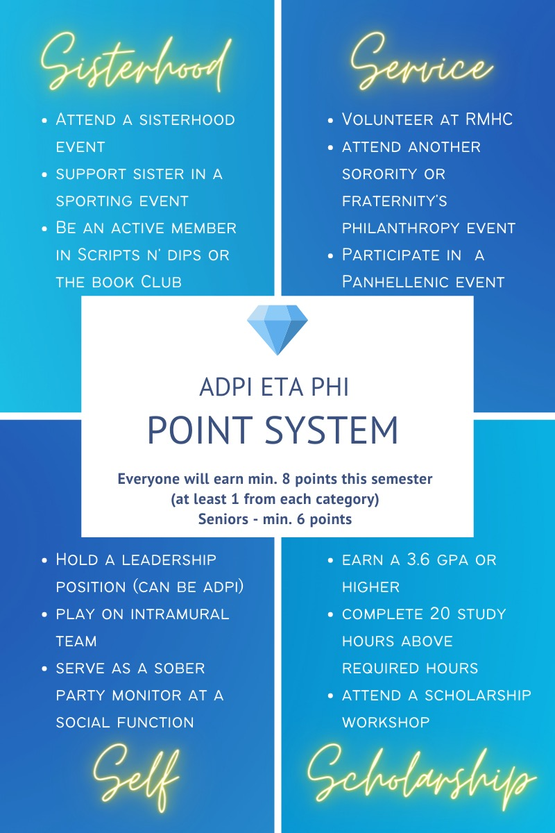
FINANCIAL STANDING RULES
Section 1: DUES AND OTHER FEES: Member dues and other fees will be announced at the first meeting after the chapter budget has been
approved. Alpha member dues will be announced at the first Alpha member class meeting. Alpha and Delta member dues must be equal in amount.
Section 2: DUES FOR MEMBER TEMPORARILY OFF CAMPUS: Any member who temporarily leaves campus for study abroad, internship, student teaching, virtual student, or undergraduate/graduate programs shall pay chapter the yearly delta member fee of $129.00 to Executive Office if abroad in the Fall and there is no fee if abroad in the Spring for the semester/term she is not on campus plus any additional dues or fees that the chapter pays on behalf of the member.
Section 3: INVOICE: Each Alpha and Delta member will be issued a dated invoice via the approved Sorority accounting system.
Section 4: DUE DATE: Invoices are due 5 days after the invoice date.
Section 5: PAYMENT METHOD: Invoices must be paid by credit card, debit card, e-check, personal check, cashier’s check or money order and submitted directly to the approved Sorority accounting system. Alpha Delta Pi will not accept cash for payment.
Section 6: FINES: Fines will be levied as the chapter’s Standing Rules dictate. Fines will be added and invoiced via the next monthly invoice sent to the member via the Sorority accounting system. A member whose fine remains unpaid after 5 days is considered delinquent.
Section 7: MEMBERSHIP CANCELLATION: Voluntary membership cancellation or involuntary membership cancellation does not excuse the member/Alpha member from debts incurred during membership/Alpha membership. Dues will continue to accrue according to the dues and fees levied until a
member/Alpha member cancellation has been granted. If notice of
cancellation is before the payment due date, then the member will not be required to pay. If the member is on the payment plan and the first
rounds of dues have already been completed, then the remaining
balance must be paid in full.
Section 8: MOVING OUT OF ALPHA DELTA PI HOUSING: An Alpha or Delta member moving out of Alpha Delta Pi housing is not excused from past or future debts in connection with her signed room contract nor dues and fees owed to the chapter.
Section 9: DAMAGE FINES: In the event that damage to any property occurs as a result of any Alpha or Delta member action during an event, it will result in a fee billed to said member via Omega Fi. The fees must be paid within 30 days of the event.
HOUSING STANDING RULES
Section 1: HOUSING POLICIES: The designated “ADPi Hall” in Furman University’s Lakeside Housing is owned by Furman University. Members living on the hall must follow Furman University Housing and Residence Life’s rules and policies.
Section 2: LOCKS/SECURITY SYSTEM: All Alpha Delta Pi housing must be locked 24 hours a day. A security alarm system, if applicable, must be in the armed mode 24 hours a day.
Section 3: PETS AND WEAPONS: There shall be no pets in Alpha Delta Pi housing unless approved by Furman University Housing and Residence Life. There shall be no weapons (guns, knives, etc.) in Alpha Delta Pi housing.
Section 4: ALCOHOL AND ILLEGAL SUBSTANCES: No alcohol or non-prescription, non-over the counter substances are permitted on chapter property.
Section 5: VISITATION: In Alpha Delta Pi chapter housing, guests are only allowed in private areas for maintenance, repair or transport/haulage or for
special celebrations such as Parents’ Weekend or Alumnae Reunions.
Section 6: LIVE-IN/LIVE OUT REQUIREMENTS: The chapter’s housing facility must be filled at all times before members are allowed to live out. The order for granting is as follows: N/A
Section 7: ROOMMATE CHOICE: Roommates will be selected mid-way through second semester
Section 8: ROOM ASSIGNMENTS: Room assignments shall be made as follows: Rooms will be assigned by a lottery system after each member has chosen her roommate. Each roommate pair will draw a number from a basket, and in numerical order, each pair will select a room on the hall in which they choose to live.
Section 9: CLEAN/ORDERLY HOUSING FACILITY: Alpha and Delta members are required to maintain the clean and orderly appearance of the chapter facility.
Section 10: NOISE: A quiet atmosphere will be maintained in the chapter facility from the hours of 10pm to 10am During finals week, quiet hours will be
enforced 24 hours a day.
Section 11: PERSONAL PROPERTY: Individual rooms should be locked to ensure privacy and security of personal belongings.
Section 12: SMOKING: In order to promote a safe, healthy and gracious environment, smoking shall not be permitted in any chapter facility.
Section 13: EATING AREAS: Eating and drinking will be allowed in the following areas of the chapter housing facility: All areas of the ADPi hall.
Section 14: ROOM DEPOSIT: A member must clean her room prior to moving out of the house. If the room is left in poor condition, the member will lose a portion or all of her house deposit as decided jointly by the House
Director and the House Corporation officer who conducts the final
inspection.
Section 15: MEALS: N/A
Section 16: OVERNIGHT GUESTS: Alpha Delta Pi residential facilities are for member use. Overnight guests are for special events only and not for regular or multiple use by the same guest. Therefore, overnight guests are discouraged. To host an overnight guest, the member must have permission from her roommate, and follow Furman University’s rules regarding overnight guests. Failure to inform and/or seek necessary permission will result in a Standards Council Meeting.
Section 17: INTIMATE CONTACT: As a residential environment aimed at supporting the academic mission of the host institution, the chapter facility should not be a location for physical intimacy or sexual relations among
members and/or guests. Inappropriate behavior will result in a Standards Council Meeting.
SCHOLARSHIP STANDING RULES
Section 1: OFFICIAL GRADE TRANSCRIPT: The Director of Academic Affairs will review the transcript of all members each semester to determine a sister’s academic standing.
Section 2: DIAMOND SISTER REQUIREMENT: A member must maintain a cumulative grade point average of 2.80 in order to be a Diamond Sister. Should there be more Delta members wanting to take Diamond Sisters than Alpha members, then priority shall be given based on cumulative
GPA, chapter involvement, informal recruitment involvement, funshop meetings and formal recruitment attendance.
Section 3: ALPHA MEMBER SCHOLARSHIP REQUIREMENTS: The pledging requirement for this chapter shall be as follows: (based on chapter membership selection goals)
· A 2.60 GPA for incoming freshmen
· A 2.60 GPA for those women with established college grades
(both cumulative and prior term)
· A 2.50 GPA for women participating in Continuous Open
Recruitment
(Note: Minimum may be higher.)

Section 4: ALPHA AND DELTA MEMBER STUDY PROGRAM: All Alpha and Delta members must follow the study program developed by the Scholarship Chair and approved by the chapter. Members with a semester GPA below a 3.0 are required to attend study hall hours as set by the Director of Academic Affairs r and Scholarship Committee.
Section 5: CHAPTER OFFICER SCHOLARSHIP REQUIREMENTS: All chapter officers serving on the Executive Committee must have a semester GPA of 2.80. All other officers must have a semester GPA of 2.6. If an officer falls below these requirements after she is elected, the chapter’s Executive Board will vote to determine whether she may stay in her current leadership position.
Date of Approval by Collegiate Province Director: April 8, 2020 Date of Approval by Chapter: April 10, 2020

