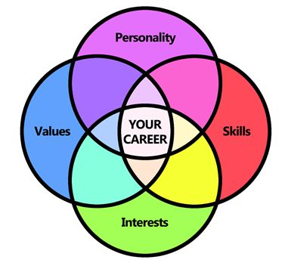
Pulling the Pieces Together!

Record your results from each section of the Focus 2 in each appropriate circle. After combining your assessments results, research and narrow some potential careers that match your combined results, record them in the center. These careers could be a potential good fit for you and worth exploring further!

