MALONE CENTER FOR CAREER ENGAGEMENT
  - GUIDE TO INTERVIEW ATTIRE

INTERVIEW ATTIRE

In the same way that you want a perfectly tailored resume when applying for a job, you should also consider your overall appearance and presentation when meeting employers for the first time. A professional, individualized outfit signals maturity, reliability, and sophistication. Follow these guidelines to make the best impression:

Wear a suit with pants or a skirt. Coordinate your outfit in classic, neutral colors like black, gray, or navy:

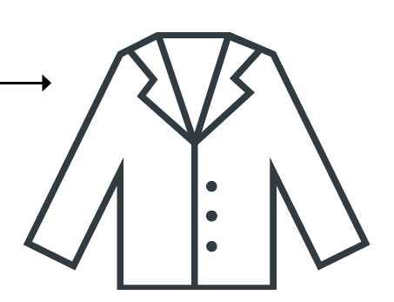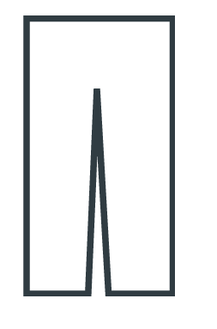

Wear a shirt/blouse that contrasts your blazer or coat:
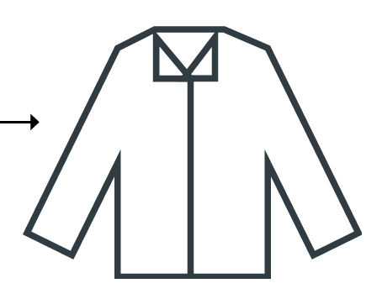

Choose accessories that enhance your outfit but are not distracting:


When selecting shoes, choose comfortable, closed-toe, and classic. Try to match your shoes to your belt:
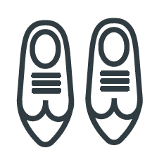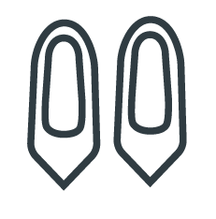

If wearing a dress, try to wear a sheath dress that covers your shoulders and reaches your knees. If it doesn’t cover, wear a blazer or cardigan:
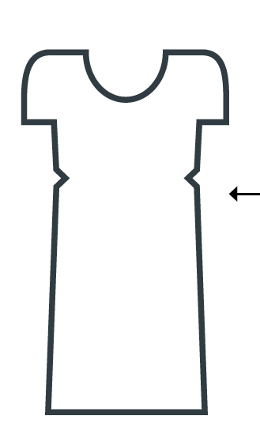

Bring a padfolio with several printed copies of your resume and supporting documents:


