Minutes of the
Furman University Student Government Association
48th Council
.
5th Meeting
15 October 2018
Trone Student Center, 208A (Thomas Room)

Call to Order:
The meeting was called to order by President Will Sanders at 6:00 PM.

Roll Call:
President Will Sanders took attendance and determined quorum was present. Twenty-one (21) of twenty (24) voting members were present. Absences:
Approval of Minutes:
Move to approve meeting minutes from September 10th. Motion seconded; motion carried.

Special Guests:
Neil Jamerson, Student Life, Involvement and Inclusion
- Regarding recent incidents: ongoing investigations involving two organizations
- Social activities have stopped for those two organizations until investigations have stopped
- All parties have been very cooperative
- Contact Neil Jamerson with any questions or concerns
- If organizations do not accept their sanctions, they will proceed with a full hearing
Melissa Nichols, Title IX Coordinator
- Included in Sexual Misconduct Policy:
  - Sexual harassment
  - Gender-based harassment
    - New definition added this year
  - Sexual intimidation
  - Sexual exploitation
  - Non-consensual sexual contact
  - Non-consensual sexual penetration
  - Intimate partner violence
  - Stalking
- Changes to policy this year:
  - Academic freedom statement
  - Role of faculty in process
  - Sexual harassment definition
  - Language clarifying organizations are not authorized to investigate or resolve sexual misconduct complaints
  - Timeframes
  - Use of outside investigators along with Furman investigators to expedite investigations
  - Informal resolution

Officer Reports:
Will Sanders, Executive President
  - Thanks to Sarah and Scott for a great tailgate!
  - FU won the bet against Wofford SGA!
  - FU Board of Trustees will discuss Task Force suggestions at meetings next week
  - Met with Chief Milby: working on getting GPS put in trolley and golf carts to put in LiveSafe so locations can be tracked
  - Class Presidents now on Furman Parking Committee
  - Active Shooting and Title IX Don’t Be a Victim training
  - Potential changes to SafeRide route
Scott Finney, Vice President
- Thanks to Sarah for help on SGA tailgate!
- New org app is closed for this semester
Prem Chockalingam, Executive Treasurer
  - New money requests in Old Business
Caroline Tucker, Secretary
  - Secretaries meet after
Connor Dial, Parliamentarian
  - If interested in starting a new committee, come see exec first

Representative Reports:
Sarah Bourlakas, FUSAB Rep.
- HAVOC & Homecoming schedule this week:
- 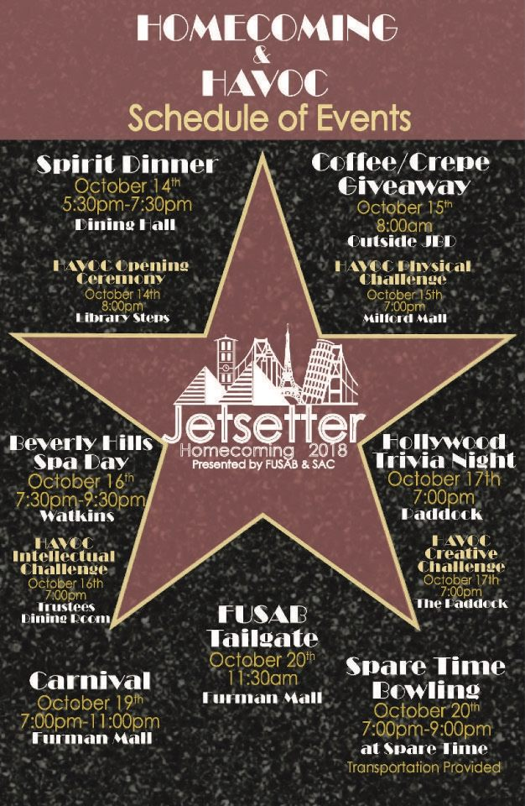
Hayden Braun, RLC Rep.
- Thursday night Homecoming pomping: RLC providing hot cider and donuts
Payton Isner, Religious Council Rep.
  - Oct. 16th 6:30pm in Daniel Chapel EVM CLP: Good Sex: Living Our Faith
  - Oct. 25th 7pm in Watkins Room BCM, MCF, Wesley Fellowship CLP pending: QUnion
  - Nov. 1st 7:30pm in Daniel Chapel EVM CLP: Hot, Healthy Sex in the Age of #MeToo
  - Islam Awareness Week:
  - 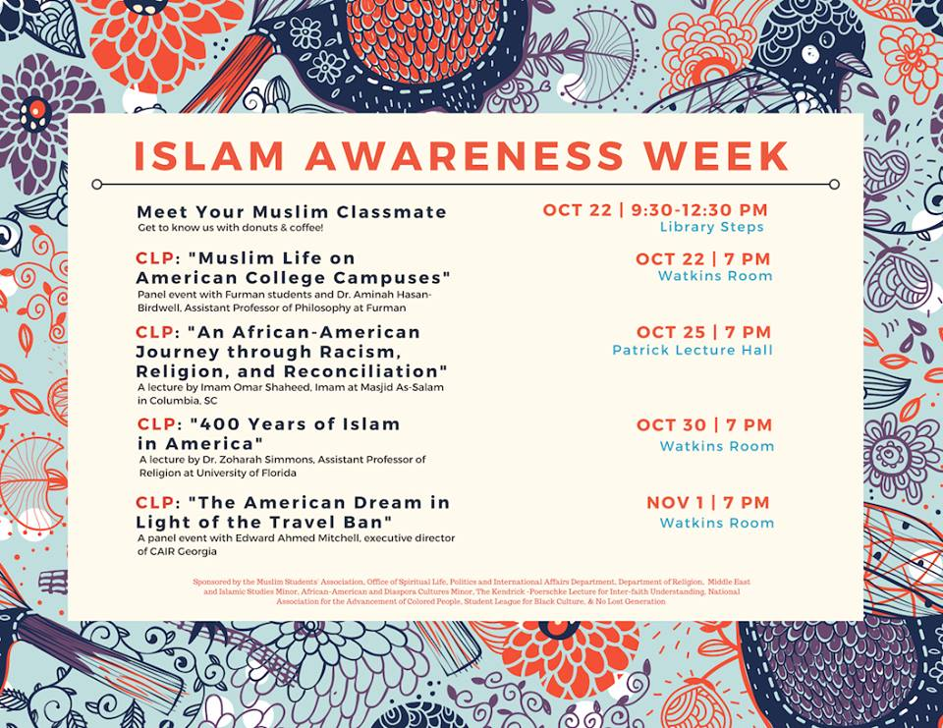
Chase Shaner, Campus Recreation Rep.
  - Send Campus Rec any photos from your clubs/intermural sports teams
Muhammad Zakaria Shafqut, Student Diversity Council.
  - Oct. 22 Chinese Student Association CLP: Movie showing, Monkey King 2
  - Oct. 25th 4-5pm in Haynsworth Room: SDC Open Forum on racism, microaggression, and misconceptions
  - Nov. 8th 7pm in Hartness Pavilion: We Are Furman panel as part of International Education Week
  - Homecoming game tailgate at 11:30 with BBQ

Non Voting Representative Reports:

Panhellenic Representatives
  - None
Ryan Smith, IFC Representative
  - None
Payton Isner, Housing and Residence Life
  - None
Avery Armstrong, Athletics
  - None

Class Reports:
Mary Morrow, Senior Class President
  - Senior Class Reps officially chosen to help with Senior Class Gift
Brooke O’Neill, Junior Class President
  - looking to do something in front of library soon
Sophia Groves , Sophomore Class President
  - looking into getting printers in Judson
Sarah Mobley , Freshman Class President
  - No report

Ad Hoc Committees:
- Vitality Committee:
  - Great tailgate Saturday!
  - Meals on Wheels looking for 16 volunteers for race event on Oct. 27th 8-1pm; email Sarah Mobley at sarah.mobley@furman.edu if interested in passing out water
- Service Committee:
  - Heller Fall Fest looking for volunteers for Oct. 27th, need as many people as possible; contact Morgan Fretwell
- Bylaw Committee:
  - Need 2 more members
Old Business:
- Approval of Furman Photographers, carried
- New Budget Request from Furman Conservative Society approved for $1,000
New Business:
- Introduce budget request for Furman Pre-Dental Club, tabled to discuss among Finance Committee

Open Forum & Announcements:
- Be on the lookout for other speakers to speak at Council
Adjournment:
The meeting was adjourned by President Will Sanders at 7:40 PM.

