Minutes of the
Furman University Student Government Association
48th Council
.
5th Meeting
22 October 2018
Trone Student Center, 208A (Thomas Room)

Call to Order:
The meeting was called to order by President Will Sanders at 6:00 PM.

Roll Call:
President Will Sanders took attendance and determined quorum was present. Twenty (20) of twenty (24) voting members were present. Absences: Mary Morrow, Max Dudley, Campus Rec., SDC
Approval of Minutes:
Move to approve meeting minutes from October 15, 2018. Motion seconded; motion carried.

Special Guests:
Jason Cassidy, Dean of Students
- Communication about Health Center will be sent out soon
- Students can have their prescriptions sent to Furman from any upstate health clinic using online portal; will be further explained in cohesive report sent to students
- Another flu shot session will happen soon
Teddi Walker, Housing and Residence Life
- Student staff selection coming up: FRADs and RAs
  - RAs are peer leaders who can assist with any issues and policy enforcement in all of campus housing
  - FRADs offer academic support in freshman halls
  - Mandatory info sessions
  - Email Teddi.Walker@furman.edu with questions and for more information

Officer Reports:
Will Sanders, Executive President
  - Thursday-Saturday: Board of Trustees meetings; will discuss Task Force and come up with a plan to be presented on Wednesday; read the report
  - FUPO training on Oct. 23rd from 6-7pm in Burgiss
  - Shuttle route ideas should be sent to Will
  - Take the Gallup survey
Scott Finney, Vice President
- Met with Ron Thompson from Housing:
  - RLC working as a liaison between Housing and students
  - Send Ron all feedback and comments; email housingadnresidencelife@furman.edu and/or ron.thompson@furman.edu
  - Looking at starting a new system where Facility Services can schedule a window of time to take care of any maintenance requests you have
  - No ice machines can be added to housing because of sanitation and cleanliness concerns
  - Adding printers is an ITS concern that will be raised to them soon
  - North Village renovations beginning to be discussed
Prem Chockalingam, Executive Treasurer
  - Finance Committee meet after Council
Caroline Tucker, Secretary
  - Message from Judy Bagley from SOAR for organizations that put on events:
- Put body of text in MyFurman announcements and not just in an image
- Consider food allergies at events (nuts, gluten, etc.)
- Think about accessibility when planning event venues for those with walkers or wheelchairs
- Accept a “no” when offering help
- Send photos for SGA social media
Connor Dial, Parliamentarian
  - Say “point of information” if you have a question during Council and it needs to be in the form of a question

Representative Reports:
Sarah Bourlakas, FUSAB Rep.
- "Want to win $300 while laughing your butt off? FUSAB is hosting a Campus Feud Gameshow on November 8th at 7pm in Watkins. Campus Feud is a version of the Classic TV game show, Family Feud. FOUR predetermined teams consisting of five contestants come up on stage and answer questions that are actual survey questions that were asked of current college students. Basically students get to watch family feud of their classmates and it's hilarious.

People who are interested in being one of the chosen teams have two options to apply:
1. Groups of 5 people can apply to be one of the chosen teams by posting on social media with caption and a picture/video of why they deserve to be one of the selected teams. Tag FUSAB and use the specific hashtag #FUSABCAMPUSFEUD

2. You can apply via SyncDin under FUSAB's page. Winning team gets a prize of $300 for 1st place, $150 for 2nd. If you have stage fright, don't fret you can come watch and be apart of the audience!"
- Halloweek:
- 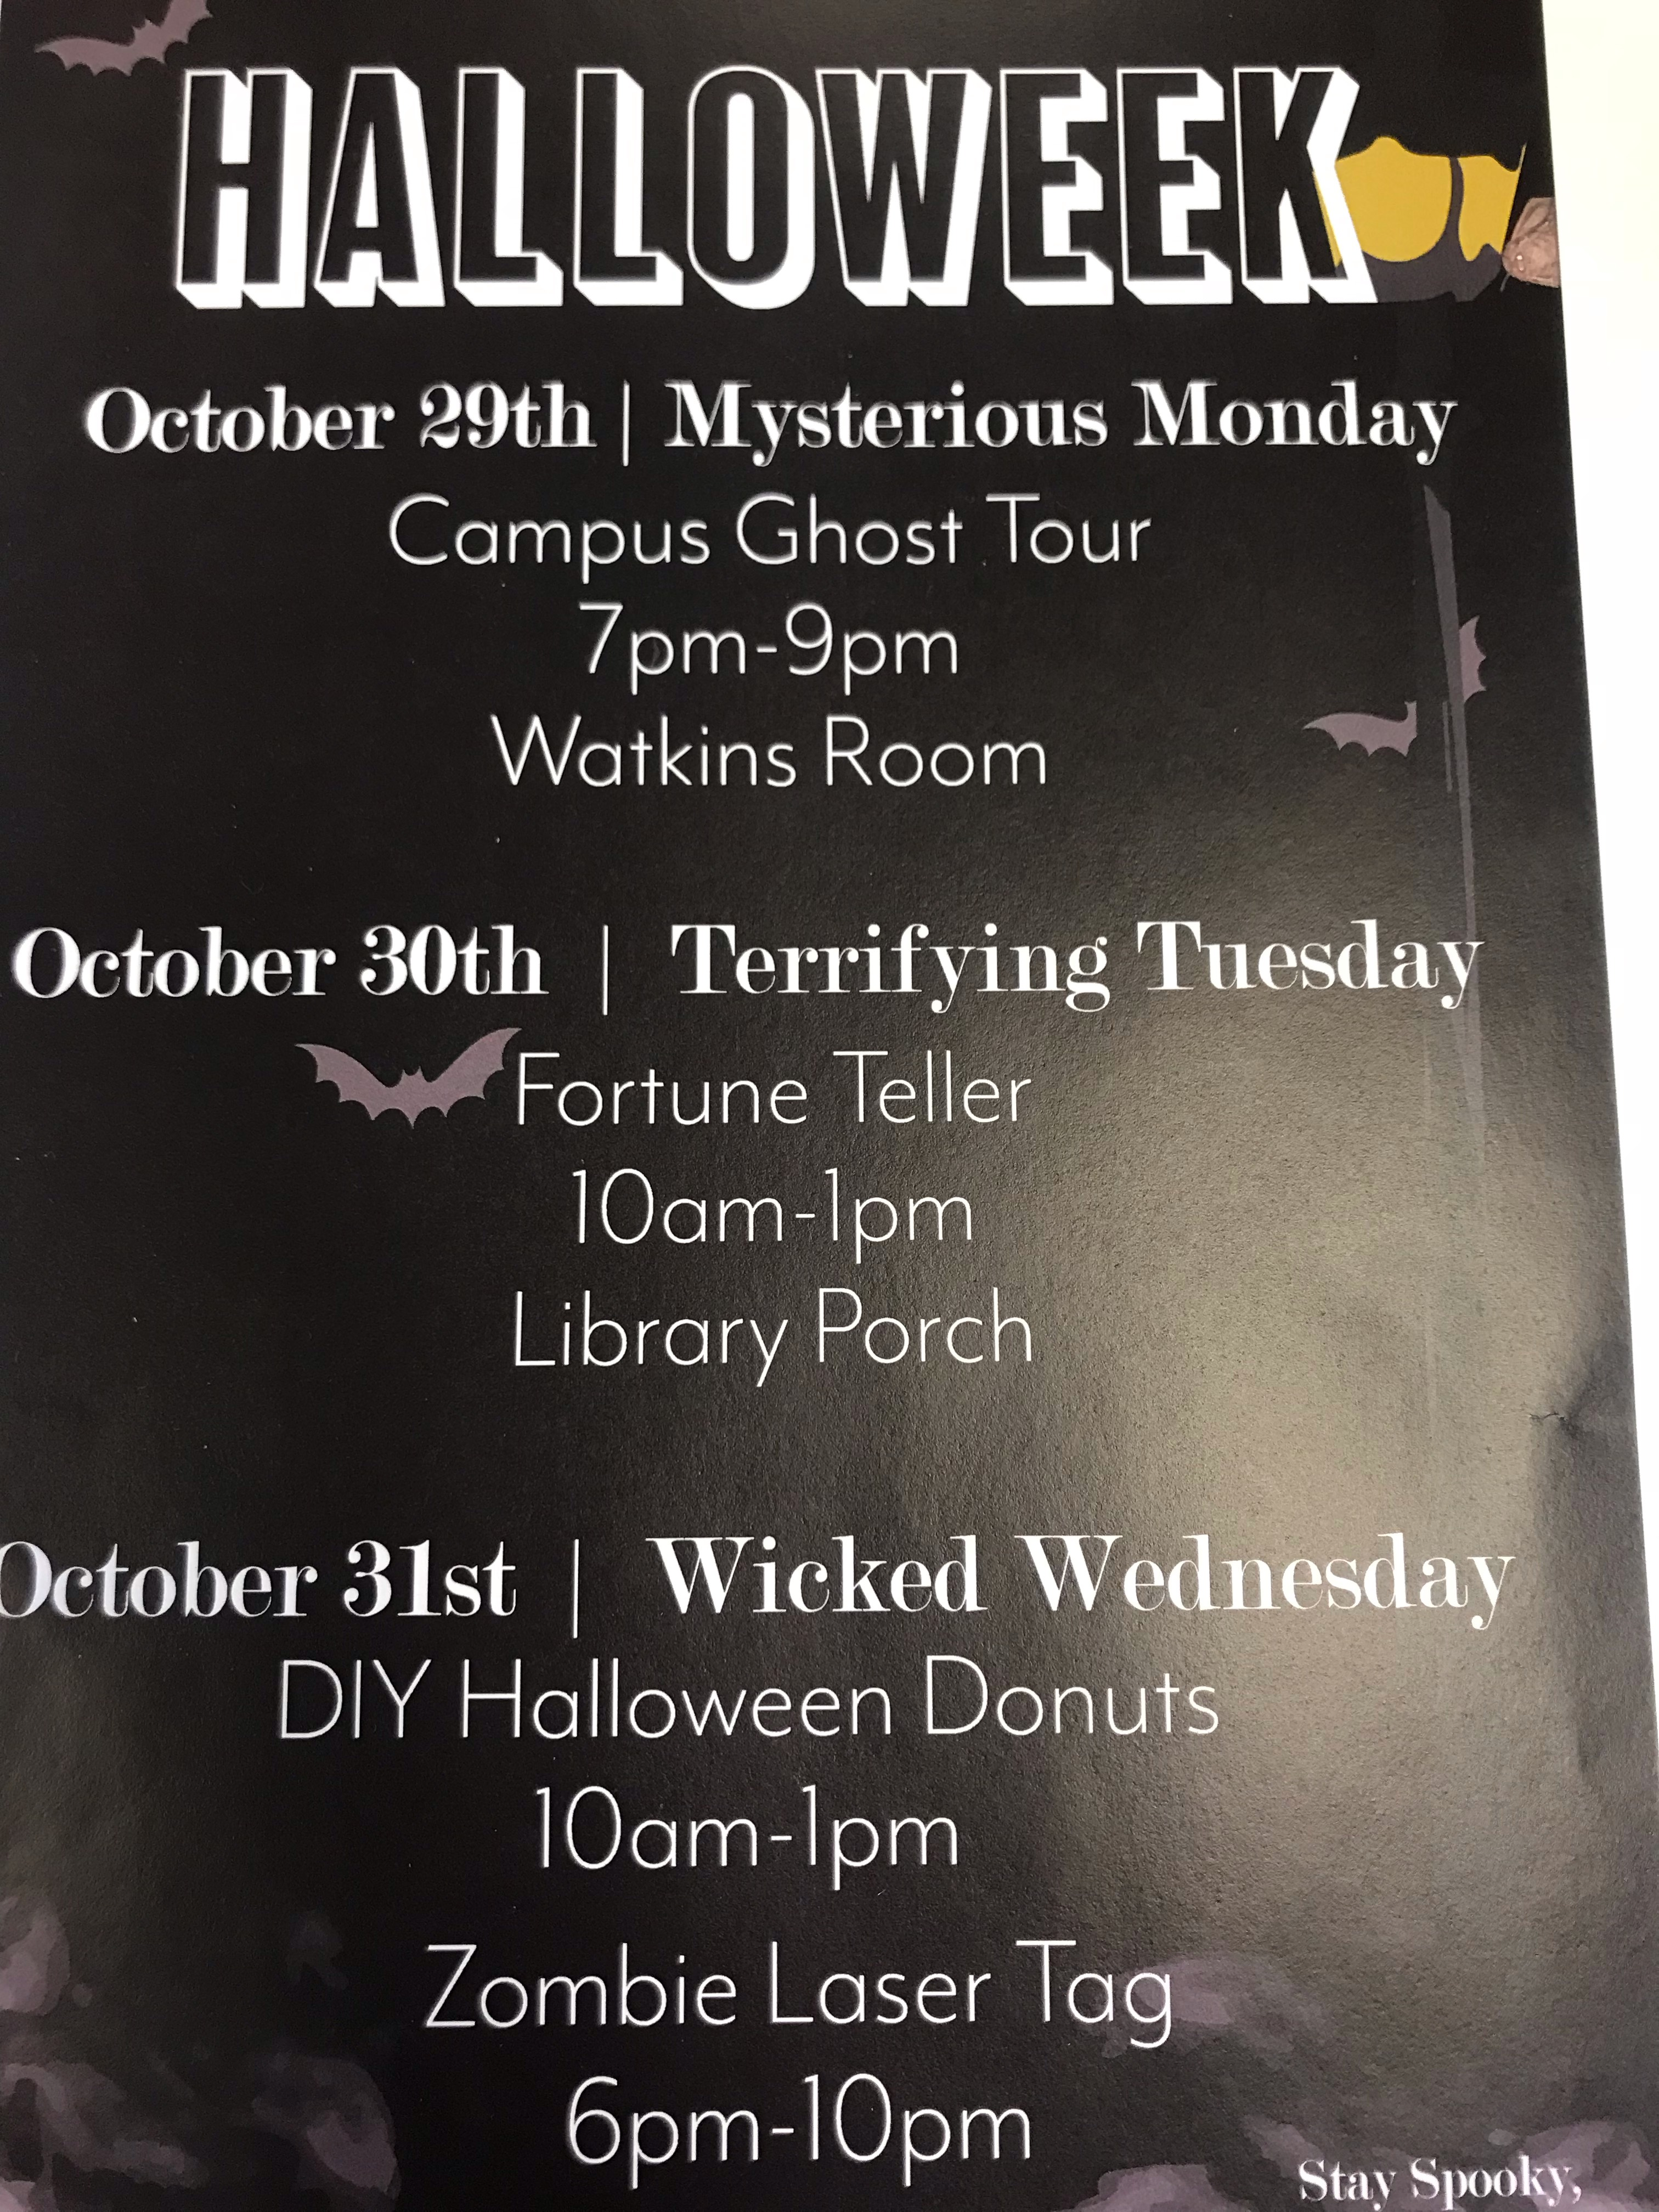
Hayden Braun, RLC Rep.
- Oct. 31st breakfast 8-9am: donuts in front of Judson, Apt A and Geer
Payton Isner, Religious Council Rep.
  - Islam Awareness Week:
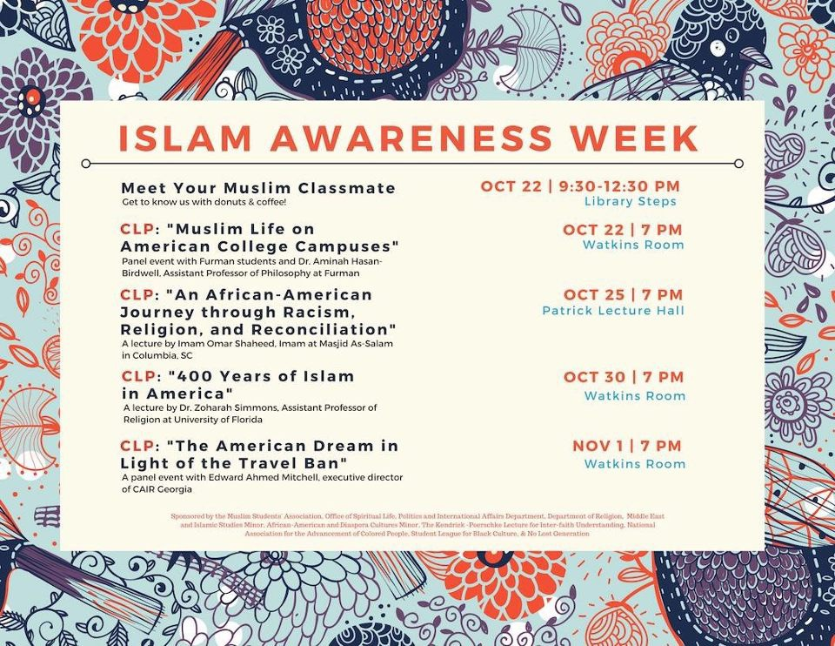
- Meet your Muslim Classmate - Oct. 22nd 9:30PM -12:30PM on the Library Steps, Doughnuts and Coffee
- Muslim Life on American College Campuses - Oct. 22nd 7PM, Watkins Room, CLP
- An African-American Journey Through Racism, Religion, and Reconciliation - Oct. 25th, 7PM, Patrick Lecture Hall, CLP
- 400 Years of Islam in America - Oct. 30th, 7PM, Watkins Room, CLP
- The American Dream in Light of the Travel Ban - Nov. 1st, 7PM, Watkins Room, CLP
- Oct. 25th at 7pm in Watkins: QUnion
- 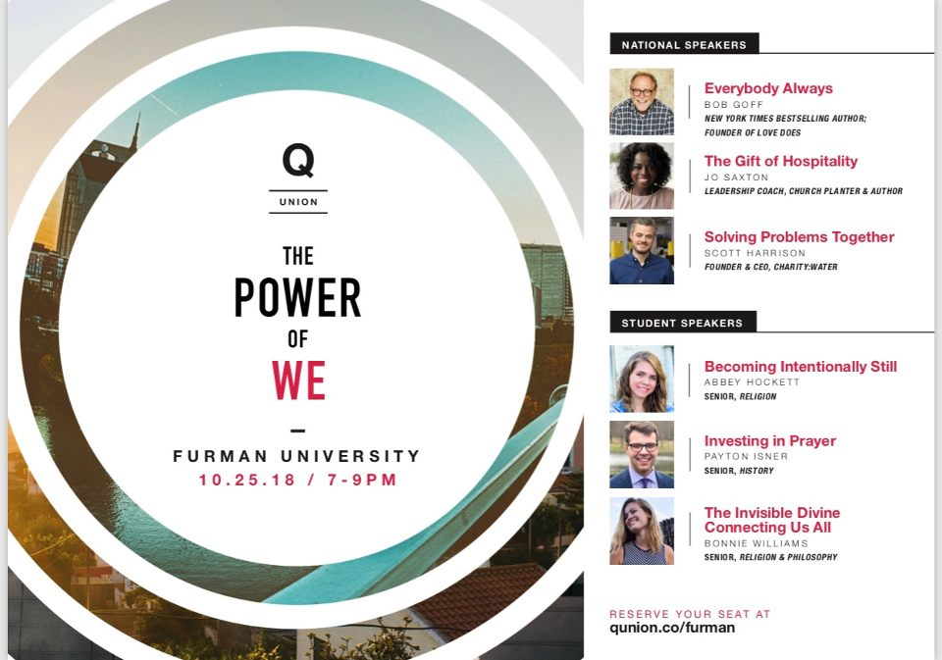
- Nov. 1st at 7:30pm in Daniel Chapel CLP: Hot, Healthy Sex in the Age of #MeToo
Chase Shaner, Campus Recreation Rep.
  - No report
Muhammad Zakaria Shafqut, Student Diversity Council.
  - 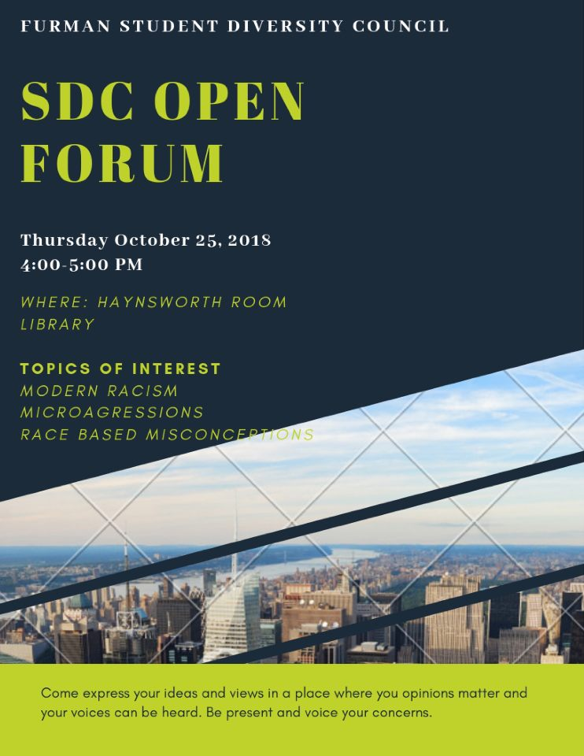
  - 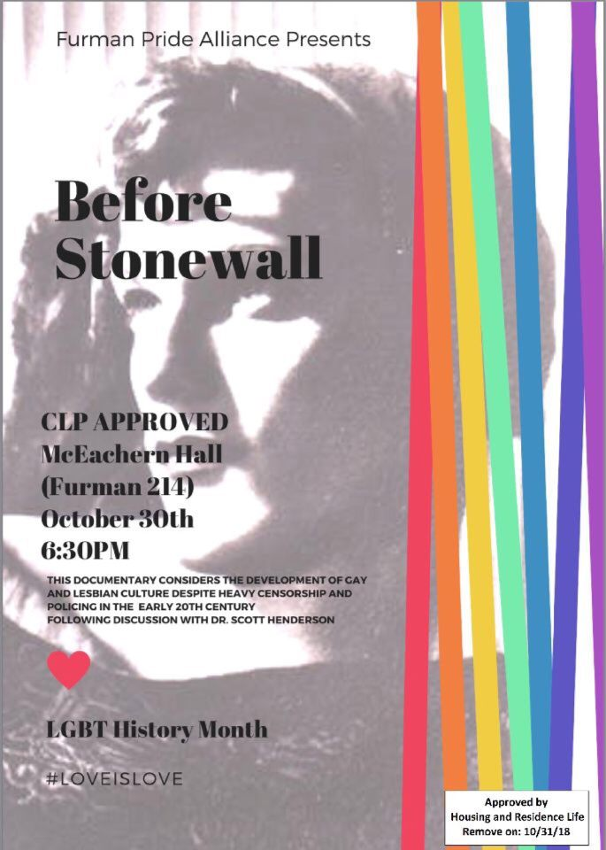
- Oct. 25th 4-5pm in Haynsworth Room: SDC Open Forum on racism, microaggression, and misconceptions
- A. Furman Pride Alliance
1) Before Stonewall - Documentary CLP - October 30th - 6:30pm - McEachern Hall
2)Intersex CLP- Scheduled for Monday Nov. 12th
- B. RAISE RA
1) Movie CLP ‘Sorry To Bother You’ with a panel discussion on Nov. 7th

Non Voting Representative Reports:

Panhellenic Representatives
  - Recruitment registration is open until December
  - Panhellenic Executive Council applications open until Wednesday
Ryan Smith, IFC Representative
  - Open House Tuesday 7-9pm
Payton Isner, Housing and Residence Life
  - No report
Avery Armstrong, Athletics
  - No report

Class Reports:
Mary Morrow, Senior Class President
  - No report
Brooke O’Neill, Junior Class President
  - See Furman 10 Days announcement in Open Forum
Sophia Groves , Sophomore Class President
  - Planning an event for sophomores before final exams
Sarah Mobley , Freshman Class President
  - No report

Ad Hoc Committees:
- Vitality Committee:
  - Fun Run volunteers still needed this weekend! Email sarahpaden.mobley@furman.edu
- Service Committee:
  - Heller still needs Fall Fest volunteers for this Saturday! Email terryl.cronic@furman.edu
- Bylaws Committee:
  - First meeting this Wednesday
- Student Health Committee:
  - Working on ideas for programming
Old Business:
- None
New Business:
- None
Open Forum & Announcements:
- Furman 10 Days:
Did you know the average American spends $50 on drinks in 10 days?? This is enough money to provide drinking water for a family for a YEAR. This November 5th -14th, we're challenging you to join us for the 10 days campaign as we partner with Living Water International to fight the global water crisis in Rwanda! Pledge to drink only water and donate the money you save on coffee, soda etc.
To learn more and sign up for the Furman 10 Days campaign click on the link https://www.10days.cc and choose "Take the Pledge". If you’re interested in starting a team email emily.sink@furman.edu!

Adjournment:
The meeting was adjourned by President Will Sanders at 6:34 PM.

