Minutes of the
Furman University Student Government Association
48th Council
.
8th Meeting
29 October 2018
Trone Student Center, 208A (Thomas Room)

Call to Order:
The meeting was called to order by President Will Sanders at 6:00 PM.

Roll Call:
President Will Sanders took attendance and determined quorum was present. Twenty (20) of twenty-four (24) voting members were present. Absences: Brooke O’Neill, Sophia Groves, Religious Council, Campus Rec
Approval of Minutes:
Move to approve meeting minutes from October 22nd. Motion seconded; motion carried.

Special Guests:
Jessica Berkey, Director of Student Involvement and Inclusion
- Check in
Patrick MacDonald, Furman Student Activities Board
- 5 committees, 55 active members
- Handles budget with percent allocations to each committee after running efficiencies based on previous semester
- Committees tend to be very efficient in spending
- Students apply to FUSAB on SyncDin, applications are read by Application Committee, group interviews, individual interviews
- Exec works on yearly calendar, not academic calendar

Officer Reports:
Will Sanders, Executive President
  - Thank you for presenting, FUSAB!
  - Attended Student Experience & Outcomes Board meeting on Friday: mainly focused on TFA and rise in students seeking those experiences and ways to increase Furman’s national ranking
  - Task Force announcement today: Board accepted recommendations and endorsed administration to move forward
  - Reach out to Will if you are interested in being a part of the Student Task Force Committee and take Gallup surveys
  - Ask Will any questions about safety on campus before his semester meeting with Chief Milby
Scott Finney, Vice President
- Will attend Investments Board meeting later this semester
- Plan to vote on Dungeons and Dragons and Pre-PA next week
Prem Chockalingam, Executive Treasurer
  - Hope everyone had a great weekend!!!!
Caroline Tucker, Secretary
  - Attended External Engagement Board meeting Friday
  - Please let Caroline know if you will be absent from Council and why
Connor Dial, Parliamentarian
  - See Connor with any questions about Robert’s Rules

Representative Reports:
Sarah Bourlakas, FUSAB Rep.
- 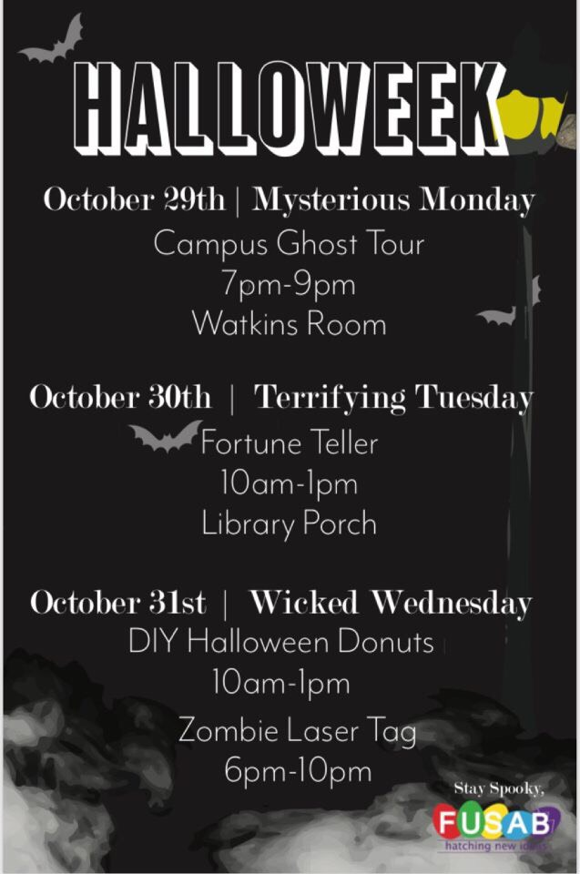
Hayden Braun, RLC Rep.
- Halloween donuts on 10/31 at 8am at Judson, Apt A and Geer
Payton Isner, Religious Council Rep.
- Jewish Student Association and Religious Council are holding a vigil for the victims of the Tree of Life Synagogue shooting this Thursday at 6:30PM in Daniel Chapel. All are welcome.
- Exploration and Vocational Ministries is hosting a CLP entitled “Hot and Healthy Sex in the Era of #MeToo” on Thursday at 7:30PM in Daniel Chapel.
- Muslim Student Association has two CLP’s this week: 400 Years of Islam in America on Wednesday from 7-8:30PM in Watkins and The American Dream in Light of the Travel Ban from 7-8:15PM in Watkins.
- Catholic Campus Ministries is hosting their “God? Forum” on November 6th from 8-9PM in the Trone Student Center.
- Jewish Student Association is hosting “Schmooze with the Jews” on November 9th from 11:30AM - 12:30PM on the library steps! Come get free bagels!
  - 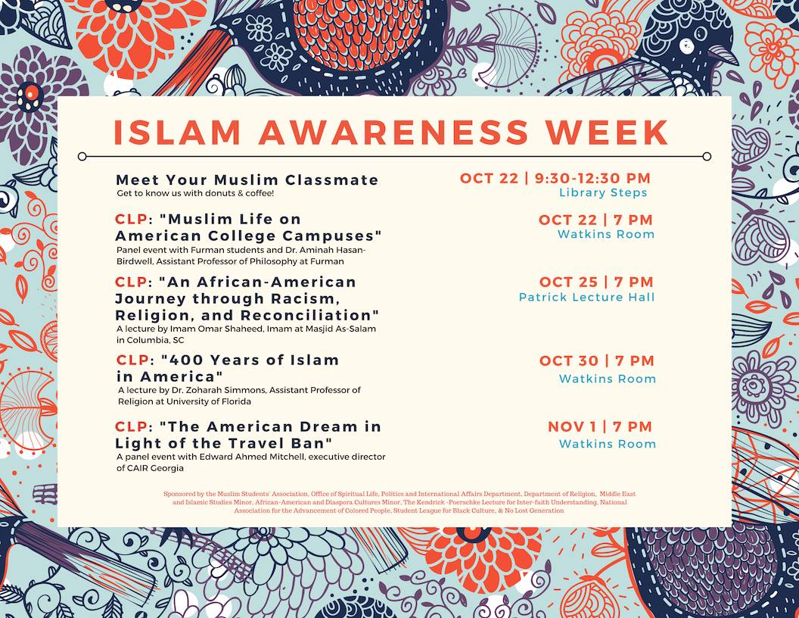
  - 
Chase Shaner, Campus Recreation Rep.
  - No report
Muhammad Zakaria Shafqut, Student Diversity Council.
  - Oct. 30 at 6:30pm in FH 214: Stonewall Movie CLP
  - International Education Week:
- Nov. 5 11-12pm on library patio: giveaways
- Nov. 5 6-7:30pm in Burgiss: Chinese Mythology CLP
- Nov. 6 7-8 in McAlister: International Fashion Show CLP
- Nov. 7 12-12pm on library patio: giveaways
- Nov. 7 6-7pm in Watkins: Diwali CLP
- Nov. 8 11-1pm on library patio: Furman Mosaic – Rangoli
- Nov. 8 7-8:30pm 7-8:30pm in Hartness: We are Furman Panel CLP
- Nov. 9 11-2pm Trone patio: Furman International giveaways
- 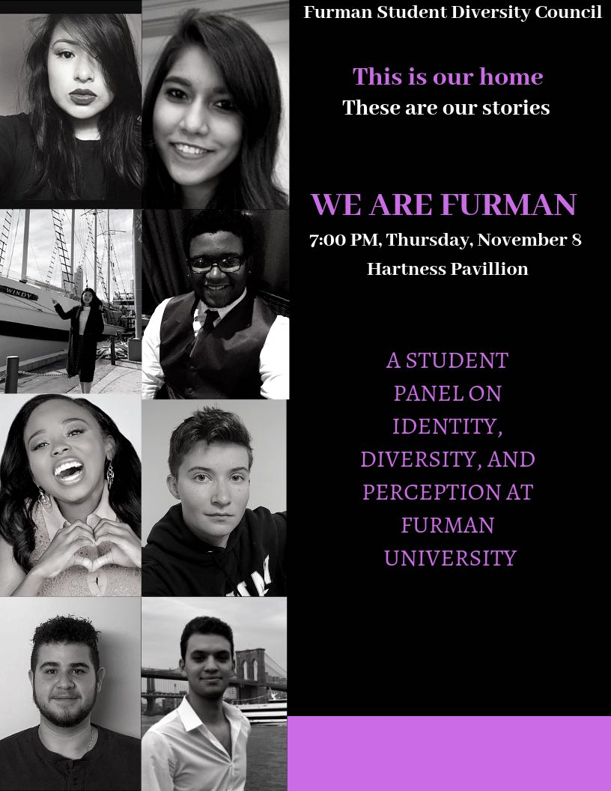

Non Voting Representative Reports:

Panhellenic Representatives
- Register for formal recruitment
Ryan Smith, IFC Representative
- No report
Payton Isner, Housing and Residence Life
- No report
Athletics
- no report.

Class Reports:
Mary Morrow, Senior Class President
- Senior Gift donations have started coming in
Brooke O’Neill, Junior Class President
- No report
Sophia Groves , Sophomore Class President
- No report
Sarah Mobley , Freshman Class President
- No report

Ad Hoc Committees:
- Vitality Committee
  - Still needs members, open to anyone in student body
- Service Committee
  - Thank you to everyone who volunteered at Fall Fest
- Bylaws Committee
  - First meeting was this weekend; will let exec know of ideas
- Student Health Committee
  - Meeting with Jason Cassidy in Nov., let Barrie know if you want to attend
Old Business:
- None
New Business:
- None
Open Forum & Announcements:
- None
Adjournment:
The meeting was adjourned by President Will Sanders at 6:35 PM.

