Minutes of the
Furman University Student Government Association
48th Council
.
12th Meeting
3 December 2018
Trone Student Center, 208A (Thomas Room)

Call to Order:
The meeting was called to order by President Will Sanders at 6:00 PM.

Roll Call:
President Will Sanders took attendance and determined quorum was present. Nineteen (19) of twenty (24) voting members were present. Absences: Bailey Votto, Morgan Fretwell, Sarah Mobley, Scott Finney, Brooke O’Neill
Approval of Minutes:
Move to approve meeting minutes from November 26th. Motion seconded; motion carried.

Special Guests:
Ainsley Moore, Treasurer of College Republicans
- Breakdown of how CR has used their budget so far
- Planning on taking students to the Conservative Political Action Conference in D.C. this spring; need more funding
Peyton Isner, Furman University Religious Council
- Explanation of what Religious Council does for the Furman community and its goals
- This has been the most active semester for Religious Council in Furman history

Officer Reports:
Will Sanders, Executive President
- One more meeting this semester next Monday
- Tom Evelyn coming from Furman Communications; be ready with questions
- If your organization will be going through turn over, touch base with Will and Connor to get new officers caught up on how SGA works
- Morning golf cart shuttle will now go to a fixed route roughly 4 times per hour: North Village J, DH, Library, PAC, Chapel
  - Ask around for feedback
  - Will be a meeting to discuss transportation options soon, keep an eye out for details—all are invited
  - This is different than an accessibility resource and is separate from SafeRide system
Scott Finney, Vice President
- No report
Prem Chockalingam, Treasurer
  - Will discuss College Republicans’ budget request in Old Business
  - Submit SGA credit card requests on SyncDIN and pick it up with Ms. Diane in Student Life office
Caroline Tucker, Secretary
  - Trolley naming contest will go live after Council! Follow the link and encourage everyone to submit a suggestion. The winner will receive 100 points on their ID card! The contest is open from now until LDOC at noon. https://furman.campuslabs.com/engage/submitter/form/start/236257
Connor Dial, Parliamentarian
  - Contact Connor with any bylaw/meeting questions

Representative Reports:
Sarah Bourlakas, FUSAB Rep.
- Mentalist | December 5th at 7pm in Watkins
- Winter Wonderland | December 9th from 5:30-7:30 in Trone
Eliza Hopkins, RLC Rep.
- 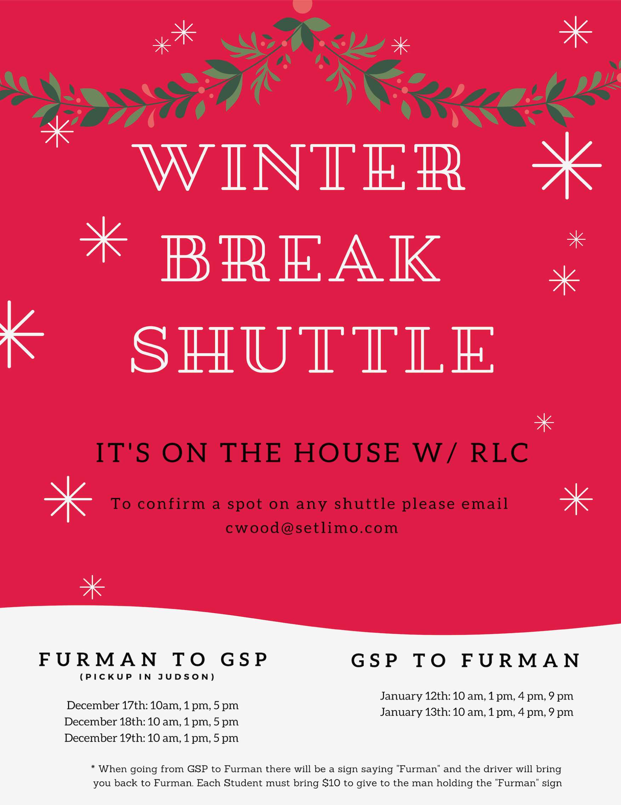
- There will be free pretzels outside the library at 2pm on reading day!
Payton Isner, Religious Council Rep.
- Jewish Student Association is hosting a film CLP entitled “In Search of Israeli Cuisine” on Wed. Dec 5th from 6-7:15PM in Burgiss Theater. Food provided afterwards.
Chase Shaner, Campus Recreation Rep.
  - No report
Muhammad Zakaria Shafqut, Student Diversity Council.
  - No report
Non Voting Representative Reports:

Panhellenic Representatives
  - No report
Ryan Smith, IFC Representative
  - No report
Payton Isner, Housing and Residence Life
- Follow closing regulations to avoid fines
- Applications to be an RA and a FRAD are still open! More information here: https://furman.campuslabs.com/engage/submitter/form/start/236257
- Please meet with your RA before you leave for break to ensure you are up-to-date on all the closing regulations!
Andrew Zinzarella, Army ROTC
  - No report
Athletics
  - Lots of games coming up! Come support!!

Class Reports:
Mary Morrow, Senior Class President
  - Dec. 9 1-2:30pm Senior Holiday Drop-In at White Oaks; looking into transportation options
Brooke O’Neill, Junior Class President
  - No report
Sophia Groves, Sophomore Class President
  - Thursday 1-2pm in front of the library with cupcakes!
Sarah Mobley, Freshman Class President
  - Planning class forum

Ad Hoc Committees:
- Vitality Committee
  - Get excited for next semester’s activities!
- Service Committee
  - MLK Day of Service on Jan. 21st, mandatory for everyone on SGA
- Bylaws Committee
  - No report
- Student Health Committee
  - Met with Dean Cassidy and Stephanie Boyd
    - Talked about alcohol education policies
    - New structure for scheduling counselling meetings; can still schedule as usual but also call an on-call counselor
    - PHOKUS planning Mental Health Week and CLPs
    - Risk of mass shootings on college campuses and procedures
  - Going to meet Wednesday with Dining Hall staff
Old Business:
- Motion to discuss College Republican’s New Money Request, request denied
New Business:
- None
Open Forum & Announcements:
- ROTC has more training sessions left; come join!
Adjournment:
The meeting was adjourned by President Will Sanders at 6:43 PM.

