Minutes of the
Furman University Student Government Association
48th Council
.
14th Meeting
28 January 2019
Trone Student Center, 208A (Thomas Room)

Call to Order:
The meeting was called to order by President Will Sanders at 6:00 PM.

Roll Call:
President Will Sanders took attendance and determined quorum was present. Twenty-three (23) of twenty (24) voting members were present. Absences: Campus Rec
Approval of Minutes:
Move to approve meeting minutes from January 14th. Motion seconded; motion carried.

Special Guests:

Neil Jamerson, Vice President for Student Development
- No report.

Andrew Lull, School Spirit Leader
- Need to get students excited about upcoming Furman/Wofford game
  - Looking into planning a tailgate beforehand
  - Giveaways, food, etc.
  - Looking for help from a larger organization to get this plan rolling; reach out to Andrew with any ideas (Andrew.Lull@furman.edu)
- Proposal for a “Senior Week” for the days between LDOC and Commencement to bond senior class
  - Ideas include: casino night, trips to CaroWinds, etc.

Officer Reports:
Will Sanders, Executive President
- Working on Task Force recommendations with SDC; looking for 3 SGA members to serve on the committee
- Start thinking about upcoming SGA elections
- Reflect on what being on SGA means to you and what campus issues you want to address while on Council
Scott Finney, Vice President
- Heller’s Valentine’s Dance is SGA Council mandatory service event
- CHAARG to soon submit constitution for consideration
- Deadline for new organizations is in 2 weeks
Prem Chockalingam, Treasurer
  - Thinking about who would want to run for Exec Treasurer early so transition can begin earlier
Caroline Tucker, Secretary
  - No report.

Connor Dial, Parliamentarian
  - Let Caroline know ahead of time if you will not make it to Council
  - Let Connor know about questions with Robert’s Rules

Representative Reports:
Burke Lipscomb, FUSAB Rep.
- January 28th: Tag Wristband Pick Up for students that signed up
- February 1st: Yule Ball- Harry Potter themed winter ball at the Westin Poinsett downtown. From 7-11 p.m. There will be free transportation going between the Soho quad and Downtown. Bring Furman ID.
- February 2nd: Baseball Team Kickball Tournament to support VS Cancer
- February 4th: Tag Begins

Cameron Langsett, RLC Rep.
- Google forum to address issues surrounding housing and facilities and to submit recommendations:
- https://docs.google.com/forms/d/e/1FAIpQLSe_NxWiVKothZ-0A-fUMz71E_siMHC29wbEn6LV5ONC3tHSOQ/viewform?vc=0&c=0&w=1
Payton Isner, Religious Council Rep.
  - No report
Chase Shaner, Campus Recreation Rep.
  - Dr. Caterisano is looking to upgrade equipment in PAC through Powerlifting Club
Muhammad Zakaria Shafqut, Student Diversity Council.

  - 
  - 

Non Voting Representative Reports:

Panhellenic Representatives
  - No report.
Ryan Smith, IFC Representative
  - No report.
Payton Isner, Housing and Residence Life
- No report
Andrew Zinzarella, Army ROTC
  - Started labs today
  - Feel free to join labs or workouts!
Jamila Johnson, Athletics
  - Upcoming games:
- 2/1: Women’s Tennis vs. Charleston Southern, 3pm
- 2/2: Women’s Basketball vs. Mercer, 2pm (Pink Game)
- 2/2: Men’s Lacrosse home opener vs. Duke, 7pm (Greek Night, FREE hot chocolate)
- 2/3: Women’s Tennis vs. Louisville/Emmanuel, 12pm/4pm
- 2/6: Football National Signing Day event at American Burger Company, 12-2pm (301 E. McBee Ave.)
- 2/9: Men’s Tennis vs. USC Upstate/North Greenville, 11am/3pm
- 2/9: Women’s Lacrosse home opener vs. High Point, 1pm
- 2/9: Men’s Basketball vs. ETSU, 4pm (Space Jam Game)
- 2/10: Women’s Tennis vs. Liberty/SC State, 11am/3:30pm

Class Reports:
Mary Morrow, Senior Class President
  - 2/7: Senior Drop-In at White Oaks
  - Chief Milby looking for SGA members to serve on Parking and Traffic Committee; reach out to Mary
Brooke O’Neill, Junior Class President
  - Don the SGA shuttle driver may come to Council to share comments
Sophia Groves, Sophomore Class President
  - Requests for printers in Lakeside and Apt J
Sarah Mobley, Freshman Class President
  - Relay for Life looking to get freshmen involved this year

Ad Hoc Committees:
- Vitality Committee
  - Let Sarah know if you have any fun ideas
- Service Committee
  - Heller’s Valentine’s Dance on 2/12, 7-8:30
  - Let Morgan know if you have any ideas for how to get involved with Relay for Life
- Bylaws Committee
  - No report.
- Student Health Committee
  - Working with Counseling Center to help clarify procedures for freshmen
  - Blood Drive 2/18 11-4pm in Watkins
  - 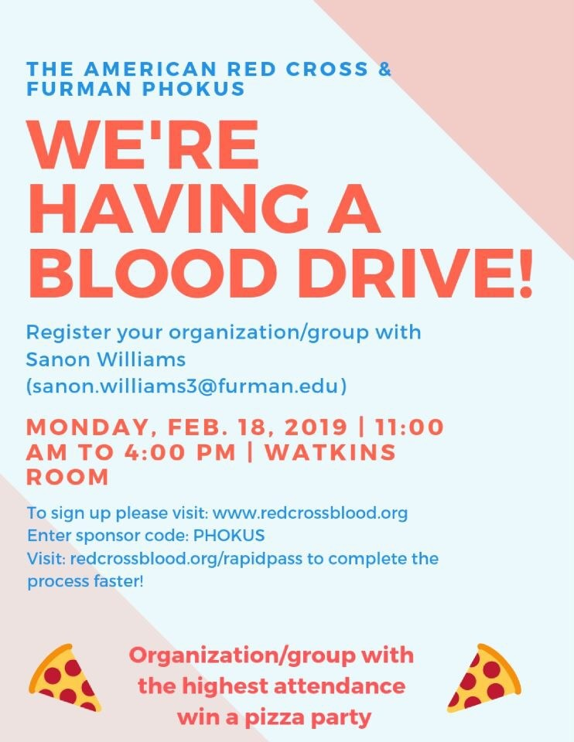

Old Business:
- None
New Business:
- None
Open Forum & Announcements:
- Buy TEDxFurmanU tickets! 2/16 1-4pm
- Pauper Players putting on A Chorus Line this weekend! Student tickets are $5
- 
- Upcoming SGA forum on transportation; let SGA know if you’d like to be included
Adjournment:
The meeting was adjourned by President Will Sanders at 6:35 PM.

