Minutes of the
Furman University Student Government Association
48th Council
.
16th Meeting
11 February 2019
Trone Student Center, 208A (Thomas Room)

Call to Order:
The meeting was called to order by President Will Sanders at 6:00 PM.

Roll Call:
President Will Sanders took attendance and determined quorum was present. Seventeen (17) of twenty (24) voting members were present. Absences: Shania Gaspard, Jaylon Godwin, Nan Perry, Sarah Mobley, Eli Titherington, Rosie Kim, Muhammad Zakaria Shafqut
Approval of Minutes:
Move to approve meeting minutes from February 4th. Motion seconded; motion carried.

Special Guests:
Connie Carson, Vice President of Student Life
- No report

Mary Elise Mullen, Political Thought Club
- Discusses political philosophy and literature
- Hosts speakers
- Requesting $3,400 for honorarium, speaker, shirts, year end party, meeting snacks

Officer Reports:
Will Sanders, Executive President
- Keep up the good work on all you are working on!
Scott Finney, Vice President
- Going to vote on CHAARG constitution
- Deadline for new club applications was last Friday, but willing to work with people who were planning on making a club
Prem Chockalingam, Treasurer
- No report
Caroline Tucker, Secretary
- The winner of the SGA trolley naming contest is Richard Rasheed with “Knight Rider”! Congrats, Richard!
Connor Dial, Parliamentarian
- No report

Representative Reports:
Burke Lipscomb, FUSAB Rep.
- February 14th- keep an eye out for something special in front of the library
- February 21st- Toast and Jams- come to Watkins room at 6 p.m. to listen to some amazing student acts! You might just get some inside information on the Spring Concert.
Hayden Braun, RLC Rep.
- No report
Payton Isner, Religious Council Rep.
- Sex in the Dark CLP
- Unprotected Text CLP
Chase Shaner, Campus Recreation Rep.
- No report
Muhammad Zakaria Shafqut, Student Diversity Council.
- Chinese new year celebrations are on Wednesday, 13th February at 7:30 in Daniel Recital Hall. It has a lecture, followed by a concert and food as well. It is also a CLP.
- 

Non Voting Representative Reports:

Panhellenic Representatives
- No report
Luke Allcock, IFC Representative
- No report
Payton Isner, Housing and Residence Life
- Sex in the Dark CLP
- Unprotected Text CLP
Andrew Zinzarella, Army ROTC
- No report
Jamila Johnson, Athletics
- Feb. 14: Women’s Basketball vs UTC, 5pm (Valentine’s Day Doubleheader)
- Men’s Basketball vs UNCG, 7:30pm (Valentine’s Day Doubleheader)
*There will be a dating game at halftime sponsored by FUSAB
- Feb. 15: Baseball vs Morehead State, 5pm
*Opening Day
- Feb. 16: Baseball vs Morehead State, 1pm
- Women’s Basketball vs ETSU, 2pm (Senior Day)
*Will be honoring Kaitlyn Duncan
- Men’s Basketball vs VMI, 4:30pm
*Tickets are sold out!! Get student tickets online ASAP.
- Feb. 17: Baseball vs Morehead State, 1pm

Class Reports:
Mary Morrow, Senior Class President
- No report
Brooke O’Neill, Junior Class President
- Looking to plan an event for juniors
Sophia Groves, Sophomore Class President
- Max Dudley putting in lots of maintenance requests
- Planning sophomore class forum
Sarah Mobley, Freshman Class President
- No report

Ad Hoc Committees:
- Vitality Committee
  - No report
- Service Committee
  - Heller Valentine’s Dance tomorrow at 7pm
  - Talk to Morgan if you are interested in Relay for Life
- Bylaws Committee
  - No report
- Student Health Committee
  - PHOKUS is having a blood drive Monday from 11-4pm in Watkins
  - 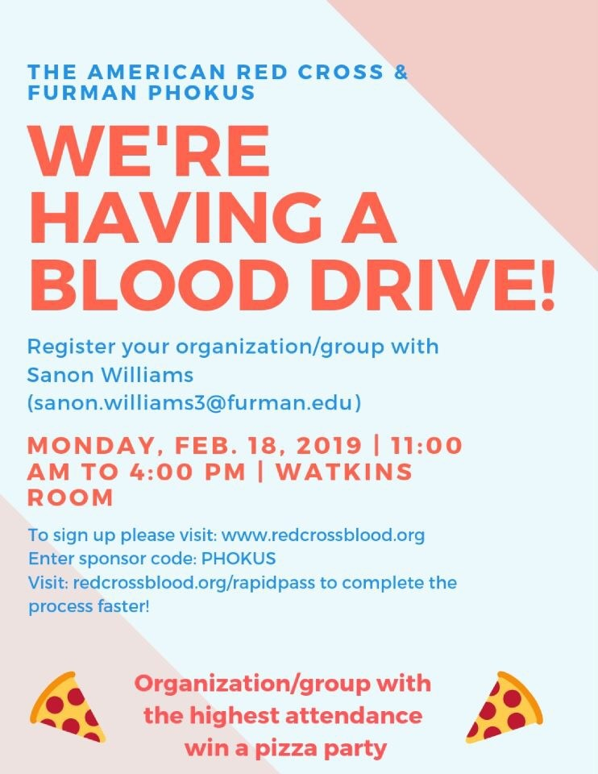
  - Table sit in DH Wednesday:
  - 
Old Business:
- Motion to discuss CHAARG by open forum, CHAARG approved to be an SGA sponsored organization
- Motion to discuss Political Thought Club’s New Money Request, approved for $2,500
New Business:
- None
Open Forum & Announcements:
- CLP on 2/27 at 7pm in McAlister: Anthony Ray Hinton about his experience on Death Row; guarantee a spot by RSVPing at Furman.edu/RayHinton
- TEDxFurmanU CLP on Saturday 1-4pm; tickets are $5 at TEDxFurmanU.com
- ROTC CrossFit competition in early April; keep an eye out!
Adjournment:
The meeting was adjourned by President Will Sanders at 6:40 PM.

