Minutes of the
Furman University Student Government Association
48th Council
.
17th Meeting
18 February 2019
Trone Student Center, 208A (Thomas Room)

Call to Order:
The meeting was called to order by President Will Sanders at 6:00 PM.

Roll Call:
President Will Sanders took attendance and determined quorum was present. Twenty-one (21) of twenty (24) voting members were present. Absences: Mary Morrow, Cameron Langsett, Max Dudley
Approval of Minutes:
Move to approve meeting minutes from February 11th. Motion seconded; motion carried.

Special Guests:
Tom Evelyn, Vice President of Communications
- Furman’s Communications Dept. is in charge of central communications
- Mission is to raise awareness and protect the brand of Furman: admissions & development
- Focused on external communications (ex. website, news, social media, print media, media relations, video/photography)
  - Mostly done in-house
  - Allow students to help
- Manage emergency/crisis communications with FUPO/administrators
- With any concerns, please feel free to contact Tom at tom.evelyn@furman.edu or visit the University Communications website: http://www2.furman.edu/sites/university-communications/Pages/default.aspx
Jason Cassidy, Dean of Students
- New Student Health Center
  - Went really well last semester; lots of positive feedback
  - Let Dean Cassidy know if you have any suggestions/comments
- Student Life policies
  - Student Handbook gets revised and reviewed every summer
  - Amnesty policy: if a student seeks medical attention for themselves or for another student as a result of alcohol use, they can call for help without fear of getting someone or themselves in trouble; may be used one time
    - Does not mean Furman will not check up on you if you get sent to the hospital
  - Students are always welcome to look at the Student Conduct Code and make suggestions to Student Life

Officer Reports:
Will Sanders, Executive President
- Fun SGA transition activity to come!
- Board of Trustees meeting this weekend; Exec members will be sitting in on meetings, let Exec know if you have anything you want communicated
- Bell Tower Ball this weekend; make sure you have RSVP’d if you were invited
- Let Will know if you want to serve on the Parking Committee; meets every other Wednesday from 3-4pm
- If there is a policy you are interested in changing, let Exec know
Scott Finney, Vice President
- Going to Investments Subcommittee Board meeting this week
- 3 clubs to propose membership
Prem Chockalingam, Treasurer
  - No report
Caroline Tucker, Secretary
  - No report
Connor Dial, Parliamentarian
  - No report

Representative Reports:
Burke Lipscomb, FUSAB Rep.
- Thursday, February 21st: Toast and Jams (come and hear student acts perform while eating a delicious variety of toasts. Stick around for a special announcement)
- Friday, February 22nd: Food Truck Friday (11:30 to 2:30 pm on Milford Mall. Free for students. Trucks include Chuck Truck, Cocobowlz, We Got the Beets, and One Love Fusion Food.)
Hayden Braun, RLC Rep.
- Study Night 2/19 from 8-9:30pm outside the library with hot cocoa, popcorn, squishy animals, etc.
Payton Isner, Religious Council Rep.





Chase Shaner, Campus Recreation Rep.
  - No report
Muhammad Zakaria Shafqut, Student Diversity Council.
  - CLP: 2/27 at 7pm in McAlister Anthony Ray Hinton event; “The Sun Does Shine”
- 
- 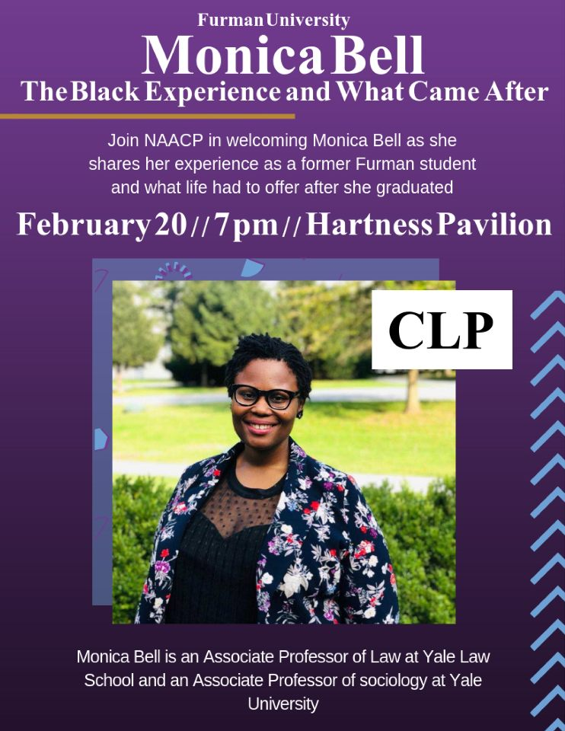

Non Voting Representative Reports:

Panhellenic Representatives
  - No report
Luke Allcock, IFC Representative
  - SAE recruitment will end on 2/27
Payton Isner, Housing and Residence Life
- Check emails about housing lottery and read them carefully
Andrew Zinzarella, Army ROTC
  - No report
Jamila Johnson, Athletics
  - No report

Class Reports:
Mary Morrow, Senior Class President
  - No report
Brooke O’Neill, Junior Class President
  - 2/21 doing breakfast outside the library at 8pm
Sophia Groves, Sophomore Class President
  - Meeting with Housing on 2/21 to address concerns, so let them know if you have any concerns
Sarah Mobley, Freshman Class President
  - No report

Ad Hoc Committees:
- Vitality Committee
  - Stay tuned for if Wofford tailgate is still on because of rain
- Service Committee
  - Thank you for coming to Valentine’s Dance!
  - Reach out to Morgan Fretwell if you are interested in Relay for Life

- Bylaws Committee
  - No report
- Student Health Committee
  - Met with Counselling Center:
    - There is a counselor on duty for emergency appointments during office hours
    - They are updating their website
    - They have an app called Well Track to help with stress and self-help tools
    - Looking to collaborate with PHOKUS
    - Starting group counselling sessions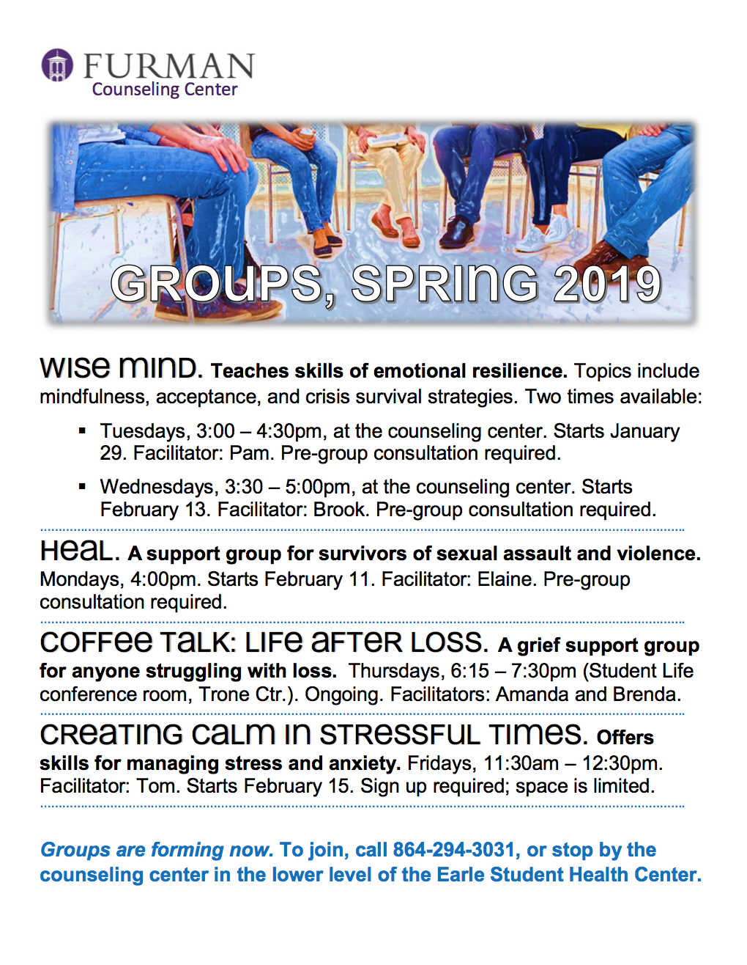
Old Business:
- None
New Business:
- Motion to approve the Healthcare Administration Club, carried
- Motion to approve the Film Club, carried
- Motion to approve the Ace of Club, carried
Open Forum & Announcements:
- Thank you for attending the Valentine’s Dance!
Adjournment:
The meeting was adjourned by President Will Sanders at 7:07 PM.

