Minutes of the
Furman University Student Government Association
48th Council
.
19th Meeting
11 March 2019
Trone Student Center, 208A (Thomas Room)

Call to Order:
The meeting was called to order by President Will Sanders at 6:00 PM.

Roll Call:
President Will Sanders took attendance and determined quorum was present. Twenty-three (23) of twenty-four (24) voting members were present. Absences: Caroline Tucker
Approval of Minutes:
Move to approve meeting minutes from February 25th. Motion seconded; motion carried.

Special Guests:
Neil Jamerson, Assistant Vice President for Student Development
- Dr. Cass is looking for people to serve on the student conduct board. Due by April 1st

Officer Reports:
Will Sanders, Executive President
- Executive Officer Elections
  - Petitions due Friday March 15th by 5:00pm
  - Speeches Monday March 18th 7:00pm
  - Primary Election Round March 25-26
  - Secondary Election Round March 28-29
- Class Officer Elections
  - Petitions due Monday April 1st by 5:00pm
  - Speeches Monday April 1st 7:00pm
  - Primary Election Round April 8-9
  - Secondary Election Round 11-12
- Meeting with Academic Dean-email Will with any questions about the academic realm that he can ask
Scott Finney, Vice President
- Eli will present next week for Healthcare Administration cCub
- Table Tennis Club
- Club sport budget meeting
Prem Chockalingam, Treasurer
  - New money request for marching band to go to nyc
  - Reviewing at large organization budgets
Caroline Tucker, Secretary
  - No report
Connor Dial, Parliamentarian
  - No report

Representative Reports:
Burke Lipscomb, FUSAB Rep.
- Check out the front of the Lib on Wednesday for a surprise event with prizes and free snacks!
- Make your bracket now and join the Furman group for March Madness! Making a bracket automatically enters students into a raffle for tickets for rounds 1 and 2 taking place in Columbia. Also be on the lookout for watch parties in the paddock.
Hayden Braun, RLC Rep.
- No report
Payton Isner, Religious Council Rep.
  - CLP: Mass at 9:00pm this Sunday in Daniel Chapel
Chase Shaner, Campus Recreation Rep.
  - No report
Muhammad Zakaria Shafqut, Student Diversity Council.
  - Hispanic Fiesta-April
  - April 23rd-Diversity banquet in Hartness at 6:00pm rsvp only
Non Voting Representative Reports:

Panhellenic Representatives
  - No report
Luke Allcock, IFC Representative
  - Greek Week
  - Rock and Roll Greek Groove
Payton Isner, Housing and Residence Life
- No report
Andrew Zinzarella, Army ROTC
  - No report
Jamila Johnson, Athletics
  - No report

Class Reports:
Mary Morrow, Senior Class President
  - No report
Brooke O’Neill, Junior Class President
  - No report
Sophia Groves, Sophomore Class President
  - No report
Sarah Mobley, Freshman Class President
  - No report

Ad Hoc Committees:
- Vitality Committee
  - No report
- Service Committee
  - PalaTHON email-sign up
    - March 23rd from 2:00pm to 8:00pm in Timmons Arena benefitting the PRISMA Health’s Greenville Childrens Hospital
    - Sign up link: https://events.dancemarathon.com/index.cfm?fuseaction=donorDrive.team&teamID=34602

- Bylaws Committee
  - No report
- Student Health Committee
  - FOCUS-CLP on addiction coming up soon!
Old Business:
- None
New Business:
- Vote on Marching Band’s new money request
  - rushed into old business
Open Forum & Announcements:
- Printer now in Judson Lounge
- ROTC CLP on Wednesday-leadership in a complex world, McEachern
- Anyone interested in Campus Rec talk to Chase Shaner
- During the week of March 18th the Shucker Center for Leadership Development will be having a "Strengths Week” to highlight and utilize strengths on campus. All you have to do is sign up to take the Clifton Strengths finder test to get your top 5 strengths and then attend events during the week to learn more about the importance of your unique talents. Here’s the link to sign up for a code to take the CliftonStrengths Test: https://docs.google.com/document/d/1amOMIALg5ueTiEtlVoOkwZPTwqAz6Qy5Pyhlw_FpzVU/edit
- 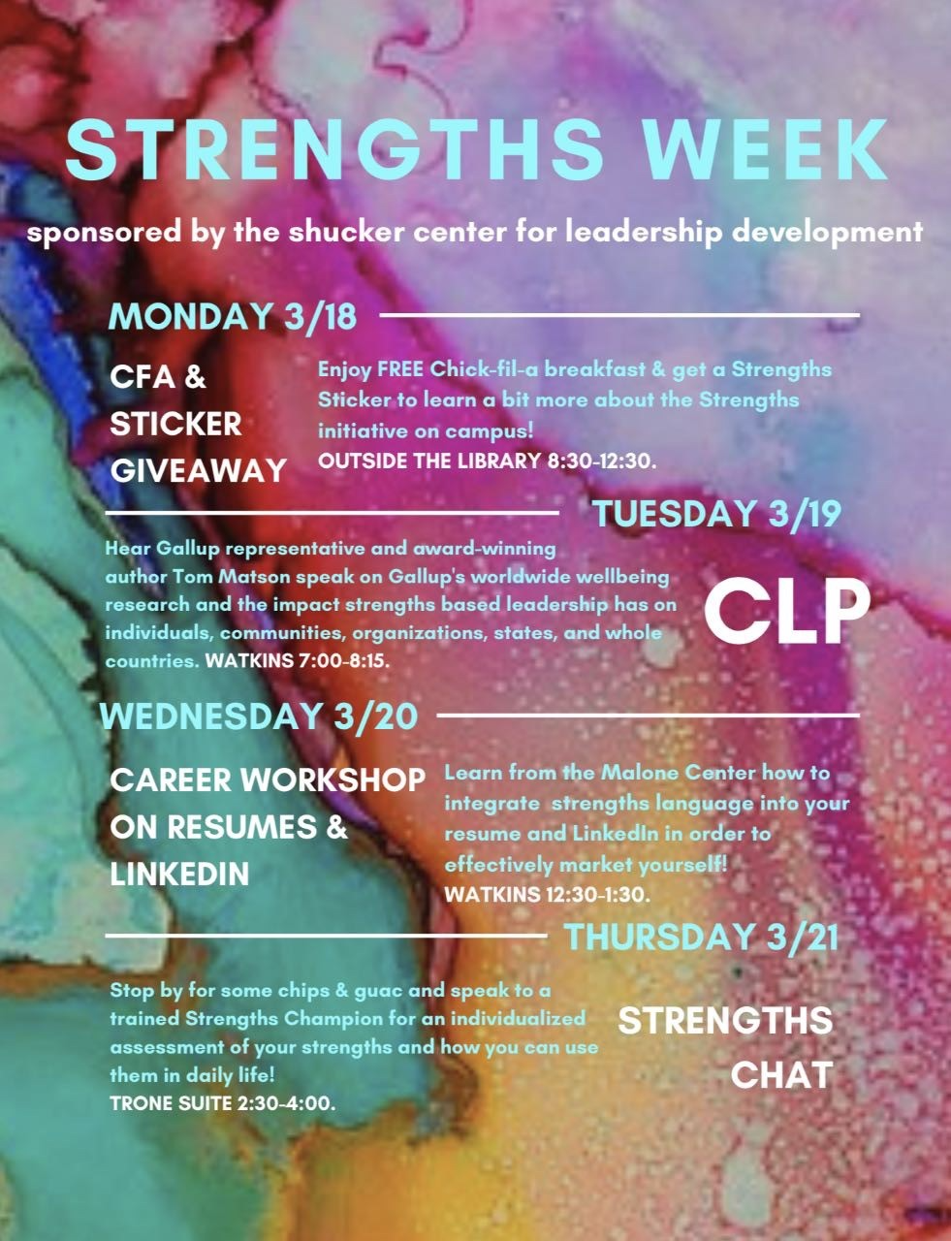
- 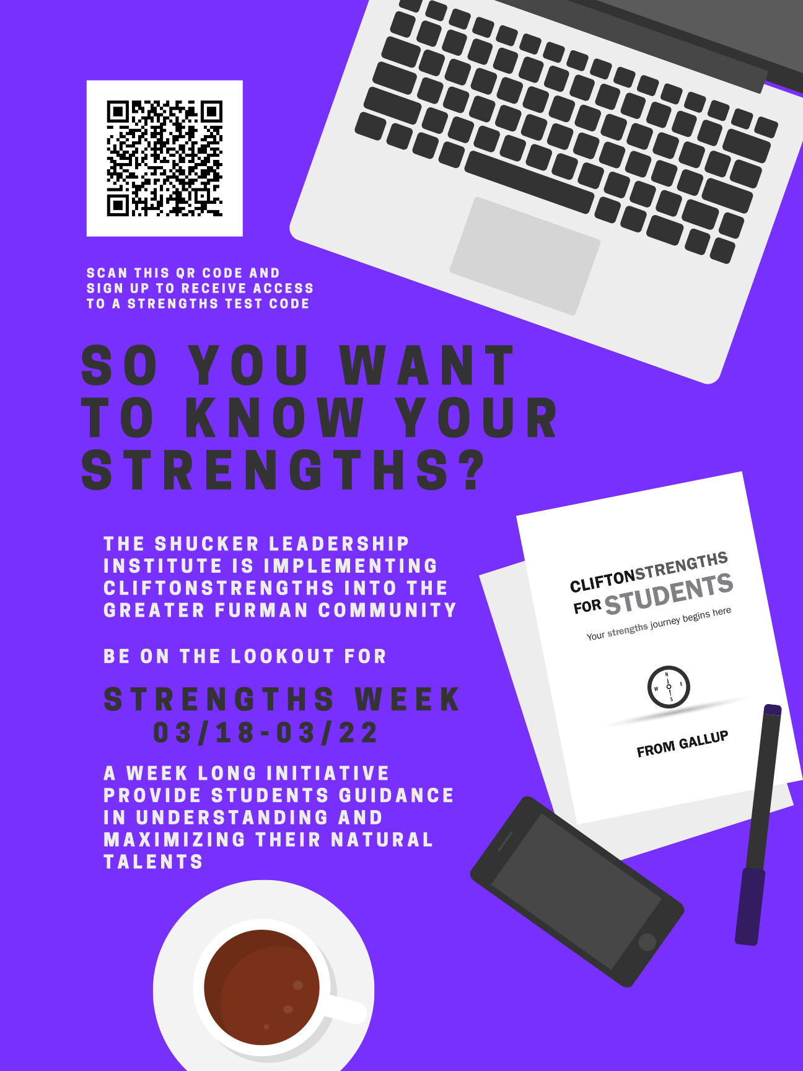

Adjournment:
The meeting was adjourned by President Will Sanders at 6:45 PM.

