Minutes of the
Furman University Student Government Association
48th Council
.
20th Meeting
18 March 2019
Trone Student Center, 208A (Thomas Room)

Call to Order:
The meeting was called to order by President Will Sanders at 6:00 PM.

Roll Call:
President Will Sanders took attendance and determined quorum was present. Twenty-one (21) of twenty-four (24) voting members were present. Absences: Nan Perry, Bailey Votto, Jaylon Goodwin
Approval of Minutes:
Move to approve meeting minutes from March 11th. Motion seconded; motion carried.

Special Guests:
Suzanne Klonis, Director of Assessment
- Aids The Furman Advantage by tracking student experiences via surveys
- Several surveys currently out right now from Suzanne’s office:
  - HERI surveys to First-Years and Seniors
  - HEDS Sexual Assault Campus Survey
  - Advising Evaluation
  - Engaged Learning Experiences
  - Course Evaluations
  - Senior Survey
- Looking to send out fewer, better surveys
- Please fill out surveys! They are super important and help Furman compare results with other institutions
- Contact Suzanne.klonis@furman.edu with any survey-related recommendations/questions
- See the attachment for results from the Spring 2018 Advising Survey and the Fall 2018 Entering Freshman Survey
Clayton Moyer, Heller Service Corps
- PalaTHON is this Saturday from 2-8pm in Timmons Arena
- All proceeds go to Greenville Children’s Hospital
Jason Cassidy, Dean of Students
- No report
Owen McFadden, Director of Campus Recreation and Fitness
- Campus Rec budget is about $79,000 for all necessary equipment for campus club sports
- Around 300 members of the Greenville area are members of the PAC
- Close to 1,500 people cycle through the PAC each day
- Intramural participation has dropped significantly
- There is currently an adequate budget provided to fund both intramural and club athletics
Chapin Silva, SGA Elections Chair
- Primary elections next Monday and Tuesday
- Regulations changes:
  - Candidates can now endorse other candidates
  - Candidates may not run on a ticket together
  - No limit on a number of posts you can do on social media per day as long as it is not overly excessive
  - More posters allowed on campus than in previous years
- Keep an eye out for malicious campaigning to be reported; we want this to be a positive experience for everyone
- Graduating seniors can vote in elections
Furman Film Club
- Hoping to start a club to get students together to watch films and discuss them
- Would bring different social groups together
- Would show films based on the Library of Congress’ list of important movies for American culture
- Would show both foreign and American films
- All club meetings would be open to everyone
- Hoping some film showings would count as CLPs
- Looking to collaborate with other clubs like FUOC for special events such as outdoor movies
Furman University Healthcare Administration Club
- For students interested in going into the healthcare administration field
- Field is projected to grow exponentially, so it is important to prepare students for related positions
- Hoping to collaborate with local organizations

Officer Reports:
Will Sanders, Executive President
- No office hours next week, election table sits instead
Scott Finney, Vice President
- Voting on Film Club next week and Healthcare Administration Club tonight
Prem Chockalingam, Treasurer
  - At-large organizations should have gotten an email from Prem
Caroline Tucker, Secretary
  - No report
Connor Dial, Parliamentarian
  - No report

Representative Reports:
Burke Lipscomb, FUSAB Rep.
- ESPN Tournament Challenge Group is live now until Tuesday! Make your bracket via the app and join the FUSAB group. The password is FUSAB. Making a bracket enters you into a drawing to get tickets for rounds 1 and 2 of the NCAA tournament in Columbia, and the person with the highest percentage bracket at Furman will get a prize basket.
- March 21st is "Spring Fling" axe throwing in Greenville, sign up in the FUSAB office
Hayden Braun, RLC Rep.
- No report
Payton Isner, Religious Council Rep.
- Tuesday 6PM - CLP Patrick Lecture Hall: Trafficked in America: A Film with International Justice Mission
- Tuesday 8PM - CLP Hartness Pavilion: God? Forum with Catholic Campus Ministries

- Wednesday 7PM - CLP Chapel Sanctuary: Sex and the Bible

- Thursday 7PM - CLP Johns Hall 101: Race, Religion, and Recompense

Chase Shaner, Campus Recreation Rep.
  - Looking into a “roll over” fund for club teams that go to championships
Muhammad Zakaria Shafqut, Student Diversity Council.
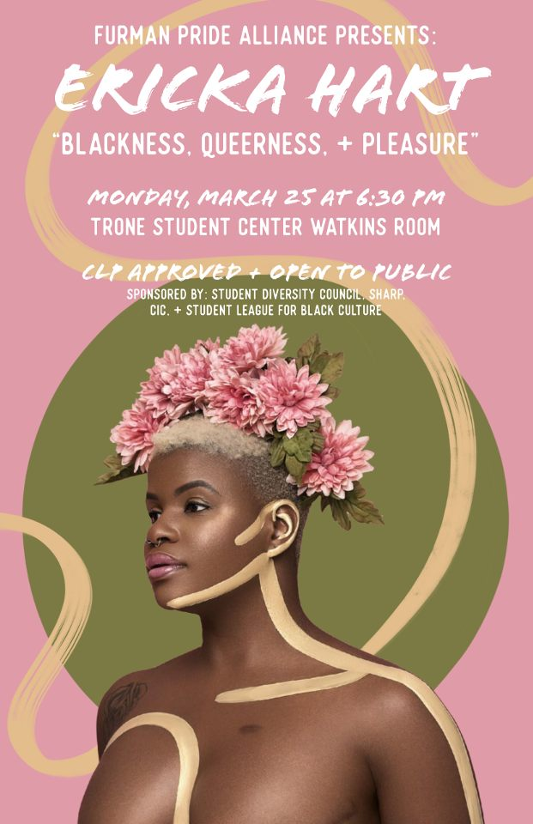

Non Voting Representative Reports:

Panhellenic Representatives
- Greek Week t-shirt orders close this Wednesday! This is a great way to get points for your chapter before the week begins!!
- https://order.universitytees.com/bird_banks/51109/signups/new
- Sign up for Greek Groove! The deadline to submit a team is this Wednesday. https://furman.crowdchange.co/7537
- General Greek Week info: https://docs.google.com/document/d/17Sgh9uDwHfSExrnqzlncwC-fGhiDfdX9aPM1s7muSws/edit?usp=sharing
Luke Allcock, IFC Representative
  - Greek Week is April 1-3
Payton Isner, Housing and Residence Life
- No report
Andrew Zinzarella, Army ROTC
  - Thanks for everyone who came to the CLP last week!
  - ROTC is doing the Color Guard for the basketball game next week; keep an eye out for them on TV!
Jamila Johnson, Athletics
  - No report

Class Reports:
Mary Morrow, Senior Class President
  - Senior Wine Tasting Thursday
Brooke O’Neill, Junior Class President
  - No report
Sophia Groves, Sophomore Class President
  - No report
Sarah Mobley, Freshman Class President
  - No report

Ad Hoc Committees:
- Vitality Committee
  - Looking to plan events for the seniors before graduation
- Service Committee
  - Go to PalaTHON!
- Bylaws Committee
  - No report
- Student Health Committee
  - No report
Old Business:
- None
New Business:
- None
Open Forum & Announcements:
- Motion to approve Furman University Healthcare Administration Club, motion carries
Adjournment:
The meeting was adjourned by President Will Sanders at 7:05 PM.

