Minutes of the
Furman University Student Government Association
48th Council
.
21th Meeting
2 April 2019
Trone Student Center, 208A (Thomas Room)

Call to Order:
The meeting was called to order by Treasurer Prem Chockalingam at 6:00 PM.

Roll Call:
Parliamentarian Connor Dial took attendance and determined quorum was present. Nineteen (19) of twenty (24) voting members were present. Absences: Will Sanders, Scott Finney, Caroline Tucker, Morgan Fretwell, Bailey Votto, Muhammad Zakaria Shafqut

Approval of Minutes:
Move to approve meeting minutes from March 18th. Motion seconded; motion carried.

Special Guests:
Chief Milby, Furman Police & Melissa Nichols, Title IX Coordinator
- There are lots of options when reporting a sexual assault; contact the Title IX office if you need anything in this regard
- April 4th at 4pm in Johns 101: speaking about stalking and dating violence

Officer Reports:
Will Sanders, Executive President
- No report
Scott Finney, Vice President
- No report
Prem Chockalingam, Treasurer
  - Has met with most at-large organizations about funding for next year
Caroline Tucker, Secretary
  - No report

Connor Dial, Parliamentarian
  - No report

Representative Reports:
Burke Lipscomb, FUSAB Rep.
- Friday, April 5th- Slide into Summer. Join FUSAB on the NV fields with shaved ice, water slides, and tie-dye tee shirts. Free and takes place 2:30-4 pm
- Wednesday, April 10th- Goat Yoga. Sign up in the FUSAB office for this unique experience to do yoga with baby goats at the Grove in TR! Cost is $10/pair
- Friday, April 12th- Amine Concert! Student tickets go up from $5 to $10 next week (the week of the concert)
Hayden Braun, RLC Rep.
- No report
Payton Isner, Religious Council Rep.
- No report

Chase Shaner, Campus Recreation Rep.
  - No report
Muhammad Zakaria Shafqut, Student Diversity Council.
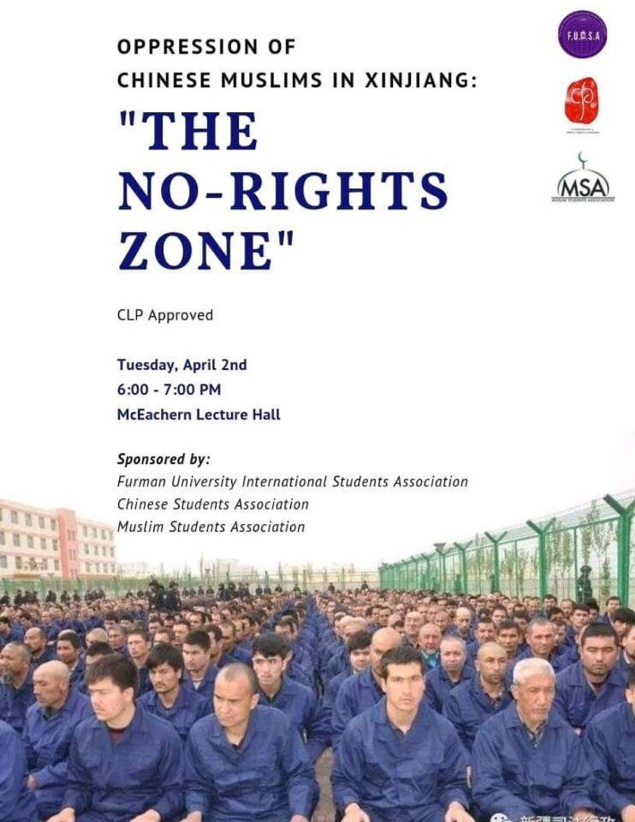

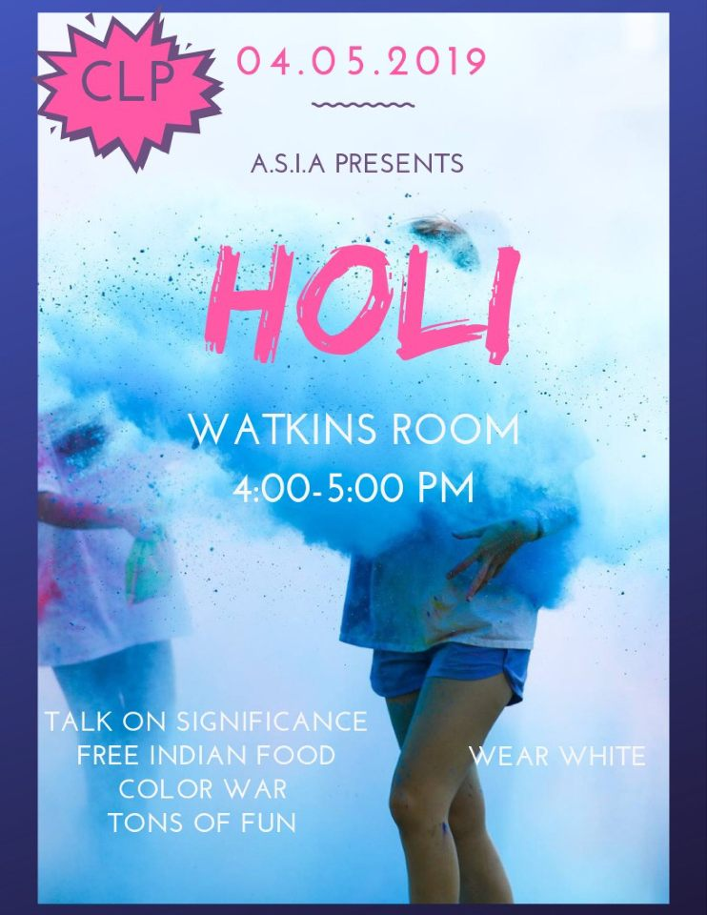



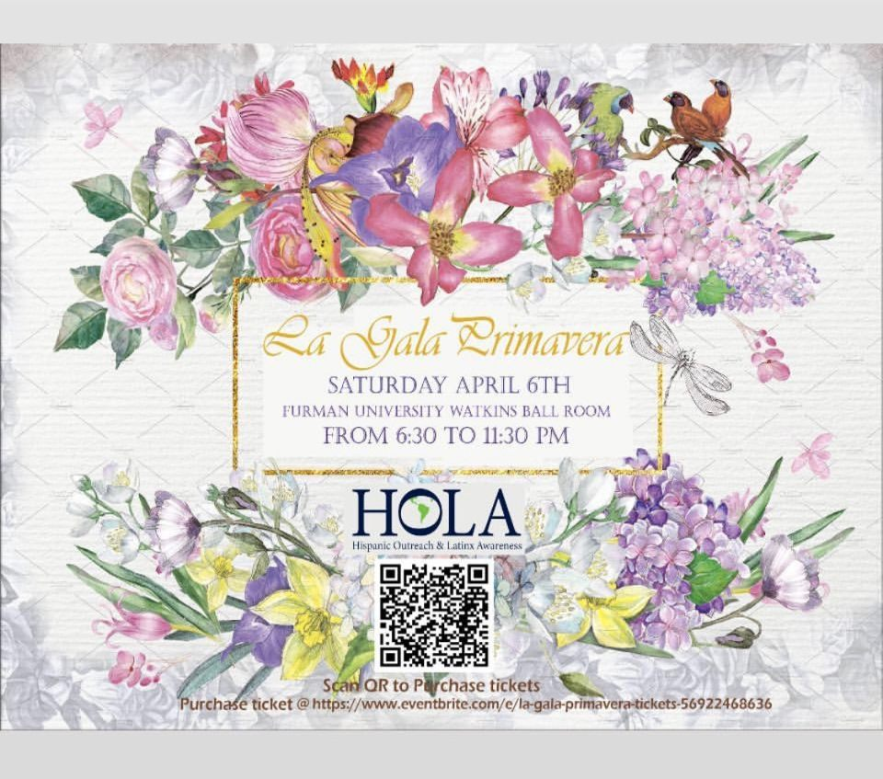

  - Non Voting Representative Reports:

Panhellenic Representatives
  - No report
Luke Allcock, IFC Representative
  - No report
Payton Isner, Housing and Residence Life
- No report
Andrew Zinzarella, Army ROTC
  - No report
Jamila Johnson, Athletics
  - No report

Class Reports:
Mary Morrow, Senior Class President
  - No report
Brooke O’Neill, Junior Class President
  - No report
Sophia Groves, Sophomore Class President
  - No report
Sarah Mobley, Freshman Class President
  - No report

Ad Hoc Committees:
- Vitality Committee
  - No report
- Service Committee
  - No report
- Bylaws Committee
  - No report
- Student Health Committee
  - No report
Old Business:

New Business:

Open Forum & Announcements:

Adjournment:
The meeting was adjourned by Treasurer Prem Chockalingam at 6:30 PM.

