<https://console.bluemix.net/docs/runtimes/php/getting-started.html#use_database>

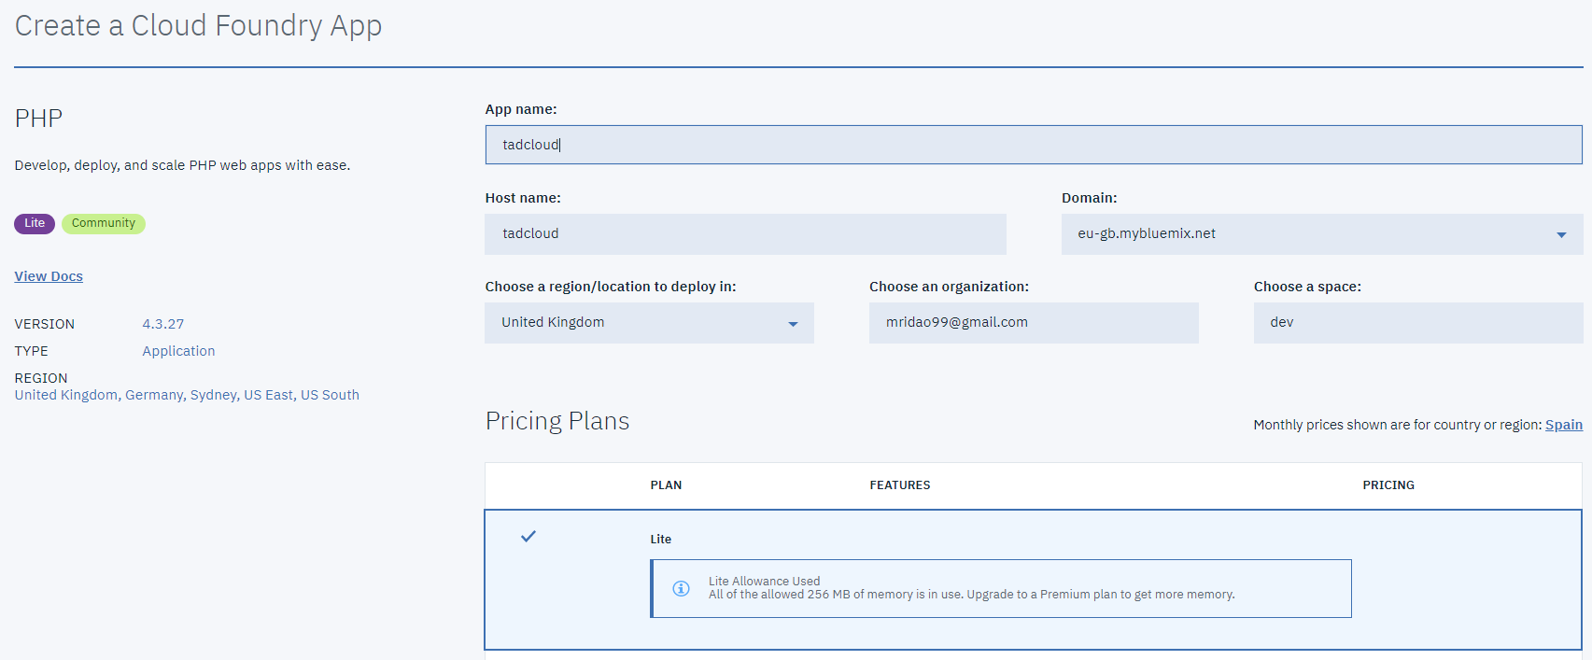

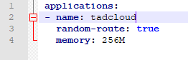

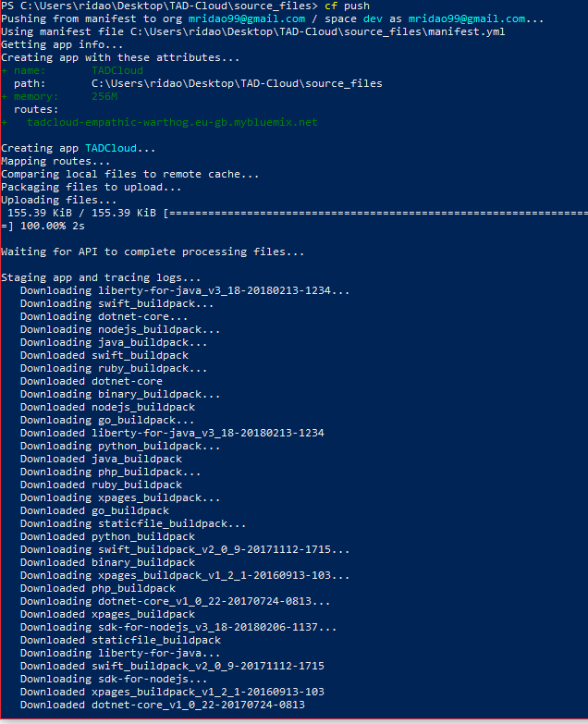

https://tadcloud-empathic-warthog.eu-gb.mybluemix.net/index.php