A
Report
on
Industrial Training
Of
CYBERVAULT – PASSWORD MANAGER, PASSWORD STRENGTH ANALYZER
AND FILE ENCRYPTION TOOLKIT USING C++
Submitted in partial fulfillment for the award of degree of
Bachelor of Technology
in
Computer Science & Engineering

Submitted By | ITS Coordinator(CC)
[Student Name] | Krati Bhatnagar
[Enrolment No.] | Assistant Professor

Department of Computer Science & Engineering
Jaipur Engineering College & Research Centre
Jaipur, Rajasthan
2026-27

CERTIFICATE
Insert your Industrial Training / Internship Certificate here

VISION OF CSE DEPARTMENT
To become renowned Centre of excellence in computer science and engineering and make competent engineers & professionals with high ethical values prepared for lifelong learning.
MISSION OF CSE DEPARTMENT
1. To impart outcome-based education for emerging technologies in the field of computer science and engineering.
2. To provide opportunities for interaction between academia and industry.
3. To provide platform for lifelong learning by accepting the change in technologies
4. To develop aptitude of fulfilling social responsibilities.
PROGRAM OUTCOMES (POs)
PO1: Engineering Knowledge: Apply knowledge of mathematics, natural science, computing, engineering fundamentals and an engineering specialization to develop to the solution of complex engineering problems.
PO2: Problem Analysis: Identify, formulate, review research literature and analyze complex engineering problems reaching substantiated conclusions with consideration for sustainable development.
PO3: Design/Development of Solutions: Design creative solutions for complex engineering problems and design/develop systems/components/processes to meet identified needs with consideration for the public health and safety, whole-life cost, net zero carbon, culture, society and environment as required.
PO4: Conduct Investigations of Complex Problems: Conduct investigations of complex engineering problems using research-based knowledge including design of experiments, modelling, analysis & interpretation of data to provide valid conclusions.
PO5: Engineering Tool Usage: Create, select and apply appropriate techniques, resources and modern engineering & IT tools, including prediction and modelling recognizing their limitations to solve complex engineering problems.
PO6: The Engineer and The World: Analyze and evaluate societal and environmental aspects while solving complex engineering problems for its impact on sustainability with reference to economy, health, safety, legal framework, culture and environment.
PO7: Ethics: Apply ethical principles and commit to professional ethics, human values, diversity and inclusion; adhere to national & international laws.
PO8: Individual and Collaborative Team work: Function effectively as an individual, and as a member or leader in diverse/multi-disciplinary teams.
PO9: Communication: Communicate effectively and inclusively within the engineering community and society at large, such as being able to comprehend and write effective reports and design documentation, make effective presentations considering cultural, language, and learning differences

PO10: Project Management and Finance: Apply knowledge and understanding of engineering management principles and economic decision-making and apply these to one’s own work, as a member and leader in a team, and to manage projects and in multidisciplinary environments.
PO11: Life-Long Learning: Recognize the need for and have the preparation and ability for independent and life-long learning adaptability to new and emerging technologies and critical thinking in the broadest context of technological change.
PROGRAM EDUCATIONAL OBJECTIVES (PEOs)
The PEOs of the B. Tech (CSE) program are:
1. To produce graduates who are able to apply computer engineering knowledge to provide turn-key IT solutions to national and international organizations.
2. To produce graduates with the necessary background and technical skills to work professionally in one or more of the areas like – IT solution design development and implementation consisting of system design, network design, software design and development, system implementation and management etc. Graduates would be able to provide solutions through logical and analytical thinking.
3. To able graduates to design embedded systems for industrial applications.
4. To inculcate in graduates’ effective communication skills and team work skills to enable them to work in multidisciplinary environment.
5. To prepare graduates for personal and professional success with commitment to their ethical and social responsibilities.
PROGRAM SPECIFIC OUTCOMES (PSOs)
• PSO1: Ability to interpret and analyze network specific and cyber security issues in real world environment.
• PSO2: Ability to design and develop mobile and web-based applications under realistic constraints.
COURSE OUTCOMES (COs)
CO1: Understand the structure, functions, and operations of the industry
CO2: Apply technical skills to practical industrial situations
CO3: Recognize the software and hardware requirements of your project
CO4: Analyse and solve real-time industrial problems using appropriate engineering methods
CO5: Develop communication, teamwork, time management, and professional ethics required in the workplace
CO6: Prepare technical reports, presentations, and documentation reflecting the work experience gained during training
MAPPING: CO’s & PO’s
PO1 | PO2 | PO3 | PO4 | PO5 | PO6 | PO7 | PO8 | PO9 | PO10 | PO11
3 | 2 | 2 | 1 | 2 | 2 | 2 | 2 | 2 | 3 | 1
3 | 3 | 3 | 2 | 3 | 2 | 2 | 2 | 2 | 3 | 1
3 | 2 | 2 | 2 | 3 | 1 | 1 | 2 | 1 | 2 | 1
3 | 3 | 3 | 3 | 3 | 2 | 2 | 2 | 2 | 3 | 1
2 | 2 | 2 | 1 | 2 | 2 | 3 | 3 | 3 | 2 | 1
2 | 2 | 2 | 1 | 2 | 2 | 2 | 2 | 3 | 2 | 1

ACKNOWLEDGEMENT
It has been a great honour and privilege to undergo training at {{ORG}}. I am very grateful to the organization for providing me the opportunity to gain practical exposure to an industrial working environment and to understand the application of technical and analytical skills in real-world situations while developing the CyberVault project.
I take this opportunity to express my deep sense of gratitude to my ITS Coordinator (CC) Krati Bhatnagar Assistant Professor Department of Computer Science and Engineering, Jaipur Engineering College & Research Centre, Jaipur, for her valuable guidance and cooperation throughout the Practical Training work.
I would like to first of all express our thanks to Mr. Arpit Agrawal Director of JECRC, for providing us such a great infrastructure and environment for our overall development.
I express sincere thanks to Dr. V. K. Chandna, Principal of JECRC, for his kind cooperation and extendible support towards the completion of Industrial Training.
I express my indebtedness to Dr. Vijeta Kumawat Professor & Head, Department of Computer Science & Engineering, and also grateful to our Dr. Nikita Gupta Deputy Head, for guiding me and for providing me ample support during my Industrial Training period. Without their support and timely guidance, the completion of our Industrial Training would have seemed a farfetched dream. Also, our warm thanks to Jaipur Engineering College and Research Centre, who provided us this opportunity.
Place: Jaipur Engineering College & Research Centre, Jaipur
[Student Name]
[Enrolment No.]
B.Tech. V Semester, III Year, CSE
ABSTRACT
The increasing use of online services has made every individual responsible for dozens of accounts, and the security of these accounts depends largely on the strength and safe storage of passwords. Weak, reused or carelessly stored passwords remain one of the most common causes of unauthorized access and data theft. Sensitive files stored on personal computers are also exposed when a device is lost, shared or compromised.
The project “CYBERVAULT – PASSWORD MANAGER, PASSWORD STRENGTH ANALYZER AND FILE ENCRYPTION TOOLKIT USING C++” focuses on developing a console-based security toolkit that combines secure user authentication, password strength analysis, file encryption and decryption, and an encrypted password vault in a single application written in C++.
The system allows a user to register with a username and password. A random salt is generated for every user, the salt and password are combined and processed using the 64-bit FNV-1a hash function, and only the username, salt and hexadecimal hash value are stored in a text file, so that the original password is never saved. During login the hash is recomputed and compared with the stored value.
After a successful login the user can open a dashboard that provides a Password Strength Analyzer, which checks length, uppercase letters, lowercase letters, digits and special characters and then reports the strength as Weak, Medium or Strong along with improvement suggestions. The dashboard also offers file encryption and decryption using a repeating-key XOR cipher, which produces .enc and .dec output files, and a Password Manager in which website, username and password entries are encrypted with a session key, hex-encoded and stored in a vault file. Entries can be added, viewed and deleted.
The project demonstrates practical use of C++ file handling, string processing, the Standard Template Library, random number generation, hashing and symmetric encryption concepts. It also provides practical experience in program structuring, input validation, error handling and security-oriented software design.
LIST OF FIGURES
S. No. | Figure No. | Figure Title
1 | Figure 1 | System Architecture
2 | Figure 2 | Application Workflow
3 | Figure 3 | Registration and Login Workflow
4 | Figure 4 | File Encryption / Decryption Workflow
5 | Figure 5 | Password Vault Workflow
6 | Figure 6 | Main Menu Console Output
7 | Figure 7 | User Registration and Login Console Output
8 | Figure 8 | User Dashboard Console Output
9 | Figure 9 | Password Strength Analyzer Console Output
10 | Figure 10 | File Encryption and Decryption Console Output
11 | Figure 11 | Password Manager Console Output

LIST OF TABLES
S. No. | Table No. | Table Title
1 | Table 1 | Hardware Requirements
2 | Table 2 | Software Requirements
3 | Table 3 | Functional Requirements
4 | Table 4 | Non-Functional Requirements
5 | Table 5 | System Components
6 | Table 6 | Password Strength Criteria
7 | Table 7 | Test Cases and Expected Output

TABLE OF CONTENTS
FRONT MATTER
Certificate ii
Vision and Mission iii
Program Outcomes (POs) iv
Program Educational Objectives (PEOs) vi
Program Specific Outcomes (PSOs) vii
Course Outcomes (COs) viii
Mapping: COs & POs ix
Acknowledgement x
Abstract xi
Table of Contents xiv
List of Figures xii
List of Tables xiii
CHAPTER 1: INTRODUCTION AND OBJECTIVE
1.1 Introduction 1
1.2 Background 2
1.3 Problem Statement 2
1.4 Motivation 3
1.5 Objectives 3
1.6 Scope 4
1.7 Advantages 4
CHAPTER 2: REQUIREMENT ANALYSIS AND SPECIFICATION
2.1 Hardware Requirement 5
2.2 Software Requirement 5
2.3 Functional Requirement 6
2.4 Non-Functional Requirements 6
2.5 User Classes and Characteristics 7
2.6 Feasibility Analysis 7
CHAPTER 3: SYSTEM DESIGN AND ARCHITECTURE
3.1 Introduction 8
3.2 System Architecture 8

3.3 Application Workflow 9
3.4 Use Case Diagram 9
3.5 Registration and Login Workflow 10
3.6 File Encryption / Decryption Workflow 11
3.7 Password Vault Workflow 12
3.8 System Components 13
3.9 Security and Privacy 13
CHAPTER 4: IMPLEMENTATION AND SOURCE CODE
4.1 Development Environment 14
4.2 Program Structure 14
4.3 Data Persistence 15
4.4 User Registration 15
4.5 Salt Generation 16
4.6 Password Hashing (FNV-1a) 16
4.7 User Login 17
4.8 Password Strength Analyzer 17
4.9 File Encryption and Decryption 18
4.10 Password Manager – Add Password 19
4.11 Password Manager – View Passwords 19
4.12 Password Manager – Delete Password 19
4.13 Dashboard and Session Management 20
4.14 Input Validation and Error Handling 20
4.15 Testing 21
CHAPTER 5: PROJECT SCREENSHOTS AND RESULTS
5.1 Screenshot 1 – Main Menu 22
5.2 Screenshot 2 – Registration and Login 22
5.3 Screenshot 3 – User Dashboard 23
5.4 Screenshot 4 – Password Strength Analyzer 23
5.5 Screenshot 5 – File Encryption and Decryption 24
5.6 Screenshot 6 – Password Manager 24
5.7 Results and Discussion 25
CHAPTER 6: CONCLUSION AND FUTURE SCOPE
6.1 Conclusion 26
6.2 Future Scope 27
REFERENCES 28

CHAPTER 1
INTRODUCTION
1.1 Introduction
Computers and the internet now store and carry a large part of our personal, academic and professional lives. Every e-mail account, bank portal, social network, cloud drive and online shop asks the user to prove his or her identity, and in most cases this proof is a password. As the number of accounts grows, users tend to choose short, predictable or repeated passwords because these are easy to remember. Attackers exploit this behaviour through guessing, dictionary attacks and the reuse of leaked credentials.
Sensitive data is also kept in ordinary files such as documents, records and notes. If such files are left in plain form, anyone who gains access to the device can read them. Encryption solves this problem by converting readable data into an unreadable form that can be recovered only by a person who knows the key.
Security tools that solve these problems are often large, closed-source and difficult to understand. For a student of computer science and engineering it is valuable to build a compact tool in which every step – from registering a user to encrypting a byte of data – can be read, understood and explained.
The CyberVault project is a console application written in C++ that brings together four important security functions: secure user registration and login, a password strength analyzer, a file encryption and decryption utility and an encrypted password manager.
1.2 Background
Information security rests on three basic goals: confidentiality, integrity and availability. Confidentiality means that information is available only to authorized persons. Passwords, hashing and encryption are the everyday tools that provide confidentiality.
Authentication is the process of verifying who a user is. A well-designed system never stores the password itself. Instead it stores a hash, a fixed-length value computed from the password by a one-way function. To make identical passwords produce different hashes and to defeat pre-computed lookup tables, a random value called a salt is combined with the password before hashing.
Encryption is the transformation of plain data into cipher data using a key. In symmetric encryption the same key is used for encryption and decryption. The XOR cipher is the simplest symmetric scheme: each byte of data is combined with a byte of the key using the exclusive-OR operation, and applying the same operation with the same key restores the original data.
A password manager stores the user’s credentials for different websites in an encrypted store so that the user needs to remember only one master password. A password strength analyzer measures how difficult a password is to guess by checking its length and the variety of characters used.
1.3 Problem Statement
The objective of the project is to develop an integrated, easy-to-understand security toolkit that authenticates users safely, evaluates the strength of passwords, protects files with encryption and stores website credentials in an encrypted vault.
The system should never store passwords in plain text, should give clear feedback and improvement suggestions for weak passwords, and should process files of any type as binary data.
1.4 Motivation
The motivation for developing this system is the gap between security theory taught in class and security practice. Reports of data breaches show that weak and reused passwords are still widespread, and that many users do not know how password storage, hashing and encryption actually work.
Building the tool from first principles in C++ provides hands-on exposure to file handling, string manipulation, containers, random number generation and the design of a menu-driven application, while at the same time teaching the core ideas of salting, hashing and symmetric encryption.
1.5 Objectives
The major objectives are:
1. To understand the importance of authentication, password security and data confidentiality.
2. To implement user registration with duplicate-username detection and password confirmation.
3. To generate a random salt for every user and store only a salted hash of the password.
4. To implement secure login by recomputing and comparing the salted hash.
5. To analyze the strength of a password and suggest improvements.
6. To encrypt and decrypt files using a key-based XOR cipher.
7. To build a password manager that stores website credentials in an encrypted vault.
8. To allow adding, viewing and deleting of saved credentials.
9. To design a simple menu-driven console interface with proper error messages.
10. To gain practical experience in secure software design using C++.
1.6 Scope
The project can be applied to:
• Learning and demonstration of authentication and password-hashing concepts
• Checking the quality of passwords before they are used
• Protecting personal documents and text files with a secret key
• Keeping a small personal vault of website credentials
• Academic laboratory exercises in cyber security and C++ programming
• Foundation for a larger, production-grade security application
The current implementation is a single-machine, console-based application that stores its data in local text files.
1.7 Advantages
The system provides:
• Integration of four security utilities in one application
• Passwords are never stored in readable form
• Per-user random salt
• Immediate strength feedback with actionable suggestions
• Works on any type of file because data is processed as bytes
• Lightweight, no external libraries or database required
• Simple and readable code that is easy to extend
CHAPTER 2
REQUIREMENT ANALYSIS AND SPECIFICATION
Requirement analysis identifies the hardware, software, functional and non-functional requirements necessary for developing and operating the application.
2.1 HARDWARE REQUIREMENT
Component | Minimum / Suggested Requirement
Processor | Intel Core i3 / Apple Silicon or equivalent
RAM | 4 GB or above
Storage | At least 500 MB free
Display | Standard monitor
Input | Keyboard

Table 1: Hardware Requirements
2.2 SOFTWARE REQUIREMENT
Technology | Purpose
C++ (Clang / g++) | Programming language and compiler
C++ Standard Library (STL) | Strings, vectors, file streams, random numbers
macOS / Linux / Windows Terminal | Console execution environment
VS Code / any text editor | Source code editing
Git and GitHub | Version control and code hosting

Table 2: Software Requirements
2.3 FUNCTIONAL REQUIREMENT
ID | Requirement
FR1 | Register a new user with a unique username and confirmed password
FR2 | Generate a random salt and store only the salted hash
FR3 | Authenticate a registered user at login
FR4 | Analyze the strength of an entered password and give suggestions
FR5 | Encrypt a file with a user-supplied key
FR6 | Decrypt a file with the same key
FR7 | Add a website, username and password entry to the vault
FR8 | View all saved vault entries of the logged-in user
FR9 | Delete a selected vault entry
FR10 | Log out and clear the session

Table 3: Functional Requirements
2.4 NON-FUNCTIONAL REQUIREMENTS
Requirement | Description
Security | No plain-text password storage; salted hashing; encrypted vault
Performance | Fast processing of hashing and file encryption
Usability | Simple numbered menus and clear messages
Reliability | Graceful handling of missing files and invalid input
Maintainability | Modular functions for each feature
Portability | Standard C++ code that can be compiled on major platforms

Table 4: Non-Functional Requirements
2.5 USER CLASSES AND CHARACTERISTICS
The main user is a person who wants to store credentials safely, check the quality of a password or protect a file. The user does not need any knowledge of hashing or encryption; all operations are available through numbered menu choices.
A developer or administrator may maintain the source code and inspect the data files (users.txt and vault.txt). The application is therefore designed with a simple user-facing layer while the security logic is kept inside separate functions.
2.6 FEASIBILITY ANALYSIS
Technical feasibility is supported by the availability of free C++ compilers and the rich C++ Standard Library, which provides every facility required by the project. Economic feasibility is supported by the use of freely available tools and the absence of any licensing cost. Operational feasibility is supported by the simple interaction model: choose an option, enter the requested values and read the result.
The project is therefore suitable for an industrial training environment and can be implemented on ordinary development hardware.
CHAPTER 3
SYSTEM DESIGN
3.1 Introduction
The system design divides the application into logical modules: the interface layer, the authentication module, the dashboard, the functional modules (strength analyzer, file encryption and password manager), the cipher engine and the storage layer. This modular design makes the system easier to understand and maintain.
3.2 System Architecture
The complete system architecture is shown below. The user interacts with the main menu; after authentication the dashboard gives access to the three functional modules, which use the XOR cipher engine and read or write the data files.
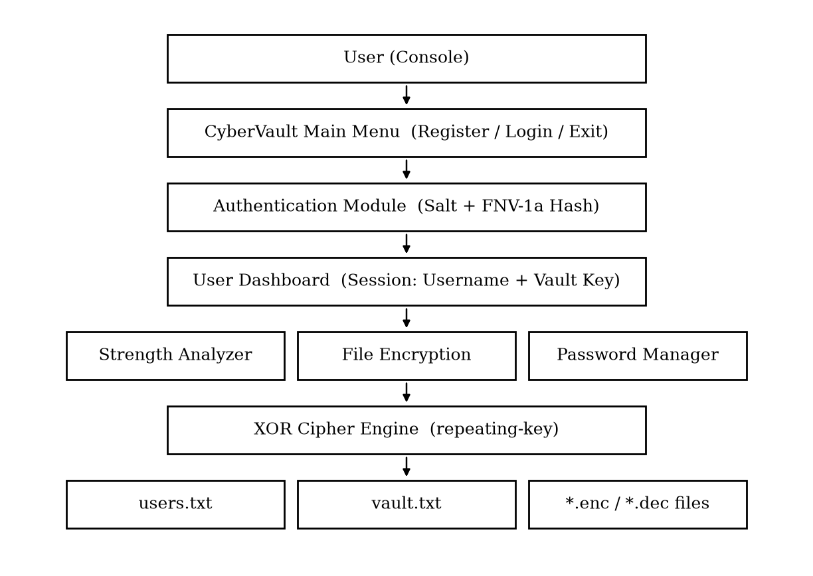
Figure 1: System Architecture
3.3 Application Workflow
The program starts at the CyberVault main menu where the user can register, log in or exit. Successful login opens the dashboard, which repeats until the user logs out, after which control returns to the main menu.
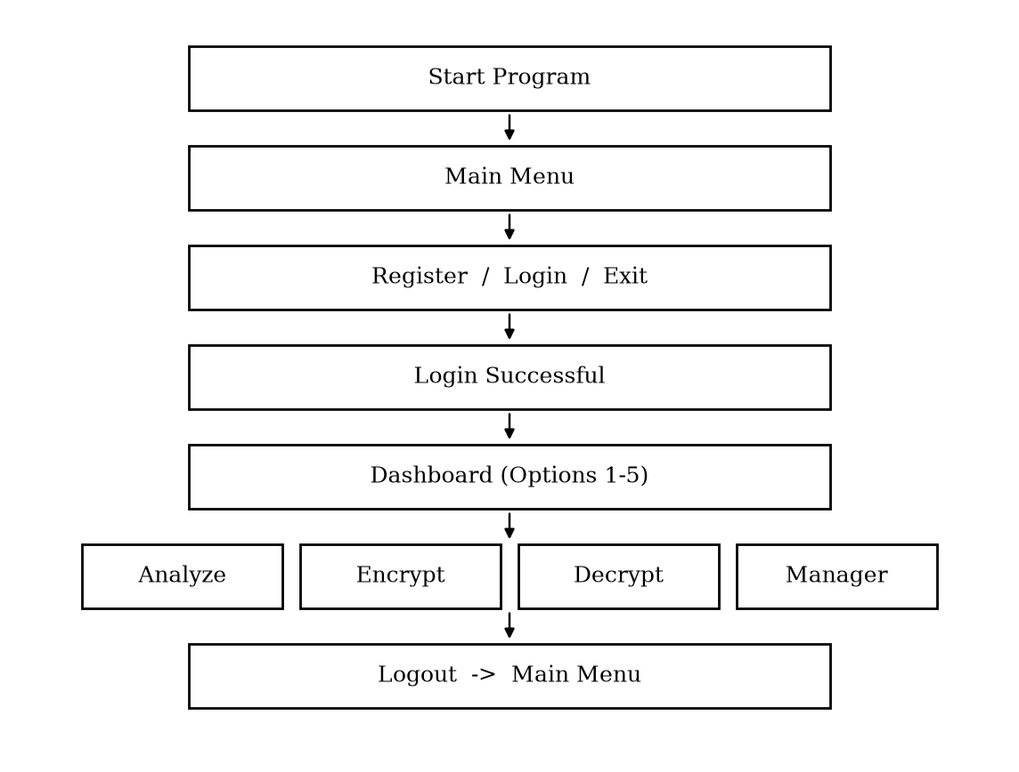
Figure 2: Application Workflow
3.4 Use Case Diagram
The principal actor is the user. The user registers, logs in and then selects one of the dashboard use cases: analyze password strength, encrypt a file, decrypt a file or manage passwords. Internal use cases include hashing, salt generation, XOR processing and file handling.
USER → REGISTER / LOGIN → DASHBOARD → (ANALYZE | ENCRYPT | DECRYPT | MANAGE PASSWORDS) → LOGOUT
3.5 Registration and Login Workflow
During registration the program rejects an existing username, asks for the password twice, generates a random salt, computes the FNV-1a hash of the salt and password and appends one record to users.txt. During login the program finds the username, reads its salt, recomputes the hash from the entered password and compares it with the stored hash.
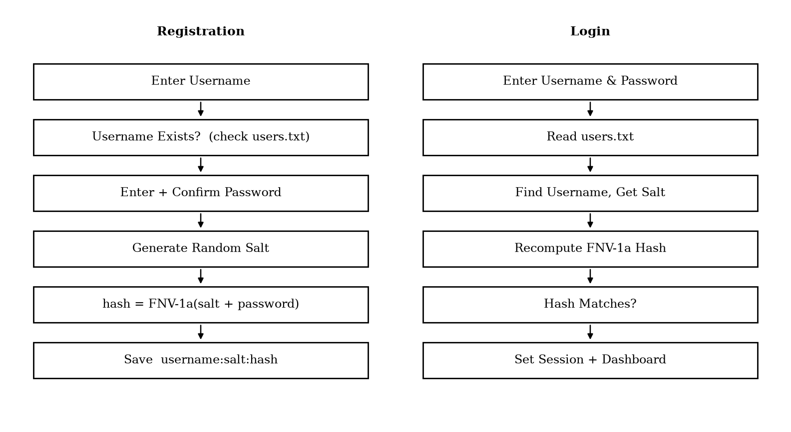
Figure 3: Registration and Login Workflow
3.6 File Encryption / Decryption Workflow
The same routine is used for encryption and decryption because the XOR operation is its own inverse. The program refuses an empty key, reads the input file as bytes, combines every byte with the corresponding byte of the repeating key and writes the result to a new output file with the extension .enc (encryption) or .dec (decryption).
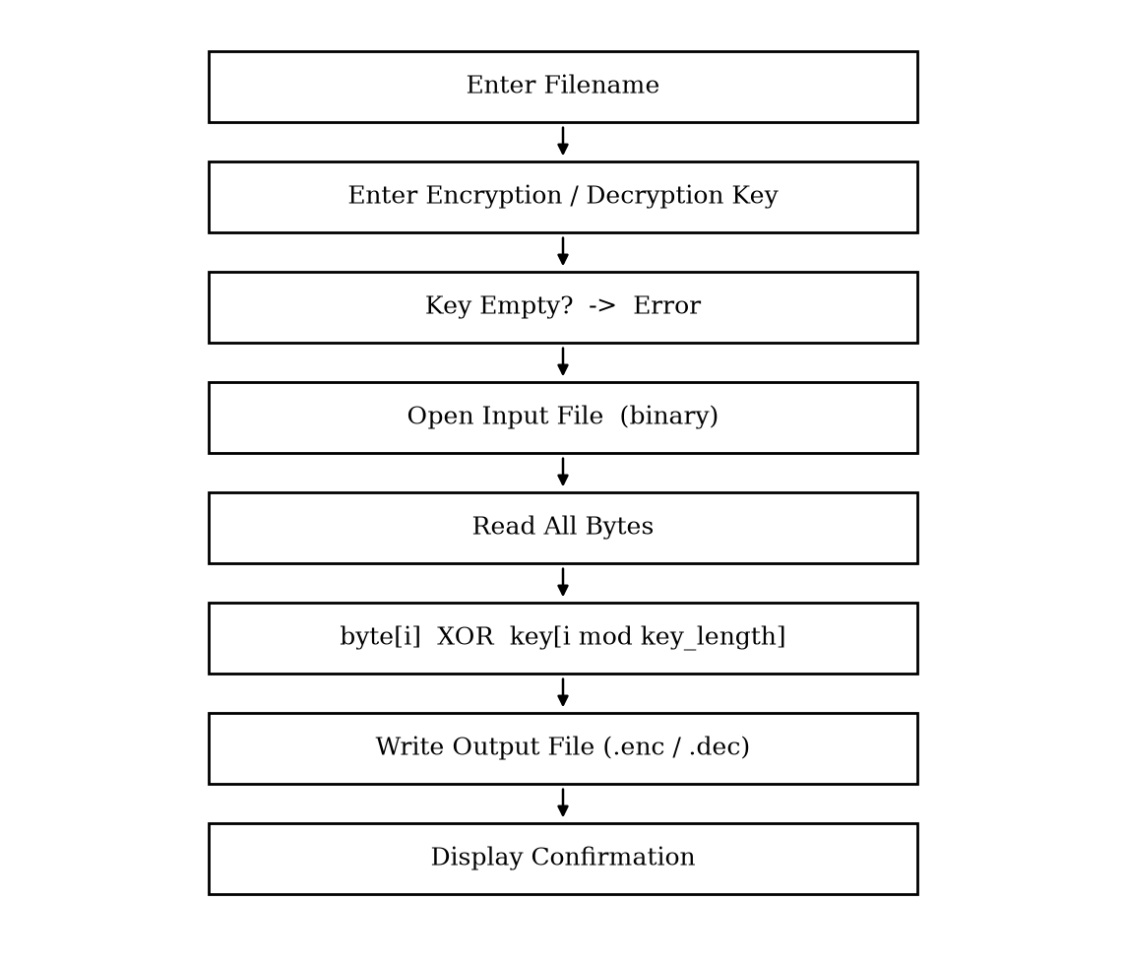
Figure 4: File Encryption / Decryption Workflow
3.7 Password Vault Workflow
The password manager keeps the vault in vault.txt. Each operation loads the entries of the logged-in user, decrypts them with the session key for display or modification and, when data changes, encrypts and stores them again.
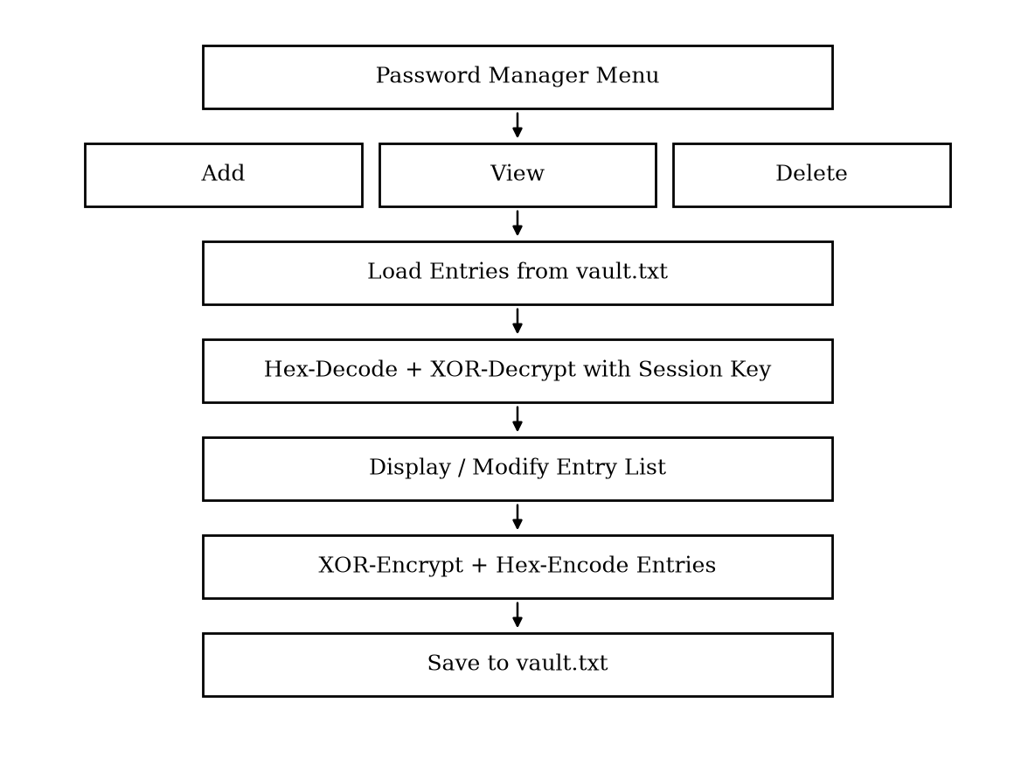
Figure 5: Password Vault Workflow
3.8 System Components
The authentication module protects access. The salt generator provides per-user randomness. The hash function converts the salted password into a fixed-length value. The analyzer evaluates passwords. The cipher engine encrypts and decrypts data. The vault stores credentials. The dashboard connects the user to all modules.
Component | Function
Main Menu | Register, login and exit options
Authentication Module | Registration and login verification
Salt Generator | Random per-user salt
FNV-1a Hash | Salted password hash
Strength Analyzer | Password rating and suggestions
XOR Cipher Engine | File and vault encryption
Password Vault | Encrypted credential storage
users.txt / vault.txt | Persistent data files

Table 5: System Components
3.9 Security and Privacy
Passwords are never written to disk in readable form: user passwords are stored only as salted hashes and vault passwords are encrypted. The session username and vault key are held in memory only and are cleared when the user logs out.
The FNV-1a hash and the XOR cipher are chosen for clarity and learning; they are not designed to resist determined attackers. For real-world use, a slow password-hashing function such as bcrypt or Argon2 and a modern cipher such as AES should be used, as suggested in the future scope. Data files should also be protected with proper operating-system permissions.
CHAPTER 4
IMPLEMENTATION
4.1 Development Environment
The application is implemented as a single C++ source file (m.cpp) that is compiled with the Clang compiler and the libc++ standard library into the executable m. The program uses only the C++ Standard Library (iostream, fstream, sstream, string, vector, random, iomanip and cctype). Development can be done in VS Code or any text editor and the program is run from a terminal.
4.2 Program Structure
The program is organized into small functions, each responsible for one task:
• main() – shows the main menu (Register, Login, Exit) and dispatches the choice.
• registerUser() and login() – create and verify user accounts.
• makeSalt(), toHexNumber() and hexValue() – salt creation and hexadecimal conversion helpers.
• A 64-bit FNV-1a hash routine that hashes the salt joined with the password.
• dashboard() – the post-login menu with five options.
• Password strength analysis and XOR-based file encryption / decryption routines.
• passwordManagerMenu(), addPassword(), viewPasswords(), deletePassword() and loadEntries() – the vault.
• logoutUser() – clears the session.
• struct PasswordEntry – holds the website, username and password of one vault record.
• Global session variables currentUsername and currentVaultKey.
4.3 Data Persistence
The program stores its data in two text files in the working directory. users.txt holds one record per registered user containing the username, the salt and the salted hash, separated by a colon. vault.txt holds the encrypted password entries. Both files are created automatically when first needed. If a file cannot be opened the program displays “Unable to open users file.” or “Unable to open vault file.”
4.4 User Registration
Registration is implemented in registerUser(). The steps are:
1. Read the new username and scan users.txt; if the username already exists, display “Username already exists.” and stop.
2. Read the password and its confirmation; if they differ, display “Passwords do not match.”
3. Call makeSalt() to generate a random salt.
4. Compute the hash of the salt joined with the password.
5. Append the username, salt and hash to users.txt and display “Registration successful.”
4.5 Salt Generation
The function makeSalt() creates a random 64-bit number using the C++ std::mt19937_64 generator that is seeded from std::random_device. The number is converted to a zero-padded, 16-digit hexadecimal string by toHexNumber(), using the stream manipulators std::hex, std::setw(16) and std::setfill('0'). Because every user receives a different salt, two users with the same password obtain different stored hashes.
4.6 Password Hashing (FNV-1a)
Passwords are hashed with the 64-bit Fowler–Noll–Vo (FNV-1a) algorithm. The hash starts with the offset basis 0xcbf29ce484222325. For every byte of the input the hash is XOR-ed with the byte and multiplied by the FNV prime 0x100000001b3. The result is converted to hexadecimal and stored.
uint64_t fnv1a64(const std::string& s) {
uint64_t hash = 14695981039346656037ULL; // offset basis
for (unsigned char c : s) {
hash ^= c; // XOR the byte
hash *= 1099511628211ULL; // multiply by FNV prime
}
return hash;
}

// stored value = toHexNumber( fnv1a64( salt + password ) )

Listing 4.1: FNV-1a hashing routine used for password storage
4.7 User Login
The function login() reads the username and password and opens users.txt. If the file does not exist the message “No users registered yet.” is displayed. Otherwise every record is read, split at the colon separators and the username is compared. When the username matches, the stored salt is joined with the entered password, hashed again and compared with the stored hash. If both hashes are equal the message “Login successful.” is displayed, the session variables currentUsername and currentVaultKey are set and the dashboard opens. Otherwise “Invalid username or password.” is shown. The same message is used for an unknown user and a wrong password so that an attacker cannot tell which part was wrong.
4.8 Password Strength Analyzer
The analyzer is available from the dashboard. It examines the entered password using the character-class functions isupper, islower and isdigit (and a test for special characters) and produces the rating Weak, Medium or Strong followed by specific suggestions.
Criterion | Suggestion shown when the criterion is not met
Length of at least 8 | Increase length to at least 8 characters.
Length of 12 or more | Use 12 or more characters for better security.
Uppercase letter | Add an uppercase letter.
Lowercase letter | Add a lowercase letter.
Digit | Add a number.
Special character | Add a special character.
All criteria met | Password looks strong.

Table 6: Password Strength Criteria
4.9 File Encryption and Decryption
The encrypt and decrypt options ask for a filename and a key. If the key is empty the message “Key cannot be empty.” is shown. The input file is opened in binary mode; if it cannot be opened, “Unable to open input file.” is shown. The entire file is read into a byte vector and each byte is combined with the key using a repeating-key XOR: byte number i is XOR-ed with the key character at position i modulo the key length.
for (size_t i = 0; i < data.size(); ++i) {
data[i] = data[i] ^ key[i % key.size()];
}

Listing 4.2: Repeating-key XOR used for encryption and decryption
The result is written to a new file whose name is the input name followed by .enc (for encryption) or .dec (for decryption), and the message “Encrypted file created:” or “Decrypted file created:” together with the filename is displayed. If the output file cannot be created, “Unable to open output file.” is shown. Since XOR is its own inverse, decrypting with the same key restores the original file exactly; a wrong key produces unreadable data.
4.10 Password Manager – Add Password
The Password Manager menu (Add Password, View Passwords, Delete Password, Back) is opened from the dashboard. To add an entry the program asks for the website, username and password and stores them in a PasswordEntry. The fields are encrypted with the XOR routine using the session key held in currentVaultKey, converted to hexadecimal so that the file contains only printable characters, and appended to vault.txt. The message “Password saved.” confirms the operation.
4.11 Password Manager – View Passwords
loadEntries() reads vault.txt, converts the hexadecimal text back to bytes using hexValue(), decrypts the fields with the session key and fills a std::vector<PasswordEntry>. The entries are then displayed under the heading “Saved Passwords” as a numbered list showing website and credentials. If there is nothing to show, “No passwords saved.” is displayed.
4.12 Password Manager – Delete Password
The delete option lists all entries under “Your Password Entries” and asks “Choose entry number to delete:”. A number outside the valid range produces “Invalid choice.”. For a valid number the entry is erased from the vector, the vault file is rewritten and “Password deleted.” is displayed. When the vault is empty the program shows “No passwords to delete.”
4.13 Dashboard and Session Management
After login the function dashboard() greets the user (“Welcome, <username>”) and repeatedly shows five options: Password Strength Analyzer, Encrypt File, Decrypt File, Password Manager and Logout. The global variables currentUsername and currentVaultKey identify the logged-in user and supply the key for vault encryption. logoutUser() clears both variables, displays “Logged out.” and returns to the main menu, so no session data remains after logout.
4.14 Input Validation and Error Handling
The program checks every operation that may fail and reports the problem in plain language:
• Duplicate usernames and mismatching password confirmation during registration.
• Missing user file or wrong credentials during login.
• Empty encryption / decryption key.
• Input or output file that cannot be opened.
• Vault file that cannot be opened.
• Invalid menu choice (“Invalid choice.”) and invalid entry number when deleting.
4.15 Testing
Testing involves supplying valid and invalid inputs to each module and comparing the displayed message with the expected behaviour. The following test cases cover the main paths; the actual output observed during execution should be recorded at demonstration time.
No. | Test Case | Expected Output
1 | Register with an unused username and matching passwords | Registration successful.
2 | Register with an existing username | Username already exists.
3 | Register with different password and confirmation | Passwords do not match.
4 | Login before any user is registered | No users registered yet.
5 | Login with correct username and password | Login successful.
6 | Login with wrong password | Invalid username or password.
7 | Encrypt a file with an empty key | Key cannot be empty.
8 | Encrypt a file that does not exist | Unable to open input file.
9 | Encrypt an existing file with a key | Encrypted file created: <file>.enc
10 | Decrypt the .enc file with the same key | Decrypted file created: <file>.dec (original content)
11 | Add a website, username and password | Password saved.
12 | View passwords when the vault is empty | No passwords saved.
13 | Delete with an out-of-range entry number | Invalid choice.
14 | Delete an existing entry | Password deleted.

Table 7: Test Cases and Expected Output
CHAPTER 5
PROJECT SCREENSHOTS AND RESULTS
This chapter presents the console output of the implemented program. The figures reproduce the prompts and messages produced by the application; angle brackets <> mark values entered by the user. They can be replaced by terminal screenshots captured during the demonstration.
5.1 Screenshot 1 – Main Menu
The main menu is the entry point of the CyberVault application. It offers registration, login and exit.
===========================
CyberVault
===========================
1. Register
2. Login
3. Exit
Choose:

Figure 6: Main Menu Console Output
5.2 Screenshot 2 – Registration and Login
A new user is registered with a confirmed password and then logs in with the same credentials.
Enter new username: <username>
Enter new password: <password>
Confirm password: <password>
Registration successful.

Username: <username>
Password: <password>
Login successful.

Figure 7: User Registration and Login Console Output
5.3 Screenshot 3 – User Dashboard
After a successful login the dashboard welcomes the user and lists the available tools.
============================
Welcome, <username>
============================
1. Password Strength Analyzer
2. Encrypt File
3. Decrypt File
4. Password Manager
5. Logout
Choose:

Figure 8: User Dashboard Console Output
5.4 Screenshot 4 – Password Strength Analyzer
The analyzer reports the strength and lists the improvements that apply to the entered password.
Password: <password to analyze>

Strength: <Weak | Medium | Strong>

Suggestions:
- Increase length to at least 8 characters.
- Use 12 or more characters for better security.
- Add an uppercase letter.
- Add a lowercase letter.
- Add a number.
- Add a special character.
- Password looks strong. (shown when nothing is missing)

Figure 9: Password Strength Analyzer Console Output
5.5 Screenshot 5 – File Encryption and Decryption
A file is encrypted with a key and later decrypted with the same key.
Filename: <file>
Encryption key: <key>
Encrypted file created: <file>.enc

Filename: <file>.enc
Decryption key: <key>
Decrypted file created: <file>.enc.dec

Figure 10: File Encryption and Decryption Console Output
5.6 Screenshot 6 – Password Manager
The password manager adds, lists and deletes encrypted credential entries.
===== Password Manager =====
1. Add Password
2. View Passwords
3. Delete Password
4. Back
Choose:

Website: <website>
Username: <username>
Password: <password>
Password saved.

Saved Passwords
---------------
1. <website> | <username> | <password>

Figure 11: Password Manager Console Output
5.7 Results and Discussion
The developed application provides an end-to-end workflow for secure account handling and data protection. A user can register, log in, check the quality of passwords, encrypt and decrypt files and maintain an encrypted vault of website credentials – all from one console program.
Authentication: user passwords are never stored in readable form. Each record in users.txt contains only the username, a random salt and a hash, so two users who choose the same password have different stored values. Login succeeds only when the recomputed hash equals the stored hash.
Password analysis: the analyzer converts the abstract idea of “a good password” into concrete checks on length and character variety and gives specific suggestions, which helps users improve weak passwords immediately.
Encryption: the XOR cipher processes any file as raw bytes, and decryption with the correct key restores the original content exactly. Vault: entries are encrypted with the session key, hex-encoded for storage and removed cleanly when deleted.
The project meets its objectives as a learning-oriented security toolkit. Its limitation is that FNV-1a and XOR are not cryptographically strong; the planned improvements in Chapter 6 address this.
CHAPTER 6
CONCLUSION AND FUTURE SCOPE
6.1 Conclusion
The CyberVault project successfully demonstrates how core security concepts – salting, hashing, symmetric encryption, password-strength evaluation and secure credential storage – can be combined in a single C++ application. The program follows a clear process: register, authenticate, open the dashboard and then use the analyzer, the file cipher or the password manager.
During the development of this project practical knowledge was gained in C++ programming, file handling, string processing, use of the Standard Template Library, random number generation, hashing and encryption, menu-driven interface design and error handling. The project also showed why passwords must never be stored in plain text and why every user needs a unique salt.
Overall, the project fulfills its objective of providing a practical and understandable security toolkit. It forms a strong foundation for further development of more advanced and production-grade security applications.
6.2 Future Scope
The CyberVault project can be further improved and extended in several ways:
1. Stronger Hashing: replace FNV-1a with a slow, salted password-hashing function such as bcrypt, scrypt or Argon2 (or at least SHA-256 with many iterations).
2. Modern Encryption: replace the XOR cipher with AES-256 in an authenticated mode such as GCM.
3. Secure Randomness: use a cryptographically secure random source for salts and keys.
4. Master Password and Key Derivation: derive the vault key from a master password with a key-derivation function.
5. Graphical Interface: build a desktop or web front end on top of the existing logic.
6. Password Generator: add a generator for strong random passwords.
7. Cloud Backup and Multi-device Sync: securely synchronize the vault across devices.
8. Two-factor Authentication and Account Lockout: protect the login against repeated guessing.
Overall, these improvements can make the system more secure, flexible, scalable and suitable for real-world applications.
REFERENCES
[1] B. Stroustrup, “The C++ Programming Language,” Addison-Wesley.
[2] cppreference.com, “C++ Standard Library Reference.”
[3] G. Fowler, L. C. Noll and K.-P. Vo, “The FNV Non-Cryptographic Hash Algorithm,” IETF Internet-Draft.
[4] W. Stallings, “Cryptography and Network Security: Principles and Practice,” Pearson.
[5] B. Schneier, “Applied Cryptography,” John Wiley & Sons.
[6] OWASP Foundation, “Password Storage Cheat Sheet.”
[7] NIST, “Special Publication 800-63B: Digital Identity Guidelines – Authentication and Lifecycle Management.”
[8] LLVM Project, “Clang and libc++ Documentation.”
[9] Git and GitHub Documentation.
[10] Technical resources and training material consulted during Industrial Training.

