Project Title: Babbly - A Social Media Web App

1. Introduction
Project Overview:
Babbly is a modern social media web application inspired by the X platform (formerly Twitter). It allows users to interact through posts, follow relationships, and receive real-time notifications. The application is designed to be responsive, scalable, and user-friendly.
Team ID: SWTID1743684560
Team Members:
- Mridul Rakhecha (Team Leader & Backend Developer): Led the team, managed project timelines, and handled backend development including server-side logic and API integration.

- Shorya Rakhecha (Frontend & UI Developer): Designed and implemented the user interface, ensuring a responsive and user-friendly experience.

- Virochna Saxena (Design & Documentation): Contributed to UI/UX design elements and assisted with preparing project documentation.

- Rohan Raj (Design & Documentation): Supported in visual design tasks and helped compile and format technical documentation.

2. Prerequisites
Before starting development or setting up the project, ensure you have knowledge of the following technologies:
Frontend Prerequisites:
- HTML5: A core markup language for structuring web content
- CSS3: Styling language used alongside Tailwind CSS
- JavaScript (JS): Primary programming language for frontend functionality
- React.js: JavaScript library for building user interfaces with component-based architecture
Backend Prerequisites:
- Node.js: JavaScript runtime for server-side development
- Express.js: Web framework for building RESTful APIs
These technologies form the foundation of the MERN stack (MongoDB, Express.js, React.js, Node.js) that powers Babbly.

3. Project Overview
Purpose:
The goal of Babbly is to provide users with a platform to share their thoughts in the form of posts, interact with others through likes/comments, follow other users, and receive notifications in real time.
Features:
- User Authentication: Secure signup/login functionality using JWT tokens.
- Post Management: Create, delete, like/unlike posts, and add comments.
- Follow System: Follow/unfollow other users to curate a personalized feed.
- Admin Controls: Admins have the ability to delete any user's post for moderation purposes.
- Profile Management: View and edit personal profiles; view other user profiles.
- Real-Time Notifications: Receive notifications for likes, comments, follows, etc., in real time.
- Responsive Design: Built using Tailwind CSS & DaisyUI for mobile-first responsiveness.
- Image Uploads: Users can upload images via Cloudinary integration for posts or profiles.
- Cloud-Based Storage: MongoDB Atlas is used for scalable cloud storage.

4. Architecture
Frontend Architecture:
- Framework: React.js with Vite for fast builds and development.
- Styling: Tailwind CSS combined with DaisyUI for consistent design.
- Structure:
- Component-based architecture with common components, skeletons, and SVGs
- Custom hooks for reusable logic (useFollow, useUpdateUserProfile)
- Page components organized by functionality (auth, home, notification, profile)
- State Management:
- Context API for global state handling
- Local component state for UI-specific functionality
- Routing:
- React Router for navigation between pages
- Protected routes for authenticated-only access
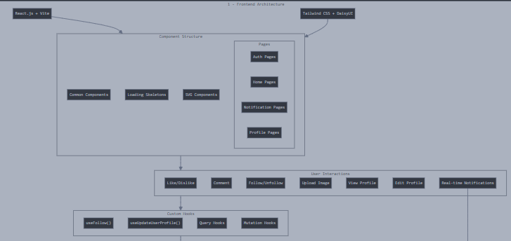
Backend Architecture:
- Framework: Node.js with Express.js for RESTful API development.
- Organization:
  - Controllers handle business logic for auth, notifications, posts, and users
  - Routes define API endpoints
  - Middleware enforces security measures like route protection
  - Models define database schemas using Mongoose ODM
  - Database connection handled via dedicated module
- Authentication:
  - JWT-based authentication system
  - Token validation middleware
- Error Handling:
  - Centralized error handling middleware
  - Consistent error response format
Database:
- MongoDB:
  - NoSQL document-based database
  - Cloud-hosted on MongoDB Atlas for scalability
- Schema Design:
  - User schema with authentication and profile details
  - Post schema with content, engagement metrics, and relationship to users
  - Notification schema tracking user interactions
- Data Relationships:
  - References between collections for normalized data
  - Embedded documents for frequently accessed related data
- Indexing:
  - Strategic indexes for query optimization
  - Compound indexes for complex queries
Full Project Architecture
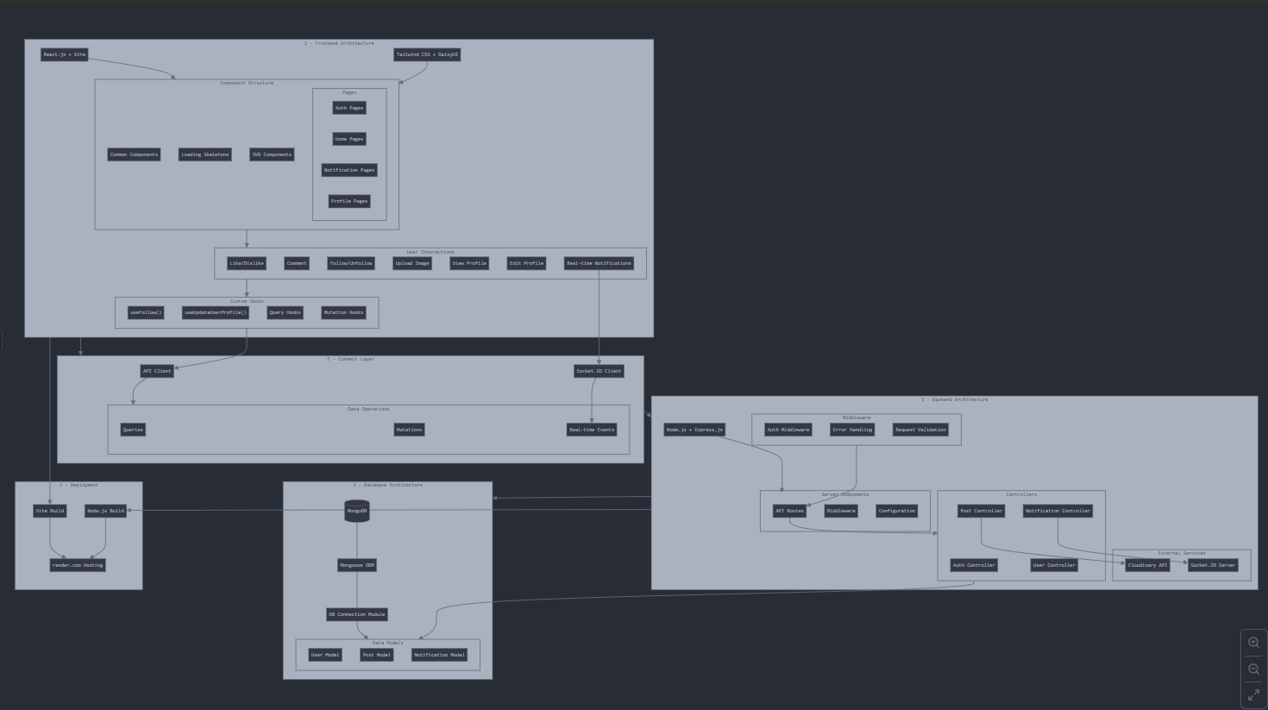

5. Component Functionality
Frontend Components:
Common Components:
- LoadingSpinner: Provides visual feedback during data fetching operations. Displays an animated spinner to indicate background processing.
- Post: Renders individual post content with user information, post text, image (if any), interaction buttons (like, comment), and displays likes count and comments. Handles conditional rendering based on post properties.
- Posts: Container component that manages the collection of Post components. Handles loading states, empty states, and pagination of posts.
- RightPanel: Displays supplementary information like suggested users to follow, trending topics, and relevant links. Adapts its content based on the current route.
- Sidebar: Navigation component providing links to main app sections (Home, Profile, Notifications). Includes the app logo and user avatar for quick profile access.
Skeleton Components:
- PostSkeleton: Placeholder component shown during post data loading. Mimics the structure of Post components with animated gradient effects.
- ProfileHeaderSkeleton: Displays loading state for profile headers with placeholder elements for avatar, name, bio, and statistics.
- RightPanelSkeleton: Loading state for the RightPanel with placeholder content for suggested users and trending topics.
Custom Hooks:
- useFollow: Manages the follow/unfollow logic and state. Handles API calls, optimistic updates, and error handling related to user relationships.
- useUpdateUserProfile: Encapsulates profile update functionality including form handling, validation, image uploads, and API communication.
Page Components:
- Authentication Pages: Manage user login and registration with form validation and error handling.
- HomePage: Central feed displaying posts from followed users and creation of new posts.
- NotificationPage: Displays and manages user notifications with marking as read functionality.
- ProfilePage: Shows user information, statistics, and posts with conditional editing options for the user's own profile.
- EditProfileModal: Modal component for editing profile information with image upload capabilities.
Backend Components:
Controllers:
- auth.controllers: Handles user registration, login validation, JWT token generation, and logout functionality.
- notification.controllers: Manages the creation, retrieval, and status updates of user notifications.
- post.controllers: Processes post creation, deletion, retrieval, and interaction (likes, comments).
- user.controllers: Handles user profile operations, follow relationships, and user data retrieval.
Middleware:
- protectRoute: Validates JWT tokens to ensure authenticated access to protected routes. Attaches user information to the request object.
Models:
- User Model: Defines user data structure with authentication details, profile information, and relationship tracking.
- Post Model: Structures post content, ownership, engagement metrics, and comments.
- Notification Model: Organizes notification data including type, sender, recipient, and related content.

6. Setup Instructions
Prerequisites:
Ensure the following tools/services are installed or configured:
- Node.js (v16 or higher recommended).
- MongoDB Atlas account with a cluster created for database storage.
- Cloudinary account for image hosting.
- Git for version control.
Installation Steps:
- Clone the repository using Git:
  - git clone https://github.com/username/babbly.git
- Navigate into the project folder:

- Install dependencies for both frontend and backend:
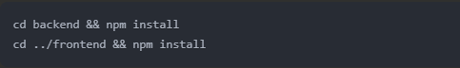
- Create a .env file in the root directory:
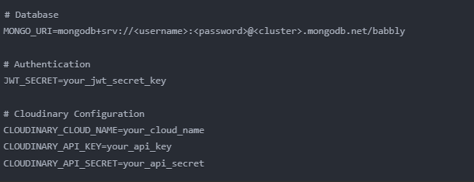
- Start the development servers:
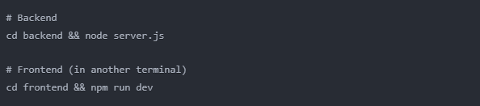
- # Backendcd backend && node server.js# Frontend (in another terminal)cd frontend && npm run dev

7. Folder Structure
Your project follows a clear separation between frontend and backend:
Project Root:
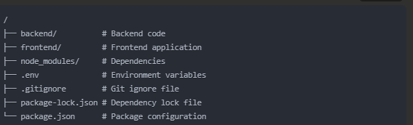
Frontend Directory:
frontend/
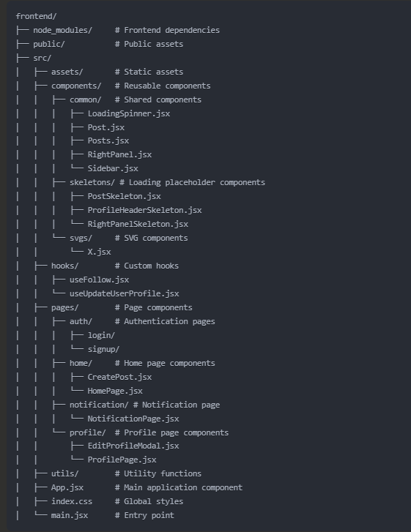
Backend Directory:
backend/
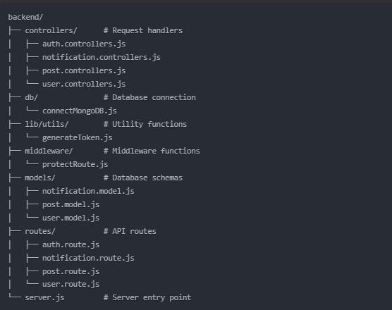

8. Running the Application
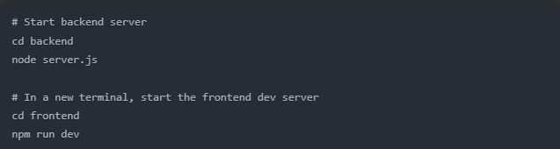
The frontend will be available at http://localhost:3000 (Vite's default port). The backend API will be available at http://localhost:5000 (assuming the default port).

9. API Documentation
Auth Endpoints:
- POST /api/auth/signup: Create a new user account.
- POST /api/auth/login: Log in to an existing account.
- GET /api/auth/logout: Log out the current user.
Post Endpoints:
- GET /api/posts: Get all posts (with pagination).
- POST /api/posts: Create a new post.
- DELETE /api/posts/:id: Delete a post by ID.
- PUT /api/posts/:id/like: Like/unlike a post.
- POST /api/posts/:id/comment: Add a comment to a post.
User Endpoints:
- GET /api/users/:id: View a user profile by ID.
- PUT /api/users/:id: Update user profile details.
- POST /api/users/:id/follow: Follow/unfollow another user.
- GET /api/users/:id/followers: Get all followers of a user.
- GET /api/users/:id/following: Get all users followed by a user.
Notification Endpoints:
- GET /api/notifications: Retrieve all notifications for the logged-in user.
- PUT /api/notifications/:id/read: Mark a notification as read.
Admin Endpoints (to be implemented):
- GET /api/admin/users: Get all users (admin only).
- DELETE /api/admin/users/:id: Delete user account (admin only).
- GET /api/admin/posts: Get all posts with moderation options.
- DELETE /api/admin/posts/:id: Delete any post for moderation.

10. Authentication
Authentication is implemented using JSON Web Tokens (JWT):
- User credentials are validated during login.
- Upon successful authentication, a JWT token is generated using the generateToken.js utility.
- Protected routes are secured using the protectRoute.js middleware.
- Token validation occurs on each protected request.
Implementation Details:
- Token is generated with user ID as payload.
- Admin role checking will be added to the token payload.
- Protected routes verify token validity before granting access.

13. User Interface
The UI is designed with responsiveness in mind:
- Core screens include:
  - Authentication: Login and Signup pages
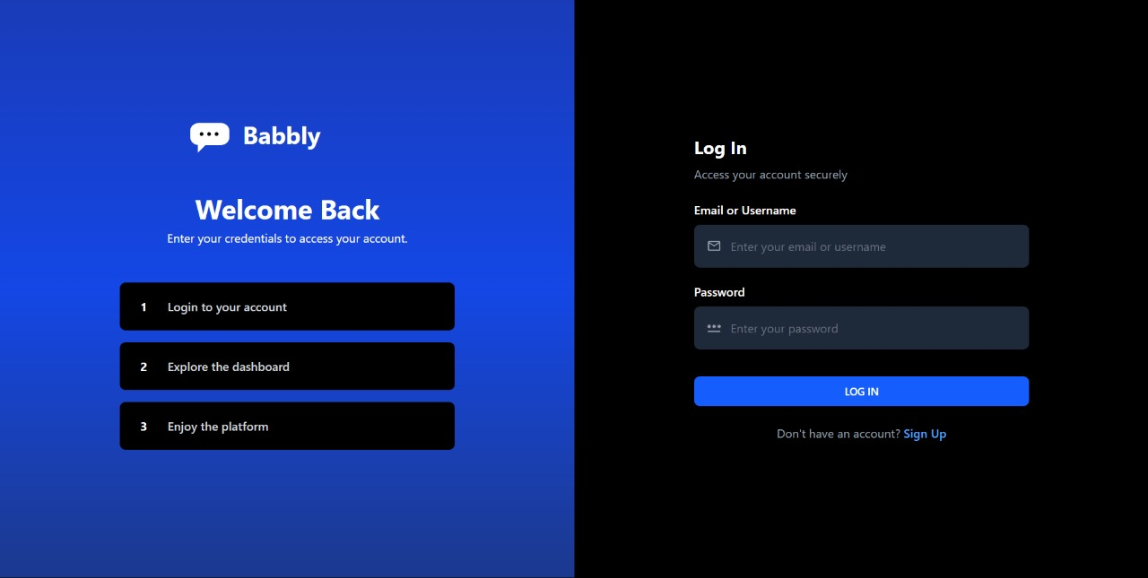
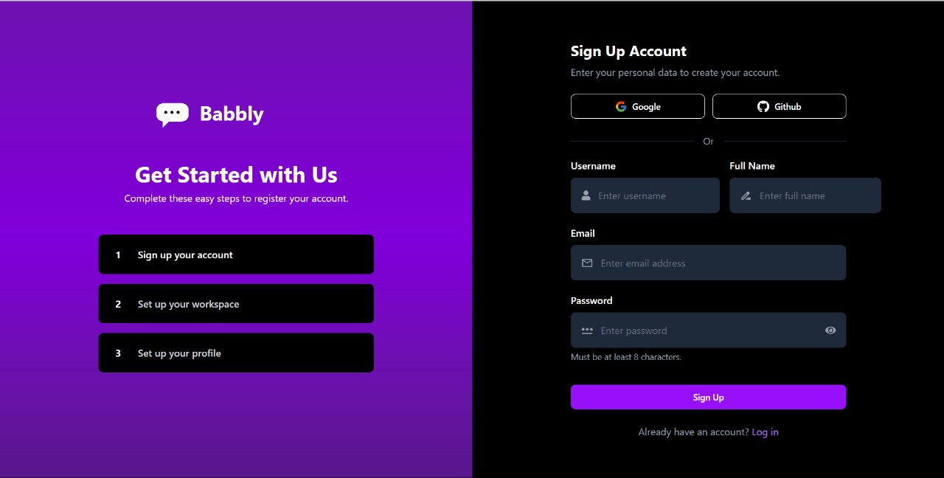
  - Home: Feed of posts with create post functionality
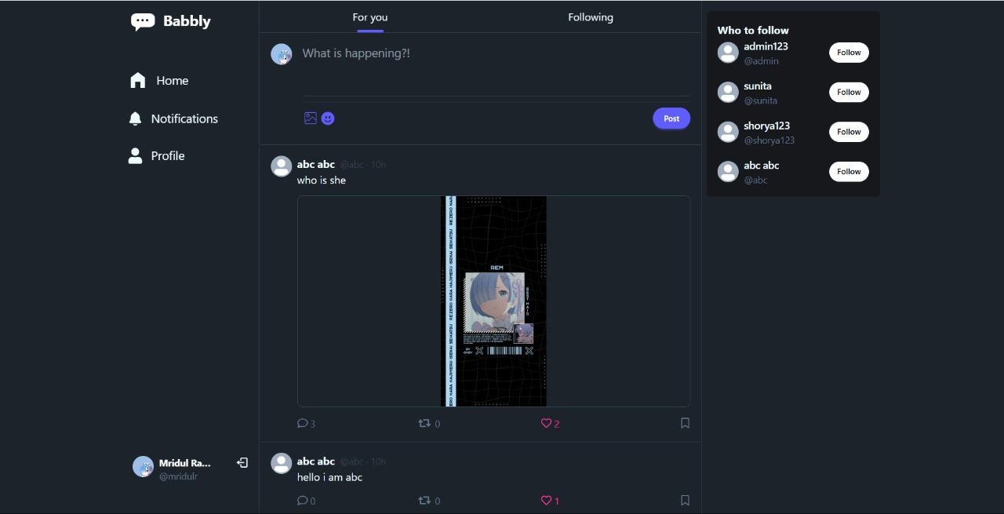
  - Profile: User profiles with edit capabilities
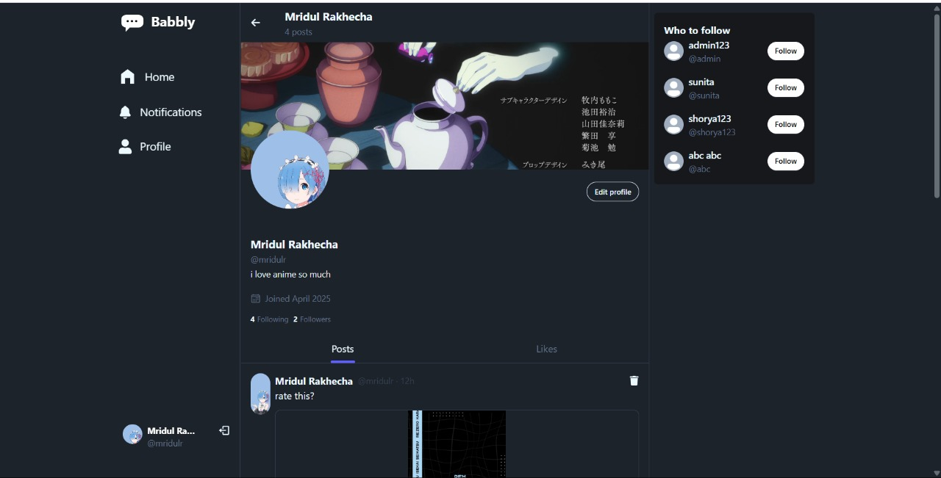
  - Notifications: List of user notifications
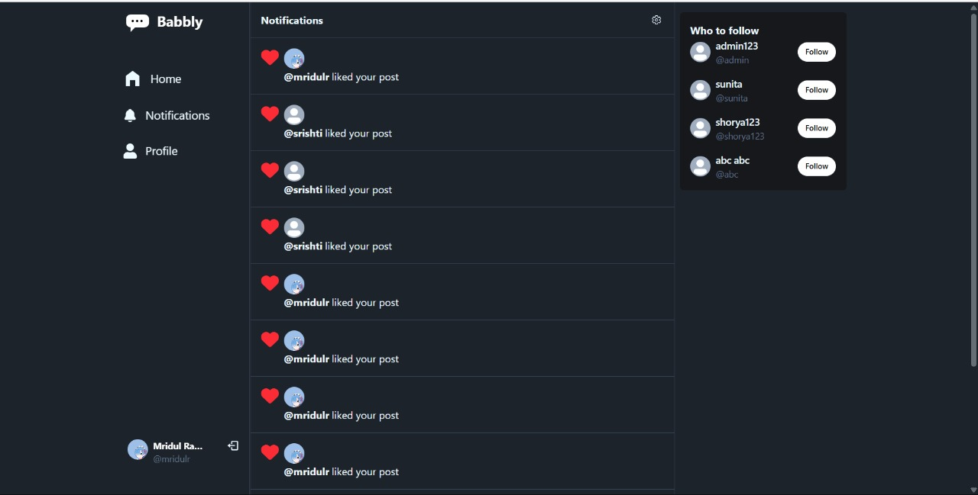
Components:
- Common components like LoadingSpinner, Post, and Sidebar provide consistency
- Skeleton loaders improve perceived performance during data fetching
- Custom SVG components maintain design fidelity
Proposed Admin UI:
The admin interface should include:
- Admin Dashboard with usage statistics
- User Management page for viewing/deleting users
- Content Moderation page for reviewing/removing posts
- Settings page for system configuration

14. Testing
Testing recommendations:
- API endpoint testing using Postman or Thunder Client
- Component testing using the React Testing Library
- End-to-end testing with Cypress
- Manual testing across different devices and browsers

15. Known Issues
- Admin functionality is not yet fully implemented
- Limited profile customization options
- No search functionality implemented yet

16. Future Enhancements
- Add a robust admin dashboard for content moderation
- Implement search functionality
- Add user blocking/reporting features
- Implement media-rich posts (videos, polls)
- Add hashtag support and trending topics
- Implement direct messaging between users
- Add post analytics for user engagement
- Implement content recommendation algorithm
- Add accessibility improvements

17. Implementation Priorities
Phase 1 (Current):
- Complete core functionality (authentication, posts, follows)
- Implement a basic notification system
- Ensure responsive design
Phase 2 (Next Steps):
- Implement admin functionality
- Add real-time updates
- Enhance user profiles
Phase 3 (Future):
- Add messaging features
- Implement content discovery
- Add analytics and insights

