Ideation Phase
Define the Problem Statements

Date | 10 April 2025
Team ID | SWITD1743598785
Project Name | Stock Trading Web App
Maximum Marks | 3 Marks

Customer Problem Statement Template:
Problem 1: How can we design and implement a robust stock trading web application using the MERN stack that ensures real-time data synchronization across multiple users and devices while maintaining high scalability and performance?
Problem 2: How can we ensure the security, privacy, and regulatory compliance of a stock trading web application built with the MERN stack, while providing a seamless and user-friendly experience?
Example:
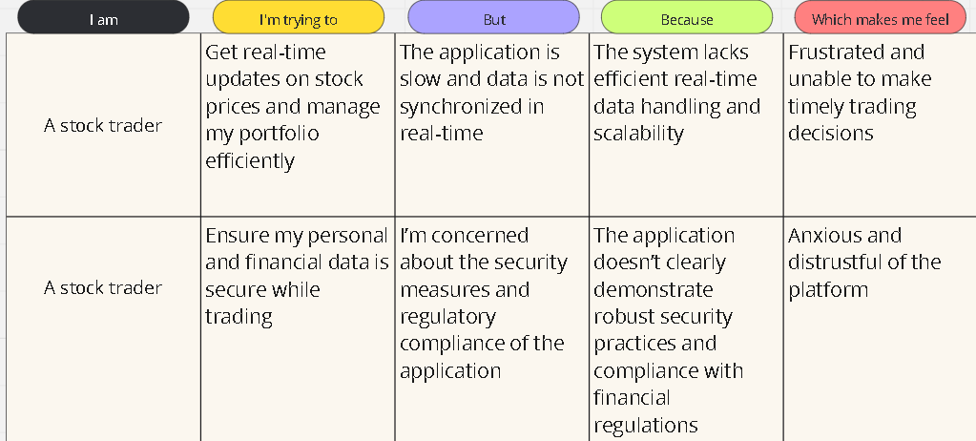
Problem Statement (PS) | I am (Customer) | I’m trying to | But | Because | Which makes me feel
PS-1 | Rikesh (A stock trader) | Get real-time updates on stock prices and manage my portfolio efficiently | The application is slow and data is not synchronized in real-time | The system lacks efficient real-time data handling and scalability | Frustrated and unable to make timely trading decisions which decreases productivity
PS-2 | Rohan (A stock trader) | Ensure my personal and financial data is secure while trading | I’m concerned about the security measures and regulatory compliance of the application | The application doesn’t clearly demonstrate robust security practices and compliance with financial regulations | Anxious and distrustful of the platform

