OPERATING SYSTEMS PRACTICE
(ASSIGNMENT 6)

Name – Mridul Harish
Roll number – CED18I034

Question 1 : Generate Armstrong number generation within a range.

Code :-

#include<pthread.h>
#include<stdio.h>
#include<stdlib.h>

void *generate(void *number);

int main(int argc, char const *argv[])
{
pthread_t tid;
pthread_attr_t attr;
if(argc < 2)
{
printf("This is not allowed\n");
return 0;
}

int n = atoi(argv[1]);
for(int i = 1;i <= n; i = i+1)
{
int *number = (int*)malloc(2*sizeof(int));
int original_number = i; int remainder; int result=0;
while(original_number != 0)
{
remainder = original_number % 10;
result += remainder * remainder * remainder;
original_number /= 10;
}

number[0] = i;
number[1] = result;
pthread_attr_init(&attr);
pthread_create(&tid, NULL, generate, (void *)number);
pthread_join(tid, NULL);
free(number);
}
return 0;
}

void *generate(void *number)
{
int *parameter = (int *)number;
if(parameter[0] == parameter[1])
{
printf("%d\n", parameter[0]);
}
pthread_exit(0);
}

Output :-

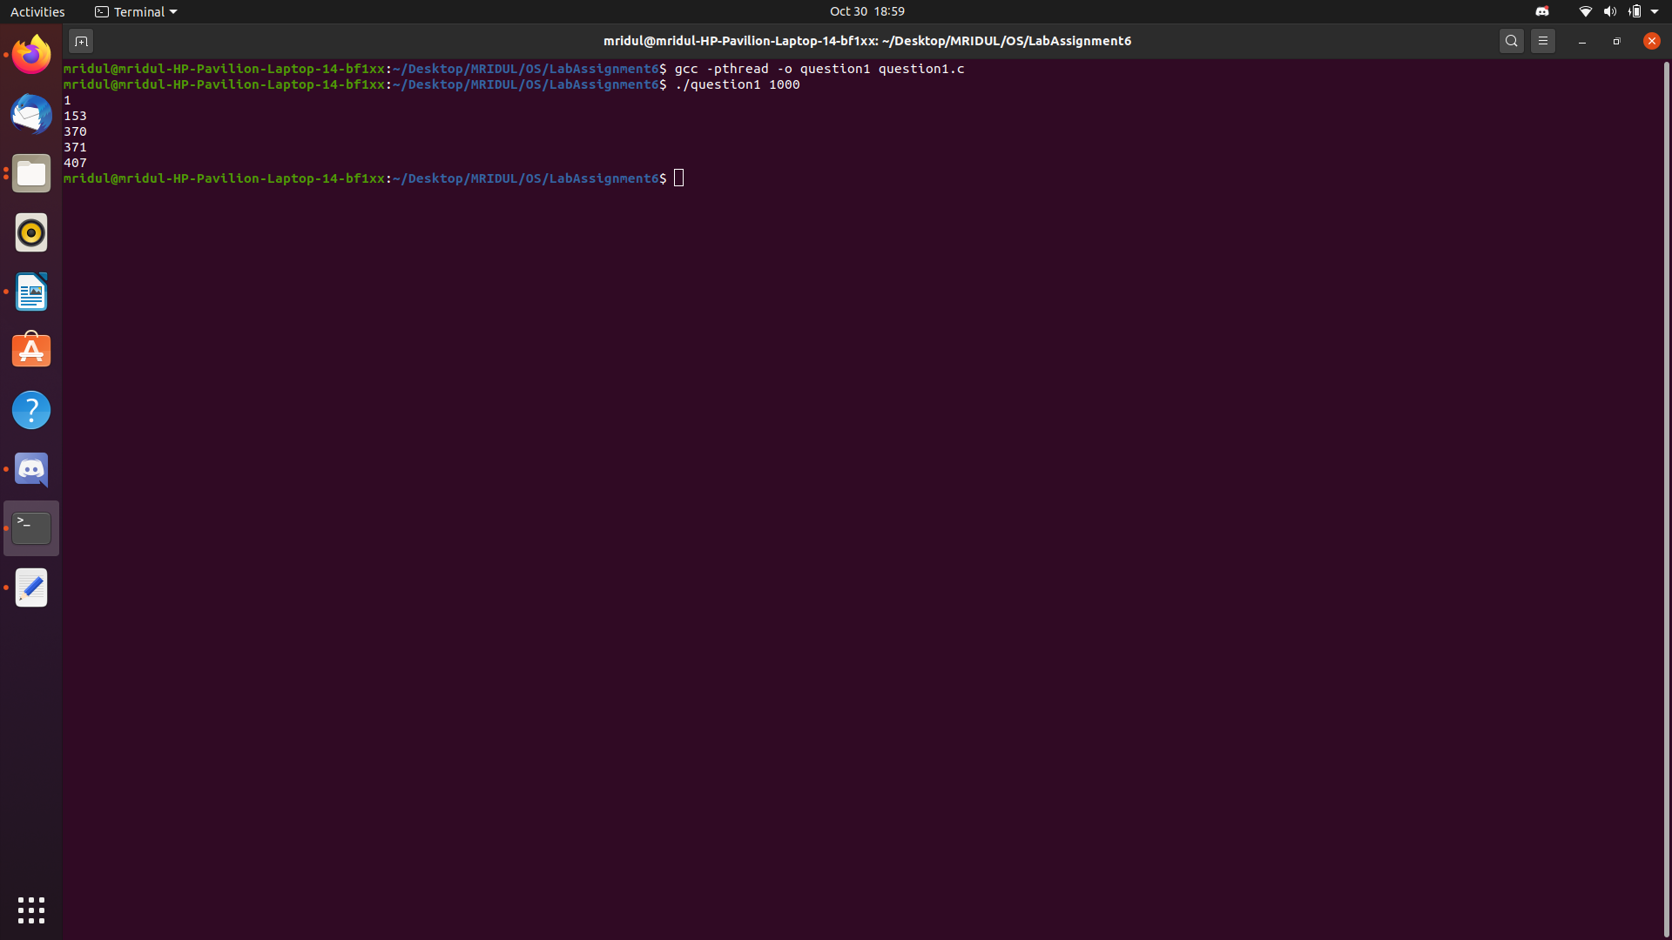
Question 2 : Ascending Order sort and Descending order sort.

Code :-

#include<pthread.h>
#include<stdio.h>
#include<stdlib.h>

void *generate(void *number);

int main(int argc, char const *argv[])
{
pthread_t tid;
pthread_attr_t attr;

if (argc<2)
{
printf("This is not allowed\n");
return 0;
}

int n = argc-1;
int *number = (int *)malloc((n+1)*sizeof(int));

for(int i = 1; i < argc; i = i+1)
{
number[i] = atoi(argv[i]);
}

number[0] = n;
pthread_attr_init(&attr);
pthread_create(&tid ,NULL, generate, (void *)number);
pthread_join(tid,NULL);

n = n+1;
printf("Ascending order\n");
for(int i = 1; i < n; i = i+1)
{
for(int j = i+1; j < n; j = j+1 )
{
if(number[j] < number[i])
{
int t = number[i];
number[i] = number[j];
number[j] = t;
}
}
}

for(int i = 1; i < n; i = i+1)
{
printf("%d ",number[i]);
}

printf("\n");

free(number);
return 0;
}

void *generate(void *number)
{
int *parameter = (int *)number;
int n = parameter[0];
n = n+1;

printf("Descending order\n");
for(int i = 1; i < n; i = i+1)
{
for (int j = i+1; j < n; j = j+1 )
{
if(parameter[i] < parameter[j])
{
int t = parameter[i];
parameter[i] = parameter[j];
parameter[j] = t;
}
}
}

for(int i = 1;i < n;i = i+1)
{
printf("%d ", parameter[i]);
}
printf("\n");

pthread_exit(0);
}

Output :-

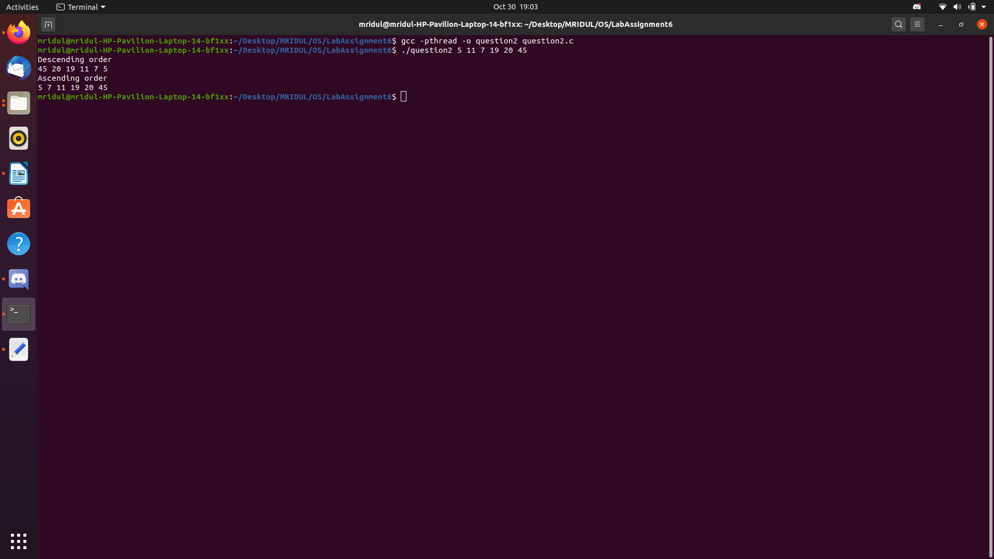
Question 3 : Implement a multithreaded version of binary search. By default, you can implement a search for the first occurrence and later extend to support multiple occurrence (duplicated elements search as well).

Code :-

#include<stdio.h>
#include<stdlib.h>
#include<string.h>
#include<math.h>
#include<sys/types.h>
#include<sys/wait.h>
#include<pthread.h>
#include<unistd.h>

int a[100]; int position = -1;

struct data
{
int begin;
int end;
int m;
};

void *runner(void *param);
void print(int x);

int main(int argc, char *argv[])
{
if(argc < 4)
{
printf("This is not allowed\n");
}
else
{
int n = argc - 2;
//printf("n = %d",n);
for(int j = 0; j < n; j = j+1)
{
a[j] = atoi(argv[j+2]);
}

for(int k = 0; k < n; k = k+1)
{
for(int l = 0; l < n-k-1; l = l+1)
{
if(a[l] > a[l+1])
{
int temp = a[l];
a[l] = a[l+1];
a[l+1] = temp;
}
}
}

printf("The sorted sequence is :-\n");
for(int o = 0; o < n; o = o+1)
{
printf("%d ", a[o]);
}
printf("\n");

//printf("n = %d\n",n);

struct data param[4];
param[0].begin = 0;
param[0].end = n/4 - 1;
param[0].m = atoi(argv[1]);
param[1].begin = n/4;
param[1].end = n/2 -1;
param[1].m = atoi(argv[1]);
param[2].begin = n/2;
param[2].end = 3*n/4 - 1;
param[2].m = atoi(argv[1]);
param[3].begin = 3*n/4;
param[3].end = n-1;
param[3].m = atoi(argv[1]);

pthread_t tid[4];
pthread_attr_t attr;
pthread_attr_init(&attr);

for(int p = 0; p < 4; p = p+1)
{
pthread_create(&tid[p], &attr, runner, &param[p]);
}

for(int q = 0; q < 4; q = q+1)
{
pthread_join(tid[q], NULL);
}

if(position > -1)
{
print(atoi(argv[1]));
}
else
{
printf("\n%d not found\n", atoi(argv[1]));
}

printf("\n");
}
}

void *runner(void *param)
{
struct data *dm = param;
int begin = dm -> begin;
int end = dm -> end;
int m = dm -> m;
//printf("begin = %d, end = %d, m = %d\n",begin, end, m);
if(begin < end)
{
int mid = (begin + end)/2;

if(a[mid] = m)
{
position = mid;
}
else
{
pthread_t tid;
pthread_attr_t attr;
pthread_attr_init(&attr);

struct data param;
param.m = m;

if(m < a[mid])
{
param.begin = begin;
param.end = mid;
}
else if(m > a[mid])
{
param.begin = mid + 1;
param.end = end;
}

pthread_create(&tid, &attr, runner, &param);
pthread_join(tid, NULL);
}
}
pthread_exit(0);
}

void print(int x)
{
printf("%d is found at indice = ", x);

int left_end = 0;
while(left_end >= 0)
{
if(a[position - left_end] == x)
{
printf("%d ", position - left_end);
left_end = -1;
}
else
{
left_end = left_end - 1;
}
}

int right_end = 1;
while(right_end >= 1)
{
if(a[position + right_end] == x)
{
printf("%d ", position - right_end);
right_end = -1;
}
else
{
right_end = right_end - 1;
}
}
}

Output :-

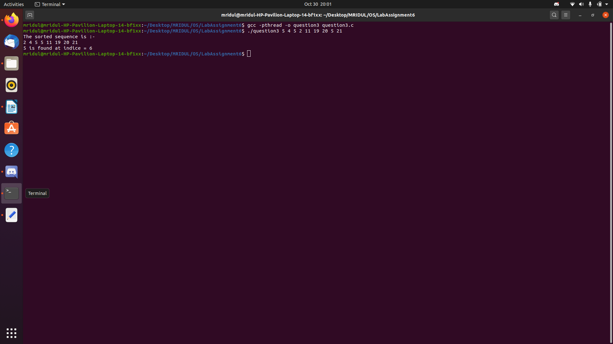
Question 4 : Generation of Prime Numbers upto a limit supplied as Command Line Parameter.

Code :-

#include<stdio.h>
#include<stdlib.h>
#include<math.h>
#include<string.h>
#include<time.h>
#include<sys/types.h>
#include<sys/wait.h>
#include<unistd.h>
#include<pthread.h>

void *runner(void *param);

int main(int argc, const char *argv[])
{
if(argc != 2)
{
printf("This is not allowed\n");
}
else
{
int count = atoi(argv[1]);
pthread_t tid[count*2];
pthread_attr_t attr;
pthread_attr_init(&attr);

for(int i = 1; i <= count; i = i+1)
{
pthread_create(&tid[i], &attr, runner, &i);
pthread_join(tid[i], NULL);
}
}
return 0;
}

void *runner(void *param)
{
int n = *((int *)param);
int j; int flag = 1;

if(n <= 1)
{
flag = 0;
}
else if(n == 2)
{
flag = 1;
}
else
{
for(int j = 2; j <= sqrt(n); j = j+1)
{
if(n%j == 0)
{
flag = 0;
break;
}
}
}

if(flag == 1)
{
printf("%d\n", n);
}
}

Output :-
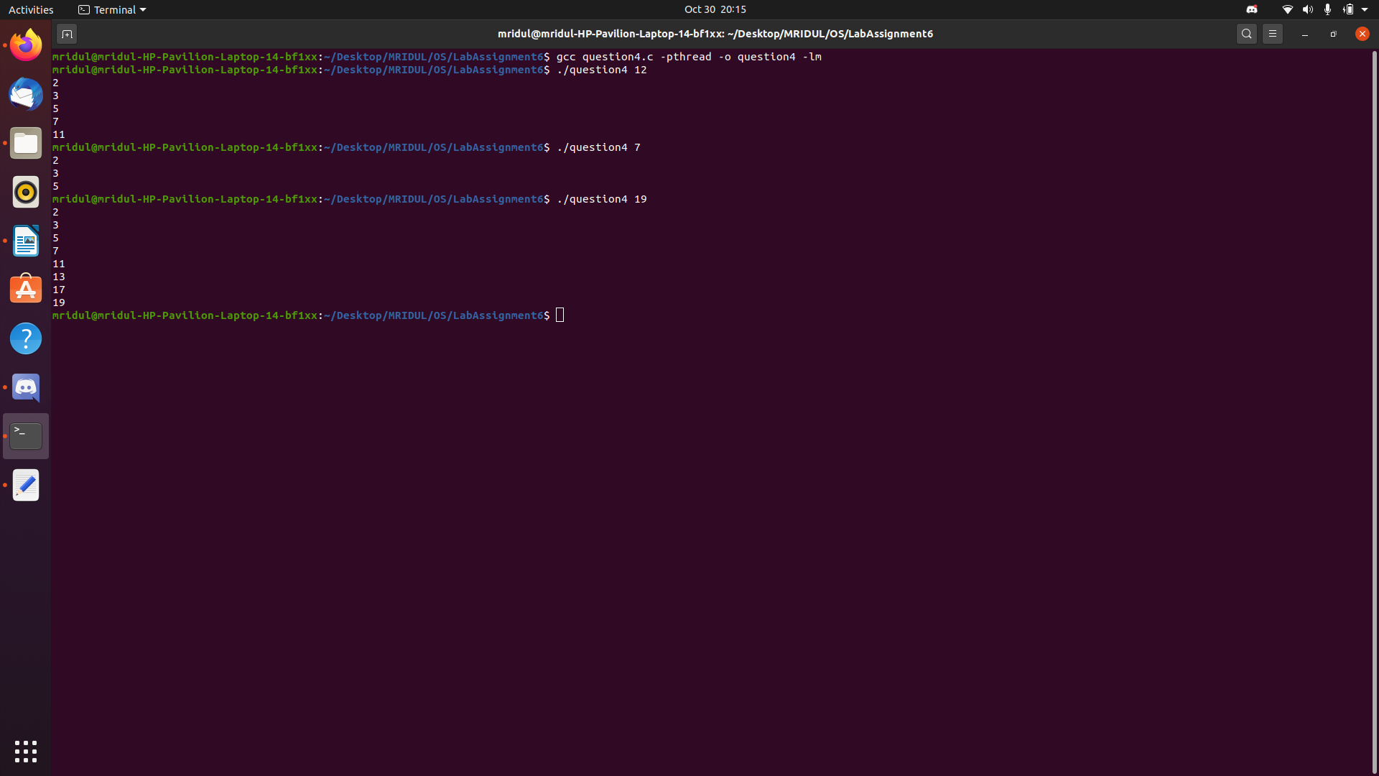

Question 5 : Computation of Mean, Median, Mode for an array of integers.

Code :-

#include<stdio.h>
#include<stdlib.h>
#include<math.h>
#include<string.h>
#include<time.h>
#include<sys/types.h>
#include<sys/wait.h>
#include<unistd.h>
#include<pthread.h>

#define MAX 512

int a[MAX];
int n;

int cmpfunc(const void *a, const void *b);
void *mean(void *param);
void *median(void *param);
void *mode(void *param);

int main(int argc, char const *argv[])
{
if(argc < 2)
{
printf("This is not allowed\n");
}

n = argc - 1;
for(int i = 0; i < n; i = i+1)
{
a[i] = atoi(argv[i+1]);
}

pthread_t tid[3];
pthread_attr_t attr;
pthread_attr_init(&attr);

pthread_create(&tid[0], &attr, mean, NULL);
pthread_create(&tid[1], &attr, median, NULL);
pthread_create(&tid[2], &attr, mode, NULL);

pthread_join(tid[0], NULL);
pthread_join(tid[1], NULL);
pthread_join(tid[2], NULL);

return 0;
}

int cmpfunc(const void *a, const void *b)
{
return (*(int *)a - *(int *)b);
}

void *mean(void *param)
{
int temp[n];
for(int i = 0; i < n; i = i+1)
{
temp[i] = a[i];
}

float mean;

for(int i = 0; i < n; i = i+1)
{
mean = mean + temp[i];
}

mean = mean/n;

printf("\nMean = %f\n", mean);
pthread_exit(NULL);
}

void *median(void *param)
{
int temp[n];
for(int i = 0; i < n; i = i+1)
{
temp[i] = a[i];
}

qsort(temp, n, sizeof(int), cmpfunc);

int median;
if(n%2 == 1)
{
median = temp[(n - 1)/2];
}
else
{
median = (temp[n/2] + temp[n/2 - 1])/2;
}

printf("\nMedian = %d\n", median);
pthread_exit(NULL);
}

void *mode(void *param)
{
int temp[n];
for(int i = 0; i < n; i = i+1)
{
temp[i] = a[i];
}

int mode;
int max_count;
for(int i = 0; i < n; i = i+1)
{
int count = 0;
for(int j = 0; j < n; j = j+1)
{
if(temp[j] == temp[i])
{
count = count + 1;
}
}
if(count > mode)
{
max_count = count;
mode = temp[i];
}
}

printf("\nMode = %d\n", mode);
pthread_exit(NULL);
}
Output :-

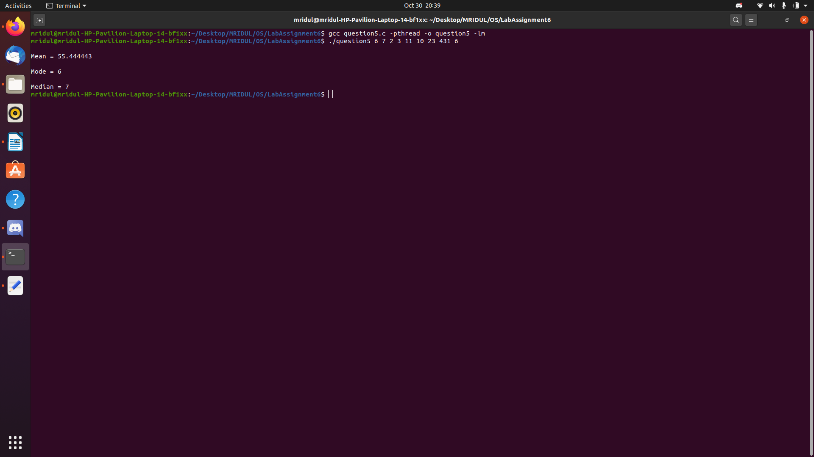
Question 6 : Implement Merge Sort and Quick Sort in a multithreaded fashion.

Code :-

#include<stdio.h>
#include<stdlib.h>
#include<math.h>
#include<string.h>
#include<time.h>
#include<sys/types.h>
#include<sys/wait.h>
#include<unistd.h>
#include<pthread.h>

#define MAX 512
int q_sort[MAX];
int m_sort[MAX];

struct data
{
int begin;
int end;
};

int partition(int begin, int end);
void *quicksort(void *arg1);
void merge_array(int begin, int mid, int end);
void *mergesort(void *arg2);

int main(int argc, char *argv[])
{
if(argc < 2)
{
printf("This is not allowed\n");
}
else
{
int n = argc - 1;
for(int i = 0; i < n; i = i+1)
{
q_sort[i] = atoi(argv[i + 1]);
m_sort[i] = atoi(argv[i + 1]);
}

struct data param;
param.begin = 0;
param.end = n - 1;

pthread_t tid[2];
pthread_attr_t attr;
pthread_attr_init(&attr);

pthread_create(&tid[0], &attr, mergesort, &param);
pthread_create(&tid[1], &attr, quicksort, &param);

pthread_join(tid[0], NULL);
pthread_join(tid[1], NULL);

printf("Sorted array using Merge sort is : ");
for(int i = 0; i < n; i = i+1)
{
printf("%d ", m_sort[i]);
}

printf("\n");

printf("Sorted array using Quick sort is : ");
for(int i = 0; i < n; i = i+1)
{
printf("%d ", q_sort[i]);
}

printf("\n");
}
}

int partition(int begin, int end)
{
int i = begin; int j = end;
int p = begin;
int val = p;

while(i < j)
{
while(q_sort[p] >= q_sort[i] && i < end)
{
i = i+1;
}

while(q_sort[p] < q_sort[j] && j > begin)
{
if(j == p+1 && i <=p)
{
j = p-1;
}
else
{
j = j-1;
}
}

if(i < j)
{
int temp = q_sort[i];
q_sort[i] = q_sort[j];
q_sort[j] = temp;
}
}

int temp = q_sort[p];
q_sort[p] = q_sort[j];
q_sort[j] = temp;
val = j;

return val;
}

void *quicksort(void *arg1)
{
struct data *temp = arg1;
int begin = temp -> begin;
int end = temp -> end;

if(begin < end)
{
int j = partition(begin, end);

struct data left;
left.begin = begin;
left. end = j-1;

struct data right;
right.begin = j+1;
right.end = end;

pthread_t tid[2];
pthread_attr_t attr;
pthread_attr_init(&attr);

pthread_create(&tid[0], &attr, quicksort, &left);
pthread_create(&tid[1], &attr, quicksort, &right);

pthread_join(tid[0], NULL);
pthread_join(tid[1], NULL);
}
pthread_exit(0);
}

void merge_array(int begin, int mid, int end)
{
int n1 = mid - begin + 1;
int n2 = end - mid;

int L[n1]; int R[n2];

for(int i = 0; i < n1; i = i+1)
{
L[i] = m_sort[begin + i];
}
for(int j = 0; j < n2; j = j+1)
{
R[j] = m_sort[mid + 1 + j];
}

int i = 0; int j = 0; int k = begin;
while(i < n1 && j < n2)
{
if(L[i] <= R[j])
{
m_sort[k] = L[i];
i = i+1;
}
else
{
m_sort[k] = R[j];
j = j+1;
}
k = k+1;
}

while(i < n1)
{
m_sort[k] = L[i];
i = i+1;
k = k+1;
}
while(j < n2)
{
m_sort[k] = R[j];
j = j+1;
k = k+1;
}
}

void *mergesort(void *arg2)
{
struct data *temp = arg2;
int begin = temp -> begin;
int end = temp -> end;

if(begin < end)
{
int mid = (begin + end)/2;

struct data left;
left.begin = begin;
left. end = mid;

struct data right;
right.begin = mid+1;
right.end = end;

pthread_t tid[2];
pthread_attr_t attr;
pthread_attr_init(&attr);

pthread_create(&tid[0], &attr, mergesort, &left);
pthread_create(&tid[1], &attr, mergesort, &right);

pthread_join(tid[0], NULL);
pthread_join(tid[1], NULL);

merge_array(begin, mid, end);
}
pthread_exit(0);
}

Output :-

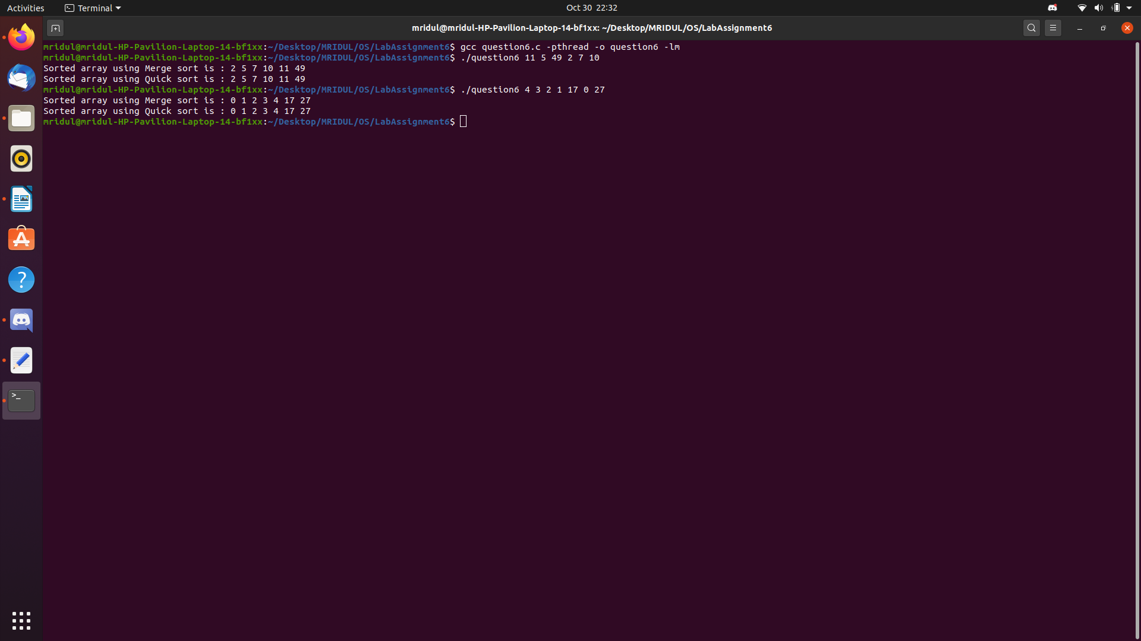
Question 7 : Estimation of PI Value using Monte carlo simulation technique (refer the internet for the method..) using threads.

Code :-

#include<stdio.h>
#include<stdlib.h>
#include<math.h>
#include<string.h>
#include<time.h>
#include<sys/types.h>
#include<sys/wait.h>
#include<unistd.h>
#include<pthread.h>

int circle_points = 0;
int square_points = 0;

double rand_x; double rand_y; double original_distance;

int interval;

void *runner(void *parameter);

int main(int argc, char *argv[])
{
if(argc != 2)
{
printf("This is not allowed\n");
}
else
{
interval = atoi(argv[1]);
pthread_t tid[interval * interval];
pthread_attr_t attr;
pthread_attr_init(&attr);
srand(time(NULL));

for(int i = 0; i < (interval * interval); i = i+1)
{
pthread_create(&tid[i], &attr, runner, NULL);
}

for(int i = 0; i < (interval * interval); i = i+1)
{
pthread_join(tid[i], NULL);
}

double pi = (double)(4 * circle_points) / square_points;
printf("\nFinal Estimated value of Pi is = %f\n", pi);
}
printf("\n");
return 0;
}

void *runner(void *parameter)
{
rand_x = (double)(rand() % (interval + 1)) / interval;
rand_y = (double)(rand() % (interval + 1)) / interval;

original_distance = (rand_x * rand_x) + (rand_y * rand_y);

if(original_distance <= 1)
{
circle_points = circle_points + 1;
}
square_points = square_points + 1;

pthread_exit(NULL);
}

Output :-

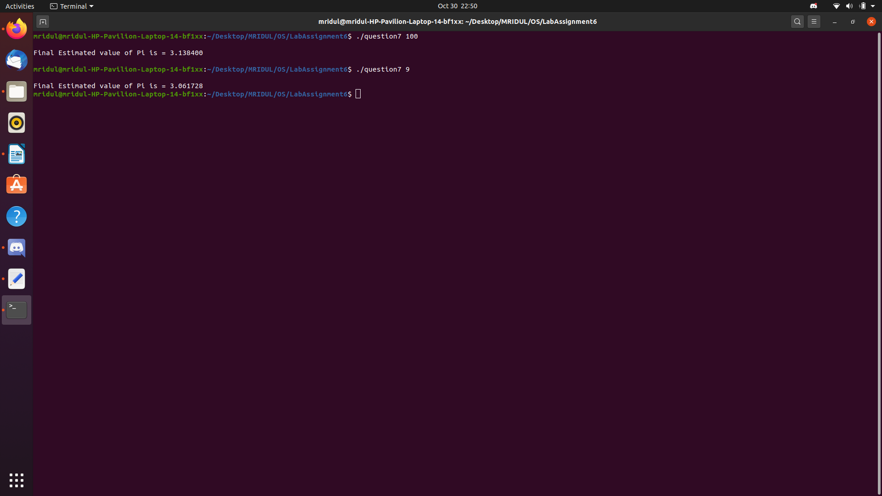
Question 8 : Computation of a Matrix Inverse using Determinant, Cofactor threads, etc.

Code :-

#include <stdio.h>
#include <stdlib.h>
#include <stdbool.h>
#include <pthread.h>

int N = 2;

struct data
{
int** arr;
int** temp;
int p;
int q;
int n;
};

struct data init_data(int** A, int i, int j, int N);
void* getCofactor(void* params);
int determinant(int** A, int n);
void adjoint(int** A,int** adj);
bool inverse(int** A, float** inverse);
void display(float** A);

int main()
{
printf("Enter the size of the matrix: ");
scanf("%d", &N);
int** A;
A = (int **) malloc(sizeof(int*)*N);
for(int k = 0; k < N; k++)
A[k] = (int*)malloc(sizeof(int)*N);

for(int i = 0; i < N; i++)
for(int j = 0; j < N; j++)
{
printf("Enter number [%d][%d]: ", i, j);
scanf("%d", &A[i][j]);
}
float** inv;
inv = (float **) malloc(sizeof(float*)*N);
for(int k = 0; k < N; k++)
inv[k] = (float*)malloc(sizeof(float)*N);

printf("\nThe Inverse is :\n");
if (inverse(A, inv))
display(inv);
return 0;
}

struct data init_data(int** A, int i, int j, int N)
{
struct data params;
params.arr = (int **) malloc(sizeof(int*)*N);
for(int k = 0; k < N; k++)
params.arr[k] = (int*)malloc(sizeof(int)*N);
params.arr = A;
params.temp = (int **) malloc(sizeof(int*)*N);
for(int k = 0; k < N; k++)
params.temp[k] = (int*)malloc(sizeof(int)*N);
params.p = i;
params.q = j;
params.n = N;
return params;
}

void* getCofactor(void* params)
{
struct data* temp = (struct data* )params;
int i = 0, j = 0;

for (int row = 0; row < temp->n; row++)
{
for (int col = 0; col < temp->n; col++)
{
if (row != temp->p && col != temp->q)
{
temp->temp[i][j++] = temp->arr[row][col];

if (j == temp->n - 1)
{
j = 0;
i++;
}
}
}
}

pthread_exit(0);
}

int determinant(int** A, int n)
{
int D = 0;

if (n == 1)
return A[0][0];
int sign = 1;

pthread_t tid[n];
struct data params[n];
for(int i = 0; i < n; i++)
{
params[i] = init_data(A, 0, i, n);
pthread_create(&tid[i], NULL, getCofactor, &params[i]);
}

for(int i = 0; i < n; i++)
pthread_join(tid[i], NULL);

for (int f = 0; f < n; f++)
{

D += sign * A[0][f] * determinant(params[f].temp, n - 1);

sign = -sign;
}
return D;
}

void adjoint(int** A,int** adj)
{
if (N == 1){
adj[0][0] = 1;
return;
}
int sign = 1;

pthread_t tid[N][N];
struct data params[N][N];
for(int i = 0; i < N; i++){
for(int j = 0; j < N; j++)
{
params[i][j] = init_data(A, i, j, N);
pthread_create(&tid[i][j], NULL, getCofactor, &params[i][j]);
}
}

for(int i = 0; i < N; i++)
for(int j = 0; j < N; j++)
pthread_join(tid[i][j], NULL);

for (int i=0; i<N; i++)
{
for (int j=0; j<N; j++)
{
sign = ((i+j)%2==0)? 1: -1;

adj[j][i] = (sign)*(determinant(params[i][j].temp, N-1));
}
}
}

bool inverse(int** A, float** inverse)
{

int det = determinant(A, N);
if (det == 0)
{
printf("Singular matrix, can't find its inverse\n");
return false;
}
int** adj;
adj = (int **) malloc(sizeof(int*)*N);
for(int k = 0; k < N; k++)
adj[k] = (int*)malloc(sizeof(int)*N);

adjoint(A, adj);

for (int i=0; i<N; i++)
for (int j=0; j<N; j++)
inverse[i][j] = adj[i][j]/(float)det;
return true;
}

void display(float** A)
{
for (int i=0; i<N; i++)
{
for (int j=0; j<N; j++)
printf("%.6f ", A[i][j]);
printf("\n");
}
}

Output :-

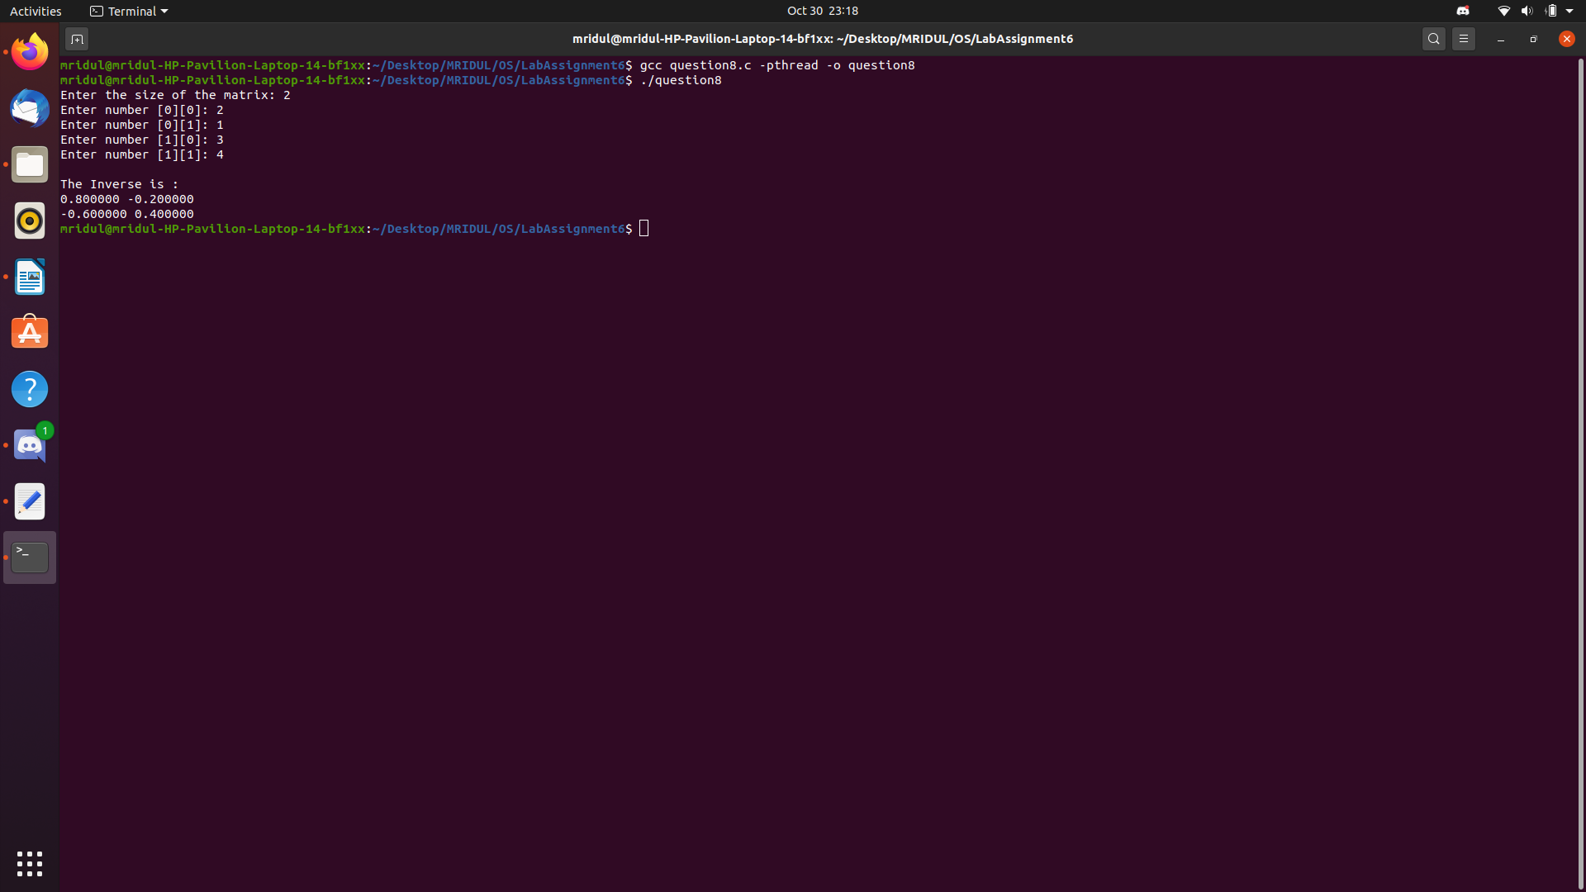

Question 9 : Read upon efficient ways of parallelizing the generation of Fibonacci series and apply the logic in a multithreaded fashion to contribute a faster version of fib series generation.

Code :-

#include<stdio.h>
#include<stdlib.h>
#include<math.h>
#include<string.h>
#include<time.h>
#include<sys/types.h>
#include<sys/wait.h>
#include<unistd.h>
#include<pthread.h>

struct key_value
{
int key;
int value;
};

int fib(int n);
void *runner(void *param);

int main()
{
int range;
printf("Enter the number of fibonacci numbers to generate : \n");
scanf("%d", &range);

struct key_value *generate = (struct key_value*)malloc(range*sizeof(struct key_value));

pthread_t tid[range];

printf("The generated Fibonacci series of %d terms is\n", range);
for(int i = 0; i < range; i = i+1)
{
generate[i].key = i;
pthread_create(&tid[i], NULL, runner, &generate[i]);
pthread_join(tid[i], NULL);
}

for(int i = 0; i < range; i = i+1)
{
printf("%d\n", generate[i].value);
}

return 0;
}

int fib(int n)
{
if(n == 0 || n ==1)
{
return n;
}
else
{
return fib(n-1) + fib(n-2);
}
}

void *runner(void *param)
{
struct key_value *temporary = (struct key_value*)param;
temporary -> value = fib(temporary -> key);
pthread_exit(NULL);
}

Output :-

