OPERATING SYSTEMS PRACTICE
(ASSIGNMENT 7)

Name – Mridul Harish
Roll number – CED18I034

Question 1 : Simulate the producer consumer code discussed in the class.

Algorithm :-

do
{
//produce an item or consume an item
wait(empty);
wait(mutex);
//place in buffer

signal(mutex);
signal(full);
}while(true)

Code :-

#include<pthread.h>
#include<semaphore.h>
#include<stdlib.h>
#include<stdio.h>
#include<time.h>

#define BufferSize 5 //Size of the buffer

int in = 0; int out = 0; int buffer[BufferSize];

void *producer(void *pno);
void *consumer(void *cno);

int main()
{
srand(time(0));
pthread_t pro[5], con[5];

for(int i = 0; i < 5; i = i+1)
{
pthread_create(&pro[i], NULL, (void *)producer, NULL);
pthread_create(&con[i], NULL, (void *)consumer, NULL);
}

for(int i = 0; i < 5; i = i+1)
{
pthread_join(pro[i], NULL);
pthread_join(con[i], NULL);
}

return 0;

}

void *producer(void *pno)
{
int item;
item = rand()%101; //Produce an random item
buffer[in] = item;
printf("Producer Insert Item %d at %d\n",buffer[in],in);
in = (in+1)%BufferSize;
}

void *consumer(void *cno)
{
int item = buffer[out];
printf("Consumer Remove Item %d from %d\n",item, out);
out = (out+1)%BufferSize;
}

Explanation :-

In the given problem a producer can produce an item and can place it in the buffer while a consumer can pick a item from the buffer and consume them. The buffer in question is of fixed size here.
We need to make sure that when producer is placing an item in the buffer, no consumer is consuming an item at the same time from the buffer. So the critical section is the buffer.
So we here need 2 counting semaphores in the form of “Full” which keeps the tracks of number of items in the buffer at any given time and “Empty” keeps track of number of unoccupied slots.

Output :
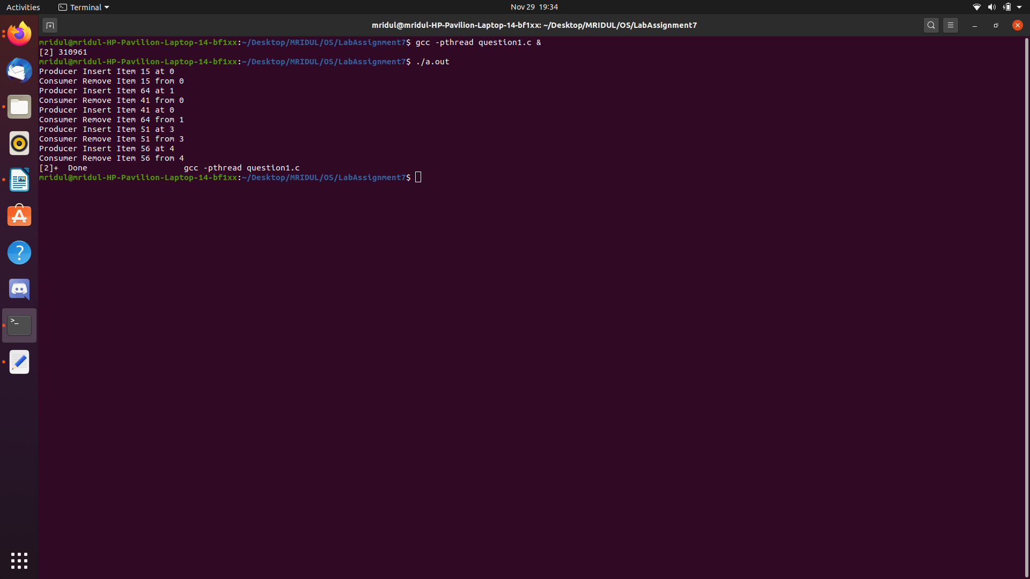

Question 2 : Extend the producer consumer simulation in Q1 to sync access of critical data using Peterson’s algorithm.

Code :-

#include<pthread.h>
#include<semaphore.h>
#include<stdlib.h>
#include<stdio.h>
#include<time.h>

#define BufferSize 5 //Size of the buffer
#define prod 0
#define cons 1

int in = 0; int out = 0; int buffer[BufferSize]; int flag[2] = {0,0}; int turn;

void *producer(void *pno);
void *consumer(void *cno);

int main()
{
srand(time(0));
pthread_t pro[5],con[5];
for(int i = 0; i < 5; i = i+1)
{
pthread_create(&pro[i], NULL, (void *)producer, NULL);
pthread_create(&con[i], NULL, (void *)consumer, NULL);
}

for(int i = 0; i < 5; i = i+1)
{
pthread_join(pro[i], NULL);
pthread_join(con[i], NULL);
}

return 0;
}

void *producer(void *pno)
{
int item;
flag[prod]=1;
turn = cons;

while (flag[cons] == 1 && turn == cons);
item = rand()%101; //Produce an random item
buffer[in] = item;
printf("Producer Insert Item %d at %d\n", buffer[in], in);
in = (in+1)%BufferSize;
flag[prod]=0;
}

void *consumer(void *cno)
{
flag[cons]=1;
turn = prod;

while (flag[prod] == 1 && turn == prod);
int item = buffer[out];
printf("Consumer Remove Item %d from %d\n",item, out);
out = (out+1)%BufferSize;
flag[cons]=0;
}

Explanation :-

So here first a thread would express its desire to acquire a lock and sets flag[self] = 1 and then gives the other thread a chance to acquire the lock. If the thread desires to acquire a lock then it gets the lock and passed the chance to the 1st thread. If it does not desire to get the lock then the while loop breaks and the 1st thread gets the chance.

Output :

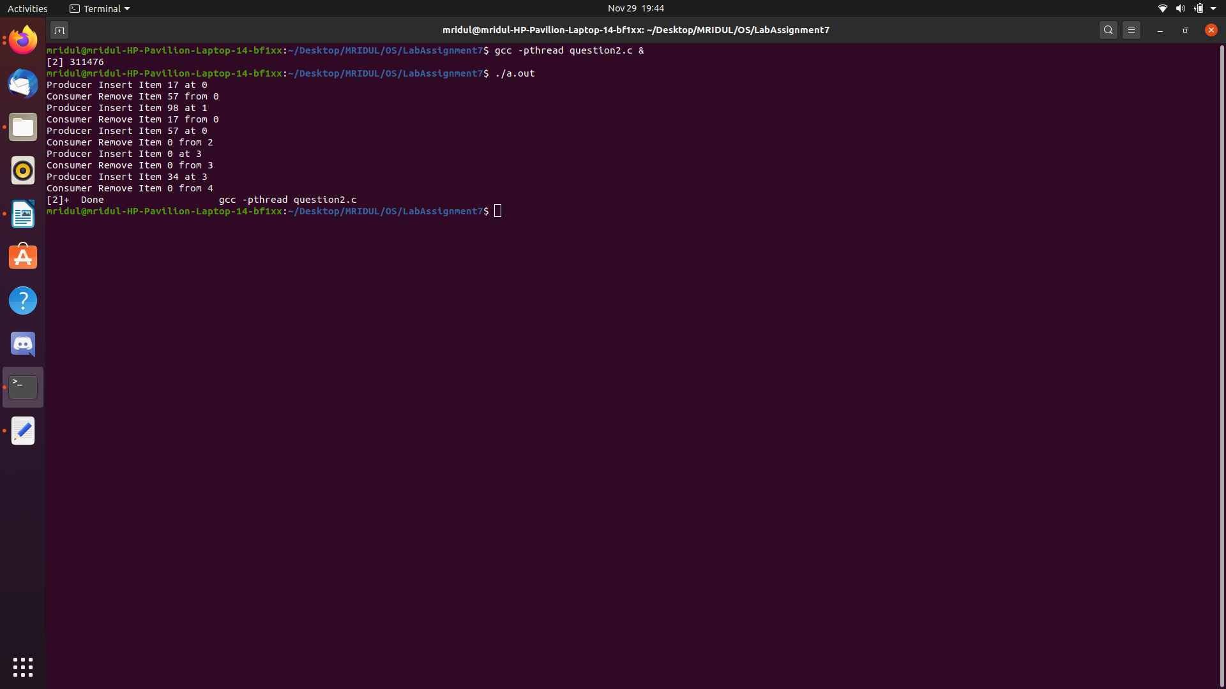
Question 3 : Dictionary problem – Let the producer set up a dictionary of at least 20 words with three attributes(word, primary meaning, secondary meaning) and let the consumer search for the word and retrieve its respective primary and secondary meaning.

Code :-

#include<pthread.h>
#include<semaphore.h>
#include<string.h>
#include<stdio.h>
#include<stdlib.h>

sem_t wrt;
char search[100];
pthread_mutex_t mutex;
int numreader = 0; int k=0; int flag;

typedef struct
{
char word[100];
char primary[1000];
char secondary[100];
}dict;

dict dictionary[5];

void *writer(void *wno);
void *reader(void *rno);

int main()
{
pthread_t read,write[5];
pthread_mutex_init(&mutex, NULL);
sem_init(&wrt,0,1);

for(int i = 0; i < 5; i = i+1)
{
pthread_create(&write[i], NULL, (void *)writer, NULL);
}

pthread_create(&read, NULL, (void *)reader, NULL);
pthread_join(read, NULL);

for(int i = 0; i < 5; i = i+1)
{
pthread_join(write[i], NULL);
}

pthread_mutex_destroy(&mutex);
sem_destroy(&wrt);
return 0;
}

void *writer(void *wno)
{
sem_wait(&wrt);
flag=1;

printf("Enter word:\n");
scanf("%s",search);
int i;

for(i = 0; i < 5; i = i+1) //duplicacy check
{
if(strcmp(dictionary[i].word,search) == 0)
{
printf("Word already present.\n");
flag=0;
break;
}
}

if(flag==1)
{
strcpy(dictionary[k].word,search);
printf("Enter meaning:\n");
scanf("%s",dictionary[k].primary);
printf("Enter secondary meaning:\n");
scanf("%s",dictionary[k].secondary);
printf("Writer added a word %s.\n", dictionary[k].word);
k = k+1;
}

sem_post(&wrt);
}

void *reader(void *rno)
{ //Reader acquire the lock before modifying numreader
pthread_mutex_lock(&mutex);
numreader = numreader + 1;

if(numreader == 1)
{
sem_wait(&wrt); //If this id the first reader, then it will block the writer
}

pthread_mutex_unlock(&mutex); //Reading Section
int i;
printf("Enter word you wanna search: \n");
scanf("%s",search);
int low = 0;
int high = 4;

while(low <= high)
{
int mid = (low+high)/2;
if(strcmp(search,dictionary[mid].word) == 0)
{
printf("Meaning: %s\n", dictionary[mid].primary);
printf("Secondary Meaning: %s\n", dictionary[mid].secondary);
exit(0);
}
else if(strcmp(search,dictionary[mid].word) > 0)
{
high = high;
low = mid+1;
}
else
{
low = low;
high = mid-1;
}
}
printf("Word not found\n"); //Reader acquire the lock before modifying numreader

pthread_mutex_lock(&mutex);
numreader = numreader - 1;

if(numreader == 0)
{
sem_post(&wrt); //If this is the last reader, it will wake up the writer.
}

pthread_mutex_unlock(&mutex);
}

Explanation :-

Here, we use one mutex m and a semaphore w.
1. An integer variable read_count - used to maintain the number of readers currently accessing the resource. The variable read_count is initialized to 0.3.
2. A value of 1 is given initially to m and w.
3. Instead of having the process to acquire lock on the shared resource, we use the mutex m to makethe process to acquire and release lock whenever it is updating the read_count variable.
a. Writer Process : Writer requests the entry to critical section. If allowed i.e. wait() gives a true value, it enters and performs the write. If not allowed, it keeps on waiting. It exits the critical section.
b. Reader Process : Reader requests the entry to critical section. If allowed :
i. It increments the count of number of readers inside the critical section. If this reader is the first reader entering, it locks the w semaphore to restrict the entry of writers if any reader is inside.
ii. It then, signals mutex as any other reader is allowed to enter while others are already reading.
iii. After performing reading, it exits the critical section. When exiting, it checks if no more reader is inside, it signals the semaphore w as now, writer can enter the critical section. If not allowed, it keeps on waiting.

Output :

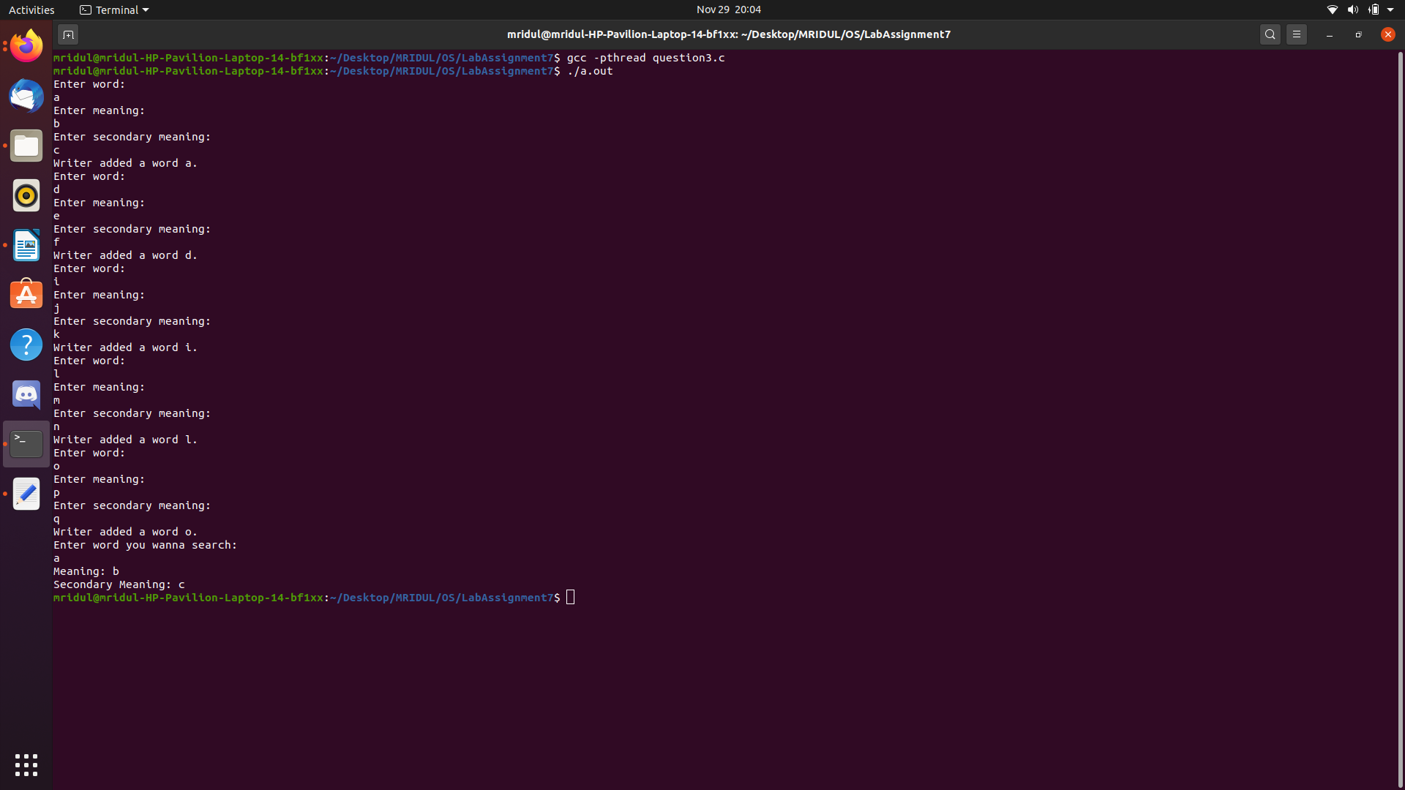
Question 4 : Extend Q3 to avoid duplication of dictionary entries and implement an effiecient binary search on the consumer side in a multithreaded fashion.

Explanation :-

Same as the previous question.

Code :-

#include<pthread.h>
#include<semaphore.h>
#include<string.h>
#include<stdio.h>
#include<stdlib.h>

sem_t wrt;
char search[100];
pthread_mutex_t mutex;
int numreader = 0; int k=0; int flag;

typedef struct
{
char word[100];
char primary[1000];
char secondary[100];
}dict;

dict dictionary[5];

void *writer(void *wno);
void *reader(void *rno);

int main()
{
pthread_t read,write[5];
pthread_mutex_init(&mutex, NULL);
sem_init(&wrt,0,1);

for(int i = 0; i < 5; i = i+1)
{
pthread_create(&write[i], NULL, (void *)writer, NULL);
}

pthread_create(&read, NULL, (void *)reader, NULL);
pthread_join(read, NULL);

for(int i = 0; i < 5; i = i+1)
{
pthread_join(write[i], NULL);
}

pthread_mutex_destroy(&mutex);
sem_destroy(&wrt);
return 0;
}

void *writer(void *wno)
{
sem_wait(&wrt);
flag=1;

printf("Enter word:\n");
scanf("%s",search);
int i;

for(i = 0; i < 5; i = i+1) //duplicacy check
{
if(strcmp(dictionary[i].word,search) == 0)
{
printf("Word already present.\n");
flag=0;
break;
}
}

if(flag==1)
{
strcpy(dictionary[k].word,search);
printf("Enter meaning:\n");
scanf("%s",dictionary[k].primary);
printf("Enter secondary meaning:\n");
scanf("%s",dictionary[k].secondary);
printf("Writer added a word %s.\n", dictionary[k].word);
k = k+1;
}

sem_post(&wrt);
}

void *reader(void *rno)
{ //Reader acquire the lock before modifying numreader
pthread_mutex_lock(&mutex);
numreader = numreader + 1;

if(numreader == 1)
{
sem_wait(&wrt); //If this id the first reader, then it will block the writer
}

pthread_mutex_unlock(&mutex); //Reading Section
int i;
printf("Enter word you wanna search: \n");
scanf("%s",search);
int low = 0;
int high = 4;

while(low <= high)
{
int mid = (low+high)/2;
if(strcmp(search,dictionary[mid].word) == 0)
{
printf("Meaning: %s\n", dictionary[mid].primary);
printf("Secondary Meaning: %s\n", dictionary[mid].secondary);
exit(0);
}
else if(strcmp(search,dictionary[mid].word) > 0)
{
high = high;
low = mid+1;
}
else
{
low = low;
high = mid-1;
}
}
printf("Word not found\n"); //Reader acquire the lock before modifying numreader

pthread_mutex_lock(&mutex);
numreader = numreader - 1;

if(numreader == 0)
{
sem_post(&wrt); //If this is the last reader, it will wake up the writer.
}

pthread_mutex_unlock(&mutex);
}

Output :

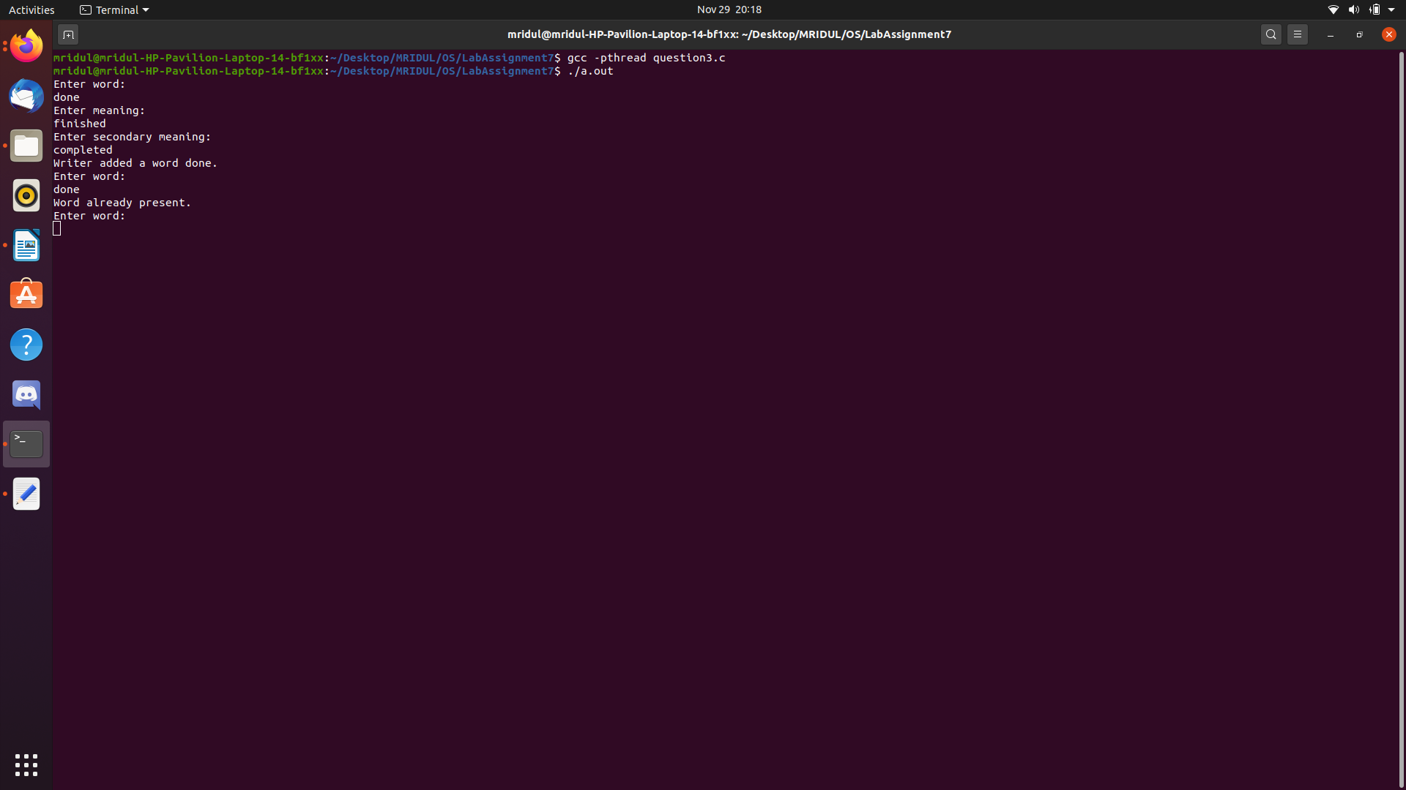
Question 5 : Dekker’s algorithm

Algorithm :-

Main()
{
// to denote which thread will enter next
int favouredthread = 1;

// flags to indicate if each thread is in queue to enter its critical section
boolean thread1wantstoenter = false;
boolean thread2wantstoenter = false;

startThreads();
}

Thread1()
{
do
{
thread1wantstoenter = true; // entry section
// wait until thread2 wants to enter its critical section

while (thread2wantstoenter == true)
{
// if 2nd thread is more favored
if (favaouredthread == 2)
{
// gives access to other thread
thread1wantstoenter = false;
// wait until this thread is favored

while (favouredthread == 2) ;
thread1wantstoenter = true;
}
}

// critical section
// favor the 2nd thread
favouredthread = 2;

// exit section
// indicate thread1 has completed its critical section
thread1wantstoenter = false;

// remainder section
}
while (completed == false)
}

Thread2()
{
do
{
thread2wantstoenter = true;
// entry section
// wait until thread1 wants to enter its critical section

while (thread1wantstoenter == true)
{
// if 1st thread is more favored
if (favaouredthread == 1)
{
// gives access to other thread
thread2wantstoenter = false;
// wait until this thread is favored
while (favouredthread == 1) ;
thread2wantstoenter = true;
}
}
// critical section
// favour the 1st thread
favouredthread = 1;
// exit section
// indicate thread2 has completed its critical section
thread2wantstoenter = false;
// remainder section
}
while (completed == false)
}

This version guarantees a complete solution to the critical solution problem.

Explanation :-

Dekker’s Algorithm : Final and completed Solution – the idea is to use favoured thread notion to determine entry to the critical section. Favoured thread alternates between the thread providing mutual exclusion and avoiding deadlock, indefinite postponement or lockstep synchronization

Question 6 : Dining Philospher’s problem

Code :-

#include<pthread.h>
#include<semaphore.h>
#include<stdio.h>
#include<unistd.h>

#define N 5 //no. of philosophers
#define THINKING 2
#define HUNGRY 1
#define EATING 0
#define LEFT (phnum + 4) % N
#define RIGHT (phnum + 1) % N

int state[N]; int phil[N] = { 0, 1, 2, 3, 4 };
sem_t mutex; sem_t S[N];

void test(int phnum);
void take_fork(int phnum);
void put_fork(int phnum);
void* philospher(void* num);

int main()
{
int i;
pthread_t thread_id[N]; //initialize the semaphores

sem_init(&mutex, 0, 1);
for(i = 0; i < N; i = i+1)
sem_init(&S[i], 0, 0);

for(i = 0; i < N; i = i+1)
{ // create philosopher processes
pthread_create(&thread_id[i], NULL, philospher, &phil[i]);
printf("Philosopher %d is thinking\n", i + 1);
}

for(i = 0; i < N; i = i+1)
pthread_join(thread_id[i], NULL);
}

void test(int phnum)
{
if(state[phnum] == HUNGRY && state[LEFT] != EATING && state[RIGHT] != EATING)
{
state[phnum] = EATING; //state that eating
sleep(2); //eating time

printf("Philosopher %d takes fork %d and %d\n", phnum + 1, LEFT + 1, phnum + 1);
printf("Philosopher %d is Eating\n", phnum + 1);
sem_post(&S[phnum]);
}
}

// take up chopsticks
void take_fork(int phnum)
{
sem_wait(&mutex); // state that hungry
state[phnum] = HUNGRY;
printf("Philosopher %d is Hungry\n", phnum + 1); // eat if neighbours are not eating
test(phnum);

sem_post(&mutex); // if unable to eat wait to be signalled
sem_wait(&S[phnum]);
sleep(1);
}

// put down chopsticks
void put_fork(int phnum)
{
sem_wait(&mutex); //state that thinking
state[phnum] = THINKING;
printf("Philosopher %d putting fork %d and %d down\n", phnum + 1, LEFT + 1, phnum + 1);
printf("Philosopher %d is thinking\n", phnum + 1);

test(LEFT);
test(RIGHT);
sem_post(&mutex);
}

void* philospher(void* num)
{
while(1)
{
int* i = num;
sleep(1);
take_fork(*i);
sleep(0); //immediately drops fork after eating

put_fork(*i);
}
}

Explanation :-

Solution of Dining Philosophers Problem - A solution of the Dining Philosophers Problem is to use a semaphore to represent a chopstick. A chopstick can be picked up by executing a wait operation on the semaphore and released by executing a signal semaphore.
The structure of the chopstick is shown below − semaphore chopstick [5];
Initially the elements of the chopstick are initialized to 1 as the chopsticks are on the table and not picked up by a philosopher.
The structure of a random philosopher i is given as follows −
do
{
wait( chopstick[i] );
wait( chopstick[ (i+1) % 5] ); . . . EATING THE RICE .
signal( chopstick[i] );
signal( chopstick[ (i+1) % 5] ); . . THINKING
} while(1);

Output :

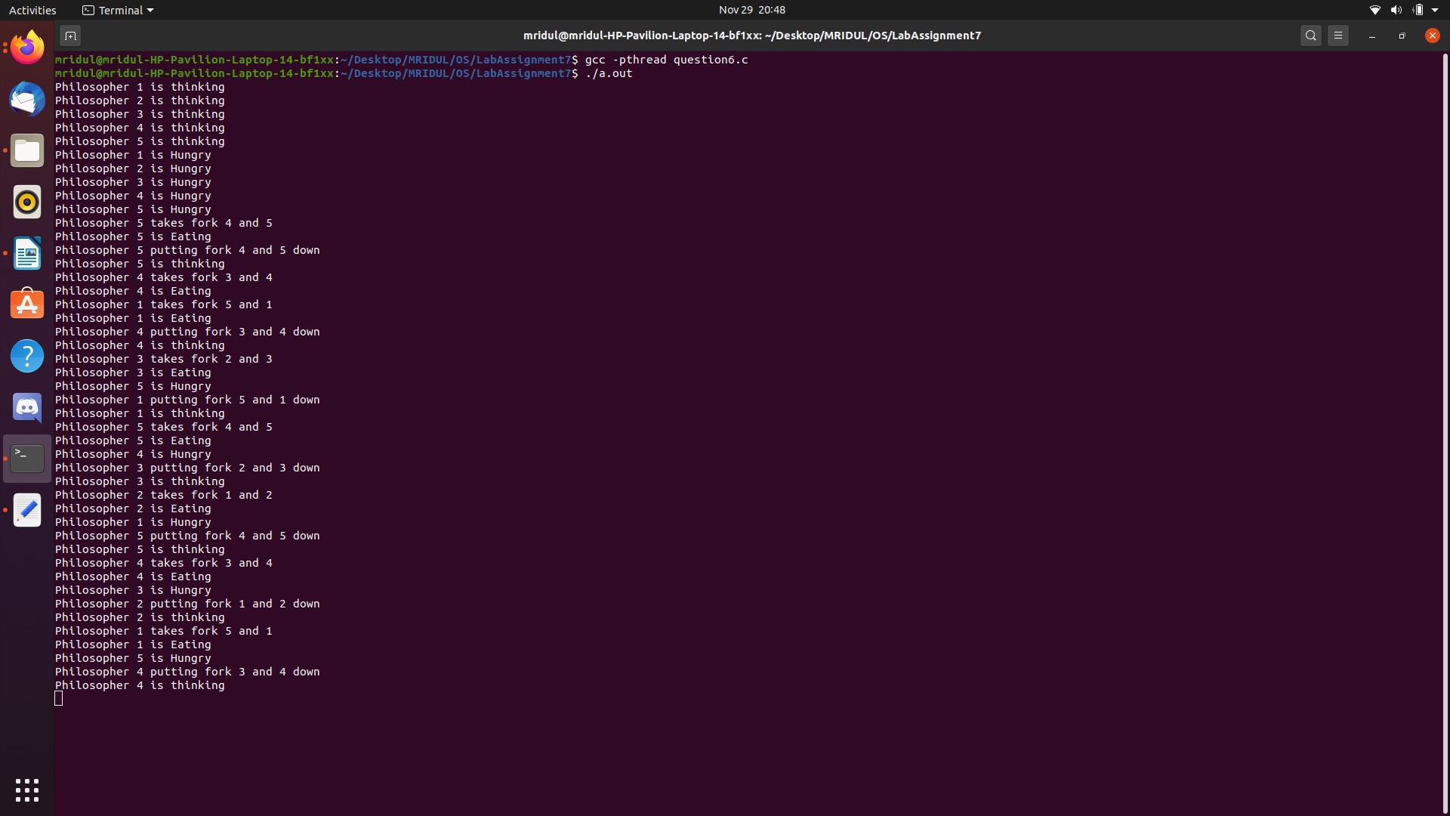

Question 7 : Readers Writers problem

Code :-

#include<iostream>
#include<pthread.h>
#include<unistd.h>

using namespace std;
class monitor
{
private:
int rcnt;
int wcnt;
int waitr;
int waitw;
pthread_cond_t canread;

pthread_cond_t canwrite;
pthread_mutex_t condlock;

public:
monitor()
{
rcnt = 0;
wcnt = 0;
waitr = 0;
waitw = 0;
pthread_cond_init(&canread, NULL);
pthread_cond_init(&canwrite, NULL);
pthread_mutex_init(&condlock, NULL);
}

void beginread(int i)
{
pthread_mutex_lock(&condlock);
if(wcnt == 1 || waitw > 0)
{
waitr = waitr + 1;
pthread_cond_wait(&canread, &condlock);
waitr = waitr - 1;
}

rcnt = rcnt + 1;
cout << "reader " << i << " is reading\n";
pthread_mutex_unlock(&condlock);
pthread_cond_broadcast(&canread);
}

void endread(int i)
{
pthread_mutex_lock(&condlock);
if(--rcnt == 0)
pthread_cond_signal(&canwrite);

pthread_mutex_unlock(&condlock);
}

void beginwrite(int i)
{
pthread_mutex_lock(&condlock);
if(wcnt == 1 || rcnt > 0)
{
++waitw;
pthread_cond_wait(&canwrite, &condlock);
--waitw;
}

wcnt = 1;
cout << "writer " << i << " is writing\n";
pthread_mutex_unlock(&condlock);
}

void endwrite(int i)
{
pthread_mutex_lock(&condlock);
wcnt = 0; // if any readers are waiting, threads are unblocked

if(waitr > 0)
pthread_cond_signal(&canread);
else
pthread_cond_signal(&canwrite);

pthread_mutex_unlock(&condlock);
}
} M; //object

void* reader(void* id);

void* writer(void* id);

int main()
{
pthread_t r[5], w[5];
int id[5];

for(int i = 0; i < 5; i = i+1)
{
id[i] = i;
pthread_create(&r[i], NULL, &reader, &id[i]);
pthread_create(&w[i], NULL, &writer, &id[i]);
}

for(int i = 0; i < 5; i = i+1 )
{
pthread_join(r[i], NULL);
}

for(int i = 0; i < 5; i = i+1)
{
pthread_join(w[i], NULL);
}
}

void* writer(void* id)
{
int c = 0;
int i = *(int*)id;

while(c < 5)
{
usleep(1);
M.beginwrite(i);
M.endwrite(i);
c++;
}

pthread_exit(0);
}

void* writer(void* id)
{
int c = 0;
int i = *(int*)id;

while(c < 5)
{
usleep(1);
M.beginwrite(i);
M.endwrite(i);
c++;
}

pthread_exit(0);
}

Explanation :-

To solve this question, a writer should get exclusive access to an object i.e. when a writer is accessing the object, no reader or writer may access it. However, multiple readers can access the object at the same time.This can be implemented using semaphores.
The codes for the reader and writer process in the reader-writer problem are given as follows −Reader Process
The code that defines the reader process is given below −
wait (mutex);
rc ++;
if(rc == 1)
wait (wrt);
signal(mutex); ... READ THE OBJECT.
wait(mutex);
rc --;
if(rc == 0)
signal (wrt);
signal(mutex);

In the above code, mutex and wrt are semaphores that are initialized to 1. Also, rc is a variable that is initialized to 0. The mutex semaphore ensures mutual exclusion and wrt handles the writing mechanism and is common to the reader and writer process code.

Output :

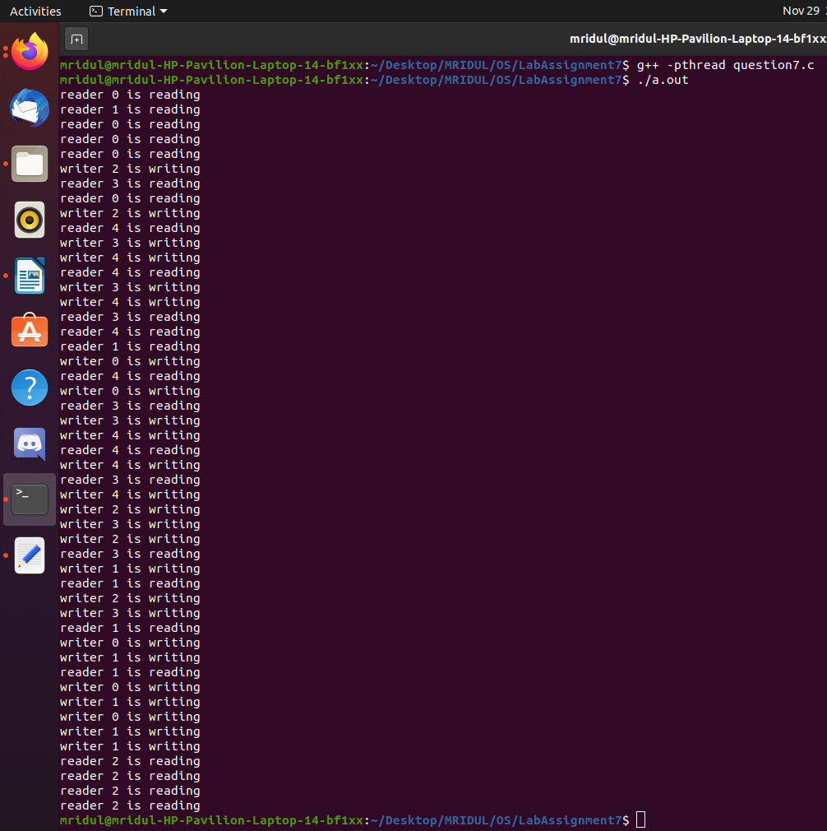
Question 8 : Santa Claus Problem

Code :-

#include<pthread.h>
#include<stdlib.h>
#include<assert.h>
#include<unistd.h>
#include<stdio.h>
#include<stdbool.h>
#include<semaphore.h>

pthread_t *CreateThread(void *(*f)(void *), void *a)
{
static long thread;
pthread_t* t;
t = (pthread_t*)malloc(sizeof(pthread_t));
assert(t != NULL);
int ret = pthread_create(t, NULL, f, a);
assert(ret == 0);return t;
}

static const int N_ELVES = 10;
static const int N_REINDEER = 9;
static int elves;
static int reindeer;
static sem_t santaSem;
static sem_t reindeerSem;
static sem_t elfTex;
static sem_t mutex;

void *SantaClaus(void *arg)
{
printf("Santa Claus: Hoho, here I am\n");

while(true)
{
sem_wait(&santaSem);
sem_wait(&mutex);

if(reindeer == N_REINDEER)
{
printf("Santa Claus: preparing sleigh\n");
for (int r = 0; r < N_REINDEER; r = r+1)
sem_post(&reindeerSem);

printf("Santa Claus: make all kids in the world happy\n");
reindeer = 0;
}
else if(elves == 3)
{
printf("Santa Claus: helping elves\n");
}

sem_post(&mutex);
}

return arg;
}

void *Reindeer(void *arg)
{
int id = *((int *)arg);
printf("This is reindeer %d\n", id);
while (true)
{
sem_wait(&mutex);
reindeer = reindeer + 1;
if (reindeer == N_REINDEER)
sem_post(&santaSem);

sem_post(&mutex);
sem_wait(&reindeerSem);

printf("Reindeer %d getting hitched\n", id);
sleep(20);
}

return arg;
}

void *Elve(void *arg)
{
int id = *((int *)arg);
printf("This is elve %d\n", id);

while (true)
{
bool need_help = random() % 100 < 10;
if(need_help)
{
sem_wait(&elfTex);
sem_wait(&mutex);
elves = elves + 1;

if (elves == 3)
sem_post(&santaSem);

else
sem_post(&elfTex);

sem_post(&mutex);
printf("Elve %d will get help from Santa Claus\n", id);
sleep(10);
sem_wait(&mutex);
elves = elves - 1;

if(elves == 0)
sem_post(&elfTex);
sem_post(&mutex);
}// Do some work

printf("Elve %d at work\n", id);
sleep(2 + random() % 5);
}

return arg;
}

int main(int ac, char **av)
{
elves = 0;
reindeer = 0;
sem_init(&santaSem, 0, 0);
sem_init(&reindeerSem, 0, 0);
sem_init(&elfTex, 0, 1);
sem_init(&mutex, 0, 1);
pthread_t *santa_claus = CreateThread(SantaClaus, 0);
pthread_t *reindeers[N_REINDEER];

for(int r = 0; r < N_REINDEER; r = r+1)
reindeers[r] = CreateThread(Reindeer, (void *)r + 1);
pthread_t *elves[N_ELVES];

for (int e = 0; e < N_ELVES; e = e+1)
elves[e] = CreateThread(Elve, (void *)e + 1);

int ret = pthread_join(*santa_claus, NULL);
assert(ret == 0);
}

Question 9 : Building H2O problem

Algorithm :-

Oxygen code;
mutex.wait()
oxygen += 1
if hydrogen >= 2:
hydroQueue.signal(2)
hydrogen -= 2
oxyQueue.signal()
oxygen -= 1
else:
mutex.signal()
oxyQueue.wait()
bond()
barrier.wait()
mutex.signal()

Hydrogen code;
mutex.wait()
hydrogen += 1
if hydrogen >= 2 and oxygen >= 1:
hydroQueue.signal(2)
hydrogen -= 2
oxyQueue.signal()
oxygen -= 1
else:
mutex.signal()
hydroQueue.wait()
bond()
barrier.wait()

Code :-

#include<pthread.h>
#include<stdio.h>
#include<semaphore.h>
#include<unistd.h>

sem_t smutex, oxyQueue, hydroQueue;
int oxygen=0; int hydrogen=0;
pthread_t oxyThread, hydroThread1, hydroThread2;

int bond();
void* oxyFn(void* arg);
void* hydroFn(void* arg);

int main()
{
if(sem_init(&smutex,0,1) == -1)
{
perror("error initilalizing semaphore\n");
}

if(sem_init(&oxyQueue,0,0) == -1)
{
perror("error initilalizing semaphore\n");
}

if(sem_init(&hydroQueue,0,0) == -1)
{
perror("error initilalizing semaphore\n");
}

sleep(2);

pthread_create(&oxyThread,0,oxyFn, NULL);
pthread_create(&hydroThread1,0,hydroFn, NULL);
pthread_create(&hydroThread2,0,hydroFn, NULL);

for(;;);
}

int bond()
{
static int i=0;
i = i+1;

if((i%3) == 0)
printf("** Molecule no. %d created**\n\n",i/3);

sleep(2);
return(0);
}

void* oxyFn(void* arg)
{
while(1)
{
sem_wait(&smutex);
oxygen+=1;

if(hydrogen >= 2)
{
sem_post(&hydroQueue);
sem_post(&hydroQueue);
hydrogen-=2;
sem_post(&oxyQueue);
oxygen-=1;
}
else
{
sem_post(&smutex);
}

sem_wait(&oxyQueue);
printf("Oxygen Bond\n");
bond();
sleep(3);
sem_post(&smutex);
}
}

void* hydroFn(void* arg)
{
while(1)
{
sem_wait(&smutex);
hydrogen = hydrogen + 1;

if(hydrogen >= 2 && oxygen >= 1)
{
sem_post(&hydroQueue);
sem_post(&hydroQueue);
hydrogen = hydrogen - 2;
sem_post(&oxyQueue);
oxygen = oxygen - 1;
}
else
{
sem_post(&smutex);
}

sem_wait(&hydroQueue);

printf("Hydrogen Bond\n");
bond();
sleep(3);
}
}

Output :

